Electronic Supplementary Material
This document contains the Supplementary Materials for Psychological flexibility typologies and non-suicidal self-injury behavior among Chinese adolescents: A latent profile and multiple mediation analysis.

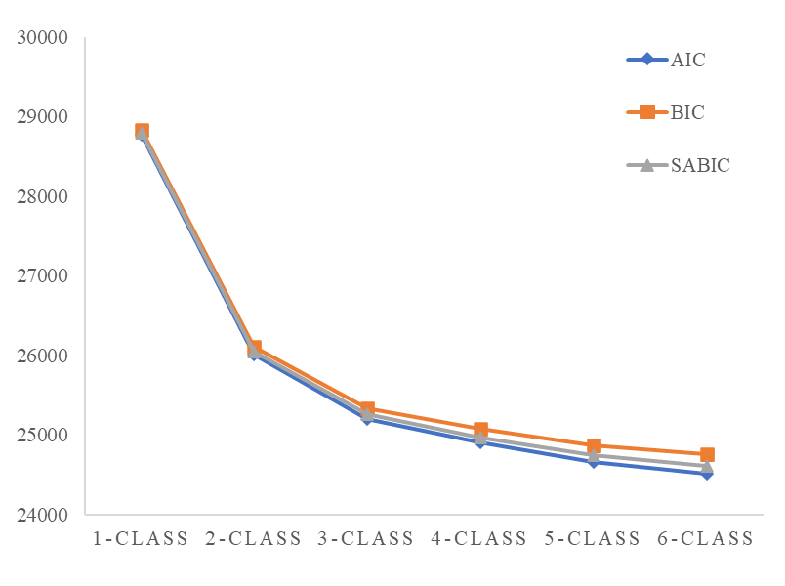
Fig. A1 The elbow plot of ICs in LPA models

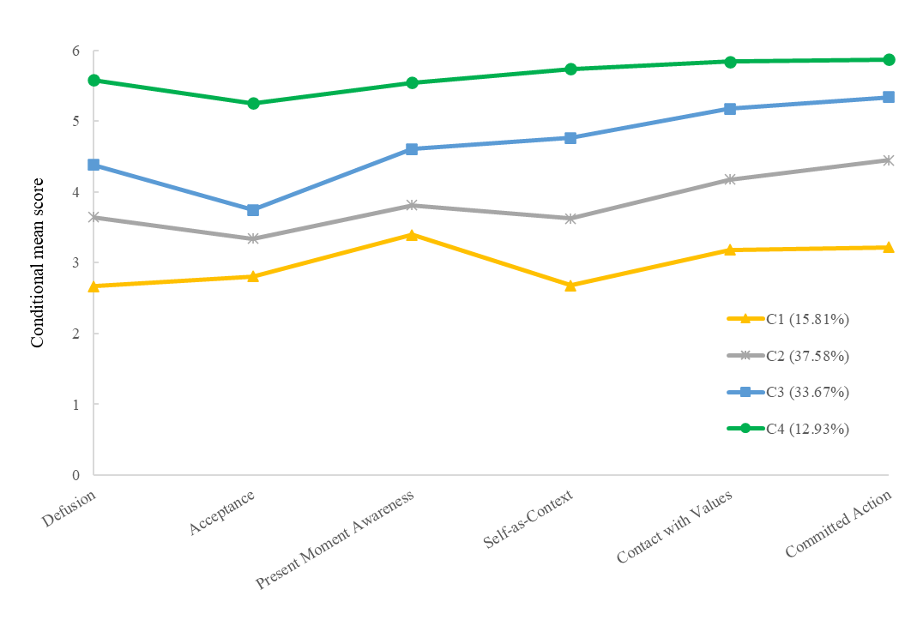 | 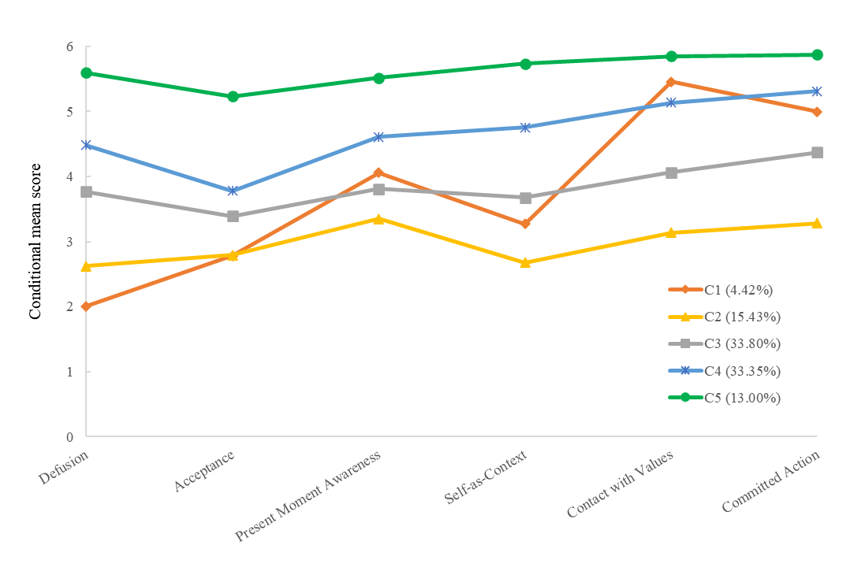
Fig. A2 The mean scores of the four profiles and five profiles of adolescent PF on six dimensions (n = 1,562)

Table A1 Comparison of the scores of the PF dimensions in Chinese adolescents with different PF profiles (n = 1,562)
Dimensions of PF | M±SD |  |  |  |  | F | LSD
Dimensions of PF | C1 | C2 | C3 | C4 | C5 | F | LSD
Defusion | 2.01±0.74 | 2.62±0.73 | 3.76±0.78 | 4.48±0.78 | 5.60±0.56 | 623.195*** | C5>C4>C3>C2>C1
Acceptance | 2.78±1.17 | 2.79±0.82 | 3.39±0.87 | 3.78±1.01 | 5.23±0.84 | 228.625*** | C5>C4>C3>C1≈C2
Present Moment Awareness | 4.06±1.48 | 3.35±0.99 | 3.81±1.01 | 4.61±0.99 | 5.51±0.78 | 172.638*** | C5>C4>C1≈C3>C2
Self-as-Context | 3.27±1.04 | 2.68±0.62 | 3.68±0.64 | 4.75±0.66 | 5.74±0.38 | 845.769*** | C5>C4>C3>C1>C2
Contact with Values | 5.46±0.51 | 3.14±0.62 | 4.06±0.54 | 5.13±0.51 | 5.85±0.27 | 1116.599*** | C5>C1>C4>C3>C2
Committed Action | 5.00±0.84 | 3.28±0.82 | 4.37±0.67 | 5.31±0.57 | 5.87±0.28 | 635.711*** | C5>C4>C1>C3>C2
Note. PF = Psychological flexibility; LSD = Least significant difference. ***p<0.001.

