Supplementary Figure S2 Distributions of the COPE 6 subscores FC (a) and DC (b)
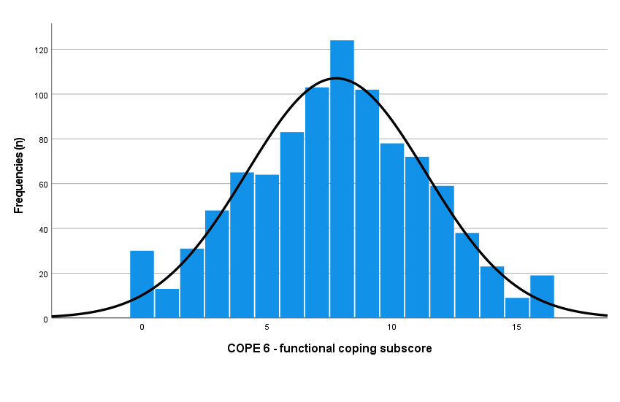
a

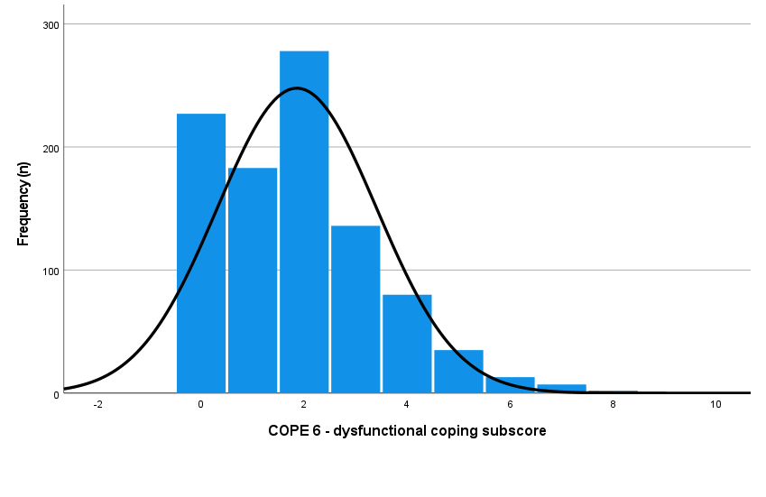
b
Note. Higher scores on the COPE 6 - functional coping (FC) subscale indicate the use of more functional coping strategies (a, Range: 0–16). Higher scores on the COPE 6 - dysfunctional coping (DC) subscale indicate the use of more dysfunctional coping strategies (b, Range: 0–8).

