Supplementary materials
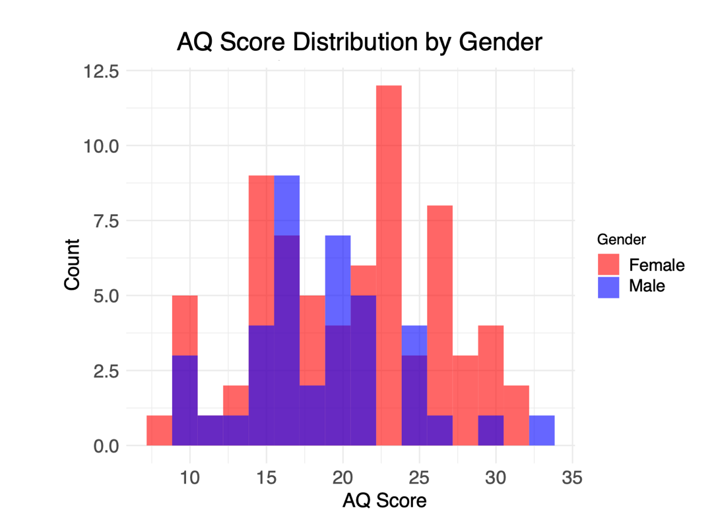
Fig. S1 Distribution of AQ scores by gender.
Correlation between AQ trait and color categorization
To examine whether autistic traits predict category membership of color stimuli, we fitted a generalized linear mixed model (GLMM) with a logistic link function. The dependent variable was binary (within-category vs. cross-category), with perceptual distance (small vs. large), AQ score, and their interaction included as fixed effects.
As expected, the results showed a significant main effect of perceptual distance, such that participants were more likely to perceive color stimuli as belonging to the same category when the perceptual distance between hues was small (β = 0.686, SE = 0.164, z = 4.18, p < .001). Importanly, there was no significant main effect of AQ on category judgments (β = 0.004, SE = 0.008, z = 0.54, p = .590), nor was the interaction between perceptual distance and AQ statistically significant (β = –0.002, SE = 0.008, z = –0.21, p = .836). These results suggested that color categorization is independent of the levels of autistic trait.
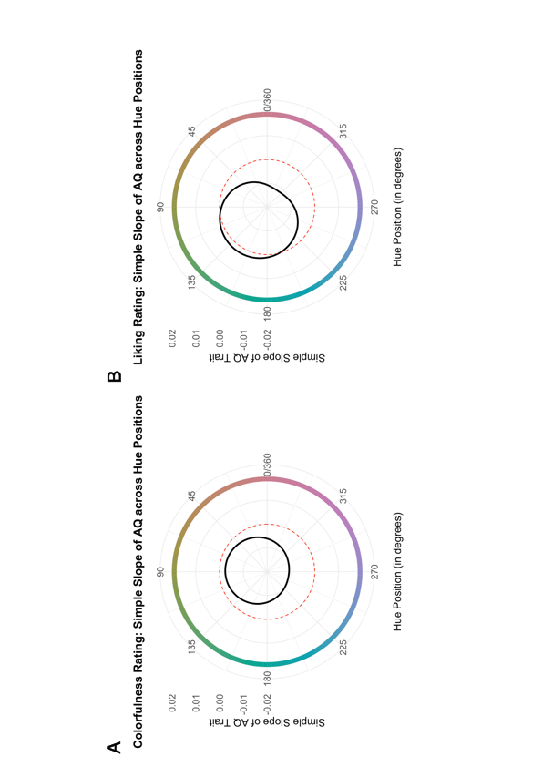
Fig. S2 Simple slopes of the AQ trait predicting colorfulness (A) and liking (B) ratings across hue positions (0-360°). The black line plot shows how the relationship between AQ and ratings varies with hue position, with the dashed red line indicating zero slope (no relationship).

