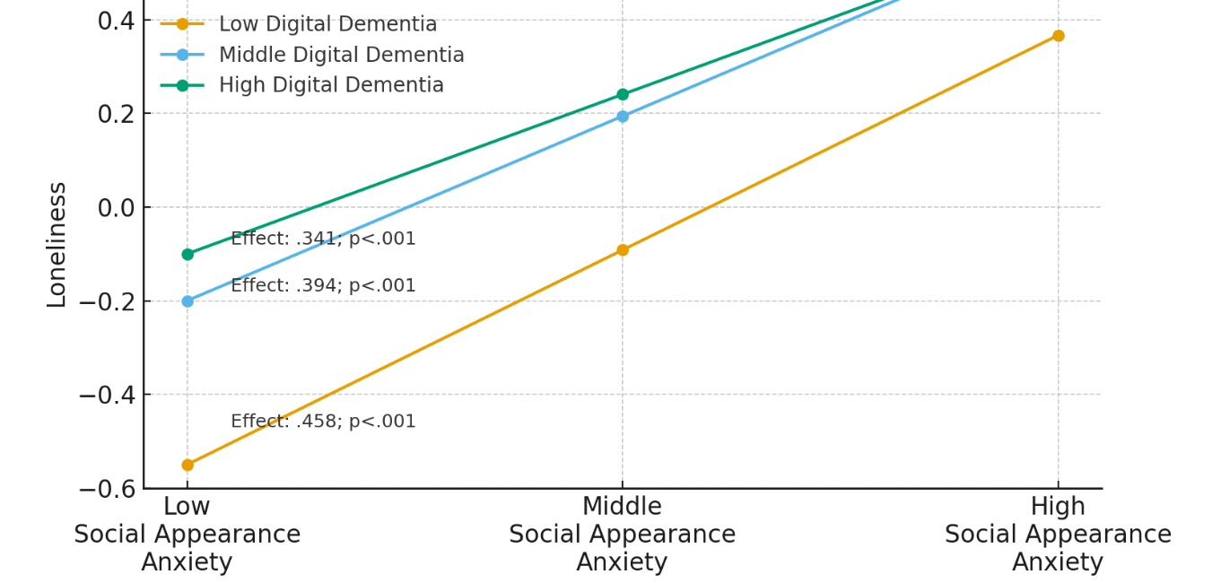
Graph 1. Slope Plot Illustrating the Moderating Effect of Digital Dementia on the Relationship Between Social Appearance Anxiety and Loneliness

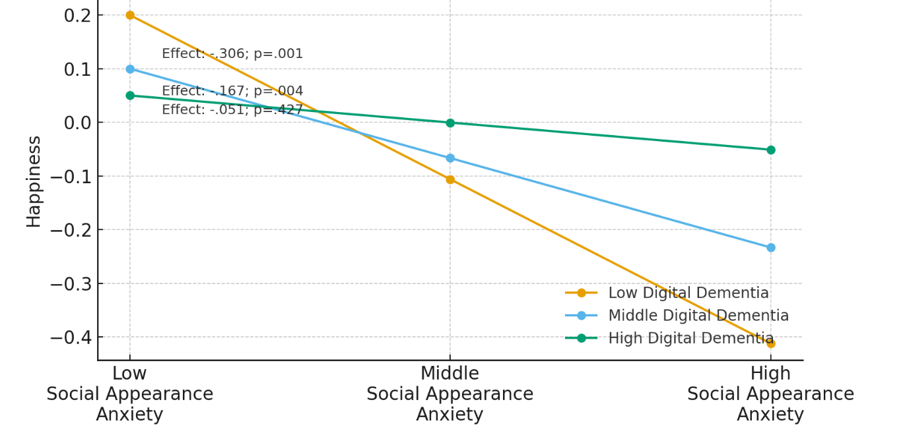
Graph 2. Slope Plot Illustrating the Moderating Effect of Digital Dementia on the Relationship Between Social Appearance Anxiety and Happiness

