Rasch Model Analysis
Existence Pay (EP)
Wright Map
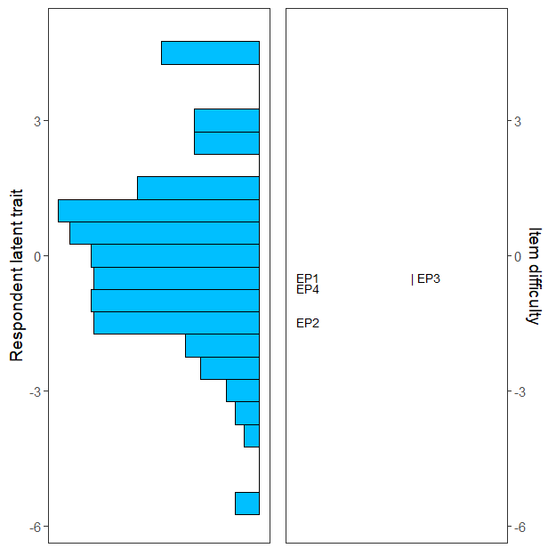

Person-item map for PCM
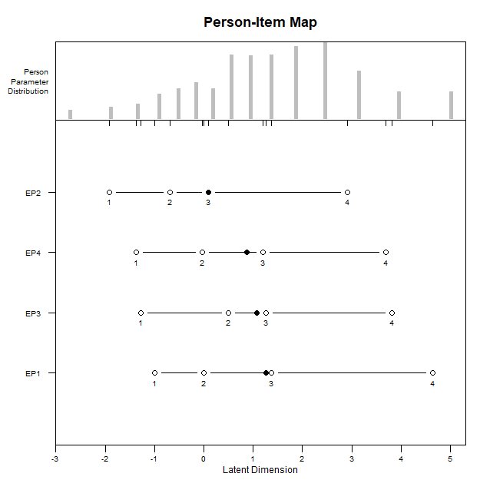

Item Infit Plot
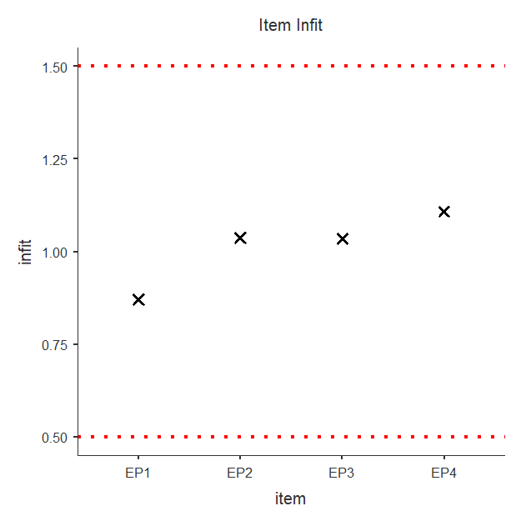

Item Outfit Plot
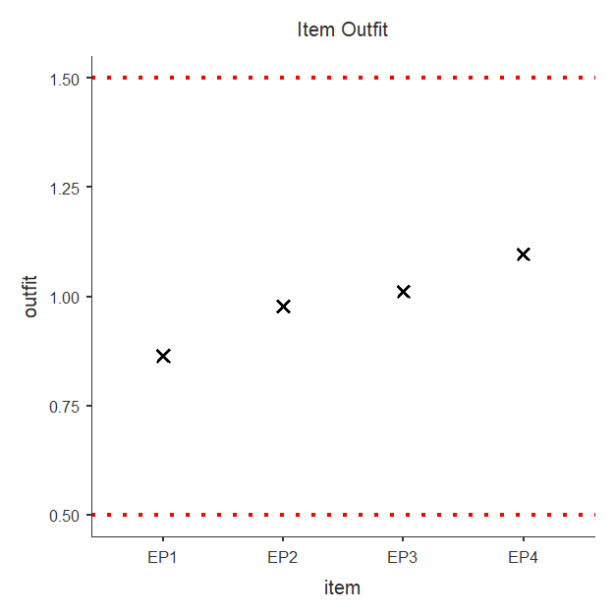
Rating Scale Deltas/thresholds
item alpha beta tau.Cat1 tau.Cat2 tau.Cat3 tau.Cat4
1 EP1 1 -0.4008 -2.325 -0.9112 0.3015 2.934
2 EP2 1 -1.5476 -2.325 -0.9112 0.3015 2.934
3 EP3 1 -0.4245 -2.325 -0.9112 0.3015 2.934
4 EP4 1 -0.6589 -2.325 -0.9112 0.3015 2.934

ICC plot
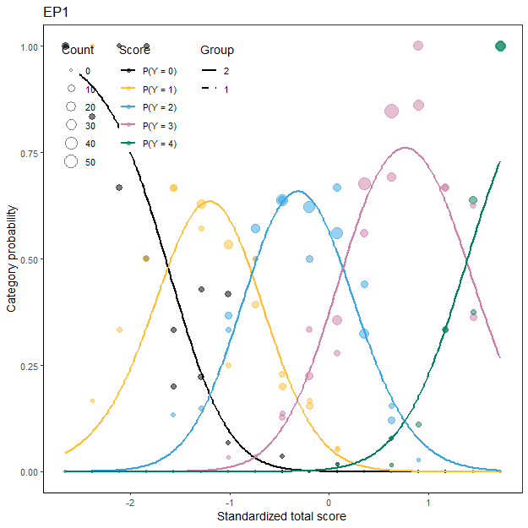

DIF For Ordinal Data
Likelihood ratio Chi-square statistics - BH
 |  | Statistic |  | p |  | Adj.p
EP1 |  | 5.2557 |  | 0.072 |  | 0.288
EP2 |  | 3.8784 |  | 0.144 |  | 0.288
EP3 |  | 0.8794 |  | 0.644 |  | 0.859
EP4 |  | 0.0115 |  | 0.994 |  | 0.994
Note. Adj.p = The adjusted p-values by likelihood ratio test using multiple comparison.

Existence Benefits (EB)
Wright Map
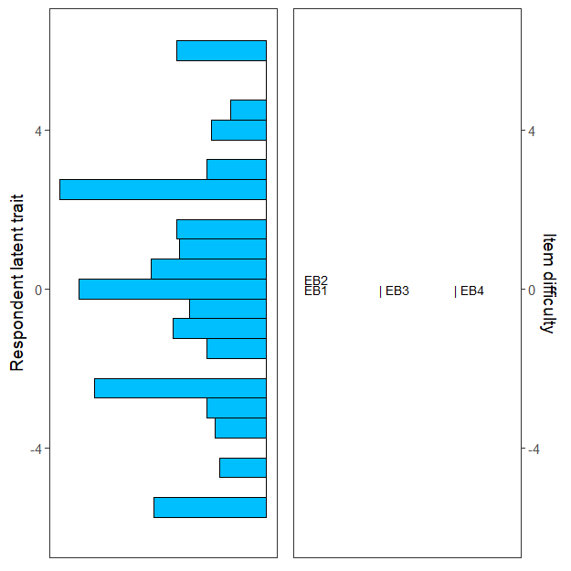

Person-item map for PCM
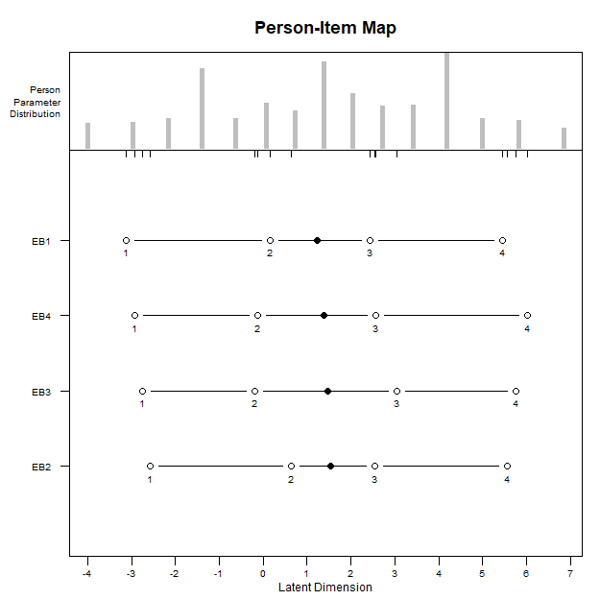

Item Infit Plot
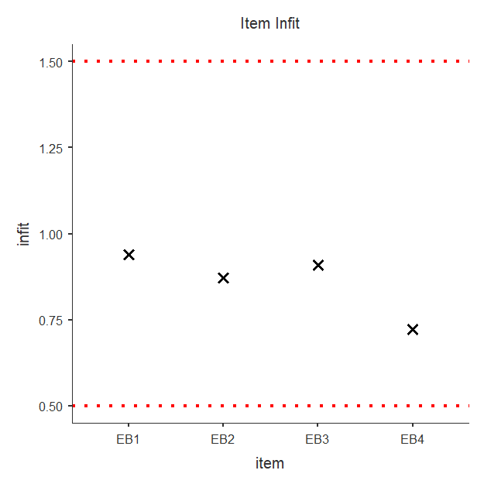

Item Outfit Plot
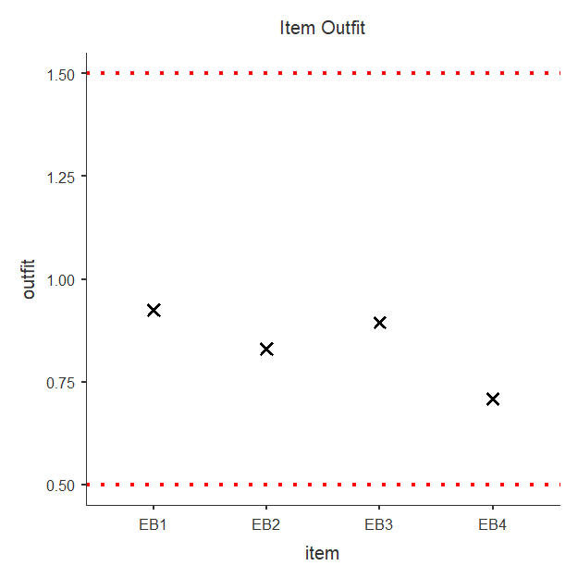
Rating Scale Deltas/thresholds
item alpha beta tau.Cat1 tau.Cat2 tau.Cat3 tau.Cat4
1 EB1 1 -0.08444 -3.509 -1.161 0.9613 3.708
2 EB2 1 0.16076 -3.509 -1.161 0.9613 3.708
3 EB3 1 0.09126 -3.509 -1.161 0.9613 3.708
4 EB4 1 -0.01853 -3.509 -1.161 0.9613 3.708

ICC plot
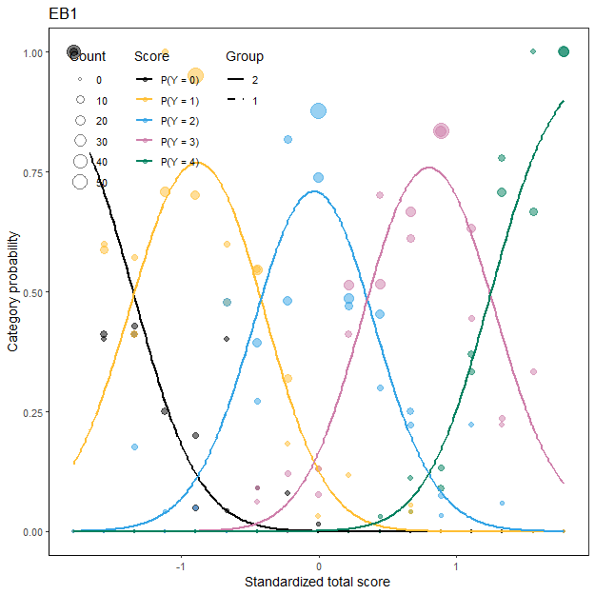
DIF for ordinal data

Likelihood ratio Chi-square statistics - BH
 |  | Statistic |  | p |  | Adj.p
EB1 |  | 1.3707 |  | 0.504 |  | 0.993
EB2 |  | 0.5147 |  | 0.773 |  | 0.993
EB3 |  | 0.0137 |  | 0.993 |  | 0.993
EB4 |  | 3.5663 |  | 0.168 |  | 0.672
Note. Adj.p = The adjusted p-values by likelihood ratio test using multiple comparison.

Relatedness Superiors (RS)
Wright Map
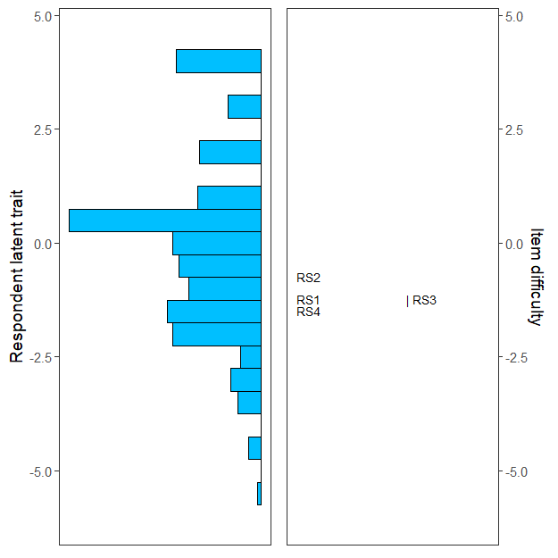

Person-item map for PCM
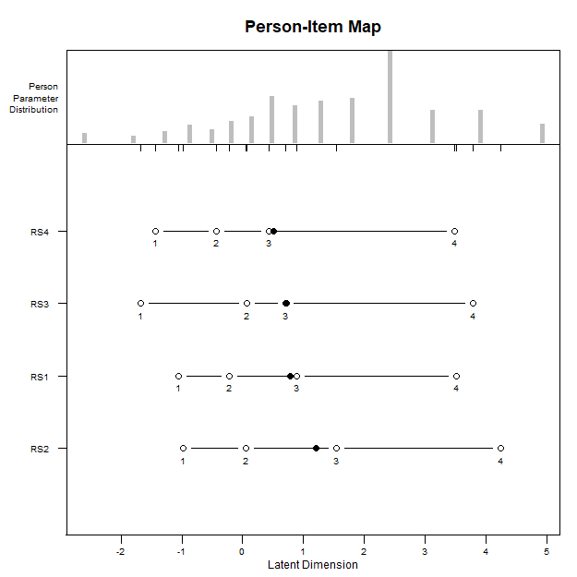

Item Infit Plot
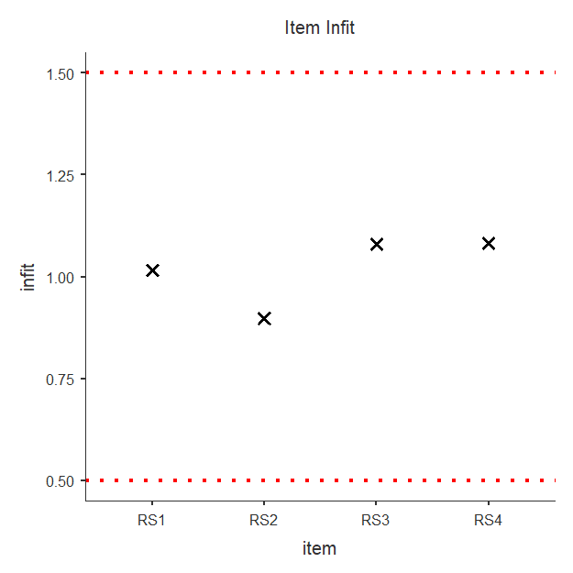

Item Outfit Plot
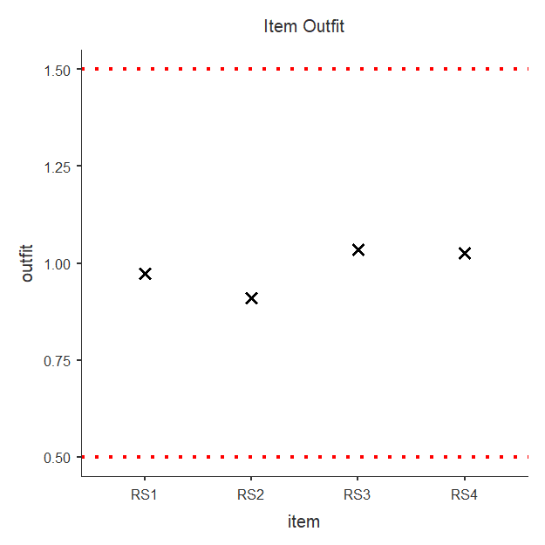
Rating Scale Deltas/thresholds
item alpha beta tau.Cat1 tau.Cat2 tau.Cat3 tau.Cat4
1 RS1 1 -1.1954 -2.284 -0.9654 0.2059 3.043
2 RS2 1 -0.7042 -2.284 -0.9654 0.2059 3.043
3 RS3 1 -1.1924 -2.284 -0.9654 0.2059 3.043
4 RS4 1 -1.4946 -2.284 -0.9654 0.2059 3.043

ICC plot
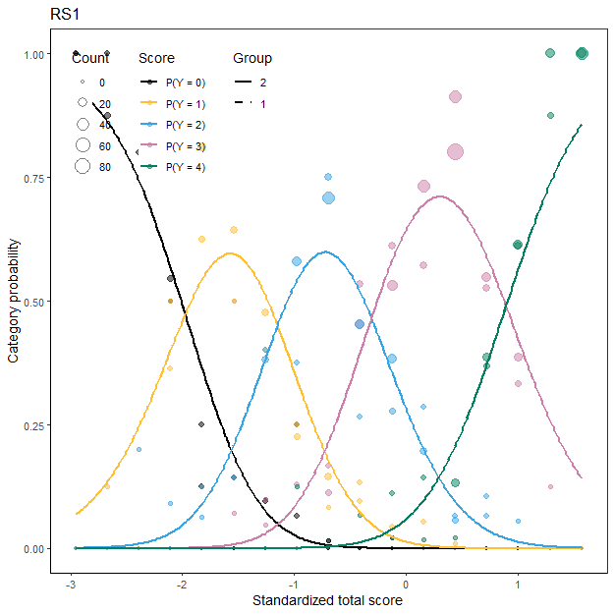
DIF for ordinal data

Likelihood ratio Chi-square statistics - BH
 |  | Statistic |  | p |  | Adj.p
RS1 |  | 0.774 |  | 0.679 |  | 0.679
RS2 |  | 1.188 |  | 0.552 |  | 0.679
RS3 |  | 8.600 |  | 0.014 |  | 0.054
RS4 |  | 3.844 |  | 0.146 |  | 0.293
Note. Adj.p = The adjusted p-values by likelihood ratio test using multiple comparison.

Relatedness Peers (RP)
Wright Map
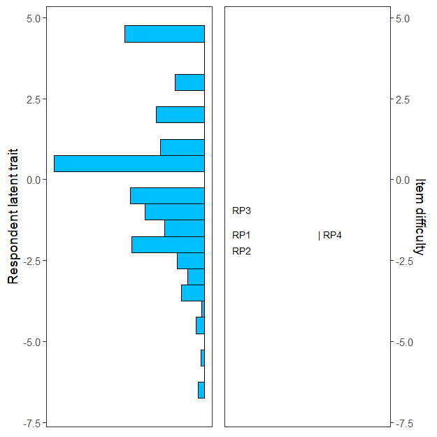

Person-item map for PCM
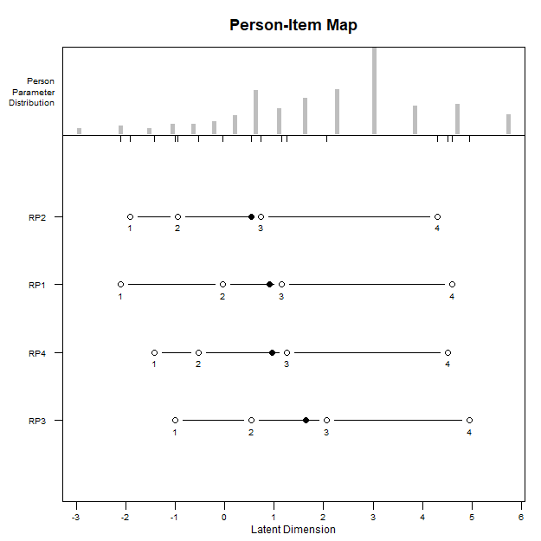

Item Infit Plot
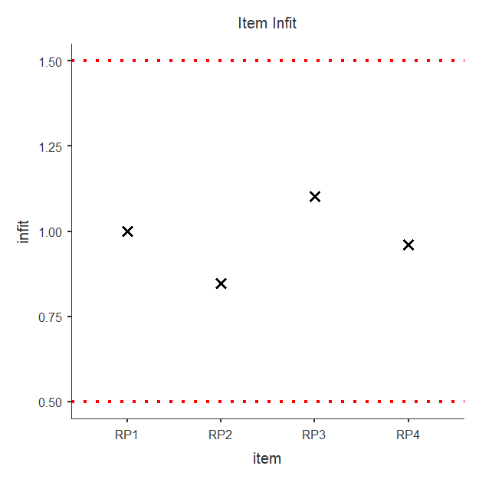

Item Outfit Plot
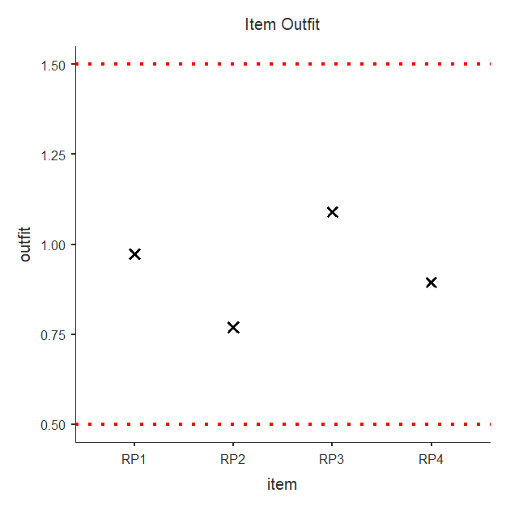
Rating Scale Deltas/thresholds
item alpha beta tau.Cat1 tau.Cat2 tau.Cat3 tau.Cat4
1 RP1 1 -1.757 -2.637 -1.32 0.2913 3.666
2 RP2 1 -2.186 -2.637 -1.32 0.2913 3.666
3 RP3 1 -1.049 -2.637 -1.32 0.2913 3.666
4 RP4 1 -1.799 -2.637 -1.32 0.2913 3.666

ICC plot
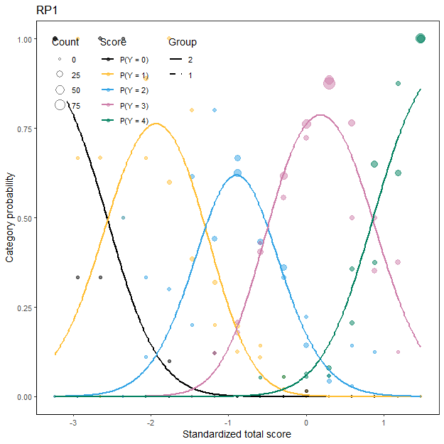
DIF for ordinal data

Likelihood ratio Chi-square statistics - BH
 |  | Statistic |  | p |  | Adj.p
RP1 |  | 0.842 |  | 0.656 |  | 0.732
RP2 |  | 0.625 |  | 0.732 |  | 0.732
RP3 |  | 1.782 |  | 0.410 |  | 0.732
RP4 |  | 1.213 |  | 0.545 |  | 0.732
Note. Adj.p = The adjusted p-values by likelihood ratio test using multiple comparison.

Growth (G)
Wright Map
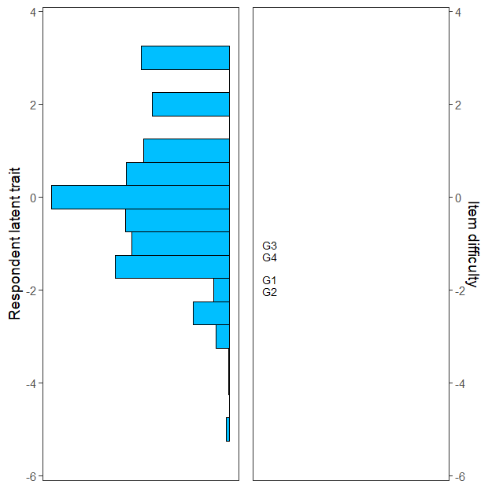

Person-item map for PCM
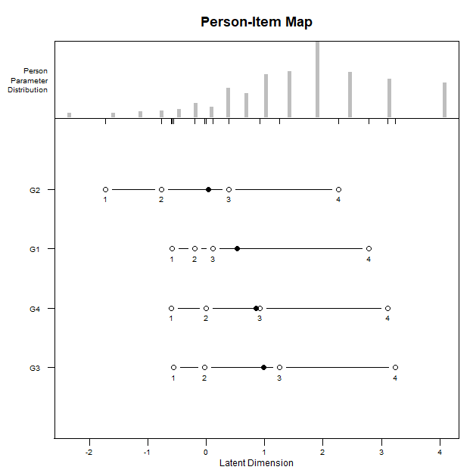

Item Infit Plot
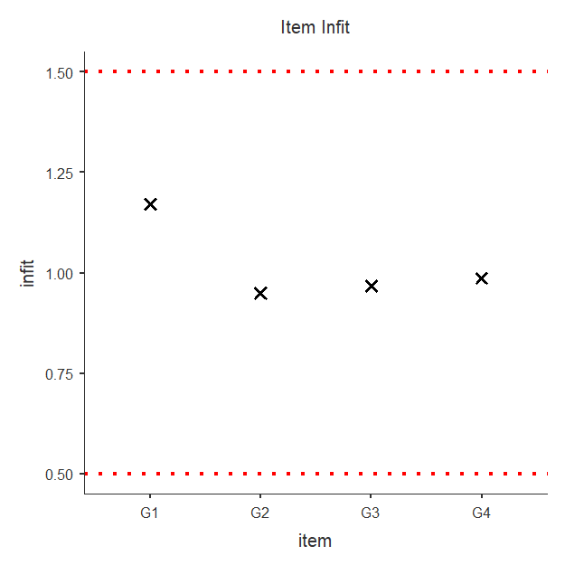

Item Outfit Plot
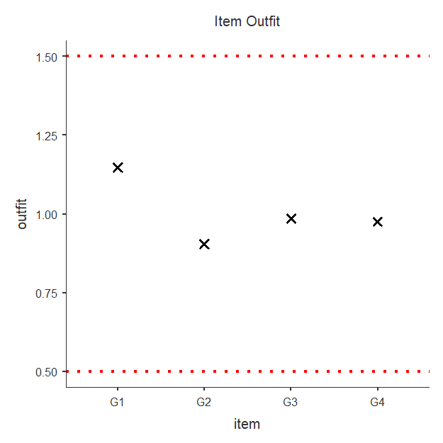
Rating Scale Deltas/thresholds
item alpha beta tau.Cat1 tau.Cat2 tau.Cat3 tau.Cat4
1 G1 1 -1.659 -1.546 -0.9596 0.1777 2.328
2 G2 1 -1.921 -1.546 -0.9596 0.1777 2.328
3 G3 1 -1.011 -1.546 -0.9596 0.1777 2.328
4 G4 1 -1.184 -1.546 -0.9596 0.1777 2.328

ICC plot
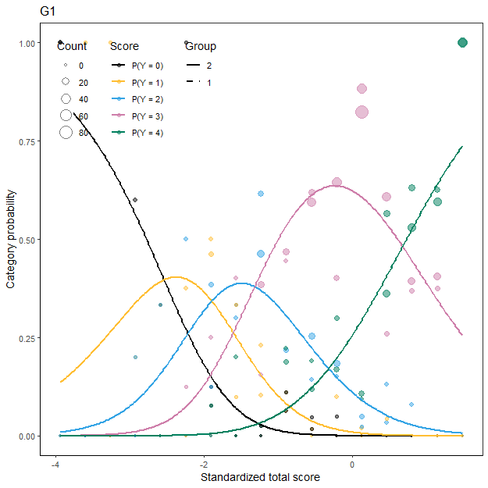
DIF for ordinal data

Likelihood ratio Chi-square statistics - BH
 |  | Statistic |  | p |  | Adj.p
G1 |  | 3.72 |  | 0.156 |  | 0.199
G2 |  | 6.07 |  | 0.048 |  | 0.193
G3 |  | 3.23 |  | 0.199 |  | 0.199
G4 |  | 4.58 |  | 0.101 |  | 0.199
Note. Adj.p = The adjusted p-values by likelihood ratio test using multiple comparison.

