Statistical Analysis: Model Selection
This document outlines the model selection procedure used to estimate item-level sensitivity scale values from the paired comparison data in the article titled Disparities in PHQ-9 Item Sensitivity: A Potential Explanation for the Two-Factor Structure. Four different models were considered: Thurstone’s Case V, Thurstone’s Case III, a binomial model, and a beta density function model, each making different assumptions about the variability in participants’ judgments. The rationale for selecting these models, along with their estimation procedures and goodness-of-fit evaluations, is described below. The data and analysis R code used can be found here: https://osf.io/mw7y9/?view_only=a27f59f7f1d5457e8d4fb21c5fab2948
Thurstone defined several different “Cases” of his law that differ based on their assumptions of the underlying scale values [1,3]. Case V was first considered to estimate the sensitivity/social desirability scale values of the PHQ-9 items since it is the simplest and most commonly used form of Thurstone’s law. Case V assumes normality, unidimensionality of the psychological continuum in question, and equal standard deviations of the scale values across all items, meaning that the variability in individuals’ reactions is the same for all comparisons. This final assumption of equal standard deviations among items becomes quite untenable in cases where there are one or more extreme items, as was the case for Item 9 (thoughts of death or self-harm) in the present study—most participants judged its content as more uncomfortable than the contents of every other item in the PHQ-9.
Case III of Thurstone’s law was then considered to estimate both the scale values and their respective standard deviations. Case III has the same assumptions as Case V, except it does not assume equal standard deviations. Instead, it is assumed that certain items may evoke more consistent judgments, while others may lead to more divergent responses. Another limitation then arose: we found that Case III handles items with extreme scale values poorly. While we would expect consistently ranked items to have low standard deviations, the model can produce unexpected reversals, yielding disproportionately large standard deviation estimates for extreme items [4]. This was the case for Item 9 in the present study; although the agreement between participants was the highest for this item, its estimated Case III standard deviation was the highest of all items.
Two additional methods were thus considered to estimate the scale values and their standard deviations, as suggested by Wild and Cabral [4]: the normal approximation of the binomial distribution (the binomial model) and the beta density function (the beta model). In cases where the Turstone model fails, these models should provide results that better apply to the observed data.
As described in the Introduction section, the method of pair comparisons provides only the relative distance between the items on the psychological continuum in question. However, since we also gathered data on participants’ absolute judgements of the items, we were able to position them on a scale that has a meaningful zero point: the position where 50% of people would judge an item as uncomfortable and 50% as not uncomfortable to disclose. Positive scale values thus indicate the item is more susceptible to SDR (people generally judged its symptoms as uncomfortable to disclose), and negative scale values indicate the item is less susceptible to SDR (people generally judged its symptoms as not uncomfortable to disclose).
The Thurstone Case V and Case III scale values for the PHQ-9 items were calculated following the procedure outlined by Guilford (pp. 160–174) [1], and the binomial and beta models were estimated using the method described by Wild and Cabral [4]. The unit of the resulting sensitivity/social undesirability scale for all models was converted to two standard deviations for easier interpretation.
The goodness of fit of the four models was evaluated using the procedure also outlined in Wild and Cabral [4]. Expected probability matrices were generated through simulation based on the distributional assumptions of each model and its estimated parameters. For the Thurstone Case V and Case III models, the estimated scale values and standard deviations were used; for the binomial model, the observed pairwise probability matrix was employed; and for the beta model, the estimated alpha and beta parameters were used. Each simulation was run for 10,000 iterations to ensure stable estimates.
Two statistics were computed to evaluate model fit by comparing the observed and expected probability matrices: the Y statistic and the absolute average discrepancy. Under the assumption of a good model fit, the Y statistic converges to a chi-square distribution as the number of observations (N) approaches infinity, allowing p-values to be derived using $\frac{m\left(m-1\right)}{2}-m$ degrees of freedom [2], where $m$ is the number of items. A significant Y statistic indicates that the estimated probabilities differ significantly from the observed probabilities, suggesting poor model fit. The absolute average discrepancy was also calculated to provide another estimate of model accuracy, with smaller values indicating a better fit.
The scale value results derived from the four different models can be seen in Table 1, Figure 1, and Figure 2.

Table 1
Results for the Thurstone Case V and Case III Models, the Binomial and the Beta Density Function Models
 |  | Case V | Case III |  | Binomial Model |  | Beta Model
Item | Absolute prop.ª | SV | SV | Sigma | SV | Sigma | SV | Alpha | Beta
1. Little interest or pleasure in doing things | .54 | 0.19 | 0.05 | 0.82 | 0.23 | 1.25 | 0.37 | 4.98 | 4.57
2. Feeling down, depressed, or hopeless | .73 | 1.03 | 0.51 | 0.77 | 1.12 | 1.18 | 1.22 | 6.30 | 3.69
3. Trouble falling or staying asleep, or sleeping too much | .09 | -2.39 | -2.06 | 1.74 | -2.43 | 1.20 | -2.59 | 1.21 | 5.00
4. Feeling tired or having little energy | .11 | -2.48 | -2.26 | 1.88 | -2.54 | 1.16 | -2.70 | 1.14 | 5.14
5. Poor appetite or overeating | .38 | -0.54 | -0.51 | 1.45 | -0.54 | 1.39 | -0.42 | 3.14 | 4.22
6. Feeling bad about yourself — or that you are a failure or have let yourself or your family down | .91 | 2.68 | 1.34 | 0.83 | 2.61 | 0.91 | 2.58 | 9.11 | 2.08
7. Trouble concentrating on things, such as reading the newspaper or watching television | .22 | -1.62 | -1.25 | 1.36 | -1.65 | 1.27 | -1.58 | 2.14 | 5.24
8. Moving or speaking so slowly that other people could have noticed? Or the opposite — being so fidgety or restless that you have been moving around a lot more than usual | .49 | 0.01 | -0.11 | 1.08 | 0.15 | 1.34 | 0.30 | 4.16 | 3.97
9. Thoughts that you would be better off dead or of hurting yourself in some way | .97 | 3.60 | 4.77 | 3.34 | 3.54 | 0.84 | 3.31 | 4.78 | 0.37
ªThe proportion of participants judging the item as uncomfortable to disclose instead of not uncomfortable.
Note. n = 265. SV = Estimated scale values; Sigma = Estimated standard deviations for the scale values.

Figure 1
Sensitivity Scale Values for the PHQ-9 Items by Model
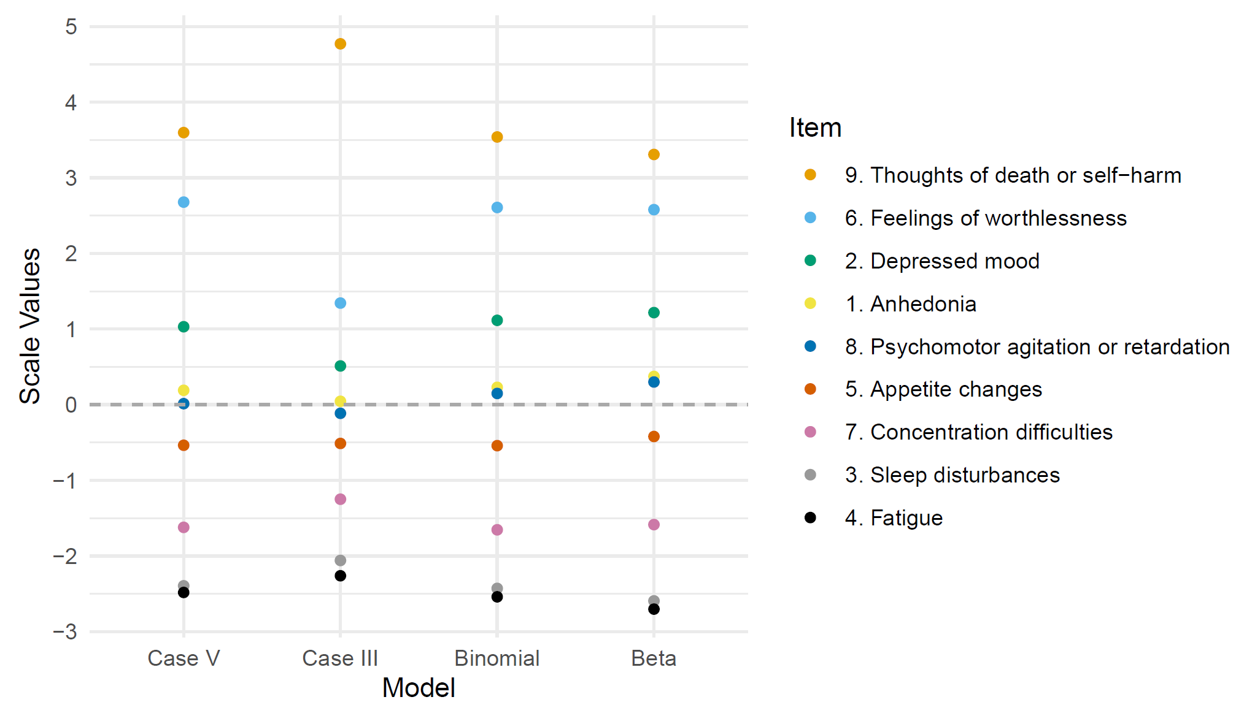
Note. n = 265. Positive values indicate higher susceptibility to SDR (symptoms uncomfortable to disclose) and negative values indicate lower susceptibility to SDR (symptoms not uncomfortable to disclose)

Figure 2
Theoretical Distributions for the Sensitivity Scale Values for the PHQ-9 Items by Model
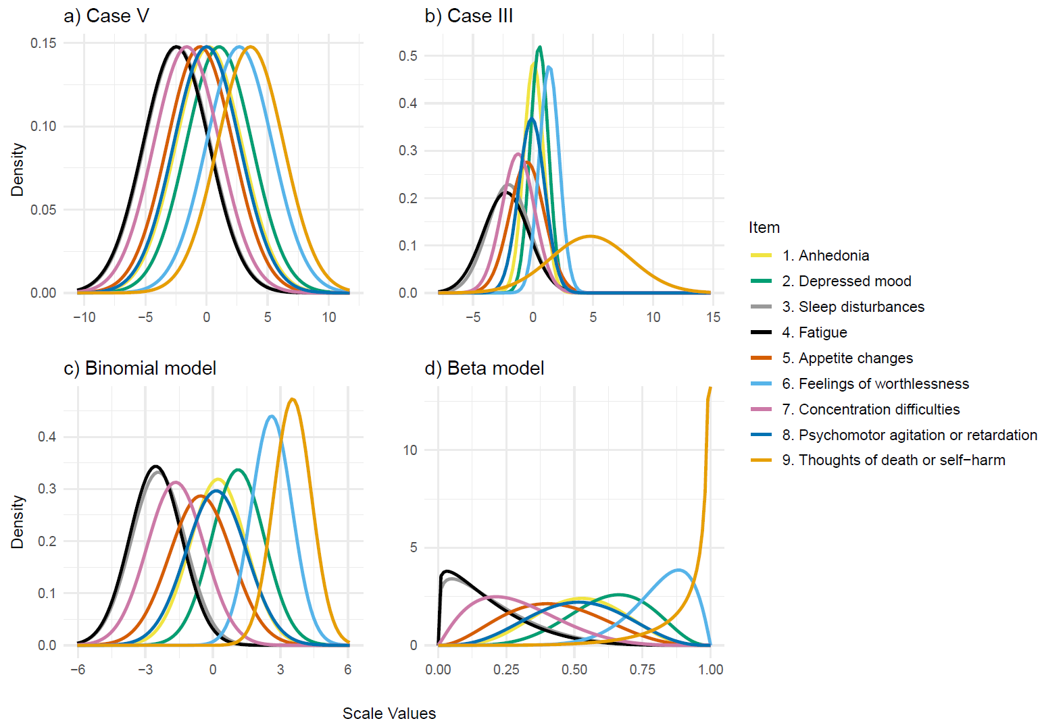

The goodness of fit results for the models can be seen in Table 2. Only the binomial model fits the data reasonably well, as it has the lowest average discrepancy and is the only one with a statistically nonsignificant Y statistic.

Table 2
Goodness of Fit Results for the Thurstone Case V and Case III Models, and the Binomial and Beta Models
Model | Goodness of fit test statistics |  |  | Absolute average discrepancy
Model | Y | df | p | Absolute average discrepancy
Case V | 754.24 | 27 | 0.000 | 0.094
Case III | 107.06 | 27 | 0.000 | 0.031
Binomial | 0.54 | 27 | 1.000 | 0.002
Beta | 686.93 | 27 | 0.000 | 0.054
Note. n = 265.

These results support the use of the binomial model for estimating the sensitivity scale values in the present study. Its superior fit suggests that it more accurately captures participants’ relative judgments without imposing overly restrictive assumptions. The sensitivity scale values reported in the main manuscript are therefore based on estimates from the binomial model.

References
- Guilford, JP. Psychometric methods. New York: McGraw-Hill; 1954.
- Hohle, RH. (1966). An empirical evaluation and comparison of two models for discriminability scales. J Math Psychol. 1966; doi:10.1016/0022-2496(66)90010-1
- Thurstone, LL. The method of paired comparisons for social values. J Abnorm Soc Psychol. 1927; doi:10.1037/h0065439
- Wild, BS, Cabral, RM. The scaling of paired comparison data with one or more extreme stimuli: a comparison of three models. Educ Psychol Meas. 1976; doi:10.1177/001316447603600311

