Table S1：Table of non-zero edge weights for cross-dimension connections
Node 1 | Node 2 | Estimate
somatization | obsessive-compulsive symptoms | 0.014040961
somatization | anxiety | 0.264508300
somatization | hostility | 0.063476429
somatization | horror | 0.065434721
somatization | paranoia | 0.078745729
somatization | psychoticism | 0.007648788
somatization | other | 0.166657460
somatization | Health responsibility | -0.069642153
obsessive-compulsive symptoms | interpersonal sensitivity | 0.230840397
obsessive-compulsive symptoms | depression | 0.217075563
obsessive-compulsive symptoms | hostility | 0.085903315
obsessive-compulsive symptoms | paranoia | 0.110741289
obsessive-compulsive symptoms | other | 0.145518967
obsessive-compulsive symptoms | Health responsibility | -0.036877677
obsessive-compulsive symptoms | nutritional diet | -0.003485603
obsessive-compulsive symptoms | mental psychology | -0.011676218
obsessive-compulsive symptoms | self-discipline dimension | -0.005267047
interpersonal sensitivity | depression | 0.232609560
interpersonal sensitivity | anxiety | 0.090131930
interpersonal sensitivity | hostility | 0.026988295
interpersonal sensitivity | horror | 0.223802479
interpersonal sensitivity | paranoia | 0.240392263
interpersonal sensitivity | psychoticism | 0.110109963
interpersonal sensitivity | other | 0.063053620
interpersonal sensitivity | physical activity | -0.044781997
depression | anxiety | 0.224174840
depression | hostility | 0.057296011
depression | paranoia | 0.112418057
depression | psychoticism | 0.103454878
depression | other | 0.136448470
depression | physical activity | -0.074675765
depression | nutritional diet | -0.010520885
anxiety | hostility | 0.223350780
anxiety | horror | 0.172361184
anxiety | psychoticism | 0.201761833
anxiety | other | 0.101892730
anxiety | physical activity | -0.040440220
hostility | horror | 0.040282700
hostility | paranoia | 0.265907677
hostility | psychoticism | 0.026383860
hostility | Health responsibility | -0.010885796
hostility | physical activity | -0.031856578
hostility | nutritional diet | 0.039358752
hostility | self-discipline dimension | -0.001002907
horror | paranoia | 0.007077209
horror | psychoticism | 0.079752921
horror | other | 0.079515990
horror | Health responsibility | -0.010322498
horror | physical activity | -0.006673604
horror | nutritional diet | -0.054922787
paranoia | psychoticism | 0.170500248
paranoia | self-discipline dimension | -0.020323335
psychoticism | other | 0.193820612
other | physical activity | -0.018801151
other | mental psychology | -0.021533370
Health responsibility | physical activity | 0.198000340
Health responsibility | nutritional diet | 0.107273463
Health responsibility | mental psychology | 0.143972770
Health responsibility | self-discipline dimension | 0.226752907
physical activity | nutritional diet | 0.219727845
nutritional diet | mental psychology | 0.261384267
nutritional diet | self-discipline dimension | 0.048645431
mental psychology | self-discipline dimension | 0.517827183

Table S2 Data values of each network node in terms of strength, proximity, mediation and expected impact.
Node | Strength | Closeness | Betweenness | ExpectedInfluence
Somatization | -0.93 | 0.88 | 0.91 | -0.76
Compel | -0.27 | 0.27 | -0.88 | -0.16
Interpersonal relationship sensitivity | 1.74 | 0.74 | 0.01 | 1.46
Depression | 1.27 | 1.75 | 1.80 | 0.79
Anxiety | 2.02 | 1.47 | 1.78 | 1.71
Antagonistic | -0.22 | -0.01 | -0.54 | -0.02
Horror | -0.88 | 0.48 | -0.99 | -0.74
Intolerance | 0.45 | -0.04 | -0.88 | 0.67
Psychosis | -0.11 | -0.02 | -0.88 | 0.39
Other | 0.06 | 0.09 | -0.88 | 0.22
Health responsibility | -0.56 | -0.84 | 0.91 | -0.92
Physical activities | -1.41 | -0.50 | 0.91 | -2.25
Nutrition diet | -0.86 | -1.18 | -0.21 | -0.69
Psychology | 0.20 | -1.57 | -0.77 | 0.38
Rhythm self-made | -0.48 | -1.52 | -0.32 | -0.09
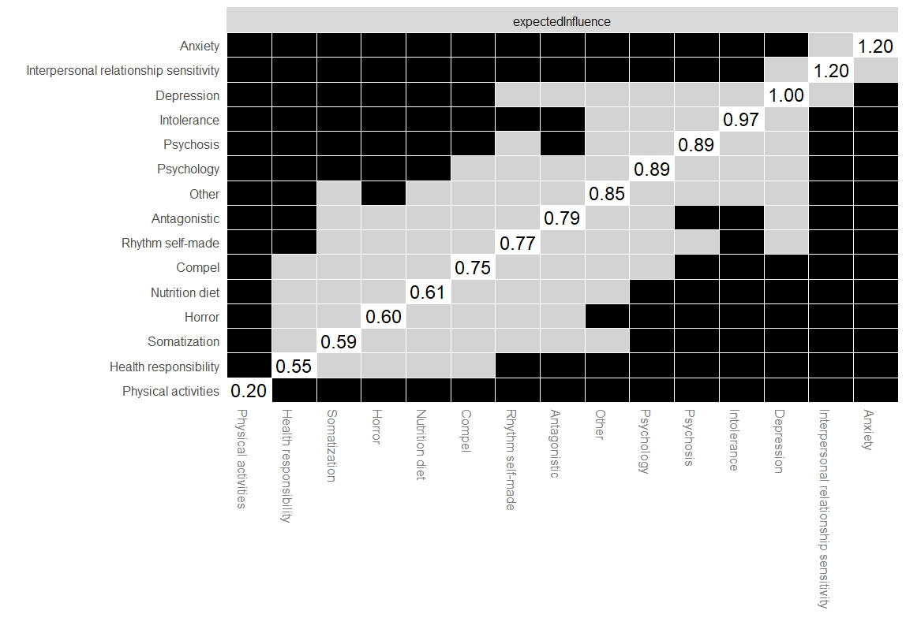
Figure S1: Bootstrap difference test for the expected impact of each node

Concepts related to active health behaviors:For adolescents, this encompasses five core dimensions: (1) Health Responsibility: Proactively understanding health knowledge, adhering to health guidelines, and demonstrating awareness and behaviors of personal health responsibility (e.g., regular check-ups, learning disease prevention); (2) Physical Activity: Engaging in sustained and moderate-intensity exercise (such as campus running, ball games, and rest activities) to meet physical development needs; (3) Nutrition and Diet: Maintaining balanced diets with proper nutrient combinations, avoiding excessive junk food intake, and establishing regular eating habits; (4) Psychology: Actively regulating emotions, maintaining positive interpersonal communication, and seeking timely help when facing psychological distress; (5) Rhythm self-made: Developing regular work-rest routines, rationally controlling electronic device usage time, and maintaining a stable life rhythm.

network analysis Related terms
Gaussian Graphical Model (GGM) | GGM is a probabilistic model used to estimate conditional dependencies between variables, where nodes represent variables and edges represent significant partial correlations (controlling for other variables in the network). In this study, GGM was fitted using nonparametric Spearman rank correlations to accommodate non-normal data. The graphical LASSO algorithm was applied to regularize the model, reducing overfitting by shrinking weak edge weights to zero. The extended Bayesian information criterion was used to select the optimal regularization parameter, ensuring network stability and interpretability
Bridge Expected Influence (BEI) | BEI is a core metric in network psychometrics that quantifies a node’s ability to connect distinct "communities" (functionally related clusters, e.g., active health behaviors vs. mental health symptoms). It is calculated as the algebraic sum of edge weights between a node and all nodes outside its own community. A higher absolute BEI value indicates stronger cross-community connectivity, identifying the node as a "bridge" between systems. Positive BEI values reflect connections via positive associations (facilitating network integration), while negative values reflect negative associations (potentially suppressing connectivity) . In this study, BEI was used to identify active health behavior dimensions that link to mental health symptoms.
Bootstrapping for Stability and Accuracy | - Stability Assessment: 1000 case-deletion bootstrap samples were generated to test whether the ranking of centrality and BEI values remained consistent with the original sample. The correlation stability (CS) coefficient was used to quantify stability, with CS ≥ 0.5 considered optimal and CS ≥ 0.25 as the minimum acceptable threshold. A high CS coefficient indicates that core node rankings are robust to sample changes.  - Accuracy Assessment: 1000 nonparametric bootstrap samples were used to estimate 95% confidence intervals for edge weights. Narrow intervals and minimal overlap between intervals indicate higher accuracy of edge weight estimates.  Difference Testing: Bootstrap difference tests were conducted to compare centrality and BEI values between nodes. Non-overlapping confidence intervals indicate statistically significant differences between nodes .
Centrality and Stability | Centrality indicators are core metrics to evaluate the importance of nodes in the network, reflecting the role and influence of each node in the overall network structure:  Strength Centrality: Measures the sum of absolute correlation strengths between a node and all other nodes in the network. Nodes with higher strength centrality have stronger overall associations with other nodes and play a "hub" role in the network.  Closeness Centrality: Quantifies the average shortest path length from a node to all other nodes. Nodes with higher closeness centrality can quickly transmit influence to the entire network, with strong "propagation efficiency".  Betweenness Centrality: Counts the number of shortest paths between any two other nodes that pass through the target node. Nodes with higher betweenness centrality act as "intermediaries" in the network, controlling the information or influence transmission between different node clusters.  Expected Influence: Evaluates the potential impact of a node on the entire network (including both positive and negative correlations). Nodes with higher absolute expected influence can significantly alter the overall network state when their values change.

