Supplementary materials

Validation of Subjective Contingency Ratings Across Groups
To ensure that participants accurately perceived the programmed action–outcome contingencies, we conducted a manipulation check based on their ratings of action effectiveness after each block. Specifically, participants rated the extent to which pressing the spacebar led to reward on a visual analog scale ranging from –100 (pressing always prevented reward) to 100 (pressing always resulted in reward). These subjective ratings were compared against the actual programmed ΔP values for each block. Correlation analysis confirmed a strong alignment between experienced and programmed contingencies across all participants (r = 0.99, p < .001), indicating high perceptual validity of the manipulation. We also detected no group differences in experienced contingencies, as there was no significant main effect of group (F (1, 34) = 1.19, p = 0.28, $η_{p}^{2}$ = 0.03) or an interaction between group and block (F (14, 476) = 0.73, p = 0.74, $η_{p}^{2}$ = 0.02). This indicates that both groups experienced the same probability settings. A significant main effect of the block was observed (F (14, 476) = 929.17, p < 0.001, $η_{p}^{2}$ = 0.96).

Fig. S1. Empirical data and simulated data for go and nogo accuracy rates and correct go RT quantiles (0.1, 0.5, and 0.9) under different simulated trials conditions (500,1000,10000 trials)

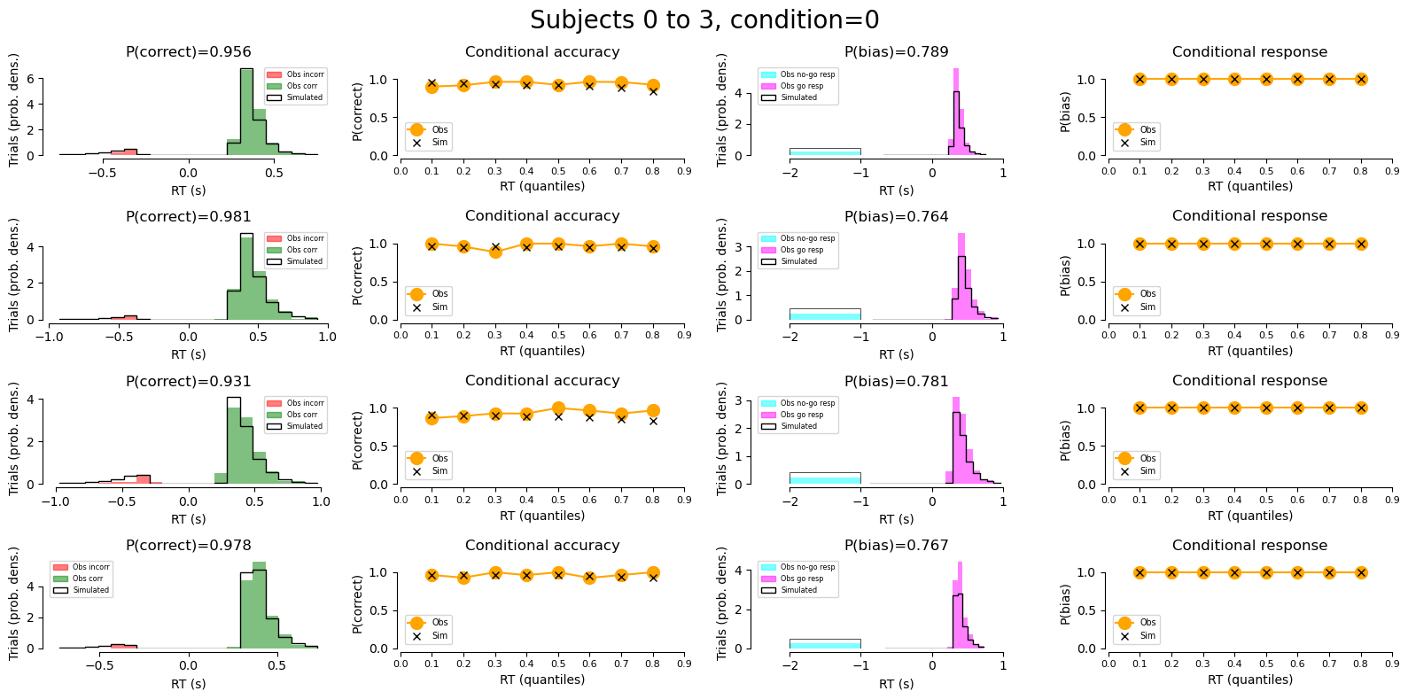
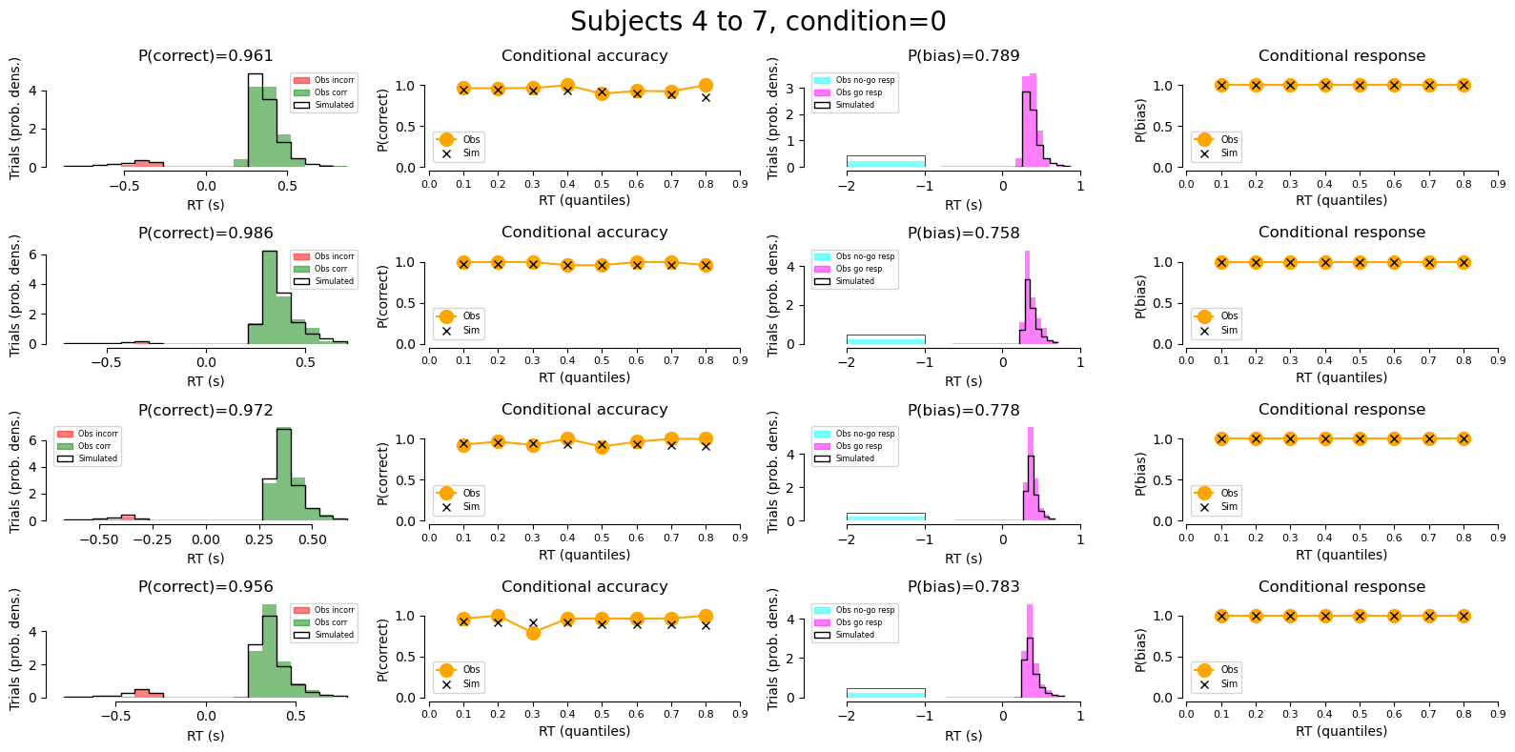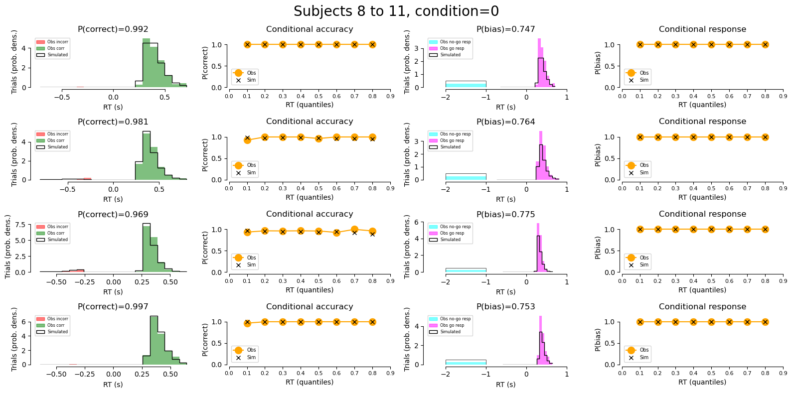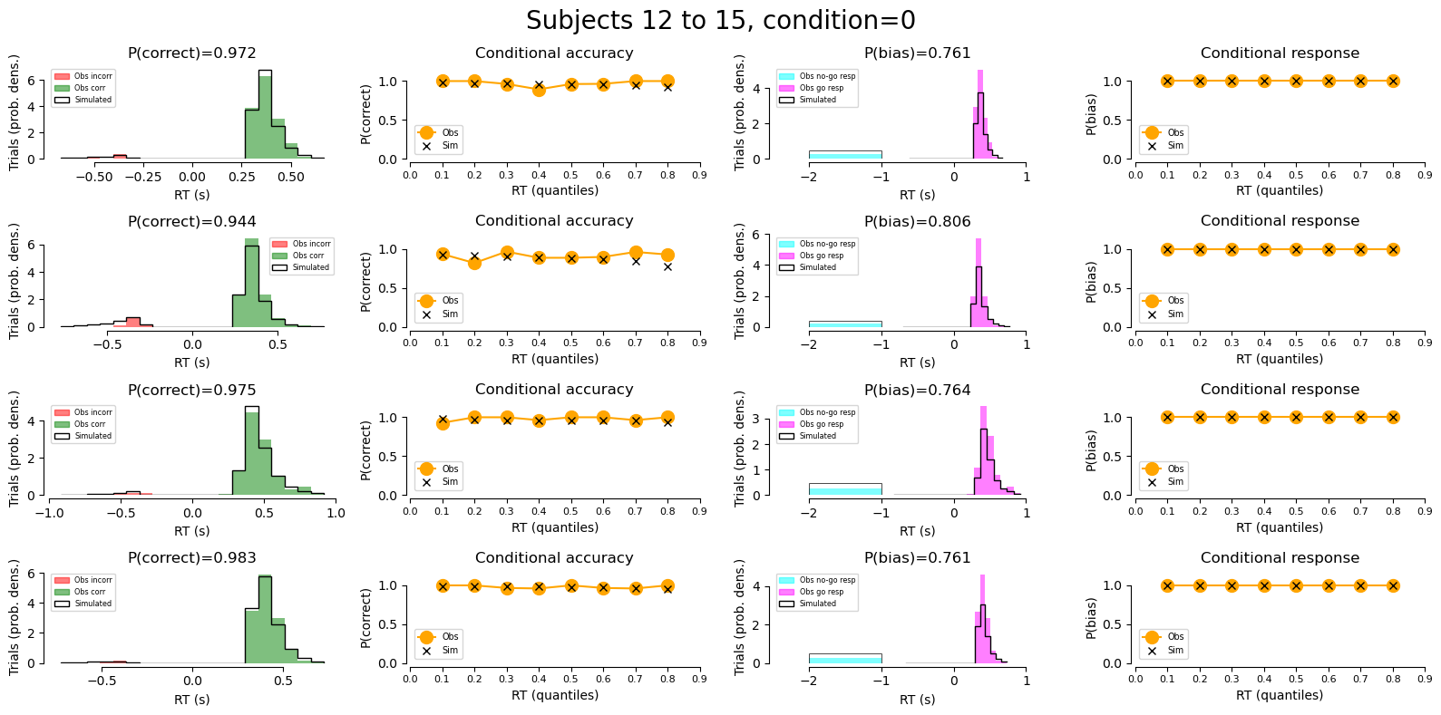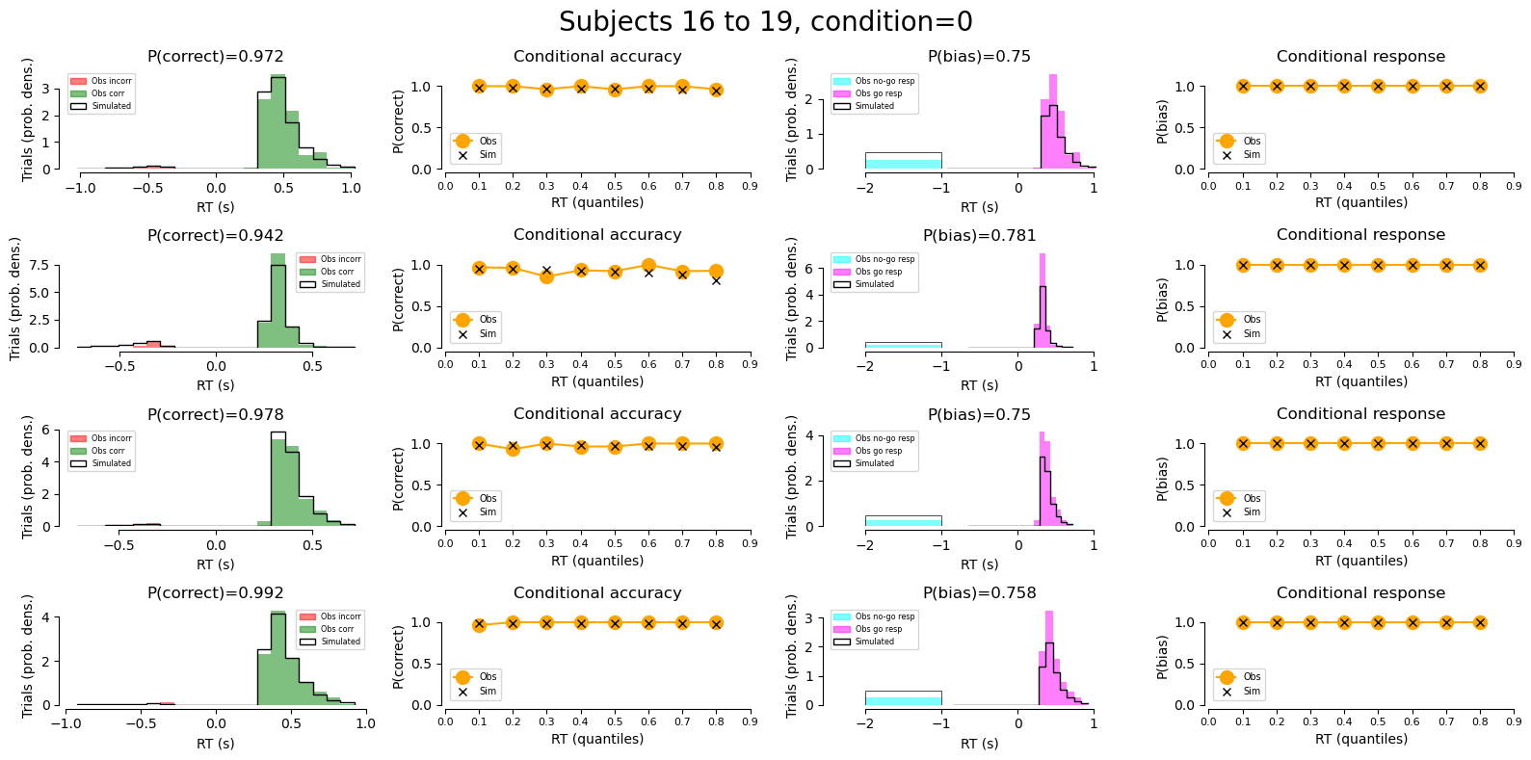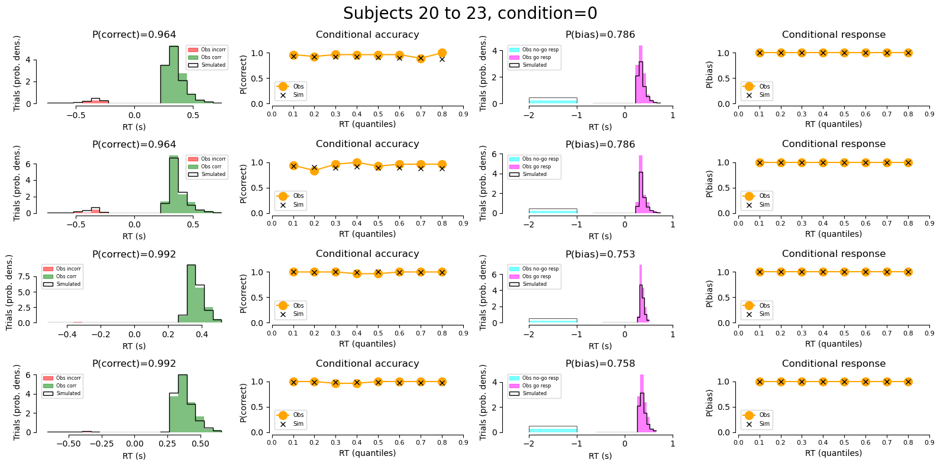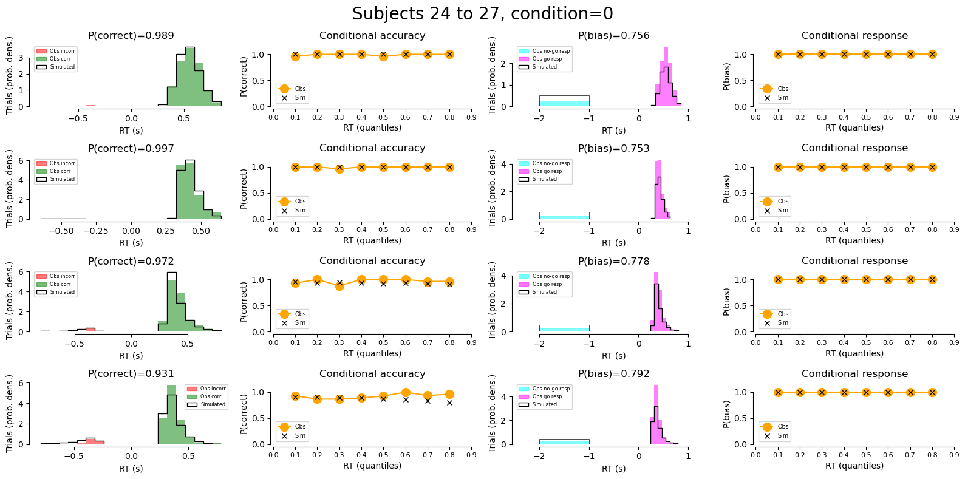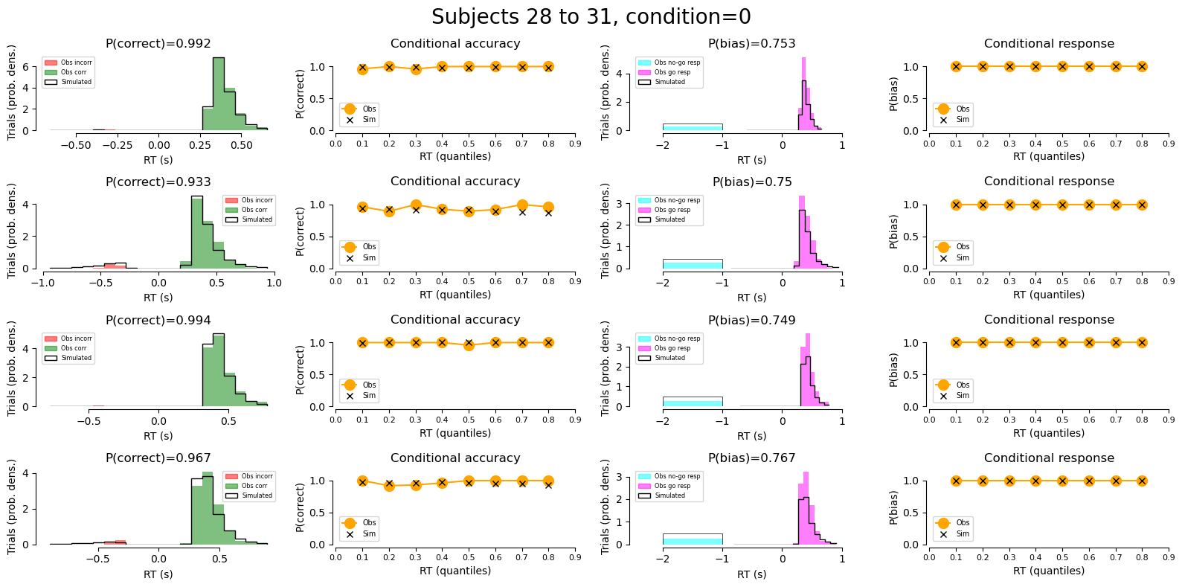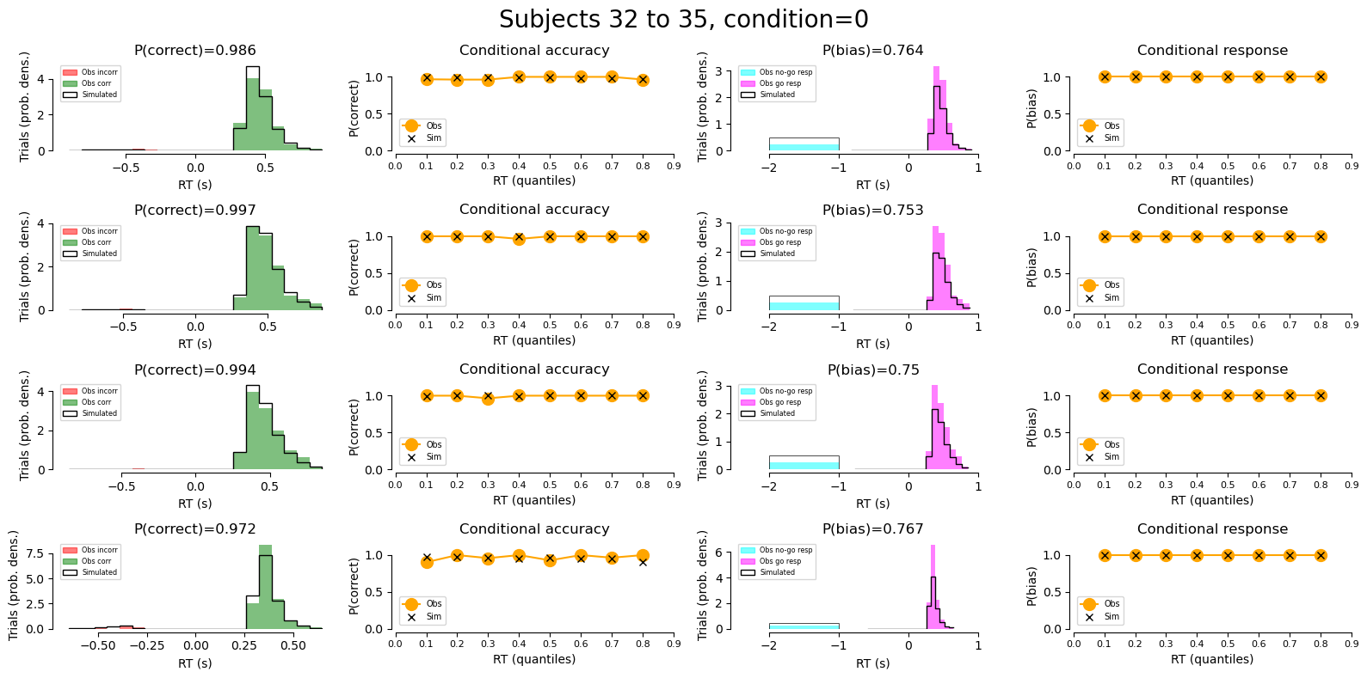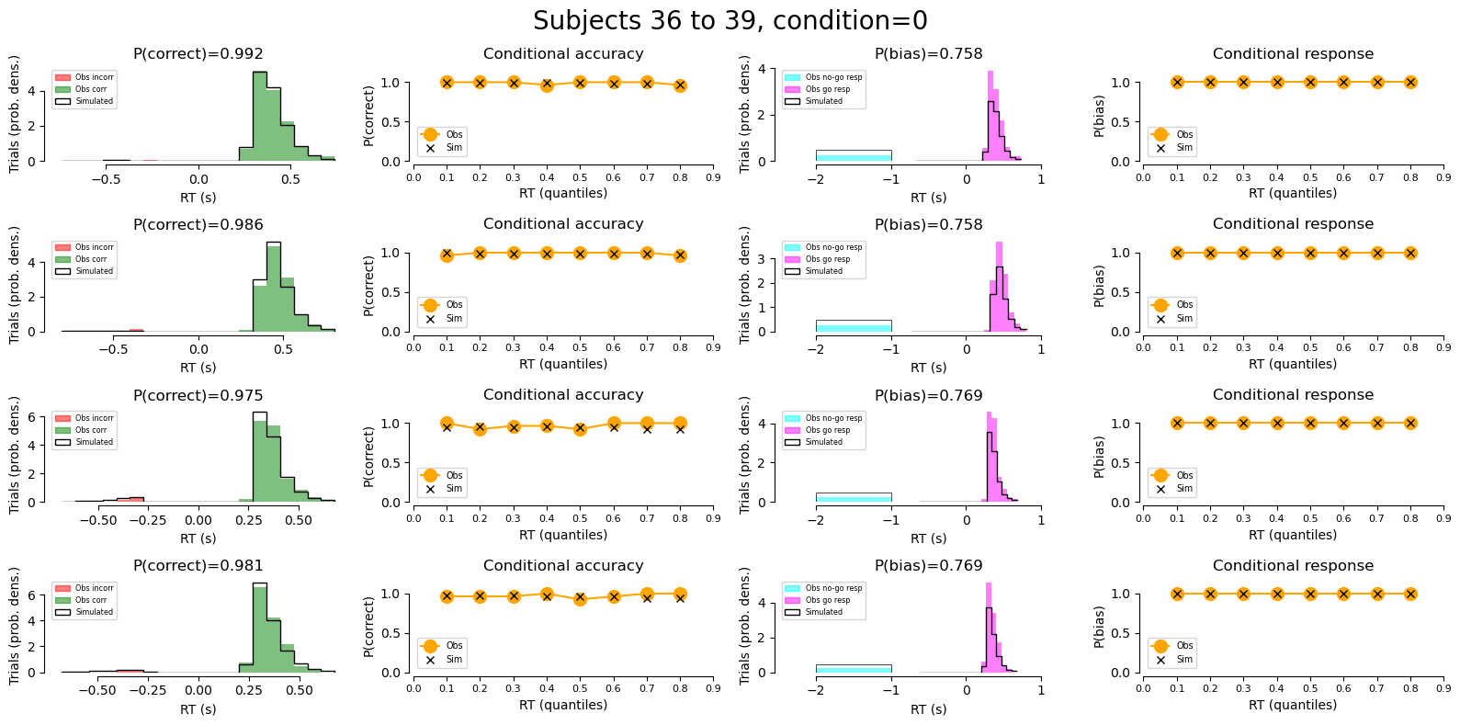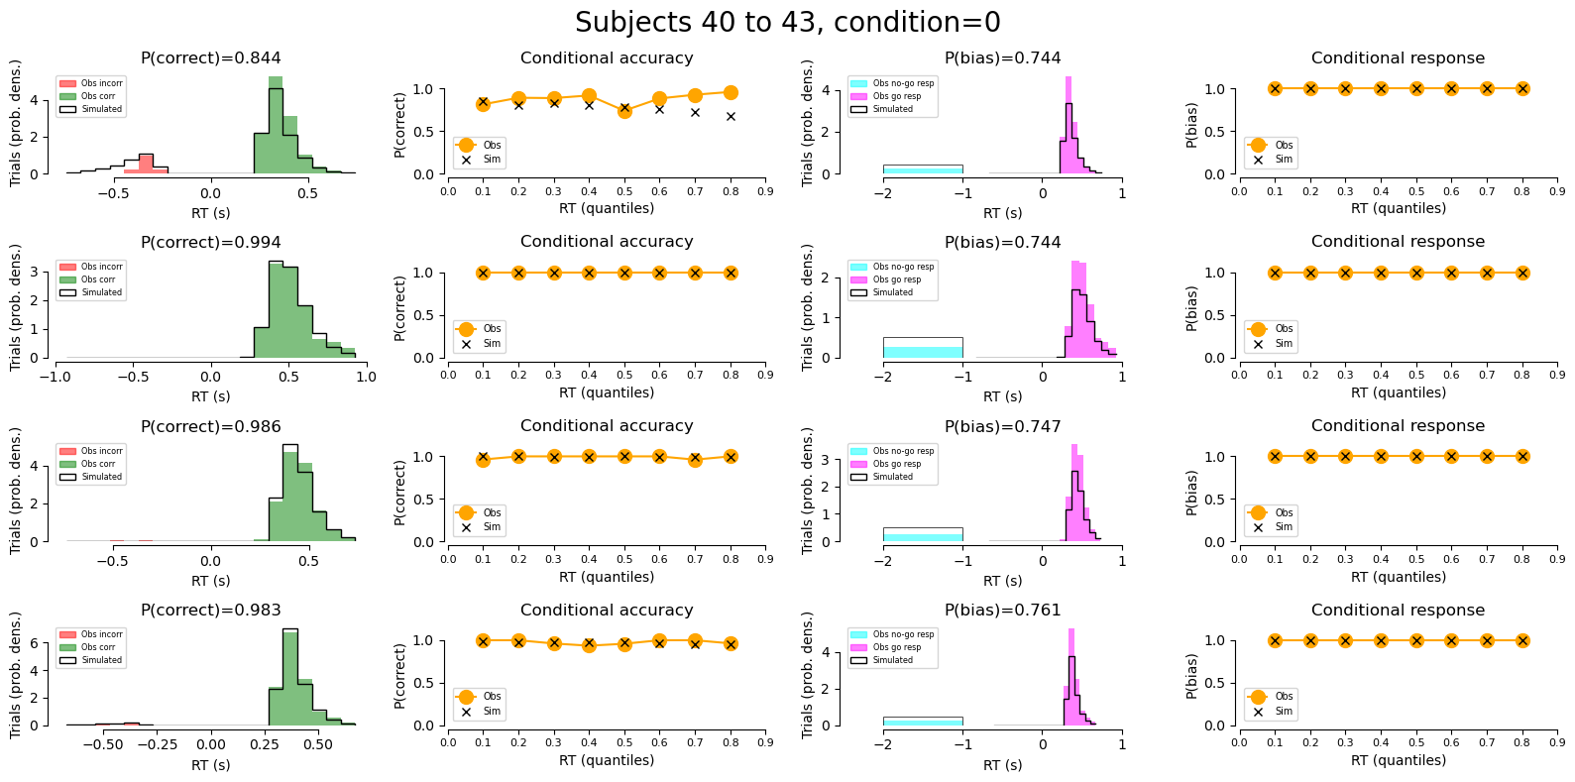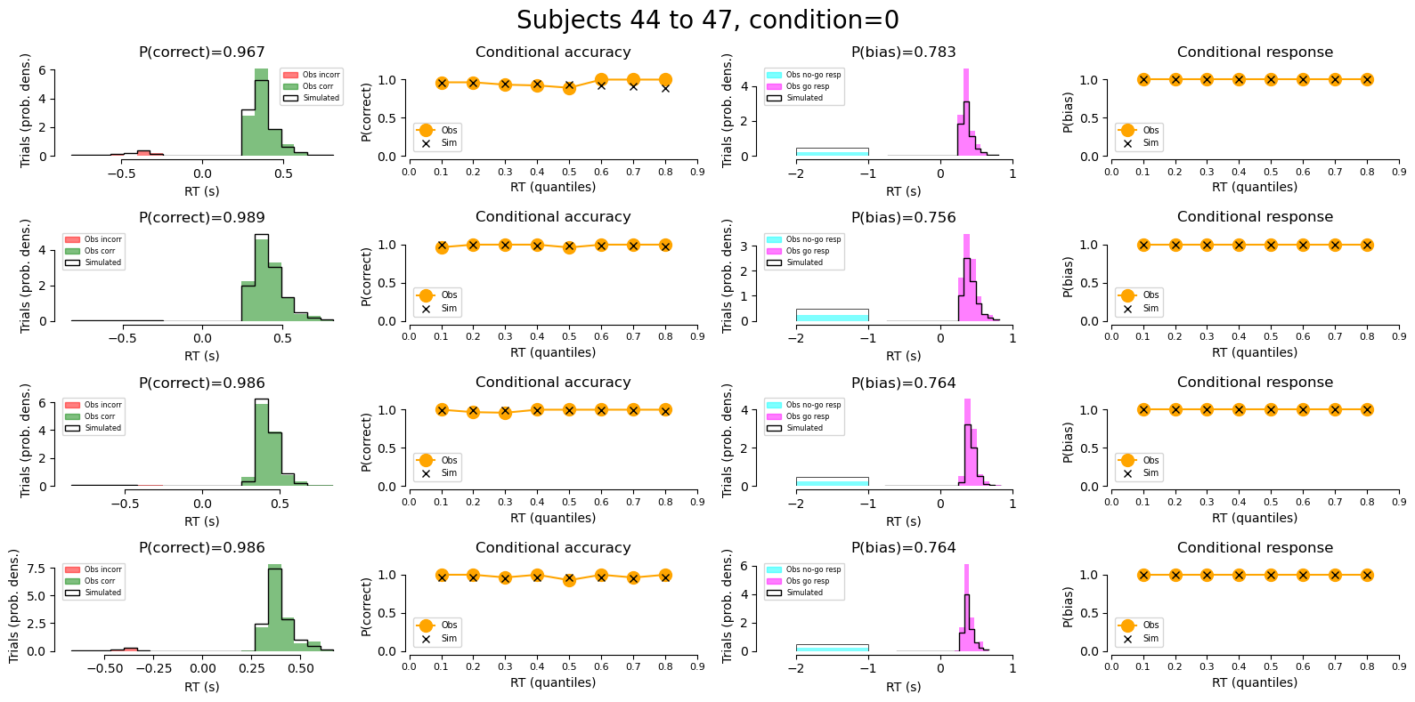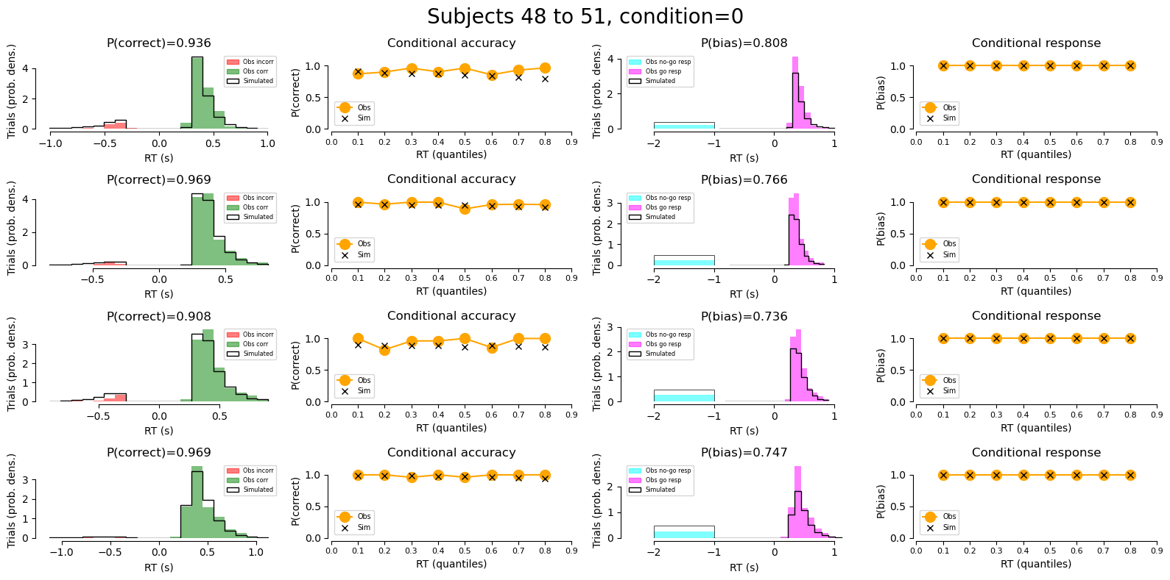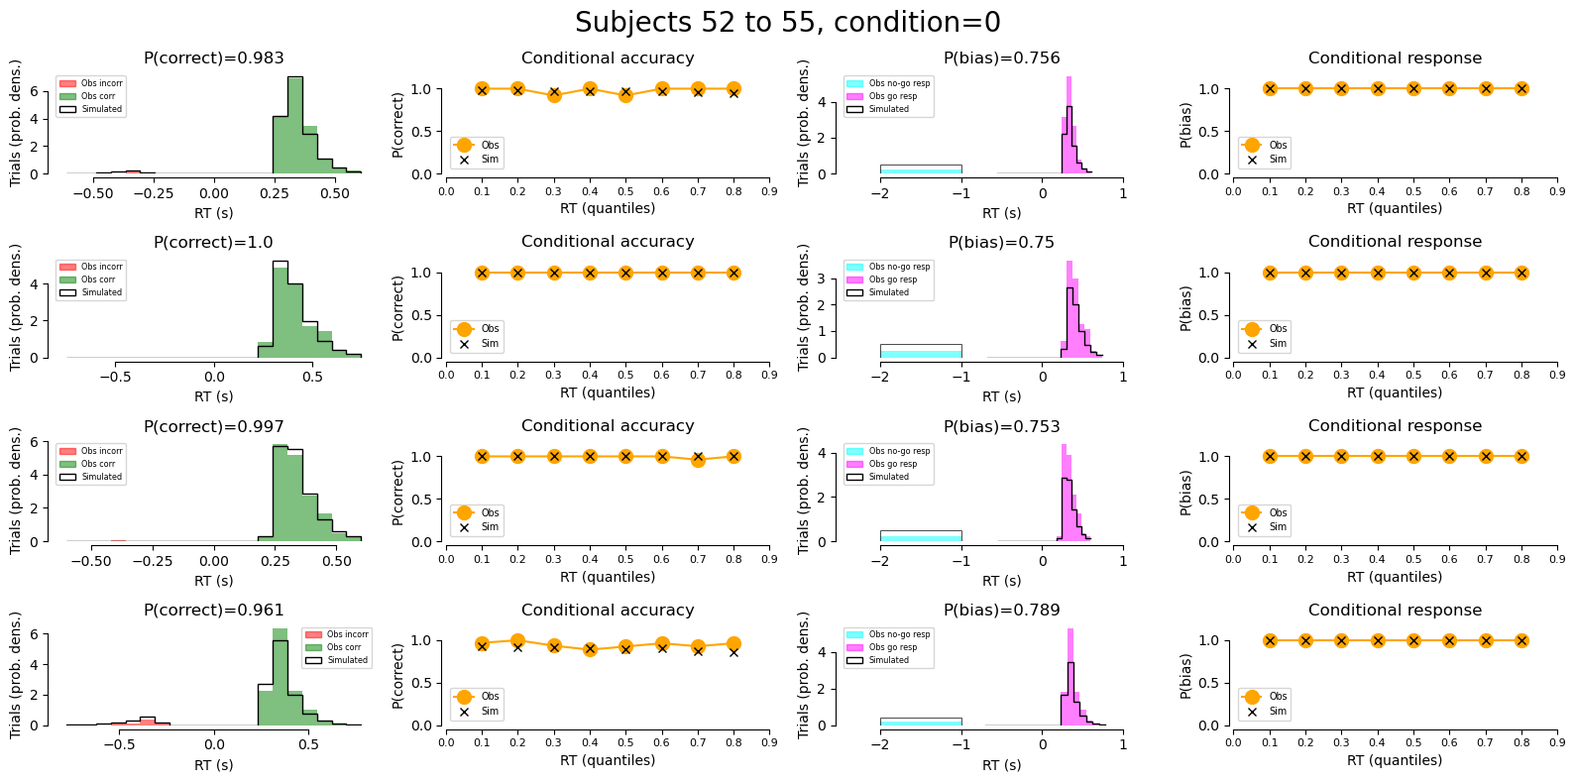
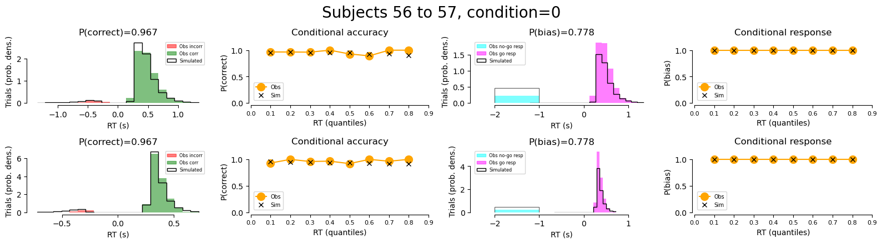
Fig. S2. Plots of empirical and simulated response in each participant. Column 1 and 3 represent probability densities. Column 2 and 4 represent percentage of correct percentage and bias in each RT quantile. Obs = observed. Sim = simulated. Corr = correct. Incorr = incorrect.

