Supplementary Materials

Table S1. Sample sizes for sleep outcomes across months.
Time | Total | Low-stable | Decreasing | Increasing | High-stable
Month 1 | 208 | n = 84 | n = 45 | n = 52 | n = 27
Month 2 | 200 | n = 81 | n = 44 | n = 50 | n = 25
Month 3 | 177 | n = 69 | n = 40 | n = 44 | n = 24
Month 4 | 168 | n = 72 | n = 39 | n = 37 | n = 20
Note: The range of observations was 5-28 for month 1 (M = 24.89), month 2 (M = 23.19), month 3 (M = 22.63), and 5-27 observations for month 4 (M = 19.90).

Table S2. Skewness and kurtosis values for linear sleep outcomes.
 |  |  | Total sleep time |  | Time in bed
Month | Cluster | n | Skewness | Kurtosis | Skewness | Kurtosis
1 | Low | 2084 | -0.49 | 3.99 | -0.52 | 4.18
1 | Decreasing | 1163 | -0.29 | 3.54 | -0.30 | 3.43
1 | Increasing | 1290 | -0.32 | 3.78 | -0.32 | 3.80
1 | High | 641 | -0.53 | 4.00 | -0.57 | 4.18
2 | Low | 1847 | -0.37 | 3.81 | -0.39 | 3.85
2 | Decreasing | 1075 | -0.07 | 3.44 | -0.07 | 3.40
2 | Increasing | 1137 | -0.19 | 3.38 | -0.21 | 3.50
2 | High | 579 | -0.22 | 3.43 | -0.23 | 3.50
3 | Low | 1548 | -0.47 | 3.95 | -0.48 | 4.08
3 | Decreasing | 967 | -0.14 | 3.62 | -0.16 | 3.49
3 | Increasing | 981 | -0.21 | 3.36 | -0.28 | 3.32
3 | High | 509 | -0.14 | 3.57 | -0.17 | 3.62
4 | Low | 1365 | -0.46 | 3.86 | -0.46 | 3.93
4 | Decreasing | 812 | -0.17 | 3.54 | -0.19 | 3.51
4 | Increasing | 771 | -0.34 | 3.46 | -0.37 | 3.52
4 | High | 396 | -0.03 | 5.83 | -0.07 | 5.86
Note: Outliers were detected using the interquartile (IQR) method and winsorized. Analyses were repeated using winsorized values of total sleep time and time in bed and results remained consistent.

Table S3. Descriptive statistics for circular sleep outcomes.
 |  |  | Bedtime |  |  | Wake time
Month | Cluster | n | Mean Direction (radians) | Mean Resultant Length (ρ) | Circular SD (radians) | Mean Direction (radians) | Mean Resultant Length (ρ) | Circular SD (radians)
1 | Low | 2084 | 2.04 | 0.89 | 0.48 | 1.29 | 0.89 | 0.47
1 | Decreasing | 1163 | 2.17 | 0.89 | 0.49 | 1.31 | 0.89 | 0.48
1 | Increasing | 1290 | 2.17 | 0.89 | 0.49 | 1.38 | 0.88 | 0.50
1 | High | 641 | 2.07 | 0.83 | 0.61 | 1.29 | 0.85 | 0.57
2 | Low | 1847 | 2.12 | 0.86 | 0.56 | 1.34 | 0.87 | 0.53
2 | Decreasing | 1075 | 2.22 | 0.87 | 0.52 | 1.37 | 0.86 | 0.56
2 | Increasing | 1137 | 2.25 | 0.84 | 0.58 | 1.45 | 0.85 | 0.58
2 | High | 579 | 2.09 | 0.78 | 0.70 | 1.29 | 0.79 | 0.68
3 | Low | 1548 | 2.11 | 0.85 | 0.58 | 1.32 | 0.86 | 0.55
3 | Decreasing | 967 | 2.25 | 0.85 | 0.56 | 1.38 | 0.86 | 0.56
3 | Increasing | 981 | 2.24 | 0.82 | 0.64 | 1.42 | 0.81 | 0.64
3 | High | 509 | 2.11 | 0.78 | 0.70 | 1.30 | 0.80 | 0.66
4 | Low | 1365 | 2.12 | 0.83 | 0.61 | 1.38 | 0.83 | 0.62
4 | Decreasing | 812 | 2.22 | 0.81 | 0.65 | 1.40 | 0.81 | 0.65
4 | Increasing | 771 | 2.27 | 0.80 | 0.66 | 1.52 | 0.81 | 0.64
4 | High | 396 | 2.02 | 0.77 | 0.73 | 1.25 | 0.77 | 0.73
Note: See Table 4-5 in the main manuscript for mean direction and circular standard deviation values in timestamp format. Higher rho (ρ) values indicates that the data cluster around a central direction and thus are appropriate for Watson-Williams testing (Pewsey et al., 2013). Rayleigh tests were also conducted to confirm that the data was not uniform (all p’s <.05) (Landler et al., 2018), thus meeting the Watson-William assumptions.

Table S4. Concentration parameter of von Mises distribution.
Month | Cluster | Bedtime κ | Wake time κ
1 | Low | 4.88 | 4.98
1 | Decreasing | 4.70 | 4.83
1 | Increasing | 4.65 | 4.56
1 | High | 3.29 | 3.69
2 | Low | 3.77 | 4.15
2 | Decreasing | 4.28 | 3.76
2 | Increasing | 3.53 | 3.59
2 | High | 2.67 | 2.79
3 | Low | 3.59 | 3.83
3 | Decreasing | 3.71 | 3.77
3 | Increasing | 3.08 | 3.04
3 | High | 2.69 | 2.92
4 | Low | 3.27 | 3.23
4 | Decreasing | 3.00 | 2.97
4 | Increasing | 2.92 | 3.06
4 | High | 2.52 | 2.52
Note: When running the Watson-William test, RStudio gave a warning that the concentration parameters were not equal between groups (one of the model assumptions for Watson-Williams test).

Table S5. Percentage of data falling within sleep windows.
 |  | Bedtime |  |  |  | Wake time
Time | Cluster | 10:00 -11:59PM | 12:00 -1:59AM | 2:00 -3:59AM | Other | 6:00 -7:59AM | 8:00 -9:59AM | 10:00 -11:59AM | Other
Month 1 | Low | 11.9 | 43.5 | 33.6 | 10.9 | 20.7 | 51.8 | 17.7 | 9.8
Month 1 | Decreasing | 6.1 | 38.5 | 37.7 | 17.6 | 22.4 | 48.5 | 18.4 | 10.7
Month 1 | Increasing | 5.9 | 37.2 | 41.2 | 15.7 | 20.4 | 45.2 | 23.3 | 11.1
Month 1 | High | 12.0 | 41.3 | 28.9 | 17.8 | 27.0 | 46.0 | 14.5 | 12.5
Month 2 | Low | 8.6 | 40.5 | 33.6 | 17.3 | 18.6 | 49.9 | 20.8 | 10.6
Month 2 | Decreasing | 6.3 | 34.0 | 39.3 | 20.3 | 20.4 | 43.8 | 22.0 | 13.9
Month 2 | Increasing | 7.5 | 28.2 | 41.2 | 23.1 | 16.7 | 41.8 | 25.8 | 15.7
Month 2 | High | 13.5 | 34.4 | 30.7 | 21.4 | 26.3 | 41.1 | 15.9 | 16.8
Month 3 | Low | 9.6 | 41.5 | 33.2 | 15.7 | 21.1 | 49.1 | 18.3 | 11.5
Month 3 | Decreasing | 5.2 | 32.7 | 39.1 | 23.1 | 19.8 | 44.0 | 21.5 | 14.8
Month 3 | Increasing | 7.1 | 30.3 | 39.0 | 23.5 | 17.4 | 41.0 | 24.0 | 17.6
Month 3 | High | 12.2 | 32.2 | 32.8 | 22.8 | 23.4 | 41.8 | 17.3 | 17.5
Month 4 | Low | 8.5 | 38.1 | 34.7 | 18.7 | 17.1 | 43.8 | 24.6 | 14.5
Month 4 | Decreasing | 8.7 | 30.9 | 34.6 | 25.7 | 20.2 | 36.8 | 24.9 | 18.1
Month 4 | Increasing | 5.8 | 28.7 | 37.9 | 27.6 | 15.0 | 37.1 | 29.6 | 18.3
Month 4 | High | 15.7 | 36.4 | 26.5 | 21.5 | 23.0 | 38.1 | 20.2 | 18.7

Figure S1. Cluster validation (elbow method).
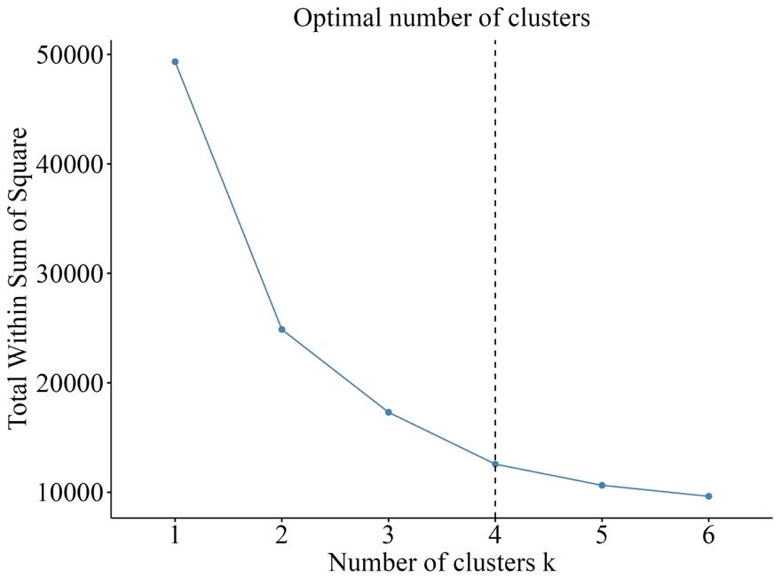
Figure S2. Cluster validation (silhouette method).
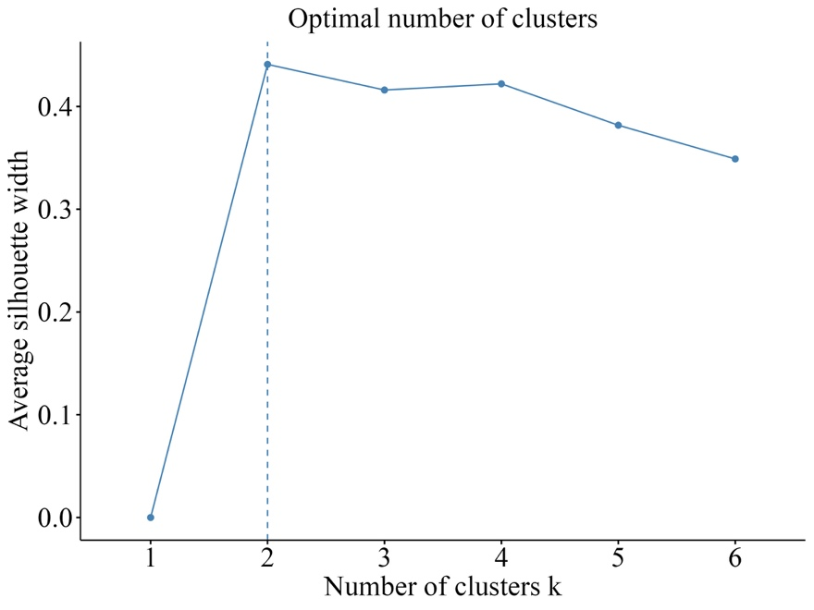
Note: We manually calculated the average silhouette width, revealing that k = 2 had a width of 0.441, k = 3 had a width of 0.416, and k = 4 had a width of 0.422. Given that the elbow method suggested k = 4 and there was empirical evidence supporting the existence of four unique depressive symptom trajectory groups, we set k = 4.
References
Landler L, Ruxton GD, Malkemper EP. Circular data in biology: advice for effectively
implementing statistical procedures. Behavioral ecology and sociobiology. 2018 Aug;72:1-0.
Pewsey A, Neuhäuser M, Ruxton GD. Circular statistics in R. OUP Oxford; 2013 Sep 26.

