To examine whether this study exhibits significant Common Method Bias (CMB), a single-factor model as depicted in Figure S1 was first constructed and subjected to confirmatory factor analysis (CFA). The results indicate that the model fit metrics are extremely unsatisfactory: CFI = 0.547, GFI = 0.285, AGFI = 0.237, TLI = 0.531, NFI = 0.511, RMSEA = 0.118, SRMR = 0.116. This result indicates that all observed variables cannot be effectively explained by a single latent factor. This further indicates that the constructs do not primarily derive from common methodological variation.
Additionally, the “common method variance” was introduced as an independent latent variable into the original multifactor model (Figure S2). Comparing the changes in model fit before and after incorporating common method variance reveals that the improvement in all fit indices is relatively minor: ΔCFI = 0.038, ΔGFI = 0.073, ΔAGFI = 0.067, ΔTLI = 0.034, ΔNFI = 0.037, ΔRMSEA = 0.006, ΔSRMR = 0.038. This indicates that the introduction of a common method bias factor did not significantly improve the model fit. Therefore, this deviation can not account for the primary source of covariation among latent variables.
In summary, this study does not exhibit any significant common method bias.
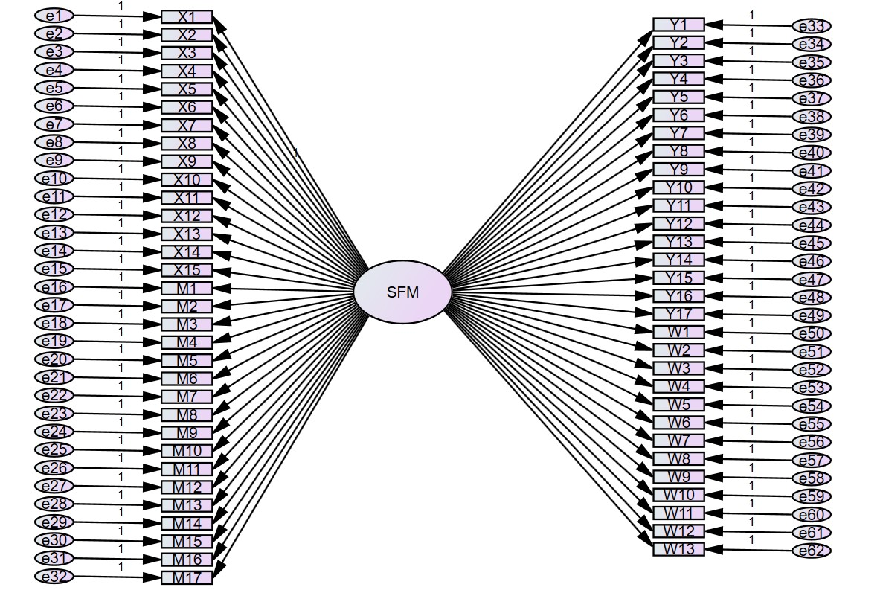
Figure S1: Single-Factor Model Diagram
NOTE. X1-X10 are the various items of self-transcendence (independent variables). Y1-Y17 are the individual items of professional identity (dependent variable). M1-M17 are the various items of learning engagement (mediating variable). W1-W13 are the individual items of career self-efficacy (moderator variable). SFM: Single-factor model.
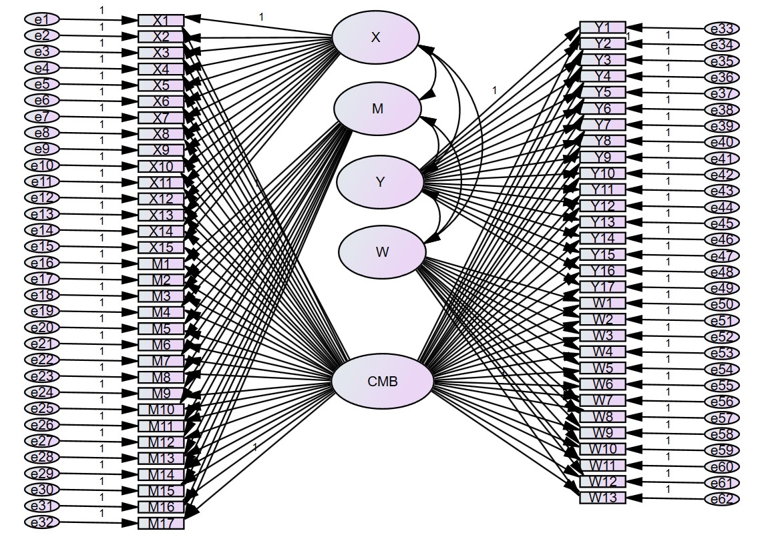
Figure S2: Potential Error Variable Control Model Diagram
NOTE. Same as above. X: Self-transcendence. Y: Professional identity. M: Learning engagement. W: career self-efficacy. CMB: Common Method Bias.

