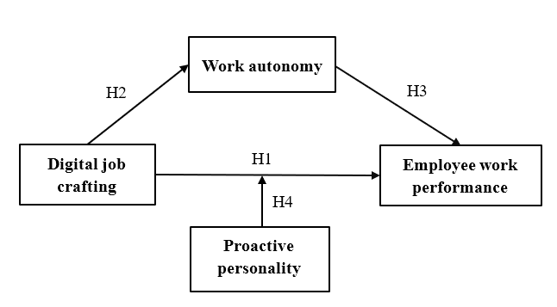
Fig. 1 Theoretical model
Table 1 Results of descriptive statistical analysis of sample data
Variables | Option | Frequency | Proportion (%)
Sex | Male | 152 | 50.3
 | Female | 150 | 49.7
Age | 23 years old and below | 138 | 45.7
 | 24-30 years old | 73 | 24.2
 | 31-35 years old | 33 | 10.9
 | 36-40 years old | 18 | 6.0
 | 41-45 years old | 19 | 6.3
 | 46-50 years old | 18 | 6.0
 | 51 years old and above | 3 | 1.0
Education | Master and above | 34 | 11.3
 | Undergraduate | 177 | 58.6
 | College | 46 | 15.2
 | High School | 23 | 7.6
 | Vocational high school | 6 | 2.0
 | Junior high school | 14 | 4.6
 | Primary school and below | 2 | 0.6
Post | Manage | 114 | 37.7
 | Professional technology | 78 | 25.8
 | Professional support | 41 | 13.6
 | Sale | 26 | 8.6
 | Operation | 43 | 14.2
Work experience | 1 year and below | 116 | 38.4
 | 1-3 years | 88 | 29.1
 | 4-6 years | 54 | 17.9
 | 7-10 years | 18 | 6.0
 | 10 years and above | 26 | 8.6
Company size | Less than 50 employees | 83 | 27.5
 | 51-100 employees | 44 | 12.6
 | 101-150 employees | 34 | 11.3
 | 151-200 employees | 31 | 10.3
 | 201-250 employees | 16 | 5.3
 | 251-300 employees | 14 | 4.6
 | More than 301 employees | 80 | 26.4
Table 2 Digital job crafting variables affecting employee performance models
Variable | Latent variable | Code | Measurement
Exogenous  variable | Digital job  crafting | S1 | Enterprises improve employee work efficiency through digital transformation.
Exogenous  variable | Digital job  crafting | S2 | Enterprises introduce artificial intelligence technology to assist in digital job crafting.
Exogenous  variable | Digital job  crafting | S3 | Enterprises place great emphasis on optimizing work processes.
Exogenous  variable | Digital job  crafting | S4 | Enterprises introduce digital technology to assist employees in digital jobs.
Mediating  variable | Work  autonomy | G1 | My work content and objectives are filled with challenges and autonomy.
Mediating  variable | Work  autonomy | G2 | In my work, I can arrange my own time and work steps.
Mediating  variable | Work  autonomy | G3 | My job offers me opportunities to demonstrate my abilities and talents.
Mediating  variable | Work  autonomy | G4 | I can complete work tasks based on my judgment and decisions.
Mediating  variable | Work  autonomy | G5 | I have a high degree of autonomy in completing work.
Regulating  variable | Proactive  personality | Z1 | I often think about and plan to achieve my career goals.
Regulating  variable | Proactive  personality | Z2 | I always actively pursue opportunities for learning and growth.
Regulating  variable | Proactive  personality | Z3 | I exhibit strong self-motivation and discipline in my job.
Regulating  variable | Proactive  personality | Z4 | I have a strong tendency to actively solve problems and innovate.
Regulating  variable | Proactive  personality | Z5 | I am inclined to proactively handle challenges and difficulties at work.
Endogenous  variables | Employee work  performance | Y1 | I am satisfied with my work performance.
Endogenous  variables | Employee work  performance | Y2 | My superiors have a high evaluation of my work performance.
Endogenous  variables | Employee work  performance | Y3 | My work performance is related to digital job crafting.
Endogenous  variables | Employee work  performance | Y4 | Digital job crafting has a positive impact on my work performance.
Table 3 Reliability test results
Variable | Cronbach's α | Number of measurement items
Digital job crafting | 0.830 | 4
Work autonomy | 0.857 | 5
Proactive personality | 0.836 | 5
Employee work performance | 0.805 | 4
Population | 0.933 | 18
Table 4 Validity test results
Variable | KMO | Bartlett's test of sphericity
Variable | KMO | Approximate Chi-square | df | P-value
Digital job crafting | 0.775 | 453.824 | 6 | 0.00***
Work autonomy | 0.868 | 616.501 | 10 | 0.00***
Proactive personality | 0.858 | 524.099 | 10 | 0.00***
Employee work performance | 0.762 | 409.877 | 6 | 0.00***
Population | 0.94 | 2803.896 | 153 | 0.00***

***P<0.001
Table 5 Convergent validity
Variable | Code | Standardized  factor loadings | SMC | S.E. | P-value | CR | AVE
Digital job  crafting | S1 | 0.724 | 0.524 | 0.084 | 0.000*** | 0.8316 | 0.5528
Digital job  crafting | S2 | 0.781 | 0.610 | 0.078 | 0.000*** | 0.8316 | 0.5528
Digital job  crafting | S3 | 0.712 | 0.507 | 0.076 | 0.000*** | 0.8316 | 0.5528
Digital job  crafting | S4 | 0.755 | 0.570 | — | — | 0.8316 | 0.5528
Work  autonomy | G1 | 0.631 | 0.398 | — | — | 0.8582 | 0.5491
Work  autonomy | G2 | 0.745 | 0.555 | 0.114 | 0.000*** | 0.8582 | 0.5491
Work  autonomy | G3 | 0.79 | 0.624 | 0.114 | 0.000*** | 0.8582 | 0.5491
Work  autonomy | G4 | 0.747 | 0.558 | 0.102 | 0.000*** | 0.8582 | 0.5491
Work  autonomy | G5 | 0.781 | 0.610 | 0.107 | 0.000*** | 0.8582 | 0.5491
Proactive  personality | Z1 | 0.604 | 0.365 | — | — | 0.8371 | 0.5083
Proactive  personality | Z2 | 0.715 | 0.511 | 0.138 | 0.000*** | 0.8371 | 0.5083
Proactive  personality | Z3 | 0.752 | 0.566 | 0.128 | 0.000*** | 0.8371 | 0.5083
Proactive  personality | Z4 | 0.75 | 0.563 | 0.135 | 0.000*** | 0.8371 | 0.5083
Proactive  personality | Z5 | 0.733 | 0.537 | 0.131 | 0.000*** | 0.8371 | 0.5083
Employee  performance | Y1 | 0.654 | 0.428 | 0.099 | 0.000*** | 0.8147 | 0.5252
Employee  performance | Y2 | 0.798 | 0.637 | 0.1 | 0.000*** | 0.8147 | 0.5252
Employee  performance | Y3 | 0.753 | 0.567 | 0.087 | 0.000*** | 0.8147 | 0.5252
Employee  performance | Y4 | 0.685 | 0.469 | — | — | 0.8147 | 0.5252
“—” indicates the reference item; ***P<0.001
Table 6 Results of the homoscedasticity variance test
Ingredient | Total | Initial  eigenvalue variance  (%) | Accumulate  (%) | Total | Extracting load squares and  variance  (%) | Accumulate  (%) | Total | Rotating load squared and variance  (%) | Accumulate  (%)
1 | 8.417 | 46.763 | 46.763 | 8.417 | 46.763 | 46.763 | 3.988 | 22.158 | 22.158
2 | 1.313 | 7.294 | 54.057 | 1.313 | 7.294 | 54.057 | 3.627 | 20.151 | 42.308
3 | 1.077 | 5.986 | 60.043 | 1.077 | 5.986 | 60.043 | 3.192 | 17.734 | 60.043
4 | 0.954 | 5.300 | 65.342
5 | 0.718 | 3.987 | 69.329
6 | 0.632 | 3.511 | 72.840
7 | 0.584 | 3.246 | 76.086
8 | 0.560 | 3.110 | 79.195
9 | 0.522 | 2.902 | 82.097
10 | 0.465 | 2.586 | 84.682
11 | 0.433 | 2.403 | 87.086
12 | 0.409 | 2.273 | 89.359
13 | 0.394 | 2.188 | 91.547
14 | 0.354 | 1.969 | 93.516
15 | 0.317 | 1.762 | 95.277
16 | 0.308 | 1.711 | 96.988
17 | 0.279 | 1.551 | 98.539
18 | 0.263 | 1.461 | 100.000
Table 7 Multi-factor model test results
model | χ² | df | χ²/df | RMSEA | RMR | GFI | CFI | NFI | TLI | IFI
One-factor model | 561.650 | 135 | 4.16 | 0.102 | 0.054 | 0.803 | 0.843 | 0.804 | 0.822 | 0.844
Two-factor model | 476.601 | 134 | 3.557 | 0.092 | 0.049 | 0.826 | 0.874 | 0.834 | 0.856 | 0.875
Three-factor model | 450.073 | 132 | 3.410 | 0.089 | 0.049 | 0.830 | 0.883 | 0.843 | 0.864 | 0.884
Four-factor model | 276.424 | 129 | 2.143 | 0.062 | 0.036 | 0.904 | 0.946 | 0.904 | 0.936 | 0.936
Table 8 Related analysis
 | Digital job  crafting | Work  autonomy | Proactive  personality | Employee work  performance
Digital job  crafting | 1
Work  autonomy | 0.615** | 1
Proactive  personality | 0.624** | 0.599** | 1
Employee work  performance | 0.691** | 0.665** | 0.726** | 1
**P< 0.01
Table 9 Hierarchical regression result
 | M1 | M2 | M3 | M4 | M5
sex | -0.056 | 0.006 | 0.016 | 0.029 | 0.042
age | 0.141 | 0.015 | 0.040 | 0.023 | 0.023
education | -0.021 | 0.129* | 0.102* | 0.130** | 0.131**
post | -0.104 | -0.124** | -0.103* | -0.114** | -0.109**
work experience | 0.084 | 0.065 | 0.010 | 0.035 | 0.025
digital job crafting |  | 0.695*** | 0.472*** | 0.403*** | 0.422***
Work autonomy |  |  | 0.365***
Proactive personality |  |  |  | 0.477*** | 0.455***
digital job crafting×  Proactive personality |  |  |  |  | 0.113***
R² | 0.056 | 0.508 | 0.588 | 0.646 | 0.658
Adjusted-R² | 0.040 | 0.498 | 0.578 | 0.637 | 0.648
∆R² | 0.056 | 0.452 | 0.080 | 0.138 | 0.012
∆F | 3.518** | 270.827*** | 57.181*** | 114.248*** | 10.282***
* P<0.05; ** P<0.01; ***P<0.001
Table 10 Fit indices
Indicator type | Fitting index | Standard | Results
Absolute fit index | χ²/df | <3.00 | 2.487
Absolute fit index | RMR | <0.05 | 0.038
Absolute fit index | RMSEA | <0.08 | 0.070
Absolute fit index | GFI | >0.90 | 0.924
Absolute fit index | AGFI | >0.90 | 0.889
Incremental fit index | NFI | >0.90 | 0.922
Incremental fit index | RFI | >0.90 | 0.902
Incremental fit index | IFI | >0.90 | 0.952
Incremental fit index | TLI | >0.90 | 0.939
Incremental fit index | CFI | >0.90 | 0.952
Parsimony fit indices | PGFI | >0.50 | 0.630
Parsimony fit indices | PNFI | >0.50 | 0.733
Parsimony fit indices | PCFI | >0.50 | 0.756

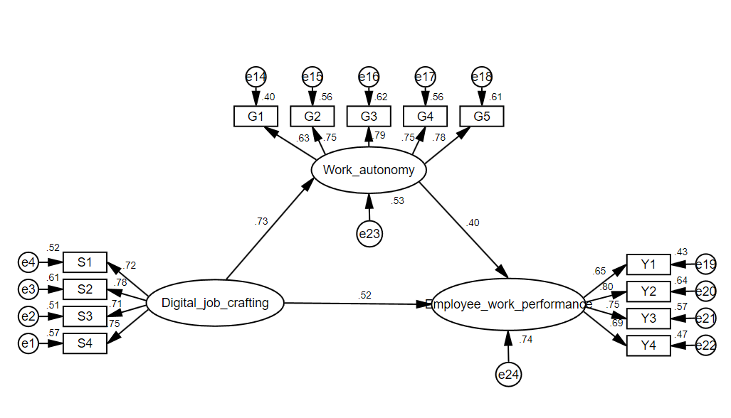
Fig. 2 The mediating role of work autonomy
Table 11 Path coefficient test results
Research hypothesis | Coefficients | Standardized  coefficients | S.E. | C.R. | P-value
Digital job craftingWork autonomy | 0.627 | 0.730 | 0.073 | 8.633 | 0.000***
Work autonomyEmployee work performance | 0.428 | 0.405 | 0.095 | 4.515 | 0.000***

***P<0.001
Table 12 Bootstrap mediation affects test results
Types of  effects | Estimate | SE | Z-value | P-value | 95%CI
 |  |  |  |  | Lower | Upper
Direct effect | 0.470** | 0.122 | 3.852 | 0.001 | 0.239 | 0.729
Indirect effect | 0.269** | 0.090 | 2.989 | 0.001 | 0.119 | 0.479
Total effect | 0.738*** | 0.089 | 8.292 | 0.000 | 0.577 | 0.926

** P<0.01; *** P<0.001
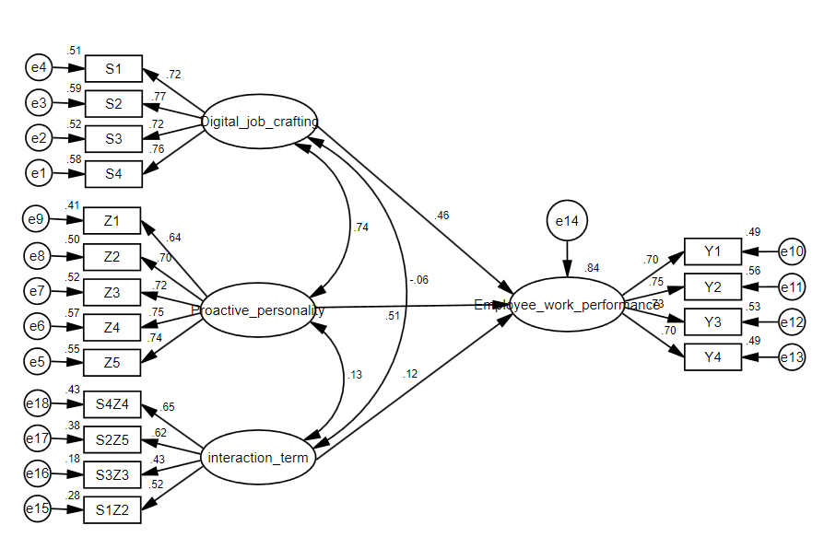
Fig. 3 Moderating effects of proactive personality

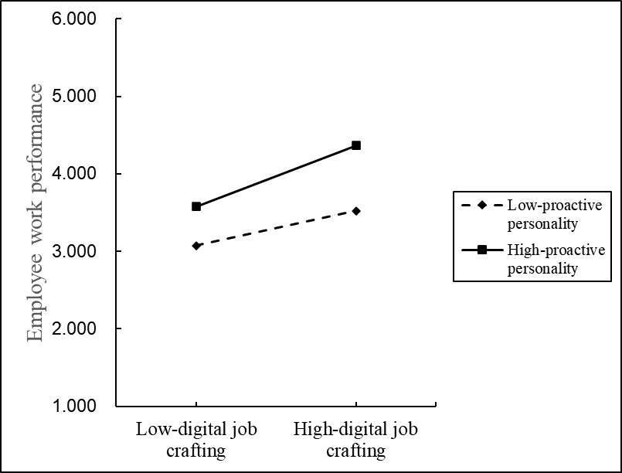
Fig. 4 The regulating role of the proactive personality

