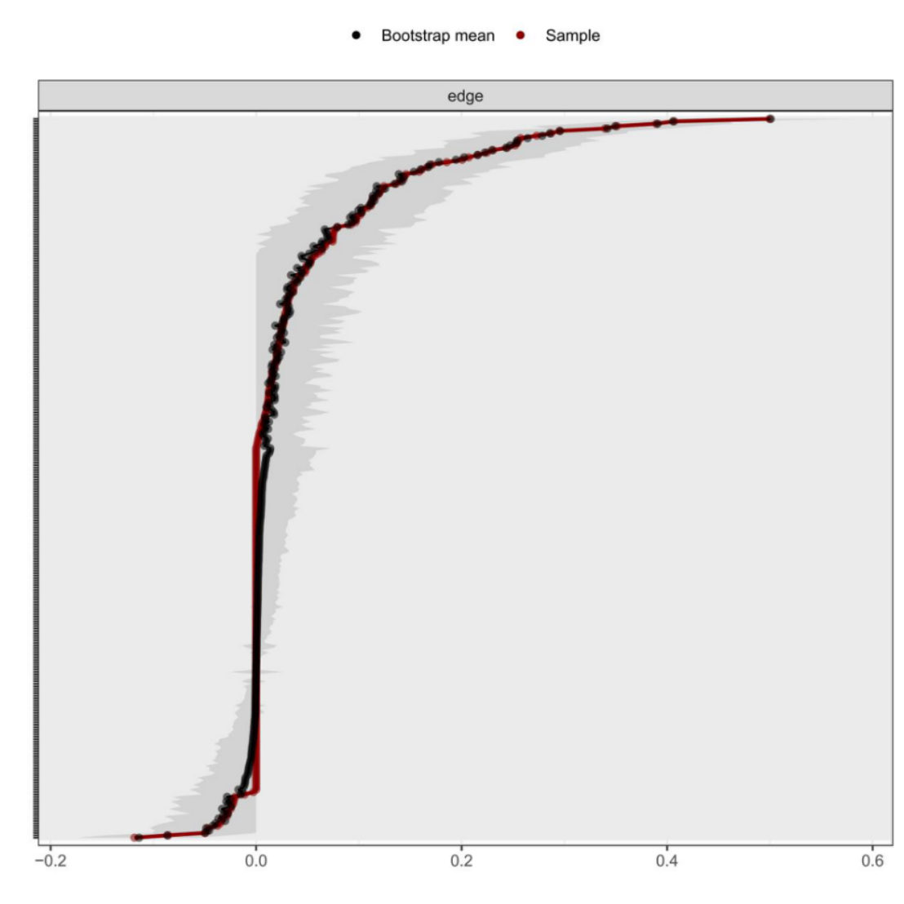
Figure S1 Bootstrapped edge weights
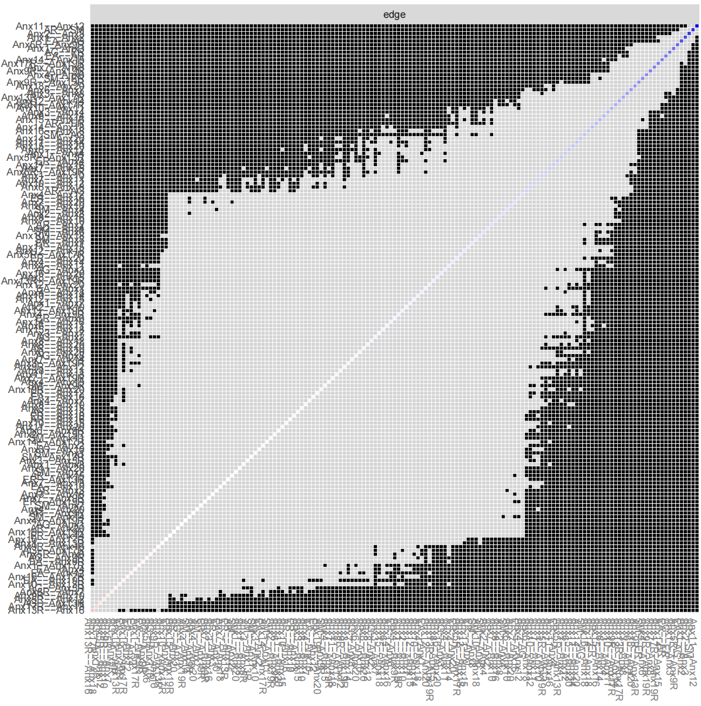
Figure S2 Bootstrapped difference test for edge weights
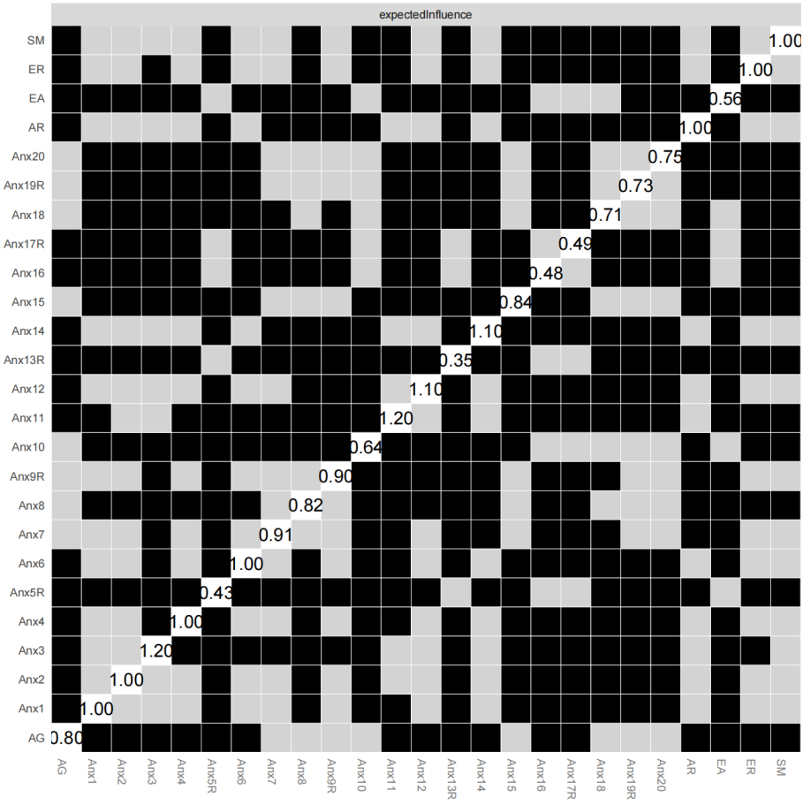
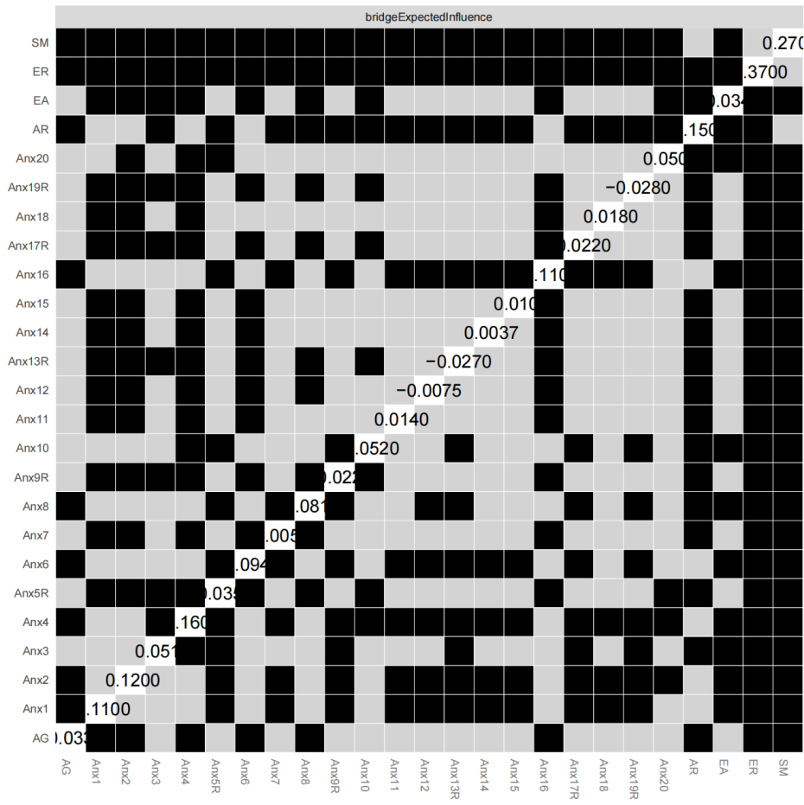
Figure S3 Bootstrapped difference test for node EI and BEI
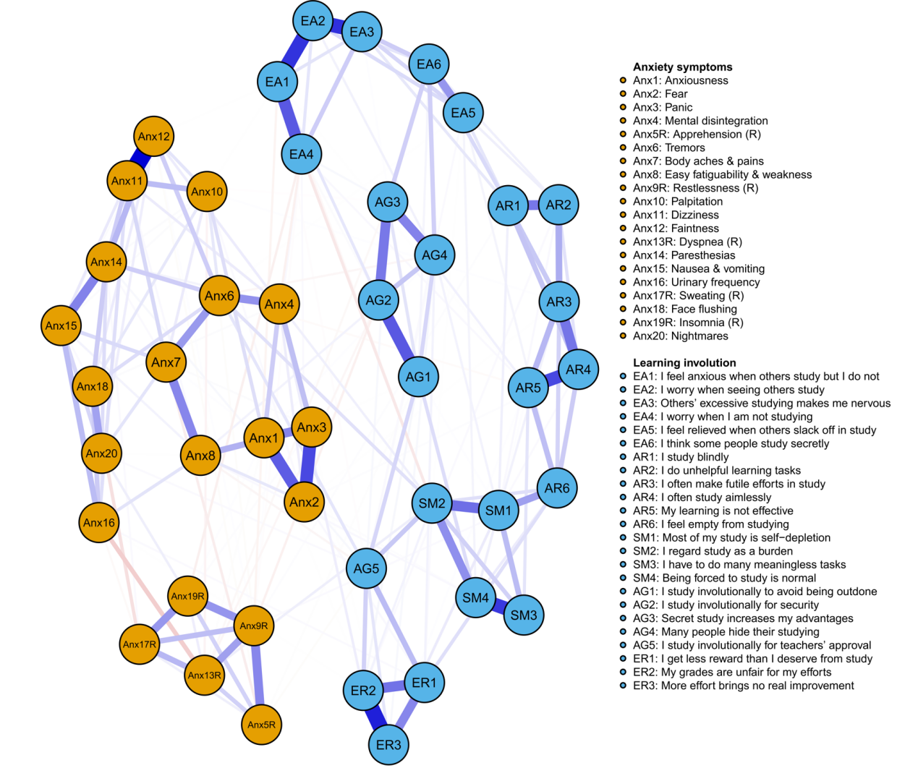Figure S4 Estimated item-level network including all academic involution and anxiety items
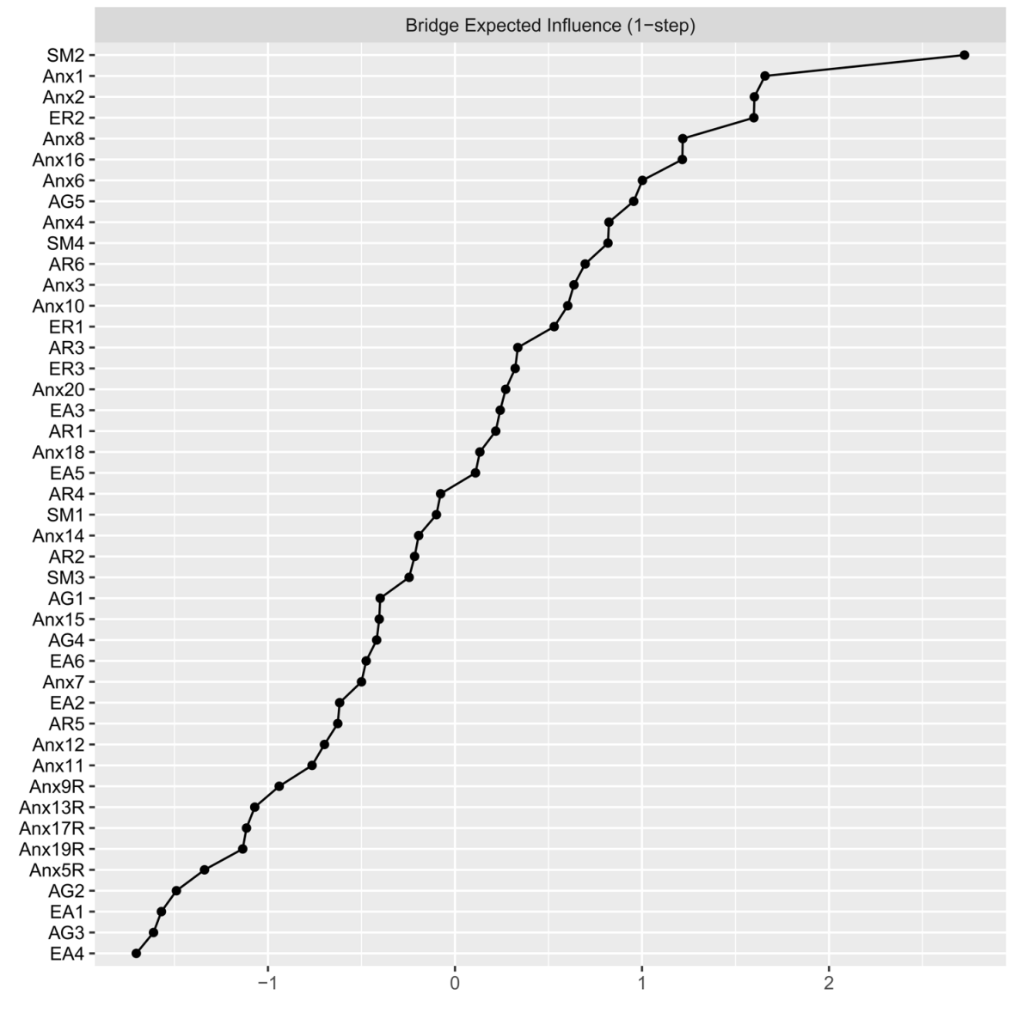
Figure S5 Bridge expected influence (1-step) for each node in the item-level network
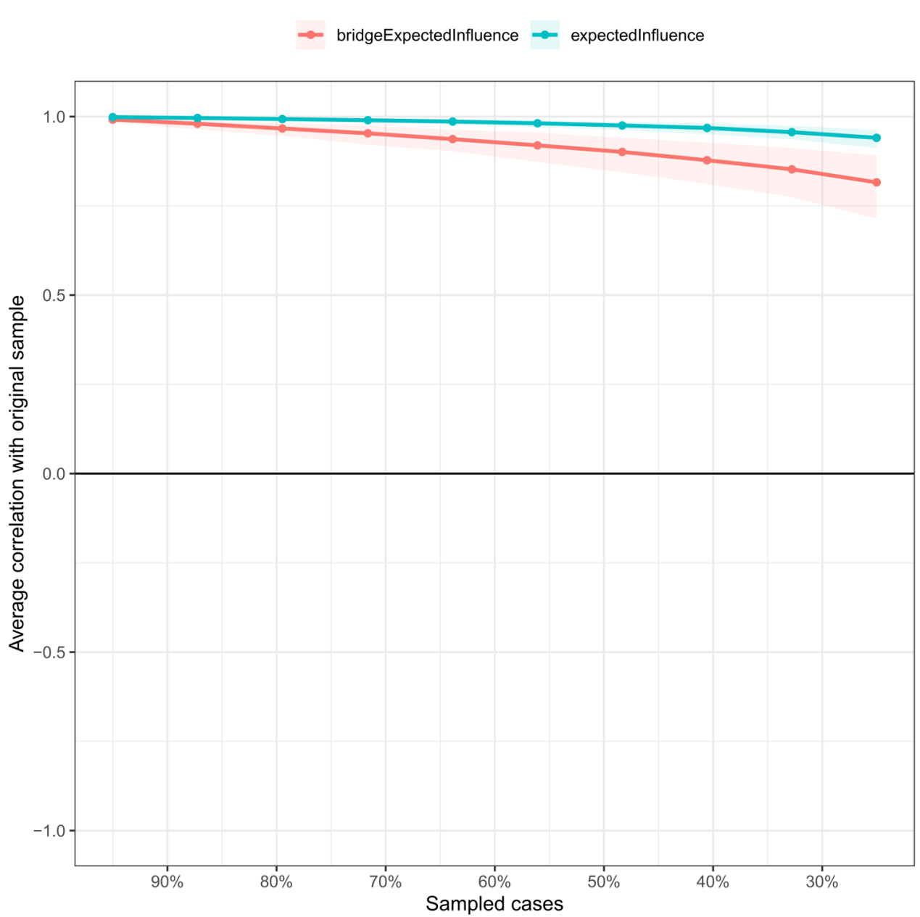
Figure S6 Stability of expected influence and bridge expected influence in the item-level network

