Supplementary Material S1. Distributional properties of PGAIU
This section reports item-level response frequencies and the distribution of the total PGAIU score. The results show that responses are generally concentrated at the lower end of the scale; however, all response categories (1–5) are represented across items, with observable proportions of higher-category endorsements, indicating meaningful variability in the construct.

İtem Statistics
 |  | pgaiu1 | pgaiu2 | pgaiu3 | pgaiu4 | pgaiu5 | pgaiu6
N | Valid | 677 | 677 | 677 | 677 | 677 | 677
N | Missing | 0 | 0 | 0 | 0 | 0 | 0
Std. Deviation |  | 1,051 | 1,206 | 1,079 | ,902 | ,929 | ,753
Skewness |  | ,515 | ,266 | 1,124 | 1,542 | 1,802 | 2,387
Std. Error of Skewness |  | ,094 | ,094 | ,094 | ,094 | ,094 | ,094
Kurtosis |  | -,346 | -,844 | ,423 | 1,825 | 2,638 | 5,532
Std. Error of Kurtosis |  | ,188 | ,188 | ,188 | ,188 | ,188 | ,188
Minimum |  | 1 | 1 | 1 | 1 | 1 | 1
Maximum |  | 5 | 5 | 5 | 5 | 5 | 5

pgaiu1
 |  | Frequency | Percent | Valid Percent | Cumulative Percent
Valid | 1 | 177 | 26,1 | 26,1 | 26,1
Valid | 2 | 231 | 34,1 | 34,1 | 60,3
Valid | 3 | 183 | 27,0 | 27,0 | 87,3
Valid | 4 | 66 | 9,7 | 9,7 | 97,0
Valid | 5 | 20 | 3,0 | 3,0 | 100,0
Valid | Total | 677 | 100,0 | 100,0

pgaiu2
 |  | Frequency | Percent | Valid Percent | Cumulative Percent
Valid | 1 | 171 | 25,3 | 25,3 | 25,3
Valid | 2 | 151 | 22,3 | 22,3 | 47,6
Valid | 3 | 208 | 30,7 | 30,7 | 78,3
Valid | 4 | 102 | 15,1 | 15,1 | 93,4
Valid | 5 | 45 | 6,6 | 6,6 | 100,0
Valid | Total | 677 | 100,0 | 100,0

pgaiu3
 |  | Frequency | Percent | Valid Percent | Cumulative Percent
Valid | 1 | 348 | 51,4 | 51,4 | 51,4
Valid | 2 | 157 | 23,2 | 23,2 | 74,6
Valid | 3 | 110 | 16,2 | 16,2 | 90,8
Valid | 4 | 43 | 6,4 | 6,4 | 97,2
Valid | 5 | 19 | 2,8 | 2,8 | 100,0
Valid | Total | 677 | 100,0 | 100,0

pgaiu4
 |  | Frequency | Percent | Valid Percent | Cumulative Percent
Valid | 1 | 424 | 62,6 | 62,6 | 62,6
Valid | 2 | 145 | 21,4 | 21,4 | 84,0
Valid | 3 | 76 | 11,2 | 11,2 | 95,3
Valid | 4 | 25 | 3,7 | 3,7 | 99,0
Valid | 5 | 7 | 1,0 | 1,0 | 100,0
Valid | Total | 677 | 100,0 | 100,0

pgaiu5
 |  | Frequency | Percent | Valid Percent | Cumulative Percent
Valid | 1 | 457 | 67,5 | 67,5 | 67,5
Valid | 2 | 122 | 18,0 | 18,0 | 85,5
Valid | 3 | 58 | 8,6 | 8,6 | 94,1
Valid | 4 | 30 | 4,4 | 4,4 | 98,5
Valid | 5 | 10 | 1,5 | 1,5 | 100,0
Valid | Total | 677 | 100,0 | 100,0

pgaiu6
 |  | Frequency | Percent | Valid Percent | Cumulative Percent
Valid | 1 | 528 | 78,0 | 78,0 | 78,0
Valid | 2 | 86 | 12,7 | 12,7 | 90,7
Valid | 3 | 43 | 6,4 | 6,4 | 97,0
Valid | 4 | 16 | 2,4 | 2,4 | 99,4
Valid | 5 | 4 | ,6 | ,6 | 100,0
Valid | Total | 677 | 100,0 | 100,0

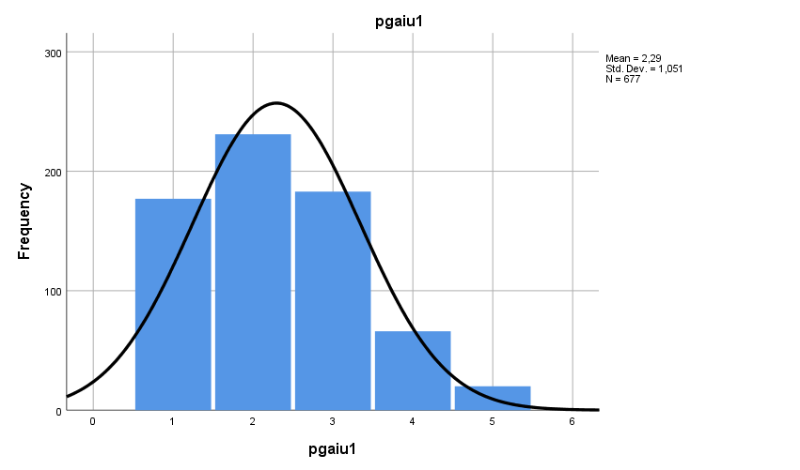

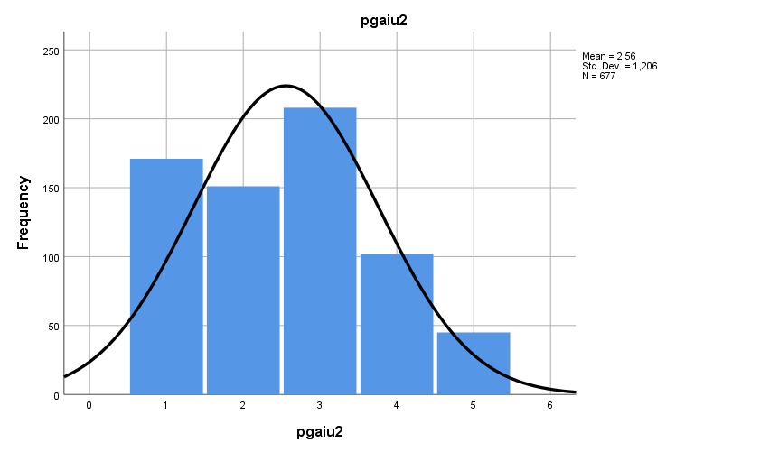

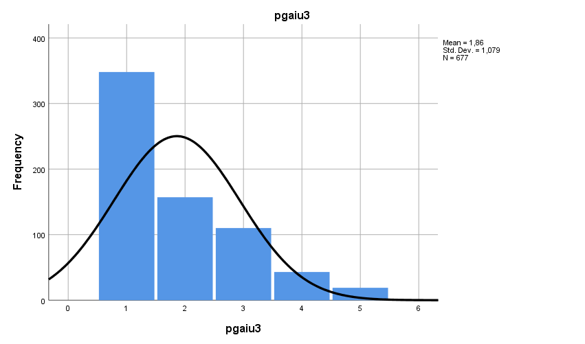

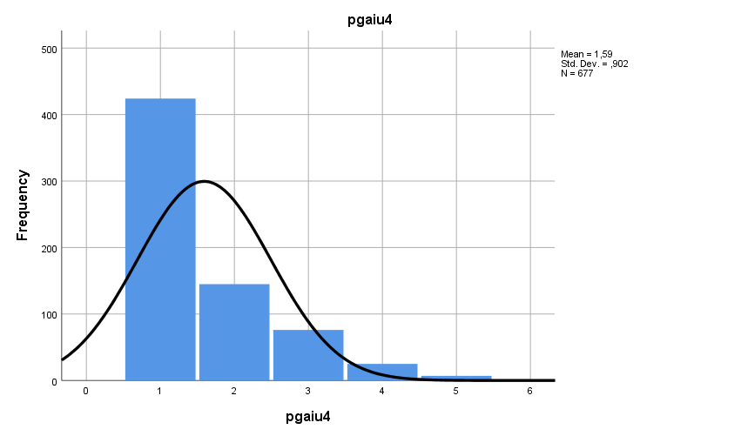

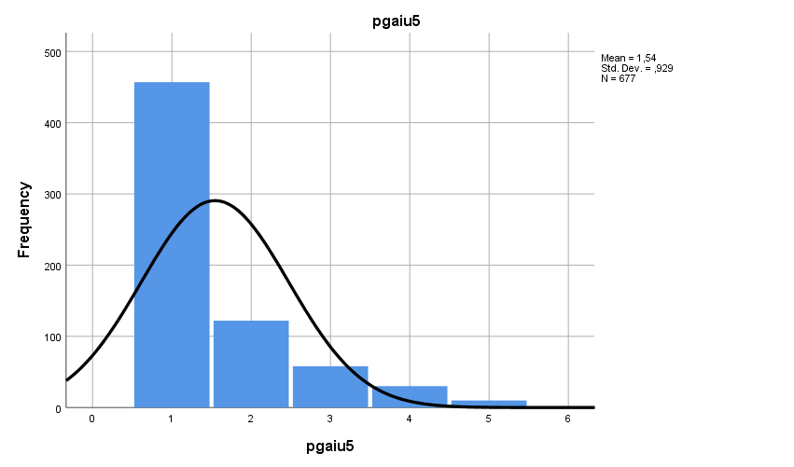

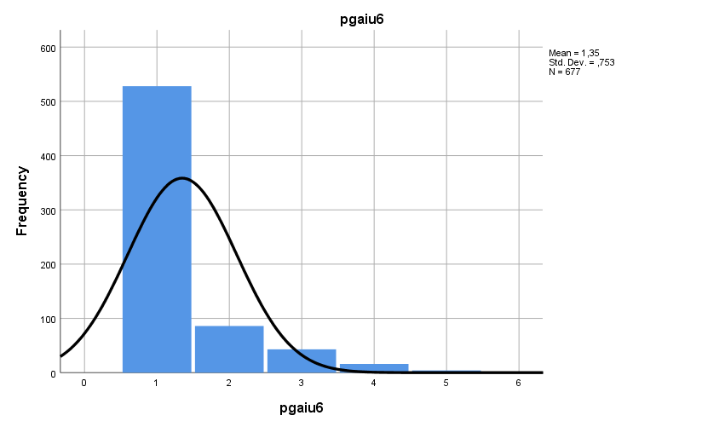

Total score Statistics
PGAIU
N | Valid | 677
N | Missing | 0
Std. Deviation |  | ,75572
Skewness |  | ,986
Std. Error of Skewness |  | ,094
Kurtosis |  | ,778
Std. Error of Kurtosis |  | ,188
Minimum |  | 1,00
Maximum |  | 5,00

PGAIU
 |  | Frequency | Percent | Valid Percent | Cumulative Percent
Valid | 1,00 | 111 | 16,4 | 16,4 | 16,4
Valid | 1,17 | 62 | 9,2 | 9,2 | 25,6
Valid | 1,33 | 56 | 8,3 | 8,3 | 33,8
Valid | 1,50 | 66 | 9,7 | 9,7 | 43,6
Valid | 1,67 | 52 | 7,7 | 7,7 | 51,3
Valid | 1,83 | 52 | 7,7 | 7,7 | 58,9
Valid | 2,00 | 51 | 7,5 | 7,5 | 66,5
Valid | 2,17 | 44 | 6,5 | 6,5 | 73,0
Valid | 2,33 | 41 | 6,1 | 6,1 | 79,0
Valid | 2,50 | 29 | 4,3 | 4,3 | 83,3
Valid | 2,67 | 24 | 3,5 | 3,5 | 86,9
Valid | 2,83 | 22 | 3,2 | 3,2 | 90,1
Valid | 3,00 | 14 | 2,1 | 2,1 | 92,2
Valid | 3,17 | 16 | 2,4 | 2,4 | 94,5
Valid | 3,33 | 8 | 1,2 | 1,2 | 95,7
Valid | 3,50 | 7 | 1,0 | 1,0 | 96,8
Valid | 3,67 | 6 | ,9 | ,9 | 97,6
Valid | 3,83 | 6 | ,9 | ,9 | 98,5
Valid | 4,00 | 5 | ,7 | ,7 | 99,3
Valid | 4,17 | 1 | ,1 | ,1 | 99,4
Valid | 4,50 | 1 | ,1 | ,1 | 99,6
Valid | 4,67 | 2 | ,3 | ,3 | 99,9
Valid | 5,00 | 1 | ,1 | ,1 | 100,0
Valid | Total | 677 | 100,0 | 100,0

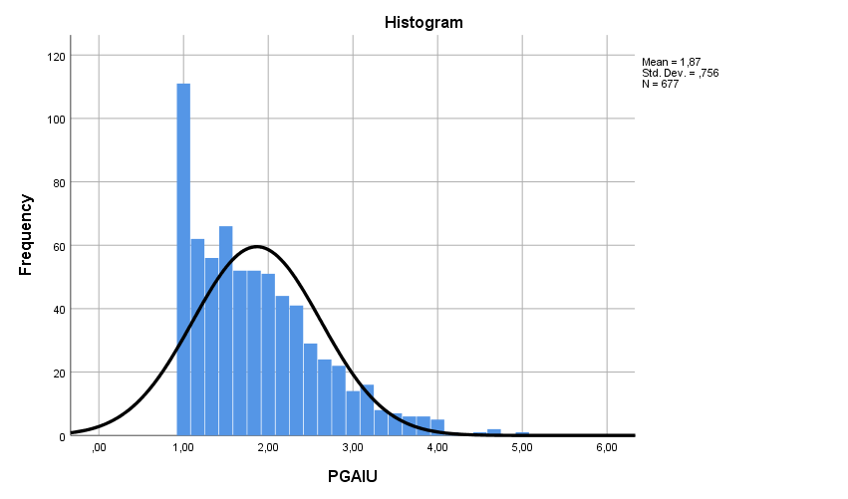

Supplementary Material S2. Sensitivity of psychopathy coefficient across model specifications
Model specification | Psychopathy → PGAIU (β)
Full model | −.12*
Without narcissism | −.12*
Without Machiavellianism | −.07 (ns)
Without sadism | −.06 (ns)

Supplementary Material S3. Standardized path coefficients with and without country controls
(Total effect) | Original Model (β) | With Country Controls (β)
Narcissism → PGAIU | .26*** | .27***
Machiavellianism → PGAIU | .08 | .07
Psychopathy → PGAIU | -.09 | -.08
Sadism → PGAIU | .08* | .07 (ns)
Vertical Individualism → PGAIU | .33*** | .33***
IU → PGAIU | .29*** | .29***

Supplementary Material S4. Omitted path coefficients for overall sample and men and women.
 | Effect (S.E.)
 | Total Sample  (N=677) | Men  (N=339) | Women (N=337)
Narcissism VI (direct effect) | .43*** | .47*** | .40***
HI (direct effect) | -.05 | -.01 | -.06
IU (total effect) | .11* | .17** | .05
IU (direct effect) | .05 | .07 | .00
IU (indirect effect) | .06* | .10** | .05
Sadism VI (direct effect) | .08* | .00 | .15**
HI (direct effect) | .08* | .05 | .11*
IU (total effect) | .04 | .08 | .00
IU (direct effect) | .02 | .07 | -.03
IU (indirect effect) | .02* | .01 | .03*
Psychopathy VI (direct effect) | .01 | -.08 | .05
HI (direct effect) | .06 | .09 | .04
IU (total effect) | .14** | .27** | .07
IU (direct effect) | .14** | .28*** | .06
IU (indirect effect) | .00 | -.01 | .01
Machiavellianism VI (direct effect) | .03 | .07 | .01
HI (direct effect) | -.07 | -.01 | -.13
IU (total effect) | .02 | -.10 | .11
IU (direct effect) | .02 | -.12 | .12
IU (indirect effect) | .00 | .02 | -.01
VI IU (direct effect) | .15* | .22** | .13
HI PGAIU (total effect) | -.05 | -.05 | -.03
PGAIU (direct effect) | -.07 | -.08 | -.04
PGAIU (indirect effect) | .02 | .03 | .01
IU (direct effect) | .07 | .08 | .06
IU PGAIU (direct effect) | .29*** | .38*** | .22***
Age PGAIU (direct effect) | -.10* | -.09* | -.11*
Note. PGAIU = Problematic Gen-AI Use; VI = Vertical individualism; HI = Horizontal individualism; IU = Intolerance of uncertainty. *p < .05, **p < .01, ***p < .001.

