Psychometric properties of the Armenian and Georgian versions of the PHQ-9, GAD-7, and WHO-5 Well-Being Index

Supplementary Materials 3 – Supporting tables and figures

Packages used in R for analyses: lavaan, survey, EGAnet, lordif, semTools, semPlot, psych, jtools, and Hmisc [1–9].

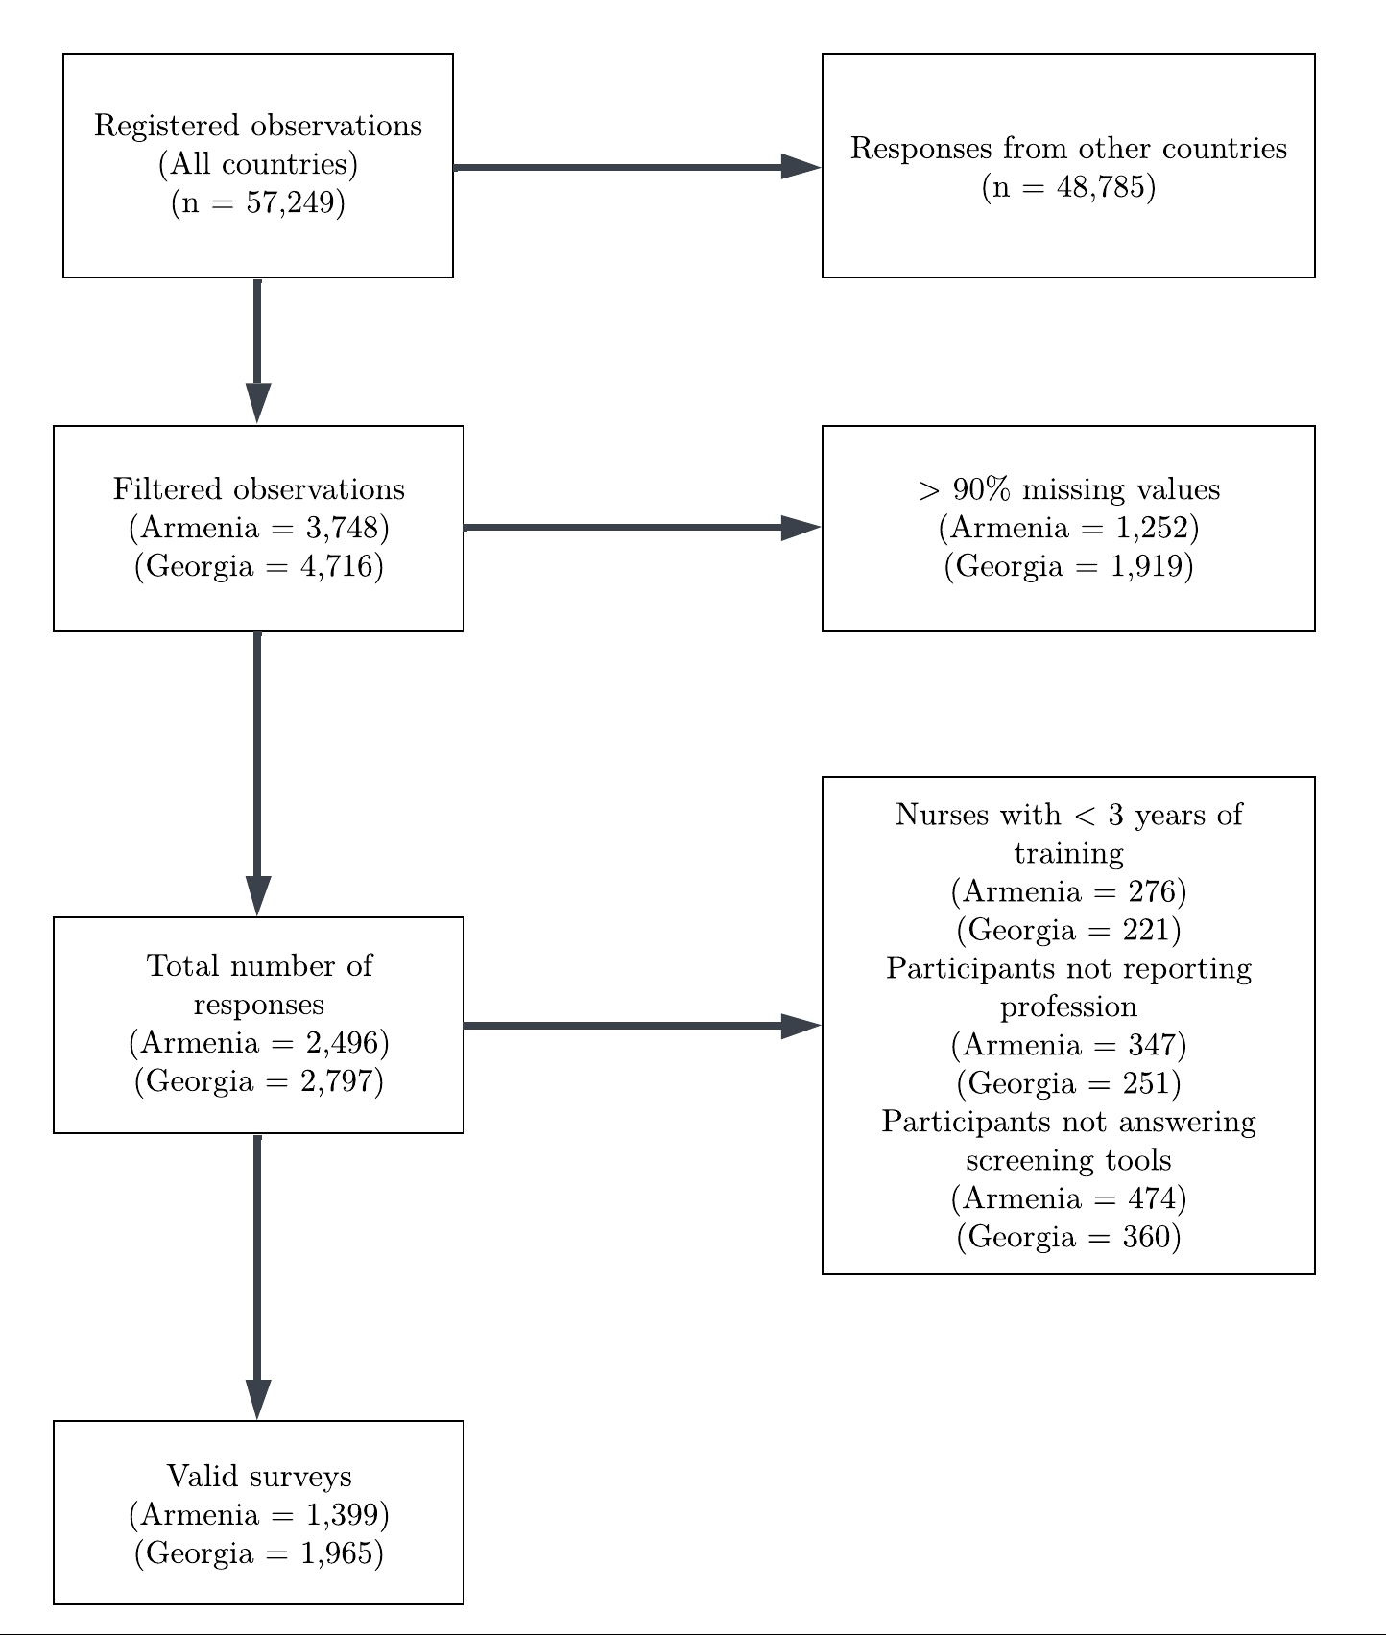
Figure S1. Caption: Participant exclusion flowchart.

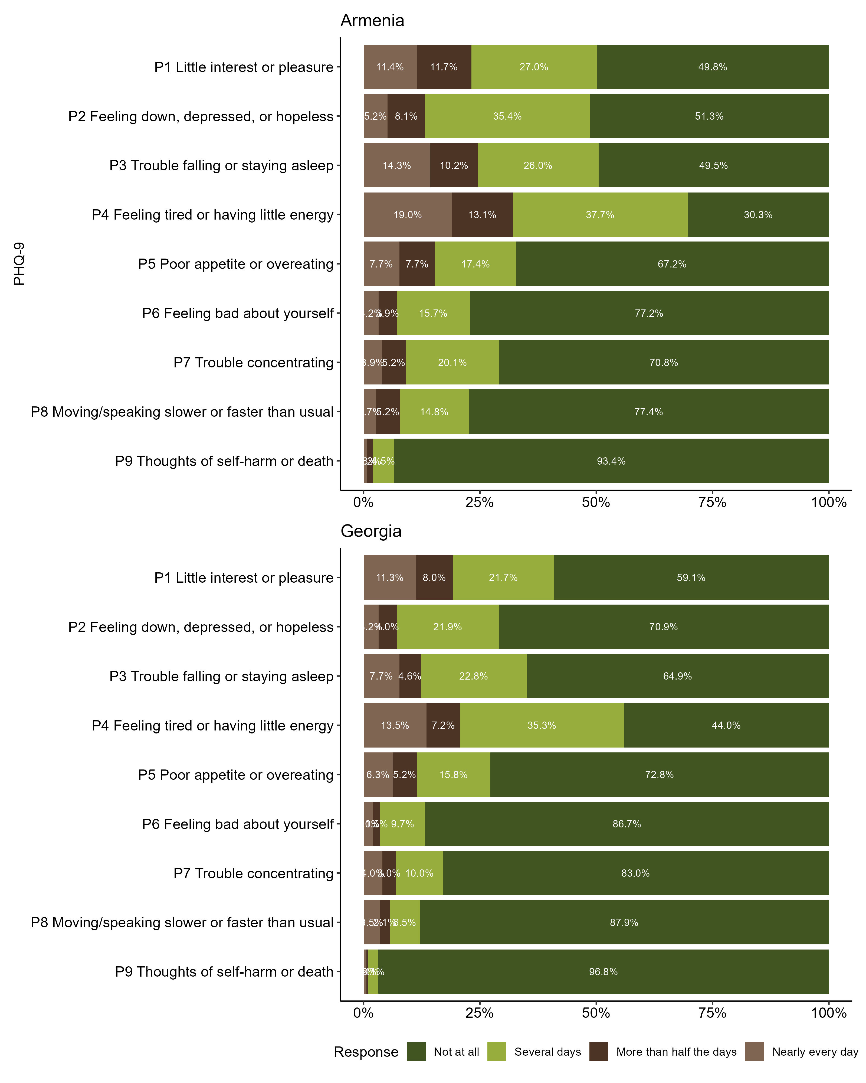
Figure S2. Caption: Response distribution for each item of the PHQ-9. Alt text: A two-panel figure displaying bar graphs representing the proportion of responses to each individual item of the PHQ-9. The top plot corresponds to Armenia and shows a trend for lower scoring responses (Corresponding to “Not at all”), being around 50% or more of the total responses. The bottom plot corresponds to Georgia and shows an even stronger trend. “Several days” is the second most frequent response but is significantly lower in proportion.

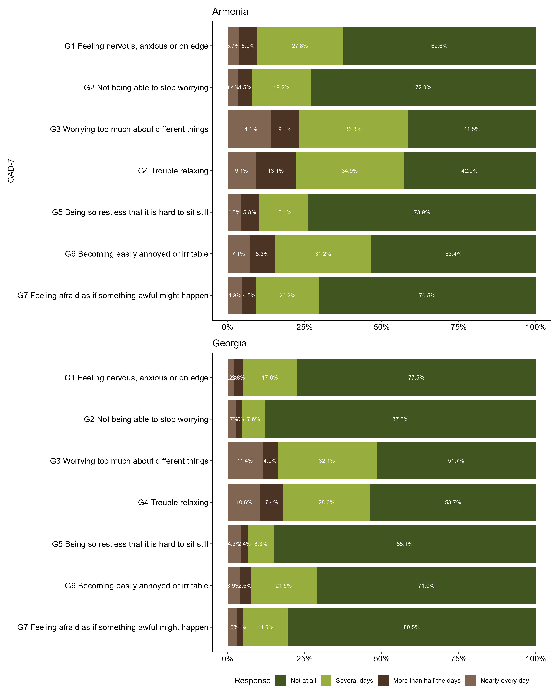
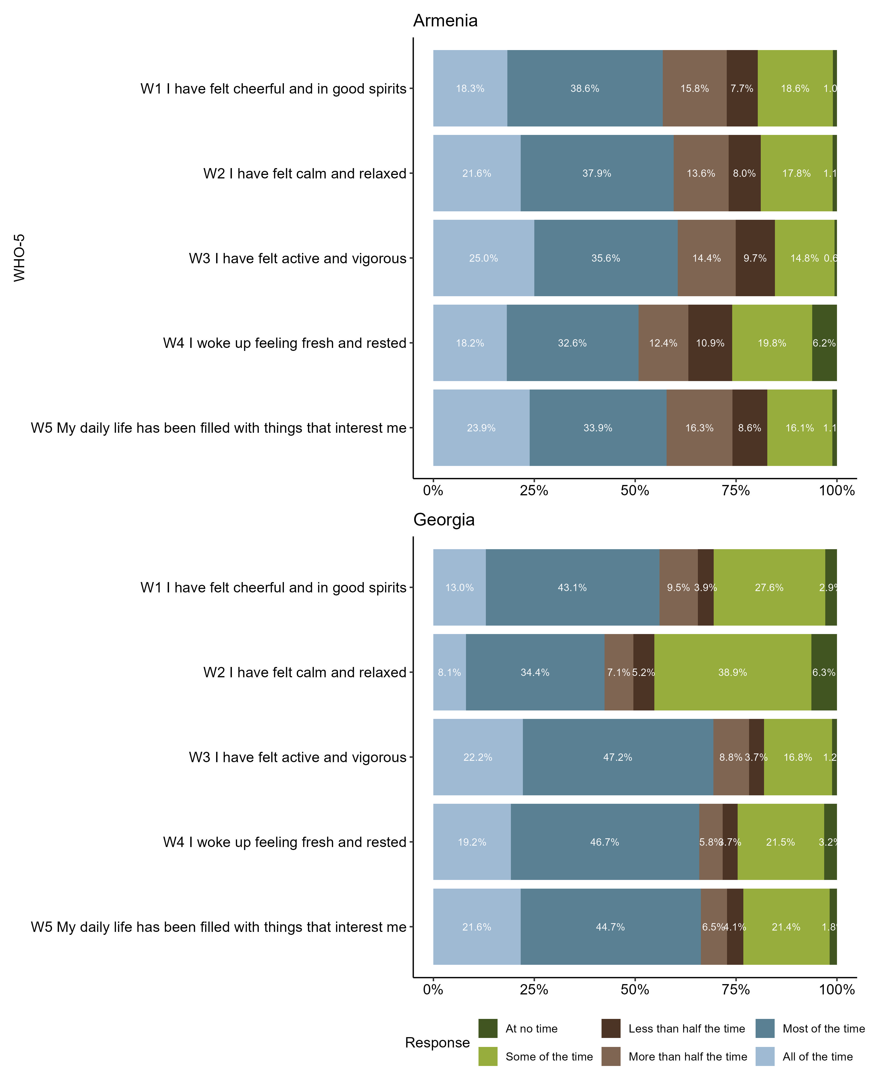
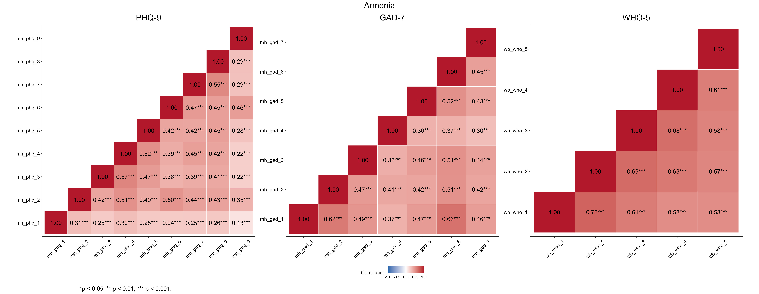
Figure S3. Caption: Response distribution for each item of the GAD-7. Alt text: A two-panel figure displaying bar graphs representing the proportion of responses to each individual item of the GAD-7. The top plot corresponds to Armenia and shows a trend for lower scoring responses (Corresponding to “Not at all”), with at least 40% or more of the total responses. The bottom plot corresponds to Georgia and shows an even stronger trend. The second most frequent response is “Several days” but account for one third of the total at most.

Figure S4. Caption: Response distribution for each item of the WHO-5. Alt text: Bar graph displaying the proportion of responses to each individual item of the WHO-5. A two-panel figure displaying bar graphs representing the proportion of responses to each individual item of the WHO-5. The top plot corresponds to Armenia and shows a trend for “Most of the time” responses, representing around one third of the total responses. The bottom plot corresponds to Georgia and shows an even stronger trend. The second most frequent response is “All of the time”, which ranges from 8% to 25%.

Figure S5. Caption: Inter-item correlation matrices for the PHQ-9, GAD-7 and WHO-5 in Armenia. Alt text: A three-panel figure of correlation matrix heatmaps for psychometric data collected in Armenia. The left panel shows inter-item correlations for the PHQ-9; the middle panel shows the GAD-7; the right panel shows the WHO-5. In all three lower-triangular matrices, numerical correlation coefficients are displayed in cells shaded red, indicating positive associations. Asterisks next to the numbers indicate statistical significance, with three of these indicating a p value < 0.001. A colour legend at the bottom indicates a scale from -1.0 (blue) to 1.0 (red). The data shows moderate to strong positive, statistically significant correlations between all items within each of the three respective scales.

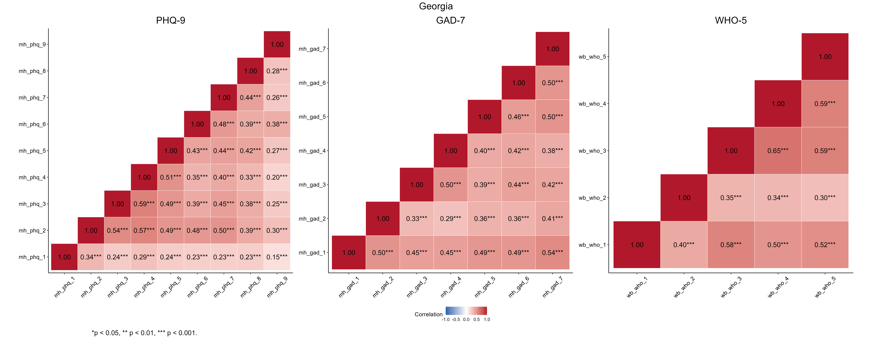
Figure S6. Caption: Inter-item correlation matrices for the PHQ-9, GAD-7 and WHO-5 in Georgia. Alt text: A three-panel figure of correlation matrix heatmaps for psychometric data collected in Georgia. The left panel shows inter-item correlations for the PHQ-9; the middle panel shows the GAD-7; the right panel shows the WHO-5. In all three lower-triangular matrices, numerical correlation coefficients are displayed in cells shaded red, indicating positive associations. Asterisks next to the numbers indicate statistical significance, with three of these indicating a p value < 0.001. A colour legend at the bottom indicates a scale from -1.0 (blue) to 1.0 (red). The data shows moderate to strong positive, statistically significant correlations between all items within each of the three respective scales.

Ideally, inter-item correlation coefficients should fall between 0.15 and 0.50 to demonstrate good internal consistency while avoiding item redundancy [10]. However, it is widely accepted that highly specific, narrow clinical constructs (such as targeted depressive or anxiety symptoms) may exhibit slightly higher correlations without compromising validity of the scale.

Table S1. Kaiser-Meyer-Olkin (KMO) and Bartlett's sphericity tests. The KMO assess data suitability for factor analysis, indicating the proportion of variance in the variables likely caused by underlying factors. The Bartlett test checks redundancy between variables, with the null hypothesis stating that these are not correlated.
 | Armenia |  |  |  | Georgia
 | KMO | Bartlett's | df | p-value | KMO | Bartlett's | df | p-value
PHQ-9 | 0.89 | 3,985 | 36 | < 0.001 | 0.90 | 5,561 | 36 | < 0.001
GAD-7 | 0.89 | 3,561 | 21 | < 0.001 | 0.89 | 4,459 | 21 | < 0.001
WHO-5 | 0.86 | 3,863 | 10 | < 0.001 | 0.83 | 3,551 | 10 | < 0.001
Note. KMO = Kaiser-Meyer-Olkin test value; df = degrees of freedom.

These KMO results are classified “meritorious” according to original criteria, indicating the data are highly suitable for factor analysis. Furthermore, Bartlett’s tests of sphericity [11,12] yielded p-values < 0.001 across all scales, confirming that the inter-item correlations are sufficiently strong to proceed.
Table S2. Exploratory Factor Analyses (EFA) for the PHQ-9, GAD-7 and WHO-5 in Armenia. Maximum Likelihood (ML) is used as the extraction method with Direct Oblimin rotation to allow for correlations between factors.
Item | ML1 | ML2 | ML3 | ML4 | h² (Communality) | % Var | Eigen
PHQ-9
P1 Little interest or pleasure | 0.05 | 0.11 | 0.25 | 0.04 | 0.15 | 0.58 | 4.08
P2 Feeling down, depressed, or hopeless | 0.01 | 0.99 | 0.01 | 0.01 | 1.00 | 0.58 | 0.99
P3 Trouble falling or staying asleep | 0.03 | -0.01 | 0.68 | 0.02 | 0.49 | 0.58 | 0.83
P4 Feeling tired or having little energy | -0.03 | 0.06 | 0.82 | -0.05 | 0.67 | 0.58 | 0.72
P5 Poor appetite or overeating | 0.08 | -0.08 | 0.54 | 0.20 | 0.46 | 0.58 | 0.58
P6 Feeling bad about yourself | 0.00 | 0.02 | 0.02 | 0.81 | 0.69 | 0.58 | 0.51
P7 Trouble concentrating | 0.28 | 0.03 | 0.25 | 0.24 | 0.44 | 0.58 | 0.46
P8 Moving/speaking slower or faster than usual | 1.00 | 0.01 | 0.00 | -0.01 | 1.00 | 0.58 | 0.45
P9 Thoughts of self-harm or death | 0.00 | 0.07 | -0.07 | 0.55 | 0.31 | 0.58 | 0.38
GAD-7
G1 Feeling nervous, anxious or on edge | 0.93 | 0.02 | 0.02 |  | 0.90 | 0.54 | 3.75
G2 Not being able to stop worrying | 0.34 | 0.16 | 0.43 |  | 0.61 | 0.54 | 0.73
G3 Worrying too much about different things | -0.02 | 0.64 | 0.11 |  | 0.48 | 0.54 | 0.64
G4 Trouble relaxing | -0.04 | 0.40 | 0.27 |  | 0.32 | 0.54 | 0.59
G5 Being so restless that it is hard to sit still | -0.06 | 0.75 | -0.03 |  | 0.48 | 0.54 | 0.53
G6 Becoming easily annoyed or irritable | 0.28 | 0.59 | -0.08 |  | 0.61 | 0.54 | 0.46
G7 Feeling afraid as if something awful might happen | 0.04 | 0.55 | 0.06 |  | 0.38 | 0.54 | 0.31
WHO-5
W1 I have felt cheerful and in good spirits | 0.89 | -0.06 |  |  | 0.70 | 0.68 | 3.47
W2 I have felt calm and relaxed | 0.79 | 0.12 |  |  | 0.77 | 0.68 | 0.55
W3 I have felt active and vigorous | 0.39 | 0.48 |  |  | 0.67 | 0.68 | 0.44
W4 I woke up feeling fresh and rested | -0.03 | 0.91 |  |  | 0.78 | 0.68 | 0.30
W5 My daily life has been filled with things that interest me | 0.26 | 0.49 |  |  | 0.50 | 0.68 | 0.25
Note. ML: Factor loadings through Maximum-Likelihood method estimation (For 1, 2, 3 or 4 factor-models); % Var: Variance explained by the item (%); Eigen: Eigenvalue.

While initial unadjusted eigenvalue outputs could be interpreted as hinting at minor secondary dimensions for the PHQ-9 and GAD-7, the rigorous Parallel Analyses demonstrated that only the primary eigenvalue strictly exceeded its corresponding simulated threshold (95th percentile) across all models. Consequently, the Parallel Analysis—further corroborated by the Exploratory Graph Analysis (EGA)—supports a strictly unidimensional solution for all scales. Any minor subdimensions implied by secondary loadings (as occasionally addressed in previous literature) [13] did not meet the empirical criteria for factor retention.

Table S3. Exploratory Factor Analyses (EFA) for the PHQ-9, GAD-7 and WHO-5 in Georgia. Maximum Likelihood (ML) is used as the extraction method with Direct Oblimin rotation to allow for correlations between factors.
Item | ML1 | ML2 | ML3 | ML4 | h² (Communality) | % Var | Eigen
PHQ-9
P1 Little interest or pleasure | 0.06 | 0.27 | 0.10 |  | 0.14 | 0.52 | 4.06
P2 Feeling down, depressed, or hopeless | 0.01 | 0.55 | 0.29 |  | 0.58 | 0.52 | 0.95
P3 Trouble falling or staying asleep | 0.05 | 0.66 | 0.08 |  | 0.54 | 0.52 | 0.85
P4 Feeling tired or having little energy | -0.02 | 0.88 | -0.09 |  | 0.67 | 0.52 | 0.72
P5 Poor appetite or overeating | 0.11 | 0.47 | 0.20 |  | 0.46 | 0.52 | 0.61
P6 Feeling bad about yourself | 0.00 | 0.01 | 0.76 |  | 0.60 | 0.52 | 0.52
P7 Trouble concentrating | 0.13 | 0.25 | 0.39 |  | 0.44 | 0.52 | 0.48
P8 Moving/speaking slower or faster than usual | 1.00 | 0.00 | -0.01 |  | 1.00 | 0.52 | 0.43
P9 Thoughts of self-harm or death | 0.06 | -0.03 | 0.47 |  | 0.23 | 0.52 | 0.38
GAD-7
G1 Feeling nervous, anxious or on edge | 0.16 | 0.53 | 0.14 |  | 0.55 | 0.58 | 3.61
G2 Not being able to stop worrying | 1.00 | 0.00 | 0.00 |  | 1.00 | 0.58 | 0.80
G3 Worrying too much about different things | 0.03 | 0.15 | 0.54 |  | 0.46 | 0.58 | 0.66
G4 Trouble relaxing | 0.00 | -0.02 | 0.76 |  | 0.56 | 0.58 | 0.54
G5 Being so restless that it is hard to sit still | -0.02 | 0.64 | 0.06 |  | 0.46 | 0.58 | 0.50
G6 Becoming easily annoyed or irritable | -0.02 | 0.56 | 0.16 |  | 0.46 | 0.58 | 0.48
G7 Feeling afraid as if something awful might happen | 0.00 | 0.81 | -0.08 |  | 0.57 | 0.58 | 0.42
WHO-5
W1 I have felt cheerful and in good spirits | 0.00 | 0.93 | -0.01 |  | 0.86 | 0.65 | 2.96
W2 I have felt calm and relaxed | 0.07 | 0.31 | 0.13 |  | 0.21 | 0.65 | 0.78
W3 I have felt active and vigorous | 0.93 | 0.00 | 0.00 |  | 0.87 | 0.65 | 0.50
W4 I woke up feeling fresh and rested | 0.00 | -0.01 | 0.92 |  | 0.83 | 0.65 | 0.43
W5 My daily life has been filled with things that interest me | 0.22 | 0.21 | 0.35 |  | 0.48 | 0.65 | 0.33
Note. ML: Factor loadings through Maximum-Likelihood method estimation (For 1, 2, 3 or 4 factor-models); % Var: Variance explained by the item (%); Eigen: Eigenvalue.

Table S4. Exploratory Factor Analyses (EFA) using polychoric correlations for the PHQ-9, GAD-7 and WHO-5 in Armenia.
Item | MR1 | MR2 | MR3 | MR4 | h² (Communality) | % Var | Eigen
PHQ-9
P1 Little interest or pleasure | 0.12 | -0.09 | 0.23 | 0.26 | 0.25 | 0.69 | 5.36
P2 Feeling down, depressed, or hopeless | 0.02 | 0.04 | 0.93 | 0.01 | 0.95 | 0.69 | 0.80
P3 Trouble falling or staying asleep | 0.78 | 0.03 | 0.00 | -0.02 | 0.60 | 0.69 | 0.75
P4 Feeling tired or having little energy | 0.83 | -0.09 | 0.12 | 0.02 | 0.77 | 0.69 | 0.52
P5 Poor appetite or overeating | 0.71 | 0.16 | -0.11 | 0.08 | 0.64 | 0.69 | 0.43
P6 Feeling bad about yourself | 0.05 | 0.35 | 0.16 | 0.38 | 0.69 | 0.69 | 0.36
P7 Trouble concentrating | -0.03 | 0.00 | 0.00 | 0.86 | 0.69 | 0.69 | 0.31
P8 Moving/speaking slower or faster than usual | 0.08 | -0.01 | 0.02 | 0.77 | 0.70 | 0.69 | 0.26
P9 Thoughts of self-harm or death | 0.02 | 0.93 | 0.04 | 0.01 | 0.93 | 0.69 | 0.23
GAD-7
G1 Feeling nervous, anxious or on edge | -0.02 | 0.14 | 0.84 |  | 0.89 | 0.68 | 4.61
G2 Not being able to stop worrying | 0.05 | 0.86 | 0.09 |  | 0.93 | 0.68 | 0.64
G3 Worrying too much about different things | 0.61 | 0.17 | 0.06 |  | 0.61 | 0.68 | 0.48
G4 Trouble relaxing | 0.45 | 0.34 | -0.13 |  | 0.39 | 0.68 | 0.42
G5 Being so restless that it is hard to sit still | 0.77 | 0.00 | 0.05 |  | 0.66 | 0.68 | 0.39
G6 Becoming easily annoyed or irritable | 0.38 | -0.07 | 0.59 |  | 0.75 | 0.68 | 0.29
G7 Feeling afraid as if something awful might happen | 0.55 | 0.09 | 0.13 |  | 0.54 | 0.68 | 0.17
WHO-5
W1 I have felt cheerful and in good spirits | 0.94 | -0.05 |  |  | 0.81 | 0.75 | 3.72
W2 I have felt calm and relaxed | 0.74 | 0.19 |  |  | 0.81 | 0.75 | 0.48
W3 I have felt active and vigorous | 0.33 | 0.57 |  |  | 0.73 | 0.75 | 0.37
W4 I woke up feeling fresh and rested | -0.05 | 0.94 |  |  | 0.81 | 0.75 | 0.24
W5 My daily life has been filled with things that interest me | 0.23 | 0.56 |  |  | 0.57 | 0.75 | 0.19
Note. MR: Factor loadings using polychoric correlation matrix (For 1, 2, 3 or 4 factor-models); % Var: Variance explained by the item (%); Eigen: Eigenvalue.

Table S5. Exploratory Factor Analyses (EFA) using polychoric correlations for the PHQ-9, GAD-7 and WHO-5 in Georgia.
Item | MR1 | MR2 | MR3 | MR4 | h² (Communality) | % Var | Eigen
PHQ-9
P1 Little interest or pleasure | 0.01 | 0.10 | 0.00 | 0.62 | 0.47 | 0.71 | 5.68
P2 Feeling down, depressed, or hopeless | 0.38 | -0.03 | 0.37 | 0.31 | 0.80 | 0.71 | 0.74
P3 Trouble falling or staying asleep | 0.23 | 0.12 | 0.58 | -0.04 | 0.65 | 0.71 | 0.63
P4 Feeling tired or having little energy | -0.05 | 0.00 | 0.95 | 0.04 | 0.88 | 0.71 | 0.47
P5 Poor appetite or overeating | 0.36 | 0.16 | 0.39 | -0.05 | 0.62 | 0.71 | 0.39
P6 Feeling bad about yourself | 0.88 | 0.02 | -0.01 | 0.00 | 0.78 | 0.71 | 0.35
P7 Trouble concentrating | 0.46 | 0.24 | 0.18 | 0.03 | 0.64 | 0.71 | 0.28
P8 Moving/speaking slower or faster than usual | 0.00 | 0.99 | 0.00 | 0.02 | 1.00 | 0.71 | 0.26
P9 Thoughts of self-harm or death | 0.64 | 0.05 | -0.01 | 0.13 | 0.57 | 0.71 | 0.20
GAD-7
G1 Feeling nervous, anxious or on edge | 0.00 | 0.02 | 0.98 |  | 1.00 | 0.73 | 4.74
G2 Not being able to stop worrying | 0.42 | -0.02 | 0.42 |  | 0.61 | 0.73 | 0.56
G3 Worrying too much about different things | 0.01 | 0.99 | 0.00 |  | 1.00 | 0.73 | 0.43
G4 Trouble relaxing | 0.44 | 0.25 | 0.09 |  | 0.51 | 0.73 | 0.40
G5 Being so restless that it is hard to sit still | 0.93 | -0.03 | -0.05 |  | 0.75 | 0.73 | 0.35
G6 Becoming easily annoyed or irritable | 0.67 | 0.10 | 0.05 |  | 0.61 | 0.73 | 0.30
G7 Feeling afraid as if something awful might happen | 0.65 | 0.06 | 0.14 |  | 0.66 | 0.73 | 0.23
WHO-5
W1 I have felt cheerful and in good spirits | 0.09 | 0.74 | 0.15 |  | 0.75 | 0.65 | 3.19
W2 I have felt calm and relaxed | 0.01 | 0.63 | -0.24 |  | 0.37 | 0.65 | 0.78
W3 I have felt active and vigorous | 0.62 | 0.24 | 0.12 |  | 0.72 | 0.65 | 0.44
W4 I woke up feeling fresh and rested | 0.96 | -0.07 | -0.07 |  | 0.80 | 0.65 | 0.34
W5 My daily life has been filled with things that interest me | 0.65 | 0.13 | 0.12 |  | 0.62 | 0.65 | 0.26
Note. MR: Factor loadings using polychoric correlation matrix (For 1, 2, 3 or 4 factor-models); % Var: Variance explained by the item (%); Eigen: Eigenvalue.
Table S6. Weighted polychoric correlation matrix: PHQ-9 (Armenia).
Variable | Item 1 | Item 2 | Item 3 | Item 4 | Item 5 | Item 6 | Item 7 | Item 8 | Item 9
Item 1 | 1.00 | 0.43 | 0.33 | 0.40 | 0.36 | 0.39 | 0.36 | 0.40 | 0.28
Item 2 | 0.43 | 1.00 | 0.54 | 0.64 | 0.53 | 0.67 | 0.57 | 0.60 | 0.63
Item 3 | 0.33 | 0.54 | 1.00 | 0.68 | 0.61 | 0.52 | 0.52 | 0.57 | 0.43
Item 4 | 0.40 | 0.64 | 0.68 | 1.00 | 0.67 | 0.56 | 0.61 | 0.61 | 0.44
Item 5 | 0.36 | 0.53 | 0.61 | 0.67 | 1.00 | 0.58 | 0.56 | 0.60 | 0.52
Item 6 | 0.39 | 0.67 | 0.52 | 0.56 | 0.58 | 1.00 | 0.64 | 0.62 | 0.71
Item 7 | 0.36 | 0.57 | 0.52 | 0.61 | 0.56 | 0.64 | 1.00 | 0.70 | 0.54
Item 8 | 0.40 | 0.60 | 0.57 | 0.61 | 0.60 | 0.62 | 0.70 | 1.00 | 0.54
Item 9 | 0.28 | 0.63 | 0.43 | 0.44 | 0.52 | 0.71 | 0.54 | 0.54 | 1.00

Table S7. Weighted polychoric correlation matrix: GAD-7 (Armenia).
Variable | Item 1 | Item 2 | Item 3 | Item 4 | Item 5 | Item 6 | Item 7
Item 1 | 1.00 | 0.77 | 0.63 | 0.47 | 0.62 | 0.79 | 0.61
Item 2 | 0.77 | 1.00 | 0.65 | 0.55 | 0.60 | 0.67 | 0.60
Item 3 | 0.63 | 0.65 | 1.00 | 0.47 | 0.62 | 0.64 | 0.60
Item 4 | 0.47 | 0.55 | 0.47 | 1.00 | 0.49 | 0.46 | 0.42
Item 5 | 0.62 | 0.60 | 0.62 | 0.49 | 1.00 | 0.67 | 0.59
Item 6 | 0.79 | 0.67 | 0.64 | 0.46 | 0.67 | 1.00 | 0.60
Item 7 | 0.61 | 0.60 | 0.60 | 0.42 | 0.59 | 0.60 | 1.00

Table S8. Weighted polychoric correlation matrix: WHO-5 (Armenia).
Variable | Item 1 | Item 2 | Item 3 | Item 4 | Item 5
Item 1 | 1.00 | 0.80 | 0.68 | 0.60 | 0.60
Item 2 | 0.80 | 1.00 | 0.75 | 0.69 | 0.63
Item 3 | 0.68 | 0.75 | 1.00 | 0.74 | 0.65
Item 4 | 0.60 | 0.69 | 0.74 | 1.00 | 0.66
Item 5 | 0.60 | 0.63 | 0.65 | 0.66 | 1.00

Table S9. Weighted polychoric correlation matrix: PHQ-9 (Georgia).
Variable | Item 1 | Item 2 | Item 3 | Item 4 | Item 5 | Item 6 | Item 7 | Item 8 | Item 9
Item 1 | 1.00 | 0.52 | 0.36 | 0.41 | 0.37 | 0.40 | 0.40 | 0.43 | 0.40
Item 2 | 0.52 | 1.00 | 0.68 | 0.74 | 0.65 | 0.70 | 0.68 | 0.62 | 0.63
Item 3 | 0.36 | 0.68 | 1.00 | 0.72 | 0.62 | 0.59 | 0.62 | 0.60 | 0.53
Item 4 | 0.41 | 0.74 | 0.72 | 1.00 | 0.67 | 0.57 | 0.60 | 0.55 | 0.49
Item 5 | 0.37 | 0.65 | 0.62 | 0.67 | 1.00 | 0.64 | 0.61 | 0.63 | 0.56
Item 6 | 0.40 | 0.70 | 0.59 | 0.57 | 0.64 | 1.00 | 0.69 | 0.64 | 0.66
Item 7 | 0.40 | 0.68 | 0.62 | 0.60 | 0.61 | 0.69 | 1.00 | 0.69 | 0.57
Item 8 | 0.43 | 0.62 | 0.60 | 0.55 | 0.63 | 0.64 | 0.69 | 1.00 | 0.57
Item 9 | 0.40 | 0.63 | 0.53 | 0.49 | 0.56 | 0.66 | 0.57 | 0.57 | 1.00

Table S10. Weighted polychoric correlation matrix: GAD-7 (Georgia).
Variable | Item 1 | Item 2 | Item 3 | Item 4 | Item 5 | Item 6 | Item 7
Item 1 | 1.00 | 0.75 | 0.64 | 0.62 | 0.68 | 0.66 | 0.71
Item 2 | 0.75 | 1.00 | 0.54 | 0.51 | 0.64 | 0.59 | 0.63
Item 3 | 0.64 | 0.54 | 1.00 | 0.61 | 0.59 | 0.60 | 0.61
Item 4 | 0.62 | 0.51 | 0.61 | 1.00 | 0.61 | 0.55 | 0.55
Item 5 | 0.68 | 0.64 | 0.59 | 0.61 | 1.00 | 0.66 | 0.69
Item 6 | 0.66 | 0.59 | 0.60 | 0.55 | 0.66 | 1.00 | 0.65
Item 7 | 0.71 | 0.63 | 0.61 | 0.55 | 0.69 | 0.65 | 1.00

Table S11. Weighted polychoric correlation matrix: WHO-5 (Georgia).
Variable | Item 1 | Item 2 | Item 3 | Item 4 | Item 5
Item 1 | 1.00 | 0.45 | 0.66 | 0.55 | 0.59
Item 2 | 0.45 | 1.00 | 0.38 | 0.35 | 0.33
Item 3 | 0.66 | 0.38 | 1.00 | 0.71 | 0.67
Item 4 | 0.55 | 0.35 | 0.71 | 1.00 | 0.68
Item 5 | 0.59 | 0.33 | 0.67 | 0.68 | 1.00
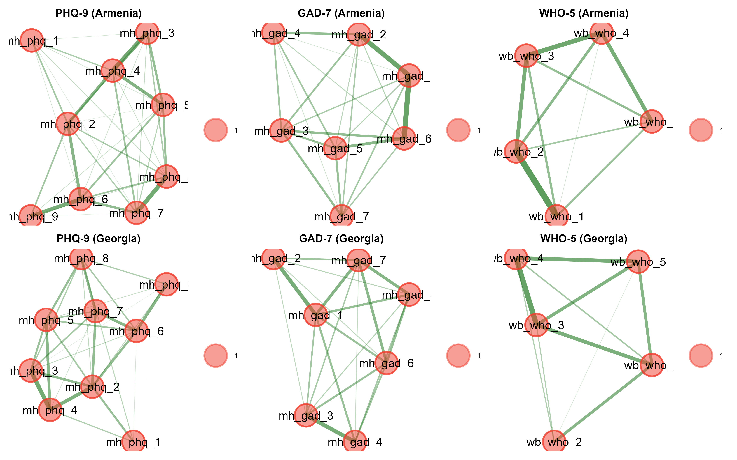
Figure S7. Caption: Exploratory Graph Analysis (EGA) networks for the PHQ-9, GAD-7, and WHO-5 in Armenia and Georgia. Alt-text: Nodes represent individual items, and edges represent the regularised partial correlations between them. The EGA estimated a single-dimension structure (represented by a single-color cluster) for all three scales across both countries, corroborating the unidimensionality suggested by the Parallel Analysis.

Table S12. Unweighted and weighted CFA fit indices comparison.
Scale | Chi2 | df | CFI | TLI | RMSEA | SRMR | Model
Armenia
GAD-7 | 132.65 | 14 | 0.964 | 0.946 | 0.078 | 0.028 | Unweighted
GAD-7 | 75.04 | 14 | 0.970 | 0.954 | 0.074 | 0.026 | Weighted (IPW)
PHQ-9 | 338.37 | 27 | 0.919 | 0.892 | 0.091 | 0.042 | Unweighted
PHQ-9 | 215.09 | 27 | 0.920 | 0.893 | 0.092 | 0.043 | Weighted (IPW)
WHO-5 | 36.25 | 4 | 0.991 | 0.978 | 0.077 | 0.015 | Unweighted
WHO-5 | 33.53 | 4 | 0.992 | 0.980 | 0.074 | 0.016 | Weighted (IPW)
Georgia
GAD-7 | 146.39 | 14 | 0.969 | 0.953 | 0.069 | 0.028 | Unweighted
GAD-7 | 67.49 | 14 | 0.969 | 0.953 | 0.070 | 0.030 | Weighted (IPW)
PHQ-9 | 365.60 | 27 | 0.937 | 0.916 | 0.080 | 0.037 | Unweighted
PHQ-9 | 153.05 | 27 | 0.946 | 0.928 | 0.075 | 0.037 | Weighted (IPW)
WHO-5 | 74.43 | 5 | 0.979 | 0.959 | 0.085 | 0.026 | Unweighted
WHO-5 | 50.57 | 5 | 0.981 | 0.962 | 0.083 | 0.024 | Weighted (IPW)

Table S13. Item factor loadings, item-total correlation coefficients, and Cronbach's alpha if deleted. Armenia and Georgia are shown side-to-side with every scale included for direct comparison. The alpha value when deleting a specific item is used to assess internal consistency, and factor loadings show item discrimination.
 | Armenia |  |  | Georgia
Item | Item-total correlation | α if deleted | Factor loading | Item-total correlation | α if deleted | Factor loading
PHQ-9
P1 Little interest or pleasure | 0.36 | 0.84 | 0.39 | 0.35 | 0.84 | 0.38
P2 Feeling down, depressed, or hopeless | 0.62 | 0.81 | 0.68 | 0.70 | 0.79 | 0.76
P3 Trouble falling or staying asleep | 0.59 | 0.81 | 0.64 | 0.64 | 0.80 | 0.71
P4 Feeling tired or having little energy | 0.66 | 0.80 | 0.71 | 0.63 | 0.80 | 0.70
P5 Poor appetite or overeating | 0.61 | 0.81 | 0.66 | 0.62 | 0.80 | 0.68
P6 Feeling bad about yourself | 0.59 | 0.81 | 0.66 | 0.56 | 0.81 | 0.62
P7 Trouble concentrating | 0.59 | 0.81 | 0.67 | 0.59 | 0.80 | 0.66
P8 Moving/speaking slower or faster than usual | 0.60 | 0.81 | 0.67 | 0.52 | 0.81 | 0.57
P9 Thoughts of self-harm or death | 0.39 | 0.83 | 0.44 | 0.35 | 0.83 | 0.40
GAD-7
G1 Feeling nervous, anxious or on edge | 0.70 | 0.81 | 0.80 | 0.67 | 0.80 | 0.75
G2 Not being able to stop worrying | 0.64 | 0.82 | 0.72 | 0.49 | 0.82 | 0.57
G3 Worrying too much about different things | 0.62 | 0.83 | 0.66 | 0.59 | 0.81 | 0.63
G4 Trouble relaxing | 0.48 | 0.85 | 0.51 | 0.57 | 0.81 | 0.60
G5 Being so restless that it is hard to sit still | 0.60 | 0.83 | 0.64 | 0.59 | 0.80 | 0.66
G6 Becoming easily annoyed or irritable | 0.69 | 0.81 | 0.78 | 0.61 | 0.80 | 0.68
G7 Feeling afraid as if something awful might happen | 0.56 | 0.83 | 0.60 | 0.63 | 0.80 | 0.71
WHO-5
W1 I have felt cheerful and in good spirits | 0.70 | 0.87 | 0.71 | 0.64 | 0.77 | 0.70
W2 I have felt calm and relaxed | 0.78 | 0.85 | 0.80 | 0.42 | 0.84 | 0.45
W3 I have felt active and vigorous | 0.77 | 0.86 | 0.85 | 0.71 | 0.76 | 0.82
W4 I woke up feeling fresh and rested | 0.72 | 0.87 | 0.80 | 0.67 | 0.77 | 0.78
W5 My daily life has been filled with things that interest me | 0.67 | 0.88 | 0.72 | 0.64 | 0.77 | 0.73

Corrected item-total correlation coefficients ≥0.30 are generally considered indicative of adequate item discrimination [14]. In our models, all items were specified as indicators of a single factor. Factor loadings above 0.30 or 0.40 are typically considered meaningful in explaining the underlying latent variable [15]. For the PHQ-9, the lowest factor loadings were observed for items 1 and 9, subtly suggesting the potential presence of minor dimensions. For the WHO-5, the loading for item 2 in the Armenian sample was the lowest at 0.42; however, the vast majority of items across all scales and countries yielded loadings exceeding 0.50, demonstrating strong item discrimination.

Table S14. Confirmatory Factor Analysis treating response items as ordinal.
Scale | Estimator | χ² | Df | P value | CFI | TLI | RMSEA | 90% CI of RMSEA | SRMR
Armenia
PHQ-9 | WLSMV (Ordinal) | 196.51 | 27 | < 0.001 | 0.978 | 0.970 | 0.067 | 0.059-0.076 | 0.052
GAD-7 | WLSMV (Ordinal) | 107.62 | 14 | < 0.001 | 0.989 | 0.984 | 0.070 | 0.058-0.083 | 0.030
WHO-5 | WLSMV (Ordinal) | 63.64 | 4 | < 0.001 | 0.996 | 0.990 | 0.105 | 0.083-0.128 | 0.015
Georgia
PHQ-9 | WLSMV (Ordinal) | 152.69 | 27 | < 0.001 | 0.987 | 0.983 | 0.049 | 0.042-0.057 | 0.041
GAD-7 | WLSMV (Ordinal) | 87.09 | 14 | < 0.001 | 0.991 | 0.986 | 0.052 | 0.042-0.063 | 0.028
WHO-5 | WLSMV (Ordinal) | 180.97 | 5 | < 0.001 | 0.983 | 0.967 | 0.136 | 0.119-0.153 | 0.035
WLSMV = robust diagonally weighted least squares estimator. Df = degrees of freedom; CFI = comparative fit index; TLI: Tucker-Lewis Index; RMSEA = root-mean-square error of approximation; 90% CI of RMSEA = 90% confidence interval for RMSEA; SRMR: standardized root-mean-square residual.

Table S15. Comparison of factor loadings between ML and WLSMV methods.
 | Armenia |  |  |  | Georgia
Item | Item-total correlation | α if deleted | ML Loading | WLSMV Loading | Item-total correlation | α if deleted | ML Loading | WLSMV Loading
PHQ-9
P1 Little interest or pleasure | 0.36 | 0.84 | 0.39 | 0.49 | 0.35 | 0.84 | 0.38 | 0.52
P2 Feeling down, depressed, or hopeless | 0.62 | 0.81 | 0.68 | 0.77 | 0.70 | 0.79 | 0.76 | 0.86
P3 Trouble falling or staying asleep | 0.59 | 0.81 | 0.64 | 0.74 | 0.64 | 0.80 | 0.71 | 0.80
P4 Feeling tired or having little energy | 0.66 | 0.80 | 0.71 | 0.83 | 0.63 | 0.80 | 0.70 | 0.83
P5 Poor appetite or overeating | 0.60 | 0.81 | 0.66 | 0.76 | 0.62 | 0.80 | 0.68 | 0.78
P6 Feeling bad about yourself | 0.59 | 0.81 | 0.66 | 0.80 | 0.56 | 0.81 | 0.62 | 0.80
P7 Trouble concentrating | 0.60 | 0.81 | 0.67 | 0.77 | 0.59 | 0.80 | 0.66 | 0.80
P8 Moving/speaking slower or faster than usual | 0.60 | 0.81 | 0.67 | 0.80 | 0.52 | 0.81 | 0.57 | 0.77
P9 Thoughts of self-harm or death | 0.39 | 0.83 | 0.44 | 0.72 | 0.35 | 0.83 | 0.40 | 0.72
GAD-7
G1 Feeling nervous, anxious or on edge | 0.70 | 0.81 | 0.80 | 0.89 | 0.67 | 0.80 | 0.75 | 0.87
G2 Not being able to stop worrying | 0.64 | 0.82 | 0.72 | 0.84 | 0.49 | 0.82 | 0.57 | 0.78
G3 Worrying too much about different things | 0.62 | 0.83 | 0.66 | 0.77 | 0.59 | 0.81 | 0.63 | 0.76
G4 Trouble relaxing | 0.48 | 0.85 | 0.51 | 0.59 | 0.57 | 0.81 | 0.60 | 0.73
G5 Being so restless that it is hard to sit still | 0.60 | 0.83 | 0.64 | 0.76 | 0.59 | 0.80 | 0.66 | 0.82
G6 Becoming easily annoyed or irritable | 0.68 | 0.81 | 0.78 | 0.85 | 0.61 | 0.80 | 0.68 | 0.78
G7 Feeling afraid as if something awful might happen | 0.55 | 0.83 | 0.60 | 0.73 | 0.63 | 0.80 | 0.71 | 0.81
WHO-5
W1 I have felt cheerful and in good spirits | 0.70 | 0.87 | 0.71 | 0.76 | 0.64 | 0.77 | 0.70 | 0.75
W2 I have felt calm and relaxed | 0.78 | 0.85 | 0.80 | 0.83 | 0.42 | 0.84 | 0.45 | 0.47
W3 I have felt active and vigorous | 0.76 | 0.85 | 0.85 | 0.88 | 0.71 | 0.76 | 0.82 | 0.86
W4 I woke up feeling fresh and rested | 0.72 | 0.87 | 0.80 | 0.83 | 0.67 | 0.77 | 0.78 | 0.81
W5 My daily life has been filled with things that interest me | 0.67 | 0.88 | 0.72 | 0.77 | 0.64 | 0.77 | 0.73 | 0.79

Table S16. Multiple factor confirmatory factor analysis (CFA). Goodness-of-fit indices are reported for competing structural models in both Armenia and Georgia: Single and Two-factor models for the GAD-7, and Single, Two-, and Three-factor models for the PHQ-9. The absolute (χ², SRMR) and comparative fits (CFI, TLI), along with their parsimony and information criteria (RMSEA, BIC), are included. Model improvement can be seen through difference testing (Δχ², ΔCFI, ΔRMSEA, ΔBIC).
 | Model | χ² | Df | Δχ² | CFI | ΔCFI | TLI | RMSEA | ΔRMSEA | SRMR | BIC | ΔBIC
Armenia
GAD-7 | Single factor | 127.25*** | 14 |  | 0.967 |  | 0.951 | 0.077 |  | 0.029 | 20,461.86
 | Two-factor | 124.58*** | 13 | 2.67·  df = 1 | 0.968 | 0.000 | 0.948 | 0.080 | 0.002 | 0.029 | 20,466.40 | 4.54
PHQ-9 | Single factor | 371.29*** | 27 |  | 0.912 |  | 0.883 | 0.096 |  | 0.048 | 26,056.62
 | Two-factor | 288.97*** | 26 | 82.32***  df = 1 | 0.933 | 0.021 | 0.907 | 0.086 | -0.011 | 0.043 | 25,981.52 | -75.10
 | Three-factor | 262.56*** | 25 | 26.41***  df = 1 | 0.939 | 0.006 | 0.913 | 0.083 | -0.003 | 0.040 | 25,962.34 | -19.18
Georgia
GAD-7 | Single factor | 170.75*** | 14 |  | 0.964 |  | 0.946 | 0.076 |  | 0.034 | 26,139.60
 | Two-factor | 169.19*** | 13 | 1.56·  df = 1 | 0.964 | 0.000 | 0.942 | 0.079 | 0.003 | 0.034 | 26,145.61 | 6.01
PHQ-9 | Single factor | 366.85*** | 27 |  | 0.938 |  | 0.917 | 0.081 |  | 0.041 | 32,290.54
 | Two-factor | 345.43*** | 26 | 21.42***  df = 1 | 0.942 | 0.004 | 0.919 | 0.080 | -0.001 | 0.040 | 32,276.69 | -13.85
 | Three-factor | 334.70*** | 25 | 10.73**  df = 1 | 0.943 | 0.002 | 0.918 | 0.080 | 0.000 | 0.039 | 32,273.52 | -3.16
Note. ·p>0.05, *p<0.05, **p<0.01, ***p<0.001; df = degrees of freedom; Δχ2 = change in χ2; CFI = comparative fit index; ΔCFI = change in CFI; TLI: Tucker-Lewis Index; RMSEA = root-mean-square error of approximation; ΔRMSEA = change in RMSEA; SRMR: standardized root-mean-square residual; BIC: Bayesian Information Criterion; ΔBIC: change in BIC.

Overall, multidimensional structures did not exhibit meaningful improvements over the unidimensional models. A notable exception was the two-factor model for the PHQ-9 in the Armenian sample, which demonstrated a change in CFI > 0.01 and an improved RMSEA [16]. However, to achieve model parsimony and maintain cross-cultural comparability, the single-factor structure was retained.

Multi-Group CFA (MG-CFA)
To evaluate measurement invariance, we assessed changes in the CFI and RMSEA, as standard chi-square statistics are highly sensitive to sample size [17]. Generally, a ΔCFI <0.01 [16] and a ΔRMSEA < 0.015 [18] indicate that invariance holds. Most models successfully met these thresholds under progressively stronger constraints.
Exceptions to metric invariance (ΔCFI > 0.01) were observed for the PHQ-9 in Armenia and the GAD-7 in Georgia concerning exposure to workplace violence, as well as for both scales across age groups in Georgia. When evaluating scalar invariance for the remaining models, only the WHO-5 failed to satisfy the criteria across Georgian age groups. Notably, if the stricter ΔRMSEA < 0.015 criterion is applied, the WHO-5 also demonstrates metric non-invariance across Armenian subgroups based on gender and parental status (having children), as well as across gender groups in the Georgian sample.
Table S17. Multi-Group CFA (MG-CFA) for the PHQ-9.
PHQ-9 | Armenia |  |  |  |  |  |  |  | Georgia
PHQ-9 | n | χ2 | df | Δχ2 | CFI | ΔCFI | RMSEA | ΔRMSEA | n | χ2 | df | Δχ2 | CFI | ΔCFI | RMSEA | ΔRMSEA
Gender
Configural | 1,362 | 406.02*** | 54 |  | 0.908 |  | 0.098 |  | 1,948 | 419.1*** | 54 |  | 0.934 |  | 0.083
Metric | 1,362 | 423.57*** | 62 | 17.55 | 0.906 | -0.002 | 0.093 | -0.005 | 1,948 | 472.19*** | 62 | 53.09 | 0.925 | -0.008 | 0.082 | -0.001
Scalar | 1,362 | 442.35*** | 70 | 17.55 | 0.903 | -0.003 | 0.088 | -0.004 | 1,948 | 492.49*** | 70 | 53.09 | 0.923 | -0.002 | 0.079 | -0.004
Age <55/≥55
Configural | 1,372 | 435.02*** | 54 |  | 0.902 |  | 0.101 |  | 1,950 | 394.37*** | 54 |  | 0.927 |  | 0.080
Metric | 1,372 | 472.55*** | 62 | 37.52 | 0.895 | -0.008 | 0.098 | -0.003 | 1,950 | 540.56*** | 62 | 146.19 | 0.897 | -0.030 | 0.089 | 0.009
Scalar | 1,372 | 503.97*** | 70 | 37.52 | 0.889 | -0.006 | 0.095 | -0.003 | 1,950 | 562.74*** | 70 | 146.19 | 0.894 | -0.003 | 0.085 | -0.004
Has children
Configural | 1,358 | 405.78*** | 54 |  | 0.910 |  | 0.098 |  | 1,947 | 371.79*** | 54 |  | 0.938 |  | 0.078
Metric | 1,358 | 417.7*** | 62 | 11.92 | 0.909 | -0.001 | 0.092 | -0.006 | 1,947 | 416.39*** | 62 | 44.60 | 0.931 | -0.007 | 0.077 | -0.001
Scalar | 1,358 | 426.4*** | 70 | 11.92 | 0.909 | 0.000 | 0.087 | -0.005 | 1,947 | 427.73*** | 70 | 44.60 | 0.931 | -0.001 | 0.072 | -0.004
Makes ends meet financially
Configural | 1,367 | 422*** | 54 |  | 0.907 |  | 0.100 |  | 1,951 | 511.88*** | 54 |  | 0.916 |  | 0.093
Metric | 1,367 | 447.99*** | 62 | 25.99 | 0.903 | -0.005 | 0.095 | -0.004 | 1,951 | 521.93*** | 62 | 10.05 | 0.916 | 0.000 | 0.087 | -0.006
Scalar | 1,367 | 463.88*** | 70 | 25.99 | 0.901 | -0.002 | 0.091 | -0.005 | 1,951 | 541.72*** | 70 | 10.05 | 0.914 | -0.002 | 0.083 | -0.004
Exposure to violence
Configural | 1,369 | 400.27*** | 54 |  | 0.908 |  | 0.097 |  | 1,943 | 404.18*** | 54 |  | 0.930 |  | 0.082
Metric | 1,369 | 457.01*** | 62 | 56.73 | 0.895 | -0.013 | 0.096 | 0.000 | 1,943 | 452.26*** | 62 | 48.08 | 0.922 | -0.008 | 0.080 | -0.001
Scalar | 1,369 | 462.29*** | 70 | 56.73 | 0.896 | 0.001 | 0.090 | -0.006 | 1,943 | 474.45*** | 70 | 48.08 | 0.919 | -0.003 | 0.077 | -0.003
Note. ·p>0.05, *p<0.05, **p<0.01, ***p<0.001; df = degrees of freedom; Δχ2 = change in χ2; CFI = comparative fit index; ΔCFI = change in CFI; RMSEA = root-mean-square error of approximation; ΔRMSEA = change in RMSEA.

Table S18. Multi-Group CFA (MG-CFA) for the GAD-7.
GAD-7 | Armenia |  |  |  |  |  |  |  | Georgia
GAD-7 | n | χ2 | df | Δχ2 | CFI | ΔCFI | RMSEA | ΔRMSEA | n | χ2 | df | Δχ2 | CFI | ΔCFI | RMSEA | ΔRMSEA
Gender
Configural | 1,365 | 142.96*** | 28 |  | 0.967 |  | 0.078 |  | 1,947 | 208.07*** | 28 |  | 0.959 |  | 0.081
Metric | 1,365 | 155.78*** | 34 | 12.82 | 0.965 | -0.002 | 0.072 | -0.005 | 1,947 | 216.04*** | 34 | 7.98 | 0.959 | 0.000 | 0.074 | -0.007
Scalar | 1,365 | 165.12*** | 40 | 12.82 | 0.964 | -0.001 | 0.068 | -0.005 | 1,947 | 216.71*** | 40 | 7.98 | 0.960 | 0.001 | 0.067 | -0.007
Age <55/≥55
Configural | 1,375 | 180.05*** | 28 |  | 0.957 |  | 0.089 |  | 1,950 | 192.32*** | 28 |  | 0.956 |  | 0.078
Metric | 1,375 | 188.44*** | 34 | 8.39 | 0.956 | -0.001 | 0.081 | -0.008 | 1,950 | 280.76*** | 34 | 88.44 | 0.934 | -0.022 | 0.086 | 0.009
Scalar | 1,375 | 202.88*** | 40 | 8.39 | 0.954 | -0.002 | 0.077 | -0.004 | 1,950 | 304.87*** | 40 | 88.44 | 0.929 | -0.005 | 0.082 | -0.004
Has children
Configural | 1,361 | 147.99*** | 28 |  | 0.965 |  | 0.079 |  | 1,947 | 201.49*** | 28 |  | 0.960 |  | 0.080
Metric | 1,361 | 173.6*** | 34 | 25.61 | 0.960 | -0.006 | 0.078 | -0.002 | 1,947 | 230.44*** | 34 | 28.95 | 0.954 | -0.005 | 0.077 | -0.003
Scalar | 1,361 | 190.19*** | 40 | 25.61 | 0.957 | -0.003 | 0.074 | -0.003 | 1,947 | 245.8*** | 40 | 28.95 | 0.952 | -0.002 | 0.073 | -0.004
Makes ends meet financially
Configural | 1,370 | 154.37*** | 28 |  | 0.964 |  | 0.081 |  | 1,951 | 190.53*** | 28 |  | 0.963 |  | 0.077
Metric | 1,370 | 158.23*** | 34 | 3.86 | 0.965 | 0.001 | 0.073 | -0.008 | 1,951 | 214.5*** | 34 | 23.96 | 0.958 | -0.004 | 0.074 | -0.003
Scalar | 1,370 | 162.43*** | 40 | 3.86 | 0.965 | 0.001 | 0.067 | -0.006 | 1,951 | 245.7*** | 40 | 23.96 | 0.953 | -0.006 | 0.073 | -0.001
Exposure to violence
Configural | 1,370 | 145.01*** | 28 |  | 0.966 |  | 0.078 |  | 1,941 | 175.82*** | 28 |  | 0.962 |  | 0.074
Metric | 1,370 | 165.46*** | 34 | 20.46 | 0.961 | -0.004 | 0.075 | -0.003 | 1,941 | 274.13*** | 34 | 98.31 | 0.939 | -0.023 | 0.085 | 0.012
Scalar | 1,370 | 172.61*** | 40 | 20.46 | 0.961 | 0.000 | 0.070 | -0.006 | 1,941 | 293.67*** | 40 | 98.31 | 0.936 | -0.003 | 0.081 | -0.004
Note. ·p>0.05, *p<0.05, **p<0.01, ***p<0.001; df = degrees of freedom; Δχ2 = change in χ2; CFI = comparative fit index; ΔCFI = change in CFI; RMSEA = root-mean-square error of approximation; ΔRMSEA = change in RMSEA.

Table S19. Multi-Group CFA (MG-CFA) for the WHO-5.
WHO-5 | Armenia |  |  |  |  |  |  |  | Georgia
WHO-5 | n | χ2 | df | Δχ2 | CFI | ΔCFI | RMSEA | ΔRMSEA | n | χ2 | df | Δχ2 | CFI | ΔCFI | RMSEA | ΔRMSEA
Gender
Configural | 1,347 | 34.78*** | 8 |  | 0.993 |  | 0.070 |  | 1,911 | 89.97*** | 10 |  | 0.977 |  | 0.091
Metric | 1,347 | 36.77*** | 12 | 1.99 | 0.993 | 0.001 | 0.055 | -0.015 | 1,911 | 92.14*** | 14 | 2.16 | 0.977 | 0.001 | 0.076 | -0.015
Scalar | 1,347 | 44.84*** | 16 | 8.07 | 0.992 | -0.001 | 0.052 | -0.004 | 1,911 | 96.89*** | 18 | 2.16 | 0.977 | 0.000 | 0.068 | -0.009
Age <55/≥55
Configural | 1,357 | 31.98*** | 8 |  | 0.994 |  | 0.066 |  | 1,914 | 73.76*** | 10 |  | 0.981 |  | 0.082
Metric | 1,357 | 42.44*** | 12 | 10.47 | 0.992 | -0.002 | 0.061 | -0.005 | 1,914 | 78.35*** | 14 | 4.58 | 0.981 | 0.000 | 0.069 | -0.012
Scalar | 1,357 | 65.48*** | 16 | 23.04 | 0.987 | -0.005 | 0.067 | 0.006 | 1,914 | 119.56*** | 18 | 4.58 | 0.970 | -0.011 | 0.077 | 0.007
Has children
Configural | 1,342 | 39.36*** | 8 |  | 0.992 |  | 0.076 |  | 1,911 | 82.99*** | 10 |  | 0.979 |  | 0.087
Metric | 1,342 | 42.71*** | 12 | 3.35 | 0.992 | 0.000 | 0.062 | -0.015 | 1,911 | 86.89*** | 14 | 3.90 | 0.979 | 0.000 | 0.074 | -0.014
Scalar | 1,342 | 50.28*** | 16 | 7.58 | 0.991 | -0.001 | 0.056 | -0.005 | 1,911 | 92.29*** | 18 | 3.90 | 0.978 | 0.000 | 0.066 | -0.008
Makes ends meet financially
Configural | 1,351 | 43.13*** | 8 |  | 0.991 |  | 0.080 |  | 1,915 | 80.88*** | 10 |  | 0.979 |  | 0.086
Metric | 1,351 | 48.1*** | 12 | 4.96 | 0.990 | 0.000 | 0.066 | -0.014 | 1,915 | 82.93*** | 14 | 2.05 | 0.980 | 0.001 | 0.072 | -0.014
Scalar | 1,351 | 65.27*** | 16 | 17.17 | 0.987 | -0.004 | 0.067 | 0.001 | 1,915 | 90.98*** | 18 | 2.05 | 0.978 | -0.001 | 0.065 | -0.007
Exposure to violence
Configural | 1,349 | 39.82*** | 8 |  | 0.991 |  | 0.076 |  | 1,902 | 77.32*** | 10 |  | 0.980 |  | 0.084
Metric | 1,349 | 43.84*** | 12 | 4.02 | 0.991 | 0.000 | 0.062 | -0.014 | 1,902 | 84.08*** | 14 | 6.76 | 0.979 | -0.001 | 0.073 | -0.012
Scalar | 1,349 | 46.15*** | 16 | 2.31 | 0.992 | 0.000 | 0.053 | -0.01 | 1,902 | 89.65*** | 18 | 6.76 | 0.979 | 0.000 | 0.065 | -0.008
Note. ·p>0.05, *p<0.05, **p<0.01, ***p<0.001; df = degrees of freedom; Δχ2 = change in χ2; CFI = comparative fit index; ΔCFI = change in CFI; RMSEA = root-mean-square error of approximation; ΔRMSEA = change in RMSEA.

Table S20. Measurement invariance between countries across the three scales.
 | n (Armenia) | n (Georgia) | χ² | df | Δχ² | CFI | ΔCFI | RMSEA | ΔRMSEA
PHQ-9
Configural | 1,386 | 1,954 | 737.53*** | 54 | - | 0.928 | - | 0.087 | -
Metric | 1,386 | 1,954 | 775.92*** | 62 | 38.39 | 0.925 | -0.003 | 0.083 | -0.004
Scalar | 1,386 | 1,954 | 832.47*** | 70 | 56.55 | 0.919 | -0.005 | 0.081 | -0.002
GAD-7
Configural | 1,389 | 1,954 | 306.96*** | 28 | - | 0.965 | - | 0.077 | -
Metric | 1,389 | 1,954 | 421.88*** | 34 | 114.92 | 0.951 | -0.014 | 0.083 | 0.005
Scalar | 1,389 | 1,954 | 448.55*** | 40 | 26.68 | 0.949 | -0.003 | 0.078 | -0.004
WHO-5
Configural | 1,371 | 1,918 | 231.42*** | 10 | - | 0.969 | - | 0.116 | -
Metric | 1,371 | 1,918 | 354.22*** | 14 | 122.80 | 0.953 | -0.016 | 0.122 | 0.006
Scalar | 1,371 | 1,918 | 894.86*** | 18 | 540.64 | 0.879 | -0.074 | 0.172 | 0.051
Note. ·p>0.05, *p<0.05, **p<0.01, ***p<0.001; df = degrees of freedom; Δχ² = change in χ²; CFI = comparative fit index; RMSEA = root-mean-square error of approximation; ΔCFI = change in CFI; ΔRMSEA = change in RMSEA.

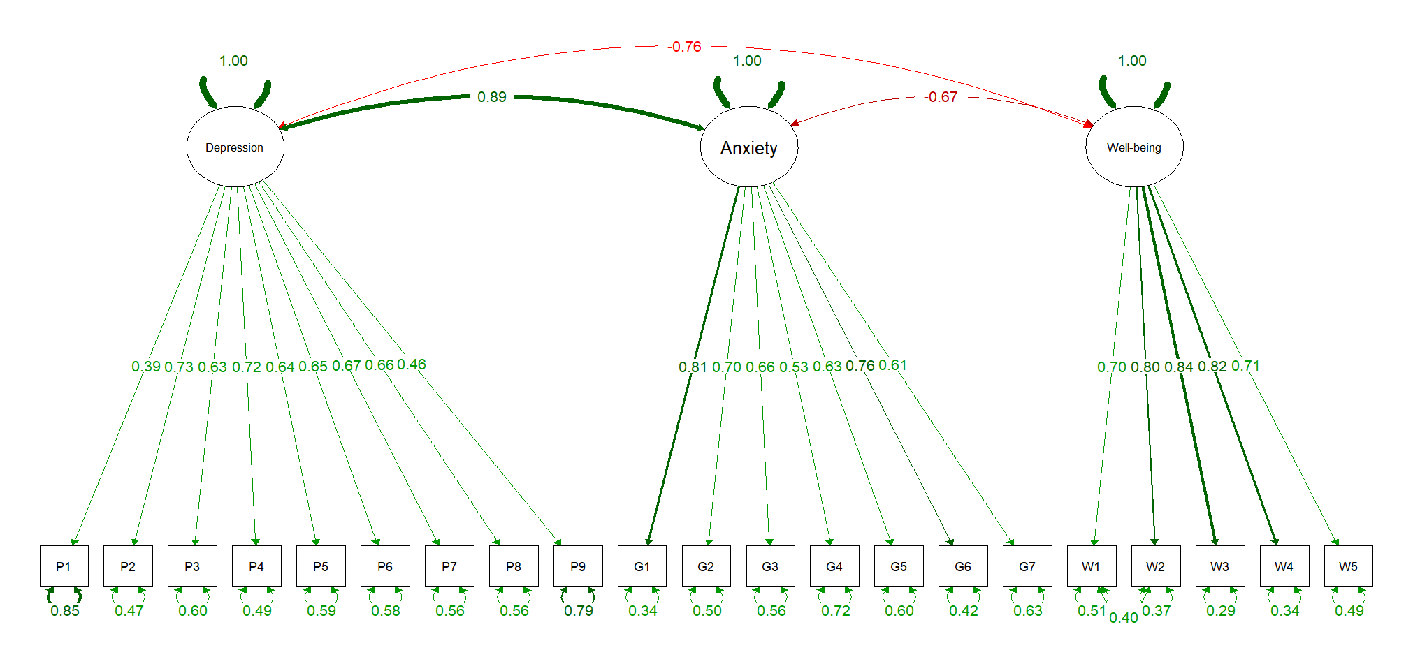
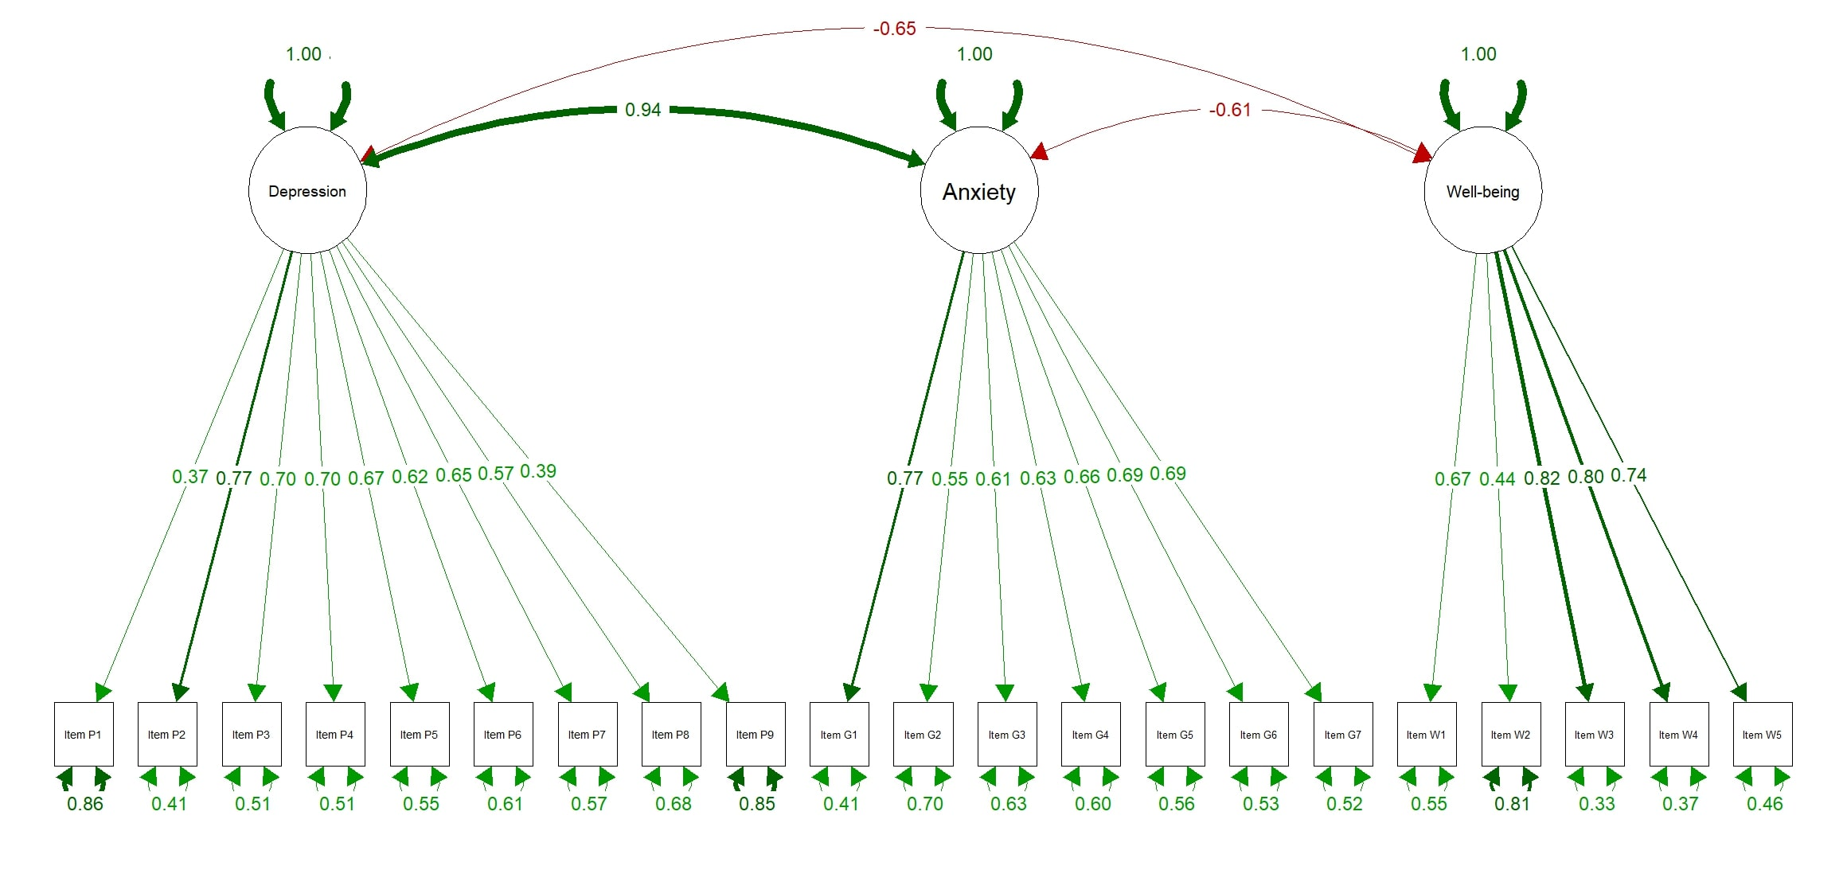
Figure S8. Caption: SEM Plot for Armenian versions of the PHQ-9, GAD-7 and WHO-5. Alt text: A Structural Equation Modeling path diagram for Armenia showing three latent variables corresponding to each scale: Depression, Anxiety, and Well-being. Depression is measured by 9 observed items (P1–P9), Anxiety by 7 items (G1–G7), and Well-being by 5 items (W1–W5). The diagram shows a strong positive correlation between Depression and Anxiety (Value of 0.89, represented by a green line) and strong negative correlations between Well-being and both Depression and Anxiety (Value of at least -0.66, shown by a red line). Factor loadings for all individual items are positive, ranging from 0.39 to 0.84. The residual covariance between W1 and W2 (0.40) has been included.

Figure S9. Caption: SEM Plot for Georgian versions of the PHQ-9, GAD-7 and WHO-5. Alt text: A Structural Equation Modeling path diagram for Georgia showing three latent variables corresponding to each scale: Depression, Anxiety, and Well-being. Depression is measured by 9 observed items (P1–P9), Anxiety by 7 items (G1–G7), and Well-being by 5 items (W1–W5). The diagram shows a strong positive correlation between Depression and Anxiety (Value of 0.94, represented by a green line) and strong negative correlations between Well-being and both Depression and Anxiety (Value of at least -0.61, shown by a red line). Factor loadings for all individual items are positive, ranging from 0.37 to 0.82.

References
1. Rosseel Y. lavaan: An R Package for Structural Equation Modeling. J Stat Softw. 2012;48:1–36. https://doi.org/10.18637/jss.v048.i02
2. Lumley T. survey: analysis of complex survey samples [Internet]. 2024. https://CRAN.R-project.org/package=survey
3. Golino H, Christensen A. EGAnet: Exploratory Graph Analysis – A framework for estimating the number of dimensions in multivariate data using network psychometrics [Internet]. 2026. https://doi.org/10.32614/CRAN.package.EGAnet
4. Choi SW, Gibbons LE, Crane PK. lordif: An R Package for Detecting Differential Item Functioning Using Iterative Hybrid Ordinal Logistic Regression/Item Response Theory and Monte Carlo Simulations. J Stat Softw. 2011;39:1–30. https://doi.org/10.18637/jss.v039.i08
5. Jorgensen TD, Pornprasertmanit S, Schoemann AM, Rosseel Y. semTools: Useful tools for structural equation modeling [Internet]. 2025. https://CRAN.R-project.org/package=semTools
6. Epskamp S. semPlot: Path Diagrams and Visual Analysis of Various SEM Packages’ Output [Internet]. 2022. https://doi.org/10.32614/CRAN.package.semPlot
7. Revelle W. psych: Procedures for Psychological, Psychometric, and Personality Research [Internet]. Evanston, Illinois: Northwestern University; 2025. https://CRAN.R-project.org/package=psych
8. Long JA. jtools: Analysis and Presentation of Social Scientific Data [Internet]. 2022. https://cran.r-project.org/package=jtools
9. Harrell FE. Hmisc: Harrell Miscellaneous [Internet]. 2025. https://doi.org/10.32614/CRAN.package.Hmisc
10. Clark LA, Watson D. Constructing validity: Basic issues in objective scale development. Psychol Assess. US: American Psychological Association; 1995;7:309–19. https://doi.org/10.1037/1040-3590.7.3.309
11. Bartlett MS. Properties of Sufficiency and Statistical Tests. Proc R Soc Lond Ser Math Phys Sci [Internet]. 1937 [cited 2025 Oct 1];160:268–82. http://www.jstor.org/stable/96803. Accessed 1 Oct 2025
12. Kaiser HF. An Index of Factorial Simplicity. Psychometrika [Internet]. 1974 [cited 2025 Oct 1];39:31–6. https://doi.org/10.1007/BF02291575
13. Boothroyd L, Dagnan D, Muncer S. PHQ-9: One factor or two? Psychiatry Res [Internet]. 2019 [cited 2025 Oct 14];271:532–4. https://doi.org/10.1016/j.psychres.2018.12.048
14. Nunnally JC, Bernstein IH. Psychometric theory. 3. ed. New York, NY: McGraw-Hill; 1994.
15. Floyd FJ, Widaman KF. Factor analysis in the development and refinement of clinical assessment instruments. Psychol Assess [Internet]. 1995 [cited 2025 Oct 1];7:286–99. https://doi.org/10.1037/1040-3590.7.3.286
16. Cheung GW, Rensvold RB. Evaluating Goodness-of-Fit Indexes for Testing Measurement Invariance. Struct Equ Model [Internet]. 2002 [cited 2025 Sept 3];9:233–55. https://doi.org/10.1207/S15328007SEM0902_5
17. Tanaka JS. ‘How Big Is Big Enough?’: Sample Size and Goodness of Fit in Structural Equation Models with Latent Variables. Child Dev [Internet]. 1987 [cited 2025 Oct 1];58:134–46. https://doi.org/10.2307/1130296
18. Chen FF. Sensitivity of Goodness of Fit Indexes to Lack of Measurement Invariance. Struct Equ Model Multidiscip J [Internet]. 2007 [cited 2025 Oct 1];14:464–504. https://doi.org/10.1080/10705510701301834

