Table of Contents
Supplementary document Retrieval Strategy 2
Study selection consistency and Cohen’s κ 4
Inter-Rater Agreement Results for Each ROB2 Domain 5
Contour Plot of Effect Size and I² Statistic 6
Contour Plot of Effect Size and Tau² Statistic 7
DBSCAN Density-Based Clustering GOSH Plot 8
Distribution of Effect Sizes 9
Distribution of I² Statistic 10
Distribution of Tau² Statistic 11
GOSH Plot of Effect Size and H² Statistic 12
GOSH Plot of Effect Size and I² Statistic 13
GOSH Plot of Effect Size and Cochrane's Q Statistic 14
GOSH Plot of Effect Size and Tau² Statistic 15
Trial Sequential Analysis (TSA) 15
Hierarchical Clustering GOSH Plot 16
Standardized Residuals and Cook's Distance Threshold Plot for Intervention Endpoint 17
Sensitivity Analysis Plot for Intervention Endpoint 17
Results of Leave-One-Out Sensitivity Analysis (Top 5 Most Influential Studies) 17
Trim-and-Fill Plot for Intervention Endpoint 18
Table 2. Summary of Findings — Chinese Traditional Mind-Body Practices for College Students’ Anxiety 19
Table 3. Subgroup Analysis of Traditional Chinese Mind-Body Exercise on Anxiety Symptoms in University Students 21
Posterior Distribution of the Model-Estimated Dose Turning Point 24
Interval Plot: Showing posterior predictive intervals for each observation and plotting observed values 26
ECDF Comparison 26

Supplementary document Retrieval Strategy

The original searches ended on November 18, 2025. We reran the same database-specific strategies for the subsequent six-month period through May 18, 2026; no additional eligible randomized controlled trial was identified. The complete reproducible search strings for PubMed, Web of Science, PsycINFO, the Cochrane Library, and CNKI are reproduced below with the final search date and applied limits.
1. PubMed
("Tai Ji"[Mesh] OR "Qi Gong"[Mesh] OR "Mind-Body Therapies"[Mesh] OR "Breathing Exercises"[Mesh]) OR (Tai ji OR tai-ji OR taiji OR "tai chi" OR tai-chi OR qigong OR qi-gong OR chi kung OR "Baduanjin" OR "Ba Duan Jin" OR "Eight-section Brocade" OR "Wuqinxi" OR "Wu Qin Xi" OR "Five-animal Exercises" OR "Yi Jin Jing" OR "Yijinjing" OR "standing meditation" OR zhan zhuang OR "mind-body training" OR "traditional Chinese mind-body exercise"[tiab])
AND
("Students"[Mesh] OR "Universities"[Mesh] OR "college student*"[tiab] OR "university student*"[tiab] OR "undergraduate*"[tiab] OR "graduate student*"[tiab] OR "postgraduate student*"[tiab])
AND
("Randomized Controlled Trial"[pt] OR randomized[tiab] OR randomised[tiab] OR randomization[tiab] OR randomly[tiab] OR "clinical trial"[tiab] OR "control group"[tiab] OR RCT[tiab])
NOT
("Review"[pt] OR "Case Reports"[pt] OR "Comment"[pt] OR "Editorial"[pt])
2. Web of Science
(TS=("tai chi" OR taiji OR "tai ji" OR tai-ji OR qigong OR "qi gong" OR "chi kung" OR Baduanjin OR "Ba Duan Jin" OR "Eight-section Brocade" OR Wuqinxi OR "Wu Qin Xi" OR "Five-animal" OR "Yi Jin Jing" OR Yijinjing OR "standing meditation" OR "zhan zhuang" OR "mind-body" OR "traditional Chinese mind-body")) AND (TS=("college student*" OR "university student*" OR undergraduate* OR "graduate student*" OR "postgraduate student*")) AND (TS=("randomized controlled trial" OR "randomised controlled trial" OR randomized OR randomised OR RCT))
Refined by: [excluding] DOCUMENT TYPES: (REVIEW OR MEETING ABSTRACT OR PROCEEDINGS PAPER OR EDITORIAL MATERIAL) AND LANGUAGES: (ENGLISH OR CHINESE)
Timespan: All years to 2026-05-18.
3. PsycINFO
1. exp Tai Chi/ or exp Qi Gong/ or exp Meditation/ or exp Mind Body Techniques/ or (Tai ji or tai-ji or taiji or "tai chi" or tai-chi or qigong or qi-gong or chi kung or "Baduanjin" or "Ba Duan Jin" or "Eight-section Brocade" or "Wuqinxi" or "Wu Qin Xi" or "Five-animal Exercises" or "Yi Jin Jing" or "Yijinjing" or "standing meditation" or zhan zhuang or "mind-body training" or "traditional Chinese mind-body exercise").ti,ab,id.
2. exp College Students/ or exp University Students/ or ("college student*" or "university student*" or undergraduate* or "graduate student*" or "postgraduate student*").ti,ab,id.
3. exp "Randomized Controlled Trials"/ or (randomized or randomised or randomization or "random allocation" or "control group" or RCT or "clinical trial").ti,ab,id.
4. limit 4 to (english or chinese language)
4. Cochrane Library
#1 [mh "Tai Ji"] or [mh "Qi Gong"] or [mh "Breathing Exercises"] or [mh "Meditation"] or (Tai ji or tai-ji or taiji or "tai chi" or tai-chi or qigong or qi-gong or chi kung or "Baduanjin" or "Ba Duan Jin" or "Eight-section Brocade" or "Wuqinxi" or "Wu Qin Xi" or "Five-animal Exercises" or "Yi Jin Jing" or "Yijinjing" or "standing meditation" or zhan zhuang or "mind-body training" or "traditional Chinese mind-body exercise"):ti,ab,kw
#2 [mh "Students"] or ("college student*" or "university student*" or undergraduate* or "graduate student*" or "postgraduate student*"):ti,ab,kw
#3 (randomized or randomised or randomization or "control group" or RCT):ti,ab,kw OR [mh "Randomized Controlled Trials"]
#4 #1 AND #2 AND #3
Publication Date to 2026 May 18
5. CNKI
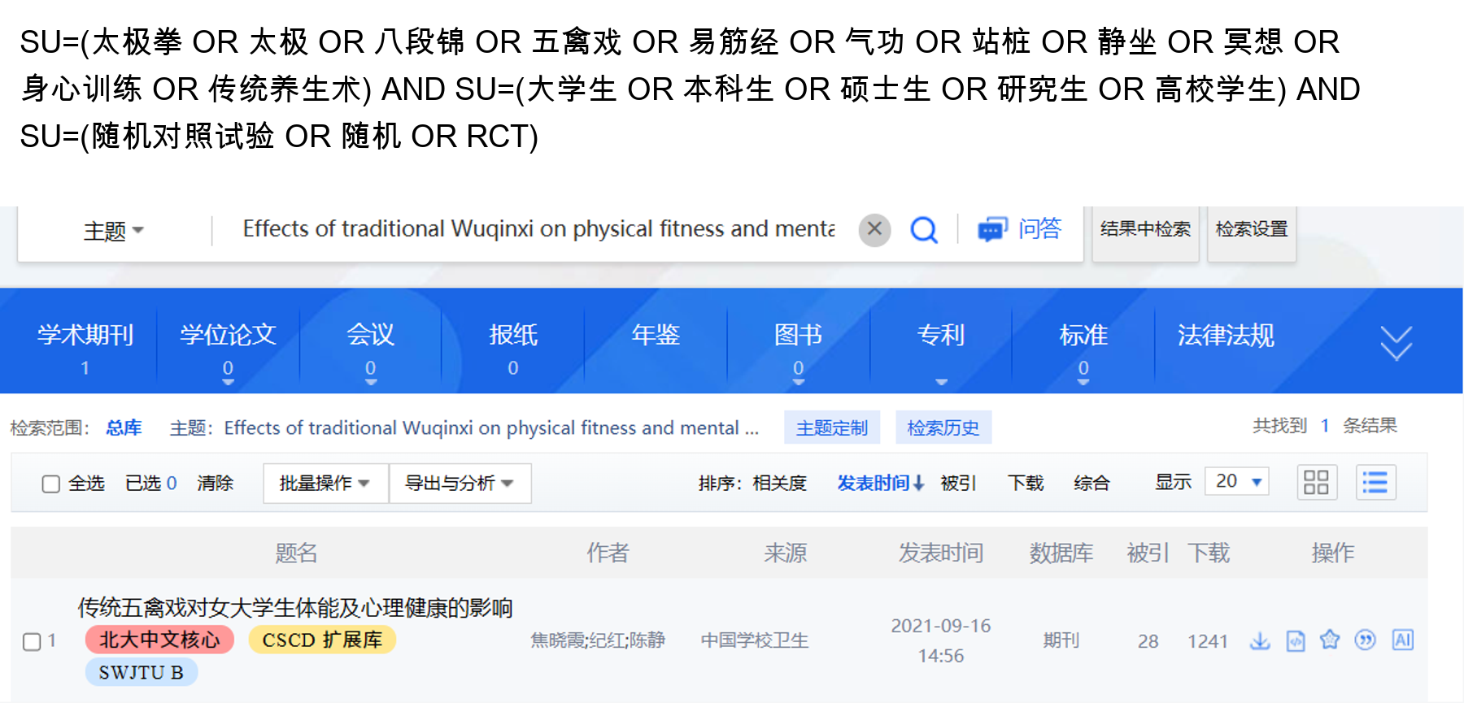

Study selection consistency and Cohen’s κ
1. Title/abstract screening (records screened = 300)
Independent 2×2 table (J.L. vs H.R.): both include = 223; J.L. include / H.R. exclude = 15; J.L. exclude / H.R. include = 11; both exclude = 51 (total n = 300; reports sought for retrieval a + b + c = 249, consistent with the PRISMA flowchart).
- Observed agreement: $P_{o}=(a+d)/n=(223+51)/300=0.91333$.
- Expected agreement: $P_{e}≈0.66427$.
- Cohen’s κ $≈0.742$(more precisely 0.7419).
- Approximate standard error: $SE≈0.0484$.
- 95% CI: $κ≈0.7419$, 95% CI ≈ 0.647–0.837 (reporting rounded as 0.65–0.84).
- z ≈ 15.33 (p ≪ 0.001).
Interpretation (Landis & Koch): κ ≈ 0.74, indicating substantial agreement.
2. Full-text screening (reports assessed = 244)
Independent 2×2 table (J.L. vs H.R.): both include = 13; J.L. include / H.R. exclude = 2; J.L. exclude / H.R. include = 1; both exclude = 228 (total n = 244; a + b + c = 16, consistent with the PRISMA flowchart).
- Observed agreement: $P_{o}=(13+228)/244=0.98770$.
- Expected agreement: $P_{e}≈0.88820$.
- Cohen’s κ $≈0.890$(more precisely 0.8900).
- Approximate standard error: $SE≈0.0631$.
- 95% CI: ≈ 0.766–1.00 (upper bound truncated at 1.00 as customary when the normal approximation slightly exceeds 1).
- z ≈ 14.10 (p ≪ 0.001).
Interpretation (Landis & Koch): κ ≈ 0.89, indicating almost perfect agreement.

Inter-Rater Agreement Results for Each ROB2 Domain
The table below displays the simple agreement rate, Cohen's Kappa, and Weighted Kappa calculated separately for each domain (D1-D5).
Domain | Simple Agreement Rate | Cohen's Kappa | Weighted Kappa​ | Strength of Agreement
D1 (Randomization process)​ | 75.0% (12/16) | 0.619 | 0.741​ | Good
D2 (Deviations from intended interventions)​ | 43.8% (7/16) | 0.151 | 0.308​ | Fair
D3 (Missing outcome data)​ | 100% (16/16) | 1.000 | 1.000​ | Almost Perfect
D4 (Measurement of the outcome)​ | 68.8% (11/16) | 0.531 | 0.655​ | Good
D5 (Selection of the reported result)​ | 87.5% (14/16) | 0.774 | 0.870​ | Very Good

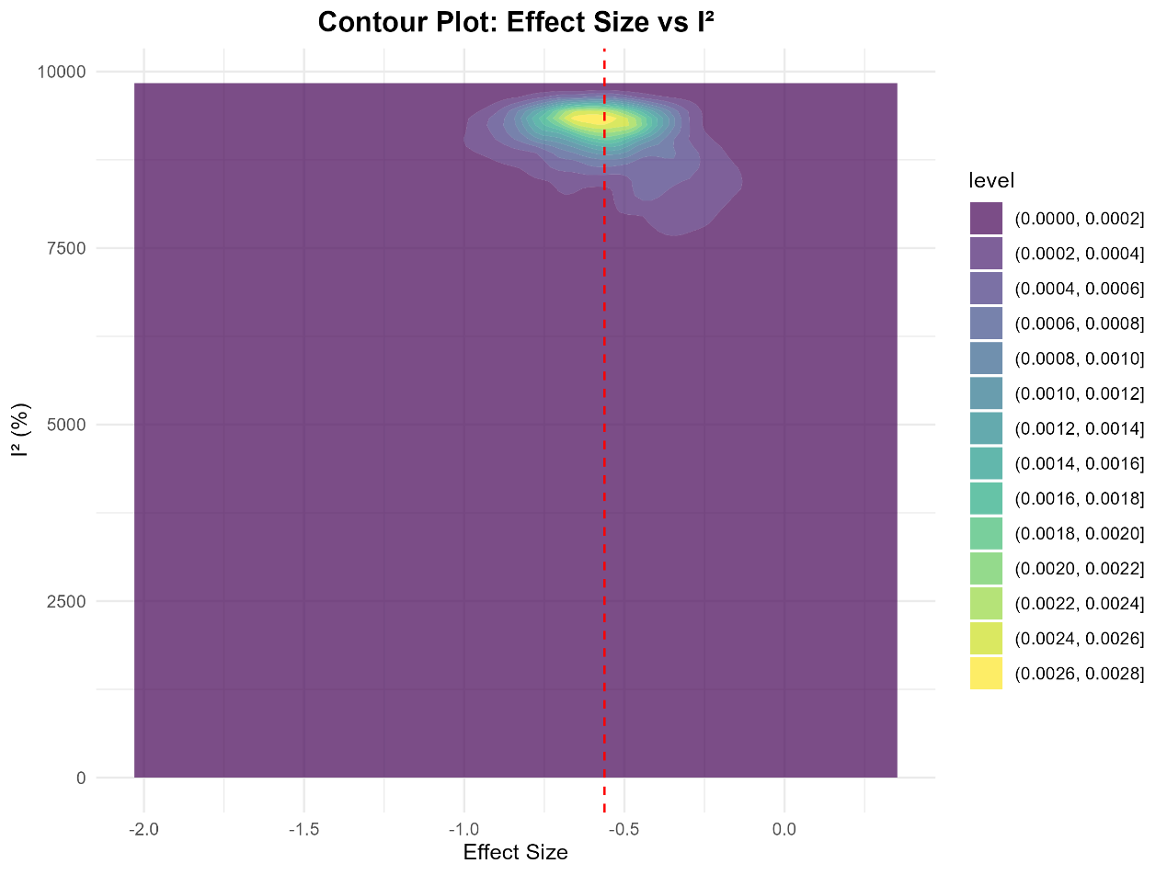

Contour Plot of Effect Size and I² Statistic
Brief Description: Displays the bivariate density distribution of effect sizes and the heterogeneity index I².
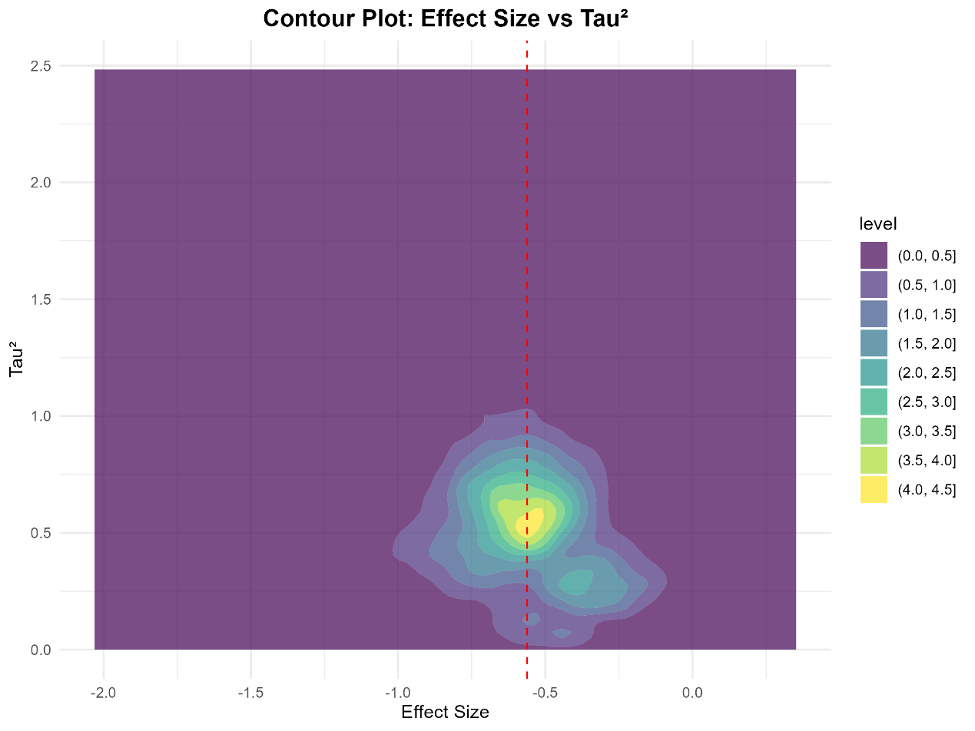

Contour Plot of Effect Size and Tau² Statistic
Brief Description: Displays the bivariate density distribution of effect sizes and the heterogeneity variance Tau².
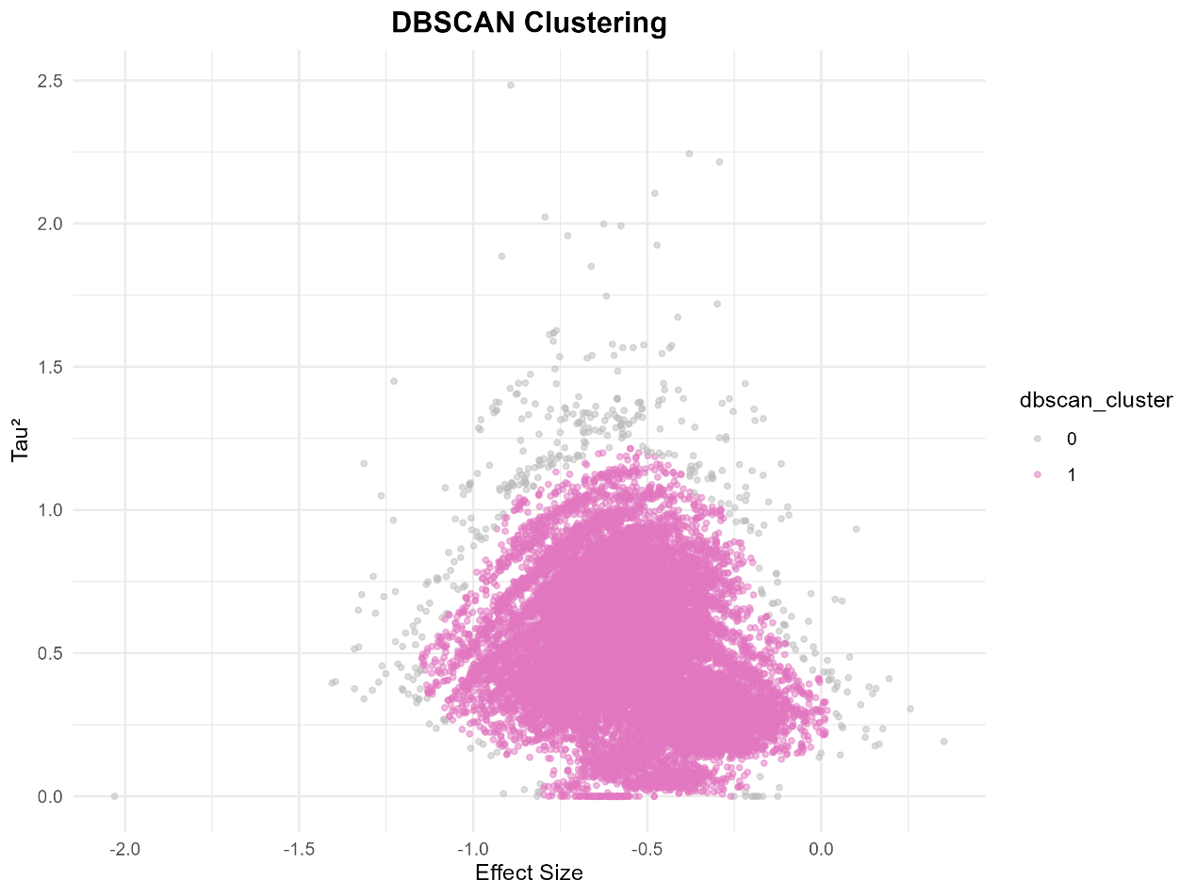

DBSCAN Density-Based Clustering GOSH Plot
Brief Description: Uses the DBSCAN algorithm to cluster data points in the GOSH plot, identifying core data clusters and outliers.
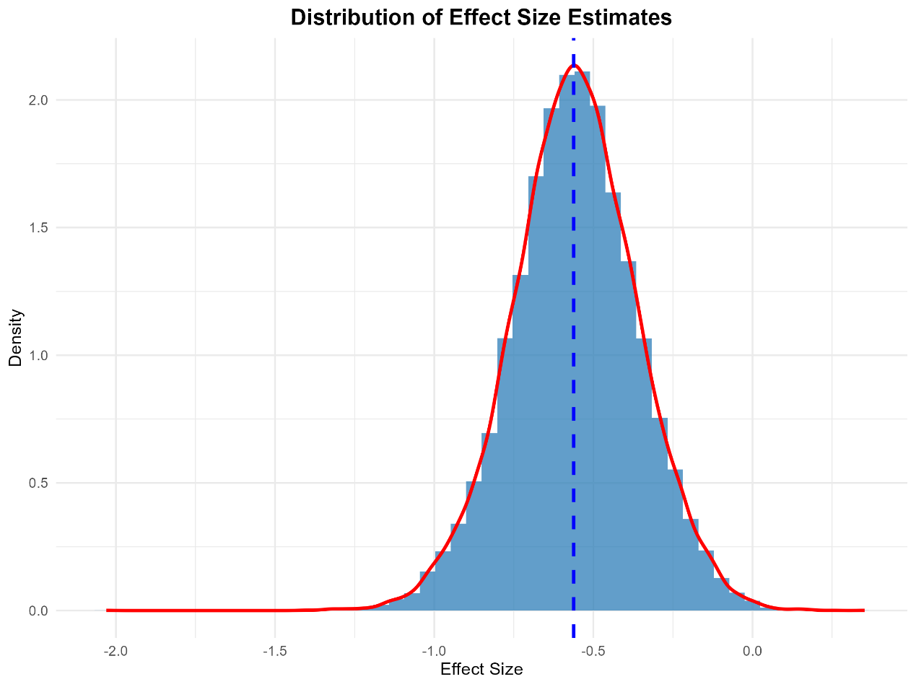

Distribution of Effect Sizes
Brief Description: Displays the distribution of effect size estimates for all possible study subsets.
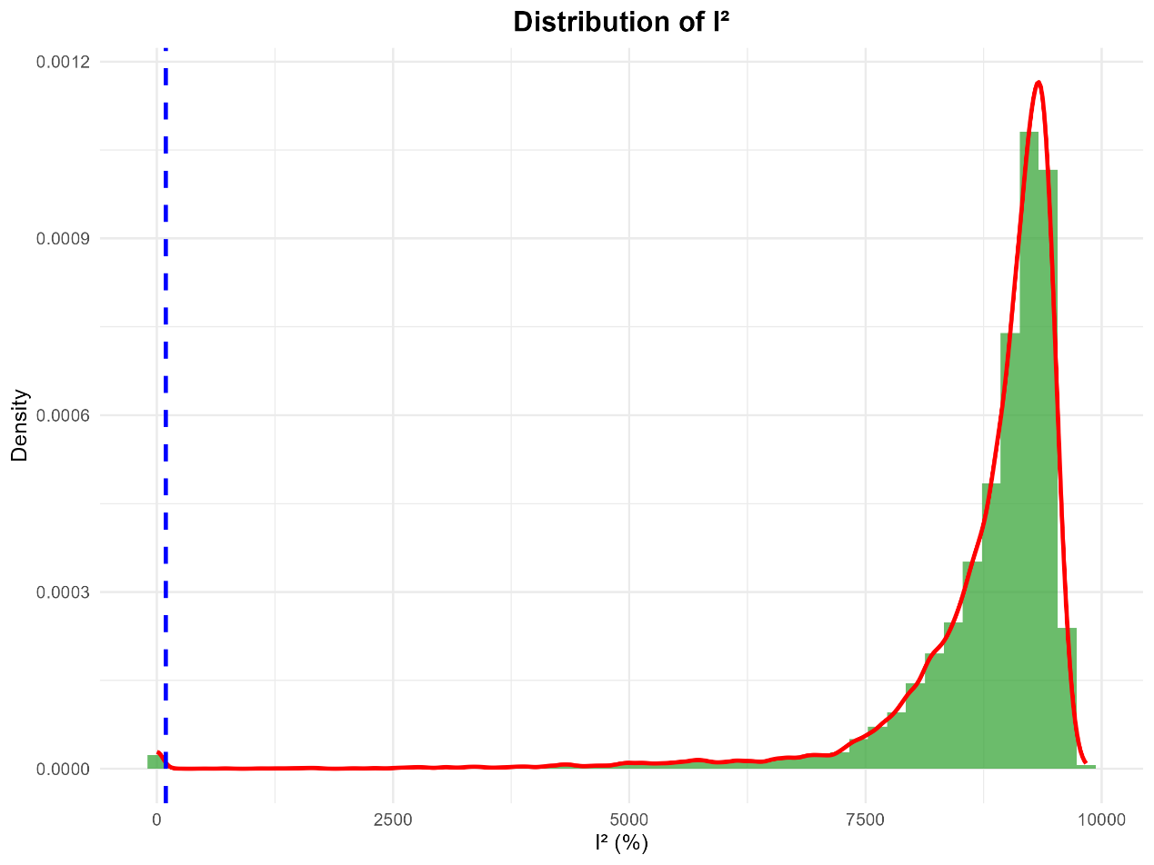

Distribution of I² Statistic
Brief Description: Displays the distribution of I² heterogeneity indices for all possible study subsets.
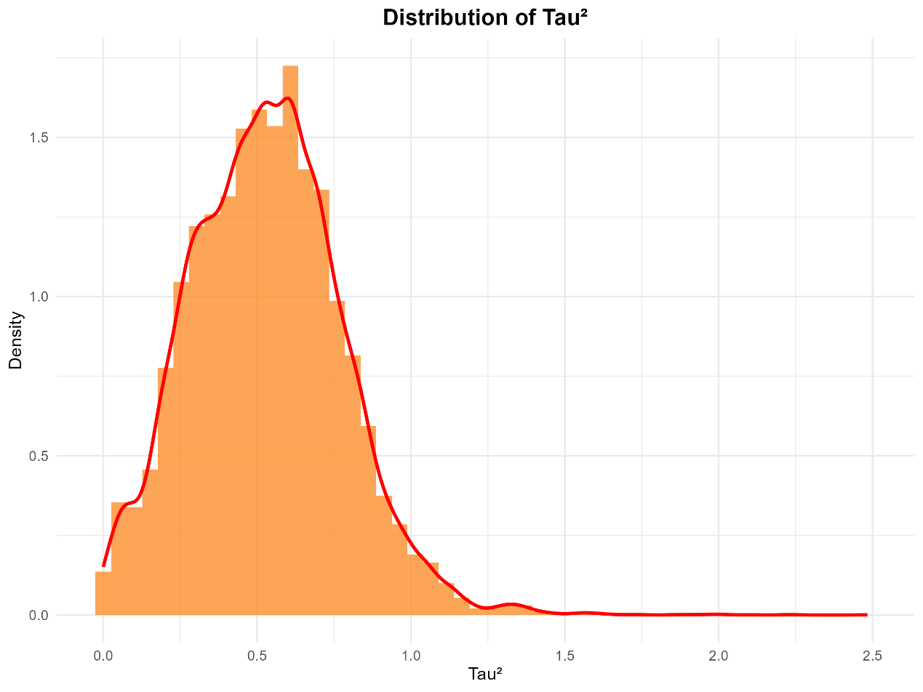

Distribution of Tau² Statistic
Brief Description: Displays the distribution of Tau² heterogeneity variances for all possible study subsets.
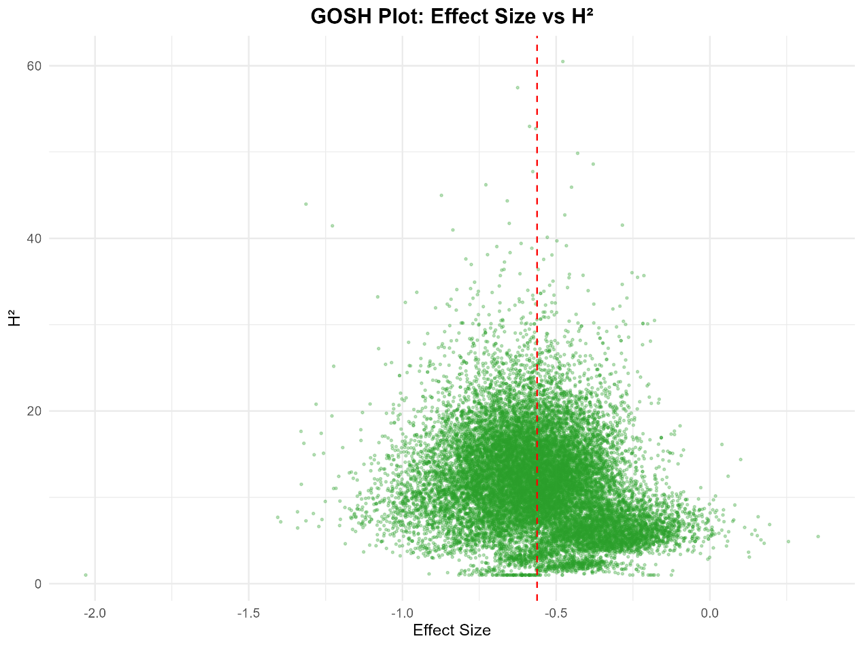

GOSH Plot of Effect Size and H² Statistic
Brief Description: Graphical representation of study heterogeneity, where each point represents the effect size and H² statistic of a study subset.
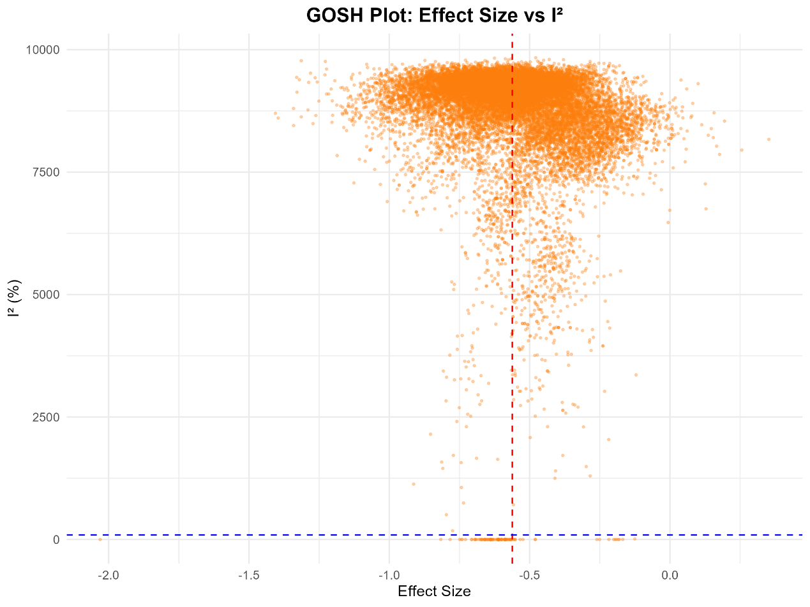

GOSH Plot of Effect Size and I² Statistic
Brief Description: Graphical representation of study heterogeneity, where each point represents the effect size and I² statistic of a study subset.
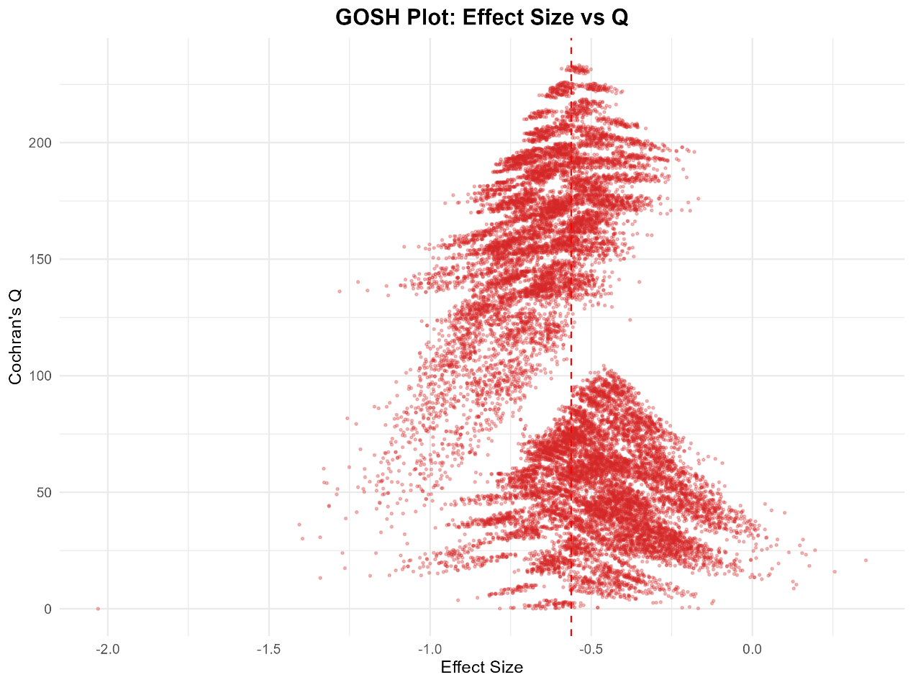

GOSH Plot of Effect Size and Cochrane's Q Statistic
Brief Description: Graphical representation of study heterogeneity, where each point represents the effect size and Q statistic of a study subset.
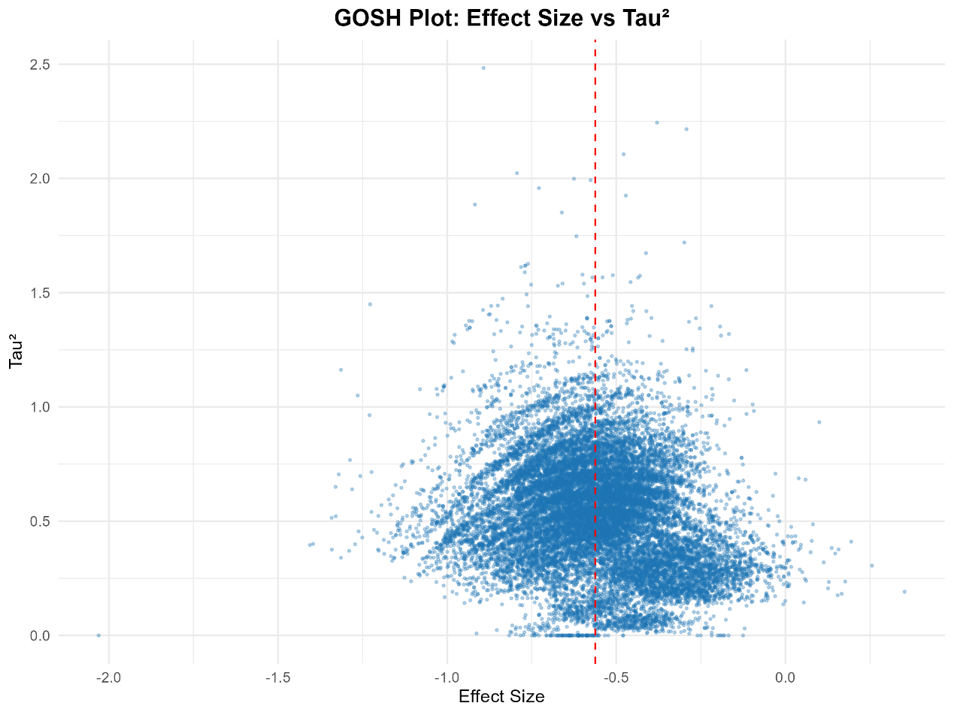

GOSH Plot of Effect Size and Tau² Statistic
Brief Description: Graphical representation of study heterogeneity, where each point represents the effect size and Tau² statistic of a study subset.
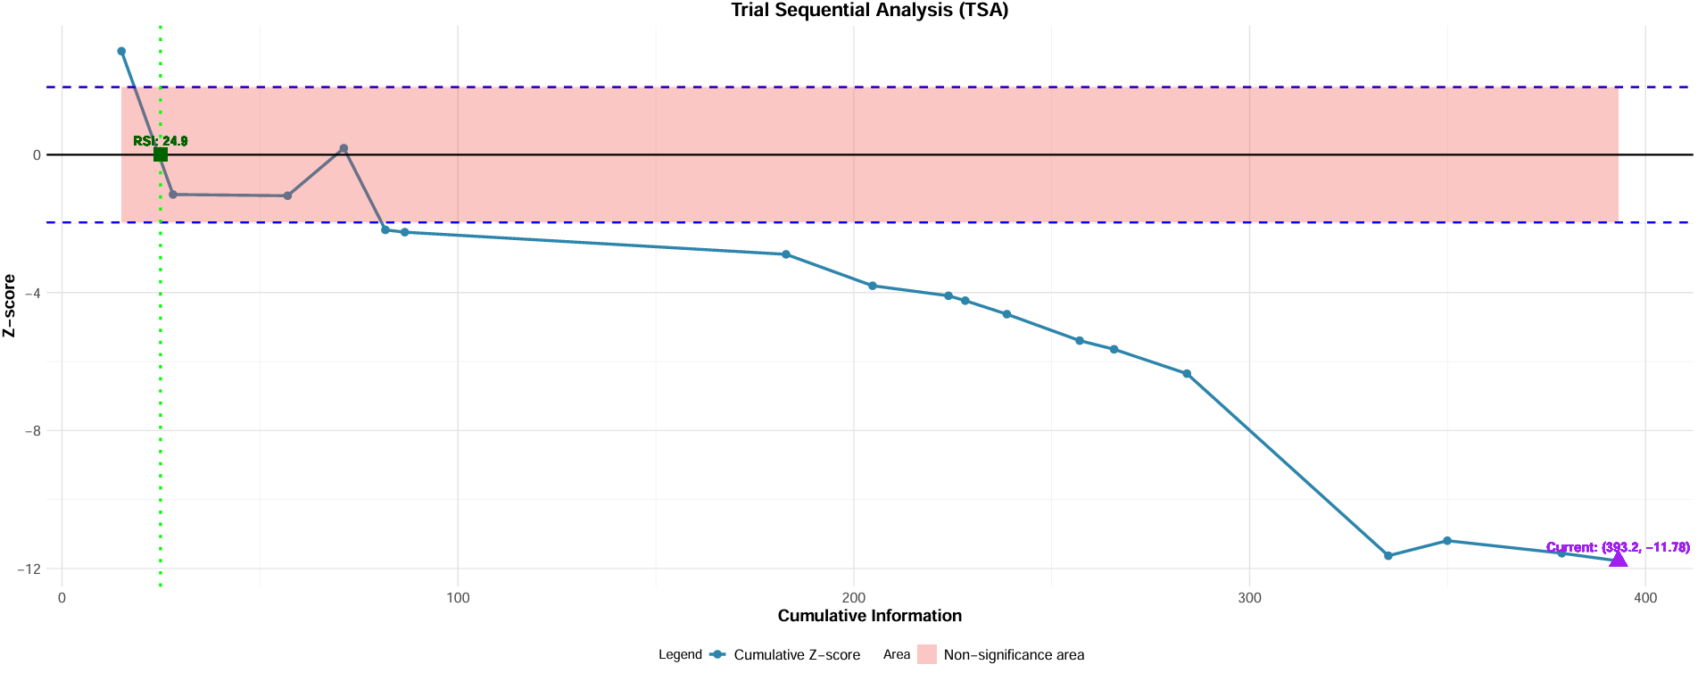

Trial Sequential Analysis (TSA)

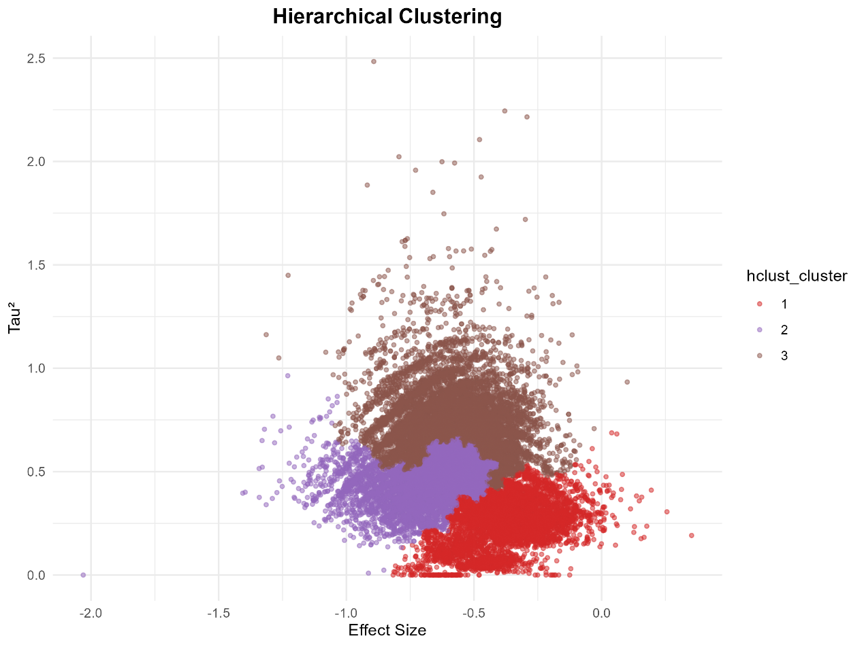

Hierarchical Clustering GOSH Plot
Brief Description: Uses the hierarchical clustering algorithm to cluster data points in the GOSH plot to identify potential subgroup structures.
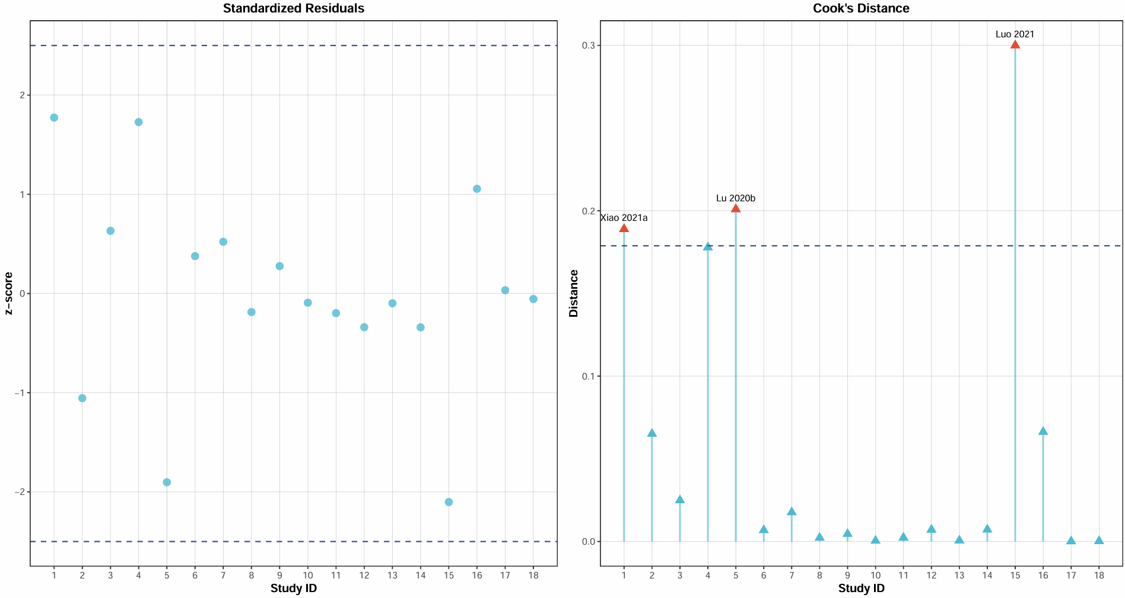

Standardized Residuals and Cook's Distance Threshold Plot for Intervention Endpoint

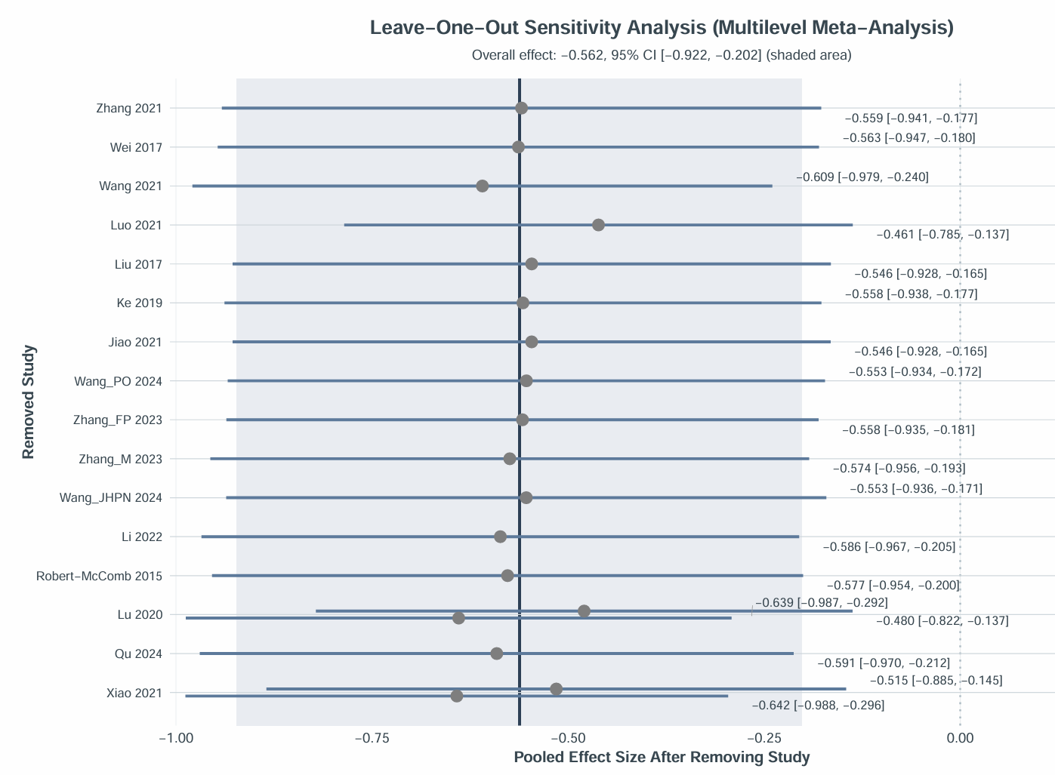

Sensitivity Analysis Plot for Intervention Endpoint

Results of Leave-One-Out Sensitivity Analysis (Top 5 Most Influential Studies)
Rank | Study Omitted | Pooled Effect Size After Omission (95% CI) | Deviation from Overall Effect (Δ) | Significant Deviation?
1 | Luo 2021 | -0.461 [-0.785, -0.137] | +0.101 | No
2 | Lu 2020 | -0.480 [-0.822, -0.137] | +0.082 | No
3 | Xiao 2021 | -0.642 [-0.988, -0.296] | -0.080 | No
4 | Lu 2020 | -0.639 [-0.987, -0.292] | -0.078 | No
5 | Wang 2021 | -0.609 [-0.979, -0.240] | -0.047 | No

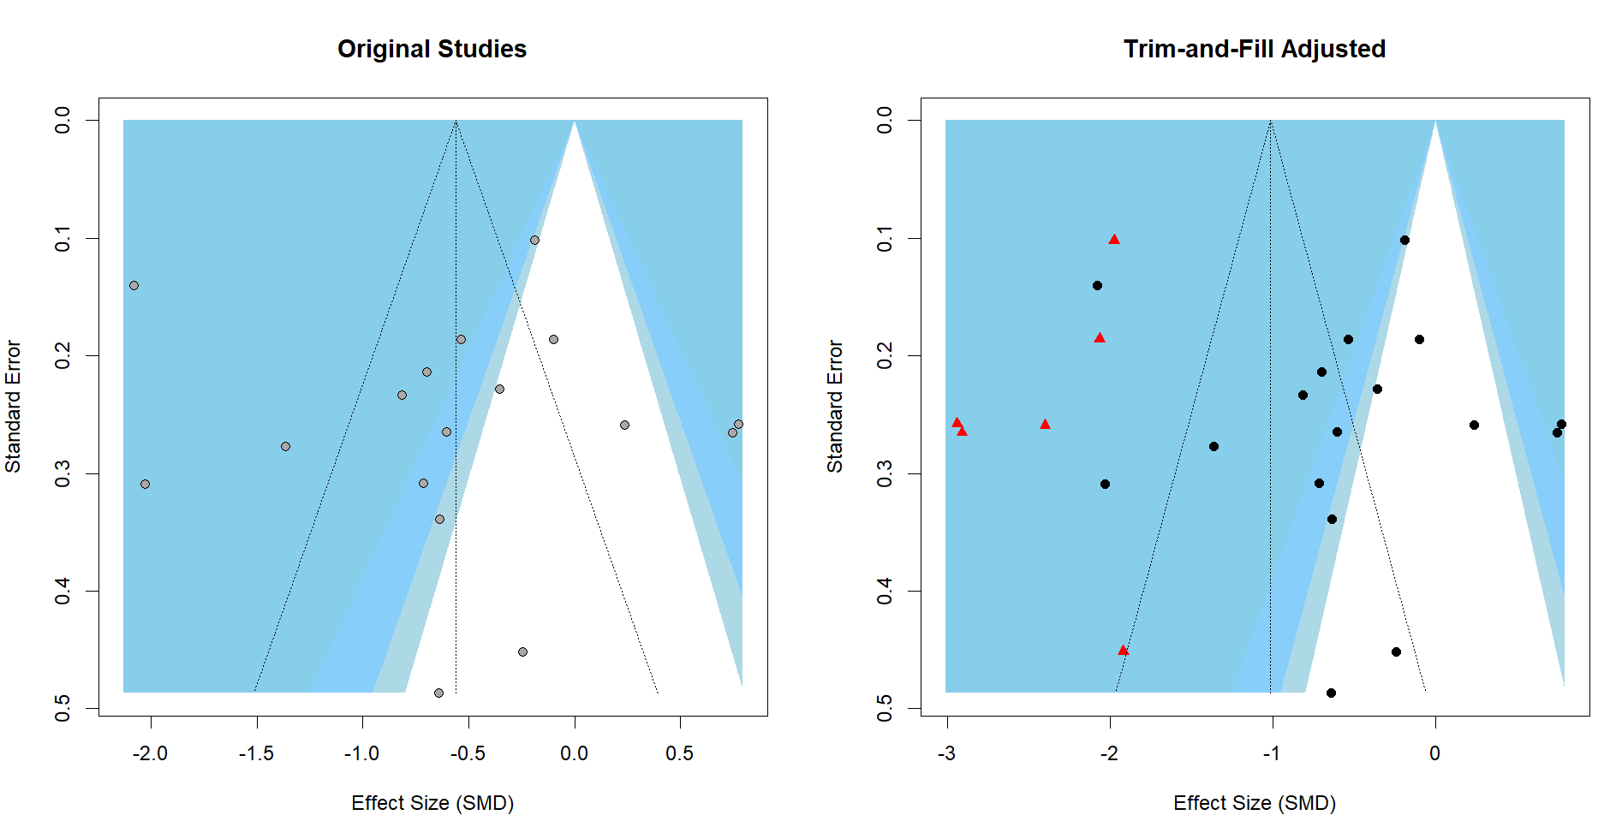

Trim-and-Fill Plot for Intervention Endpoint

Sensitivity analysis restricted to Baduanjin and Taijiquan
Using the original effect-level dataset and the same multilevel model specification as the primary analysis, we restricted the dataset to Baduanjin and Taijiquan. Thirteen trials contributed 14 effect estimates because one trial contributed two eligible dependent contrasts.
The restricted multilevel meta-analysis yielded SMD = −0.541 (95% CI −0.968 to −0.113; p = 0.017; I² = 87.5%). The 95% prediction interval was −1.94 to 0.85. The average result remained in the same direction as the primary estimate, suggesting that the pooled result was not dependent on the less common practice types. Nevertheless, the prediction interval crossed zero and heterogeneity remained substantial; the analysis therefore does not imply a uniform effect across settings or establish equivalence between Baduanjin and Taijiquan.
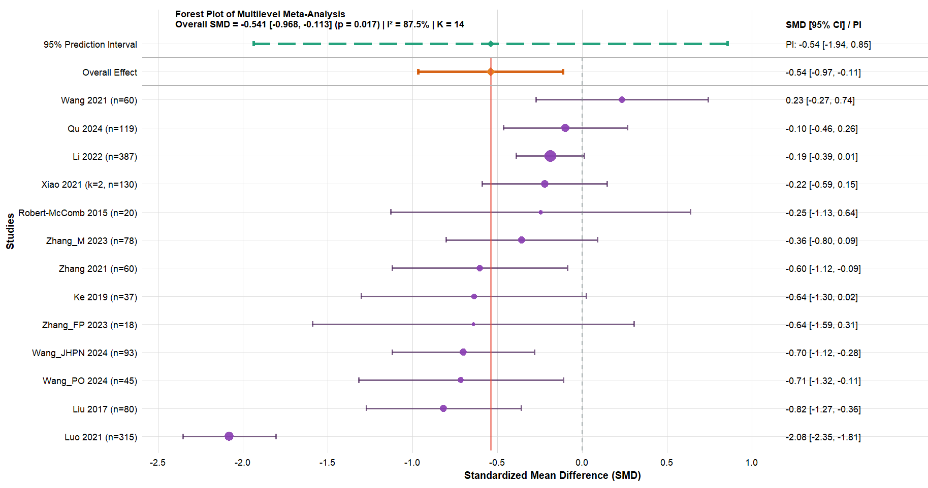
Sensitivity-analysis forest plot. Multilevel meta-analysis restricted to Baduanjin and Taijiquan.

Table 2. Summary of Findings — Chinese Traditional Mind-Body Practices for College Students’ Anxiety (overall certainty: Low)
GRADE interpretation note: the overall certainty is low because risk of bias and inconsistency were each downgraded one level. The small Control-Int subgroup is rated very low certainty and should not be interpreted as evidence of equivalence.
GRADE domain | Judgment | Rationale
Risk of bias | Serious (downgraded 1 level) | Most included trials were judged to have “some concerns” or “high risk” overall, driven primarily by D1 (randomization process) and D2 (deviations from intended intervention). Key issues: incomplete reporting of allocation concealment (D1, Cohen’s κ=0.619) and inadequate management of intervention adherence/blinding (D2, Cohen’s κ=0.151, some studies rated high risk). D4 (outcome measurement) showed heterogeneity in assessor blinding. D3 (missing outcome data) and D5 (selective reporting) were mostly low risk (100% consistency for D3, 87.5% for D5).
Inconsistency | Serious (downgraded 1 level) | Between-study heterogeneity was extremely high (I²=94.10%) in the multilevel meta-analysis. GOSH analysis revealed wide distribution of effect sizes (-2.03 to 0.35) and heterogeneity metrics (Tau²=0.00 to 2.48), with evidence of sub-group clustering and 6.40% outliers. Heterogeneity sources were not fully explained by initial sub-group analyses.
Indirectness | Not downgraded | Participants (college students, regardless of gender/background), interventions (Chinese traditional mind-body practices including Tai Chi, Baduanjin, Qigong, etc.), and outcomes (validated anxiety scales: SAS, STAI, SCL-90-R anxiety, etc.) directly matched the review question.
Imprecision | Not downgraded | The pooled effect size (SMD=-0.56, 95% CI: -0.92 to -0.20) excluded the null value and was clinically interpretable. Sequential sample size analysis (TSA) confirmed sufficient information (current info/RSI=15.80), and cumulative meta-analysis showed stable effects after 2023 (minimal change of 0.01).
Publication bias | Not downgraded | Egger’s test did not detect a small-study effect (t = 0.20, p = 0.844), whereas trim-and-fill imputed six hypothetical estimates and produced a larger adjusted effect. With few studies, dependent estimates, and I² = 94.10%, both procedures are difficult to interpret. Publication bias was not downgraded separately, but it cannot be excluded; the trim-and-fill result is treated as exploratory rather than as evidence that the unadjusted effect was underestimated.

Table 3. Subgroup Analysis of Traditional Chinese Mind-Body Exercise on Anxiety Symptoms in University Students
Dimensionality | sort | K | N | I² | Effect model | SMD and 95%CI | GRADE | P | P-interaction​​​
Nation |  |  |  |  |  |  |  |  | 0.500
 | China | 17 | 1748 | 93.1% | Random | -0.57(-0.95, -0.20) | Low | 0.03*
 | USA | 1 | 20 | * | Random | -0.25(-1.13, 0.64) | Very Low | 0.586
Intervention frequency/week |  |  |  |  |  |  |  |  | 0.989
 | 1 | 2 | 199 | 82.7% | Random | -0.44(-1.15, 0.26) | Very Low | 0.215
 | 2 | 4 | 206 | 93.6% | Random | -0.53(-1.68, 0.61) | Very Low | 0.361
 | 3 | 7 | 721 | 95.8% | Random | -0.61(-1.33, 0.10) | Very Low | 0.094
 | 5 | 5 | 642 | 53.3% | Random | -0.49(-0.78, -0.21) | Moderate | 0.001*
Intervention cycle/week |  |  |  |  |  |  |  |  | 0.599
 | 1 | 1 | 80 | 0.0% | Random | -0.82(-1.27, -0.36) | Low | 0.001*
 | 8 | 3 | 98 | 0.0% | Random | -0.54(-0.94, -0.13) | Moderate | 0.010*
 | 10 | 2 | 156 | 48.7% | Random | -0.30(-0.80, 0.21) | Very Low | 0.256
 | 12 | 8 | 886 | 91.6% | Random | -0.50(-1.10, 0.20) | Very Low | 0.176
 | 16 | 4 | 548 | 96.2% | Random | -0.86(-1.79, 0.08) | Very Low | 0.074
Intervention time/minute |  |  |  |  |  |  |  |  | 0.288
 | 30 | 2 | 395 | 95.4% | Random | -1.46(-2.70, -0.22) | Low | 0.021*
 | 45 | 3 | 469 | 48.7% | Random | -0.41(-0.79, -0.03) | Moderate | 0.033*
 | 60 | 6 | 389 | 43.8% | Random | -0.38(-0.68, -0.08) | Moderate | 0.013*
 | 80 | 1 | 80 | 0.0% | Random | -0.82(-1.27, -0.36) | Low | 0.001*
 | 90 | 6 | 435 | 93.9% | Random | -0.42(-1.32, 0.48) | Very Low | 0.357
Subject type |  |  |  |  |  |  |  |  | 0.203
 | FUS | 4 | 255 | 69.0% | Random | -0.39(-0.85, 0.07) | Very Low | 0.095
 | GUS | 5 | 691 | 29.0% | Random | -0.30(-0.52, -0.09) | Moderate | 0.005*
 | PSU | 4 | 256 | 96.2% | Random | -0.46(-1.88, 0.95) | Very Low | 0.521
 | SDU | 1 | 93 | 0.0% | Random | -0.70(-1.12, -0.28) | Low | 0.001*
 | SSC | 4 | 473 | 92.6% | Random | -1.08(-1.83, -0.34) | Low | 0.004*
Intervention mode2 |  |  |  |  |  |  |  |  | 0.001*
 | Control-NoInt | 12 | 996 | 84.9% | Random | -0.92(-1.28, -0.56) | Low | 0.001*
 | Control-Int | 6 | 772 | 88.4% | Random | -0.09(-0.38, 0.56) | Very Low | 0.708
Intervention mode1 |  |  |  |  |  |  |  |  | 0.828
 | BDJ | 7 | 785 | 84.6% | Random | -0.43(-0.90, 0.04) | Very Low | 0.075
 | QG | 2 | 126 | 97.8% | Random | -0.64(-3.36, 2.08) | Very Low | 0.646
 | Tai Chi | 7 | 657 | 94.6% | Random | -0.65(-1.25, -0.04) | Low | 0.035*
 | Wuqinxi | 1 | 80 | 0.0% | Random | -0.82(-1.27, -0.36) | Low | 0.001*
 | Yijinjing | 1 | 120 | 0.0% | Random | -0.54(-0.90, -0.17) |  | 0.004*
Scale type |  |  |  |  |  |  |  |  | 0.092
 | SAS | 8 | 686 | 95.8% | Random | -0.74(-1.51, 0.04) | Very Low | 0.063
 | SCL-90-R | 6 | 511 | 61.3% | Random | -0.51(-0.81, -0.22) | Moderate | 0.001*
 | STAI | 2 | 65 | 0.0% | Random | -0.57(-1.07, -0.07) | Moderate | 0.026*
 | Other scales | 2 | 506 | 0.0% | Random | -0.17(-0.34, 0.01) | Very Low | 0.060
ROB2_Domain |  |  |  |  |  |  |  |  | 0.705
 | High | 5 | 336 | 95.1% | Random | -0.53(-1.63, 0.57) | Very Low | 0.343
 | Some concerns | 12 | 1534 | 92.5% | Random | -0.60(-0.96, -0.24) | Low | 0.001*
 | Low | 1 | 78 | 0.0% | Random | -0.36(-0.80, 0.09) | Very Low | 0.118
Note: SMD, Standardized Mean Difference; statistical significance is assumed if the 95% confidence interval does not include zero. GRADE represents the certainty of evidence (High, Moderate, Low, Very low). Definitions for subject subgroups are as follows: FUS, Female University Students; GUS, General University Students; PSU, University Students with Problematic Smartphone Use; SDU, Sports-Disadvantaged University Students; SSC, University Students with Specific Constitutions (e.g., Qi-Stagnation constitution). For control mode: Control-NoInt, waitlist or no-intervention control; Control-Int, usual care or another intervention control (e.g., conventional exercise, health education, or psychological intervention). P-interaction tests whether subgroup estimates differ; P-interaction = 0.001 for comparator type indicates a statistically significant between-subgroup difference. This value is distinct from p = 0.708, which tests the pooled contrast within Control-Int. Other abbreviations: BDJ, Baduanjin; QG, Qigong; SAS, Self-Rating Anxiety Scale; SCL-90-R, Symptom Checklist-90-Revised; STAI, State-Trait Anxiety Inventory; ROB2, Risk of Bias 2 tool.
Terminology note: The embedded diagnostic figure retains the original plotting label “optimal dose.” In the revised interpretation, this label denotes only a model-estimated dose turning point and is not a treatment recommendation.

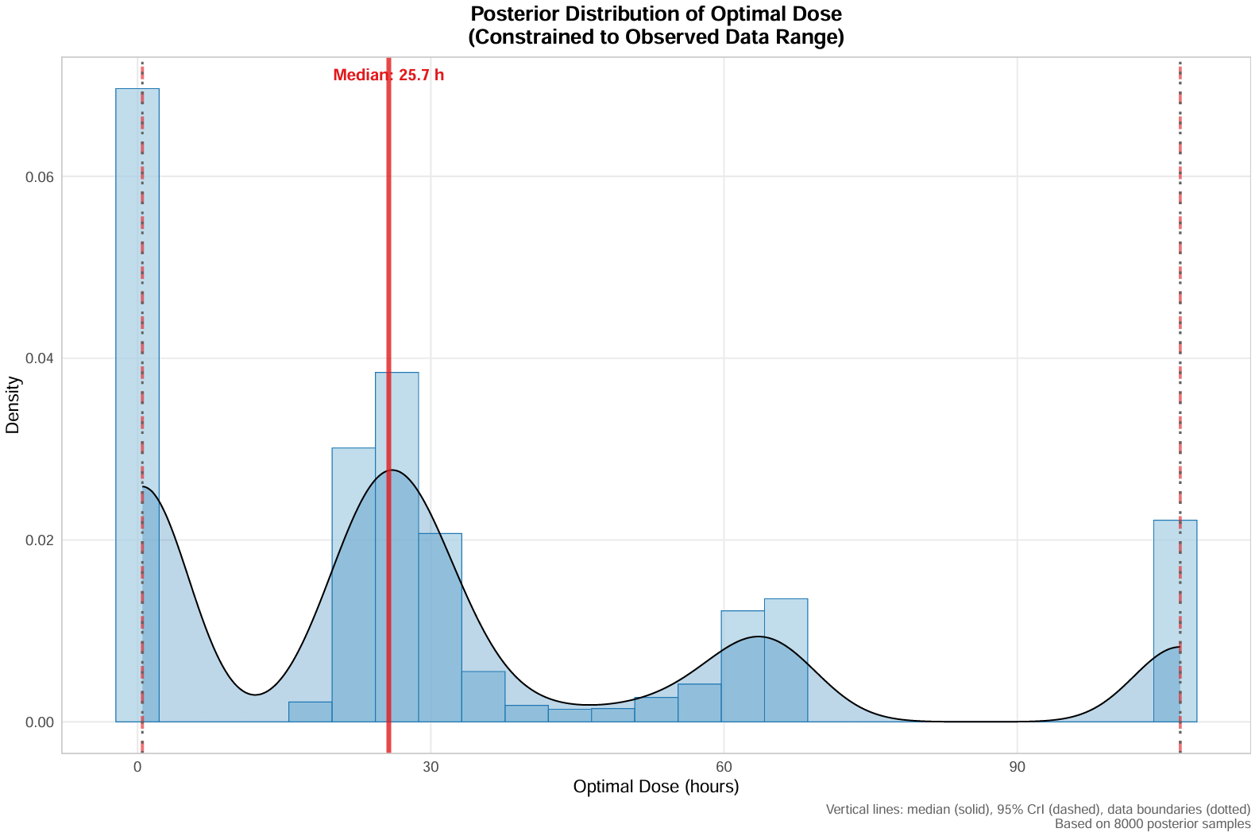

Posterior Distribution of the Model-Estimated Dose Turning Point
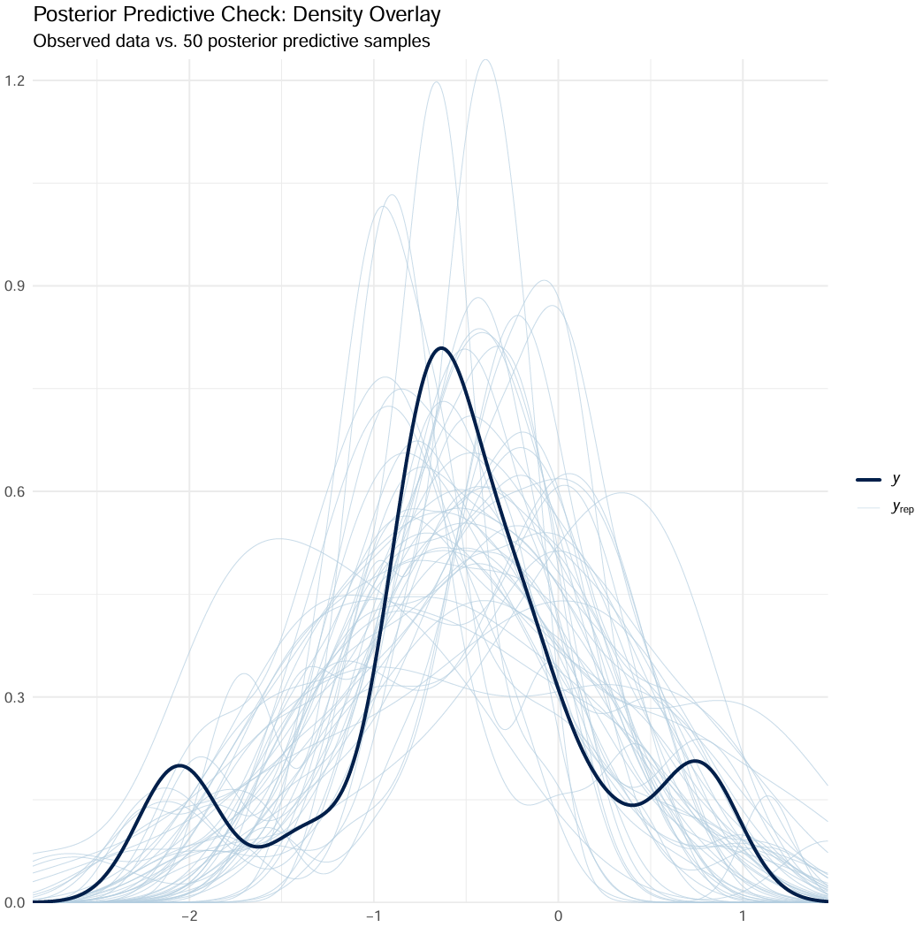

Global Density Overlay (Observed yi vs. multiple yrep densities)
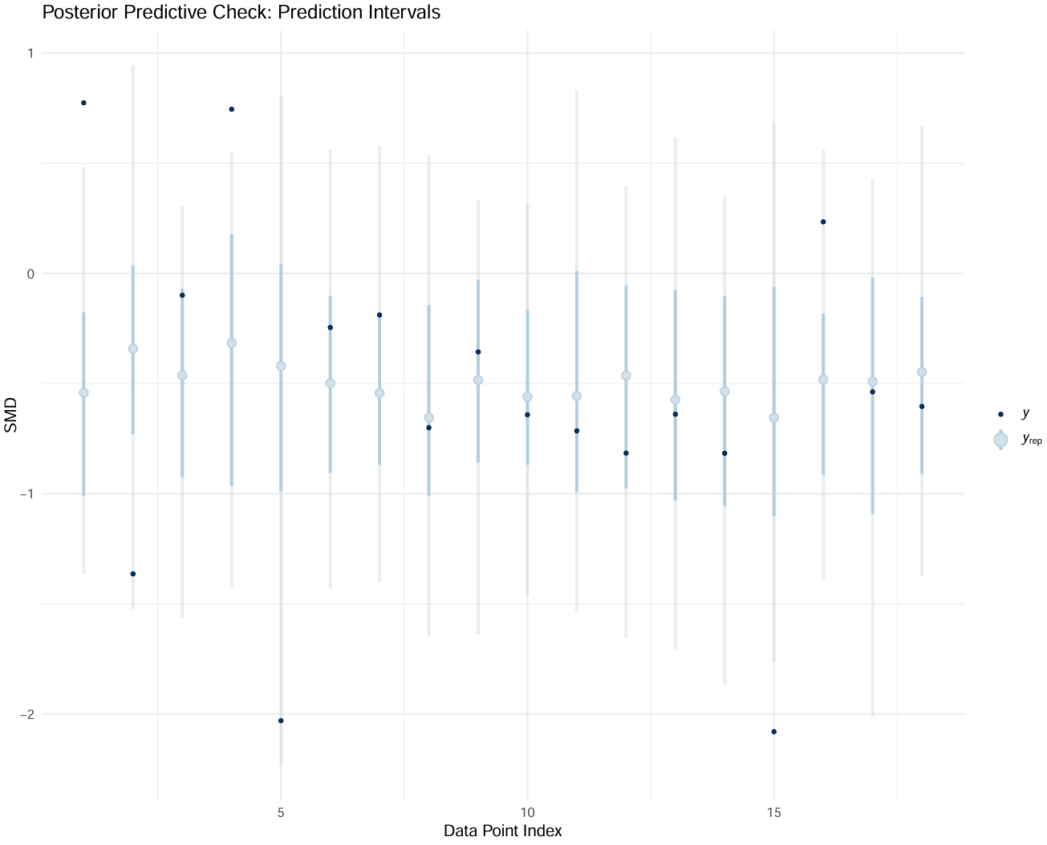

Interval Plot: Showing posterior predictive intervals for each observation and plotting observed values
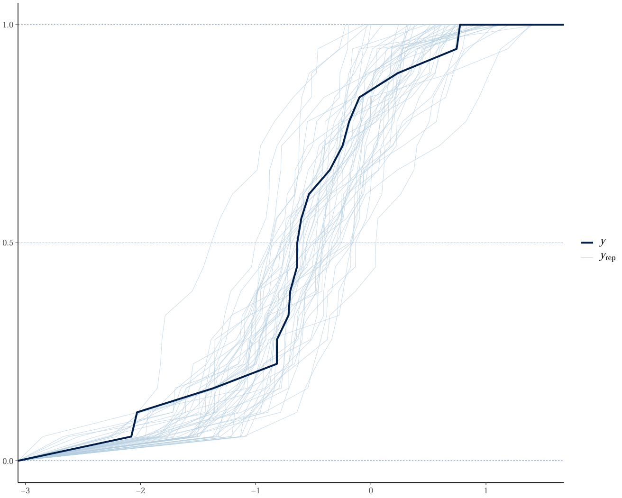

ECDF Comparison

