Supplementary Material: Outcome-Specific Risk-of-Bias Assessment and Sensitivity Analysis
Assessment target and approach. Risk of bias was assessed at the study-outcome-time-point level for each primary outcome entering the quantitative evidence base. Separate RoB 2 assessments are presented for dichotomous NSSI/self-harm outcomes, continuous NSSI/self-harm outcomes, and broader dichotomous self-harm outcomes. Individually randomized trials were assessed using Cochrane RoB 2, and the school-based cluster trial was assessed using the corresponding cluster-randomized considerations. When a trial contributed more than one primary outcome type, the relevant outcome was assessed separately so that judgments for missing outcome data, outcome measurement, and selective reporting could differ where appropriate. Multiple reports from the same trial were considered jointly. Insufficient reporting was not assumed to indicate adequate methods.
Outcome-specific summary. For dichotomous NSSI/self-harm outcomes, 3 of 10 assessments (30.0%) were judged at low risk, 6 (60.0%) raised some concerns, and 1 (10.0%) was judged at high risk. For continuous NSSI/self-harm outcomes, 1 of 19 assessments (5.3%) was judged at low risk, 12 (63.2%) raised some concerns, and 6 (31.6%) were judged at high risk. For broader dichotomous self-harm outcomes, both assessments raised some concerns. These distributions are reported by outcome rather than as a single study-level summary because the RoB 2 judgment is specific to the outcome and analysis time point.
Clarification for trials contributing to more than one outcome. Li et al. (2025) contributed both dichotomous NSSI prevalence and continuous NSSI severity and is therefore represented separately in the corresponding outcome-specific assessments. The domain judgments are the same for these two outcomes because both were self-reported and the principal high-risk concern arose from the same school-level allocation/confounding issue; nevertheless, the assessments are reported separately to preserve outcome-specific transparency.
Supplementary Figure S1A. Traffic-light summary for dichotomous NSSI/self-harm outcomes
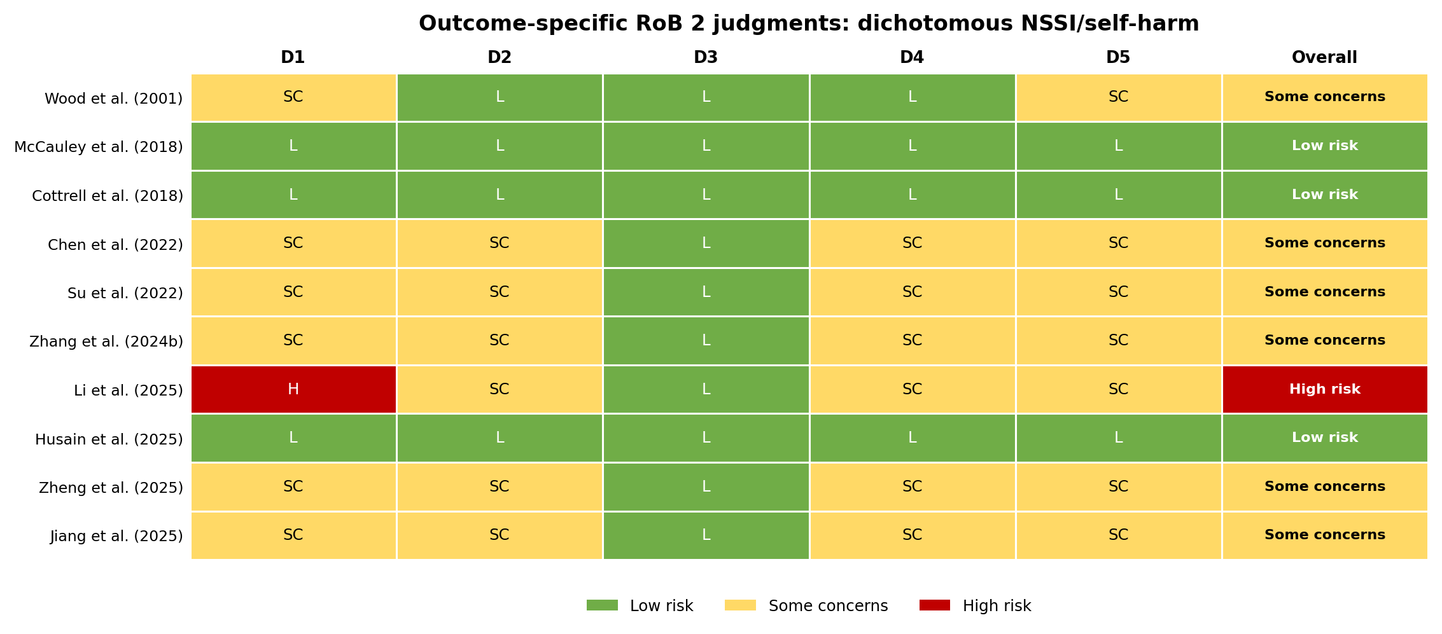
D1, randomization process; D2, deviations from intended interventions; D3, missing outcome data; D4, measurement of the outcome; D5, selection of the reported result.

Supplementary Figure S1B. Traffic-light summary for continuous NSSI/self-harm outcomes
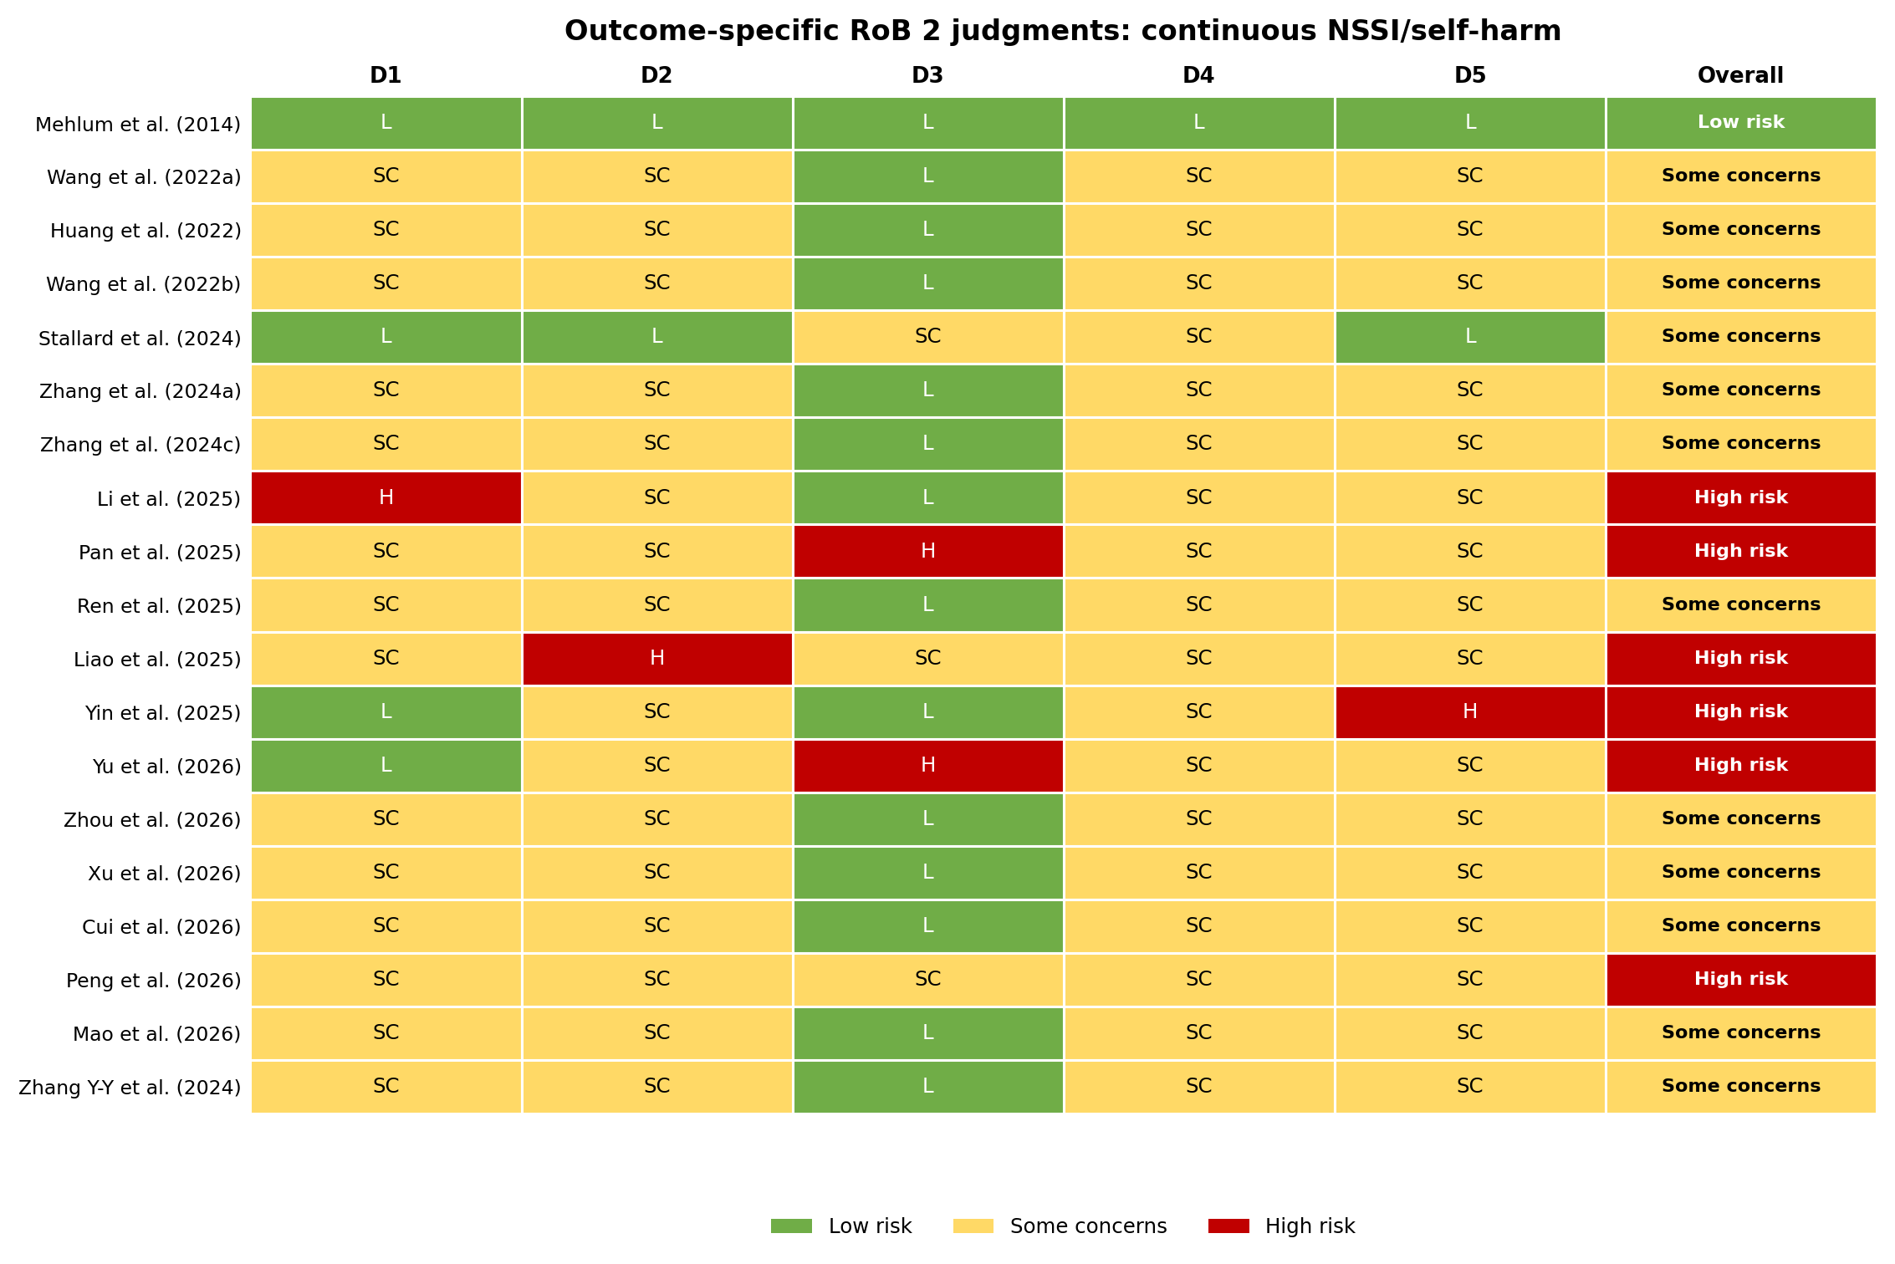
D1, randomization process; D2, deviations from intended interventions; D3, missing outcome data; D4, measurement of the outcome; D5, selection of the reported result.

Supplementary Figure S1C. Traffic-light summary for broader dichotomous self-harm outcomes
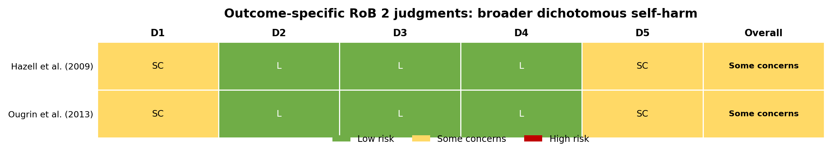
D1, randomization process; D2, deviations from intended interventions; D3, missing outcome data; D4, measurement of the outcome; D5, selection of the reported result.

Supplementary Table S1A. Detailed outcome-specific RoB 2 judgments for dichotomous NSSI/self-harm outcomes
Study | Target outcome/time point | D1 | D2 | D3 | D4 | D5 | Overall | Key basis for judgment
Wood et al. (2001) | Repeated self-harm, approximately 29 weeks | SC | L | L | L | SC | Some concerns | Single-blind randomized trial with near-complete follow-up and allocation-blinded outcome assessment; sequence generation, concealment, and a prespecified analysis plan were incompletely reported.
McCauley et al. (2018) | NSSI/overall self-harm during the prespecified treatment period | L | L | L | L | L | Low risk | Randomized design with masked independent outcome assessment, intention-to-treat analysis, and prespecified registered outcomes.
Cottrell et al. (2018) | Repeat self-harm during 18-month follow-up | L | L | L | L | L | Low risk | Large multicenter trial with central allocation, prespecified registered outcomes, masked/objective ascertainment, and appropriate intention-to-treat analysis.
Chen et al. (2022) | Dichotomous NSSI/self-harm endpoint used in synthesis | SC | SC | L | SC | SC | Some concerns | Outcome data were largely complete, but sequence generation, allocation concealment, masking of the subjective outcome, and prospective analysis specification were insufficiently reported.
Su et al. (2022) | Dichotomous NSSI/self-harm endpoint used in synthesis | SC | SC | L | SC | SC | Some concerns | Limited reporting of sequence generation and concealment; independent blinded outcome assessment and prospective outcome specification were not clearly documented.
Zhang et al. (2024b) | Dichotomous NSSI/self-harm endpoint used in synthesis | SC | SC | L | SC | SC | Some concerns | Intervention and endpoint were reported, but concealment, deviations/adherence, assessor masking, and prespecified reporting were incompletely described.
Li et al. (2025) | Dichotomous NSSI prevalence after the 6-month school intervention | H | SC | L | SC | SC | High risk | Classes from one school were assigned to intervention and classes from another to control, creating potential school-level confounding; cluster-adjusted primary analysis was not clearly reported and outcomes were self-reported.
Husain et al. (2025) | Repetition of self-harm at 12 months | L | L | L | L | L | Low risk | Large multicenter, prospectively registered, rater-blind randomized trial with prespecified follow-up, appropriate allocation, and intention-to-treat analysis.
Zheng et al. (2025) | Dichotomous NSSI/self-harm endpoint used in synthesis | SC | SC | L | SC | SC | Some concerns | Group outcome data were reported, but concealed allocation, deviations, blinded measurement, and prospective outcome specification were incompletely described.
Jiang et al. (2025) | Dichotomous NSSI/self-harm endpoint used in synthesis | SC | SC | L | SC | SC | Some concerns | Outcome completeness appeared acceptable; randomization safeguards, assessor masking, and a prospective protocol/analysis plan were not clearly available.
Abbreviations: L, low risk; SC, some concerns; H, high risk; D1, randomization process; D2, deviations from intended interventions; D3, missing outcome data; D4, measurement of the outcome; D5, selection of the reported result.

Supplementary Table S1B. Detailed outcome-specific RoB 2 judgments for continuous NSSI/self-harm outcomes
Study | Target outcome/time point | D1 | D2 | D3 | D4 | D5 | Overall | Key basis for judgment
Mehlum et al. (2014) | Self-harm frequency at 19 weeks | L | L | L | L | L | Low risk | Concealed block randomization, successful assessor masking, treatment-fidelity monitoring, intention-to-treat analysis, and no research dropout were reported.
Wang et al. (2022a) | Continuous NSSI/self-harm endpoint used in synthesis | SC | SC | L | SC | SC | Some concerns | Outcome data appeared complete; allocation concealment, deviations, blinded assessment of subjective outcomes, and prospective outcome specification were unclear.
Huang et al. (2022) | Continuous NSSI/self-harm endpoint used in synthesis | SC | SC | L | SC | SC | Some concerns | Randomized/controlled methods were briefly reported; concealment, masking, adherence, and prespecified outcome selection could not be fully verified.
Wang et al. (2022b) | Continuous NSSI/self-harm endpoint used in synthesis | SC | SC | L | SC | SC | Some concerns | No major missing data were evident, but allocation concealment, blinded outcome assessment, and a prespecified analysis plan were not adequately described.
Stallard et al. (2024) | Continuous self-harm endpoint at the main follow-up | L | L | SC | SC | L | Some concerns | Published protocol and randomized design; concern remained because the principal behavioral outcome was self-reported in an unblinded app trial and relied on available follow-up data.
Zhang et al. (2024a) | Continuous NSSI/self-harm endpoint used in synthesis | SC | SC | L | SC | SC | Some concerns | Random sequence generation, allocation concealment, blinded assessment, and prospective endpoint selection were insufficiently described.
Zhang et al. (2024c) | Continuous NSSI/self-harm endpoint used in synthesis | SC | SC | L | SC | SC | Some concerns | No major attrition was apparent, but randomization safeguards, blinded outcome assessment, and prospective analysis specifications were not sufficiently documented.
Li et al. (2025) | Continuous NSSI severity after the 6-month school intervention | H | SC | L | SC | SC | High risk | The same school-level allocation created potential confounding for the continuous severity outcome; cluster-adjusted primary analysis was not clearly reported and severity was self-reported.
Pan et al. (2025) | Continuous NSSI/self-harm endpoint used in synthesis | SC | SC | H | SC | SC | High risk | Participant flow and analyzable sample size were insufficiently transparent to verify missing-data handling; concealment, masking, and prespecification were also unclear.
Ren et al. (2025) | Continuous NSSI/self-harm endpoint used in synthesis | SC | SC | L | SC | SC | Some concerns | Sequence generation, concealment, deviations, blinded measurement, and prospective selection of outcomes were reported in limited detail.
Liao et al. (2025) | Continuous NSSI/self-harm endpoint in the disconnected active-comparator network | SC | H | SC | SC | SC | High risk | The bibliotherapy/pharmacotherapy comparison did not clearly separate co-intervention effects; adherence/deviations, allocation, missing-data handling, masking, and prespecified reporting were unclear.
Yin et al. (2025) | OSI NSSI-frequency item at 12 weeks | L | SC | L | SC | H | High risk | Random-number allocation and balanced attrition were reported, but assessors were not blinded and selected OSI items were analyzed without an accessible prospective protocol specifying those choices.
Yu et al. (2026) | OSI NSSI-frequency item at 12 weeks | L | SC | H | SC | SC | High risk | Randomization, independent oversight, concealment, and blinded evaluation were reported; however, 12/60 participants withdrew and efficacy analysis used 48 completers without a clearly reported intention-to-treat approach.
Zhou et al. (2026) | Continuous NSSI/self-harm endpoint used in synthesis | SC | SC | L | SC | SC | Some concerns | Usable group data were reported, but concealment, deviations/adherence, blinded assessment, and prospective outcome selection were insufficiently described.
Xu et al. (2026) | Continuous NSSI/self-harm endpoint used in synthesis | SC | SC | L | SC | SC | Some concerns | Outcome data appeared complete, while randomization safeguards, independent masked measurement, and a prospectively specified analysis plan were unclear.
Cui et al. (2026) | Continuous NSSI/self-harm endpoint used in synthesis | SC | SC | L | SC | SC | Some concerns | The article did not provide enough information to confirm allocation concealment, management of deviations, blinded assessment, or prespecified outcome reporting.
Peng et al. (2026) | Continuous NSSI/self-harm endpoint used in synthesis | SC | SC | SC | SC | SC | High risk | The small trial did not adequately document concealment, adherence/deviations, participant flow and missing-data handling, blinded measurement, or a prespecified analysis plan; concerns across several domains materially reduced confidence.
Mao et al. (2026) | Continuous NSSI/self-harm endpoint used in synthesis | SC | SC | L | SC | SC | Some concerns | Usable group-level outcomes were reported, but sequence concealment, blinded assessment, and prospective analysis specifications were insufficiently detailed.
Zhang Y-Y et al. (2024) | Continuous NSSI/self-harm endpoint used in synthesis | SC | SC | L | SC | SC | Some concerns | The prospective randomized report showed no major attrition signal, but concealment, masking of the subjective outcome, and a prospectively accessible analysis plan were insufficiently documented.
Abbreviations: L, low risk; SC, some concerns; H, high risk; D1, randomization process; D2, deviations from intended interventions; D3, missing outcome data; D4, measurement of the outcome; D5, selection of the reported result.

Supplementary Table S1C. Detailed outcome-specific RoB 2 judgments for broader dichotomous self-harm outcomes
Study | Target outcome/time point | D1 | D2 | D3 | D4 | D5 | Overall | Key basis for judgment
Hazell et al. (2009) | Repetition of self-harm at 6 months | SC | L | L | L | SC | Some concerns | Parallel randomized trial with masked outcome assessors, intention-to-treat analysis, and primary outcome data for 68/72 participants; sequence generation and prospective analysis plan were incompletely reported.
Ougrin et al. (2013) | Emergency-department self-harm presentations over 2 years | SC | L | L | L | SC | Some concerns | Long-term follow-up with near-complete electronic-record ascertainment and raters unaware of allocation; randomization occurred at assessor level and this follow-up outcome was reported separately from the original principal outcome.
Abbreviations: L, low risk; SC, some concerns; H, high risk; D1, randomization process; D2, deviations from intended interventions; D3, missing outcome data; D4, measurement of the outcome; D5, selection of the reported result.

Supplementary Table S2. Distribution of outcome-specific RoB 2 judgments by domain
S2A. Dichotomous NSSI/self-harm outcomes (10 outcome assessments)
Domain | Low risk, n (%) | Some concerns, n (%) | High risk, n (%)
D1: Randomization process | 3 (30.0%) | 6 (60.0%) | 1 (10.0%)
D2: Deviations from intended interventions | 4 (40.0%) | 6 (60.0%) | 0 (0.0%)
D3: Missing outcome data | 10 (100.0%) | 0 (0.0%) | 0 (0.0%)
D4: Measurement of the outcome | 4 (40.0%) | 6 (60.0%) | 0 (0.0%)
D5: Selection of the reported result | 3 (30.0%) | 7 (70.0%) | 0 (0.0%)
Overall judgment | 3 (30.0%) | 6 (60.0%) | 1 (10.0%)

S2B. Continuous NSSI/self-harm outcomes (19 outcome assessments, including the disconnected active-comparator network)
Domain | Low risk, n (%) | Some concerns, n (%) | High risk, n (%)
D1: Randomization process | 4 (21.1%) | 14 (73.7%) | 1 (5.3%)
D2: Deviations from intended interventions | 2 (10.5%) | 16 (84.2%) | 1 (5.3%)
D3: Missing outcome data | 14 (73.7%) | 3 (15.8%) | 2 (10.5%)
D4: Measurement of the outcome | 1 (5.3%) | 18 (94.7%) | 0 (0.0%)
D5: Selection of the reported result | 2 (10.5%) | 16 (84.2%) | 1 (5.3%)
Overall judgment | 1 (5.3%) | 12 (63.2%) | 6 (31.6%)

S2C. Broader dichotomous self-harm outcomes (2 outcome assessments)
Domain | Low risk, n (%) | Some concerns, n (%) | High risk, n (%)
D1: Randomization process | 0 (0.0%) | 2 (100.0%) | 0 (0.0%)
D2: Deviations from intended interventions | 2 (100.0%) | 0 (0.0%) | 0 (0.0%)
D3: Missing outcome data | 2 (100.0%) | 0 (0.0%) | 0 (0.0%)
D4: Measurement of the outcome | 2 (100.0%) | 0 (0.0%) | 0 (0.0%)
D5: Selection of the reported result | 0 (0.0%) | 2 (100.0%) | 0 (0.0%)
Overall judgment | 0 (0.0%) | 2 (100.0%) | 0 (0.0%)

Supplementary Table S3. Network meta-analysis after excluding trials judged at high risk of bias for the corresponding outcome
Outcome | Intervention | Effect measure | Estimate | 95% CI | P value
Dichotomous NSSI/self-harm | Culturally adapted CBT/problem-solving intervention | OR | 0.19 | 0.06 to 0.67 | 0.010
Dichotomous NSSI/self-harm | DBT/DBT-A | OR | 0.14 | 0.03 to 0.69 | 0.016
Dichotomous NSSI/self-harm | Group therapy/psychosocial intervention | OR | 0.14 | 0.03 to 0.71 | 0.017
Continuous NSSI/self-harm | DBT-based intervention | SMD | -1.82 | -2.96 to -0.69 | 0.002
Continuous NSSI/self-harm | CBT-based/third-wave CBT | SMD | -1.29 | -2.43 to -0.16 | 0.025
Continuous NSSI/self-harm | General psychosocial/nursing intervention | SMD | -1.64 | -2.78 to -0.51 | 0.005
Continuous NSSI/self-harm | Narrative/expressive therapy | SMD | -0.74 | -2.72 to 1.25 | 0.468
Continuous NSSI/self-harm | Family-based interpersonal psychotherapy | SMD | Not estimable | - | -
Continuous NSSI/self-harm | Group interpersonal psychotherapy | SMD | Not estimable | - | -
Note: For the dichotomous NSSI/self-harm outcome, exclusion of the high-risk school cluster trial left 9 studies and 10 treatment nodes. Because every remaining comparison design was represented by one study, the network was saturated and residual heterogeneity could not be estimated. For the continuous NSSI/self-harm outcome, exclusion of trials judged at high risk for that outcome left 10 studies and 5 connected treatment nodes; heterogeneity remained high (τ² = 0.9491, τ = 0.9742, I² = 94.9%). Family-based and group interpersonal psychotherapy were not estimable after exclusion because each node was supported only by a high-risk trial. OR, odds ratio; SMD, standardized mean difference; CBT, cognitive behavioral therapy; DBT-A, dialectical behavior therapy for adolescents.

Supplementary Table S4. Study-level intervention-node coding for continuous NSSI/self-harm outcomes
Study | Original intervention description | Final network node | Classification rationale
Mehlum et al. (2014) | DBT-A | DBT-based intervention | Explicit DBT-A protocol; DBT skills and treatment model are the therapeutic core.
Wang et al. (2022a) | Group psychological/comprehensive psychosocial intervention | General psychosocial/nursing intervention | Multicomponent psychosocial/nursing intervention without a single named psychotherapy model as the dominant component.
Huang et al. (2022) | Collage analysis combined with cognitive behavioral therapy | CBT-based/third-wave CBT | CBT is the structured therapeutic core; collage-based work is an adjunctive delivery component.
Wang et al. (2022b) | Adolescent cognitive behavioral therapy | CBT-based/third-wave CBT | Intervention is explicitly based on CBT principles and techniques.
Stallard et al. (2024) | BlueIce digital intervention plus usual care | CBT-based/third-wave CBT | Structured digital coping and cognitive-behavioral/third-wave components were delivered as an adjunct to usual care.
Zhang et al. (2024a) | Cognitive-behavioral intervention based on DBT principles | DBT-based intervention | The intervention was explicitly developed from a DBT framework; CBT techniques were delivered within that DBT-informed structure.
Zhang et al. (2024c) | Focused psychological nursing | General psychosocial/nursing intervention | Nursing-led multicomponent psychological support without a single manualized psychotherapy model defining the intervention.
Li et al. (2025) | DBT-based school prevention intervention | DBT-based intervention | DBT principles and skills formed the defining intervention framework.
Pan et al. (2025) | DBT-based group psychological counseling | DBT-based intervention | DBT was the named and defining psychotherapeutic framework.
Ren et al. (2025) | Acceptance and commitment therapy combined with CBT | CBT-based/third-wave CBT | ACT was treated as a third-wave CBT approach and was delivered together with CBT.
Liao et al. (2025) | Clinical bibliotherapy/pharmacotherapy-combined intervention | Disconnected active-comparator network | The combined intervention and medication/clinical-management comparator formed a clinically distinct, disconnected active-comparator network and were not forced into the main TAU-connected model.
Yin et al. (2025) | Group interpersonal psychotherapy plus TAU | Group interpersonal psychotherapy | Manualized group IPT was retained as a distinct node because its interpersonal model and delivery format were clinically specific.
Yu et al. (2026) | Family-based interpersonal psychotherapy | Family-based interpersonal psychotherapy | Family-based IPT was retained as a distinct node because family involvement and the interpersonal treatment model were defining components.
Zhou et al. (2026) | Dialectical behavior therapy | DBT-based intervention | DBT was the explicit therapeutic model.
Xu et al. (2026) | Staged intervention guided by goal management | General psychosocial/nursing intervention | Multicomponent goal-management/psychosocial intervention without a single specific psychotherapy model as the sole defining treatment.
Cui et al. (2026) | Positive psychology intervention combined with DBT | DBT-based intervention | DBT was the principal structured psychotherapy framework; positive-psychology components were adjunctive.
Peng et al. (2026) | CBT-based group counseling | CBT-based/third-wave CBT | CBT was the explicit treatment framework.
Mao et al. (2026) | Mindfulness-based stress reduction combined with cognitive therapy | CBT-based/third-wave CBT | Mindfulness and cognitive therapy were grouped with third-wave CBT approaches according to the prespecified node rule.
Zhang Y-Y et al. (2024) | Narrative therapy | Narrative/expressive therapy | Narrative restructuring and expression were the defining therapeutic components.
Note: The table documents the study-level implementation of the node definitions described in Methods Section 2.8. Classification was based on theoretical orientation, core therapeutic components, and delivery format; clinically distinct IPT nodes were retained rather than merged when doing so preserved interpretability.
Supplementary Table S5. Complete database-specific search strategies
Database and coverage | Search syntax
PubMed  Coverage: inception to July 4, 2026 | (("Adolescent"[Mesh] OR adolescent*[tiab] OR youth[tiab] OR "young people"[tiab] OR "young person"[tiab] OR "young persons"[tiab]) AND ("Self-Injurious Behavior"[Mesh] OR "non-suicidal self-injury"[tiab] OR "nonsuicidal self-injury"[tiab] OR NSSI[tiab] OR self-harm*[tiab] OR "self injur*"[tiab] OR "suicidal ideation"[tiab] OR "suicide attempt*"[tiab] OR "suicidal behavio*"[tiab]) AND ("Psychotherapy"[Mesh] OR psychosocial[tiab] OR psychotherap*[tiab] OR "psychological intervention*"[tiab] OR "cognitive behavio* therapy"[tiab] OR CBT[tiab] OR "dialectical behavio* therapy"[tiab] OR DBT[tiab] OR "family therap*"[tiab] OR "family intervention*"[tiab] OR "group therap*"[tiab] OR mindfulness[tiab] OR "nursing intervention*"[tiab]) AND (randomized controlled trial[pt] OR controlled clinical trial[pt] OR random*[tiab] OR trial[tiab]))
Embase  Coverage: inception to July 4, 2026 | ('adolescent'/exp OR adolescent*:ti,ab,kw OR youth:ti,ab,kw OR 'young people':ti,ab,kw) AND ('self injurious behavior'/exp OR 'non suicidal self injury':ti,ab,kw OR 'nonsuicidal self injury':ti,ab,kw OR nssi:ti,ab,kw OR 'self harm':ti,ab,kw OR 'suicidal ideation':ti,ab,kw OR 'suicide attempt':ti,ab,kw OR 'suicidal behavior':ti,ab,kw) AND ('psychotherapy'/exp OR psychosocial:ti,ab,kw OR psychotherap*:ti,ab,kw OR 'psychological intervention':ti,ab,kw OR 'cognitive behavioral therapy'/exp OR cbt:ti,ab,kw OR 'dialectical behavior therapy':ti,ab,kw OR dbt:ti,ab,kw OR 'family therapy'/exp OR 'group therapy'/exp OR mindfulness:ti,ab,kw OR 'nursing intervention':ti,ab,kw) AND ('randomized controlled trial'/exp OR random*:ti,ab,kw OR trial:ti,ab,kw)
Web of Science Core Collection  Coverage: inception to July 4, 2026 | TS=(adolescent* OR youth OR "young people" OR "young person*") AND TS=("non-suicidal self-injur*" OR "nonsuicidal self-injur*" OR NSSI OR self-harm* OR "self injur*" OR "suicidal ideation" OR "suicide attempt*" OR "suicidal behavio*") AND TS=(psychosocial OR psychotherap* OR "psychological intervention*" OR "cognitive behavio* therapy" OR CBT OR "dialectical behavio* therapy" OR DBT OR "family therap*" OR "family intervention*" OR "group therap*" OR mindfulness OR "nursing intervention*") AND TS=(random* OR trial OR "controlled trial")
Cochrane Library/CENTRAL  Coverage: inception to July 4, 2026 | ([mh Adolescent] OR adolescent*:ti,ab,kw OR youth:ti,ab,kw OR "young people":ti,ab,kw) AND ([mh "Self-Injurious Behavior"] OR "non-suicidal self-injur*":ti,ab,kw OR "nonsuicidal self-injur*":ti,ab,kw OR NSSI:ti,ab,kw OR self-harm*:ti,ab,kw OR "suicidal ideation":ti,ab,kw OR "suicide attempt*":ti,ab,kw OR "suicidal behavio*":ti,ab,kw) AND ([mh Psychotherapy] OR psychosocial:ti,ab,kw OR psychotherap*:ti,ab,kw OR "cognitive behavio* therapy":ti,ab,kw OR CBT:ti,ab,kw OR "dialectical behavio* therapy":ti,ab,kw OR DBT:ti,ab,kw OR "family therap*":ti,ab,kw OR "group therap*":ti,ab,kw OR mindfulness:ti,ab,kw OR "nursing intervention*":ti,ab,kw) in Trials
Scopus  Coverage: inception to July 4, 2026 | TITLE-ABS-KEY(adolescent* OR youth OR "young people" OR "young person*") AND TITLE-ABS-KEY("non-suicidal self-injur*" OR "nonsuicidal self-injur*" OR NSSI OR self-harm* OR "self injur*" OR "suicidal ideation" OR "suicide attempt*" OR "suicidal behavio*") AND TITLE-ABS-KEY(psychosocial OR psychotherap* OR "psychological intervention*" OR "cognitive behavio* therapy" OR CBT OR "dialectical behavio* therapy" OR DBT OR "family therap*" OR "family intervention*" OR "group therap*" OR mindfulness OR "nursing intervention*") AND TITLE-ABS-KEY(random* OR trial OR "controlled trial")
China National Knowledge Infrastructure (CNKI)  Coverage: inception to July 4, 2026 | 主题=(青少年 OR 青年 OR 未成年人) AND 主题=(非自杀性自伤 OR NSSI OR 自伤 OR 自残 OR 自杀意念 OR 自杀企图 OR 自杀行为) AND 主题=(心理社会干预 OR 心理治疗 OR 心理干预 OR 认知行为疗法 OR CBT OR 辩证行为疗法 OR DBT OR 家庭干预 OR 家庭治疗 OR 团体干预 OR 团体治疗 OR 正念 OR 心理护理) AND 主题=(随机 OR 随机对照 OR 对照试验 OR 临床试验)
Wanfang Data  Coverage: inception to July 4, 2026 | 主题:(青少年 OR 青年 OR 未成年人) AND 主题:(非自杀性自伤 OR NSSI OR 自伤 OR 自残 OR 自杀意念 OR 自杀企图 OR 自杀行为) AND 主题:(心理社会干预 OR 心理治疗 OR 心理干预 OR 认知行为疗法 OR CBT OR 辩证行为疗法 OR DBT OR 家庭干预 OR 团体干预 OR 正念 OR 心理护理) AND 主题:(随机 OR 随机对照 OR 对照试验 OR 临床试验)
VIP (CQVIP)  Coverage: inception to July 4, 2026 | M=(青少年 OR 青年 OR 未成年人) AND M=(非自杀性自伤 OR NSSI OR 自伤 OR 自残 OR 自杀意念 OR 自杀企图 OR 自杀行为) AND M=(心理社会干预 OR 心理治疗 OR 心理干预 OR 认知行为疗法 OR CBT OR 辩证行为疗法 OR DBT OR 家庭干预 OR 团体干预 OR 正念 OR 心理护理) AND M=(随机 OR 随机对照 OR 对照试验 OR 临床试验)
Note: Database syntax was adapted to the indexing fields and operators available in each platform. The review was restricted to Chinese- and English-language reports at the screening stage. Supplementary searching included reference lists of relevant reviews/meta-analyses and trial registries.
Supplementary Table S6A. P-score rankings for dichotomous NSSI/self-harm outcomes
Rank | Treatment node | P-score
1 | Group therapy/psychosocial intervention | 0.789
2 | CBT/problem-solving culturally adapted intervention | 0.721
3 | Narrative nursing | 0.665
4 | DBT + self-management | 0.659
5 | DBT/DBT-A | 0.587
6 | Narrative nursing + broken-window intervention | 0.529
7 | Transference-focused + emotion-regulation group intervention | 0.459
8 | General psychosocial/supportive therapy | 0.328
9 | TAU/usual care | 0.144
10 | Family/parent intervention | 0.119
Note: P-scores range from 0 to 1; larger values indicate a higher relative ranking within the fitted network. Rankings are exploratory and should not be interpreted independently of effect estimates, confidence intervals, network sparsity, and risk of bias.
Supplementary Table S6B. P-score rankings for continuous NSSI/self-harm outcomes
Rank | Treatment node | P-score
1 | General psychosocial/nursing intervention | 0.710
2 | Family-based interpersonal psychotherapy | 0.692
3 | DBT-based intervention | 0.626
4 | CBT-based/third-wave CBT | 0.535
5 | Group interpersonal psychotherapy | 0.481
6 | Narrative/expressive therapy | 0.380
7 | TAU/usual care | 0.077
Note: Values are reported to three decimals from the final continuous-outcome network. Because the network was highly heterogeneous and several nodes were supported by limited direct evidence, the P-scores are descriptive only and do not establish a definitive treatment hierarchy.
Supplementary Table S7. Statistical software and reproducibility information
Component | Software/package | Version | Role
Statistical environment | R | 4.6.0 | Primary statistical environment
Network meta-analysis | netmeta | 3.6-1 | Frequentist random-effects NMA, network estimates, heterogeneity, and P-scores
Data import | readxl | 1.5.0 | Import of structured extraction workbooks
Data management | dplyr | 1.2.1 | Data manipulation and verification
Data reshaping | tidyr | 1.3.2 | Reshaping analysis-ready tables
R-based graphics | ggplot2 | 4.0.3 | Supporting publication-quality graphics
RoB 2 traffic-light figures | Python / Matplotlib | 3.13.5 / 3.10.8 | Rendering outcome-specific RoB 2 displays from the adjudicated RoB dataset
Reproducibility statement: The extracted dataset and analysis code are available from the corresponding author on reasonable request. Studies with a zero event count in one arm were analyzed using a fixed 0.5 continuity correction applied to all four cells of that two-arm comparison; double-zero comparisons were excluded from OR estimation for that outcome.

