The list of captions
FIGURE S1 The stability of the network of Low Harsh Parenting – Low Parent-child Alienation – High Psychological Capital – Low Academic Burnout (LLHL) group
FIGURE S2 The stability of the network of High Harsh Parenting – High Parent-child Alienation – Low Psychological Capital – High Academic Burnout (HHLH) group
FIGURE S3 The stability of the network of High Harsh Parenting – High Parent-child Alienation – High Psychological Capital – High Academic Burnout (HHHH) group

FIGURE S1 The stability of the network of Low Harsh Parenting – Low Parent-child Alienation – High Psychological Capital – Low Academic Burnout (LLHL) group
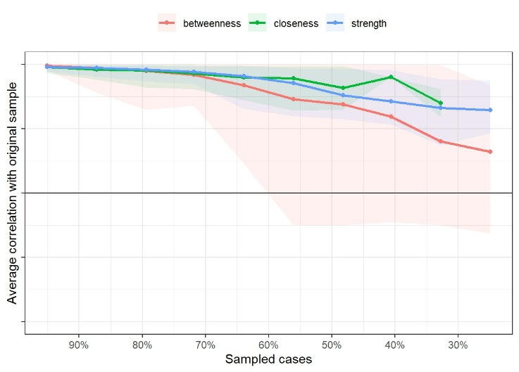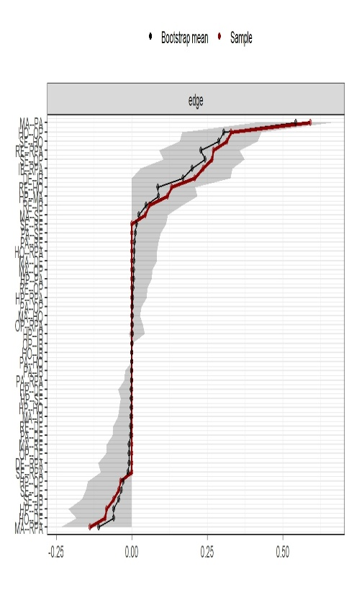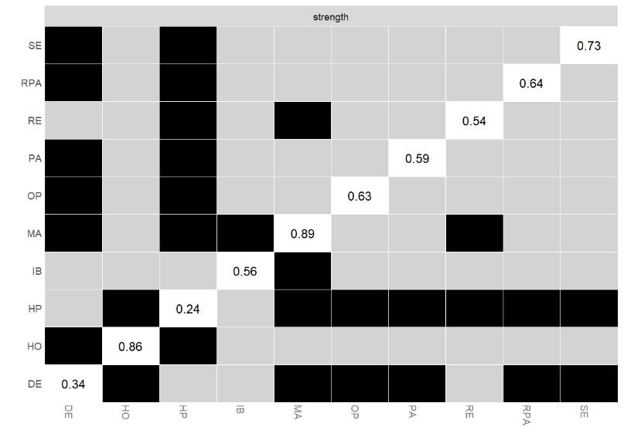

FIGURE S2 The stability of the network of High Harsh Parenting – High Parent-child Alienation – Low Psychological Capital – High Academic Burnout (HHLH) group
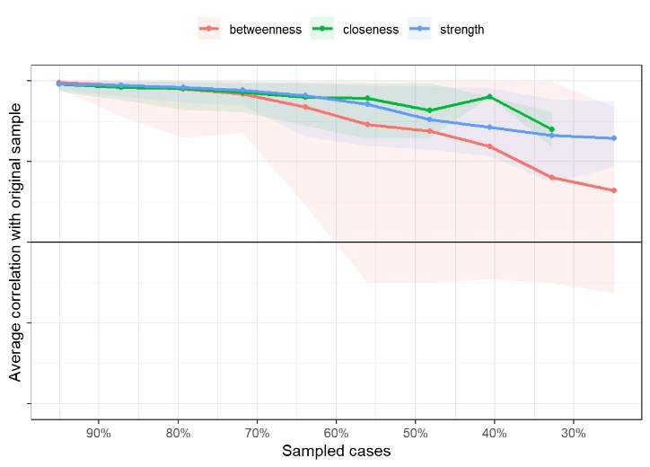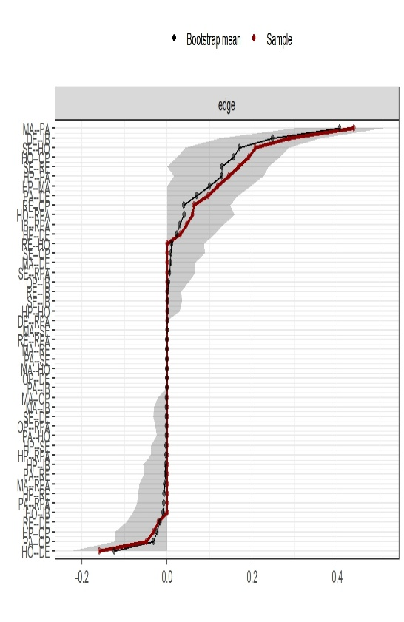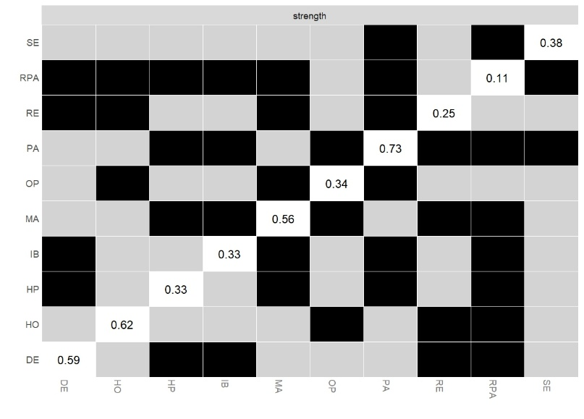

FIGURE S3 The stability of the network of High Harsh Parenting – High Parent-child Alienation – High Psychological Capital – High Academic Burnout (HHHH) group
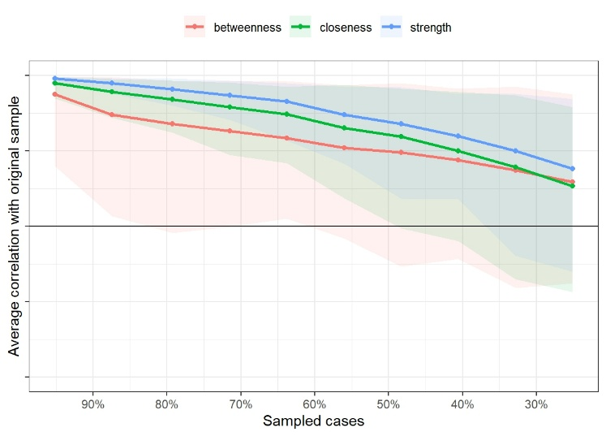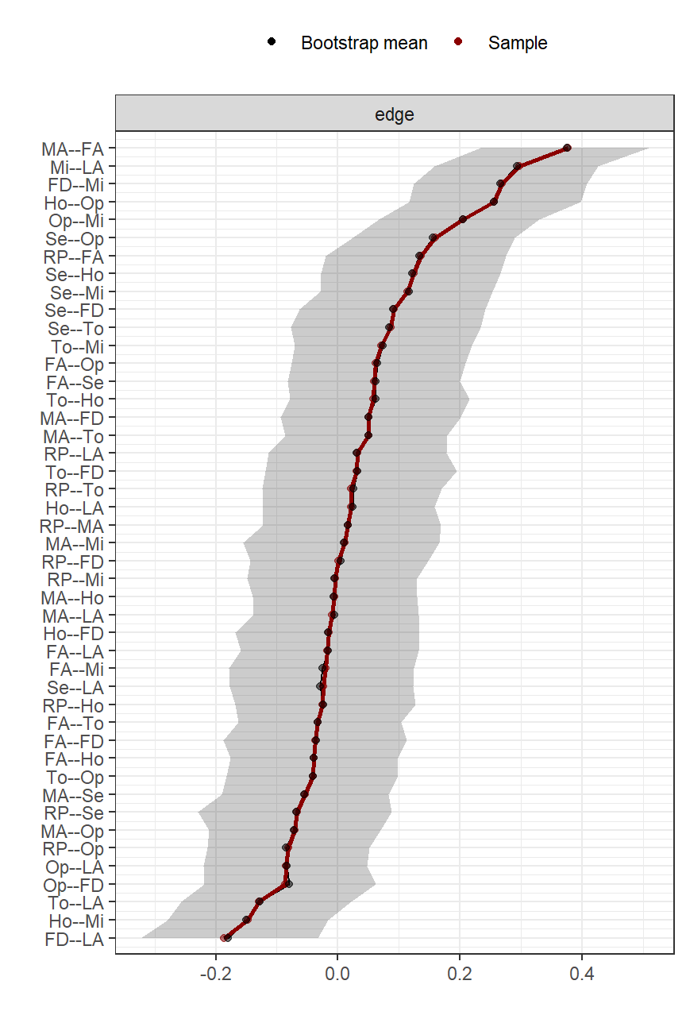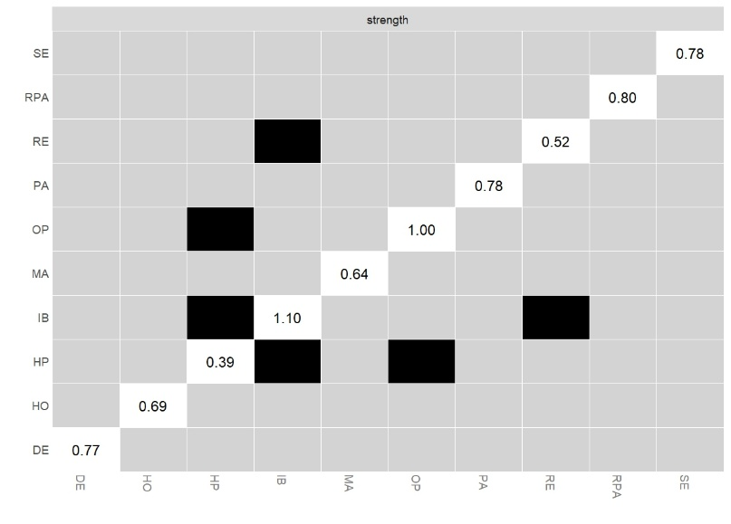

R script
##########################Packages Required#############################
library(readxl)
library(qgraph)
library(networktools)
library(bootnet)
library(NetworkComparisonTest)

####Network Esitimation of different profiles#####
dataLLHL <- read_excel("D:/DATA.xls", sheet = "LLHL")
dataHHLH <- read_excel("D:/DATA.xls", sheet = "HHLH")
dataHHHH <- read_excel("D:/DATA.xls", sheet = "HHHH")

dataLLHL.cor <- cor_auto(dataLLHL, detectOrdinal = FALSE)
dataHHLH.cor <- cor_auto(dataHHLH, detectOrdinal = FALSE)
dataHHHH.cor <- cor_auto(dataHHHH, detectOrdinal = FALSE)

names <- c("HP","MA","FA","SE","RE","HO","OP","DE","IB","RPA")
longnames <-c ("Harsh Parenting",
"Mother-child Alienation", "Father-child Alienation",
"Self-efficacy", "Resilience", "Hope", "Optimistic",
"Dejection", "Improper Behavior", "Reduced Personal Accomplishment")
Gr < -c("Harsh Parenting",
"Parent-child Alienation", "Parent-child Alienation",
"Positive psychological capital", "Positive psychological capital",
"Positive psychological capital", "Positive psychological capital",
"Academic burnout", "Academic burnout", "Academic burnout")

graphLLHL <- qgraph(dataLLHL.cor, labels = names, graph = "pcor", layout = "spring",
vsize = 7, cut = 0, maximun = .99, sampleSize = nrow(dataLLHL),
groups =gr, color = c("lightblue", "lightgreen", "lightyellow","white"),
edge.color = ifelse(cor_auto(dataLLHL) > 0, "blue", "red"),
mar = c(4,2,2,2), height = 5, width = 5,
nodeNames = longnames, legend.cex = .26, label.cex = 1.5,
filetype = "jpg", filename = "LLHL")
graphHHLH <- qgraph(dataHHLH.cor, labels=names, graph="pcor", layout="spring",
vsize = 7, cut = 0, maximun = .99, sampleSize = nrow(dataHHLH),
groups = gr, color = c("lightblue", "lightgreen", "lightyellow","white"),
edge.color = ifelse(cor_auto(dataHHLH) > 0, "blue", "red"),
mar = c(4,2,2,2), height = 5, width = 5,
nodeNames = longnames, legend.cex = .26, label.cex = 1.5,
filetype = "jpg", filename = "HHLH")
graphHHHH <- qgraph(dataHHHH.cor, labels = names, graph="pcor", layout="spring",
vsize = 7, cut = 0, maximun = .99, sampleSize = nrow(dataHHHH),
groups = gr, color = c("lightblue", "lightgreen", "lightyellow","white"),
edge.color = ifelse(cor_auto(dataHHHH) > 0, "blue", "red"),
mar = c(4,2,2,2), height = 5, width = 5,
nodeNames = longnames, legend.cex = .26, label.cex = 1.5,
filetype = "jpg", filename = "HHHH")

networkLLHL <- estimateNetwork(dataLLHL, default = "EBICglasso", corMethod = "spearman")
bootstrapLLHL <- bootnet(networkLLHL, nBoots = 1000, statistics = "edge")
plot(bootstrapLLHL, statistics = "edge",plot = "area", sampleColor = "darkred",
bootColor = "black", areaAlpha = 0.2, order = "sample",labels = TRUE)
networkHHLH <- estimateNetwork(dataHHLH, default = "EBICglasso", corMethod = "spearman")
bootstrapHHLH <- bootnet(networkHHLH, nBoots = 1000, statistics = "edge")
plot(bootstrapHHLH, statistics = "edge", plot = "area", sampleColor = "darkred",
bootColor = "black", areaAlpha = 0.2, order = "sample",labels = TRUE)
networkHHHH <- estimateNetwork(dataHHHH, default = "pcor", corMethod = "spearman")
bootstrapHHHH <- bootnet(networkHHHH, nBoots = 1000, statistics = "edge")
plot(bootstrapHHHH, statistics = "edge", plot = "area", sampleColor = "darkred",
bootColor = "black", areaAlpha = 0.2, order = "sample", labels = TRUE)

#################Centrality, Stability and difference in strength centrality#########
centralityLLHL<-bootnet(networkLLHL,nBoots = 1000, nCores = 8, type = "case",
statistics = c('strength', 'betweenness', 'closeness'))
plot(centralityLLHL, labels=FALSE, order="sample", "all")
cs_resultLLHL <- corStability(centralityLLHL)
print(cs_resultLLHL)
centralityHHLH<-bootnet(networkHHLH, nBoots = 1000, nCores = 8, type = "case",
statistics = c('strength', 'betweenness', 'closeness'))
plot(centralityHHLH, labels=FALSE, order="sample", "all")
cs_resultHHLH <- corStability(centralityHHLH)
print(cs_resultHHLH)
centralityHHHH<-bootnet(networkHHHH, nBoots = 2000, nCores = 8, type = "case",
statistics = c('strength', 'betweenness', 'closeness'))
plot(centralityHHHH, labels=FALSE, order="sample", "all")
cs_resultHHHH <- corStability(centralityHHHH)
print(cs_resultHHHH)

ResultsLLHL <- bootnet(networkLLHL, statistics = c("strength", "closeness", "betweenness", "edge"), nBoots = 1500, nCores = 5)
plot(ResultsLLHL, "strength", plot = "difference")
ResultsHHLH <- bootnet(networkHHLH, statistics = c("strength", "closeness", "betweenness", "edge"), nBoots = 1500, nCores = 5)
plot(ResultsHHLH, "strength", plot = "difference")
ResultsHHHH <- bootnet(networkHHHH, statistics = c("strength", "closeness", "betweenness", "edge"), nBoots = 1500, nCores = 5)
plot(ResultsHHHH, "strength", plot = "difference")

#################Bridge Node#########
LLHL <- dataLLHL.cor
colnames(LLHL) < -c("HP", "MA", "FA", "SE", "RE", "HO", "OP", "DE", "IB", "RPA")
bridgeLLHL <- bridge(LLHL, communities = gr)
plot(bridgeLLHL, order = "value", zscore = TRUE, include = c("Bridge Strength", "Bridge Expected Influence (1-step)"))
plot(bridgeLLHL, order = "value", zscore = TRUE, include = c("Bridge Strength"))

HHLH <- dataHHLH.cor
colnames(HHLH) <- c("HP", "MA", "FA", "SE", "RE", "HO", "OP", "DE", "IB", "RPA")
bridgeHHLH <- bridge(HHLH, communities = gr)
plot(bridgeHHLH, order = "value", zscore = TRUE, include = c("Bridge Strength", "Bridge Expected Influence (1-step)"))
plot(bridgeHHLH, order = "value", zscore = TRUE, include = c("Bridge Strength"))

HHHH < -dataHHHH.cor
colnames(HHHH) < -c("HP", "MA", "FA", "SE", "RE", "HO", "OP", "DE", "IB", "RPA")
bridgeHHHH <- bridge(HHHH, communities = gr)
plot(bridgeHHHH, order = "value", zscore = TRUE, include = c("Bridge Strength", "Bridge Expected Influence (1-step)"))
plot(bridgeHHHH, order = "value", zscore = TRUE, include = c("Bridge Strength"))

######################Network Comparison############
com1 <- NCT(dataLLHL, dataHHLH, 0.5, it = 1000, binary.data = FALSE, paired = FALSE,
weighted = TRUE, AND = FALSE, abs = FALSE, test.edges = TRUE,
edges ="all", test.centrality = TRUE, progressbar = TRUE,
make.positive.definite = TRUE, verbose = TRUE)
com2 <- NCT(dataLLHL, dataHHHH, 0.5, it = 1000, binary.data = FALSE, paired = FALSE,
weighted = TRUE, AND = FALSE, abs = FALSE, test.edges = TRUE,
edges="all", test.centrality = TRUE, progressbar = TRUE,
make.positive.definite = TRUE, verbose=TRUE)
com3 < -NCT(dataHHLH, dataHHHH, 0.5, it = 1000, binary.data = FALSE, paired = FALSE,
weighted = TRUE, AND = FALSE, abs = FALSE, test.edges = TRUE,
edges="all", test.centrality = TRUE, progressbar = TRUE,
make.positive.definite = TRUE, verbose = TRUE)
com1
com2
com3

