Methods
Definitions of metrics
On the test set, model performance was assessed using six comprehensive metrics: 1.AUC (Area Under the Curve): Values ranging from 0.9 to 1.0 signify excellent overall classification performance. 2.Accuracy: Represents the proportion of instances correctly classified. 3.Precision: Reflects the consistency of positive predictions (i.e., the proportion of predicted positives that are actual positives). 4.Recall/Sensitivity: Indicates the model’s ability to identify true positives (i.e., the proportion of actual positives correctly predicted). 5.Specificity: Measures the true negative rate (i.e., the proportion of actual negatives correctly predicted). 6.F1 Score: Balances precision and recall, making it particularly useful for imbalanced datasets.

Table S1 Individuals’ health and cognition collected at 2011
 | Domain | Questionnaire Items | Recode | range
1 | Self-reported health | r1shlt Self-reported health | Excellent = 1; Very good = 2; Good = 3; Fair = 4; Poor = 5 | 1~5
2 | Self-reported memory | r1slfmem Self-reported memory | Excellent = 1; Very good = 2; Good = 3; Fair = 4; Poor = 5 | 1~5
3 | Orientation | r1orient Cognition orient (summary date naming) |  | 1~4
4 | Draw | r1draw cognition able to draw assign picture |  | 0~1
5 | Memory | r1tr20 recall summary score |  | 0~20
6 | Calculation | r1ser7 serial 7s |  | 0~5
7 | Sleep duration | da049 average hours for one night sleeping time during the past month |  | 0~15
8 | Nap duration | da050 how long did you take a nap during the past month |  | 0~180
9 | Trouble pain | da041 currently feel any body pains | Yes = 1; No = 0 | 0~1

Table S2 Questionnaire items and score of each ACE
 | Domain | Questionnaire Items | Recode | range
1 | Physical abuse | k1_a When you were growing up, did your female guardian ever hit you? | Often = 4;  Sometimes = 3;  Rarely = 2;  Never = 1 | 3~12
1 | Physical abuse | k1_b When you were growing up, did your male guardian ever hit you? | Often = 4;  Sometimes = 3;  Rarely = 2;  Never = 1 | 3~12
1 | Physical abuse | k1_c When you were growing up, did your siblings ever hit you? | Often = 4;  Sometimes = 3;  Rarely = 2;  Never = 1 | 3~12
2 | Emotional neglect | j3_a How much love and affection did your female guardian give you while you were growing up? | Often = 1; Sometimes = 2;  Rarely = 3; Never = 4 | 2~8
2 | Emotional neglect | j4_a How much effort did your female guardian put into watching over you? | A lot = 1; Some = 2;  A little = 3; Not at all = 4 | 2~8
3 | Household substance abuse | h9_as1 During the years you were growing up, did your female ever have alcoholism? | Yes = 1; No = 0 | 0~1
3 | Household substance abuse | h9_as3 During the years you were growing up, did your female guardian ever have drug? | Yes = 1; No = 0 | 0~1
3 | Household substance abuse | h9_bs1 During the years you were growing up, did your male guardian ever have alcoholism? | Yes = 1; No = 0 | 0~1
3 | Household substance abuse | h9_bs3 During the years you were growing up, did your male guardian ever have drug? | Yes = 1; No = 0 | 0~1
4 | Household mental illness | h19_a Did your female guardian have abnormality of mind when you were young? | All = 1; Most =1;  Some = 0; Only a little = 0 | 0~1
4 | Household mental illness | h19_b Did your male guardian have abnormality of mind when you were young? |  | 0~1
4 | Household mental illness | h3_a During the years you were growing up, had female guardian s lasting 2 weeks or more depressed | Yes = 1; No = 0 | 0~1
4 | Household mental illness | h3_b During the years you were growing up, had male guardian lasting 2 weeks or more depressed |  | 0~1
5 | Domestic violence | j10_2 Have your mother ever beat up your mother/father? | Often =4; Sometimes =3;  Not very often = 2; Never = 1 | 2~8
5 | Domestic violence | j10_3 Have your father ever beat up your mother/father?
6 | Incarcerated household member | h15_as5 During the years you were growing up, have your female guardian ever been arrested or sent to prison? | Yes = 1; No = 0 | 0~1
6 | Incarcerated household member | h15_bs5 During the years you were growing up, have your male guardian ever been arrested or sent to prison? | Yes = 1; No = 0 | 0~1
7 | Parental separation or divorce | Were your biological parents divorced (including long separation due to emotional problems) before you were 17 years? | Yes = 1  No = 0 | 0~1
7 | Parental separation or divorce | a7 Had your biological parents divorced | Yes = 1  No = 0
7 | Parental separation or divorce | a10 Age when parents’ divorce | <=17: 1; > 17: 0
8 | Unsafe neighborhood | d1Was it safe being out alone at night in the neighborhood where you lived as a child? | Very safe = 1; Somewhat safe = 2;  Not very safe = 3; Not safe at all = 4 | 1~4
9 | Bullying | f1 When you were a child, how often were you picked on or bullied by kids in your neighborhood? | Often =4; Sometimes =3;  Not very often = 2; Never = 1 | 2~8
9 | Bullying | f3 When you were a child, how often were you picked on or bullied by kids in your school? | Often =4; Sometimes =3;  Not very often = 2; Never = 1 | 2~8
10 | Parental death | a1a (a2a_2 >=0 & a2a_2 <18) Either of the parents was dead before participant was 18 years. | Yes = 1; No = 0 | 0~1
11 | Sibling death | b11* Any of the siblings was dead before participant was 18 years. | Yes = 1; No = 0 | 0~1
12 | Parental disability | h17_a Did your female guardian have a long time being sick on bed when you were young? | Yes = 1; No = 0 | 0~4
12 | Parental disability | h17_b Did your male guardian have a long time being sick on bed when you were young? | Yes = 1; No = 0 | 0~4
12 | Parental disability | h18_a Did your female guardian have a serious deformity when you were young? | Yes = 1; No = 0 | 0~4
12 | Parental disability | h18_b Did your male guardian have a serious deformity when you were young? | Yes = 1; No = 0 | 0~4
Abbreviation: ACEs: adverse childhood experiences.

Table S3 Parenting styles and family conflict
 | Domains | Questionnaire Items |  | range
1 | Maternal Affection | J1_a How would you rate your relationship with your female guardian when you were growing? | Excellent = 1; Very good = 2; Good = 3; Fair = 4; Poor = 5 | 3~13
1 | Maternal Affection | J3_a How much love and affection did your female guardian give you while you were growing up? | Often = 1; Sometimes = 2; Rarely = 3; Never =4 | 3~13
1 | Maternal Affection | J4_a How much effort did your female guardian put into watching over you? | A lot = 1; Some = 2; A little = 3; Not at all = 4 | 3~13
2 | Maternal discipline | J5_a How strict was your female guardian with her rules for you? | V Very = 4; Somewhat = 3; A little = 2; Not at all = 1 | 1~4
3 | Maternal Partiality | J6_a Did your female guardian treat your siblings better than you when you were growing up? | Very = 4; Somewhat = 3; A little = 2; Not at all = 1 | 1~4
4 | Maternal favoring Sons | J8_a Did your female guardian prefer boys to girls? | Very = 4; Somewhat = 3; A little = 2; Not at all = 1 | 1~4
5 | Paternal Affection | J1_b How would you rate your relationship with your male guardian when you were growing up? | Excellent = 1; Very good = 2; Good = 3; Fair = 4; Poor = 5 | 1~5
6 | Paternal discipline | J5_b How strict was your male guardian with her rules for you? | Very = 4; Somewhat = 3; A little = 2; Not at all = 1 | 1~4
7 | Paternal Partiality | J6_b Did your male guardian treat your siblings better than you when you were growing up? | Very = 4; Somewhat = 3; A little = 2; Not at all = 1 | 1~4
8 | Paternal favoring sons | j8_b Did your male guardian prefer boys to girls? | Very = 4; Somewhat = 3; A little = 2; Not at all = 1 | 1~4
9 | Family conflict | J10_1 Did your parents often quarrel? | Often = 4; Sometimes = 3; Not very often = 2; Never =1 | 3~12
9 | Family conflict | J10_2 Have your father ever beat up your mother? | Often = 4; Sometimes = 3; Not very often = 2; Never =1 | 3~12
9 | Family conflict | J10_3 Have your mother ever beat up your father? | Often = 4; Sometimes = 3; Not very often = 2; Never =1 | 3~12

Table S4 Participant flow and resampling procedure for the machine-learning analysis
Analysis stage | Dataset / purpose | High depressive symptoms, n | Low depressive symptoms, n | Total, n
Original analytical cohort | Full sample before model development | 2,512 | 6,915 | 9,427
Stratified 80:20 split | Training set | 2,010 | 5,532 | 7,542
Model development | Imputation, feature selection, cross-validation, hyperparameter tuning, and model training conducted using the training set | 2,010 | 5,532 | 7,542
Stratified 80:20 split | Held-out test set | 502 | 1,383 | 1,885
Final model evaluation | Test set used only for final performance evaluation | 502 | 1,383 | 1,885

Table S5 Comparison of characteristics between participants included in and excluded from the final analytical sample
Variables | Included  (N = 9,427) | Excluded  (N = 10,748) | Statistic | P value
Demographic
Age at T1 | 57.17 (8.66) | 60.30 (11.38) | Z = -14.14 | <0.001
Age at T2 | 59.17 (8.66) | 59.94 (11.88) | Z = 0.24 | 0.810
Age at T3 | 61.16 (8.66) | 57.48 (12.27) | Z = 29.45 | <0.001
Age at T4 | 64.15 (8.66) | 58.93 (11.55) | Z = 38.37 | <0.001
Gender |  |  | χ² = 31.36 | <0.001
Male | 4274 (45.34%) | 5297 (49.28%)
Female | 5153 (54.66%) | 5451 (50.72%)
Education level |  |  | χ² = 69.42 | <0.001
Less than lower secondary | 8457 (89.71%) | 9387 (87.34%)
Upper secondary & vocational training | 869 (9.22%) | 1081 (10.06%)
Tertiary | 101 (1.07%) | 280 (2.61%)
Married status at T1 | 61 (0.65%) | 70 (1.40%) | χ² = 376.95 | <0.001
Rural at T1 | 6218 (65.96%) | 2952 (58.93%) | χ² = 69.68 | <0.001
Smoke at T1 | 3541 (37.56%) | 2085 (42.29%) | χ² = 30.39 | <0.001
Drink at T1 | 3606 (38.27%) | 1971 (40.05%) | χ² = 4.31 | 0.038
Outcomes - CESD-10
Total score of CESD-10 at T1 | 3.06 (0.70) | 3.06 (0.73) | Z = -0.29 | 0.771
Total score of CESD-10 at T2 | 3.11 (0.73) | 3.12 (0.77) | Z = -0.36 | 0.721
Total score of CESD-10 at T3 | 3.39 (0.77) | 3.41 (0.80) | Z = -1.70 | 0.090
Total score of CESD-10 at T4 | 3.26 (0.80) | 3.23 (0.80) | Z = 2.65 | <0.001
Predictors
Self-reported health | 3.85 (0.90) | 3.89 (0.93) | Z = -2.37 | 0.018
Self-reported memory | 4.11 (0.83) | 4.10 (0.88) | Z = -0.69 | 0.489
Orientation | 3.06 (1.06) | 2.94 (1.16) | Z = 3.78 | <0.001
Draw | 0.65 (0.48) | 0.58 (0.49) | Z = 8.01 | <0.001
Memory | 7.33 (3.27) | 6.97 (3.47) | Z = 5.56 | <0.001
Calculation | 3.58 (1.61) | 3.38 (1.73) | Z = 5.40 | <0.001
Sleep duration | 6.37 (1.86) | 6.35 (1.96) | Z = 0.36 | 0.717
Nap duration | 31.94 (42.45) | 33.02 (43.17) | Z = -1.92 | 0.055
Trouble pain | 3191 (33.86%) | 1561 (31.77%) | χ² = 6.39 | 0.011
Family environments
Maternal affection | NA | NA
Maternal Discipline | 2.32 (1.09) | 2.28 (1.07) | Z = 2.18 | 0.030
Maternal favoring boy | NA | NA
Maternal Partiality | NA | NA
Paternal affection | 2.31 (1.12) | 2.29 (1.12) | Z = 1.36 | 0.175
Paternal discipline | 2.34 (1.12) | 2.28 (1.10) | Z = 3.54 | <0.001
Paternal favoring boy | NA | NA
Paternal partiality | NA | NA
Family conflict | 10.82 (1.53) | 10.74 (1.53) | Z = 4.98 | <0.001
ACEs
Emotional neglect | 2991 (33.16%) | 3355 (33.93%) | χ² = 1.26 | 0.263
Household mental illness | 1239 (15.07%) | 1202 (13.42%) | χ² = 9.61 | <0.001
Household substance abuse | 665 (7.78%) | 780 (8.29%) | χ² = 1.59 | 0.208
Domestic violence | 720 (8.59%) | 786 (8.51%) | χ² = 0.04 | 0.846
Parental separation or divorce | 78 (0.83%) | 90 (0.85%) | χ² = 0.02 | 0.896
Parental death | 21 (0.22%) | 24 (0.23%) | χ² = 0.00 | 0.985
Parental disability | 2025 (23.19%) | 2117 (21.52%) | χ² = 7.40 | <0.001
Unsafe neighborhood | 777 (8.40%) | 922 (9.12%) | χ² = 3.16 | 0.076
Bullying | 1421 (18.98%) | 1783 (21.14%) | χ² = 11.50 | <0.001
Sibling death | 412 (4.89%) | 368 (3.89%) | χ² = 10.57 | <0.001
Incarcerated household member | 32 (0.34%) | 24 (0.24%) | χ² = 1.96 | 0.161
Physical abuse | 3229 (37.97%) | 3154 (33.70%) | χ² = 57.09 | <0.001

Data are presented as mean (SD) for continuous variables and n (%) for categorical variables. Continuous variables were compared using the Mann-Whitney U test, with standardized Z statistics reported. Categorical variables were compared using Pearson's chi-square test. CESD-10, 10-item Center for Epidemiologic Studies Depression Scale; ACEs, adverse childhood experiences.

Table 6 Missingness of Candidate Predictors Before Imputation
Variable | Total sample (N = 9427) | Training set (N = 6915) | Testing set (N = 2512)
Age | 336 (3.56%) | 278 (3.69%) | 58 (3.08%)
Gender | 0 (0.00%) | 0 (0.00%) | 0 (0.00%)
Edu | 0 (0.00%) | 0 (0.00%) | 0 (0.00%)
Marry | 0 (0.00%) | 0 (0.00%) | 0 (0.00%)
Drink | 5 (0.05%) | 3 (0.04%) | 2 (0.11%)
Smoke | 0 (0.00%) | 0 (0.00%) | 0 (0.00%)
Rural | 0 (0.00%) | 0 (0.00%) | 0 (0.00%)
Orientation | 453 (4.81%) | 364 (4.83%) | 89 (4.72%)
Calculation | 871 (9.24%) | 699 (9.27%) | 172 (9.12%)
Memory | 933 (9.90%) | 753 (9.98%) | 180 (9.55%)
Sleep duration | 62 (0.66%) | 55 (0.73%) | 7 (0.37%)
Nap duration | 22 (0.23%) | 18 (0.24%) | 4 (0.21%)
Trouble pain | 3 (0.03%) | 3 (0.04%) | 0 (0.00%)
Self reported health | 2799 (29.69%) | 2237 (29.66%) | 562 (29.81%)
Self reported memory | 5 (0.05%) | 3 (0.04%) | 2 (0.11%)
Draw | 109 (1.16%) | 89 (1.18%) | 20 (1.06%)
Physical abuse | 922 (9.78%) | 734 (9.73%) | 188 (9.97%)
Emotional neglect | 447 (4.74%) | 366 (4.85%) | 81 (4.30%)
Household substance abuse | 878 (9.31%) | 701 (9.29%) | 177 (9.39%)
Household mental illness | 46 (0.49%) | 40 (0.53%) | 6 (0.32%)
Domestic violence | 1057 (11.21%) | 847 (11.23%) | 210 (11.14%)
Incarcerated household member | 81 (0.86%) | 68 (0.90%) | 13 (0.69%)
Parental separation or divorce | 37 (0.39%) | 25 (0.33%) | 12 (0.64%)
Unsafe neighborhood | 177 (1.88%) | 141 (1.87%) | 36 (1.91%)
Bullying | 2183 (23.16%) | 1742 (23.10%) | 441 (23.40%)
Parental death | 47 (0.50%) | 36 (0.48%) | 11 (0.58%)
Sibling death | 420 (4.46%) | 347 (4.60%) | 73 (3.87%)
Parental disability | 825 (8.75%) | 666 (8.83%) | 159 (8.44%)
Maternal affection | 456 (4.84%) | 374 (4.96%) | 82 (4.35%)
Maternal discipline | 367 (3.89%) | 293 (3.88%) | 74 (3.93%)
Maternal partiality | 409 (4.34%) | 323 (4.28%) | 86 (4.56%)
Maternal favoring boy | 620 (6.58%) | 502 (6.66%) | 118 (6.26%)
Paternal affection | 567 (6.01%) | 454 (6.02%) | 113 (5.99%)
Paternal discipline | 633 (6.71%) | 500 (6.63%) | 133 (7.06%)
Paternal partiality | 630 (6.68%) | 503 (6.67%) | 127 (6.74%)
Paternal favoring boy | 382 (4.05%) | 312 (4.14%) | 70 (3.71%)
Family conflict | 1092 (11.58%) | 876 (11.61%) | 216 (11.46%)
Notes: Values are presented as missing N (%). Missingness was assessed before multiple imputation.

Table S7 Results for latent growth curve analyses
 | AIC | BIC | SSA-BIC | CFI | TLI | RMSEA (CI)
Intercept only | 235093.820 | 235136.728 | 235117.661 | 0.969 | 0.977 | 0.066 (0.061- 0.073)
Linear | 234933.237 | 234997.599 | 234968.999 | 0.984 | 0.981 | 0.060 (0.053-0.068)
Quadratic | 234773.289 | 234866.256 | 234824.944 | 0.999 | 0.997 | 0.025 (0.010- 0.044)
Notes: AIC: Akaike information criterion; BIC: Bayesian information criterion; SSA-BIC: sample-size adjusted BIC; CFI: Comparative Fit Index; TLI: Tucker-Lewis Index; RMSEA(CI): Root Mean Square Error of Approximation.

Table S8 Latent class growth analysis

 |  |  |  |  | Class Size and Average Posterior Probability Based on Most Likely Class Membership
 | AIC | BIC | SSA- BIC | Entropy | Class 1 | Class 2 | Class 3 | Class 4 | Class 5 | LMR - LRT  P-value | P-value
Linear latent class growth analyses
1 class | 245685.043 | 245713.649 | 245700.937 | 1 | 9427
2 classes | 235925.169 | 235982.380 | 235956.957 | 0.822 | 6915 (0.961) | 2512 (0.910) |  |  |  | < 0.001 | < 0.001
3 classes | 233824.136 | 233909.952 | 233871.818 | 0.780 | 814 (0.893) | 5478 (0.927) | 3135 (0.850) |  |  | < 0.001 | < 0.001
4 classes | 233029.456 | 233143.878 | 233093.032 | 0.766 | 1248 (0.751) | 1756 (0.765) | 5605 (0.928) | 818 (0.878) |  | < 0.001 | < 0.001
5 classes | 232713.750 | 232856.777 | 232793.220 | 0.747 | 1103 (0.748) | 5154 (0.908) | 673 (0.749) | 2075 (0.727) | 422 (0.841) | < 0.001 | < 0.001
Notes: AIC: Akaike information criterion; BIC: Bayesian information criterion; LMR – LRT: SSA-BIC: sample-size adjusted BIC;

Table S9 Total score of CESD-10 of total sample, high and low trajectory group
Time point | Total sample | High trajectory | Low trajectory | T | P
T1 | 8.36 ± 6.27 | 14.71 ± 6.07 | 6.05 ± 4.50 | 65.226 | < 0.001
T2 | 7.96 ± 5.80 | 14.07 ± 5.73 | 5.75 ± 3.94 | 67.258 | < 0.001
T3 | 8.18 ± 6.46 | 15.31 ± 6.01 | 5.60 ± 4.31 | 74.319 | < 0.001
T4 | 8.88 ± 6.60 | 15.83 ± 6.01 | 6.36 ± 4.72 | 71.451 | < 0.001
Notes: CESD-10: 10-item Center for Epidemiologic Studies Depression Scale; T1: 2011; T2: 2013; T3: 2015; T4: 2018.

Table S10 Confusion Matrix Counts and Column Percentages for the Machine-Learning Models
Model | Reference | Prediction | Count | Column_Percent
Logistic Regression | High | High | 362 | 72.11 %
Logistic Regression | High | Low | 140 | 27.89 %
Logistic Regression | Low | High | 392 | 28.34 %
Logistic Regression | Low | Low | 991 | 71.66 %
Random Forest | High | High | 339 | 67.53 %
Random Forest | High | Low | 163 | 32.47 %
Random Forest | Low | High | 340 | 24.58 %
Random Forest | Low | Low | 1043 | 75.42 %
SVM | High | High | 344 | 68.53 %
SVM | High | Low | 158 | 31.47 %
SVM | Low | High | 371 | 26.83 %
SVM | Low | Low | 1012 | 73.17 %
XGBoost | High | High | 358 | 71.31 %
XGBoost | High | Low | 144 | 28.69 %
XGBoost | Low | High | 380 | 27.48 %
XGBoost | Low | Low | 1003 | 72.52 %

Table S11 Pairwise Comparisons of AUCs Between Machine-Learning Models Using DeLong’s Test With FDR-Adjusted P Values
Model_1 | Model_2 | AUC_1 | AUC_2 | AUC_Difference | Z | P_value | P_FDR
LR | RF | 0.781 | 0.783 | -0.002 | -0.565 | 0.572 | 0.774
LR | SVM | 0.781 | 0.775 | 0.006 | 2.168 | 0.030 | 0.091
LR | XGBoost | 0.781 | 0.782 | -0.001 | -0.224 | 0.823 | 0.823
RF | SVM | 0.783 | 0.775 | 0.009 | 2.186 | 0.029 | 0.091
RF | XGBoost | 0.783 | 0.782 | 0.002 | 0.460 | 0.645 | 0.774
SVM | XGBoost | 0.775 | 0.782 | -0.007 | -1.511 | 0.131 | 0.262
Notes: Pairwise comparisons of AUC between models were performed using paired DeLong tests on the untouched test set. LR: logistic regression; RF: random forest; SVM: support vector machine; XGBoost: extreme gradient boosting.

Table S12 Brier Scores, Calibration Intercepts, and Calibration Slopes of the Machine-Learning Models
Model | Brier_Score | Calibration_Intercept | Calibration_Slope
Logistic Regression | 0.192 (0.183 - 0.201) | -1.021 (-1.138 - -0.911) | 0.893 (0.788 - 1.004)
Random Forest | 0.180 (0.170 - 0.189) | -0.827 (-0.949 - -0.716) | 0.771 (0.674 - 0.876)
SVM | 0.190 (0.180 - 0.199) | -0.958 (-1.080 - -0.846) | 0.787 (0.697 - 0.886)
XGBoost | 0.189 (0.180 - 0.198) | -0.995 (-1.110 - -0.881) | 0.938 (0.838 - 1.048)
Note: Lower Brier scores indicate better overall probabilistic accuracy. Ideally, the calibration intercept is 0 and the calibration slope is 1, indicating agreement between predicted and observed probabilities. LR, logistic regression; RF, random forest; SVM, support vector machine; XGBoost: extreme gradient boosting.

Table S13 Discriminative performance of the four machine learning models
Model | AUC | Accuracy | Precision | Recall (sensitivity) | Specificity | F1 Score
LR | 0.818 (0.794 - 0.841) | 0.747 (0.725 - 0.767) | 0.485 (0.445 - 0.523) | 0.737 (0.692 - 0.780) | 0.751 (0.726 - 0.773) | 0.585 (0.548 - 0.620)
RF | 0.819 (0.796 - 0.841) | 0.720 (0.698 - 0.741) | 0.454 (0.417 - 0.490) | 0.789 (0.747 - 0.826) | 0.698 (0.673 - 0.723) | 0.576 (0.539 - 0.610)
SVM | 0.812 (0.788 - 0.835) | 0.791 (0.771 - 0.811) | 0.575 (0.526 - 0.627) | 0.516 (0.468 - 0.564) | 0.879 (0.862 - 0.897) | 0.544 (0.501 - 0.585)
XGBoost | 0.827 (0.804 - 0.849) | 0.745 (0.724 - 0.765) | 0.481 (0.443 - 0.517) | 0.730 (0.686 - 0.770) | 0.750 (0.727 - 0.773) | 0.580 (0.543 - 0.614)
Notes: AUC: area under the curve of receiver operating characteristic; LR: logistic regression; RF: random forest; SVM: support vector machine; XGBoost: extreme gradient boosting. All reported performance metrics were derived from the independent test set preserving the original class imbalance.

Figure S1 Feature selection with LASSO
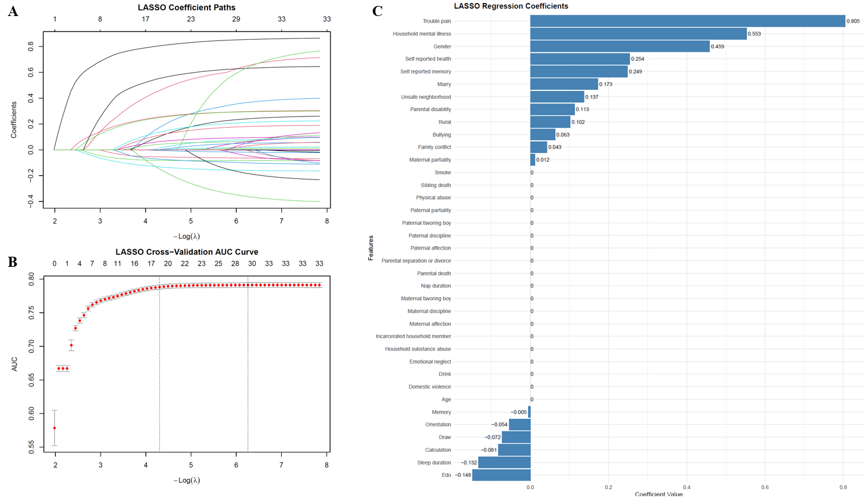
Notes: (A) Shows the coefficient paths as the regularization parameter (log λ) changes. (B) Shows the mean cross-validated AUC across values of log λ; the selected 1-SE λ was used for feature selection. (C) Displays the retained features and their coefficients at the selected 1-SE λ. AUC: area under the receiver operating characteristic curve; LASSO: least absolute shrinkage and selection operator.

Figure S2 Feature selection with Elastic Net
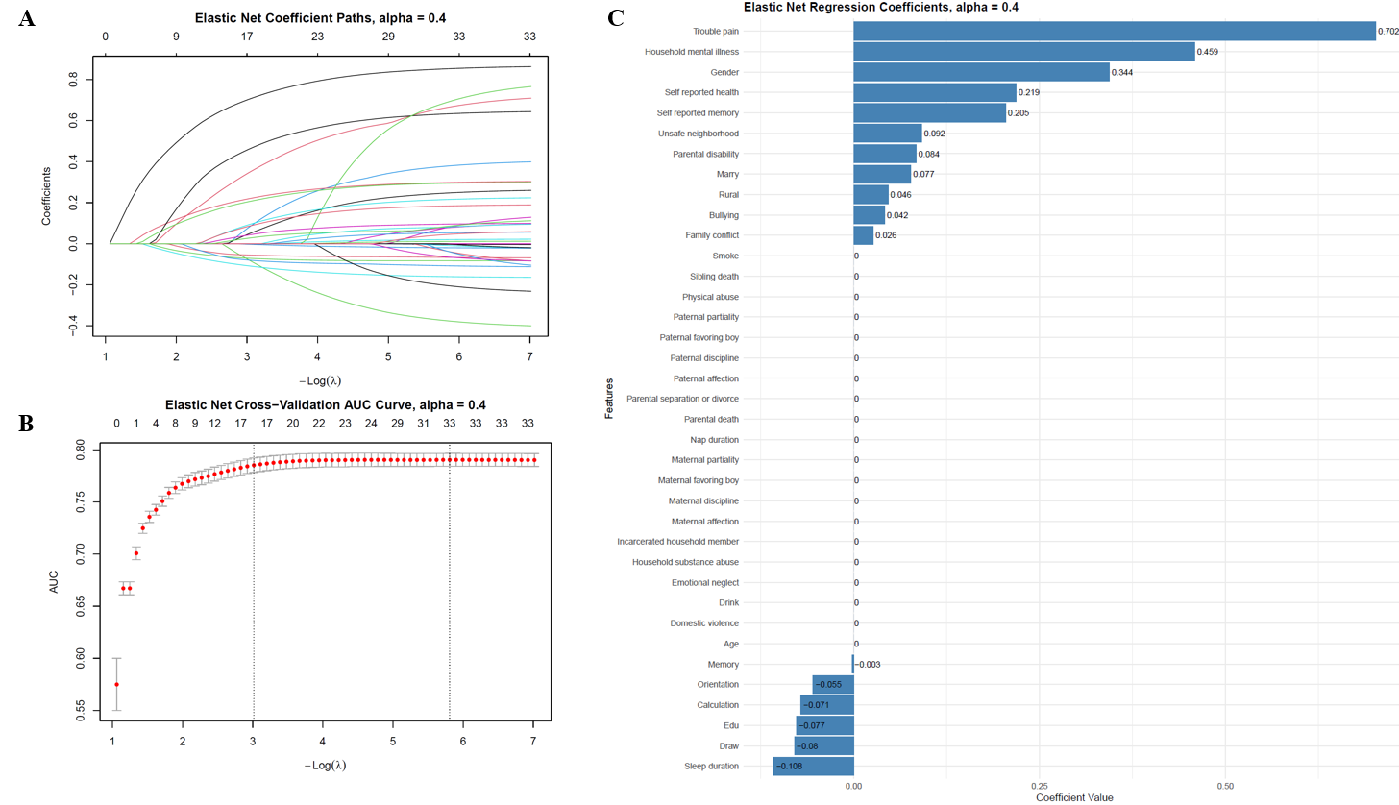
Notes: (A) Shows the coefficient paths as the regularization parameter (log λ) changes. (B) Shows the mean cross-validated AUC across values of log λ; the selected 1-SE λ was used for feature selection. (C) Displays the retained features and their coefficients at the selected 1-SE λ. AUC: area under the receiver operating characteristic curve.

Figure S3 Feature selection with Boruta
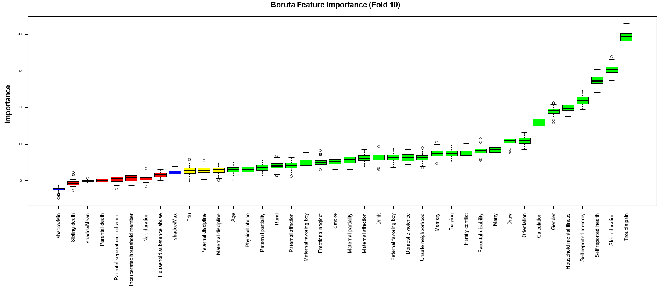
Notes: the blue plot displays the minimum, average, and maximum shadow scores, while variables are color-coded by importance: green for confirmed important features, yellow for tentative candidates, and red for rejected ones.

Figure S4 Confusion matrices
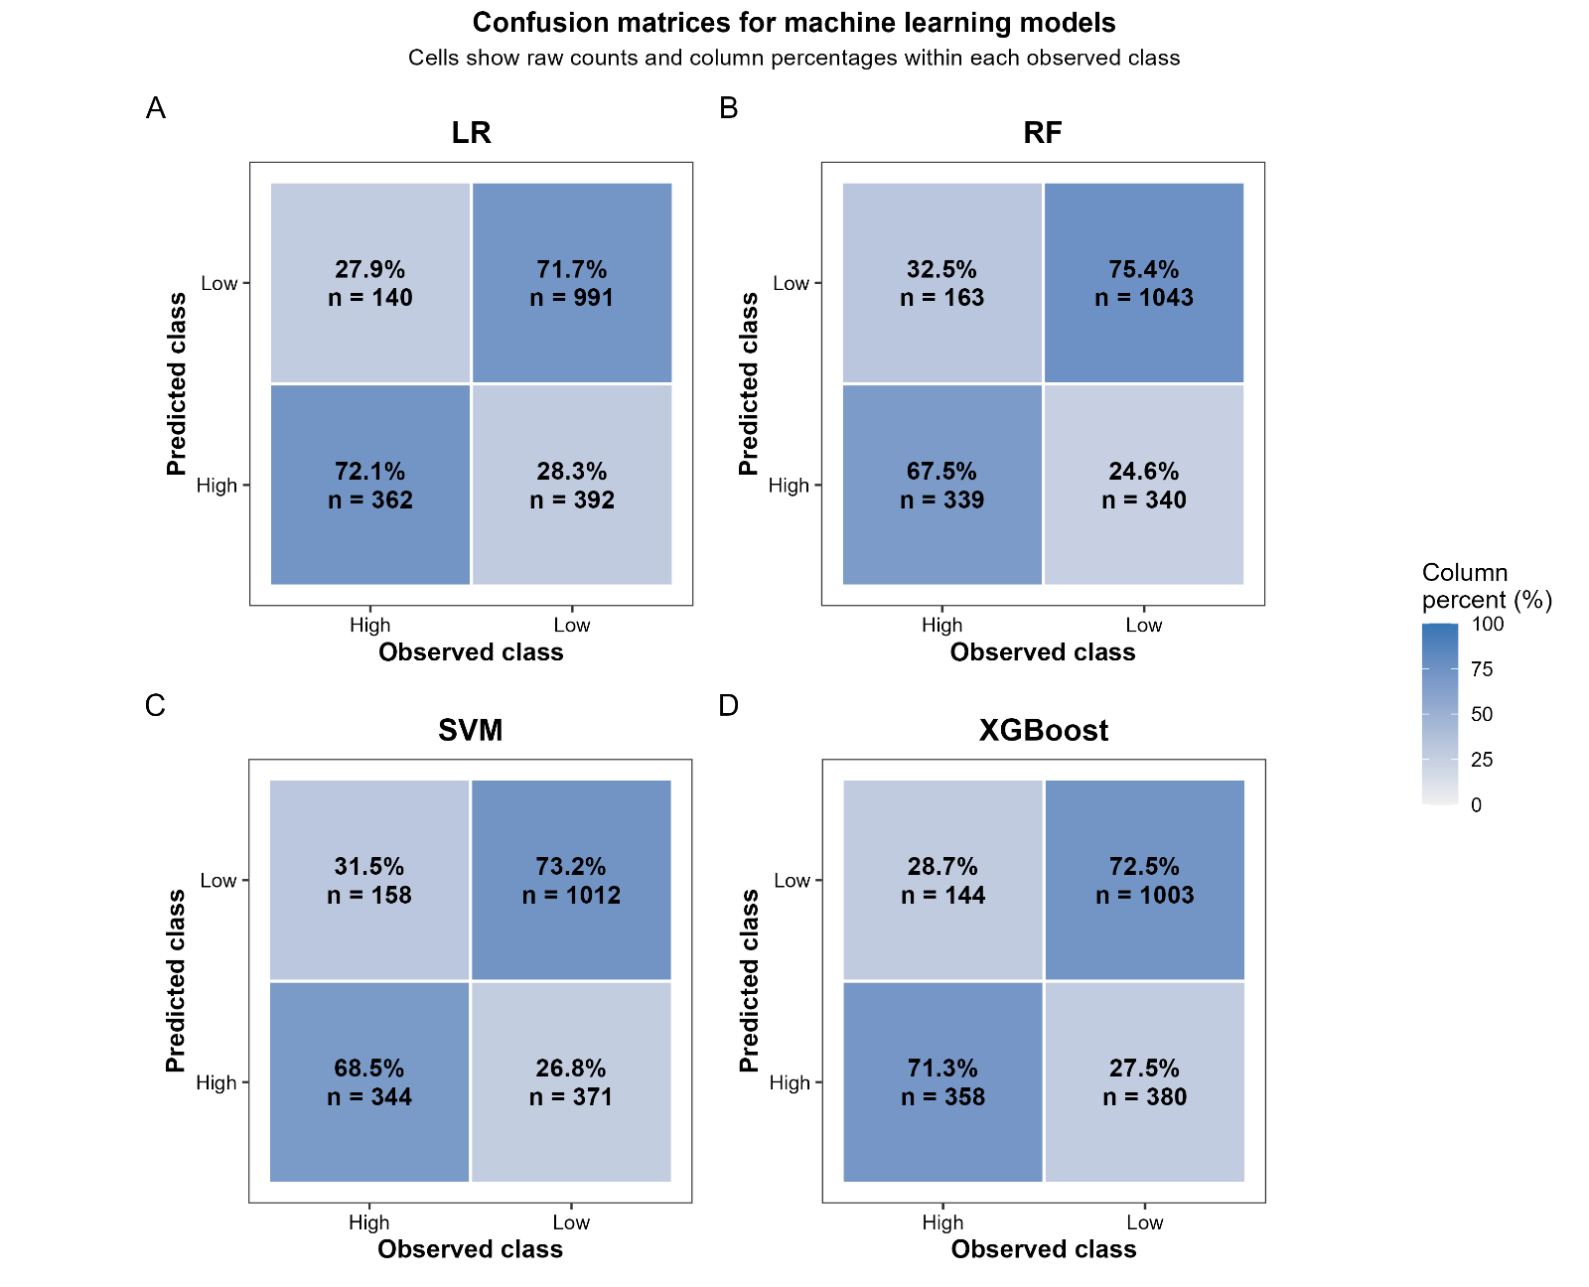
Notes: LR, logistic regression; RF, random forest; SVM, supported vector machine; XGBoost, extreme gradient boosting.

Figure S5 Calibration and Clinical Utility of the Machine-Learning Models 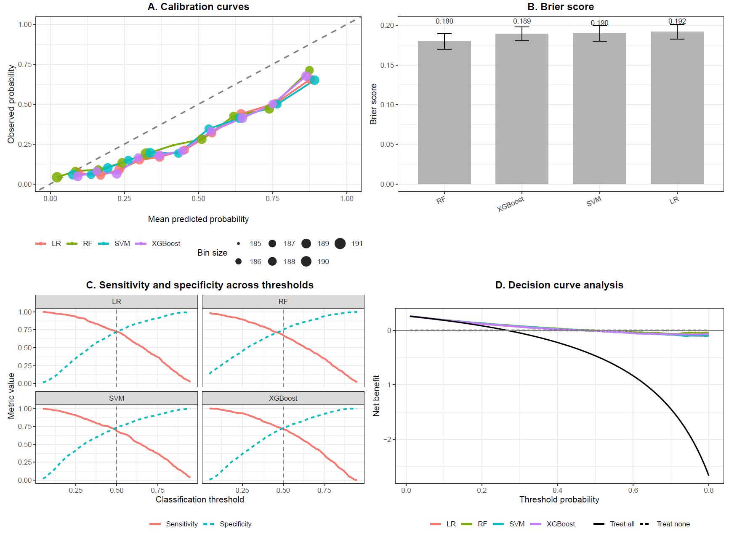 Notes: (A) Calibration curves comparing mean predicted probabilities with observed probabilities in the independent test set. The diagonal dashed line represents perfect calibration, and point size represents the number of participants within each probability bin. (B) Brier scores for each model; lower values indicate better overall probabilistic accuracy. (C) Sensitivity and specificity across classification thresholds for each model; the vertical dashed line indicates the prespecified threshold of 0.50. (D) Decision curve analysis showing the net benefit of each model across a range of threshold probabilities, together with the “treat all” and “treat none” strategies. LR, logistic regression; RF, random forest; SVM, support vector machine; XGBoost, extreme gradient boosting.

Figure S6 Features selected using a three-stage consensus strategy in the sensitivity analysis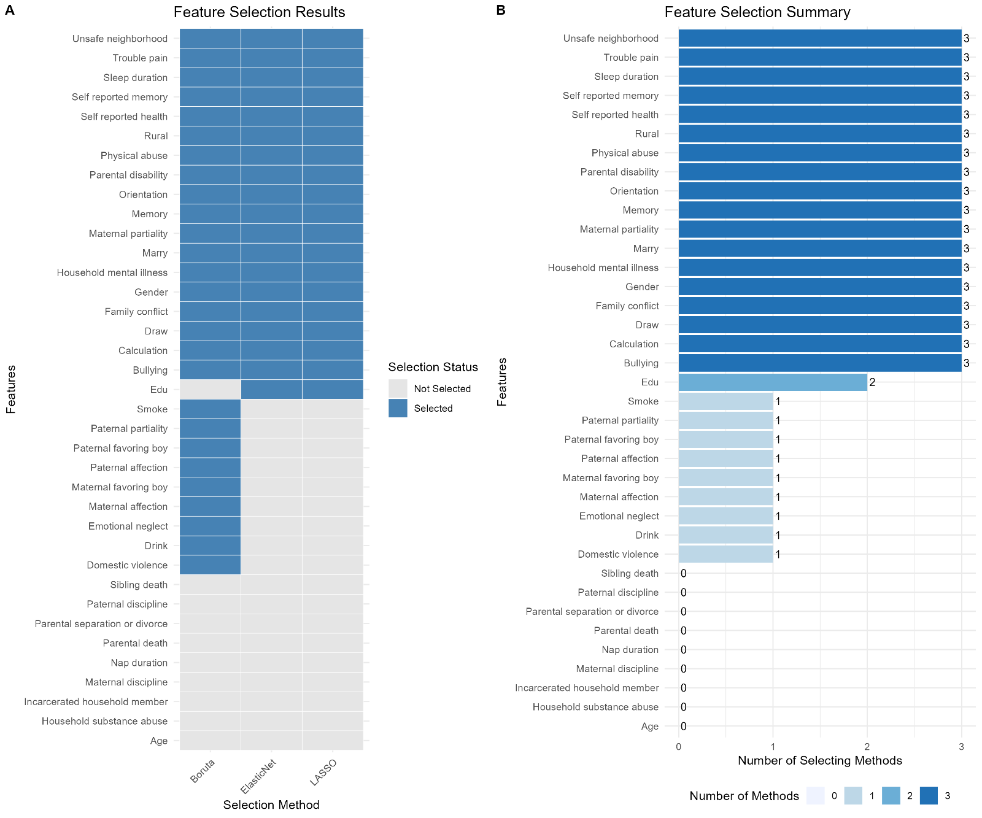

Figure S7 Receiver operating characteristic curves for four machine-learning models in the sensitivity analysis
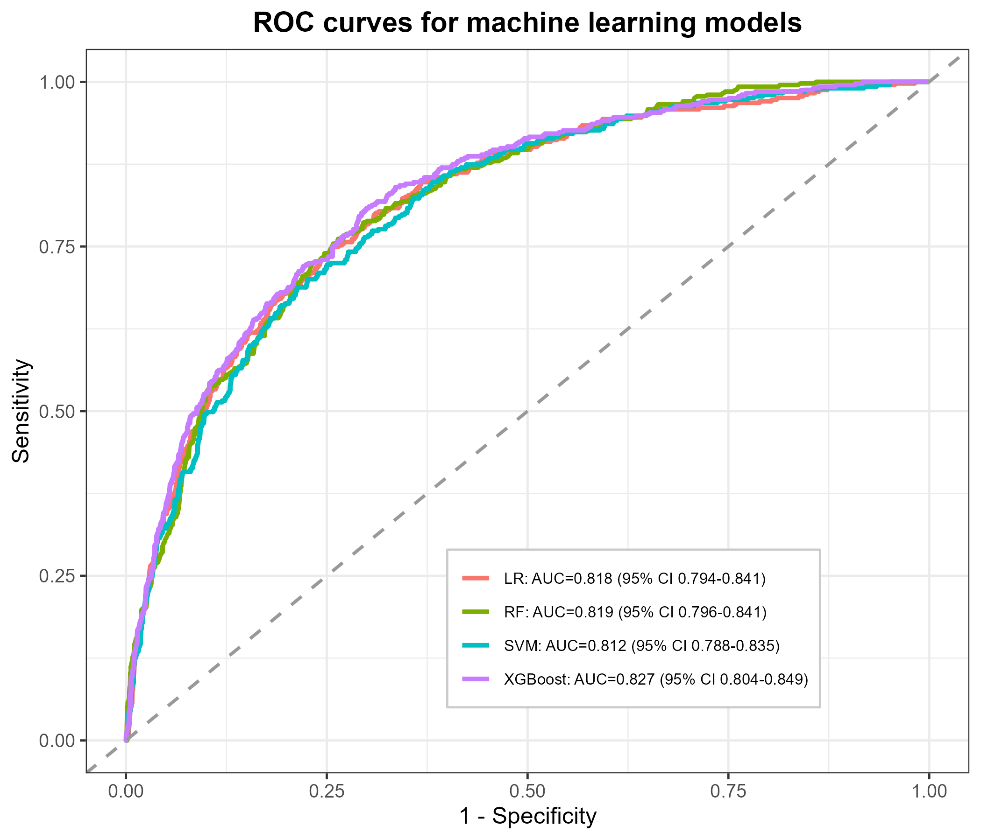
Notes: AUC, area under the receiver operating characteristic curve; LR, logistic regression; RF, random forest; SVM, support vector machine; XGBoost, extreme gradient boosting.

Figure S8 Model interpretation in the sensitivity analysis
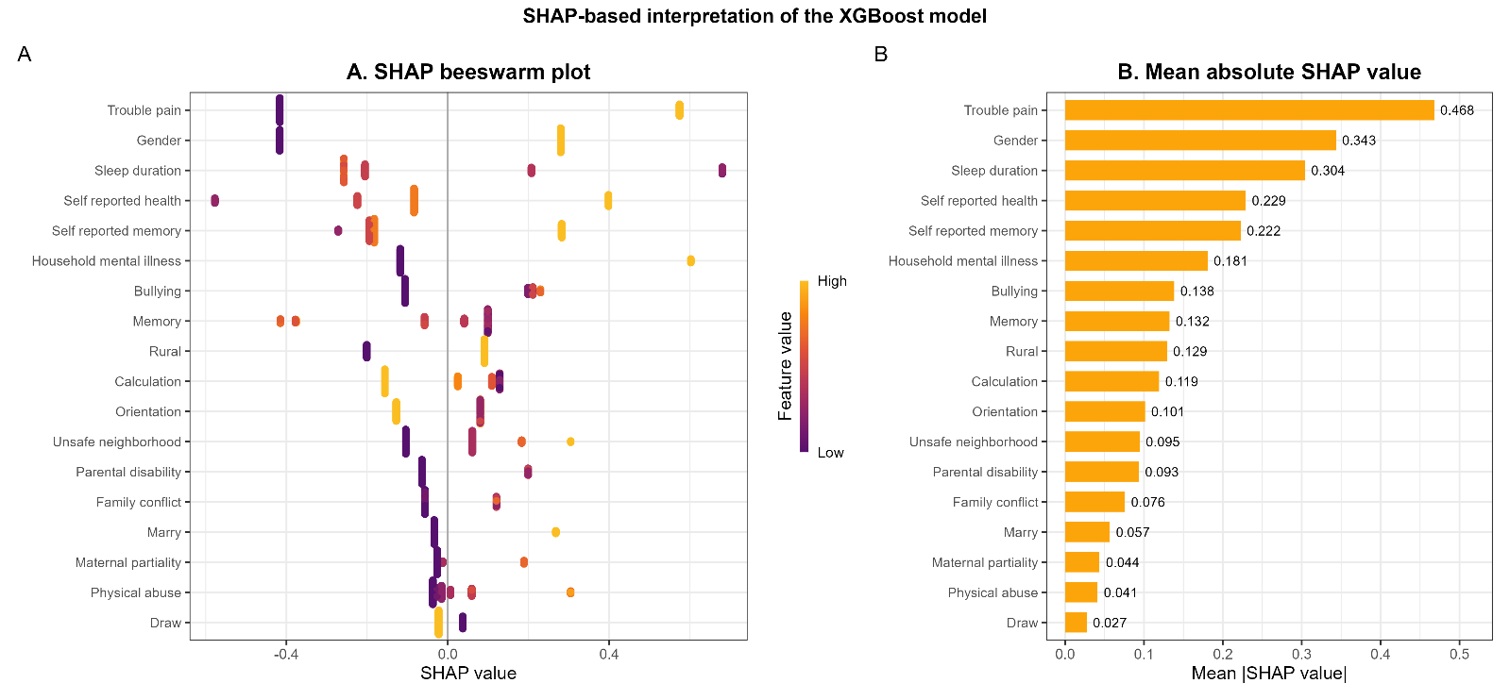
Notes: (A) SHAP summary (beeswarm) plot showing the distribution of SHAP values for each feature. The color gradient represents feature values, with yellow indicating high values and purple indicating low values. Positive SHAP values indicate an increased predicted risk, whereas negative SHAP values indicate a decreased predicted risk. (B) SHAP feature-importance plot ranking features according to their mean absolute SHAP values.

