Effects of Cognitive Behavioral Therapy on Psychological Distress in Patients with Cancer: A Systematic Review and Meta-analysis
Shuang Zheng, MSN^{1,2} ORCID: 0009-0004-0345-4873 Email: ShuangZ_frost@126.com
Li Tang, MSN^{1,2} ORCID: 0009-0006-1967-1789 Email: wyb15974433959@163.com
Hongzhen Zhou, PhD^{1,2*} ORCID: 0000-0001-7740-6779 Email: zhouhongzhen@i.smu.edu.cn
*Correspondence: Hongzhen Zhou
¹ Department of Nursing, Nanfang Hospital, Southern Medical University, Guangzhou, China
² School of Nursing, Southern Medical University, Guangzhou, China
- Funnel plot for publication bias in psychological distress.
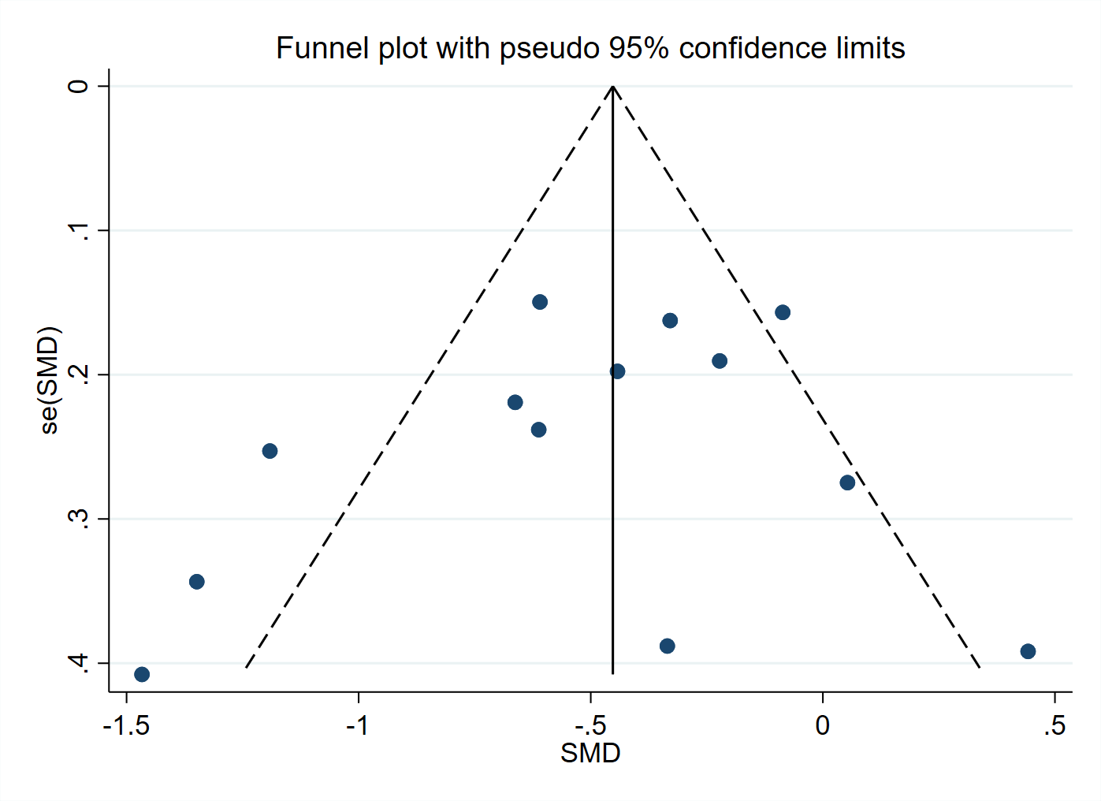
- Funnel plot for publication bias in QoL.
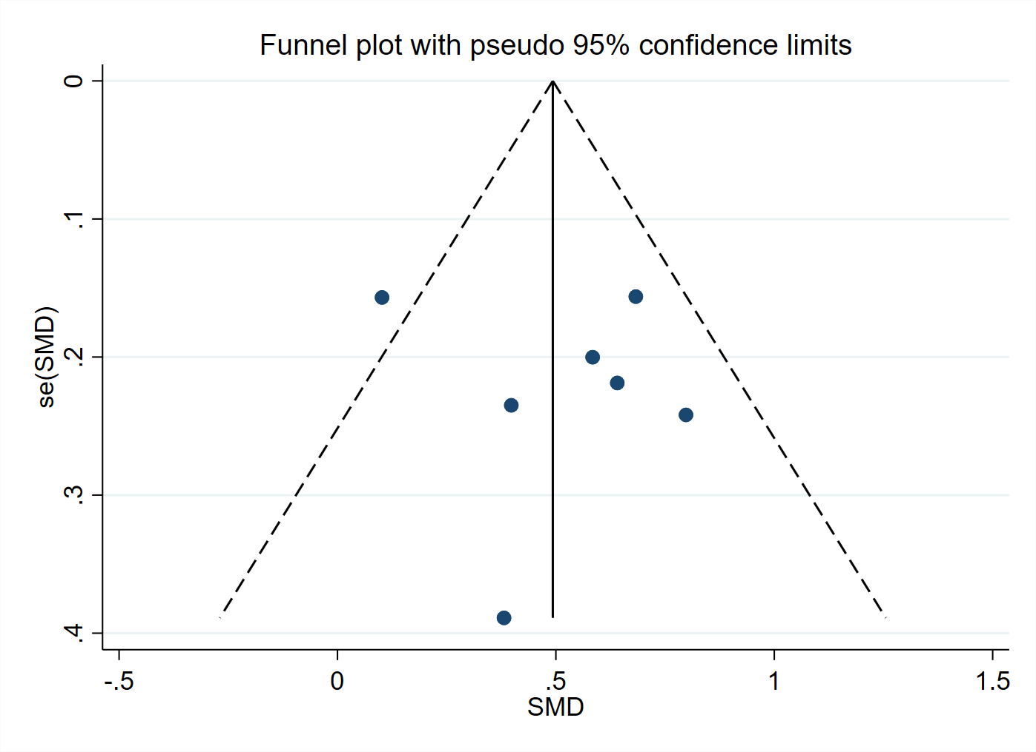
- Funnel plot for publication bias in fatigue.
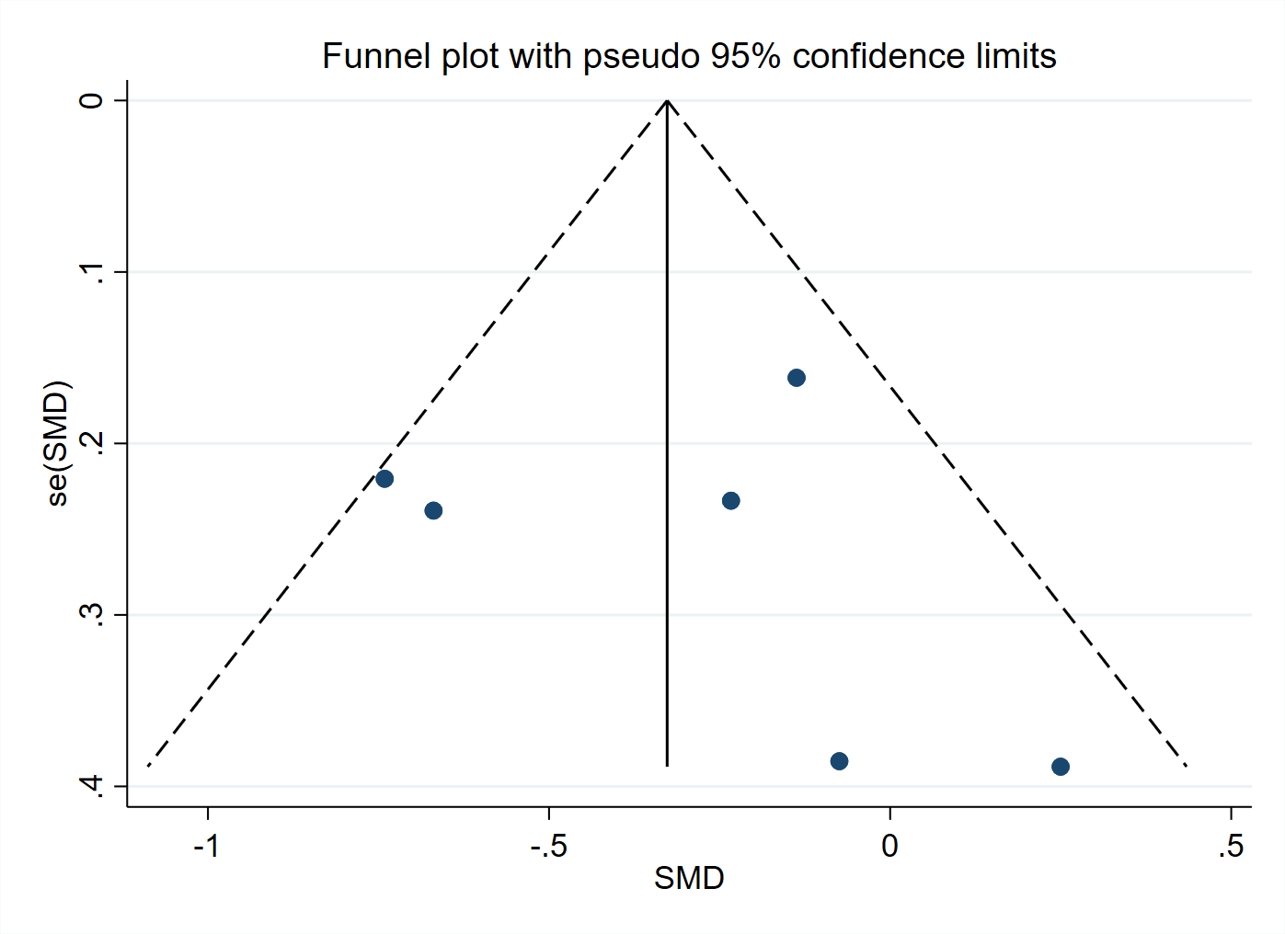
- Funnel plot for publication bias in fear of cancer recurrence.
