Additional file 1: Supplementary materials
Effects of structured exercise training on pain and multidimensional symptom burden in women with endometriosis: an updated systematic review and meta-analysis

Supplementary Tables S1–S15 follow their first substantive citation in the main text. They document protocol amendments, searches, source ambiguities, result selection, effect estimates, model comparisons, sensitivity analyses, clinical thresholds, full-text decisions, trial-report linkage, PRISMA accounting, single-trial outcomes, harms, risk of bias and certainty. Figures S1–S12 provide the additional forest plots and result-level risk-of-bias display.
Throughout, negative values favour structured exercise. All pooled estimates are random-effects estimates with the between-study variance estimated by restricted maximum likelihood and a Hartung–Knapp confidence interval unless otherwise stated.
For reference, trial and synthesis abbreviations used throughout the tables below are defined once here rather than repeated in each table. Trial labels: T1 AbrilCoello = Abril-Coello 2026 [25]; T2 Gabrielsen = Gabrielsen 2025/2026 [31,32]; T3 Goncalves = Gonçalves 2017 [33]; T4 HaPPI = Evans 2026 [29], the HaPPI trial; T5 PhysioEndEA = Artacho-Cordón 2023/Salinas-Asensio 2025 [26,27], the Physio-EndEA trial; T6 Carpenter = Carpenter 1995 [28]. Synthesis identifiers correspond to the outcomes in Table 3 as follows: PAIN_SMD, overall endometriosis-related pain; EHP30_PAIN_MD, EHP-30 pain domain; EHP30_TOTAL_MD, disease-specific quality of life (EHP-30 total); EQVAS_MD, general quality of life (EQ-VAS); HRQOL_SMD, trial-level quality of life; PSYCH_DISTRESS_SMD, psychological distress; SLEEP_SMD, sleep; FSFI_MD, sexual function; PCS_MD, pain catastrophising; PERIOD_PAIN_MD, period pain; SEXUAL_PAIN_MD, sexual pain; MENSTRUAL_SYMPTOMS_SMD, menstrual symptoms; FATIGUE_SMD, fatigue; GI_SMD, gastrointestinal symptoms.

Table S1. Protocol amendments and deviations from the registered plan.
ID | Date | Element | As registered | As applied | Reason | Effect on the review
A1 | 20 Aug 2026 | Information sources | Five databases named at registration (CENTRAL, Embase, PubMed, Science Citation Index Expanded, Scopus) | Six databases: PubMed, Embase, CENTRAL, Web of Science Core Collection, Scopus and SPORTDiscus | SPORTDiscus indexes sports and exercise science journals that are incompletely covered by the biomedical databases, and the intervention of interest is an exercise intervention. Web of Science Core Collection was searched in place of the registered Science Citation Index Expanded, which it contains. Both departures from the registered source list are recorded here. | SPORTDiscus adds 33 records and no included trial; the broader Web of Science interface adds no included trial. Recorded here for transparency
A2 | 20 Aug 2026 | Search date | No date restriction; search executed to 1 March 2026 | Complete search re-executed in all six databases to 20 August 2026 | Peer-review request to update the search to a date close to resubmission | Adds one eligible trial and one companion report of an included trial
A3 | 23 Aug 2026 | Outcome selection | Primary outcomes listed without an operational hierarchy | Locked hierarchy for construct, instrument, recall period and timepoint; one result per trial per synthesis; single-item pain ratings within generic utility instruments excluded from the pain synthesis | Several trials reported multiple eligible pain measures, timepoints and analyses, so an availability-based rule was required to prevent outcome-driven selection | Determines which result each trial contributes; selected and non-selected alternatives are documented in Table S4 and quantified in Tables S5–S7.
A4 | 23 Aug 2026 | Effect estimate | Not specified at registration | Locked hierarchy: published baseline-adjusted or longitudinal between-group estimate, then final-value difference, then change-score difference, combined by generic inverse variance | The previously submitted analysis recomputed unadjusted post-intervention contrasts instead of retaining the published adjusted treatment estimates and their model-based precision. | Principal driver of the change in results; selected inputs are documented in Table S5 and model dependence in Tables S6–S7.
A5 | 23 Aug 2026 | Statistical model | Random-effects meta-analysis, estimator not specified | Restricted maximum likelihood with a Hartung–Knapp confidence interval as the primary model, with five comparison models and an explicit classification of method dependence | With two to four trials per synthesis the normal-approximation interval understates uncertainty | Reported in full in Table S6
A6 | 23 Aug 2026 | Risk of bias | RoB 2; one person or machine assessed, checked by at least one other person. A trial-level rather than result-level unit was not specified. | Reported conduct: two independent result-level assessments with discussion and third-reviewer resolution; full signalling worksheets and algorithm checks. | RoB 2 judgements are specific to a result, including its outcome, measurement and timepoint | Changes several judgements in both directions; see Table S14
A7 | 23 Aug 2026 | Certainty of evidence | GRADE, imprecision criteria not specified | Clinical decision thresholds and optimal information size defined from published anchors and locked before certainty rating | Imprecision should not be judged on whether an interval crosses the null | Thresholds were not registered prospectively; recorded as a limitation
A8 | 23 Aug 2026 | Outcomes not pooled | Fatigue and gastrointestinal symptoms were planned for pooling only if at least two sufficiently comparable and usable trial results were available. | Reported as single-trial results without a pooled estimate | One contributing result for each outcome could not be assigned a defensible variance or orientation from the source report, and the instruments measure non-equivalent constructs | No pooled estimate or forest plot is presented for either outcome
A9 | 23 Aug 2026 | Unit of analysis | Not specified at registration | Group-level denominators reconstructed for one trial from the reported total analysed number and a flow diagram documenting no loss from the control arm | The trial would otherwise have been excluded from all pooled analyses despite meeting every eligibility criterion | Recorded per outcome in Table S5; quantified in sensitivity analyses S1 and S7 in Table S7.
A10 | 20 May 2026 (registration); review-stage amendments dated 23 Aug 2026 | Registered record | Version 1.0 (20 May 2026): anxiety, depression and fatigue prioritised; Yiqiang Wang listed as guarantor/contact with Weibao Liang. | Pain designated primary; eligibility narrowed to repeated active exercise, non-exercise controls and randomized/quasi-randomized designs. Current manuscript authors differ from the registered team; no public-record update or consent status is presumed. | The final review scope differed from the registered plan; these post-registration eligibility restrictions and the designation of pain as the primary outcome are therefore reported explicitly as protocol amendments. | No revision-stage rule was changed after inspection of the corresponding re-analysed pooled estimate; the rules were locked before the revised re-extraction.
A11 | 20 Aug 2026 | Trial-register search | No standalone trial-register interface search specified | ClinicalTrials.gov searched using the same endometriosis and structured exercise/physical-therapy concept blocks | Peer-review request to search trial registries and strengthen identification of unpublished or ongoing trials | Retrieved 68 registrations; 30 duplicated database records and 38 unique records were screened. One additional potentially eligible ongoing trial (NCT07765680) was identified; no new completed eligible results report was found.
A12 | 14 Sep 2026 | Denominator reporting and reproducibility | Outcome and SD-estimation sample sizes were not consistently distinguished. | Separate outcome and SD sample counts; harmonise reported search dates to 20 August 2026; retain distinct export provenance; rebuild the complete archive. | Minor-revision request and source-report audit. | Denominator labels corrected without changing numerical inputs. Forward citation searching remained incomplete and is reported as a review-process limitation.
A13 | 15 Sep 2026 | RoB 2 documentation | The prior worksheets abbreviated selection questions and contained answer–judgement conflicts. | Restore complete questions and reconcile domain algorithms against the available report evidence; distinguish data-usability errors from selective reporting. | Final source and algorithm check; full changes are in rob2_documentation_revision_log.csv. | 17 high-risk and 23 some-concerns results. High-risk contributors to primary syntheses and the pooled numerical results are unchanged.
A14 | 15 Sep 2026 | Final eligibility decision | Patel 2025 was originally excluded under the study-design criterion; an interim verification copy left the decision open. | Final exclusion confirmed by the review authors; retain the previously recorded study-design rationale in Table S9. | Final review-team confirmation of the previously recorded study-design decision. | Thirty reports: 22 excluded and eight included, representing six trials; five trials contribute quantitative data. No eligibility decision remains open; pooled estimates are unchanged.
A15 | Omission identified at final verification | Supplementary searches and contacts | Forward citation and conference-proceedings searches were planned. Extraction field says no author contact, but the RoB field envisages contact if information is unclear. | No completed forward-citation or standalone conference-proceedings search; trial authors were not contacted. | The actual omitted procedures are disclosed; conflicting registered contact fields are not described as a single unambiguous no-contact plan. | Potential missed evidence and unresolved reporting ambiguities remain limitations.
The registered comparator and narrative-study scope was broader than the final review, and no minimum four-week exercise duration was stated in version 1.0. These restrictions are post-registration decisions. Dates of later documentation corrections are not represented as dates of original independent assessment or analysis locking. Registration: CRD420261400459, version 1.0, first published 20 May 2026. The supplied registration is the basis of this comparison; an updated public record is not assumed.

Table S2. Full search strategies, by database and trial registry.
Database (platform); date searched | Reported search strategy | Records
PubMed (MEDLINE); 20 Aug 2026 | ("Endometriosis"[Mesh] OR endometriosis[tiab] OR endometrioma*[tiab] OR adenomyosis[tiab]) AND ("Exercise"[Mesh] OR "Exercise Therapy"[Mesh] OR "Yoga"[Mesh] OR "Physical Therapy Modalities"[Mesh] OR exercise[tiab] OR "physical activity"[tiab] OR aerobic[tiab] OR "resistance training"[tiab] OR "strength training"[tiab] OR stretching[tiab] OR yoga[tiab] OR pilates[tiab] OR "pelvic floor muscle training"[tiab] OR physiotherap*[tiab] OR "physical therapy"[tiab] OR walking[tiab]) | 477
Embase (Elsevier); 20 Aug 2026 | ('endometriosis'/exp OR endometriosis:ti,ab OR endometrioma*:ti,ab OR adenomyosis:ti,ab) AND ('exercise'/exp OR 'kinesiotherapy'/exp OR 'yoga'/exp OR 'physiotherapy'/exp OR exercise:ti,ab OR 'physical activity':ti,ab OR aerobic:ti,ab OR 'resistance training':ti,ab OR 'strength training':ti,ab OR stretching:ti,ab OR yoga:ti,ab OR pilates:ti,ab OR 'pelvic floor muscle training':ti,ab OR physiotherap*:ti,ab OR 'physical therapy':ti,ab OR walking:ti,ab); exported in three batches (100 + 200 + 500) | 800
Cochrane CENTRAL (Cochrane Library); 20 Aug 2026 | #1 MeSH descriptor: [Endometriosis] explode all trees; #2 (endometriosis OR endometrioma* OR adenomyosis):ti,ab,kw; #3 #1 OR #2; #4 MeSH descriptor: [Exercise] explode all trees; #5 MeSH descriptor: [Exercise Therapy] explode all trees; #6 MeSH descriptor: [Yoga] explode all trees; #7 (exercise OR "physical activity" OR aerobic OR "resistance training" OR "strength training" OR stretching OR yoga OR pilates OR "pelvic floor muscle training" OR physiotherap* OR "physical therapy" OR walking):ti,ab,kw; #8 #4 OR #5 OR #6 OR #7; #9 #3 AND #8, in Trials | 162
Web of Science Core Collection (Clarivate); 20 Aug 2026 | TS=(endometriosis OR endometrioma* OR adenomyosis) AND TS=(exercise OR "physical activity" OR aerobic OR "resistance training" OR "strength training" OR stretching OR yoga OR pilates OR "pelvic floor muscle training" OR physiotherap* OR "physical therapy" OR walking) | 533
Scopus (Elsevier); 20 Aug 2026 | TITLE-ABS-KEY(endometriosis OR endometrioma* OR adenomyosis) AND TITLE-ABS-KEY(exercise OR "physical activity" OR aerobic OR "resistance training" OR "strength training" OR stretching OR yoga OR pilates OR "pelvic floor muscle training" OR physiotherap* OR "physical therapy" OR walking) | 1192
SPORTDiscus (EBSCOhost); 20 Aug 2026 | S1 (DE "ENDOMETRIOSIS") OR TI (endometriosis OR endometrioma* OR adenomyosis) OR AB (endometriosis OR endometrioma* OR adenomyosis); S2 (DE "EXERCISE") OR (DE "YOGA") OR TI (exercise OR "physical activity" OR aerobic OR "resistance training" OR "strength training" OR stretching OR yoga OR pilates OR "pelvic floor muscle training" OR physiotherap* OR "physical therapy" OR walking) OR AB (exercise OR "physical activity" OR aerobic OR "resistance training" OR "strength training" OR stretching OR yoga OR pilates OR "pelvic floor muscle training" OR physiotherap* OR "physical therapy" OR walking); S3 S1 AND S2 | 33
ClinicalTrials.gov; 20 Aug 2026 | (AREA[ConditionSearch]endometriosis OR AREA[ConditionSearch]endometrioma OR AREA[ConditionSearch]adenomyosis) AND (AREA[InterventionSearch]exercise OR AREA[InterventionSearch]"physical activity" OR AREA[InterventionSearch]aerobic OR AREA[InterventionSearch]"resistance training" OR AREA[InterventionSearch]"strength training" OR AREA[InterventionSearch]stretching OR AREA[InterventionSearch]yoga OR AREA[InterventionSearch]pilates OR AREA[InterventionSearch]"pelvic floor muscle training" OR AREA[InterventionSearch]physiotherapy OR AREA[InterventionSearch]"physical therapy" OR AREA[InterventionSearch]walking) | 68
Backward citation searching; Aug 2026 | Reference lists of all eight included reports were screened for records not retrieved by the database search | 2
Forward citation searching | Not performed for the eight included reports; stated as a retrieval limitation. | Not applicable
Total records identified from bibliographic databases (registry and citation-search records are listed separately) |  | 3197
tiab, title/abstract; ti,ab,kw, title/abstract/keyword; TS, topic; DE, descriptor (subject heading); * truncation. The six bibliographic databases were searched from inception to 20 August 2026 with no language restriction or study-design filter. ClinicalTrials.gov was searched on 20 August 2026 with the same two concept blocks and no recruitment-status or results filter. The six database searches identified 3,197 records; after removal of 1,327 duplicates, 1,870 unique database records were screened. ClinicalTrials.gov identified 68 registry records; 30 were already captured in the database search and 38 unique registrations were screened. Thirty-seven were excluded at registry-record screening, one additional potentially eligible ongoing trial (NCT07765680) was retained for surveillance, and no new completed eligible results report was identified. Two additional reports were identified by backward citation searching. SPORTDiscus was added to the five sources named in the registered protocol and this is recorded as an amendment in Table S1. Search dates are author-confirmed. The SPORTDiscus abstract-field abbreviation in the retained table has been expanded using the immediately preceding title-field terms; this is an explicit transcription expansion, not an independently verified new search. A Scopus export filename is labelled 22 August 2026; export-label and search dates are distinguished. No new database search or completed forward-citation search is claimed.

Table S3. Source-report ambiguities and their disposition.
ID | Trial | Ambiguity identified in the source report | Information that would resolve it | Impact on the analysis | How it was handled
AQ001 | T1 AbrilCoello | FSFI 3-month adjusted effect is printed as 0.3 with CI −3.1 to 2.5; the CI midpoint is −0.3. | Confirm the sign of the 3-month FSFI between-group effect and provide model SE. | Follow-up is narrative only, so no primary meta-analysis changes; affects accurate durability reporting. | Not used in the primary timepoint synthesis; retained as an unresolved follow-up reporting issue.
AQ002 | T2 Gabrielsen | Table 4 prints exercise-group guilt at 12 months as 0/2, unlike adjacent denominators of 17–28. | Confirm the correct numerator and denominator for guilt at 12 months. | Narrative binary-symptom table only; no primary meta-analysis effect. | Not used in any quantitative synthesis; retained as an unresolved narrative reporting issue.
AQ003 | T2 Gabrielsen | The published supporting table reporting exact full-sample FSFI subdomain effects was not available at the time of the initial extraction. | Provide Supporting Table S2 or the exact adjusted MD, 95% CI and analysis n for all six FSFI subdomains at 4 and 12 months. | Does not change the locked review-stage FSFI-total synthesis; needed for a complete candidate inventory and selective-reporting audit. | Resolved from the published supplementary table; the full-sample FSFI total remains the primary result.
AQ004 | T3 Gonçalves | EHP-30 group-level sample sizes are not reported; current extraction reconstructs pain 13/12 and other core domains 12/12. | Confirm group-specific analysed n for every EHP-30 core and modular domain; provide any adjusted group×time coefficient and SE/CI. | Directly determines whether T3 remains quantitative and the exact pain effect variance; triggers S1/S7. | Pain counts 13/12 were reconstructed from the reported total of 25 and no documented control-arm loss. These counts were already used for the post-intervention SD, df=23 and J=0.967033; stale 28/12 metadata were corrected in v3. Sensitivity analysis S1 excludes this result.
AQ005 | T3 Gonçalves | Control participants could receive medication and/or weekly individual physiotherapy, but physiotherapy content is not described. | Describe the control physiotherapy modalities and whether active exercise was prescribed. | May violate the non-exercise comparator rule; triggers the Gonçalves exclusion analyses S1/S7 (with high-risk exclusion assessed separately as S5) and could exclude T3 from the primary synthesis. | Potential comparator contamination was examined by exclusion sensitivity analysis and remains disclosed as a limitation.
AQ006 | T3 Gonçalves | Session duration is 90 minutes in the abstract but method components sum to approximately 120 minutes. | Confirm planned and delivered session duration. | Affects intervention-dose characteristics, not the effect estimate. | Both reported session-duration values are presented transparently; the discrepancy does not affect the effect estimate.
AQ007 | T4 HaPPI | Fatigue row is internally inconsistent: B=1.28, printed SE=1.2, z=0.64 and p=0.52. B/z implies SE=2.00. | Provide the exact mixed-model coefficient SE (or variance-covariance output) for FSI disruption. | Because T4 is one of only two fatigue trials, this internal inconsistency materially affects the variance; the T4 result was therefore not pooled. | The HaPPI fatigue result was not pooled; only the usable Physio-EndEA result is reported.
AQ008 | T4 HaPPI | Education-group satisfaction SD is printed as 9.49, implausible for the apparent scale. | Confirm the education satisfaction SD and group-specific n. | Narrative acceptability result only; no primary meta-analysis effect. | Not used in a synthesis; retained as an unresolved acceptability-reporting issue.
AQ009 | T4 HaPPI | Six- and 12-month outcomes are said to be reported separately, but that report was not included. | Provide the long-term companion report or unpublished estimates if available. | Follow-up is narrative only under the current review specification; needed for completeness and selective-reporting review. | Later follow-up was outside the primary timepoint and was not pooled; the missing companion report is disclosed.
AQ010 | T5 PhysioEndEA | Main tables label ITT n=16/15, while the flow diagram reports analysed n=13/14. | Clarify whether adjusted estimates are from all 31 randomised participants after multiple imputation or from 27 analysed participants; provide model n by outcome. | Affects SMD standardizers and S10; raw adjusted MDs remain unchanged. | Primary adjusted mean differences use the reported intention-to-treat analysis; an alternative 13/14 standardiser is examined in sensitivity analysis S10.
AQ011 | T5 PhysioEndEA | GIQLI is described as higher=better, but intervention scores decline from 59.23 to 44.46 while the paper interprets the negative adjusted effect as improvement. | Confirm the GIQLI scoring direction, whether scores were transformed/reversed, and the correct adjusted estimate sign. | One of only two gastrointestinal-symptom trials; current harmonised effect is harmful and is held from pooling. | The GIQLI result was held from pooling; only the usable KESS result is reported.
AQ012 | T5 PhysioEndEA | PFS behavioural/severity one-year means (exercise 5.92, control 3.43) conflict with the reported adjusted effect −1.29 favouring exercise. | Confirm the one-year arm means and adjusted effect for PFS behavioural/severity. | Follow-up narrative only, but necessary for accurate durability reporting and data-integrity audit. | The one-year result was not pooled and remains an unresolved follow-up reporting issue.
AQ013 | T6 Carpenter | Target pain outcomes are narrative only and arm allocation totals are incompletely reported. | Author contact would be required to obtain group-specific pain, dysmenorrhoea and dyspareunia means, standard deviations, analysed n and allocation counts. | Without these data T6 remains qualitative only; author contact is unlikely feasible for a 1995 report. | The trial remains narrative-only because no defensible target-outcome effect and precision can be reconstructed.
Trial authors were not contacted. The registration’s extraction section states that authors would not be contacted, whereas its risk-of-bias section permits additional investigator information; this discrepancy is acknowledged in the amendment log. Unresolved precision, scoring and denominator issues are handled by transparent inclusion, withholding or sensitivity rules. Data-usability problems do not automatically establish selective reporting under RoB 2 domain 5.

Table S4. Outcome- and result-selection log.
Synthesis | Trial | Selected result (outcome | instrument | timepoint | analysis) | Metric | Eligible alternatives not selected | Reason not selected | Linked sensitivity analyses
PAIN_SMD | T2 Gabrielsen | Pain | NRS 0-10 | 4 months | change_MD_4m | SMD | Gastrointestinal symptoms KESS; Psychological distress HSCL-5; Dyspareunia/dysuria symptoms Binary symptom presence; Pelvic floor function Surface EMG; Pelvic floor function Manometry | C1 for the gastrointestinal, psychological-distress and pelvic-floor measures, which are different constructs analysed in their own syntheses; C5 for the dyspareunia and dysuria items, which are reported only as symptom presence or absence. Worst/usual pelvic-genital pain on the NRS was the highest-ranked pain result available in this trial. | S3
PAIN_SMD | T3 Gonçalves | Pain | EHP-30 | 8 weeks | derived_endpoint_MD | SMD | Disease-specific HRQoL domain EHP-30 | C1: the remaining EHP-30 core and modular domains measure disease-specific quality of life rather than pain. The daily pain VAS was additionally unusable (C5) because it is presented only as a line graph. | S1; S5; S7
PAIN_SMD | T4 HaPPI | Pain | EHP-30 | 8 weeks | mixed_model_B | SMD | Disease-specific HRQoL EHP-30; General HRQoL EQ-VAS; Period pain NRS 0-10; Bowel pain NRS 0-10; Bladder pain NRS 0-10; Sexual pain NRS 0-10; Menstrual symptoms Menstrual symptoms questionnaire; Pain catastrophising PCS; Central sensitization FM-2016 symptoms; Psychological distress DASS-21; Pain self-efficacy Pain Self-Efficacy Questionnaire; Sleep Jenkins Sleep Scale | C2 for the site-specific NRS pain items, because the locked hierarchy ranks overall pain above site-specific pain and the EHP-30 pain domain above VAS/NRS; C1 for the quality-of-life, menstrual, catastrophizing, central-sensitisation, distress, self-efficacy and sleep measures, each analysed in its own synthesis. | S4; S6; S8
PAIN_SMD | T5 PhysioEndEA | Pain | EHP-30 | 9 weeks | adjusted_posthoc_T1 | SMD | Disease-specific HRQoL domain EHP-30; Disease-specific HRQoL EHP-30; Pain NRS 0-10; Period pain NRS 0-10; Sexual pain NRS 0-10; Bowel pain NRS 0-10; Bladder pain NRS 0-10; Pain catastrophising PCS; Pressure pain threshold Algometry | C2 for the site-specific NRS pain items, which rank below the EHP-30 pain domain; C1 for the quality-of-life, catastrophizing and pressure-pain-threshold measures, which are different constructs or are not patient-reported. | S10; S4
EHP30_PAIN_MD | T3 Gonçalves | Pain | EHP-30 | 8 weeks | derived_endpoint_MD | MD | Disease-specific HRQoL domain EHP-30 | C1: this synthesis is restricted to the EHP-30 pain domain, and the remaining EHP-30 domains measure disease-specific quality of life. | —
EHP30_PAIN_MD | T4 HaPPI | Pain | EHP-30 | 8 weeks | mixed_model_B | MD | Disease-specific HRQoL EHP-30; General HRQoL EQ-VAS; Period pain NRS 0-10; Bowel pain NRS 0-10; Bladder pain NRS 0-10; Sexual pain NRS 0-10; Menstrual symptoms Menstrual symptoms questionnaire; Pain catastrophising PCS; Central sensitization FM-2016 symptoms; Psychological distress DASS-21; Pain self-efficacy Pain Self-Efficacy Questionnaire; Sleep Jenkins Sleep Scale | C1 for the alternatives that measure other constructs; C2 for the site-specific NRS pain items, which are not the instrument that defines this synthesis. | S6; S8
EHP30_PAIN_MD | T5 PhysioEndEA | Pain | EHP-30 | 9 weeks | adjusted_posthoc_T1 | MD | Disease-specific HRQoL domain EHP-30; Disease-specific HRQoL EHP-30; Pain NRS 0-10; Period pain NRS 0-10; Sexual pain NRS 0-10; Bowel pain NRS 0-10; Bladder pain NRS 0-10; Pain catastrophising PCS; Pressure pain threshold Algometry | C1 for the alternatives that measure other constructs; C2 for the NRS pain items and the pressure-pain threshold, which are not the instrument that defines this synthesis. | —
PERIOD_PAIN_MD | T4 HaPPI | Period pain | NRS 0-10 | 8 weeks | mixed_model_B | MD | Pain EHP-30; Disease-specific HRQoL EHP-30; General HRQoL EQ-VAS; Bowel pain NRS 0-10; Bladder pain NRS 0-10; Sexual pain NRS 0-10; Menstrual symptoms Menstrual symptoms questionnaire; Pain catastrophising PCS; Central sensitization FM-2016 symptoms; Psychological distress DASS-21; Pain self-efficacy Pain Self-Efficacy Questionnaire; Sleep Jenkins Sleep Scale | C1: this synthesis is restricted to dysmenorrhoea on a 0-10 NRS, so all listed alternatives measure another construct or another pain site and enter their own syntheses. | S6; S8
PERIOD_PAIN_MD | T5 PhysioEndEA | Period pain | NRS 0-10 | 9 weeks | adjusted_posthoc_T1 | MD | Pain EHP-30; Disease-specific HRQoL domain EHP-30; Disease-specific HRQoL EHP-30; Pain NRS 0-10; Sexual pain NRS 0-10; Bowel pain NRS 0-10; Bladder pain NRS 0-10; Pain catastrophising PCS; Pressure pain threshold Algometry | C1: this synthesis is restricted to dysmenorrhoea on a 0-10 NRS, so all listed alternatives measure another construct or another pain site and enter their own syntheses. | —
SEXUAL_PAIN_MD | T4 HaPPI | Sexual pain | NRS 0-10 | 8 weeks | mixed_model_B | MD | Pain EHP-30; Disease-specific HRQoL EHP-30; General HRQoL EQ-VAS; Period pain NRS 0-10; Bowel pain NRS 0-10; Bladder pain NRS 0-10; Menstrual symptoms Menstrual symptoms questionnaire; Pain catastrophising PCS; Central sensitization FM-2016 symptoms; Psychological distress DASS-21; Pain self-efficacy Pain Self-Efficacy Questionnaire; Sleep Jenkins Sleep Scale | C1: this synthesis is restricted to dyspareunia on a 0-10 NRS, so all listed alternatives measure another construct or another pain site. | S6; S8
SEXUAL_PAIN_MD | T5 PhysioEndEA | Sexual pain | NRS 0-10 | 9 weeks | adjusted_posthoc_T1 | MD | Pain EHP-30; Disease-specific HRQoL domain EHP-30; Disease-specific HRQoL EHP-30; Pain NRS 0-10; Period pain NRS 0-10; Bowel pain NRS 0-10; Bladder pain NRS 0-10; Pain catastrophising PCS; Pressure pain threshold Algometry | C1: this synthesis is restricted to dyspareunia on a 0-10 NRS, so all listed alternatives measure another construct or another pain site. | —
EHP30_TOTAL_MD | T4 HaPPI | Disease-specific HRQoL | EHP-30 | 8 weeks | mixed_model_B | MD | Pain EHP-30; General HRQoL EQ-VAS; Period pain NRS 0-10; Bowel pain NRS 0-10; Bladder pain NRS 0-10; Sexual pain NRS 0-10; Menstrual symptoms Menstrual symptoms questionnaire; Pain catastrophising PCS; Central sensitization FM-2016 symptoms; Psychological distress DASS-21; Pain self-efficacy Pain Self-Efficacy Questionnaire; Sleep Jenkins Sleep Scale | C1: this synthesis is restricted to the EHP-30 total score; the alternatives are pain, generic-utility and symptom measures reported in their own syntheses. | S6; S8
EHP30_TOTAL_MD | T5 PhysioEndEA | Disease-specific HRQoL | EHP-30 | 9 weeks | adjusted_posthoc_T1 | MD | Pain EHP-30; Disease-specific HRQoL domain EHP-30; Pain NRS 0-10; Period pain NRS 0-10; Sexual pain NRS 0-10; Bowel pain NRS 0-10; Bladder pain NRS 0-10; Pain catastrophising PCS; Pressure pain threshold Algometry | C1: this synthesis is restricted to the EHP-30 total score; the alternatives are pain, generic-utility and symptom measures reported in their own syntheses. | —
EQVAS_MD | T1 AbrilCoello | General HRQoL | EQ-VAS | 8 weeks | model_T1 | MD | Mobility EQ-5D-5L; Self-care EQ-5D-5L; Usual activities EQ-5D-5L; Pain/discomfort EQ-5D-5L; Anxiety/depression EQ-5D-5L; General HRQoL EQ-5D-5L index; Abdominal wall morphology Ultrasound thickness | C4 for the individual EQ-5D-5L dimension items, which are single items of a generic utility instrument and are excluded by rule; C1 for the remaining measures, which belong to other constructs. | —
EQVAS_MD | T4 HaPPI | General HRQoL | EQ-VAS | 8 weeks | mixed_model_B | MD | Pain EHP-30; Disease-specific HRQoL EHP-30; Period pain NRS 0-10; Bowel pain NRS 0-10; Bladder pain NRS 0-10; Sexual pain NRS 0-10; Menstrual symptoms Menstrual symptoms questionnaire; Pain catastrophising PCS; Central sensitization FM-2016 symptoms; Psychological distress DASS-21; Pain self-efficacy Pain Self-Efficacy Questionnaire; Sleep Jenkins Sleep Scale | C1: this synthesis is restricted to the EQ visual analogue scale, and every alternative listed measures a different construct. | S6; S8
HRQOL_SMD | T1 AbrilCoello | General HRQoL | EQ-5D-5L index | 8 weeks | model_T1 | SMD | Mobility EQ-5D-5L; Self-care EQ-5D-5L; Usual activities EQ-5D-5L; Pain/discomfort EQ-5D-5L; Anxiety/depression EQ-5D-5L; General HRQoL EQ-VAS; Abdominal wall morphology Ultrasound thickness | C4 for the EQ-5D-5L dimension items; C1 for the remaining constructs. The EQ-5D-5L index was used as this trial’s single quality-of-life contribution so that one trial contributes once (C6). | —
HRQOL_SMD | T4 HaPPI | Disease-specific HRQoL | EHP-30 | 8 weeks | mixed_model_B | SMD | Pain EHP-30; General HRQoL EQ-VAS; Period pain NRS 0-10; Bowel pain NRS 0-10; Bladder pain NRS 0-10; Sexual pain NRS 0-10; Menstrual symptoms Menstrual symptoms questionnaire; Pain catastrophising PCS; Central sensitization FM-2016 symptoms; Psychological distress DASS-21; Pain self-efficacy Pain Self-Efficacy Questionnaire; Sleep Jenkins Sleep Scale | C6: only one quality-of-life result per trial enters this synthesis, so the EQ-VAS result already used in the EQ-VAS synthesis was not reused; C1 for the alternatives that measure other constructs. | S6; S8
HRQOL_SMD | T5 PhysioEndEA | Disease-specific HRQoL | EHP-30 | 9 weeks | adjusted_posthoc_T1 | SMD | Pain EHP-30; Disease-specific HRQoL domain EHP-30; Pain NRS 0-10; Period pain NRS 0-10; Sexual pain NRS 0-10; Bowel pain NRS 0-10; Bladder pain NRS 0-10; Pain catastrophising PCS; Pressure pain threshold Algometry | C6: only one quality-of-life result per trial enters this synthesis, so the EHP-30 domain scores were not added to the EHP-30 total; C1 for the alternatives that measure other constructs. | S10
FATIGUE_SMD | T4 HaPPI | Fatigue | FSI | 8 weeks | mixed_model_B | SMD | Pain EHP-30; Disease-specific HRQoL EHP-30; General HRQoL EQ-VAS; Period pain NRS 0-10; Bowel pain NRS 0-10; Bladder pain NRS 0-10; Sexual pain NRS 0-10; Menstrual symptoms Menstrual symptoms questionnaire; Pain catastrophising PCS; Central sensitization FM-2016 symptoms; Psychological distress DASS-21; Pain self-efficacy Pain Self-Efficacy Questionnaire | C1 for the alternatives that measure constructs other than fatigue. The selected Fatigue Symptom Inventory result was subsequently held from pooling (C5) because the reported coefficient, standard error and test statistic are mutually inconsistent (Table S3, AQ007). | S6; S8
FATIGUE_SMD | T5 PhysioEndEA | Fatigue | Piper Fatigue Scale | 9 weeks | adjusted_posthoc_T1 | SMD | Pain EHP-30; Disease-specific HRQoL domain EHP-30; Disease-specific HRQoL EHP-30; Pain NRS 0-10; Period pain NRS 0-10; Sexual pain NRS 0-10; Bowel pain NRS 0-10; Bladder pain NRS 0-10; Pain catastrophising PCS | C1 for the alternatives that measure constructs other than fatigue; C2 for the four Piper Fatigue Scale subscales, because the total score was the prespecified summary. | S10
PSYCH_DISTRESS_SMD | T2 Gabrielsen | Psychological distress | HSCL-5 | 4 months | hscl_change | SMD | Pain NRS 0-10; Gastrointestinal symptoms KESS; Dyspareunia/dysuria symptoms Binary symptom presence; Pelvic floor function Surface EMG; Pelvic floor function Manometry | C1: the alternatives measure pain, gastrointestinal, sexual and pelvic-floor constructs. HSCL-5 was the only psychological-distress measure reported by this trial. | —
PSYCH_DISTRESS_SMD | T4 HaPPI | Psychological distress | DASS-21 | 8 weeks | mixed_model_B | SMD | Pain EHP-30; Disease-specific HRQoL EHP-30; General HRQoL EQ-VAS; Period pain NRS 0-10; Bowel pain NRS 0-10; Bladder pain NRS 0-10; Sexual pain NRS 0-10; Menstrual symptoms Menstrual symptoms questionnaire; Pain catastrophising PCS; Central sensitization FM-2016 symptoms; Pain self-efficacy Pain Self-Efficacy Questionnaire; Sleep Jenkins Sleep Scale | C1 for the alternatives that measure other constructs; C2 for the DASS-21 subscales, because the total score was used as the trial’s distress summary. | S6; S8
PSYCH_DISTRESS_SMD | T5 PhysioEndEA | Psychological distress | HADS-D | 9 weeks | adjusted_posthoc_T1 | SMD | Pain EHP-30; Disease-specific HRQoL domain EHP-30; Disease-specific HRQoL EHP-30; Pain NRS 0-10; Period pain NRS 0-10; Sexual pain NRS 0-10; Bowel pain NRS 0-10; Bladder pain NRS 0-10; Pain catastrophising PCS | C1 for the alternatives that measure other constructs; C6 because only one distress result per trial enters the synthesis, so HADS-D was used and HADS-A was not added. The use of a depression subscale is carried into the GRADE indirectness judgement (Table S15). | S10
SLEEP_SMD | T4 HaPPI | Sleep | Jenkins Sleep Scale | 8 weeks | mixed_model_B | SMD | Pain EHP-30; Disease-specific HRQoL EHP-30; General HRQoL EQ-VAS; Period pain NRS 0-10; Bowel pain NRS 0-10; Bladder pain NRS 0-10; Sexual pain NRS 0-10; Menstrual symptoms Menstrual symptoms questionnaire; Pain catastrophising PCS; Central sensitization FM-2016 symptoms; Psychological distress DASS-21; Pain self-efficacy Pain Self-Efficacy Questionnaire | C1: the alternatives measure other constructs. The Jenkins Sleep Scale was the only sleep measure reported by this trial. | S6; S8
SLEEP_SMD | T5 PhysioEndEA | Sleep | PSQI | 9 weeks | adjusted_posthoc_T1 | SMD | Pain EHP-30; Disease-specific HRQoL domain EHP-30; Disease-specific HRQoL EHP-30; Pain NRS 0-10; Period pain NRS 0-10; Sexual pain NRS 0-10; Bowel pain NRS 0-10; Bladder pain NRS 0-10; Pain catastrophising PCS | C1 for the alternatives that measure other constructs; C2 for the PSQI component scores, because the global score was used. | S10
FSFI_MD | T1 AbrilCoello | Sexual function | FSFI | 8 weeks | model_T1 | MD | Mobility EQ-5D-5L; Self-care EQ-5D-5L; Usual activities EQ-5D-5L; Pain/discomfort EQ-5D-5L; Anxiety/depression EQ-5D-5L; General HRQoL EQ-VAS; General HRQoL EQ-5D-5L index; Abdominal wall morphology Ultrasound thickness | C4 for the EQ-5D-5L dimension items; C1 for the remaining constructs. The FSFI total was the only sexual-function result reported by this trial. | —
FSFI_MD | T2 Gabrielsen | Sexual function | FSFI | 4 months | ancova_fsfi_total | MD | Pain NRS 0-10; Gastrointestinal symptoms KESS; Psychological distress HSCL-5; Dyspareunia/dysuria symptoms Binary symptom presence; Pelvic floor function Surface EMG | C1 for the alternatives that measure other constructs; C2 for the six FSFI subdomains; C3 for the 12-month follow-up; and C6 for the post-randomisation sexually active subgroup, which was not used in place of the full-sample 4-month FSFI total. | S9
FSFI_MD | T5 PhysioEndEA | Sexual function | FSFI | 9 weeks | adjusted_posthoc_T1 | MD | Pain EHP-30; Disease-specific HRQoL domain EHP-30; Disease-specific HRQoL EHP-30; Pain NRS 0-10; Period pain NRS 0-10; Sexual pain NRS 0-10; Bowel pain NRS 0-10; Bladder pain NRS 0-10; Pain catastrophising PCS | C1 for the alternatives that measure other constructs; C2 for the FSFI subdomains, because the total score was used. | —
GI_SMD | T2 Gabrielsen | Gastrointestinal symptoms | KESS | 4 months | change_MD_4m | SMD | Pain NRS 0-10; Psychological distress HSCL-5; Dyspareunia/dysuria symptoms Binary symptom presence; Pelvic floor function Surface EMG; Pelvic floor function Manometry | C1: the alternatives measure other constructs. KESS was the only gastrointestinal-symptom measure reported by this trial. | —
GI_SMD | T5 PhysioEndEA | Gastrointestinal symptoms | GIQLI | 9 weeks | adjusted_posthoc_T1 | SMD | Pain EHP-30; Disease-specific HRQoL domain EHP-30; Disease-specific HRQoL EHP-30; Pain NRS 0-10; Period pain NRS 0-10; Sexual pain NRS 0-10; Bowel pain NRS 0-10; Bladder pain NRS 0-10; Pain catastrophising PCS | C1 for the alternatives that measure other constructs. The selected GIQLI result was subsequently held from pooling (C5) because its reported direction cannot be reconciled with the scoring of the instrument (Table S3, AQ011). | S10
PCS_MD | T4 HaPPI | Pain catastrophising | PCS | 8 weeks | mixed_model_B | MD | Pain EHP-30; Disease-specific HRQoL EHP-30; General HRQoL EQ-VAS; Period pain NRS 0-10; Bowel pain NRS 0-10; Bladder pain NRS 0-10; Sexual pain NRS 0-10; Menstrual symptoms Menstrual symptoms questionnaire; Central sensitization FM-2016 symptoms; Psychological distress DASS-21; Pain self-efficacy Pain Self-Efficacy Questionnaire; Sleep Jenkins Sleep Scale | C1 for the alternatives that measure other constructs; C2 for the PCS subscales, because the total score was used. | S6; S8
PCS_MD | T5 PhysioEndEA | Pain catastrophising | PCS | 9 weeks | adjusted_posthoc_T1 | MD | Pain EHP-30; Disease-specific HRQoL domain EHP-30; Disease-specific HRQoL EHP-30; Pain NRS 0-10; Period pain NRS 0-10; Sexual pain NRS 0-10; Bowel pain NRS 0-10; Bladder pain NRS 0-10; Pressure pain threshold Algometry | C1 for the alternatives that measure other constructs; C2 for the PCS subscales, because the total score was used. | —
MENSTRUAL_SYMPTOMS_SMD | T1 AbrilCoello | Menstrual symptoms | CVM-22 | 8 weeks | model_T1 | SMD | Mobility EQ-5D-5L; Self-care EQ-5D-5L; Usual activities EQ-5D-5L; Pain/discomfort EQ-5D-5L; Anxiety/depression EQ-5D-5L; General HRQoL EQ-VAS; General HRQoL EQ-5D-5L index; Abdominal wall morphology Ultrasound thickness | C4 for the EQ-5D-5L dimension items; C1 for the remaining constructs. CVM-22 was the only menstrual-symptom measure reported by this trial. | —
MENSTRUAL_SYMPTOMS_SMD | T4 HaPPI | Menstrual symptoms | Menstrual symptoms questionnaire | 8 weeks | mixed_model_B | SMD | Pain EHP-30; Disease-specific HRQoL EHP-30; General HRQoL EQ-VAS; Period pain NRS 0-10; Bowel pain NRS 0-10; Bladder pain NRS 0-10; Sexual pain NRS 0-10; Pain catastrophising PCS; Central sensitization FM-2016 symptoms; Psychological distress DASS-21; Pain self-efficacy Pain Self-Efficacy Questionnaire; Sleep Jenkins Sleep Scale | C1: the alternatives measure other constructs. The menstrual-symptoms questionnaire total was the only eligible menstrual-symptom result in this trial. | S6; S8
Exactly one result per trial enters each synthesis. Selection followed the locked construct, instrument, recall-period and timepoint hierarchy set out in the Methods and was based on outcome availability alone; no selection was made on the basis of the direction or statistical significance of a result. The log documents review-level result selection. It does not itself establish whether a primary trial selected a published result on the basis of its findings; that separate question is assessed under RoB 2 domain 5 in Table S14. Reason codes: C1, the alternative measures a different construct and is analysed in its own synthesis; C2, lower-ranked instrument, subscale or component within the same construct; C3, later follow-up timepoint, because the end-of-intervention result was primary; C4, single item of a generic utility instrument, excluded by rule; C5, no usable between-group estimate, precision or scoring direction; C6, a second result from the same trial that would have made the trial contribute twice.

Table S5. Study-level effect estimates used in every synthesis.
Synthesis | Trial | Instrument (subscale) | Timepoint | Analysis used | Reported effect | Harmonised effect | SE | Variance | Metric | Outcome n  exp / ctrl | Standardiser; SD sample; df; Hedges J | Source
EHP30_PAIN_MD | T3 Gonçalves | EHP-30 (Pain) | 8 weeks | Final-value between-group difference | −22.66 | −22.660 | 8.692 | 75.5467 | MD | 13 / 12 | — | p. 5; Table 3
EHP30_PAIN_MD | T4 HaPPI | EHP-30 (Pain domain) | 8 weeks | Mixed-model group×time coefficient | −1.11 | −1.110 | 2.260 | 5.1076 | MD | 71 / 73 | — | p. 9-10; Tables 3 and 4
EHP30_PAIN_MD | T5 PhysioEndEA | EHP-30 (Pain domain) | 9 weeks | Adjusted (ANCOVA) between-group difference | −12.29 | −12.290 | 5.247 | 27.5357 | MD | 16 / 15 | — | p. 6; Table 2
EHP30_TOTAL_MD | T4 HaPPI | EHP-30 (Total score) | 8 weeks | Mixed-model group×time coefficient | −0.82 | −0.820 | 2.200 | 4.8400 | MD | 71 / 73 | — | p. 9-10; Tables 3 and 4
EHP30_TOTAL_MD | T5 PhysioEndEA | EHP-30 (Total score) | 9 weeks | Adjusted (ANCOVA) between-group difference | −9.08 | −9.080 | 4.357 | 18.9847 | MD | 16 / 15 | — | p. 6; Table 2
EQVAS_MD | T1 AbrilCoello | EQ-VAS (Global health VAS) | 8 weeks | Adjusted model between-group difference | 14.80 | −14.800 | 4.541 | 20.6190 | MD | 19 / 21 | — | p. 5; Table 1
EQVAS_MD | T4 HaPPI | EQ-VAS (Global health) | 8 weeks | Mixed-model group×time coefficient | 3.28 | −3.280 | 2.960 | 8.7616 | MD | 70 / 73 | — | p. 9-10; Tables 3 and 4
FATIGUE_SMD | T4 HaPPI | FSI (Disruption/interference subscale) | 8 weeks | Mixed-model group×time coefficient; held from pooling because precision is unresolved | 1.28 | 0.084 | 0.131 | 0.0171 | SMD | 70 / 73 | Baseline SD=15.22252188; nSD=93/83; df=174; J=0.995683 | p. 9-10; Tables 3 and 4
FATIGUE_SMD | T5 PhysioEndEA | Piper Fatigue Scale (Global) | 9 weeks | Adjusted (ANCOVA) between-group difference | −2.08 | −0.913 | 0.231 | 0.0532 | SMD | 16 / 15 | Baseline SD=2.21973593; nSD=16/15; df=29; J=0.973913 | p. 4; Table 1
FSFI_MD | T1 AbrilCoello | FSFI (Total score) | 8 weeks | Adjusted model between-group difference | 1.85 | −1.850 | 1.862 | 3.4680 | MD | 19 / 21 | — | p. 6; Table 3
FSFI_MD | T2 Gabrielsen | FSFI (Total score) | 4 months | Adjusted (ANCOVA) between-group difference | 3.52 | −3.520 | 1.543 | 2.3820 | MD | 37 / 36 | — | p. 5; Table 2
FSFI_MD | T5 PhysioEndEA | FSFI (Total score) | 9 weeks | Adjusted (ANCOVA) between-group difference | 0.57 | −0.570 | 1.954 | 3.8184 | MD | 16 / 15 | — | p. 6; Table 3
GI_SMD | T2 Gabrielsen | KESS (Constipation symptom score) | 4 months | Between-group difference in change | 0.00 | 0.000 | 0.189 | 0.0359 | SMD | 37 / 36 | Baseline SD=4.00000000; nSD=41/39; df=78; J=0.990354 | p. 5; Table 3
GI_SMD | T5 PhysioEndEA | GIQLI (Total score) | 9 weeks | Adjusted (ANCOVA) between-group difference; held from pooling because scoring direction is unresolved | −14.00 | 0.736 | 0.250 | 0.0623 | SMD | 16 / 15 | Baseline SD=18.51459359; nSD=16/15; df=29; J=0.973913 | p. 6; Table 3
HRQOL_SMD | T1 AbrilCoello | EQ-5D-5L index (Utility index) | 8 weeks | Adjusted model between-group difference | 0.39 | −1.412 | 0.296 | 0.0874 | SMD | 19 / 21 | Baseline SD=0.27071057; nSD=19/21; df=38; J=0.980132 | p. 5; Table 1
HRQOL_SMD | T4 HaPPI | EHP-30 (Total score) | 8 weeks | Mixed-model group×time coefficient | −0.82 | −0.052 | 0.140 | 0.0197 | SMD | 71 / 73 | Baseline SD=15.61680231; nSD=93/84; df=175; J=0.995708 | p. 9-10; Tables 3 and 4
HRQOL_SMD | T5 PhysioEndEA | EHP-30 (Total score) | 9 weeks | Adjusted (ANCOVA) between-group difference | −9.08 | −0.526 | 0.253 | 0.0638 | SMD | 16 / 15 | Baseline SD=16.80081330; nSD=16/15; df=29; J=0.973913 | p. 6; Table 2
MENSTRUAL_SYMPTOMS_SMD | T1 AbrilCoello | CVM-22 (Total score) | 8 weeks | Adjusted model between-group difference | 13.70 | −1.339 | 0.406 | 0.1651 | SMD | 19 / 21 | Baseline SD=10.02901055; nSD=19/21; df=38; J=0.980132 | p. 6; Table 3
MENSTRUAL_SYMPTOMS_SMD | T4 HaPPI | Menstrual symptoms questionnaire (Total score) | 8 weeks | Mixed-model group×time coefficient | −5.27 | −0.382 | 0.143 | 0.0204 | SMD | 53 / 50 | Baseline SD=13.72482897; nSD=73/58; df=129; J=0.994175 | p. 9-10; Tables 3 and 4
PAIN_SMD | T2 Gabrielsen | NRS 0-10 (Worst pelvic/genital pain) | 4 months | Between-group difference in change | −0.50 | −0.229 | 0.234 | 0.0547 | SMD | 36 / 35 | Baseline SD=2.16134042; nSD=41/40; df=79; J=0.990476 | p. 5; Table 3
PAIN_SMD | T3 Gonçalves | EHP-30 (Pain) | 8 weeks | Final-value between-group difference | −22.66 | −1.008 | 0.427 | 0.1824 | SMD | 13 / 12 | Post SD=21.73121488; nSD=13/12; df=23; J=0.967033 | p. 5; Table 3
PAIN_SMD | T4 HaPPI | EHP-30 (Pain domain) | 8 weeks | Mixed-model group×time coefficient | −1.11 | −0.064 | 0.130 | 0.0170 | SMD | 71 / 73 | Baseline SD=17.27082387; nSD=93/84; df=175; J=0.995708 | p. 9-10; Tables 3 and 4
PAIN_SMD | T5 PhysioEndEA | EHP-30 (Pain domain) | 9 weeks | Adjusted (ANCOVA) between-group difference | −12.29 | −0.596 | 0.255 | 0.0648 | SMD | 16 / 15 | Baseline SD=20.07126862; nSD=16/15; df=29; J=0.973913 | p. 6; Table 2
PCS_MD | T4 HaPPI | PCS (Total score) | 8 weeks | Mixed-model group×time coefficient | 0.02 | 0.020 | 1.340 | 1.7956 | MD | 67 / 72 | — | p. 9-10; Tables 3 and 4
PCS_MD | T5 PhysioEndEA | PCS (Total score) | 9 weeks | Adjusted (ANCOVA) between-group difference | −7.62 | −7.620 | 3.791 | 14.3703 | MD | 16 / 15 | — | p. 9; Table 4
PERIOD_PAIN_MD | T4 HaPPI | NRS 0-10 (Period pain) | 8 weeks | Mixed-model group×time coefficient | −0.48 | −0.480 | 0.240 | 0.0576 | MD | 69 / 71 | — | p. 9-10; Tables 3 and 4
PERIOD_PAIN_MD | T5 PhysioEndEA | NRS 0-10 (dysmenorrhoea) | 9 weeks | Adjusted (ANCOVA) between-group difference | −0.88 | −0.880 | 0.625 | 0.3906 | MD | 16 / 15 | — | p. 9; Table 4
PSYCH_DISTRESS_SMD | T2 Gabrielsen | HSCL-5 (Total score) | 4 months | Between-group difference in change | 0.00 | 0.000 | 0.233 | 0.0544 | SMD | 36 / 36 | Baseline SD=0.75448345; nSD=26/29; df=53; J=0.985782 | p. 6; Table 5
PSYCH_DISTRESS_SMD | T4 HaPPI | DASS-21 (Total score) | 8 weeks | Mixed-model group×time coefficient | −0.84 | −0.043 | 0.123 | 0.0151 | SMD | 68 / 72 | Baseline SD=19.54158366; nSD=92/83; df=173; J=0.995658 | p. 9-10; Tables 3 and 4
PSYCH_DISTRESS_SMD | T5 PhysioEndEA | HADS-D (Depression subscale) | 9 weeks | Adjusted (ANCOVA) between-group difference | −2.62 | −0.814 | 0.161 | 0.0259 | SMD | 16 / 15 | Baseline SD=3.13434039; nSD=16/15; df=29; J=0.973913 | p. 6; Table 3
SEXUAL_PAIN_MD | T4 HaPPI | NRS 0-10 (Painful sex) | 8 weeks | Mixed-model group×time coefficient | −0.74 | −0.740 | 0.290 | 0.0841 | MD | 69 / 74 | — | p. 9-10; Tables 3 and 4
SEXUAL_PAIN_MD | T5 PhysioEndEA | NRS 0-10 (Dyspareunia) | 9 weeks | Adjusted (ANCOVA) between-group difference | −1.92 | −1.920 | 0.763 | 0.5818 | MD | 16 / 15 | — | p. 9; Table 4
SLEEP_SMD | T4 HaPPI | Jenkins Sleep Scale (Total score) | 8 weeks | Mixed-model group×time coefficient | −1.11 | −0.246 | 0.124 | 0.0154 | SMD | 70 / 72 | Baseline SD=4.49596645; nSD=93/84; df=175; J=0.995708 | p. 9-10; Tables 3 and 4
SLEEP_SMD | T5 PhysioEndEA | PSQI (Total score) | 9 weeks | Adjusted (ANCOVA) between-group difference | −2.39 | −0.566 | 0.326 | 0.1060 | SMD | 16 / 15 | Baseline SD=4.11277866; nSD=16/15; df=29; J=0.973913 | p. 6; Table 3
ANCOVA, analysis of covariance; SE, standard error; SD, standard deviation; df, degrees of freedom. Negative harmonised effects favour exercise. Outcome n is the reported sample for the selected outcome, using primary-timepoint observed counts where a unique longitudinal-model N is not reported; it is not the SD-estimation sample. HaPPI counts are 8-week available-case counts, not an exact mixed-model N; Physio-EndEA retains the reported intention-to-treat table counts (16/15). Gabrielsen worst pain uses 36/35 observed values at month 4 (Table 3: 37/36 less one missing value per arm), KESS uses 37/36, and HSCL-5 uses the printed month-4 counts 36/36. The HSCL-5 baseline header gives 26/29 for its SD sample; the exact paired change-score N is not separately stated. For SMDs, nSD and df refer only to the pooled SD actually used, with J = 1 − 3/(4df − 1) and df = nSD,exp + nSD,ctrl − 2. Gonçalves uses reconstructed final-value counts 13/12 (total 25), the post-intervention pooled SD 21.731215 and df=23. Adjusted/change-score effects and SEs use the selected pooled baseline SD; the Gonçalves final-value SMD uses the approximate sampling variance, (nexp+nctrl)/(nexp×nctrl) + g²/(2df). The reporting-N/SD-sample totals are pain 271/314, trial-level HRQoL 215/248, psychological distress 243/261, sleep 173/208 and menstrual symptoms 143/171. Fatigue and gastrointestinal symptoms remain unpooled; their single usable results have reporting N=31 and N=73, respectively, and SD samples of 31 and 80. Held rows do not enter reported N or OIS. Result-by-result counts, source locations and conversions are supplied in the reviewer-only reproducibility archive.

Table S6. Comparison of meta-analytical models for every synthesis.
Synthesis | Model | k | Estimate (95% CI) | p | τ² | I² (%) | CI excludes null
PAIN_SMD | Primary: REML, Hartung–Knapp | 4 | −0.355 (−0.95 to 0.24) | 0.153 | 0.069 | 57.2 | No
 | REML, modified Hartung–Knapp | 4 | −0.355 (−0.95 to 0.24) | 0.153 | 0.069 | 57.2 | No
 | REML, normal-approximation (Wald) | 4 | −0.355 (−0.71 to −0.004) | 0.048 | 0.069 | 57.2 | Yes
 | Paule–Mandel, modified Hartung–Knapp | 4 | −0.363 (−0.96 to 0.24) | 0.149 | 0.081 | 57.2 | No
 | DerSimonian–Laird, Wald (alternative estimator) | 4 | −0.356 (−0.71 to −0.002) | 0.048 | 0.071 | 57.2 | Yes
 | Common-effect model (reference only) | 4 | −0.231 (−0.43 to −0.03) | 0.022 | 0.000 | 57.2 | Yes
EHP30_PAIN_MD | Primary: REML, Hartung–Knapp | 3 | −9.949 (−35.96 to 16.06) | 0.242 | 80.744 | 77.1 | No
 | REML, modified Hartung–Knapp | 3 | −9.949 (−36.00 to 16.10) | 0.242 | 80.744 | 77.1 | No
 | REML, normal-approximation (Wald) | 3 | −9.949 (−21.81 to 1.92) | 0.100 | 80.744 | 77.1 | No
 | Paule–Mandel, modified Hartung–Knapp | 3 | −9.943 (−35.95 to 16.07) | 0.242 | 80.429 | 77.1 | No
 | DerSimonian–Laird, Wald (alternative estimator) | 3 | −9.956 (−21.85 to 1.93) | 0.101 | 81.182 | 77.1 | No
 | Common-effect model (reference only) | 3 | −3.928 (−7.88 to 0.03) | 0.052 | 0.000 | 77.1 | No
PERIOD_PAIN_MD | Primary: REML, Hartung–Knapp | 2 | −0.531 (−2.23 to 1.17) | 0.157 | 0.000 | 0.0 | No
 | REML, modified Hartung–Knapp | 2 | −0.531 (−3.38 to 2.32) | 0.254 | 0.000 | 0.0 | No
 | REML, normal-approximation (Wald) | 2 | −0.531 (−0.97 to −0.09) | 0.018 | 0.000 | 0.0 | Yes
 | Paule–Mandel, modified Hartung–Knapp | 2 | −0.531 (−3.38 to 2.32) | 0.254 | 0.000 | 0.0 | No
 | DerSimonian–Laird, Wald (alternative estimator) | 2 | −0.531 (−0.97 to −0.09) | 0.018 | 0.000 | 0.0 | Yes
 | Common-effect model (reference only) | 2 | −0.531 (−0.97 to −0.09) | 0.018 | 0.000 | 0.0 | Yes
SEXUAL_PAIN_MD | Primary: REML, Hartung–Knapp | 2 | −1.119 (−8.12 to 5.88) | 0.291 | 0.363 | 52.2 | No
 | REML, modified Hartung–Knapp | 2 | −1.119 (−8.12 to 5.88) | 0.291 | 0.363 | 52.2 | No
 | REML, normal-approximation (Wald) | 2 | −1.119 (−2.20 to −0.04) | 0.042 | 0.363 | 52.2 | Yes
 | Paule–Mandel, modified Hartung–Knapp | 2 | −1.119 (−8.12 to 5.88) | 0.291 | 0.363 | 52.2 | No
 | DerSimonian–Laird, Wald (alternative estimator) | 2 | −1.119 (−2.20 to −0.04) | 0.042 | 0.363 | 52.2 | Yes
 | Common-effect model (reference only) | 2 | −0.889 (−1.42 to −0.36) | 0.001 | 0.000 | 52.2 | Yes
EHP30_TOTAL_MD | Primary: REML, Hartung–Knapp | 2 | −4.094 (−55.43 to 47.24) | 0.496 | 22.201 | 65.1 | No
 | REML, modified Hartung–Knapp | 2 | −4.094 (−55.43 to 47.24) | 0.496 | 22.201 | 65.1 | No
 | REML, normal-approximation (Wald) | 2 | −4.094 (−12.01 to 3.83) | 0.311 | 22.201 | 65.1 | No
 | Paule–Mandel, modified Hartung–Knapp | 2 | −4.094 (−55.43 to 47.24) | 0.496 | 22.201 | 65.1 | No
 | DerSimonian–Laird, Wald (alternative estimator) | 2 | −4.094 (−12.01 to 3.83) | 0.311 | 22.201 | 65.1 | No
 | Common-effect model (reference only) | 2 | −2.498 (−6.35 to 1.35) | 0.203 | 0.000 | 65.1 | No
EQVAS_MD | Primary: REML, Hartung–Knapp | 2 | −8.525 (−81.42 to 64.37) | 0.377 | 51.665 | 77.9 | No
 | REML, modified Hartung–Knapp | 2 | −8.525 (−81.42 to 64.37) | 0.377 | 51.665 | 77.9 | No
 | REML, normal-approximation (Wald) | 2 | −8.525 (−19.77 to 2.72) | 0.137 | 51.665 | 77.9 | No
 | Paule–Mandel, modified Hartung–Knapp | 2 | −8.525 (−81.42 to 64.37) | 0.377 | 51.665 | 77.9 | No
 | DerSimonian–Laird, Wald (alternative estimator) | 2 | −8.525 (−19.77 to 2.72) | 0.137 | 51.665 | 77.9 | No
 | Common-effect model (reference only) | 2 | −6.715 (−11.58 to −1.86) | 0.007 | 0.000 | 77.9 | Yes
HRQOL_SMD | Primary: REML, Hartung–Knapp | 3 | −0.632 (−2.34 to 1.08) | 0.252 | 0.414 | 88.8 | No
 | REML, modified Hartung–Knapp | 3 | −0.632 (−2.34 to 1.08) | 0.252 | 0.414 | 88.8 | No
 | REML, normal-approximation (Wald) | 3 | −0.632 (−1.41 to 0.14) | 0.110 | 0.414 | 88.8 | No
 | Paule–Mandel, modified Hartung–Knapp | 3 | −0.632 (−2.34 to 1.07) | 0.252 | 0.417 | 88.8 | No
 | DerSimonian–Laird, Wald (alternative estimator) | 3 | −0.631 (−1.39 to 0.13) | 0.105 | 0.398 | 88.8 | No
 | Common-effect model (reference only) | 3 | −0.347 (−0.57 to −0.13) | 0.002 | 0.000 | 88.8 | Yes
PSYCH_DISTRESS_SMD | Primary: REML, Hartung–Knapp | 3 | −0.293 (−1.43 to 0.85) | 0.385 | 0.183 | 87.6 | No
 | REML, modified Hartung–Knapp | 3 | −0.293 (−1.44 to 0.86) | 0.387 | 0.183 | 87.6 | No
 | REML, normal-approximation (Wald) | 3 | −0.293 (−0.82 to 0.23) | 0.273 | 0.183 | 87.6 | No
 | Paule–Mandel, modified Hartung–Knapp | 3 | −0.293 (−1.43 to 0.85) | 0.385 | 0.181 | 87.6 | No
 | DerSimonian–Laird, Wald (alternative estimator) | 3 | −0.293 (−0.83 to 0.24) | 0.286 | 0.195 | 87.6 | No
 | Common-effect model (reference only) | 3 | −0.278 (−0.45 to −0.10) | 0.002 | 0.000 | 87.6 | Yes
SLEEP_SMD | Primary: REML, Hartung–Knapp | 2 | −0.286 (−1.64 to 1.07) | 0.227 | 0.000 | 0.0 | No
 | REML, modified Hartung–Knapp | 2 | −0.286 (−1.76 to 1.19) | 0.245 | 0.000 | 0.0 | No
 | REML, normal-approximation (Wald) | 2 | −0.286 (−0.51 to −0.06) | 0.013 | 0.000 | 0.0 | Yes
 | Paule–Mandel, modified Hartung–Knapp | 2 | −0.286 (−1.76 to 1.19) | 0.245 | 0.000 | 0.0 | No
 | DerSimonian–Laird, Wald (alternative estimator) | 2 | −0.286 (−0.51 to −0.06) | 0.013 | 0.000 | 0.0 | Yes
 | Common-effect model (reference only) | 2 | −0.286 (−0.51 to −0.06) | 0.013 | 0.000 | 0.0 | Yes
FSFI_MD | Primary: REML, Hartung–Knapp | 3 | −2.227 (−5.96 to 1.51) | 0.124 | 0.000 | 0.0 | No
 | REML, modified Hartung–Knapp | 3 | −2.227 (−6.60 to 2.14) | 0.160 | 0.000 | 0.0 | No
 | REML, normal-approximation (Wald) | 3 | −2.227 (−4.22 to −0.24) | 0.028 | 0.000 | 0.0 | Yes
 | Paule–Mandel, modified Hartung–Knapp | 3 | −2.227 (−6.60 to 2.14) | 0.160 | 0.000 | 0.0 | No
 | DerSimonian–Laird, Wald (alternative estimator) | 3 | −2.227 (−4.22 to −0.24) | 0.028 | 0.000 | 0.0 | Yes
 | Common-effect model (reference only) | 3 | −2.227 (−4.22 to −0.24) | 0.028 | 0.000 | 0.0 | Yes
PCS_MD | Primary: REML, Hartung–Knapp | 2 | −2.977 (−50.38 to 44.42) | 0.571 | 21.102 | 72.3 | No
 | REML, modified Hartung–Knapp | 2 | −2.977 (−50.38 to 44.42) | 0.571 | 21.102 | 72.3 | No
 | REML, normal-approximation (Wald) | 2 | −2.977 (−10.29 to 4.33) | 0.425 | 21.102 | 72.3 | No
 | Paule–Mandel, modified Hartung–Knapp | 2 | −2.977 (−50.38 to 44.42) | 0.571 | 21.102 | 72.3 | No
 | DerSimonian–Laird, Wald (alternative estimator) | 2 | −2.977 (−10.29 to 4.33) | 0.425 | 21.102 | 72.3 | No
 | Common-effect model (reference only) | 2 | −0.829 (−3.30 to 1.65) | 0.512 | 0.000 | 72.3 | No
MENSTRUAL_SYMPTOMS_SMD | Primary: REML, Hartung–Knapp | 2 | −0.785 (−6.79 to 5.22) | 0.345 | 0.365 | 79.8 | No
 | REML, modified Hartung–Knapp | 2 | −0.785 (−6.79 to 5.22) | 0.345 | 0.365 | 79.8 | No
 | REML, normal-approximation (Wald) | 2 | −0.785 (−1.71 to 0.14) | 0.097 | 0.365 | 79.8 | No
 | Paule–Mandel, modified Hartung–Knapp | 2 | −0.785 (−6.79 to 5.22) | 0.345 | 0.365 | 79.8 | No
 | DerSimonian–Laird, Wald (alternative estimator) | 2 | −0.785 (−1.71 to 0.14) | 0.097 | 0.365 | 79.8 | No
 | Common-effect model (reference only) | 2 | −0.487 (−0.75 to −0.22) | <0.001 | 0.000 | 79.8 | Yes
CI, confidence interval; REML, restricted maximum likelihood. All models use the same selected effect and variance inputs. The primary specification is REML with Hartung–Knapp inference. Method dependence is assessed only across random-effects models M0–M4; M5 is a common-effect reference excluded from that classification. The five method-dependent syntheses are overall pain, period pain, sexual pain, sleep and sexual function. “Not method-dependent” means no change in significance across those random-effects models; it does not establish clinical robustness. With at most four contributing trials, between-study variance and prediction intervals are uncertain. No synthesis reached ten trials, so funnel plots and regression tests were not performed and reporting bias cannot be excluded.

Table S7. Sensitivity analyses.
ID | Analysis | Synthesis | k | Result | Note
S1 | Exclude the trial whose group-level denominators were reconstructed (Gonçalves 2017) | PAIN_SMD | 3 | −0.238 (−0.89 to 0.41), p = 0.256 | Exclude Gonçalves conditional/endpoint-only estimate.
S7 | Restrict to directly reported adjusted or longitudinal estimates | PAIN_SMD | 3 | −0.238 (−0.89 to 0.41), p = 0.256 | Retain direct adjusted/longitudinal estimates only.
S2 | Add a construct-mismatched single-item pain rating (Abril-Coello 2026) to the pain synthesis | PAIN_SMD | 5 | −0.576 (−1.24 to 0.09), p = 0.074 | Construct-mismatch sensitivity only.
S3 | Substitute current pain for worst pain in the Gabrielsen trial | PAIN_SMD | 4 | −0.425 (−1.00 to 0.15), p = 0.100 | Current pain result is more favourable but lower in locked hierarchy.
S4 | Reverse the instrument hierarchy: numeric rating scale before the EHP-30 pain domain | PAIN_SMD | 4 | −0.334 (−0.69 to 0.03), p = 0.060 | Restore NRS/VAS priority over EHP-30 for T4 and T5.
S6 | Exclude the trial carrying the largest weight in the synthesis | EHP30_PAIN_MD | 2 | −15.160 (−74.11 to 43.79), p = 0.189 | Excluded actual largest REML-weight trial: T4_HaPPI (42.70% weight).
S6 | Exclude the trial carrying the largest weight in the synthesis | EHP30_TOTAL_MD | 1 | Not pooled (fewer than two trials remain) | Excluded actual largest REML-weight trial: T4_HaPPI (60.37% weight).
S6 | Exclude the trial carrying the largest weight in the synthesis | EQVAS_MD | 1 | Not pooled (fewer than two trials remain) | Excluded actual largest REML-weight trial: T4_HaPPI (54.47% weight).
S6 | Exclude the trial carrying the largest weight in the synthesis | FSFI_MD | 2 | −1.241 (−9.36 to 6.88), p = 0.303 | Excluded actual largest REML-weight trial: T2_Gabrielsen (43.28% weight).
S6 | Exclude the trial carrying the largest weight in the synthesis | HRQOL_SMD | 2 | −0.956 (−6.58 to 4.67), p = 0.276 | Excluded actual largest REML-weight trial: T4_HaPPI (36.07% weight).
S6 | Exclude the trial carrying the largest weight in the synthesis | MENSTRUAL_SYMPTOMS_SMD | 1 | Not pooled (fewer than two trials remain) | Excluded actual largest REML-weight trial: T4_HaPPI (57.90% weight).
S6 | Exclude the trial carrying the largest weight in the synthesis | PAIN_SMD | 3 | −0.509 (−1.37 to 0.36), p = 0.127 | Excluded actual largest REML-weight trial: T4_HaPPI (37.27% weight).
S6 | Exclude the trial carrying the largest weight in the synthesis | PCS_MD | 1 | Not pooled (fewer than two trials remain) | Excluded actual largest REML-weight trial: T4_HaPPI (60.77% weight).
S6 | Exclude the trial carrying the largest weight in the synthesis | PERIOD_PAIN_MD | 1 | Not pooled (fewer than two trials remain) | Excluded actual largest REML-weight trial: T4_HaPPI (87.15% weight).
S6 | Exclude the trial carrying the largest weight in the synthesis | PSYCH_DISTRESS_SMD | 2 | −0.425 (−5.59 to 4.74), p = 0.486 | Excluded actual largest REML-weight trial: T4_HaPPI (35.94% weight).
S6 | Exclude the trial carrying the largest weight in the synthesis | SEXUAL_PAIN_MD | 1 | Not pooled (fewer than two trials remain) | Excluded actual largest REML-weight trial: T4_HaPPI (67.87% weight).
S6 | Exclude the trial carrying the largest weight in the synthesis | SLEEP_SMD | 1 | Not pooled (fewer than two trials remain) | Excluded actual largest REML-weight trial: T4_HaPPI (87.33% weight).
S8 | Exclude the remotely delivered trial (Evans 2026) | EHP30_PAIN_MD | 2 | −15.160 (−74.11 to 43.79), p = 0.189 | Excluded remote-delivery Evans trial.
S8 | Exclude the remotely delivered trial (Evans 2026) | EHP30_TOTAL_MD | 1 | Not pooled (fewer than two trials remain) | Excluded remote-delivery Evans trial.
S8 | Exclude the remotely delivered trial (Evans 2026) | EQVAS_MD | 1 | Not pooled (fewer than two trials remain) | Excluded remote-delivery Evans trial.
S8 | Exclude the remotely delivered trial (Evans 2026) | HRQOL_SMD | 2 | −0.956 (−6.58 to 4.67), p = 0.276 | Excluded remote-delivery Evans trial.
S8 | Exclude the remotely delivered trial (Evans 2026) | MENSTRUAL_SYMPTOMS_SMD | 1 | Not pooled (fewer than two trials remain) | Excluded remote-delivery Evans trial.
S8 | Exclude the remotely delivered trial (Evans 2026) | PAIN_SMD | 3 | −0.509 (−1.37 to 0.36), p = 0.127 | Excluded remote-delivery Evans trial.
S8 | Exclude the remotely delivered trial (Evans 2026) | PCS_MD | 1 | Not pooled (fewer than two trials remain) | Excluded remote-delivery Evans trial.
S8 | Exclude the remotely delivered trial (Evans 2026) | PERIOD_PAIN_MD | 1 | Not pooled (fewer than two trials remain) | Excluded remote-delivery Evans trial.
S8 | Exclude the remotely delivered trial (Evans 2026) | PSYCH_DISTRESS_SMD | 2 | −0.425 (−5.59 to 4.74), p = 0.486 | Excluded remote-delivery Evans trial.
S8 | Exclude the remotely delivered trial (Evans 2026) | SEXUAL_PAIN_MD | 1 | Not pooled (fewer than two trials remain) | Excluded remote-delivery Evans trial.
S8 | Exclude the remotely delivered trial (Evans 2026) | SLEEP_SMD | 1 | Not pooled (fewer than two trials remain) | Excluded remote-delivery Evans trial.
S9 | Substitute the sexually active subgroup for the full sample (Gabrielsen 2026) | FSFI_MD | 3 | −0.553 (−2.74 to 1.64), p = 0.391 | Post-randomisation subgroup; interpret cautiously.
S10 | Use the alternative analysis sample reported in the Physio-EndEA flow diagram | PAIN_SMD | 4 | −0.357 (−0.95 to 0.24), p = 0.153 | SDpool=19.85314333; J=0.96969697. Raw adjusted MD/SE unchanged.
S10 | Use the alternative analysis sample reported in the Physio-EndEA flow diagram | HRQOL_SMD | 3 | −0.632 (−2.34 to 1.07), p = 0.252 | SDpool=16.70056586; J=0.96969697. Raw adjusted MD/SE unchanged.
S10 | Use the alternative analysis sample reported in the Physio-EndEA flow diagram | SLEEP_SMD | 2 | −0.286 (−1.63 to 1.06), p = 0.225 | SDpool=4.12654238; J=0.96969697. Raw adjusted MD/SE unchanged.
S10 | Use the alternative analysis sample reported in the Physio-EndEA flow diagram | PSYCH_DISTRESS_SMD | 3 | −0.291 (−1.42 to 0.84), p = 0.384 | SDpool=3.14883407; J=0.96969697. Raw adjusted MD/SE unchanged.
S5 | Exclude results at high risk of bias | EHP30_PAIN_MD | 1 | Not pooled; single remaining result −12.290 (−22.58 to −2.00) | Removed: T3 Gonçalves; T4 HaPPI
S5 | Exclude results at high risk of bias | EHP30_TOTAL_MD | 1 | Not pooled; single remaining result −9.080 (−17.62 to −0.54) | Removed: T4 HaPPI
S5 | Exclude results at high risk of bias | EQVAS_MD | 1 | Not pooled; single remaining result −14.800 (−23.70 to −5.90) | Removed: T4 HaPPI
S5 | Exclude results at high risk of bias | FSFI_MD | 3 | −2.227 (−5.96 to 1.51), p = 0.124 | Removed: none
S5 | Exclude results at high risk of bias | HRQOL_SMD | 2 | −0.956 (−6.58 to 4.67), p = 0.276 | Removed: T4 HaPPI
S5 | Exclude results at high risk of bias | MENSTRUAL_SYMPTOMS_SMD | 1 | Not pooled; single remaining result −1.339 (−2.14 to −0.54) | Removed: T4 HaPPI
S5 | Exclude results at high risk of bias | PAIN_SMD | 2 | −0.399 (−2.73 to 1.93), p = 0.274 | Removed: T3 Gonçalves; T4 HaPPI
S5 | Exclude results at high risk of bias | PCS_MD | 1 | Not pooled; single remaining result −7.620 (−15.05 to −0.19) | Removed: T4 HaPPI
S5 | Exclude results at high risk of bias | PERIOD_PAIN_MD | 1 | Not pooled; single remaining result −0.880 (−2.10 to 0.35) | Removed: T4 HaPPI
S5 | Exclude results at high risk of bias | PSYCH_DISTRESS_SMD | 2 | −0.425 (−5.59 to 4.74), p = 0.486 | Removed: T4 HaPPI
S5 | Exclude results at high risk of bias | SEXUAL_PAIN_MD | 1 | Not pooled; single remaining result −1.920 (−3.41 to −0.43) | Removed: T4 HaPPI
S5 | Exclude results at high risk of bias | SLEEP_SMD | 1 | Not pooled; single remaining result −0.566 (−1.20 to 0.07) | Removed: T4 HaPPI
All ten revision-stage sensitivity analyses, defined before the revised analyses were run, were executed. Estimates are from the revision-stage primary model. The direction of the primary pain estimate was preserved in every sensitivity analysis. Because at most four trials contribute to any synthesis, excluding results at high risk of bias (S5) leaves fewer than two results in most syntheses, so no pooled estimate can be calculated for them; the single remaining result is shown instead. Protocol-planned subgroup analyses by exercise modality, delivery mode, programme length, comparator type and diagnostic certainty were not formally tested because no stratum contained more than four trials; the distribution of trials across strata was modality (mind-body 2, therapeutic or general exercise 3, programme including pelvic floor muscle training 1), delivery (in person 5, remote 1), length (8–9 weeks 4, 16 weeks 1, 24 weeks 1), comparator (usual care or no intervention 3, active education 2, same background treatment 1) and diagnosis (surgically confirmed in most participants 3, clinical or imaging 3).

Table S8. Clinical decision thresholds and optimal information size.
Synthesis | Metric | Important benefit / important harm threshold | Alternative threshold | Unit | Basis of the threshold | Representative SD | Optimal information size | Observed N | OIS met
EHP30_PAIN_MD | MD | −11.5 / +11.5 | 30.0 | EHP-30 pain points | Endometriosis-specific EHP-30 pain thresholds reported in the included Evans 2026 trial range from 11.5 to 30 points; 11.5 is the primary lower decision threshold. | 20.07 | 96 | 200 | Yes
EHP30_TOTAL_MD | MD | −11.5 / +11.5 | 30.0 | EHP-30 total points | Review-team proxy informed by EHP thresholds discussed in HaPPI; not a validated EHP-30 total-score between-group MID. | 16.21 | 63 | 175 | Yes
EQVAS_MD | MD | −7.5 / +7.5 | 8.4 | EQ-VAS points | The included HaPPI trial used 7.5 and 8.4 points as alternative clinically important thresholds. | 17.04 | 163 | 183 | Yes
FATIGUE_SMD | SMD | −0.2 / +0.2 | 0.5 | standard deviation units | Minimally contextualised cross-instrument SMD decision threshold; not an instrument-specific patient-level MID. | 1.00 | 785 | 31 usable† | No†
FSFI_MD | MD | −4.2 / +4.2 | 2.0 | FSFI total points | Review-team decision: 4.2 FSFI points, with 2 points as a lower alternative; not a validated endometriosis-specific between-group MID. | 9.20 | 151 | 144 | No
GI_SMD | SMD | −0.2 / +0.2 | 0.5 | standard deviation units | KESS and GIQLI are different GI constructs; a minimally contextualised SMD threshold is used. | 1.00 | 785 | 73 usable† | No†
HRQOL_SMD | SMD | −0.2 / +0.2 | 0.5 | standard deviation units | Cross-instrument generic/disease-specific HRQoL synthesis; minimally contextualised SMD threshold. | 1.00 | 785 | 215 | No
MENSTRUAL_SYMPTOMS_SMD | SMD | −0.2 / +0.2 | 0.5 | standard deviation units | Exploratory cross-instrument symptom synthesis; minimally contextualised SMD threshold. | 1.00 | 785 | 143 | No
PAIN_SMD | SMD | −0.2 / +0.2 | 0.5 | standard deviation units | Primary cross-scale pain synthesis; minimally contextualised SMD threshold, with a 1-point NRS anchor for interpretation. | 1.00 | 785 | 271 | No
PCS_MD | MD | −8.0 / +8.0 | 5.0 | PCS points | Review-team decision: 8 PCS points, with 5 points as a lower alternative; not a validated endometriosis-specific between-group MID. | 11.14 | 61 | 170 | Yes
PERIOD_PAIN_MD | MD | −1.0 / +1.0 | 2.0 | 0–10 NRS points | One NRS point is the primary MCID boundary; 2 points is a more conservative sensitivity threshold. | 2.08 | 136 | 171 | Yes
PSYCH_DISTRESS_SMD | SMD | −0.2 / +0.2 | 0.5 | standard deviation units | HSCL-5, DASS-21 and HADS-D differ; minimally contextualised SMD threshold. | 1.00 | 785 | 243 | No
SEXUAL_PAIN_MD | MD | −1.0 / +1.0 | 2.0 | 0–10 NRS points | One NRS point is the primary MCID boundary; 2 points is a more conservative sensitivity threshold. | 3.09 | 301 | 174 | No
SLEEP_SMD | SMD | −0.2 / +0.2 | 0.5 | standard deviation units | Jenkins and PSQI are different scales; a minimally contextualised SMD threshold is primary, with PSQI original-scale anchoring. | 1.00 | 785 | 173 | No
ADVERSE_EVENTS | Narrative | Any serious intervention-related event | Not applicable | Events | No valid pooled participant-level adverse-event effect was available. | — | — | — | —
OIS, optimal information size; SD, standard deviation. Thresholds were specified during review revision before certainty rating, not prospectively registered. Original-scale thresholds and cross-instrument SMD thresholds are decision aids for between-group interpretation, not individual responder definitions. The EHP-30 total, FSFI and PCS values are explicit review-team choices or proxies; alternatives may be higher or lower and are not uniformly described as more conservative. OIS = 4(z(1−α/2) + z(1−β))²(SD/threshold)², with two-sided α=0.05 and 80% power. SMD calculations use SD=1. Observed N follows the reported outcome-specific counts in Table S5, excluding SD-only observations. For fatigue and gastrointestinal symptoms, N refers to the single usable result; failure to meet OIS is based on that sample versus the stated target, not merely on an inability to pool. No participant-level comparative harms denominator is substituted from the total randomized population.

Table S9. Reports excluded after full-text eligibility assessment, with reasons.
# | Report | DOI | Why it appeared eligible | Decision and reason | PICOS domain
1 | Awad et al. 2017. Efficacy of exercise on pelvic pain and posture associated with endometriosis: within subject design | 10.1589/jpts.29.2112 | Laparoscopy-confirmed diagnosis; 8-week structured exercise programme; pain/posture outcomes reported | Within-subject, single-group repeated-measures design with no parallel comparator arm | S - Study design
2 | 2406 The Role of Exercise in Decreasing Ongoing Pain in the Post-Excision Endometriosis Population | 10.1016/j.jmig.2019.09.359 | Post-excision endometriosis population; structured exercise prescription; pain outcome | Conference abstract without sufficient outcome data to extract (single-group design) | S - Study design/publication type
3 | A Single Session of a Digital Health Tool-Delivered Exercise Intervention May Provide Immediate Relief from Pelvic Pain in Women with Endometriosis: A Pilot Randomized Controlled Study | 10.3390/ijerph20031665 | Randomised 3-arm trial; VR/telehealth exercise intervention; pain outcome | Single acute exercise session only; does not meet the review-stage requirement for repeated structured exercise lasting at least 4 weeks | I - Intervention (dose threshold)
4 | Ravins I, Joseph G, Tene L. The Effect of Practicing “Endometriosis Yoga” on Stress and Quality of Life for Women with Endometriosis: AB Design Pilot Study. Altern Ther Health Med. 2023;29(3):8–14. | No DOI identified; PMID 35839113 | 8-week structured online yoga; pain/stress/QoL outcomes | AB self-controlled pilot design; no randomisation, no parallel comparator arm | S - Study design
5 | Patel MA, Jain M, Archana K, Singh S, Deep M. Yoga and endometriosis: Exploring mind-body synergy in reducing stress and enhancing life quality: A comparative interventional study. Int J Clin Obstet Gynaecol. 2025;9(6):1563–1571. | 10.33545/gynae.2025.v9.i6k.1830 | CENTRAL CN-02968194 abstract reports 60 participants randomized 30/30; yoga plus standard treatment versus standard treatment; pain and EHP-30 outcomes. | Excluded. Randomisation and design reporting could not be verified as meeting the eligibility criteria for a randomised controlled trial. Final exclusion confirmed by the review authors. | S - Study design (randomised-trial eligibility not established in the recorded assessment)
6 | ENDO-GYM: A holistic approach with pelvic floor physiotherapy and Yoga for endometriosis pain relief | 10.1016/j.ejogrb.2026.115244 | Active yoga component central to a 12-week programme; pain outcome | Retrospective pre-post comparison; no randomisation, no concurrent comparator arm | S - Study design
7 | Physical therapy and endometriosis: Using manual therapy to assist in pain management | 10.1016/j.jmig.2017.08.369 | Post-surgical endometriosis population; exercise prescription component present | Multimodal co-intervention including manual therapy; active-exercise effect cannot be separated from passive components | I - Intervention (co-intervention, active component not separable)
8 | Strength exercise has different effects on pressure pain thresholds in women with endometriosis-related symptoms and healthy controls: A quasi-experimental study | 10.1093/pm/pnz310 | Strength-exercise intervention; pressure-pain-threshold outcome relevant to the review | Author-described quasi-experimental design (not RCT/quasi-RCT); population also only described as 'endometriosis-related symptoms', diagnosis not confirmed | S - Study design (primary); P - Population diagnosis (secondary)
9 | Transperineal Ultrasound Visual Feedback Assisted Pelvic Floor Muscle Physiotherapy in Women With Deep Infiltrating Endometriosis and Dyspareunia: A Pilot Study | 10.1080/0092623x.2020.1765057 | DIE diagnosis explicit; pelvic floor physiotherapy component | Proportion of active PFMT vs biofeedback/passive components could not be established from the report, so the intervention did not meet the definition of structured, patient-performed exercise | I - Intervention (active component not confirmed)
10 | Assessment of levator hiatal area using 3D/4D transperineal ultrasound in women with deep infiltrating endometriosis and superficial dyspareunia treated with pelvic floor muscle physiotherapy: randomized controlled trial | 10.1002/uog.23590 | DIE RCT; pelvic floor physiotherapy shown effective | Proportion of active training vs passive physiotherapy could not be established from the report, so the intervention did not meet the definition of structured, patient-performed exercise | I - Intervention (active component not confirmed)
11 | Yoga, cognitive-behavioural therapy versus education to improve quality of life and reduce healthcare costs in people with endometriosis: A randomised controlled trial | 10.1136/bmjopen-2020-046603 | Yoga arm relevant; RCT design | Protocol report without outcome data. The HaPPI trial itself is included through the Evans 2026 results report; the protocol is not a separate included trial. | S - Study design (protocol without outcome data)
12 | Does group physiotherapy improve pain scores and reduce the impact of pelvic pain for women referred with persistent pelvic pain? A clinical trial | 10.1177/22840265221141527 | Physiotherapy/exercise component; pelvic pain outcome | Only 41% of completers had confirmed endometriosis and no endometriosis-only subgroup data are separable | P - Population (mixed, not separable)
13 | 'Physio-EndEA' Study: A Randomized, Parallel-Group Controlled Trial to Evaluate the Effect of a Supervised and Adapted Therapeutic Exercise Program to Improve Quality of Life in Symptomatic Women Diagnosed with Endometriosis | 10.3390/ijerph19031738 | Protocol paper of a trial that meets the eligibility criteria | Trial protocol without outcome data. The trial itself is included through its two results reports (Artacho-Cordón 2023 and Salinas-Asensio 2025); this record is linked to that trial family in Table S10 and is not counted as an additional trial or an additional included report | S - Study design (protocol without outcome data)
14 | Effects of a physical activity and endometriosis-based education program delivered by videoconference on endometriosis symptoms: the CRESCENDO program protocol study | 10.1186/s13063-023-07792-1 | Structured PA/education programme; RCT protocol | Published as a trial protocol only; no results publication identified as of this search | S - Study design (protocol without outcome data)
15 | “A mobile application as supportive treatment of endometriosis: the effect on quality of life and endometriosis-associated pain. A randomized controlled trial. MASQUE-Trial.” Conference abstract in: Société Suisse de Gynécologie et d’Obstétrique, annual congress, 27–29 June 2024. Gynecol Obstet Invest. 2024;89(Suppl 1):1–64 (proceedings). | 10.1159/000539163 (entire proceedings, not an individual abstract DOI) | RCT design; pain and QoL outcomes; app includes an exercise module | Reported as a conference abstract stating preliminary data will follow; insufficient outcome data for extraction, and the app bundles education/diet/mindfulness/exercise/community components with exercise not separable | S - Study design/publication type (conference abstract, insufficient data)
16 | Effects of Pelvic Floor Muscle Physiotherapy on Urinary, Bowel, and Sexual Functions in Women with Deep Infiltrating Endometriosis: A Randomized Controlled Trial | 10.3390/medicina60010067 | DIE RCT; pelvic floor muscle physiotherapy; possible companion of the levator-hiatal-area trial above | Related to the Del Forno pelvic-floor physiotherapy reports listed in rows 9–10. The available description does not establish a repeated structured active-exercise intervention meeting this review’s definition; linked reports are not treated as independent trials. | I – Intervention (active-exercise eligibility not established)
17 | The impact of multimodal physiotherapy in an interdisciplinary setting for the management of women with persistent pelvic pain and pelvic floor tension myalgia | 10.1080/21679169.2023.2188901 | Physiotherapy programme; pelvic pain outcome | Persistent pelvic pain/pelvic floor tension myalgia cohort; not stated that all participants have confirmed endometriosis and no separable subgroup | P - Population (mixed, not separable)
18 | Virtual reality-based pain control in endometriosis: a questionnaire-based pilot study of applications for relaxation and physical activity | 10.1007/s00404-025-08000-y | VR physical-activity application; pain outcome | Exercise prescription/FITT elements of the VR application not confirmed as structured exercise; questionnaire-based pilot design raises additional design-eligibility concerns | I - Intervention (structured-exercise status unconfirmed); S - Study design (secondary concern)
19 | Pelvic floor muscle contraction-plus-relaxation versus relaxation-only with mindfulness for women with endometriosis-associated pelvic pain: A randomised controlled feasibility study | 10.1177/22840265251406141 | Active PFMT arm; RCT design; pelvic pain outcome | Comparator arm (relaxation-only+mindfulness) is not a non-exercise control as defined for this synthesis; this is an active exercise-vs-exercise head-to-head design | C - Comparator (active comparator, not eligible for the exercise-versus-non-exercise primary synthesis)
20 | Pelvic health physiotherapy and its role in the treatment of endometriosis. A pilot study | 10.1177/22840265261476529 | Pelvic health physiotherapy for endometriosis; pilot RCT-style framing | Single-arm design, no parallel comparator | S - Study design (no comparator)
21 | Donatti L, Podgaec S, Baracat EC. Efficacy of cognitive behavioral therapy in treating women with endometriosis and chronic pelvic pain: a randomized trial. J Health Psychol. 2025;30(5):1004-1016. | 10.1177/13591053241240198 | Appeared in the reference list of one or more of the 8 included full texts, on an endometriosis/psychological-intervention topic | Non-exercise intervention (cognitive behavioural therapy) | I - Intervention (not an exercise intervention)
22 | Rakhshaee Z. Effect of three yoga poses (cobra, cat and fish poses) in women with primary dysmenorrhea: a randomized clinical trial. J Pediatr Adolesc Gynecol. 2011;24(4):192-196. | 10.1016/j.jpag.2011.01.059 | Appeared in the reference list of one or more of the 8 included full texts, on a yoga/menstrual-pain topic | Study population is primary dysmenorrhoea, not endometriosis | P - Population (wrong condition)
Twenty-two reports were excluded: 20 database-derived reports and two reports identified through backward citation searching (rows 21–22). The primary recorded reasons comprise 11 for study design or report type, seven for intervention, three for population and one for comparator. For Patel et al. 2025 (row 5), the review authors confirmed the final exclusion under the previously recorded study-design criterion; the abstract’s description of random allocation is retained in the screening information. The report identifiers are unchanged. Ongoing registrations without results are accounted for separately in Table S11.

Table S10. Study-to-report map.
Trial | Report | Type | Registration | Outcomes taken from this report | In review | In quantitative synthesis
T1 AbrilCoello | Abril-Coello R, Jiménez-del-Barrio S, Dávila Marcos A, Pardos-Aguilella P, Correyero-León M, Ceballos-Laita L. Therapeutic exercise and pain neurophysiology education in quality of life and abdominal wall muscle thickness of women with endometriosis: a randomized controlled trial. Eur J Obstet Gynecol Reprod Biol. 2026;325:115275. doi:10.1016/j.ejogrb.2026.115275. | Primary | NCT05679063 | QoL (EQ-5D-5L index, EQ-VAS), abdominal wall muscle thickness, CVM-22, FSFI | Yes | Yes (QoL/FSFI/CVM-22 syntheses only)
T5 PhysioEndEA | Artacho-Cordón F, Salinas-Asensio MDM, Galiano-Castillo N, Ocón-Hernández O, Peinado FM, Mundo-López A, et al. Effect of a multimodal supervised therapeutic exercise program on quality of life, pain, and lumbopelvic impairments in women with endometriosis unresponsive to conventional therapy: a randomized controlled trial. Arch Phys Med Rehabil. 2023;104:1785-1795. doi:10.1016/j.apmr.2023.06.020. | Primary | NCT03979183 | EHP-30 total+domains, NRS pain (multi-site), PPT, PCS, strength/stability, ultrasound muscle architecture | Yes | Yes
T6 Carpenter | Carpenter SE, Tjaden B, Rock JA, Kimball A. The effect of regular exercise on women receiving danazol for treatment of endometriosis. Int J Gynaecol Obstet. 1995;49:299-304. doi:10.1016/0020-7292(95)02359-K. | Primary | None (pre-registry era) | Pelvic pain/dysmenorrhoea/dyspareunia (narrative only, not extractable), adverse-event counts, hormone levels | Yes (qualitative synthesis only) | No
T4 HaPPI | Evans S, Skvarc D, Esterman A, Mackay MI, O'Shea M, Van Niekerk L, et al. Telehealth cognitive behavioural therapy improves health-related quality of life and pain in endometriosis: the Healing Pelvic Pain Intervention (HaPPI)—a randomized controlled trial. Hum Reprod Open. 2026;2026:hoag006. doi:10.1093/hropen/hoag006. | Primary | ACTRN12620000756921 | EHP-30 total+pain domain, EQ-5D-5L VAS, dysmenorrhoea/dyschezia/dysuria/dyspareunia NRS, PCS, pain self-efficacy, menstrual symptoms, FM-2016, JSS, FSI, DASS-21 | Yes | Yes
T2 Gabrielsen | Gabrielsen R, Tellum T, Bø K, Ellström Engh ME, Frawley H, Nedregård Tveito S, et al. Supervised exercise and pelvic floor muscle training eases current pelvic and genital pain but not worst pelvic and genital pain in women with endometriosis: a randomised trial. J Physiother. 2025;71:246-253. doi:10.1016/j.jphys.2025.09.012. | Primary | NCT05091268 | Worst/current pelvic-genital pain NRS, dyspareunia/dysuria (binary), KESS, HSCL-5, pelvic floor sEMG/manometry | Yes | Yes
T2 Gabrielsen | Gabrielsen R, Tellum T, Bø K, Ellström Engh ME, Tennfjord MK. Effect of pain management, supervised exercise, and pelvic floor muscle training on sexual function in women with endometriosis: a randomized controlled trial. Acta Obstet Gynecol Scand. 2026. doi:10.1111/aogs.70318. | Companion | NCT05091268 | FSFI total + 6 subdomains (4- and 12-month) | Yes | Yes
T3 Gonçalves | Gonçalves AV, Barros NF, Bahamondes L. The practice of Hatha yoga for the treatment of pain associated with endometriosis. J Altern Complement Med. 2017;23:45-52. doi:10.1089/acm.2015.0343. | Primary | None reported | EHP-30 core+modular domains (no total score); daily pain VAS not extractable (line-graph only) | Yes; reconstructed endpoint counts examined in sensitivity analyses | Yes, conditionally
T5 PhysioEndEA | Salinas-Asensio MDM, Álvarez-Salvago F, Mundo-López A, Ocón-Hernández O, Lozano-Lozano M, López-Garzón M, et al. Changes in fatigue, health-related fitness, sleep quality, mental health, gastrointestinal complaints and sexual function after a multimodal supervised therapeutic exercise program in women with endometriosis unresponsive to conventional therapy: a secondary analysis of a randomized controlled trial. Eur J Obstet Gynecol Reprod Biol. 2025;312:114083. doi:10.1016/j.ejogrb.2025.114083. | Companion | NCT03979183 | PFS fatigue (total+4 subscales), grip/back strength, Schober, Flamingo, 6MWT, PSQI, HADS-A/D, GIQLI, FSFI | Yes | Yes
Evans 2026 trial family | Correction to: Telehealth cognitive behavioural therapy improves health-related quality of life and pain in endometriosis: the Healing Pelvic Pain Intervention (HaPPI)—a randomized controlled trial. Hum Reprod Open. 2026;2026:hoag059. doi:10.1093/hropen/hoag059. | correction | ACTRN12620000756921 (via R04) | None; corrects one methods detail of the parent report | No; linked to its parent report and not counted as a separate included report | No
T5 PhysioEndEA (protocol report) | 'Physio-EndEA' Study: a randomized parallel-group trial protocol. Int J Environ Res Public Health. 2022;19:1738. doi:10.3390/ijerph19031738. | Protocol | NCT03979183 | None (protocol only, no outcome data) | No; protocol report without outcome data, listed here to document the trial family | No
Eight reports correspond to six independent randomised trials. Two pairs of reports are pre-planned secondary analyses of the same randomised cohort and are each counted once, so that no participant contributes twice to any synthesis. The published correction to Evans 2026 is linked to its parent report and is not counted as a separate report.

Table S11. PRISMA 2020 count reconciliation.
Item | Value | Derivation
Records identified - PubMed | 477 | Author-confirmed search date: 20 August 2026; export labels distinguished
Records identified - Web of Science | 533
Records identified - Scopus | 1192
Records identified - Embase (3 export batches: 100+200+500) | 800
Records identified - Cochrane CENTRAL | 162
Records identified - SPORTDiscus | 33 | Added during revision; see Table S1
Records identified from bibliographic databases | 3197 | Sum of the six database rows above
Duplicate database records removed before screening | 1327 | DOI/PMID/normalised-title clustering
Unique database records screened at title/abstract level | 1870 | 3197 - 1327
ClinicalTrials.gov records identified | 68 | Standalone registry search, 20 August 2026
ClinicalTrials.gov records already captured in the database search | 30 | Matched by registry identifier/title
Unique ClinicalTrials.gov records screened | 38 | 68 - 30
ClinicalTrials.gov records excluded at registry-record screening | 37 | Did not meet PICOS or lacked an eligible intervention/comparator/design
Additional potentially eligible ongoing registry record without results | 1 | NCT07765680; retained for future surveillance
Reports identified via backward citation searching of the eight included reports' reference lists | 2 | Both were retrieved and assessed in full text
Database records excluded at title/abstract screening | 1822 | Title/abstract screening
Correction notice linked to an already-captured included report | 1 | Evans 2026 correction
Database-derived ongoing registrations without results | 19 | Tracked separately; not advanced to report retrieval
Total unique ongoing registrations without results across database and registry searches | 20 | 19 database-derived + 1 registry-only
Reports sought for retrieval - database branch | 28 | 14 strong matches + 14 boundary records with reports
Reports sought for retrieval - backward-citation branch | 2
Total reports sought for retrieval | 30 | 28 + 2
Total reports not retrieved | 0
Reports assessed for eligibility | 30 | 28 database-derived + 2 backward-citation reports
Total reports excluded with citation-level reasons | 22 | 20 database-derived + 2 citation-derived; matches Table S9
Reports of included studies | 8 | R01-R08
Independent trials included in the review | 6 | T1-T6
Trials included in at least one quantitative synthesis | 5 | T1-T5; Carpenter was qualitative-only
Validation: database records screened | 1870 | 1822 excluded + 1 correction + 19 ongoing + 28 reports sought
Validation: unique registry records screened | 38 | 37 excluded + 1 registry-only ongoing record
Validation: reports included | 8 | 30 assessed − 22 excluded = 8
Reports without a final eligibility decision | 0 | All 30 reports have a final decision; Patel 2025 is excluded
Records, reports and independent trials are distinguished. Thirty reports were assessed for eligibility: 22 were excluded and eight reports representing six independent trials were included. No report remains without a final eligibility decision. Twenty ongoing registrations and one linked correction remain outside the reports-sought pathway. Five independent trials contributed to quantitative synthesis; the included-trial set and pooled effect inputs are unchanged.
Table S12. Outcomes reported by single trials or not amenable to synthesis.
Trial | Outcome | Instrument (direction of benefit) | Result as reported | Reason not meta-analysed
Physio-EndEA (Salinas-Asensio 2025) | Anxiety | HADS anxiety subscale (lower = better) | Adjusted between-group difference −3.54 (95% CI −6.26 to −0.81); 16 versus 15 | Reported by a single trial in poolable form; not synthesised
Physio-EndEA (Artacho-Cordón 2023) | Pressure pain threshold | Algometry, 12 sites (higher = better) | Adjusted between-group differences favoured exercise at several abdominal, lumbar and remote sites, for example left lumbar 392.98 (95% CI 225.42 to 560.53); 16 versus 15 | Reported by a single trial; construct not equivalent to the central-sensitisation measure used in the other trial, so not synthesised
HaPPI (Evans 2026) | Pain self-efficacy | Pain Self-Efficacy Questionnaire (higher = better) | Group×time coefficient 1.11 (95% CI −2.03 to 4.25), p = 0.49 | Reported by a single trial
HaPPI (Evans 2026) | Central sensitisation | FM-2016 symptom score (lower = better) | Group×time coefficient 0.06 (95% CI −1.21 to 1.33), p = 0.93 | Reported by a single trial
T1 AbrilCoello | Adverse events | Abril-Coello 2026 [25] | No adverse events or intervention-related complications were reported. [0 reported events] | No event count by arm beyond zero-event statement; descriptive safety result.
T2 Gabrielsen | Adverse events | Gabrielsen 2025 [31] | No adverse effects or worsening of symptoms were reported. [0 reported adverse effects] | Zero-event statement; no event-type table.
T2 Gabrielsen | Sexual activity status | Gabrielsen 2026 [32] | At 4 months, 31 exercise and 18 control participants remained sexually active; 3/4 became active and 0/4 became inactive. [Exercise 3/3/0/31; control 10/4/4/18 across four transition categories] | Transition outcome is post-randomisation and descriptive.
T3 Gonçalves | Daily pelvic pain VAS | R07_Gonçalves2017 | The daily pain trajectory favoured yoga by the reported repeated-measures test, but numeric arm-level values were presented only as a line graph. [Group-difference p=0.0007; no extractable means/SD or coefficient] | Locked rules prohibit visual digitisation when reliable numeric values are not supplied.
T3 Gonçalves | Menstrual flow | R07_Gonçalves2017 | No between-group difference was reported for menstrual flow. [p=0.96] | Outcome shown graphically with no extractable arm-level precision.
T4 HaPPI | Intervention dose | C01_EvansCorrection2026 | Published correction changes weekly group-yoga session duration from 120 to 60 minutes. [8 weekly group sessions × 60 min] | Methods correction; not an effect estimate.
T4 HaPPI | Clinical responder thresholds | Evans 2026 [29] | At 8 weeks, EHP-total MCID ≥30: yoga 4%, education 0%; ≥11.5: 34% vs 22%. EHP-pain ≥30: 6% vs 3%; ≥11.5: 24% vs 21%. EQ-VAS ≥7.5: 41% vs 27%. [Percentages as stated] | Responder definitions and denominators were not consistently reported for a pooled binary effect.
T4 HaPPI | Adverse events | Evans 2026 [29] | Twelve adverse events were reported across all three arms; six were in yoga and one in education, all described as mild/expected, with most yoga events unrelated. [Yoga 6 events; education 1 event; CBT 5 events] | Participant-level incidence and comparison denominators for adverse events are not sufficiently specified for a risk ratio.
T4 HaPPI | Satisfaction | Evans 2026 [29] | Mean satisfaction was reported as 3.48 (SD 0.66) for yoga and 2.33 with a printed SD of 9.49 for education. [Yoga 3.48 (0.66); education 2.33 (9.49 printed)] | The printed education-group SD is implausible for the apparent scale and could not be verified; therefore, no effect estimate was calculated.
T5 PhysioEndEA | Muscle architecture | Artacho-Cordón 2023 [26] | Right transversus abdominis thickness showed an adjusted post-intervention difference of 0.07 (95% CI 0.00 to 0.14); right lumbar multifidus width 0.35 (0.01 to 0.69). [TrA +0.07 [0.00,0.14]; multifidus width +0.35 [0.01,0.69]] | The full supplementary muscle-architecture table was not supplied and measurement constructs are heterogeneous.
T6 Carpenter | Pelvic pain/dysmenorrhoea/dyspareunia | R03_Carpenter1995 | Pelvic symptom scores decreased in both groups, and pain relief was described as similar between groups. [Narrative statement only] | No means, SDs, between-group effect or precision information is reported; no valid effect can be constructed.
T6 Carpenter | Time to pain recurrence | R03_Carpenter1995 | Mean recurrence was reported as 16 months in exercise and 11 months in danazol-only. [16 vs 11 months] | No SD, SE, CI, censoring information or survival estimate is supplied.
T6 Carpenter | Medication discontinuation | R03_Carpenter1995 | Three danazol-only participants discontinued medication because of side effects versus none in exercise. [3 vs 0 discontinuations] | Exact randomised/analysed arm denominators are not sufficiently reported.
T6 Carpenter | Weight gain | R03_Carpenter1995 | Mean weight gain was 5.55 lb in exercise and 9.47 lb in danazol-only (p=0.12). [5.55 vs 9.47 lb; p=0.12] | No SD/SE or exact group n; not a target outcome.
T6 Carpenter | Danazol serum level | R03_Carpenter1995 | Mean serum danazol was 124.7 (SE 25.6) ng/mL in exercise and 154.5 (SE 19.8) in danazol-only. [124.7 (25.6) vs 154.5 (19.8) ng/mL] | Mechanistic outcome; exact n and between-group precision not supplied.
CI, confidence interval; HADS, Hospital Anxiety and Depression Scale. Where the third column gives a report identifier rather than an instrument, the result is a descriptive finding rather than an effect estimate. Results are reported as published; no estimate was derived where the source report does not supply the precision required.

Table S13. Adverse-event ascertainment and reporting.
Trial | Timepoint | Comparison | How events were ascertained | Events reported | Participant-level denominator available | Interpretation
T1 AbrilCoello | 8 weeks | Structured exercise vs non-exercise control | Adverse events and unexpected symptoms were monitored throughout and recorded by the treating therapist. | No adverse events or intervention-related complications reported. | Not established for a comparative incidence estimate | A zero-event statement; no comparative incidence estimate calculated.
T2 Gabrielsen | 4 months | Structured exercise vs non-exercise control | Exercise-related adverse effects were recorded in training diaries; equivalent control-arm surveillance was not documented. | No adverse effects or worsening of symptoms reported. | Not established for a comparative incidence estimate | The diary-reporting sample and comparative harms denominator were not established.
T3 Goncalves | 8 weeks | Yoga vs usual care | Not reported. | No structured adverse-event results table or explicit systematic ascertainment was reported. | Not established for a comparative incidence estimate | Absence of a harms report is not a zero-event result.
T4 HaPPI | 8 weeks | Yoga vs education | All participants contacted at weeks 1, 4 and 8; unscheduled email permitted; trial manager assessed severity and relatedness. | Yoga: 6 events (5 unrelated, 1 unlikely related); education: 1 unrelated event. All reported events were mild and expected. | Not established for a comparative incidence estimate | Counts are events, not unique participants affected; no risk ratio was calculated.
T5 PhysioEndEA | 9 weeks | Structured exercise vs usual care | Detailed surveillance procedure not reported in the available source description. | No remarkable health problems reported during the intervention. | Not established for a comparative incidence estimate | No comparative participant-level harms estimate was available.
T6 Carpenter | 24 weeks | Exercise+danazol vs danazol alone | Direct questions about specific and other side effects at baseline, monthly during 6 months of treatment, and 8 and 16 weeks after treatment; coordinator recorded presence/absence. | Individual side-effect percentages and GEE counts; 3 medication withdrawals in danazol-only versus 0 with exercise. | Not established for a comparative incidence estimate | Events largely concern danazol therapy. Exact arm-specific risk denominators were insufficiently explicit for a comparative incidence calculation.
Monitoring was present in several trials, but procedures, event definitions and denominators differed. Event counts are not automatically numbers of affected participants, and a non-reporting trial is not a zero-event trial. No common participant-level comparative incidence estimate was available. Carpenter’s outcomes largely concern danazol side effects, rather than a specific exercise-harm construct. These limitations preclude a pooled harm estimate or a claim of established safety.

Table S14. Risk of bias of each individual result (Cochrane RoB 2).
Trial | Outcome (instrument; subscale) | Timepoint | Estimand | D1 | D2 | D3 | D4 | D5 | Overall | Principal reason for the overall judgement | Synthesis
T1 AbrilCoello | Adverse events (Narrative safety ascertainment) | 8 weeks | Effect of assignment to intervention | Low | Low | Low | Some concerns | Some concerns | Some concerns | D5: NCT05679063 and the 8-week report identify the outcome, but a sufficiently detailed analysis plan finalized before unblinded data was not available to verify this specific result. The report offers multiple possible measurements or analyses, but this alone does not demonstrate selection on the basis of their results. Questions 5.1 and 5.3 are therefore NI; no specific evidence supports a results-driven choice of the reported measurement (5.2=PN). | Narrative
T1 AbrilCoello | General HRQoL (EQ-5D-5L index; Utility index) | 8 weeks | Difference in change from baseline | Low | Low | Low | Some concerns | Some concerns | Some concerns | D5: NCT05679063 and the 8-week report identify the outcome, but a sufficiently detailed analysis plan finalized before unblinded data was not available to verify this specific result. The report offers multiple possible measurements or analyses, but this alone does not demonstrate selection on the basis of their results. Questions 5.1 and 5.3 are therefore NI; no specific evidence supports a results-driven choice of the reported measurement (5.2=PN). | HRQOL_SMD
T1 AbrilCoello | General HRQoL (EQ-VAS; Global health VAS) | 8 weeks | Difference in change from baseline | Low | Low | Low | Some concerns | Some concerns | Some concerns | D5: NCT05679063 and the 8-week report identify the outcome, but a sufficiently detailed analysis plan finalized before unblinded data was not available to verify this specific result. The report offers multiple possible measurements or analyses, but this alone does not demonstrate selection on the basis of their results. Questions 5.1 and 5.3 are therefore NI; no specific evidence supports a results-driven choice of the reported measurement (5.2=PN). | EQVAS_MD
T1 AbrilCoello | Menstrual symptoms (CVM-22; Total score) | 8 weeks | Difference in change from baseline | Low | Low | Low | Some concerns | Some concerns | Some concerns | D5: NCT05679063 and the 8-week report identify the outcome, but a sufficiently detailed analysis plan finalized before unblinded data was not available to verify this specific result. The report offers multiple possible measurements or analyses, but this alone does not demonstrate selection on the basis of their results. Questions 5.1 and 5.3 are therefore NI; no specific evidence supports a results-driven choice of the reported measurement (5.2=PN). | MENSTRUAL_SYMPTOMS_SMD
T1 AbrilCoello | Pain/discomfort (EQ-5D-5L; Pain/discomfort single item) | 8 weeks | Difference in change from baseline | Low | Low | Low | Some concerns | Some concerns | Some concerns | D5: NCT05679063 and the 8-week report identify the outcome, but a sufficiently detailed analysis plan finalized before unblinded data was not available to verify this specific result. The report offers multiple possible measurements or analyses, but this alone does not demonstrate selection on the basis of their results. Questions 5.1 and 5.3 are therefore NI; no specific evidence supports a results-driven choice of the reported measurement (5.2=PN). | PAIN_SMD
T1 AbrilCoello | Sexual function (FSFI; Total score) | 8 weeks | Difference in change from baseline | Low | Low | Low | Some concerns | Some concerns | Some concerns | D5: NCT05679063 and the 8-week report identify the outcome, but a sufficiently detailed analysis plan finalized before unblinded data was not available to verify this specific result. The report offers multiple possible measurements or analyses, but this alone does not demonstrate selection on the basis of their results. Questions 5.1 and 5.3 are therefore NI; no specific evidence supports a results-driven choice of the reported measurement (5.2=PN). | FSFI_MD
T2 Gabrielsen | Adverse events (Narrative safety ascertainment) | 4 months | Effect of assignment to intervention | Low | Low | Some concerns | Some concerns | Some concerns | Some concerns | D5: NCT05091268 and the primary/sexual-function reports identify the outcome, but a sufficiently detailed analysis plan finalized before unblinded data was not available to verify this specific result. The report offers multiple possible measurements or analyses, but this alone does not demonstrate selection on the basis of their results. Questions 5.1 and 5.3 are therefore NI; no specific evidence supports a results-driven choice of the reported measurement (5.2=PN). | Narrative
T2 Gabrielsen | Gastrointestinal symptoms (KESS; Constipation symptom score) | 4 months | Between-group difference in change | Low | Low | Some concerns | Some concerns | Some concerns | Some concerns | D5: NCT05091268 and the primary/sexual-function reports identify the outcome, but a sufficiently detailed analysis plan finalized before unblinded data was not available to verify this specific result. The report offers multiple possible measurements or analyses, but this alone does not demonstrate selection on the basis of their results. Questions 5.1 and 5.3 are therefore NI; no specific evidence supports a results-driven choice of the reported measurement (5.2=PN). | GI_SMD
T2 Gabrielsen | Pain (NRS 0-10; Worst pelvic/genital pain) | 4 months | Between-group difference in change | Low | Low | Some concerns | Some concerns | Low | Some concerns | D3: For the 4-month results, outcome availability was approximately 35–37 per group and varied by outcome. This judgment uses only 4-month missingness; the larger 12-month attrition was not used as the primary basis. | PAIN_SMD
T2 Gabrielsen | Psychological distress (HSCL-5; Total score) | 4 months | Between-group difference in change | Low | Low | Some concerns | Some concerns | Some concerns | Some concerns | D5: NCT05091268 and the primary/sexual-function reports identify the outcome, but a sufficiently detailed analysis plan finalized before unblinded data was not available to verify this specific result. The report offers multiple possible measurements or analyses, but this alone does not demonstrate selection on the basis of their results. Questions 5.1 and 5.3 are therefore NI; no specific evidence supports a results-driven choice of the reported measurement (5.2=PN). | PSYCH_DISTRESS_SMD
T2 Gabrielsen | Sexual function (FSFI; Total score) | 4 months sexually active subgroup | Baseline-adjusted between-group MD | Low | High | Some concerns | Some concerns | Some concerns | High | D2: No specific trial-context deviation is established. The high-risk judgement instead arises from selecting participants by post-randomisation sexual-activity status, which can break randomized comparability and does not estimate the full assignment effect. | FSFI_MD
T2 Gabrielsen | Sexual function (FSFI; Total score) | 4 months | Baseline-adjusted between-group MD | Low | Low | Some concerns | Some concerns | Some concerns | Some concerns | D5: NCT05091268 and the primary/sexual-function reports identify the outcome, but a sufficiently detailed analysis plan finalized before unblinded data was not available to verify this specific result. The report offers multiple possible measurements or analyses, but this alone does not demonstrate selection on the basis of their results. Questions 5.1 and 5.3 are therefore NI; no specific evidence supports a results-driven choice of the reported measurement (5.2=PN). | FSFI_MD
T3 Gonçalves | Pain (EHP-30; Pain) | 8 weeks | Post-intervention between-group difference | Some concerns | Some concerns | High | Some concerns | Some concerns | High | D3: EHP-30 data were available for only 24–25 of 40 randomized participants; group-specific analysed n required reconstruction and missing-data handling was unclear. | EHP30_PAIN_MD; PAIN_SMD
T4 HaPPI | Adverse events (Event counts) | 8 weeks | Effect of assignment to intervention | Low | Some concerns | High | Some concerns | Some concerns | High | D3: Yoga and education had high and unequal missingness from randomisation to 8 weeks, with outcome-specific analysed n and evidence that dropouts differed from completers on baseline variables. Mixed-model MAR assumptions were not convincingly supported by sensitivity analyses. | Narrative
T4 HaPPI | Disease-specific HRQoL (EHP-30; Total score) | 8 weeks | Group×time treatment coefficient | Low | Some concerns | High | Some concerns | Some concerns | High | D3: Yoga and education had high and unequal missingness from randomisation to 8 weeks, with outcome-specific analysed n and evidence that dropouts differed from completers on baseline variables. Mixed-model MAR assumptions were not convincingly supported by sensitivity analyses. | EHP30_TOTAL_MD; HRQOL_SMD
T4 HaPPI | Fatigue (FSI; Disruption/interference subscale) | 8 weeks | Group×time treatment coefficient | Low | Some concerns | High | Some concerns | Some concerns | High | D3: Yoga and education had high and unequal missingness from randomisation to 8 weeks, with outcome-specific analysed n and evidence that dropouts differed from completers on baseline variables. Mixed-model MAR assumptions were not convincingly supported by sensitivity analyses. | FATIGUE_SMD
T4 HaPPI | General HRQoL (EQ-VAS; Global health) | 8 weeks | Group×time treatment coefficient | Low | Some concerns | High | Some concerns | Some concerns | High | D3: Yoga and education had high and unequal missingness from randomisation to 8 weeks, with outcome-specific analysed n and evidence that dropouts differed from completers on baseline variables. Mixed-model MAR assumptions were not convincingly supported by sensitivity analyses. | EQVAS_MD
T4 HaPPI | Menstrual symptoms (Menstrual symptoms questionnaire; Total score) | 8 weeks | Group×time treatment coefficient | Low | Some concerns | High | Some concerns | Some concerns | High | D3: Yoga and education had high and unequal missingness from randomisation to 8 weeks, with outcome-specific analysed n and evidence that dropouts differed from completers on baseline variables. Mixed-model MAR assumptions were not convincingly supported by sensitivity analyses. | MENSTRUAL_SYMPTOMS_SMD
T4 HaPPI | Pain (EHP-30; Pain domain) | 8 weeks | Group×time treatment coefficient | Low | Some concerns | High | Some concerns | Some concerns | High | D3: Yoga and education had high and unequal missingness from randomisation to 8 weeks, with outcome-specific analysed n and evidence that dropouts differed from completers on baseline variables. Mixed-model MAR assumptions were not convincingly supported by sensitivity analyses. | EHP30_PAIN_MD; PAIN_SMD
T4 HaPPI | Pain catastrophising (PCS; Total score) | 8 weeks | Group×time treatment coefficient | Low | Some concerns | High | Some concerns | Some concerns | High | D3: Yoga and education had high and unequal missingness from randomisation to 8 weeks, with outcome-specific analysed n and evidence that dropouts differed from completers on baseline variables. Mixed-model MAR assumptions were not convincingly supported by sensitivity analyses. | PCS_MD
T4 HaPPI | Period pain (NRS 0-10; Period pain) | 8 weeks | Group×time treatment coefficient | Low | Some concerns | High | Some concerns | Some concerns | High | D3: Yoga and education had high and unequal missingness from randomisation to 8 weeks, with outcome-specific analysed n and evidence that dropouts differed from completers on baseline variables. Mixed-model MAR assumptions were not convincingly supported by sensitivity analyses. | PAIN_SMD; PERIOD_PAIN_MD
T4 HaPPI | Psychological distress (DASS-21; Total score) | 8 weeks | Group×time treatment coefficient | Low | Some concerns | High | Some concerns | Some concerns | High | D3: Yoga and education had high and unequal missingness from randomisation to 8 weeks, with outcome-specific analysed n and evidence that dropouts differed from completers on baseline variables. Mixed-model MAR assumptions were not convincingly supported by sensitivity analyses. | PSYCH_DISTRESS_SMD
T4 HaPPI | Sexual pain (NRS 0-10; Painful sex) | 8 weeks | Group×time treatment coefficient | Low | Some concerns | High | Some concerns | Some concerns | High | D3: Yoga and education had high and unequal missingness from randomisation to 8 weeks, with outcome-specific analysed n and evidence that dropouts differed from completers on baseline variables. Mixed-model MAR assumptions were not convincingly supported by sensitivity analyses. | SEXUAL_PAIN_MD
T4 HaPPI | Sleep (Jenkins Sleep Scale; Total score) | 8 weeks | Group×time treatment coefficient | Low | Some concerns | High | Some concerns | Some concerns | High | D3: Yoga and education had high and unequal missingness from randomisation to 8 weeks, with outcome-specific analysed n and evidence that dropouts differed from completers on baseline variables. Mixed-model MAR assumptions were not convincingly supported by sensitivity analyses. | SLEEP_SMD
T5 PhysioEndEA | Adverse events (Narrative health problems) | 9 weeks | Effect of assignment to intervention | Low | Low | Some concerns | Some concerns | Some concerns | Some concerns | D5: NCT03979183, the published protocol and the primary/companion reports identify the outcome, but a sufficiently detailed analysis plan finalized before unblinded data was not available to verify this specific result. The report offers multiple possible measurements or analyses, but this alone does not demonstrate selection on the basis of their results. Questions 5.1 and 5.3 are therefore NI; no specific evidence supports a results-driven choice of the reported measurement (5.2=PN). | Narrative
T5 PhysioEndEA | Disease-specific HRQoL (EHP-30; Total score) | 9 weeks | Adjusted post-intervention between-group effect | Low | Low | Some concerns | Some concerns | Low | Some concerns | D3: Tables use 16/15 ITT with multiple imputation, whereas observed analysed counts were 13/14. The missing-data approach is plausible but model n and assumptions were not fully transparent for every outcome. | EHP30_TOTAL_MD; HRQOL_SMD
T5 PhysioEndEA | Fatigue (Piper Fatigue Scale; Global) | 9 weeks | Adjusted post-intervention between-group effect | Low | Low | Some concerns | Some concerns | Some concerns | Some concerns | D5: NCT03979183, the published protocol and the primary/companion reports identify the outcome, but a sufficiently detailed analysis plan finalized before unblinded data was not available to verify this specific result. The report offers multiple possible measurements or analyses, but this alone does not demonstrate selection on the basis of their results. Questions 5.1 and 5.3 are therefore NI; no specific evidence supports a results-driven choice of the reported measurement (5.2=PN). | FATIGUE_SMD
T5 PhysioEndEA | Gastrointestinal symptoms (GIQLI; Total score) | 9 weeks | Adjusted post-intervention between-group effect | Low | Low | Some concerns | Some concerns | Some concerns | Some concerns | D5: The available report does not establish a sufficiently detailed pre-unblinding analysis plan or permit a reliable determination of results-dependent selection among eligible measurements and analyses. Absent registration, incomplete numerical reporting and multiple outcomes alone do not justify answering Y to questions 5.2 or 5.3. The unresolved GIQLI sign/scoring conflict remains a data-usability problem and the result remains withheld from pooling; it is not treated as proof of results-dependent selection. | GI_SMD
T5 PhysioEndEA | Pain (EHP-30; Pain domain) | 9 weeks | Adjusted post-intervention between-group effect | Low | Low | Some concerns | Some concerns | Low | Some concerns | D3: Tables use 16/15 ITT with multiple imputation, whereas observed analysed counts were 13/14. The missing-data approach is plausible but model n and assumptions were not fully transparent for every outcome. | EHP30_PAIN_MD; PAIN_SMD
T5 PhysioEndEA | Pain (NRS 0-10; Current pelvic pain) | 9 weeks | Adjusted post-intervention between-group effect | Low | Low | Some concerns | Some concerns | Some concerns | Some concerns | D5: NCT03979183, the published protocol and the primary/companion reports identify the outcome, but a sufficiently detailed analysis plan finalized before unblinded data was not available to verify this specific result. The report offers multiple possible measurements or analyses, but this alone does not demonstrate selection on the basis of their results. Questions 5.1 and 5.3 are therefore NI; no specific evidence supports a results-driven choice of the reported measurement (5.2=PN). | PAIN_SMD
T5 PhysioEndEA | Pain catastrophising (PCS; Total score) | 9 weeks | Adjusted post-intervention between-group effect | Low | Low | Some concerns | Some concerns | Some concerns | Some concerns | D5: NCT03979183, the published protocol and the primary/companion reports identify the outcome, but a sufficiently detailed analysis plan finalized before unblinded data was not available to verify this specific result. The report offers multiple possible measurements or analyses, but this alone does not demonstrate selection on the basis of their results. Questions 5.1 and 5.3 are therefore NI; no specific evidence supports a results-driven choice of the reported measurement (5.2=PN). | PCS_MD
T5 PhysioEndEA | Period pain (NRS 0-10; dysmenorrhoea) | 9 weeks | Adjusted post-intervention between-group effect | Low | Low | Some concerns | Some concerns | Some concerns | Some concerns | D5: NCT03979183, the published protocol and the primary/companion reports identify the outcome, but a sufficiently detailed analysis plan finalized before unblinded data was not available to verify this specific result. The report offers multiple possible measurements or analyses, but this alone does not demonstrate selection on the basis of their results. Questions 5.1 and 5.3 are therefore NI; no specific evidence supports a results-driven choice of the reported measurement (5.2=PN). | PERIOD_PAIN_MD
T5 PhysioEndEA | Psychological distress (HADS-D; Depression subscale) | 9 weeks | Adjusted post-intervention between-group effect | Low | Low | Some concerns | Some concerns | Some concerns | Some concerns | D5: NCT03979183, the published protocol and the primary/companion reports identify the outcome, but a sufficiently detailed analysis plan finalized before unblinded data was not available to verify this specific result. The report offers multiple possible measurements or analyses, but this alone does not demonstrate selection on the basis of their results. Questions 5.1 and 5.3 are therefore NI; no specific evidence supports a results-driven choice of the reported measurement (5.2=PN). | PSYCH_DISTRESS_SMD
T5 PhysioEndEA | Sexual function (FSFI; Total score) | 9 weeks | Adjusted post-intervention between-group effect | Low | Low | Some concerns | Some concerns | Some concerns | Some concerns | D5: NCT03979183, the published protocol and the primary/companion reports identify the outcome, but a sufficiently detailed analysis plan finalized before unblinded data was not available to verify this specific result. The report offers multiple possible measurements or analyses, but this alone does not demonstrate selection on the basis of their results. Questions 5.1 and 5.3 are therefore NI; no specific evidence supports a results-driven choice of the reported measurement (5.2=PN). | FSFI_MD
T5 PhysioEndEA | Sexual pain (NRS 0-10; Dyspareunia) | 9 weeks | Adjusted post-intervention between-group effect | Low | Low | Some concerns | Some concerns | Some concerns | Some concerns | D5: NCT03979183, the published protocol and the primary/companion reports identify the outcome, but a sufficiently detailed analysis plan finalized before unblinded data was not available to verify this specific result. The report offers multiple possible measurements or analyses, but this alone does not demonstrate selection on the basis of their results. Questions 5.1 and 5.3 are therefore NI; no specific evidence supports a results-driven choice of the reported measurement (5.2=PN). | SEXUAL_PAIN_MD
T5 PhysioEndEA | Sleep (PSQI; Total score) | 9 weeks | Adjusted post-intervention between-group effect | Low | Low | Some concerns | Some concerns | Some concerns | Some concerns | D5: NCT03979183, the published protocol and the primary/companion reports identify the outcome, but a sufficiently detailed analysis plan finalized before unblinded data was not available to verify this specific result. The report offers multiple possible measurements or analyses, but this alone does not demonstrate selection on the basis of their results. Questions 5.1 and 5.3 are therefore NI; no specific evidence supports a results-driven choice of the reported measurement (5.2=PN). | SLEEP_SMD
T6 Carpenter | Danazol side-effect burden (Count of side effects) | 24 weeks | Effect of assignment to intervention | Some concerns | High | Low | Some concerns | High | High | D2: The assigned exercise and non-exercise regimens are described, but exact randomized arm counts and the result-specific analysis populations are not sufficiently reported to verify an assignment-effect analysis. In this small trial, a material effect of unreported exclusions cannot be ruled out. The default algorithm yields high risk; this uncertainty is not attributed merely to lack of blinding. | Narrative
T6 Carpenter | Pelvic pain/dysmenorrhoea/dyspareunia (Narrative symptom assessment) | 24 weeks | Effect of assignment to intervention | Some concerns | High | Low | Some concerns | Some concerns | High | D2: The assigned exercise and non-exercise regimens are described, but exact randomized arm counts and the result-specific analysis populations are not sufficiently reported to verify an assignment-effect analysis. In this small trial, a material effect of unreported exclusions cannot be ruled out. The default algorithm yields high risk; this uncertainty is not attributed merely to lack of blinding. | Narrative
T6 Carpenter | Time to pain recurrence (Months) | 48 months | Effect of assignment to intervention | Some concerns | High | High | Some concerns | Some concerns | High | D2: The assigned exercise and non-exercise regimens are described, but exact randomized arm counts and the result-specific analysis populations are not sufficiently reported to verify an assignment-effect analysis. In this small trial, a material effect of unreported exclusions cannot be ruled out. The default algorithm yields high risk; this uncertainty is not attributed merely to lack of blinding. | Narrative
T6 Carpenter | Withdrawals due to adverse effects (Withdrawals) | 24 weeks | Effect of assignment to intervention | Some concerns | High | Low | Some concerns | Some concerns | High | D2: The assigned exercise and non-exercise regimens are described, but exact randomized arm counts and the result-specific analysis populations are not sufficiently reported to verify an assignment-effect analysis. In this small trial, a material effect of unreported exclusions cannot be ruled out. The default algorithm yields high risk; this uncertainty is not attributed merely to lack of blinding. | Narrative
D1, randomisation; D2, deviations from intended interventions for the effect-of-assignment estimand; D3, missing outcome data; D4, outcome measurement; D5, selection of the reported result. Forty results were assessed, including specified alternatives, held and narrative results; not all are pooled end-of-intervention estimates. Full signalling questions and answers are supplied in the 40 indexed worksheets. Domain and overall judgements follow the default RoB 2 algorithms without undisclosed overrides. The final documentation corrections distinguish multiplicity from results-based selection and data-usability errors from selective reporting. They are dated separately from the original assessments; the correction log is supplied in the reviewer-only archive. The final distribution is 17 high-risk and 23 some-concerns results.

Table S15. Full GRADE evidence profile, all outcomes.
Outcome | k | N | Effect (95% CI) | Risk of bias | Inconsistency | Indirectness | Imprecision | Publication bias | Certainty
EHP-30 pain domain | 3 | 200 | MD -9.95 (-35.96 to 16.06) EHP-30 pain points. | Rated down 2 levels: 2 high-risk results contributed 66.1% of REML weight; only one result remains after exclusion. | Rated down 1 level: All point estimates favoured exercise, but magnitudes and confidence intervals differed substantially; I² was about 77% and S5 left one result. | Not rated down: Direct disease-specific pain impact at end of intervention. | Rated down 2 levels: The 95% CI includes important benefit, no important effect and important harm. | Not rated down: Fewer than 10 studies precluded funnel-plot or regression tests; no sufficiently strong outcome-specific evidence justified automatic downgrading, so small-study and reporting bias could not be excluded. | Very low
Disease-specific HRQoL (EHP-30 total) | 2 | 175 | MD -4.09 (-55.43 to 47.24) EHP-30 total points. | Rated down 2 levels: one high-risk result contributed 60.4% of REML weight; only one result remains after exclusion. | Rated down 1 level: Both point estimates favoured exercise, but magnitude differed and k=2 limits distinction between heterogeneity and sampling error. | Not rated down: Direct disease-specific HRQoL at end of intervention; threshold proxy is handled transparently under imprecision. | Rated down 2 levels: The 95% CI includes important benefit, no important effect and important harm. | Not rated down: Fewer than 10 studies precluded funnel-plot or regression tests; no sufficiently strong outcome-specific evidence justified automatic downgrading, so small-study and reporting bias could not be excluded. | Very low
General HRQoL (EQ-VAS) | 2 | 183 | MD -8.53 (-81.42 to 64.37) EQ-VAS points. | Rated down 2 levels: one high-risk result contributed 54.5% of REML weight; only one result remains after exclusion. | Rated down 1 level: Both point estimates favoured exercise, but effect magnitude differed markedly; k=2 and I²≈78% make heterogeneity unstable. | Not rated down: Direct general HRQoL outcome at end of intervention. | Rated down 2 levels: The 95% CI includes important benefit, no important effect and important harm. | Not rated down: Fewer than 10 studies precluded funnel-plot or regression tests; no sufficiently strong outcome-specific evidence justified automatic downgrading, so small-study and reporting bias could not be excluded. | Very low
Fatigue | 2/1† | 31 | Piper Fatigue Scale MD −2.08 (95% CI −3.11 to −1.05) from one usable trial; not pooled. | Rated down 1 level: the usable Physio-EndEA result had some concerns. The second eligible HaPPI result was not pooled because its precision statistics could not be reconciled. | Not rated down: cross-trial inconsistency could not be estimated because only one result was usable; this uncertainty was considered under imprecision. | Not rated down: the usable result directly measured fatigue at the end of intervention. | Rated down 2 levels: only 31 participants inform the usable result versus OIS 785 for the 0.2-SD threshold. Its SMD interval (−1.36 to −0.46) crosses the alternative 0.5-SD important-benefit boundary. The magnitude and clinical importance remain fragile despite an interval excluding zero; non-pooling itself is not a downgrade criterion. | Not rated down statistically: one usable result and fewer than 10 eligible trials precluded assessment; missing evidence remains possible. | Very low
Sexual function (FSFI total) | 3 | 144 | MD -2.23 (-5.96 to 1.51) FSFI total points. | Rated down 1 level: All contributing results had some concerns; no low-risk result was available to anchor the synthesis. | Not rated down: All three point estimates favoured exercise and I² was 0%; uncertainty is handled mainly under indirectness and imprecision. | Rated down 1 level: Full-sample FSFI interpretation may be driven partly by post-randomisation sexual activity; the sexually active subgroup substantially attenuated the effect. | Rated down 1 level: The 95% CI spans an important effect and no important effect. | Not rated down: Fewer than 10 studies precluded funnel-plot or regression tests; no sufficiently strong outcome-specific evidence justified automatic downgrading, so small-study and reporting bias could not be excluded. | Very low
Gastrointestinal symptoms | 2/1† | 73 | KESS MD 0.0 points (95% CI −1.0 to 2.0) from one usable trial; not pooled. | Rated down 1 level: the usable Gabrielsen result had some concerns. The Physio-EndEA GIQLI result was withheld because its sign and scoring direction could not be reconciled; this is a data-usability issue, not evidence of results-based selection. | Not rated down: cross-trial inconsistency could not be estimated because only one result was usable; this uncertainty was considered under imprecision. | Rated down 1 level: the usable KESS result assesses constipation symptoms rather than the broader gastrointestinal construct represented by the second eligible trial. | Rated down 2 levels: the single usable KESS result has N=73 versus OIS 785 at the 0.2-SD threshold. Its native-scale interval (−1 to 2 points), considered against the approximately 0.8-point threshold (0.2 × baseline SD 4), includes important benefit, no important effect and important harm. | Not rated down statistically: one usable result and fewer than 10 eligible trials precluded assessment; missing evidence remains possible. | Very low
Trial-level HRQoL | 3 | 215 | SMD -0.63 (-2.34 to 1.08); using the representative EHP-30 total SD of 16.21, approximately -10.24 (-37.90 to 17.42) EHP-30 total units. | Rated down 1 level: one high-risk result was present but did not dominate the synthesis. | Rated down 1 level: All point estimates favoured exercise but varied greatly across generic utility and disease-specific HRQoL; I²≈89%. | Rated down 1 level: The SMD combines EQ-5D utility with EHP-30 disease-specific total scores. | Rated down 2 levels: The 95% CI includes important benefit, no important effect and important harm. | Not rated down: Fewer than 10 studies precluded funnel-plot or regression tests; no sufficiently strong outcome-specific evidence justified automatic downgrading, so small-study and reporting bias could not be excluded. | Very low
Menstrual symptoms | 2 | 143 | SMD -0.78 (-6.79 to 5.22); using the representative CVM-22 SD of 10.03, approximately -7.87 (-68.09 to 52.35) CVM-22 units. | Rated down 2 levels: one high-risk result contributed 57.9% of REML weight; only one result remains after exclusion. | Rated down 1 level: Both point estimates favoured exercise but differed in magnitude; k=2 and I²≈80% make the variance estimate unstable. | Rated down 1 level: Different menstrual-symptom instruments and constructs were pooled exploratorily. | Rated down 2 levels: The 95% CI includes important benefit, no important effect and important harm. | Not rated down: Fewer than 10 studies precluded funnel-plot or regression tests; no sufficiently strong outcome-specific evidence justified automatic downgrading, so small-study and reporting bias could not be excluded. | Very low
Overall endometriosis-related pain | 4 | 271 | SMD -0.36 (-0.95 to 0.24); using the representative NRS 0–10 SD of 2.30, approximately -0.82 (-2.18 to 0.55) NRS 0–10 units. | Rated down 2 levels: 2 high-risk results contributed 50.1% of REML weight; only 2 results remain after exclusion. | Rated down 1 level: Direction generally favoured exercise, but magnitude differed and I²≈57%; sensitivity analyses preserved direction but not precision. | Not rated down: The scales differ but directly represent the broad review-defined endometriosis-related pain construct. | Rated down 2 levels: The 95% CI includes important benefit, no important effect and important harm. | Not rated down: Fewer than 10 studies precluded funnel-plot or regression tests; no sufficiently strong outcome-specific evidence justified automatic downgrading, so small-study and reporting bias could not be excluded. | Very low
Pain catastrophising (PCS) | 2 | 170 | MD -2.98 (-50.38 to 44.42) PCS points. | Rated down 2 levels: one high-risk result contributed 60.8% of REML weight; only one result remains after exclusion. | Rated down 1 level: One study was near null and the other favoured exercise; k=2 and I²≈72% indicate uncertainty in consistency. | Not rated down: Direct pain-catastrophizing outcome. | Rated down 2 levels: The 95% CI includes important benefit, no important effect and important harm. | Not rated down: Fewer than 10 studies precluded funnel-plot or regression tests; no sufficiently strong outcome-specific evidence justified automatic downgrading, so small-study and reporting bias could not be excluded. | Very low
Period pain / dysmenorrhoea | 2 | 171 | MD -0.53 (-2.23 to 1.17) 0–10 NRS points. | Rated down 2 levels: one high-risk result contributed 87.1% of REML weight; only one result remains after exclusion. | Not rated down: Both estimates favoured exercise and I² was 0%, while recognising that k=2 provides limited evidence about consistency. | Not rated down: Direct dysmenorrhoea/period-pain outcome. | Rated down 2 levels: The 95% CI includes important benefit, no important effect and important harm. | Not rated down: Fewer than 10 studies precluded funnel-plot or regression tests; no sufficiently strong outcome-specific evidence justified automatic downgrading, so small-study and reporting bias could not be excluded. | Very low
Psychological distress | 3 | 243 | SMD -0.29 (-1.43 to 0.85); using the representative DASS-21 total SD of 19.54, approximately -5.72 (-28.03 to 16.59) DASS-21 total units. | Rated down 1 level: one high-risk result was present but did not dominate the synthesis. | Rated down 1 level: Point estimates generally favoured exercise but varied across related, non-identical instruments; I²≈88%. | Rated down 1 level: HSCL-5 distress, DASS-21 total and HADS depression are related but not identical constructs. | Rated down 2 levels: The 95% CI includes important benefit, no important effect and important harm. | Not rated down: Fewer than 10 studies precluded funnel-plot or regression tests; no sufficiently strong outcome-specific evidence justified automatic downgrading, so small-study and reporting bias could not be excluded. | Very low
Sexual pain / dyspareunia | 2 | 174 | MD -1.12 (-8.12 to 5.88) 0–10 NRS points. | Rated down 2 levels: one high-risk result contributed 67.9% of REML weight; only one result remains after exclusion. | Rated down 1 level: Both estimates favoured exercise but differed in magnitude; k=2 and I²≈52% limit firm consistency judgment. | Not rated down: Direct dyspareunia/sexual-pain outcome. | Rated down 2 levels: The 95% CI includes important benefit, no important effect and important harm. | Not rated down: Fewer than 10 studies precluded funnel-plot or regression tests; no sufficiently strong outcome-specific evidence justified automatic downgrading, so small-study and reporting bias could not be excluded. | Very low
Sleep | 2 | 173 | SMD -0.29 (-1.64 to 1.07); using the representative PSQI SD of 4.11, approximately -1.18 (-6.74 to 4.39) PSQI units. | Rated down 2 levels: one high-risk result contributed 87.3% of REML weight; only one result remains after exclusion. | Not rated down: Both estimates favoured exercise and I² was 0%; k=2 still limits confidence in the variance estimate. | Not rated down: Direct sleep disturbance/quality outcomes; scale differences are addressed by SMD. | Rated down 2 levels: The 95% CI includes important benefit, no important effect and important harm. | Not rated down: Fewer than 10 studies precluded funnel-plot or regression tests; no sufficiently strong outcome-specific evidence justified automatic downgrading, so small-study and reporting bias could not be excluded. | Very low
Adverse events / serious adverse events reporting | 6 | NR | No serious intervention-related harms were reported in the available reports; ascertainment and participant-level denominators were inconsistent. | Rated down 2 levels: surveillance varied across trials, one trial did not report a structured harms assessment, and event-level or drug-side-effect reporting did not establish a common participant-level comparative outcome. | Not rated down: No comparable participant-level effect measures were available; quantitative inconsistency could not be assessed. | Rated down 1 level: T6 adverse effects largely reflected danazol background treatment and surveillance methods varied across trials. | Rated down 2 levels: No pooled participant-level incidence or confidence interval was available; clinically important harm cannot be excluded. | Not rated down: Harms were incompletely and inconsistently reported, creating reasonable concern for missing adverse-event evidence. | Very low
Certainty starts at high for randomized evidence and is rated down outcome by outcome. Risk-of-bias decisions reflect the contributing results and their synthesis weights. Imprecision considers decision thresholds, confidence intervals and information size, not statistical significance or non-pooling alone. The single usable fatigue and gastrointestinal results are assessed on their own information and source limitations; unresolved second results are described separately. No outcome reached ten studies for statistical reporting-bias assessment, and selective non-publication cannot be excluded. For fatigue and gastrointestinal symptoms, k=2/1 denotes eligible/usable trials and N refers only to the usable result. NR indicates that a common participant-level comparative-harms denominator was unavailable.

Supplementary figures
Forest plots for every synthesis other than the primary pain outcome, which is Figure 2 of the main article, and the traffic-light display of the result-level risk-of-bias judgements. In every plot, negative values favour structured exercise; points are selected trial-level estimates following the hierarchy in Table S5 (including the reconstructed final-value Gonçalves pain result); the diamond is the random-effects pooled estimate with the between-study variance estimated by restricted maximum likelihood and a Hartung–Knapp confidence interval; and the test of the overall effect and Cochran's Q test of heterogeneity are printed separately beneath each plot. No forest plot is presented for fatigue or gastrointestinal symptoms because these outcomes were not pooled.

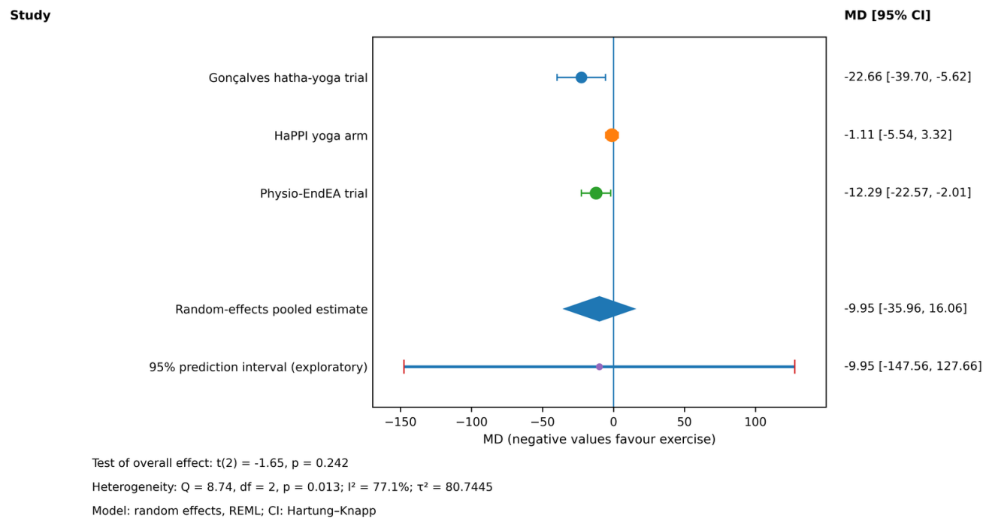
Figure S1. EHP-30 pain domain (mean difference, 0–100 points).

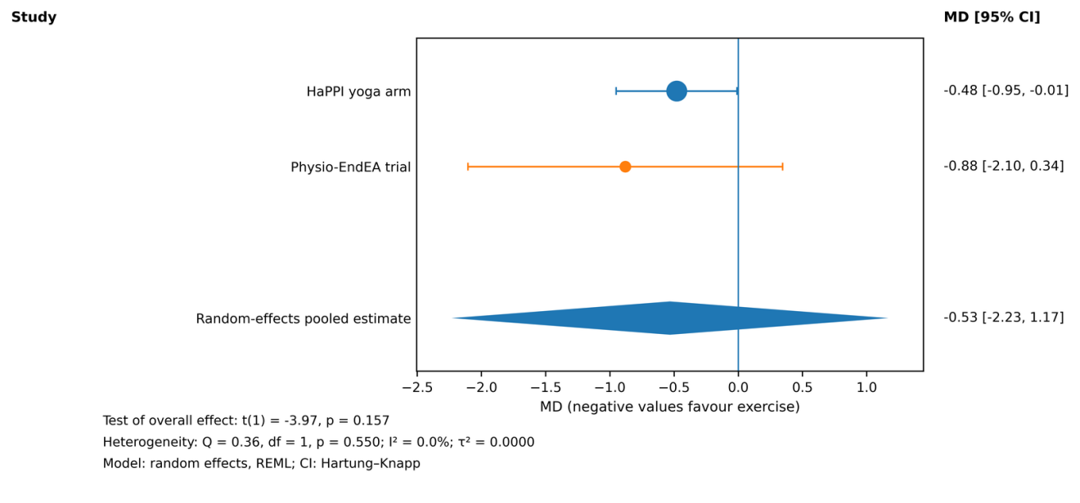
Figure S2. Period pain (mean difference, 0–10 numeric rating scale).

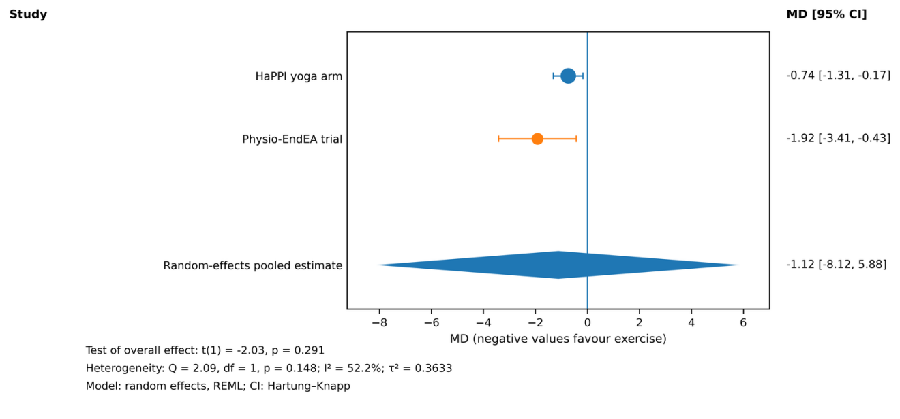
Figure S3. Sexual pain (mean difference, 0–10 numeric rating scale).

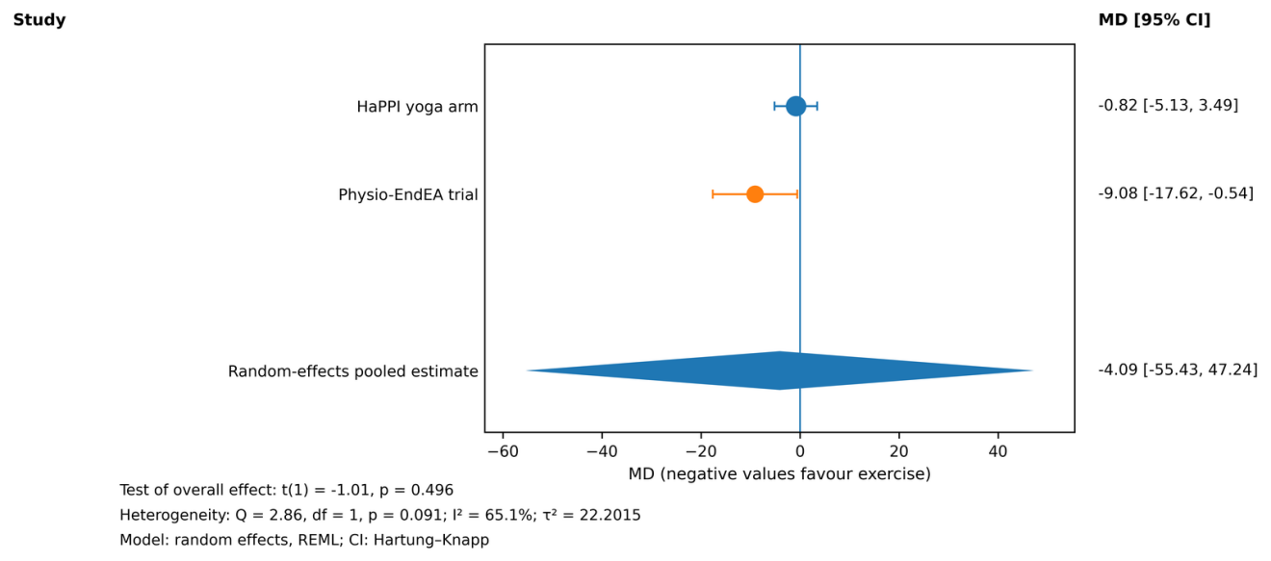
Figure S4. Disease-specific quality of life, EHP-30 total (mean difference, 0–100 points).

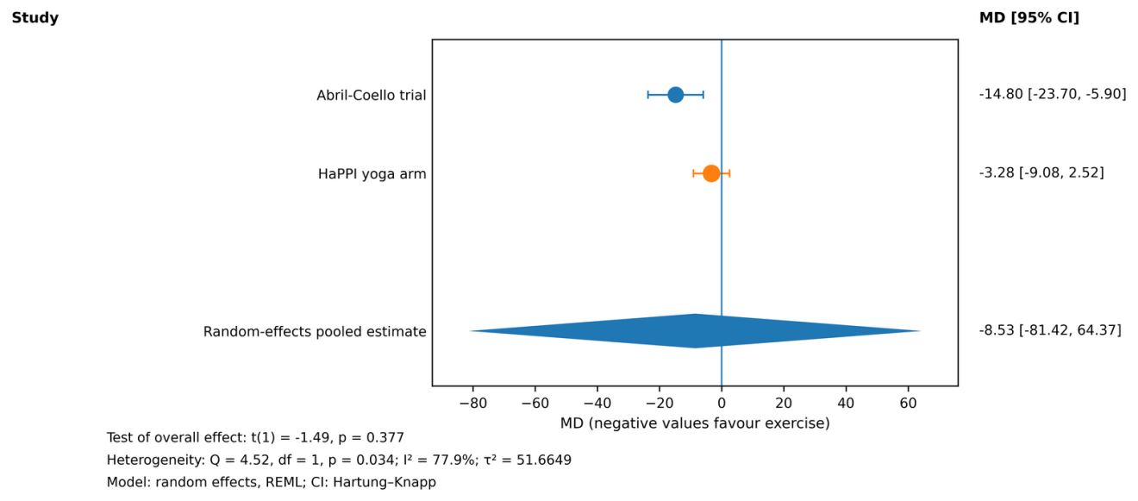
Figure S5. General quality of life, EQ visual analogue scale (mean difference, oriented so that negative values favour exercise).

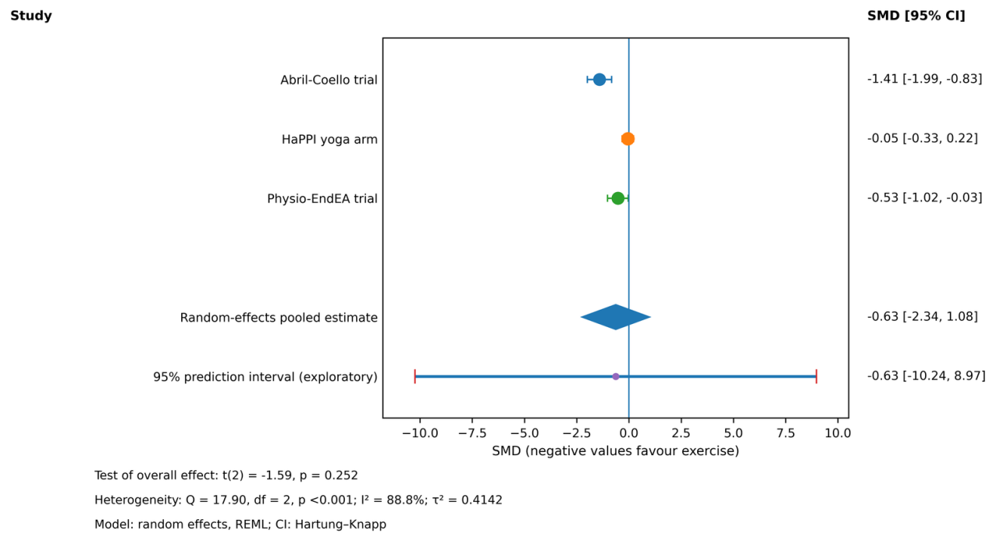
Figure S6. Trial-level quality of life, one measure per trial (standardised mean difference).

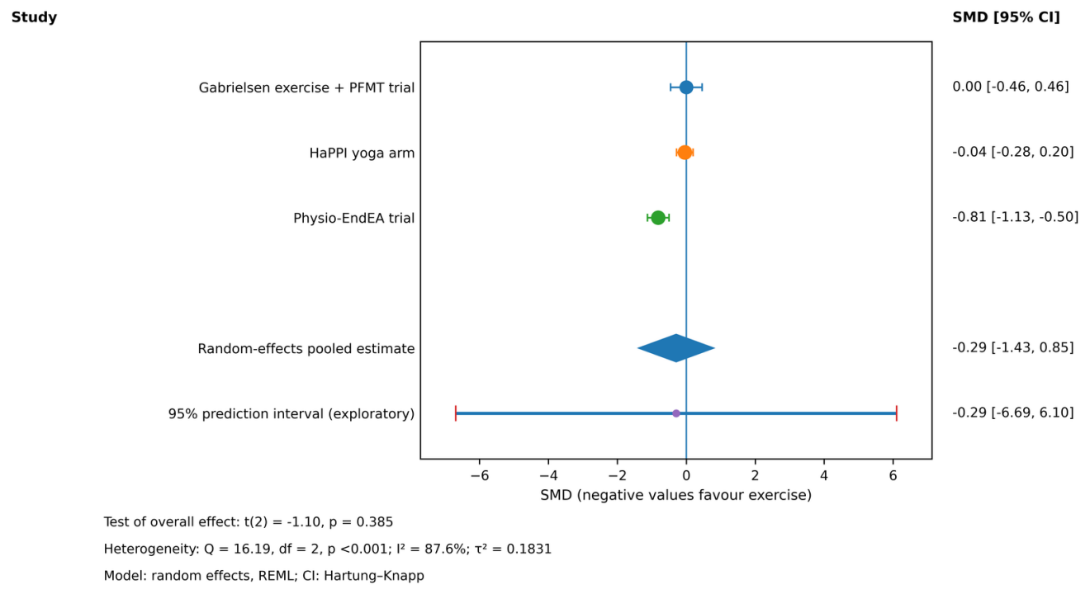
Figure S7. Psychological distress (standardised mean difference).

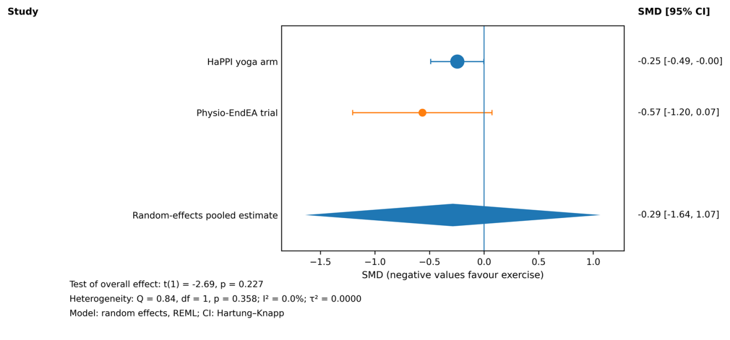
Figure S8. Sleep (standardised mean difference).

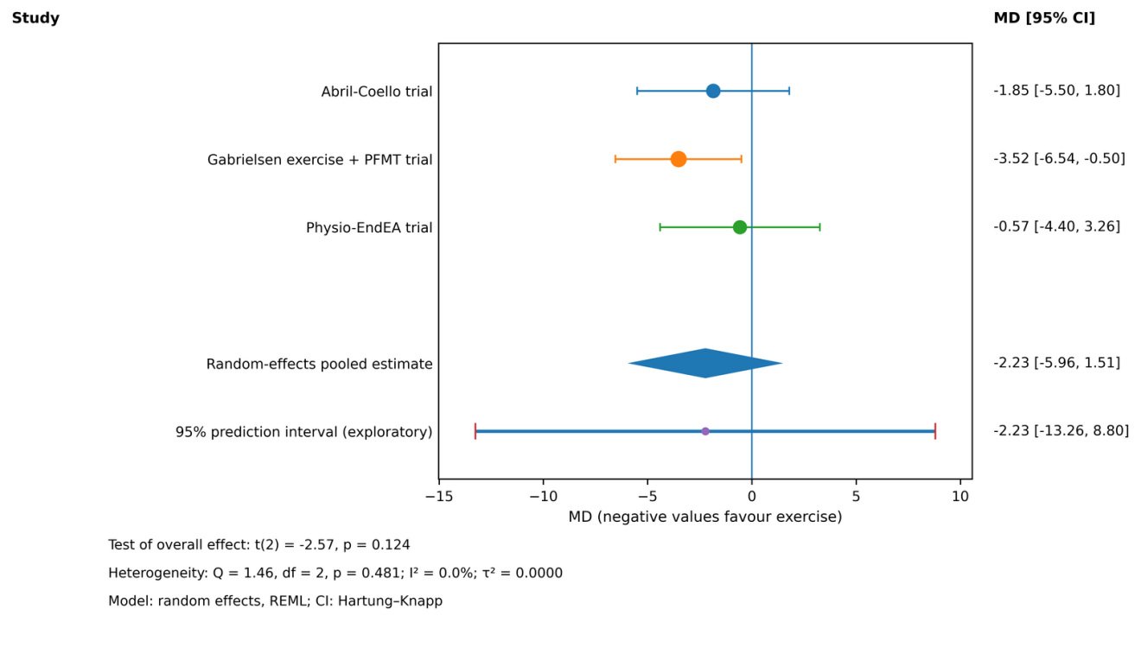
Figure S9. Sexual function, Female Sexual Function Index total (mean difference, oriented so that negative values favour exercise).

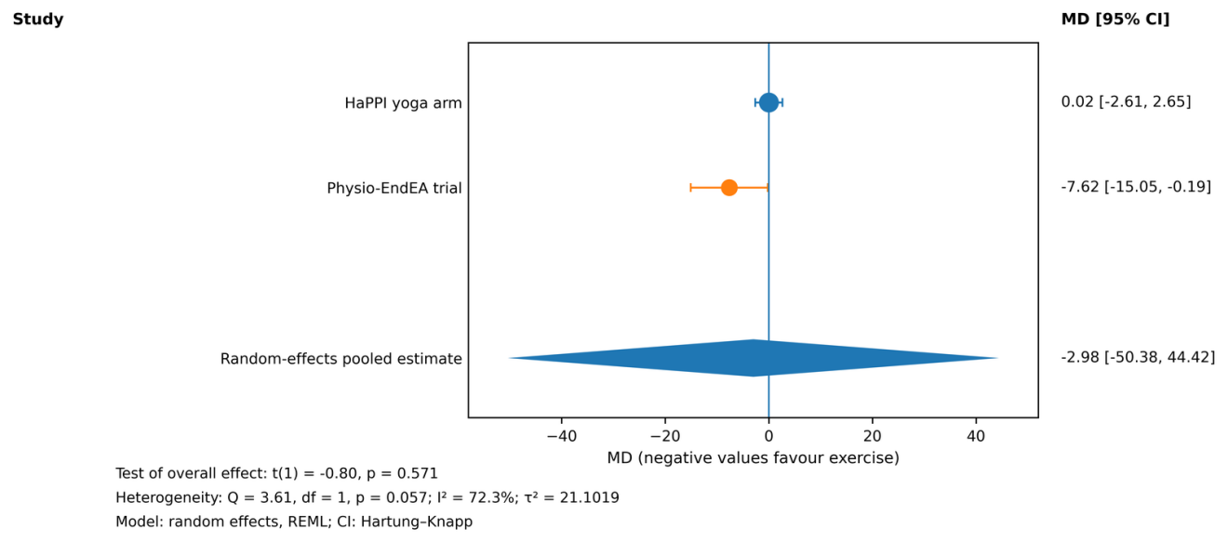
Figure S10. Pain catastrophising, Pain Catastrophizing Scale total (mean difference).

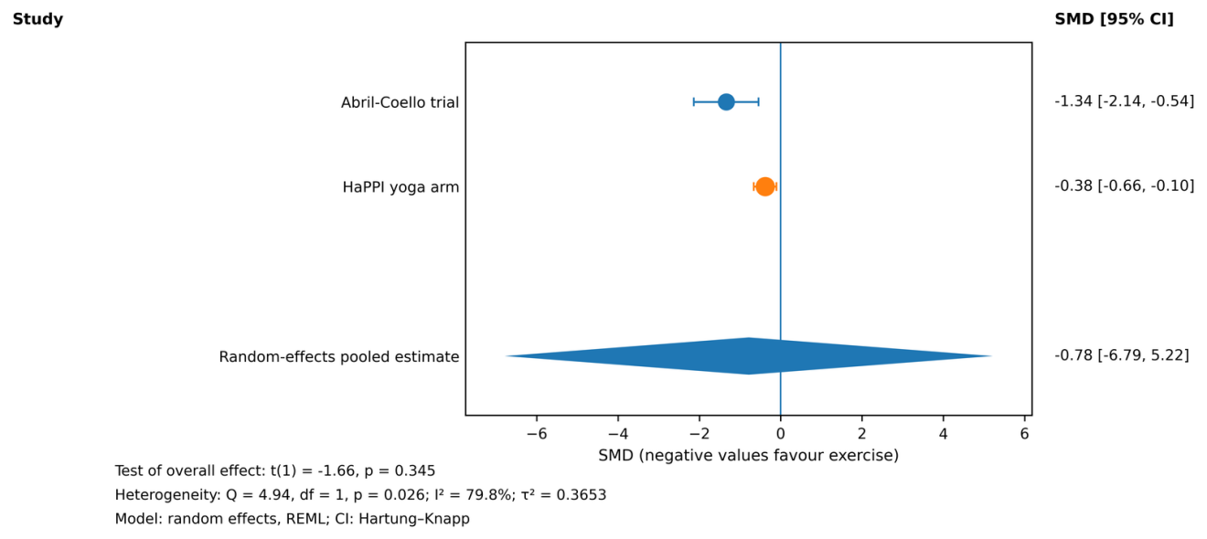
Figure S11. Menstrual symptoms (standardised mean difference; exploratory).

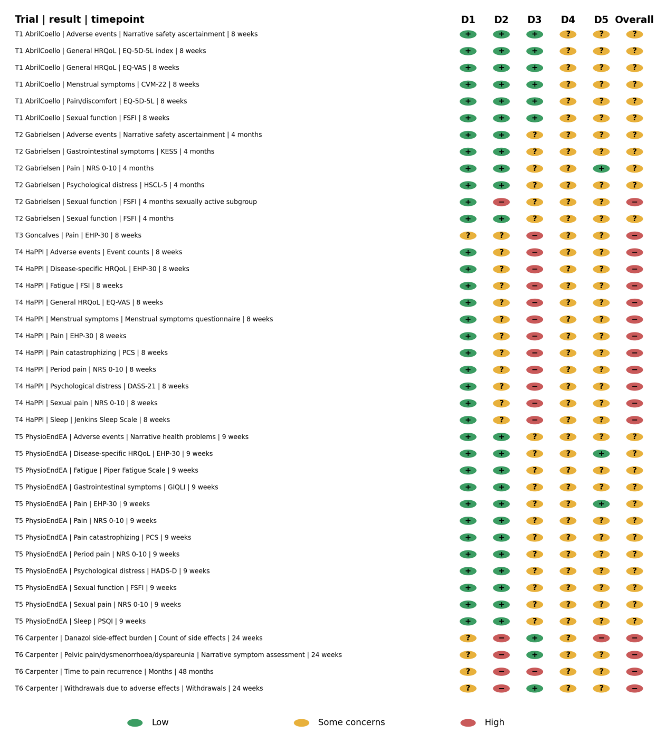
Figure S12. Traffic-light display for 40 result-level RoB 2 assessments. Rows include primary, alternative, held and narrative results and are identified by trial, instrument, timepoint and analysis. The distribution is 17 high-risk and 23 some-concerns results. D1, randomisation; D2, deviations from intended interventions; D3, missing outcome data; D4, outcome measurement; D5, selection of the reported result.

