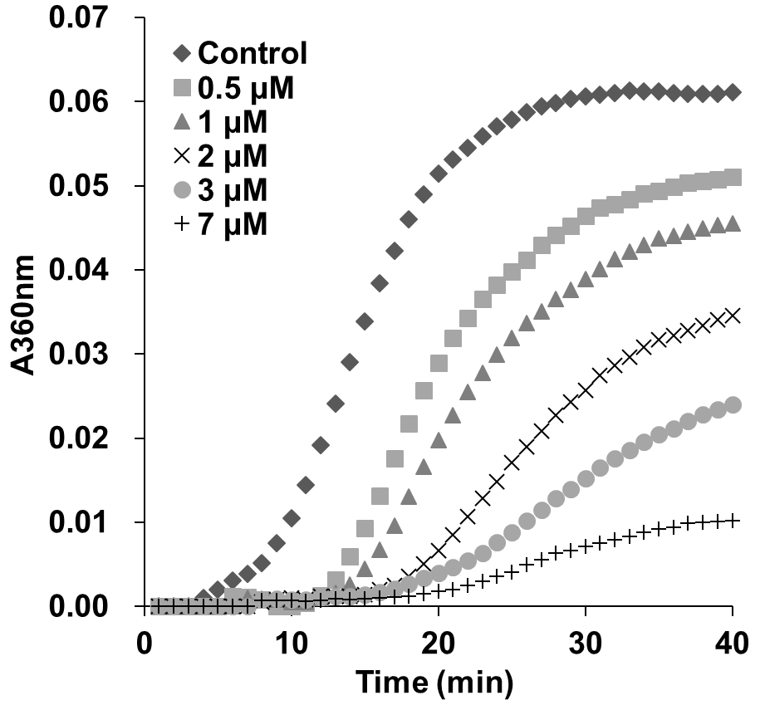
Figure 1. Podophyllotoxin inhibited tubulin polymerization in vitro. In-Vitro tubulin polymerization assay was performed according to a standard protocol (Reference 16). Polymerization of tubulin with MAPs in the assembly buffer was measured in the absence (◆) and in the presence of different concentrations of podophyllotoxin. Podophyllotoxin significantly inhibited the nucleation and growth phase during microtubule assembly.

