a
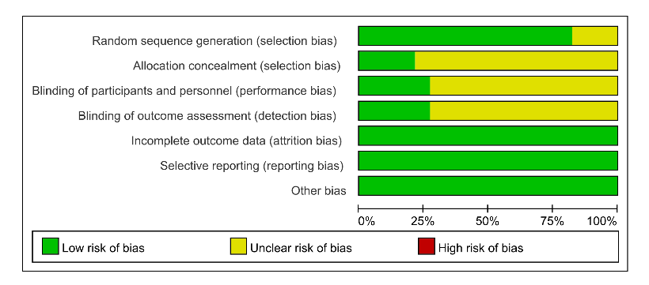
b
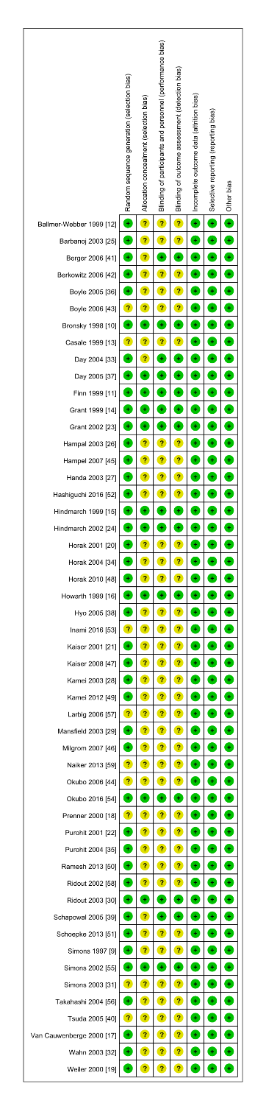
Fig. S1
Risk of bias: a risk of bias summary; b risk of bias graph.

