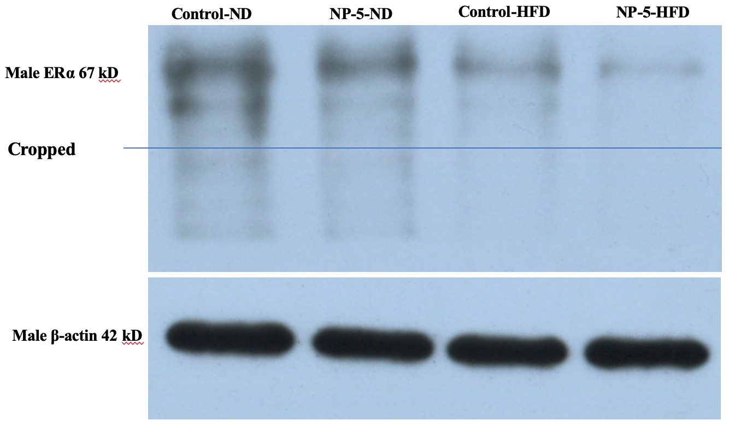
Supplementary Figure 1. full-length blots of ERα in the liver tissue in F2 male. rats

