Supplementary figures
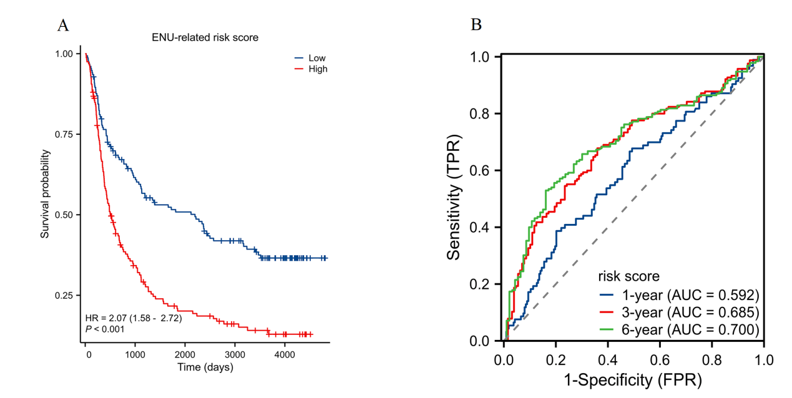
Figure S1 Validation of ENU-related risk model in CGGA-325 dataset. (A) Kaplan-Meier survival curves showing the overall survival of glioma patients in the high-risk and low-risk groups. (B) ROC curve analysis of the risk model demonstrating the predictive performance for 1-year, 3-year, and 6-year survival.
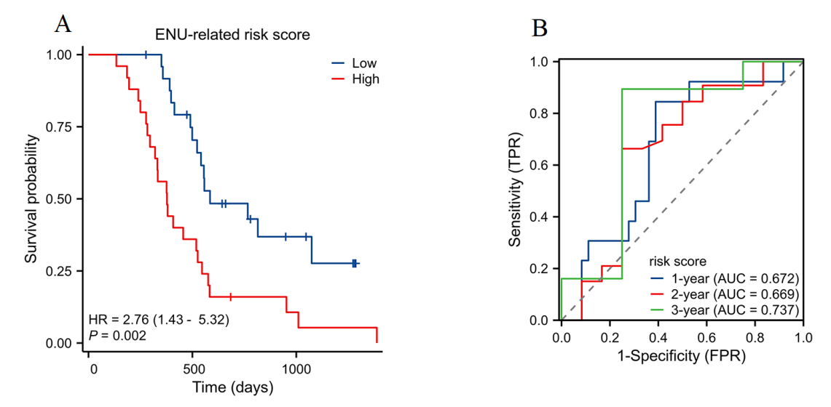
Figure S2 Validation of ENU-related risk model in GSE83300 dataset. (A) Kaplan-Meier survival curves showing the overall survival of glioma patients in the high-risk and low-risk groups. (B) ROC curve analysis of the risk model demonstrating the predictive performance for 1-year, 2-year, and 3-year survival.
Figure S3 Validation of ENU-related risk model genes in GSE16011 dataset. **p < 0.01, ***p < 0.001.
Figure S4 Validation of ENU-related risk model genes in GSE4290 dataset. *p < 0.05, **p < 0.01, ***p < 0.001.

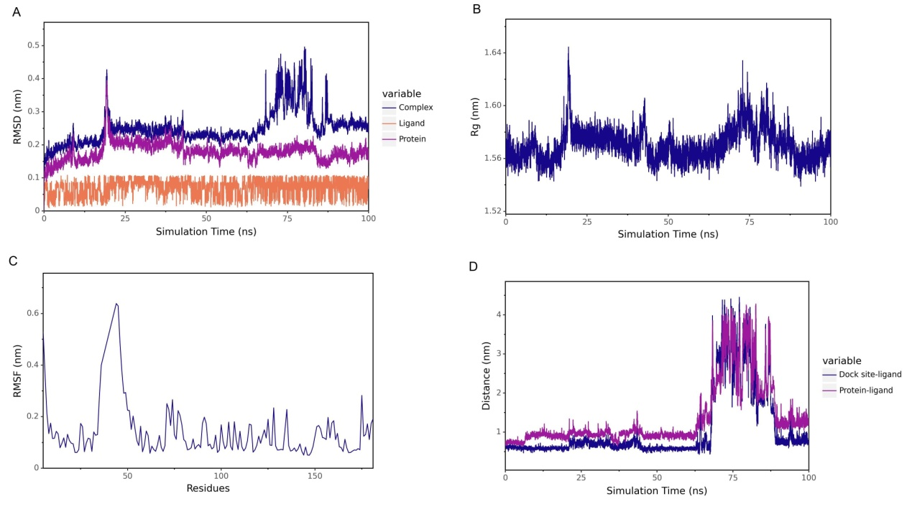
Figure S5 Molecular dynamics simulation analysis of the CA12-ENU complex. (A) RMSD plot over 100 ns. (B) Rg of the complex. (C) RMSF of protein residues. (D) Distance analysis between the docking site-ligand and protein-ligand.
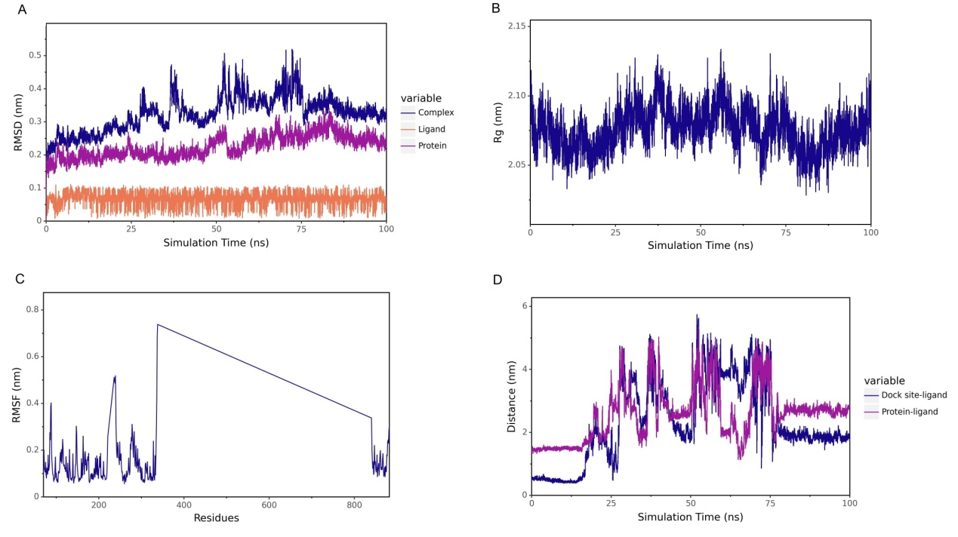
Figure S6 Molecular dynamics simulation analysis of the AURKB-ENU complex. (A) RMSD plot over 100 ns. (B) Rg of the complex. (C) RMSF of protein residues. (D) Distance analysis between the docking site-ligand and protein-ligand.

