Identification of Potential Natural BCL-2 Inhibitors for Leukemia through an Integrated Virtual Screening Approach
Uddalak Das¹, Arnab Mukherjee^{2a}, Mukunthan KS ^{2b*}, Jitendra Kumar³
¹ Department of Plant Biotechnology, University of Agricultural Sciences, Bangalore, Bengaluru, Karnataka, India – 560065 uddalakdas1998@gmail.com
^{2a} Department of Biotechnology, Manipal Institute of Technology, Manipal Academy of Higher Education, Manipal, Karnataka, India-576104 arnabbiotech.gen@gmail.com
^{2b} Department of Biotechnology, Manipal Institute of Technology, Manipal Academy of Higher Education, Manipal, Karnataka, India-576104 mukunthan.ks@manipal.edu
³ Biotechnology Industry Research Assistance Council (BIRAC), Department of Biotechnology (DBT), Ministry of Science and Technology, Government of India, Lodhi Road, New Delhi, India – 110020 md.birac@nic.in

*Corresponding Author: Associate Professor, Department of Biotechnology, Manipal Institute of Technology, Manipal, Manipal Academy of Higher Education, Karnataka, India-576104 mukunthan.ks@manipal.edu; mukunthanselvam@gmail.com

SUPPORTING INFORMATION
Table S1 Pharmacophore model evaluation using multiple scoring metrics for the top 20 generated pharmacophore models, sorted based on PhaseHypo Score
Sl. No. | Title | Survival Score | Site Score | Vector Score | Volume Score | Selectivity Score | Num Matched | Inactive Score | Adjusted Score | BEDROC Score | PhaseHypo Score
1 | AHHRR_1 | 7.069 | 0.808 | 0.919 | 0.652 | 2.134 | 360 | 0 | 7.069 | 1 | 1.424
2 | AHHRR_2 | 6.994 | 0.81 | 0.971 | 0.681 | 1.977 | 360 | 0 | 6.994 | 1 | 1.42
3 | AAHHR_1 | 6.931 | 0.775 | 0.956 | 0.637 | 2.007 | 360 | 0 | 6.931 | 1 | 1.416
4 | AHHRR_3 | 6.898 | 0.851 | 0.954 | 0.574 | 1.963 | 360 | 0 | 6.898 | 1 | 1.414
5 | HHHRR_1 | 6.808 | 0.753 | 0.912 | 0.54 | 2.046 | 360 | 0 | 6.808 | 1 | 1.408
6 | AAHRR_1 | 6.806 | 0.801 | 0.949 | 0.674 | 1.827 | 359 | 0 | 6.806 | 1 | 1.408
7 | AHHRR_4 | 6.791 | 0.744 | 0.962 | 0.596 | 1.933 | 360 | 0 | 6.791 | 1 | 1.407
8 | AHHRR_5 | 6.741 | 0.772 | 0.957 | 0.514 | 1.942 | 360 | 0 | 6.741 | 1 | 1.404
9 | AHHRR_6 | 6.736 | 0.7 | 0.948 | 0.595 | 1.937 | 360 | 0 | 6.736 | 1 | 1.404
10 | AHHRR_7 | 6.701 | 0.766 | 0.947 | 0.471 | 1.962 | 360 | 0 | 6.701 | 1 | 1.402
11 | AHHR_1 | 6.61 | 0.853 | 0.98 | 0.622 | 1.599 | 360 | 0 | 6.61 | 1 | 1.397
12 | HHRR_1 | 6.595 | 0.87 | 0.949 | 0.672 | 1.547 | 360 | 0 | 6.595 | 1 | 1.396
13 | HHRR_2 | 6.505 | 0.885 | 0.926 | 0.59 | 1.548 | 360 | 0 | 6.505 | 1 | 1.39
14 | AHRR_1 | 6.48 | 0.846 | 0.937 | 0.652 | 1.489 | 360 | 0 | 6.48 | 0.999 | 1.388
15 | AHHR_2 | 6.468 | 0.941 | 0.988 | 0.55 | 1.432 | 360 | 0 | 6.468 | 1 | 1.388
16 | AHHR_3 | 6.467 | 0.804 | 0.988 | 0.672 | 1.446 | 360 | 0 | 6.467 | 1 | 1.388
17 | HHHR_1 | 6.44 | 0.858 | 0.987 | 0.627 | 1.411 | 360 | 0 | 6.44 | 1 | 1.386
18 | AHRR_3 | 6.439 | 0.836 | 0.963 | 0.67 | 1.415 | 360 | 0 | 6.439 | 1 | 1.386
19 | AHRR_4 | 6.431 | 0.838 | 0.973 | 0.673 | 1.39 | 360 | 0 | 6.431 | 1 | 1.386
20 | AHRR_2 | 6.457 | 0.829 | 0.926 | 0.648 | 1.498 | 360 | 0 | 6.457 | 0.998 | 1.386

Table S2 Physiochemical properties of the two screened compounds
Properties | CNP0237679 | CNP0420384
Molecular Weight | 492.25 | 497.33
Dipole Moment | 7.763 | 6.157
Density | 0.932 | 0.931
pKa (Acid) | 9.463 | 8.908
pKa (Base) | 5.055 | 8.563
Melting Point (in °C) | 162.601 | 125.603
Boiling Point (in °C) | 395.362 | 302.249
H-bond donors | 4 | 5
H-bond acceptors | 6 | 7
Number of rotatable bonds | 8 | 16
Number of rings | 3 | 3
Number of atoms in the biggest ring | 10 | 6
Number of heteroatoms | 6 | 7
Formal Charge | 0 | 0
Number of rigid bonds | 21 | 16
Sterio Centres | 2 | 3
SASA | 864.34 | 893.278
FOSA | 515.008 | 586.777
FISA | 179.048 | 97.071
PISA | 170.264 | 209.43
WPSA | 0 | 0
Total solvent accessible volume (in Å³) | 1615.746 | 1685.433
Polarizability (in Å³) | 53.071 | 51.739
Hexadecane/Gas partition coefficient | 16.555 | 17.369
Octanol/Gas partition coefficient | 25.512 | 27.719
Water/Gas partition coefficient | 11.757 | 13.906
Octanol/Water partition coefficient | 5.628 | 4.792
Number of non-conjugated amine groups | 0 | 2
Number of amidine and guanidine groups | 0 | 0
Number of carboxylic acid groups | 0 | 0
Number of non-conjugated amide groups | 0 | 0
Number of reactive functional groups | 0 | 0
PM3 calculated ionization potential (negative of HOMO energy) (in eV) | 9.2 | 8.942
PM3 calculated electron affinity (negative of LUMO energy) (in eV) | 0.322 | 0.154

Table S3 Medicinal Chemistry properties of the two screened compounds
Properties | CNP0237679 | CNP0420384
Synthetic Accessibility | Easy | Easy
MCE-18 Value | 71.244 | 38
PAINS | 0 alert | 0 alert
Brenk | 1 alert | 0 alert
ALARM NMR Rule | 2 alert | 2 alert
BMS Rule | 1 alert | 0 alert
Chelator Rule | 0 alert | 0 alert
Lipinski’s Rule of 5 violations | 0 violations | 0 violations
Golden Triangle | Accepted | Accepted
Pfizer Rule | Accepted | Accepted
Reactive compound | Passed | Passed
Promiscuous compounds | Passed | Passed

Table S4 ADMET properties of the two screened compounds
Properties |  | CNP0237679 | CNP0420384
A | Water solubility (log mol/L) | -3.747 | -3.568
A | Caco-2 permeability (Papp in 10⁻⁶ cm/s) | 0.294 | -0.365
A | Human intestinal absorption (in %) | 82.309 | 73.843
A | Skin Permeability (log K_{p}) | -2.735 | -2.736
A | Human oral absorption (in %) | 88.067 | 88.457
A | P-glycoprotein substrate | Yes | Yes
A | P-glycoprotein I inhibitor | Yes | Yes
A | P-glycoprotein II inhibitor | Yes | Yes
A | MDCK Permeability | High | High
D | Volume of distribution at steady state (in log L/kg) | 12.2 | 10.298
D | Plasma protein binding (in %) | 86.1 | 82.4
D | BBB Permeability (in logBB) | -0.948 | -1.488
D | CNS permeability (in logPS) | -2.493 | -3.049
M | CYP2D6 substrate | No | Yes
M | CYP3A4 substrate | Yes | Yes
M | CYPIA2 inhibitor | No | No
M | CYP2C19 inhibitor | No | No
M | CYP2C9 inhibitor | No | Yes
M | CYP2D6 inhibitor | No | Yes
M | CYP3A4 inhibitor | No | Yes
E | Total Clearance (in log ml/min/kg) | 0.435 | 1.578
E | Renal OCT2 substrate | No | No
T | Predicted GHS Toxicity Class | 4
T | AMES toxicity | No | No
T | Max. tolerated dose (human) | 0.36 | 0.837
T | hERG I inhibitor | No | No
T | hERG II inhibitor | Yes | Yes
T | Oral Rat Acute Toxicity (LD50) (mol/kg) | 2.303 | 2.695
T | Oral Rat Chronic Toxicity (LOAEL) (log mg/kg/day) | 2.995 | 1.902
T | Skin Sensitisation | No | No
T | T Pyriformis toxicity (µg/L) | 0.286 | 0.289
T | Minnow toxicity (log mM) | -0.778 | 2.336
T | DILI | Passed | Passed
T | FDA Maximum Recommended Daily Dose | Passed | Passed
T | Carcinogenicity | Passed | Passed
T | Eye corrosion | No | No
T | Eye irritation | No | No
T | Respiratory toxicity | Yes | Yes

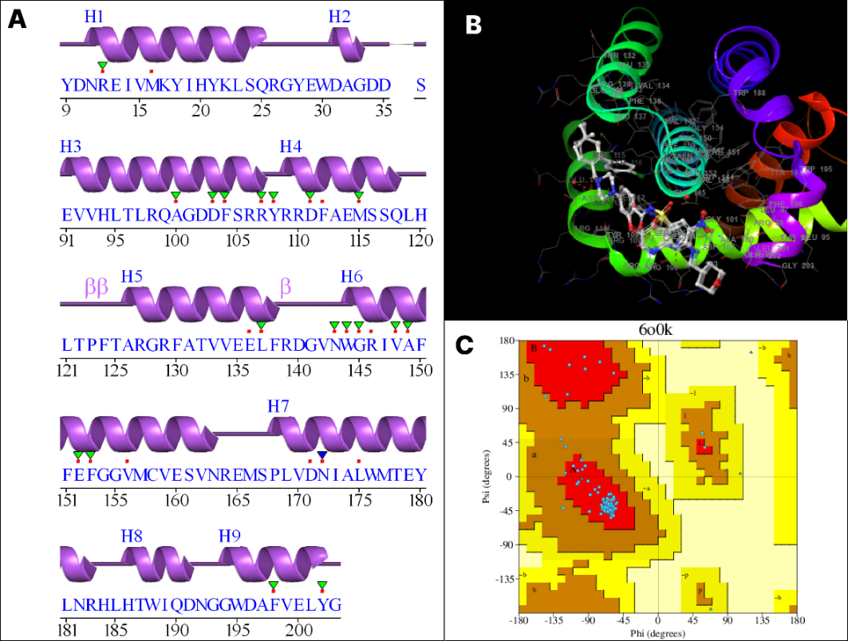
Figure S1 A: The secondary structure of the amino acid sequence of protein (6O0K) (generated by PDBsum); B: The 3D structure of the BCL2 protein; C: Ramachandran plot of the protein. The colour red indicates Iow-energy regions, yellow - allowed regions, pale yellow - generously allowed regions, and white - disallowed regions.

Figure S2 3D Molecular interactions between the ligands A. CNP03S5544 (-71.08 kcal/mol), B. CNP0339788 (-68.81 kcal/mol) and C. CNP0155847 (-67.69 kcal/mol) with the BCL2 protein and the corresponding 2D interaction highlighting various types of interactions are shown

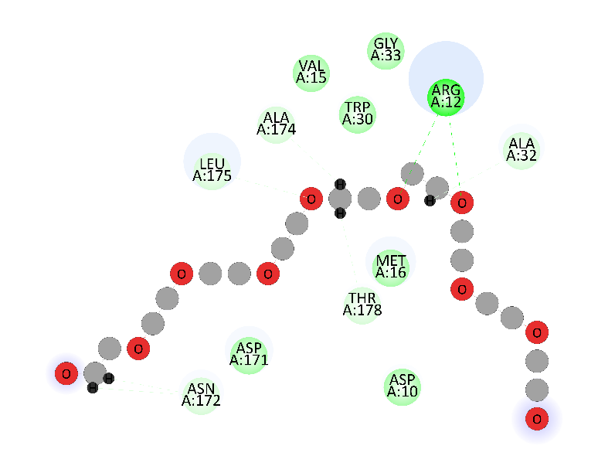
Figure S3 Molecular docking interaction of the Venetoclax with the binding pocket of BCL-2
Figure S4 The molecular orbital (MO) energy levels and electron densities for molecules - CNP03S5544, CNP0339788 and CNP0155847. The energy difference between the HOMO and LUMO, denoted as ΔE, is also shown for each molecule.

