Table S1. Systematic literature review search terms and strategy.
Search terms for PubMed
#1 sulforaphane[Title/Abstract] 3,133 items (2025.2.11)
#2 ((((autism[Title/Abstract]) OR (autistic[Title/Abstract])) OR (ASD[Title/Abstract])) OR (asperger[Title/Abstract])) OR ("pervasive developmental disorder"[Title/Abstract]) 87,859 items (2025.2.11)
#1 AND #2 = 50 items (2025.2.11)
Search terms for Web of Science
#1 TS=(sulforaphane) 6,809 items (2025.2.11)
#2 ((((TS=(autism)) OR TS=(autistic)) OR TS=(ASD)) OR TS=(asperger)) OR TS=("pervasive developmental disorder") 153,883 items (2025.2.11)
#1 AND #2 = 86 items (2025.2.11)
Search terms for Embase
#1 'sulforaphane':ti,ab,kw 4,133 items (2025.2.11)
#2 'pervasive developmental disorder':ti,ab,kw OR 'asperger':ti,ab,kw OR 'asd':ti,ab,kw OR 'autistic':ti,ab,kw OR 'autism':ti,ab,kw 118,010 items (2025.2.11)
#1 AND #2 = 58 items (2025.2.11)
Search terms for Cochrane Library
#1 (sulforaphane):ti,ab,kw 245 items (2025.2.11)
#2 (autism):ti,ab,kw OR (autistic):ti,ab,kw OR (ASD):ti,ab,kw OR (asperger):ti,ab,kw OR (pervasive developmental disorder):ti,ab,kw 6,751 items (2025.2.11)
#1 AND #2 = 24 items (2025.2.11)

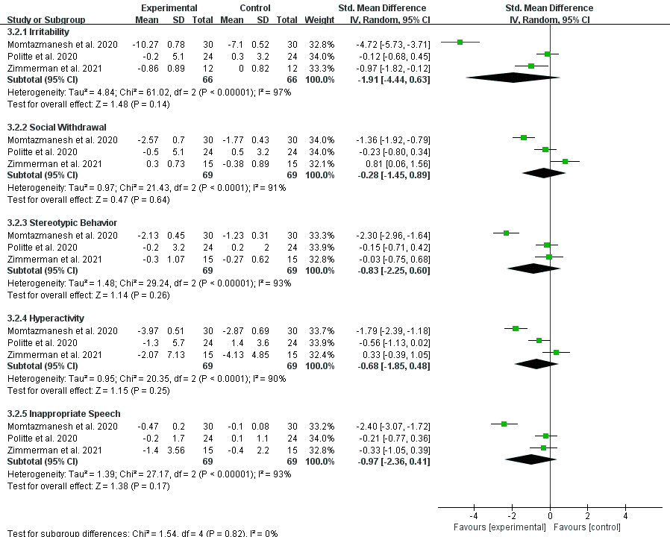
Fig. S1. Changes of ABC scores after 4 to 7 weeks of sulforaphane supplementation.

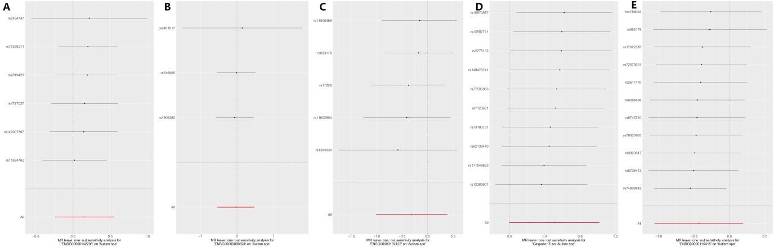
Fig. S2. Leave-one-out analysis results. (A) Leave-one-out analysis for AKT1 on ASD. (B) Leave-one-out analysis for HSP90AA1 on ASD. (C) Leave-one-out analysis for SRC on ASD. (D) Leave-one-out analysis for CASP3 on ASD. (E) Leave-one-out analysis for STAT1 on ASD.

