Supplementary Data B
A
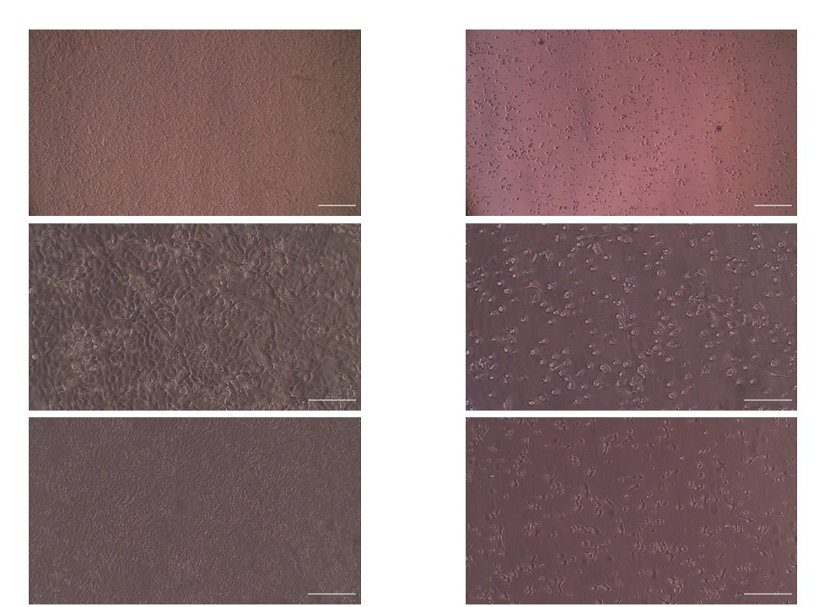
10x
20x
4x
B

Representative microscopic images of HN9 cells before and after treatment with DOX+IVM. (A) Control cells exhibited normal morphology with intact membranes. (B) DOX+IVM treated cells for 48 h showed marked morphological alterations such as cell rounding, shrinkage, and detachment. Images were obtained under inverted microscope at 10x, 20x, and 4x magnification (Scale bar =250, 125, 500 μm, respectively).

