Supplementary figures

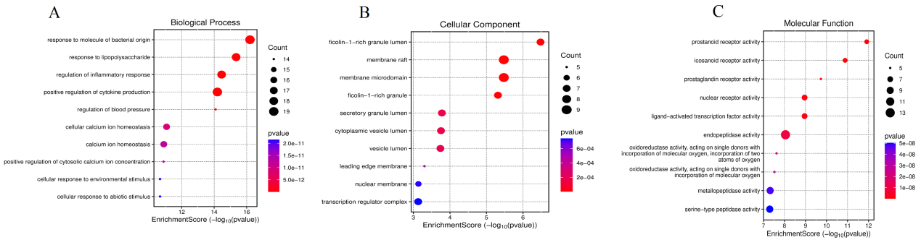
Figure S1 GO enrichment analysis of 71 overlapping targets between phthalates and AR. (A) GO enrichment analysis for Biological Processes (BP) of the 71 overlapping targets. (B) GO enrichment analysis for Cellular Components (CC). (C) GO enrichment analysis for Molecular Functions (MF). The size of the dots represents the count of genes, and the color indicates the p-value, with red representing lower p-values (greater significance).

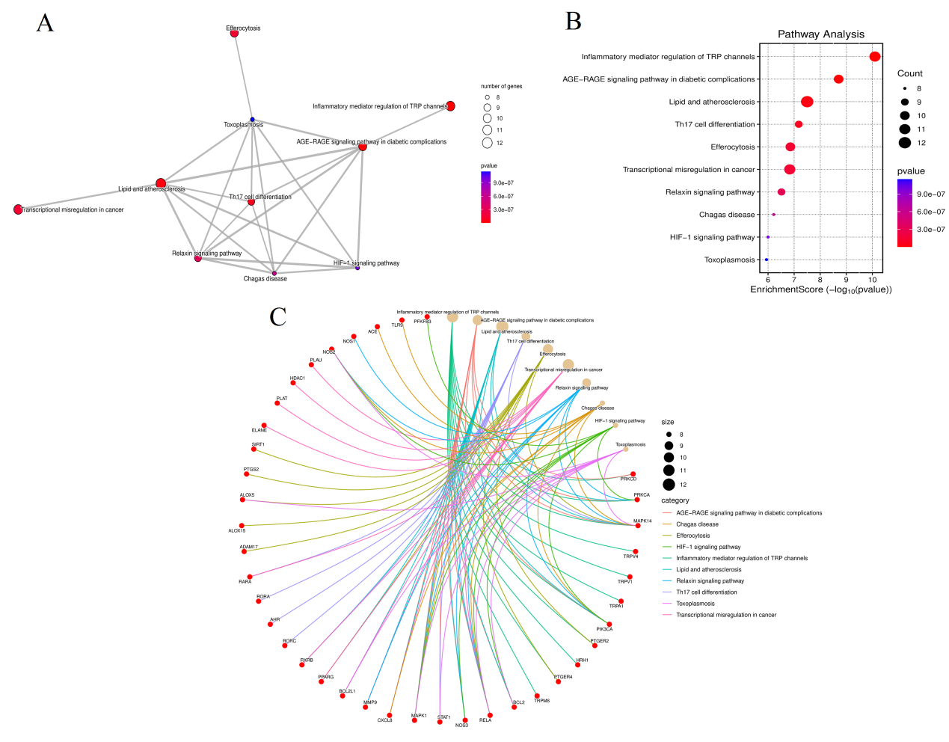

Figure S2 KEGG pathway enrichment analysis of 71 overlapping targets between phthalates and AR. (A) Network diagram visualizing the interconnected KEGG pathways enriched among the overlapping targets. (B) Bubble chart representing the KEGG pathway enrichment scores (-log10(p-value)) for the top pathways. The size of the dots indicates the number of genes involved in each pathway, and the color denotes the significance level, with red representing higher significance (lower p-values). (C) Chord diagram showing the relationship between the targets and their associated KEGG pathways. The size of the points corresponds to the number of genes involved, and the various colors categorize different pathways.

