Supplementary Data
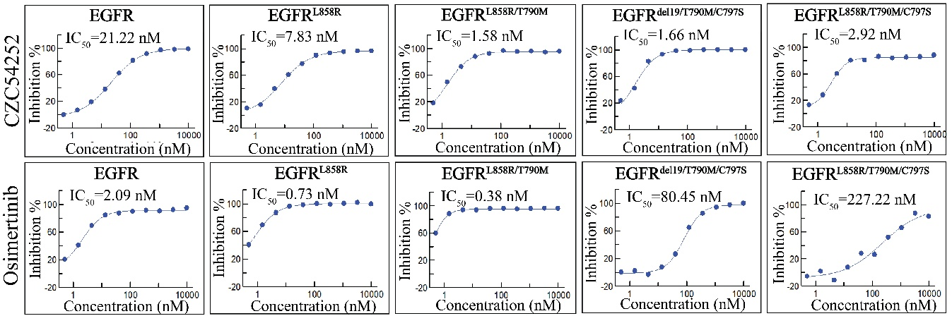
Figure S1 Kinase inhibition assay of CZC54252 and Osimertinib on several EGFR mutants.

