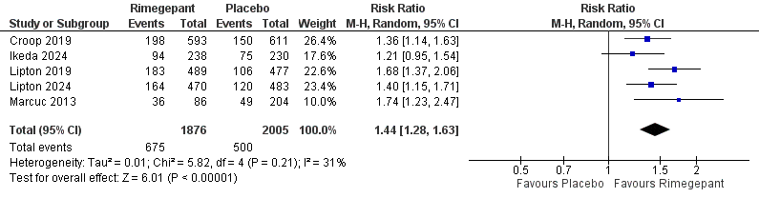
Figure S1: Comparison between rimegepant and placebo in photophobia freedom at 2 hours
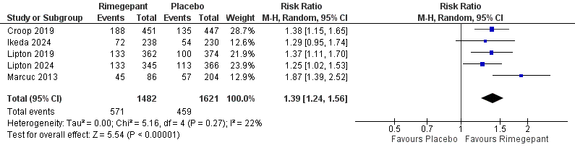
Figure S2: Comparison between rimegepant and placebo in phonophobia freedom at 2 hours
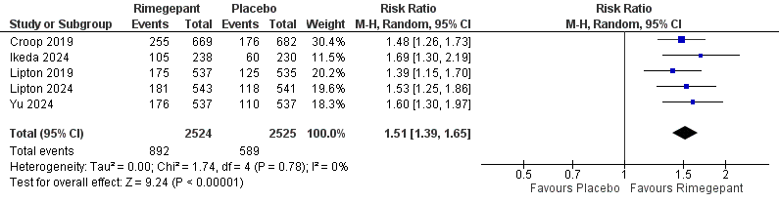
Figure S3: Comparison between rimegepant and placebo in the ability to function normally at 2 hours
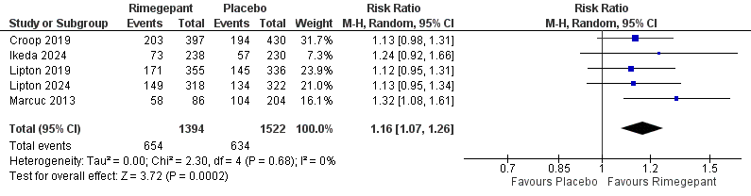
Figure S4: Comparison between rimegepant and placebo in nausea freedom at 2 hours
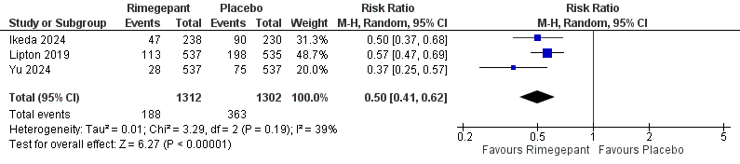
Figure S5: Comparison between rimegepant and placebo in rescue medications within 24 hours

