MTT assay
Treating HN9 cells with CIS _{IC50}, IVM _{IC50}, and their combination revealed a significant increase in cell viability in the combination group compared with CIS _{IC50} (p = 0.01) and IVM _{IC50} (p = 0.004).
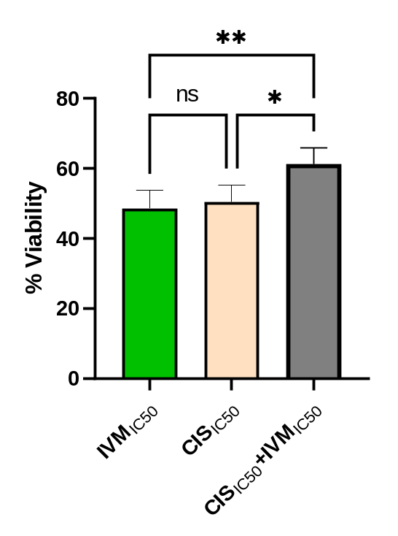
Fig 1 MTT assay showing the results of using CIS _{IC50}, IVM _{IC50}, and their combination on HN9 cells. Cells were incubated for 2 days, and the results are expressed as mean viability ± SD. All samples were analyzed in six replicates, and the experiment was conducted three independent times. Statistical analysis was calculated using one-way ANOVA followed by Tukey's post-hoc test.

Cell cycle analysis
Results showed that (Figure 2), CIS_{IC50} significantly induced cell cycle arrest at the S phase compared with all experimental groups (p < 0.0001). However, co-treatment with IVM_{IC50} attenuated this S-phase arrest induced by CIS_{IC50,} resulting in a reduced accumulation of cells in the S phase.
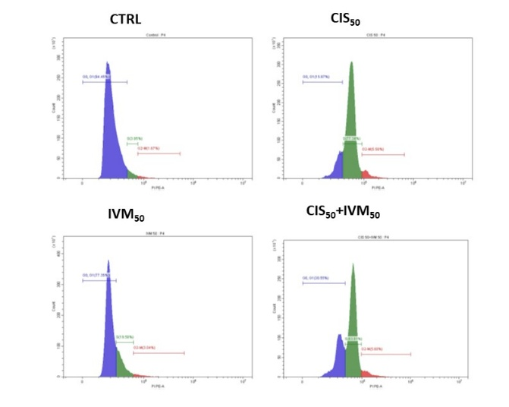
A
B
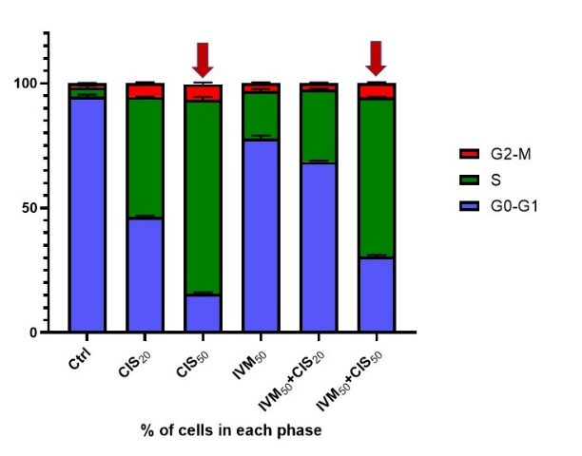
Fig 2 showing analysis of cell cycle progression in HN9 cells after treatment with CIS, IVM, and CIS+IVM combination for 48 h. (A) Histograms showing the distribution of cell populations across the different cell cycle phases. (B) Statistical analysis showing the percentage of cells in each phase of the cell cycle. Results are demonstrated as mean ± SD. All samples were analyzed in triplicate (n = 3), and the experiment was repeated three times. Statistical analysis was calculated using Two-way ANOVA then Tukey's post-hoc test.

