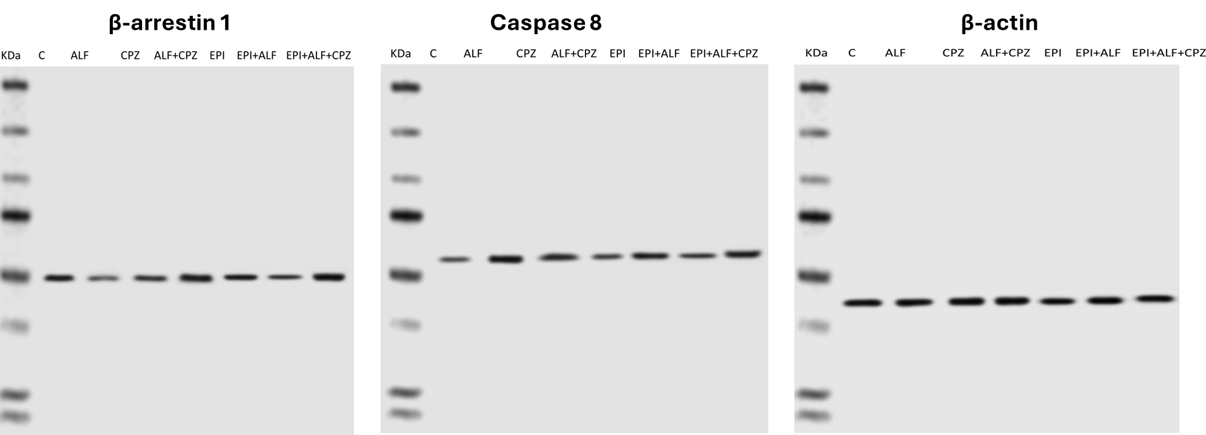

Fig. S1: Raw data of western blot analysis.

I (CPZ) | F (APAP) | G (Epinephrine)
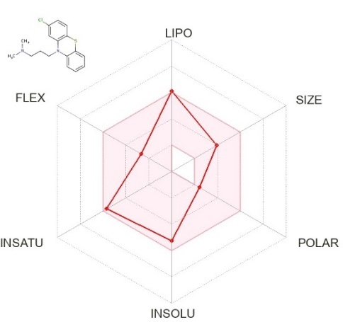 | 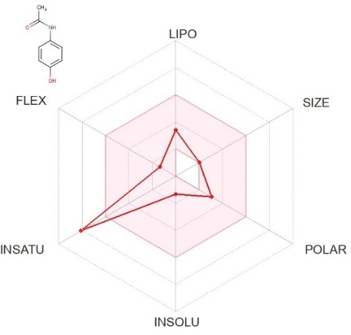 | 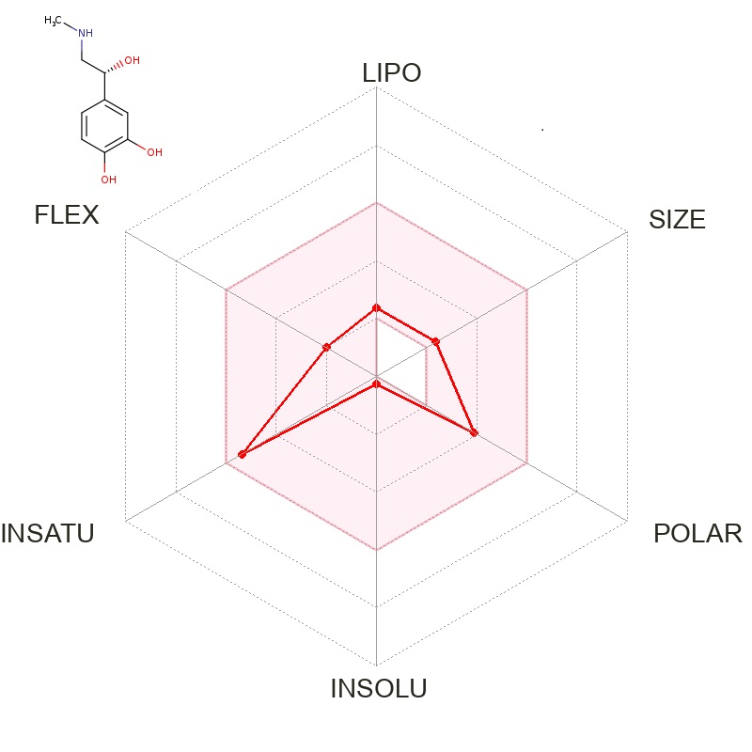
 | CPZ | APAP | EP
Lipophilicity | 4.29 | 0.93 | 0.1
Solubility | -6.28  Poorly soluble | -2.19  Soluble | -1.56  Soluble
Bioavailability score | 0.55 | 0.55 | 0.55

Fig. S2. In silico ADME analysis and bioavailability of drugs. Radar graphs demonstrate the main pharmacokinetic information of CPZ (A), APAP (B), and epinephrine (C). The graphs depict the main bioavailability factors, including lipophilicity, molecular size, polarity, water solubility, and saturation. The structures of drugs are shown at the top of each graph.

Table S1.
Epinephrine-specific cellular targets predicted by TargetNET
Uniprot ID | Protein | Probability
P05186 | Alkaline phosphatase | 1.0
P16050 | Arachidonate 15-lipoxygenase | 1.0
P08588/ P13945 | Beta-1/-3 adrenergic receptor | 1.0
P23280 | Carbonic anhydrase 6 | 1.0
O00748 | Cocaine esterase | 1.0
P14174 | Macrophage migration inhibitory factor | 1.0
O42713 | Polyphenol oxidase 2 | 1.0
P21396 | Amine oxidase [flavin-containing] A | 0.998
P05979 | Prostaglandin G/H synthase 1 | 0.997
P07943 | Aldose reductase | 0.996
P23977 | Sodium-dependent dopamine transporter | 0.993
P37059 | Estradiol 17-beta-dehydrogenase 2 | 0.992
Q04609 | Glutamate carboxypeptidase 2 | 0.988
P30305 | M-phase inducer phosphatase 2 | 0.984
P05093 | Steroid 17-alpha-hydroxylase/17,20 lyase | 0.982
Q3KRE8/ Q6B856 | Tubulin beta-2B chain | 0.967
P15917 | Lethal factor | 0.919
P29477 | Inducible Nitric oxide synthase, (iNOS) | 0.908
P23141 | Liver carboxylesterase 1 | 0.854
P31652 | Sodium-dependent serotonin transporter | 0.848

Table S2.
Chlorpromazine-specific cellular targets predicted by TargetNET
Uniprot ID | Protein | Probability
P18130/ P23944/ P08913 | Alpha-1A/-1D/-2A adrenergic receptor | 1.0
P35367/ P31390 | Histamine H1 receptor | 1.0
P28223/P35563/ P28564 | 5-hydroxytryptamine receptor 2A/3A/1B | 1.0
P30729/ P21917 | D(4) dopamine receptor | 1.0
P11229/P10980/ P08173 | Muscarinic acetylcholine receptor M1/M2/ M4 | 1.0
P20288/ P61169/ P14416 | D(2) dopamine receptor | 1.0
P21728/ P35462 | D(1A)/ D(3) dopamine receptor | 1.0
P31941 | DNA dC->dU-editing enzyme APOBEC-3A | 1.0
P28335/P34969/ P32305 | 5-hydroxytryptamine receptor 2C/ 7 | 1.0
Q9HC97 | G-protein coupled receptor 35 | 1.0
P16257 | Translocator protein | 1.0
P22086 | Alpha-2C adrenergic receptor | 1.0
P81908 | Cholinesterase | 1.0
Q9R0C9/ Q99720 | Sigma non-opioid intracellular receptor 1 | 0.998
P24468 | COUP transcription factor 2 | 0.994
P08908/ P19327/ P50406 | 5-hydroxytryptamine receptor 1A/6 | 0.991
Q00987 | E3 ubiquitin-protein ligase Mdm2 | 0.99
O95180 | Voltage-dependent T-type calcium channel | 0.989
Q9NR96 | Toll-like receptor 9 | 0.985
P29475 | Nitric oxide synthase | 0.979
Q12809 | Potassium voltage-gated channel subfamily H2 | 0.976
P51452 | Dual specificity protein phosphatase 3 | 0.968
P37058 | Testosterone 17-beta-dehydrogenase 3 | 0.955
P35869 | Aryl hydrocarbon receptor | 0.953
P51679 | C-C chemokine receptor type 4 | 0.95
P30939 | 5-hydroxytryptamine receptor 1F | 0.882
P15207 | Androgen receptor | 0.881
O60755 | Galanin receptor type 3 | 0.867

