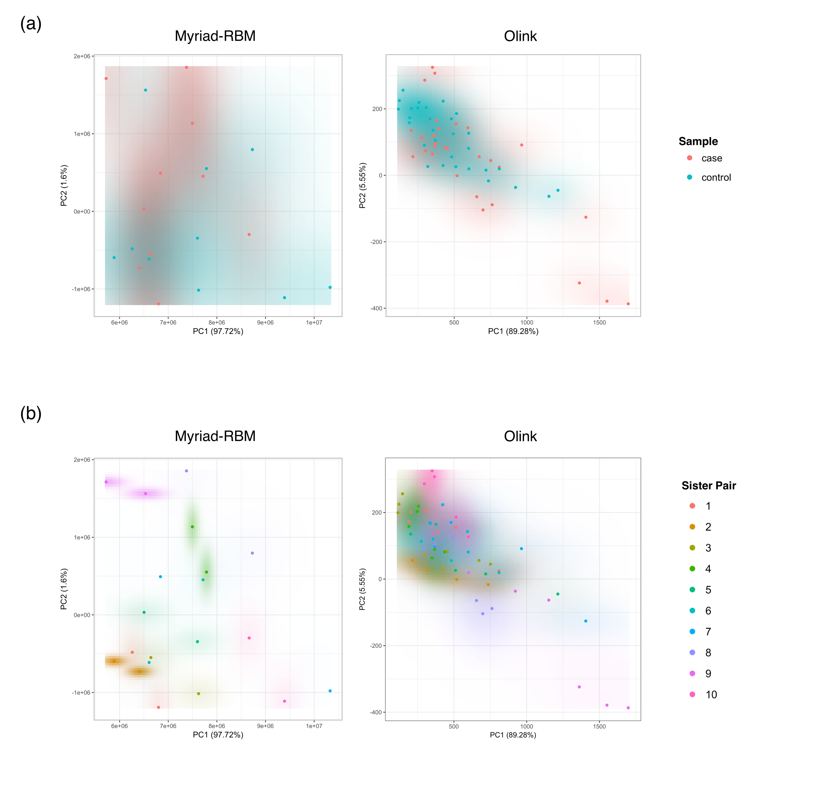

Figure S1: Principal Component Analysis. (a) first (x-axis) and second (y-axis) principal components capture more than 90% of variance in both Myriad-RBM and Olink datasets but are unable to separate case and control samples (supported visually by heavily overlapping red and blue density maps). (b) the same PCA plots as (a) with samples colored with anonymized sister pair indices reveal that, when evaluated in covariance, protein levels are not more similar between biological sisters than between unrelated individuals in the antibody-based assays.

