S-Figure 1. The prediction error rate of five models based on data from Brazil, France, Indonesia, USA, and Vietnam.
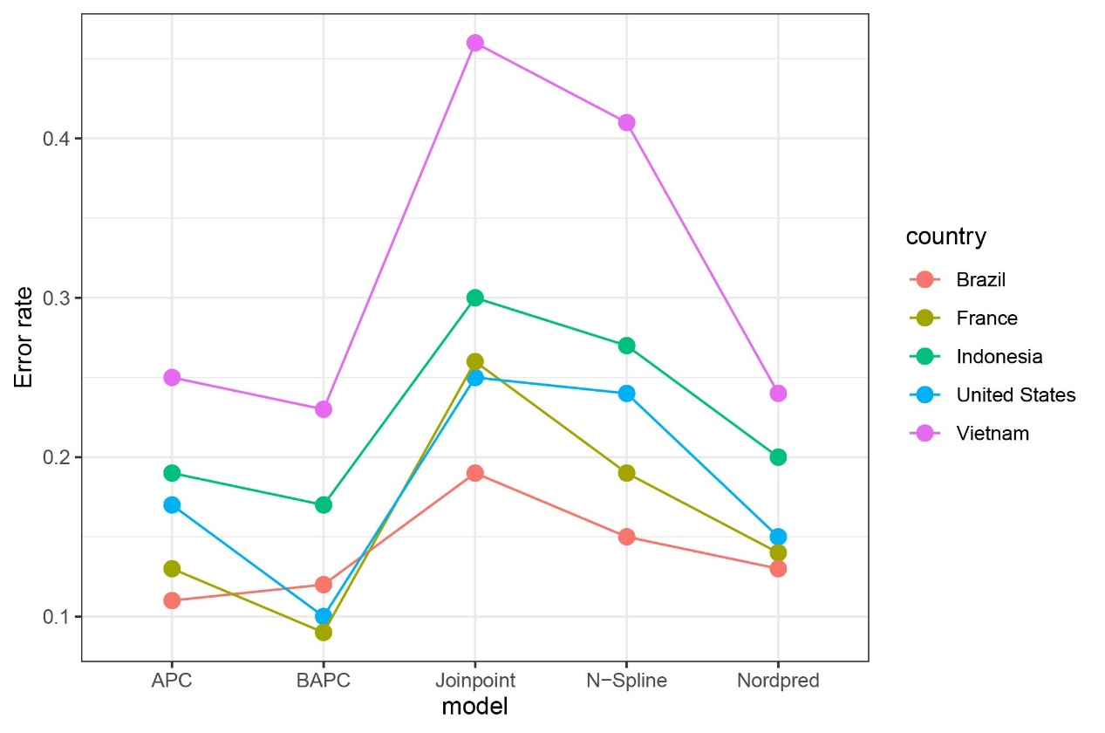

S-Figure 2. The predictions of kidney cancer incidence based on GBD data and IARC data (CI5 plus database). (IARC data: Australia, 1993-2012; Spain, 1993-2010; France, 1998-2010; Italy, 1998-2010; USA, 1990-2012). The blue triangles were point estimates of kidney cancer incidence based on CI5p data. The white open dots were point estimates of kidney cancer incidence based on GBD data.
