AML Risk Stratification Models Utilizing ELN-2017 Guidelines and Additional Prognostic Factors: A SWOG Report

Era L. Pogosova-Agadjanyan, Anna Moseley, Megan Othus, Frederick R. Appelbaum, Thomas R. Chauncey, I-Ming L. Chen, Harry P. Erba, John E. Godwin, Isaac C. Jenkins, Min Fang, Mike Huynh, Kenneth J. Kopecky, Alan F. List, Jasmine Naru, Jerald P. Radich, Emily Stevens, Brooke E. Willborg, Cheryl L. Willman, Brent L. Wood, Qing Zhang, Soheil Meshinchi, and Derek L. Stirewalt

Additional File

Supplemental Methods: Wafergen Sequencing page 2
Table S1: Targeted Sequencing Details pages 3-5
Table S1A: Target regions for Wafergen Sequencing page 3
Table S1B: Primers and Amplicon Details for Wafergen Sequencing page 4
Table S1C: Primers for CEBPA targeted MiSeq Assay page 5
Table S2. Loci that Failed Quality Control page 6
Table S3: Characteristics of selected and unselected SWOG patients page 7
Fig. S1: Comparison of Performance Characteristics of selected page 9
and unselected SWOG patients
Table S4: Characteristics of SWOG patients in the discovery and validation cohorts page 10
Fig. S2: Comparison of Performance Characteristics of SWOG patients in the page 12
discovery and validation cohorts.
Table S5: Mutation distribution in discovery and validation cohorts page 13
Fig. S3: Mutation Frequency (OncoPrint) page 14
Table S6: Expression fold change differences between MNCs and VLBs page 15
in discovery cohort
Table S7: Univariate analyses results, non-significant findings page 16
Models Details page 18
Table S8: ELN₂₀₁₇ versus ELN₂₀₁₇-MOD risk assignment in MNCs and VLBs page 23

Supplemental Methods: Wafergen Sequencing

A target list of gene targets was provided to Wafergen as input for primer design. Redundant primer assays were added for difficult target regions where the selected assays were not optimal such as where the amplicon lengths were long or where multiple hits were produced. Primers were bioinformatically and manually verified to ensure all target regions were covered. Wafergen compatible adapters were added to the primer sequences and the oligos targeted PCR products that were 203-500bp in length.

Primers were synthesized by IDT (Integrated DNA Technologies, USA) and normalized to a working stock of 1.25uM. PCR reactions were set up against samples using the Seq-Ready™ TE MultiSample System (Wafergen, USA) with Seq-Ready™ TE MultiSample FLEX Kits (Wafergen, USA) according to manufacturer’s specifications. Brew containing template and brew containing primers were dispensed into 384-well plates using the Janus liquid handling system (Perkin Elmer, USA). DNA samples and PCR reagents from the 384-well brew plates were dispensed into nanowell SmartChips using the MultiSample NanoDispenser (Wafergen, USA). The SmartChips were amplified on a SmartChip™ TE Cycler (Wafergen, USA) using the manufacturer’s COT40 program with 40 cycles of amplification. The amplified products were pooled and purified with Ampure XP SPRI beads.

Samples were sequenced on the Illumina MiSeq platform at PET250 read length, using V2 chemistry, as per manufacturer’s instructions.

Table S1: Targeted Sequencing Details
Table S1A: Target regions for Wafergen Sequencing
Target | RefSeqID | Gene | Chr. | Start | Stop
ASXL1 | NM_015338 | ASXL1 | 20 | 31022234 | 31027122
ASXL1 | NM_001164603 | ASXL1-SV | 20 | 30959966 | 30960352
CEPBA | NM_004364.3 | CEBPA | 19 | 33790839 | 33793430
RUNX1 | NM_001754 | RUNX1 | 21 | 36231770 | 36231875
RUNX1 | NM_001754 | RUNX1 | 21 | 36252853 | 36253010
RUNX1 | NM_001754 | RUNX1 | 21 | 36259139 | 36259393
RUNX1 | NM_001754 | RUNX1 | 21 | 36265221 | 36265260
RUNX1 | NM_001754 | RUNX1 | 21 | 36160097 | 36164907
TP53 | NM_00546.5 | TP53 | 17 | 7571719 | 7573008
TP53 | NM_00546.5 | TP53 | 17 | 7573926 | 7574033
TP53 | NM_00546.5 | TP53 | 17 | 7576852 | 7576926
TP53 | NM_00546.5 | TP53 | 17 | 7577018 | 7577155
TP53 | NM_00546.5 | TP53 | 17 | 7577498 | 7577608
TP53 | NM_00546.5 | TP53 | 17 | 7578176 | 7578289
TP53 | NM_00546.5 | TP53 | 17 | 7578370 | 7578554
TP53 | NM_00546.5 | TP53 | 17 | 7579311 | 7579590
TP53 | NM_00546.5 | TP53 | 17 | 7579699 | 7579721
TP53 | NM_00546.5 | TP53 | 17 | 7579838 | 7579940
TP53 | NM_00546.5 | TP53 | 17 | 7590694 | 7590868
TP53 | NM_001276698 | TP53-SV | 17 | 7571719 | 7573008
TP53 | NM_001276698 | TP53-SV | 17 | 7573926 | 7574033
TP53 | NM_001276698 | TP53-SV | 17 | 7576524 | 7576657
TP53 | NM_001276698 | TP53-SV | 17 | 7576852 | 7576926
TP53 | NM_001276698 | TP53-SV | 17 | 7577018 | 7577155
TP53 | NM_001276698 | TP53-SV | 17 | 7577498 | 7577608
TP53 | NM_001276698 | TP53-SV | 17 | 7578176 | 7578289
TP53 | NM_001276698 | TP53-SV | 17 | 7578370 | 7578811

Table S1B: Primers and Amplicon Details for Wafergen Sequencing

Table S1C: Primers for CEBPA targeted MiSeq Assay
Primer Name | Primer Sequence (5'-3')
CEBPA-p1-F | AGCAGGGTCTCCGGGTGGGCGG
CEBPA-p1-R | CGGCTGTGCTGGAACAGGTCGGC
CEBPA-p2-F | GCACGAGACGTCCATCGACATCAGC
CEBPA-p2-R | AGCTGCTTGGCTTCATCCTCCTCGC
CEBPA-p3-F | TGGACGGCAGGCTGGAGCCCCTGTA
CEBPA-p3-R | CAGCCCCTTGAGCGCGCTGCCA
CEBPA-p4-F | ACGCCCGTGCCCAGCCCGCAC
CEBPA-p4-R | GCAGCTGGCGGAAGATGCCCCGCA
CEBPA-p5-F | ACAATGACCGCCTGCGCAAGCGGGT
CEBPA-p5-R | CCCAGCTCAGCCCCAAGAATTCTCC

Table S2. Loci that Failed Quality Control
 |  |  |  |  |  |  | Cosmic Mutation Frequency
Gene | Genomic Start | Genomic End | Start | End | Exon | Accession | MS | FS | SG
ASXL1 | chr20:31,022,343 | chr20:31,022,413 | G610 | H633 | Exon 12 | NM_015338 | 24 | 10 | 4
RUNX1 | chr21:36,259,363 | chr21:36,259,409 | D33 | P43 | Exon 4 | NM_001754 | 0 | 1 | 0
RUNX1 | chr21:36,164,579 | chr21:36,164,720 | P386 | C432 | Exon 9 | NM_001754 | 3 | 0 | 4

Genomic mutation frequency for missense (MS), frame shift (FS) and stop/gain (SG) mutations in myeloid malignancies based on Cosmic Database

Table S3: Characteristics of selected and remaining SWOG patients
Characteristic |  | Total  (N=1042) |  | Included  (N=351) |  | Not Included (N=691) |  | P*
 |  | No. |  | No. |  | No. |  | P*
Age (yrs) | median | 57.1 |  | 56.3 |  | 57.4 |  | 0.211
Age (yrs) | Range | 18.5 -88.8 |  | 18.5 -88.8 |  | 18.7 -85.1 |  | 0.211
Age (yrs) | N Missing | 0 |  | 0 |  | 0 |  | 0.211
Marrow blasts (%) | median | 65 |  | 71 |  | 60 |  | <.0001
Marrow blasts (%) | Range | 0 -100 |  | 7 -100 |  | 0 -100 |  | <.0001
Marrow blasts (%) | N Missing | 41 |  | 11 |  | 30 |  | <.0001
WBC (10^9/L) | median | 11.6 |  | 36.5 |  | 6.2 |  | <.0001
WBC (10^9/L) | Range | 0.2 -545 |  | 0.7 -369.7 |  | 0.2 -545 |  | <.0001
WBC (10^9/L) | N Missing | 0 |  | 0 |  | 0 |  | <.0001
PB Blasts (%) | median | 27 |  | 41 |  | 21 |  | <.0001
PB Blasts (%) | Range | 0 -99 |  | 0 -99 |  | 0 -99 |  | <.0001
PB Blasts (%) | N Missing | 62 |  | 10 |  | 52 |  | <.0001
PB Blasts (10^9/L) | median | 3.2 |  | 10.1 |  | 1.2 |  | <.0001
PB Blasts (10^9/L) | Range | 0 -490.5 |  | 0 -347.5 |  | 0 -490.5 |  | <.0001
PB Blasts (10^9/L) | N Missing | 62 |  | 10 |  | 52 |  | <.0001
Neutrophils (%) | median | 11 |  | 8 |  | 13 |  | <.0001
Neutrophils (%) | Range | 0 -97 |  | 0 -96 |  | 0 -97 |  | <.0001
Neutrophils (%) | N Missing | 31 |  | 4 |  | 27 |  | <.0001
ANC (10^9/L) | median | 1 |  | 2.1 |  | 0.7 |  | <.0001
ANC (10^9/L) | Range | 0 -171.6 |  | 0 -106.9 |  | 0 -171.6 |  | <.0001
ANC (10^9/L) | N Missing | 31 |  | 4 |  | 27 |  | <.0001
Hg (g/dL) | median | 9.1 |  | 9.1 |  | 9.1 |  | 0.275
Hg (g/dL) | Range | 3.5 -29.1 |  | 4.4 -29.1 |  | 3.5 -28.5 |  | 0.275
Hg (g/dL) | N Missing | 18 |  | 8 |  | 10 |  | 0.275
PLT (10^9/L) | median | 54 |  | 52.5 |  | 55 |  | 0.336
PLT (10^9/L) | Range | 2 -9300 |  | 6 -449 |  | 2 -9300 |  | 0.336
PLT (10^9/L) | N Missing | 3 |  | 1 |  | 2 |  | 0.336
Registration year | median | 2006 |  | 2005 |  | 2006 |  | 0.6060
Registration year | Range | 1992 -2009 |  | 1992 -2009 |  | 1992 -2009 |  | 0.6060
Registration year | N Missing | 0 |  | 0 |  | 0 |  | 0.6060
Characteristic |  | No. | % | No. | % | No. | % | P*
Sex | Female | 483 | 46% | 169 | 48% | 314 | 45% | 0.408
Sex | Male | 559 | 54% | 182 | 52% | 377 | 55% | 0.408
Race | White | 897 | 86% | 291 | 83% | 606 | 88% | 0.042
Race | Black | 74 | 7% | 37 | 11% | 37 | 5% | 0.042
Race | Asian | 33 | 3% | 11 | 3% | 22 | 3% | 0.042
Race | Hawaiian or Pacific Islander | 4 | 0% | 0 | 0% | 4 | 1% | 0.042
Race | Am. Indian or Alaska Native | 7 | 1% | 2 | 1% | 5 | 1% | 0.042
Race | Unknown | 27 | 3% | 10 | 3% | 17 | 2% | 0.042
Hispanic ethnicity | Yes | 39 | 4% | 14 | 4% | 25 | 4% | 0.035
Hispanic ethnicity | No | 893 | 86% | 288 | 82% | 605 | 88% | 0.035
Hispanic ethnicity | Unknown | 110 | 11% | 49 | 14% | 61 | 9% | 0.035
Secondary AML | No | 934 | 90% | 322 | 92% | 612 | 89% | 0.113
Secondary AML | Yes | 108 | 10% | 29 | 8% | 79 | 11% | 0.113
Cytogenetics | -5/5q-,-7/7q- | 102 | 10% | 22 | 6% | 80 | 12% | 0.003
Cytogenetics | CBF | 86 | 8% | 40 | 11% | 46 | 7% | 0.003
Cytogenetics | Normal | 326 | 31% | 127 | 36% | 199 | 29% | 0.003
Cytogenetics | Normal+Nonclonal | 18 | 2% | 7 | 2% | 11 | 2% | 0.003
Cytogenetics | Other | 234 | 22% | 76 | 22% | 158 | 23% | 0.003
Cytogenetics | Missing | 276 | 26% | 79 | 23% | 197 | 29% | 0.003
FAB class | M0 | 67 | 6% | 22 | 6% | 45 | 7% | <.0001
FAB class | M1 | 234 | 22% | 75 | 21% | 159 | 23% | <.0001
FAB class | M2 | 292 | 28% | 83 | 24% | 209 | 30% | <.0001
FAB class | M3 | 3 | 0% | 1 | 0% | 2 | 0% | <.0001
FAB class | M4/M4eos | 251 | 24% | 111 | 32% | 140 | 20% | <.0001
FAB class | M5 | 125 | 12% | 47 | 13% | 78 | 11% | <.0001
FAB class | M6 | 27 | 3% | 1 | 0% | 26 | 4% | <.0001
FAB class | M7 | 16 | 2% | 1 | 0% | 15 | 2% | <.0001
FAB class | Other | 12 | 1% | 4 | 1% | 8 | 1% | <.0001
FAB class | Missing | 15 | 1% | 6 | 2% | 9 | 1% | <.0001
Performance status | 0 | 344 | 33% | 108 | 31% | 236 | 34% | 0.235
Performance status | 1 | 495 | 48% | 166 | 47% | 329 | 48% | 0.235
Performance status | 2 | 125 | 12% | 48 | 14% | 77 | 11% | 0.235
Performance status | 3 | 66 | 6% | 28 | 8% | 38 | 5% | 0.235
Performance status | Missing | 12 | 1% | 1 | 0% | 11 | 2% | 0.235
Clinical trial | S0106 | 597 | 57% | 206 | 59% | 391 | 57% | 0.013
Clinical trial | S0112 | 60 | 6% | 23 | 7% | 37 | 5% | 0.013
Clinical trial | S9031 | 224 | 21% | 57 | 16% | 167 | 24% | 0.013
Clinical trial | S9333 | 161 | 15% | 65 | 19% | 96 | 14% | 0.013
Complete response | No | 433 | 42% | 141 | 40% | 292 | 42% | 0.518
Complete response | Yes | 609 | 58% | 210 | 60% | 399 | 58% | 0.518
Abbreviations: WBC, white blood cell count; PB, peripheral blood; ANC, absolute neutrophil count; Hg, hemoglobin; PLT, platelet count; AML, acute myeloid leukaemia; FAB, French American British classification.
*P-value from Wilcoxon rank-sum tests for continuous variables and chi-squared or Fisher’s exact tests for categorical variables, depending on the frequency distribution.

Fig. S1: Comparison of Survival Outcomes of selected and unselected SWOG patients.
B. Overall Survival
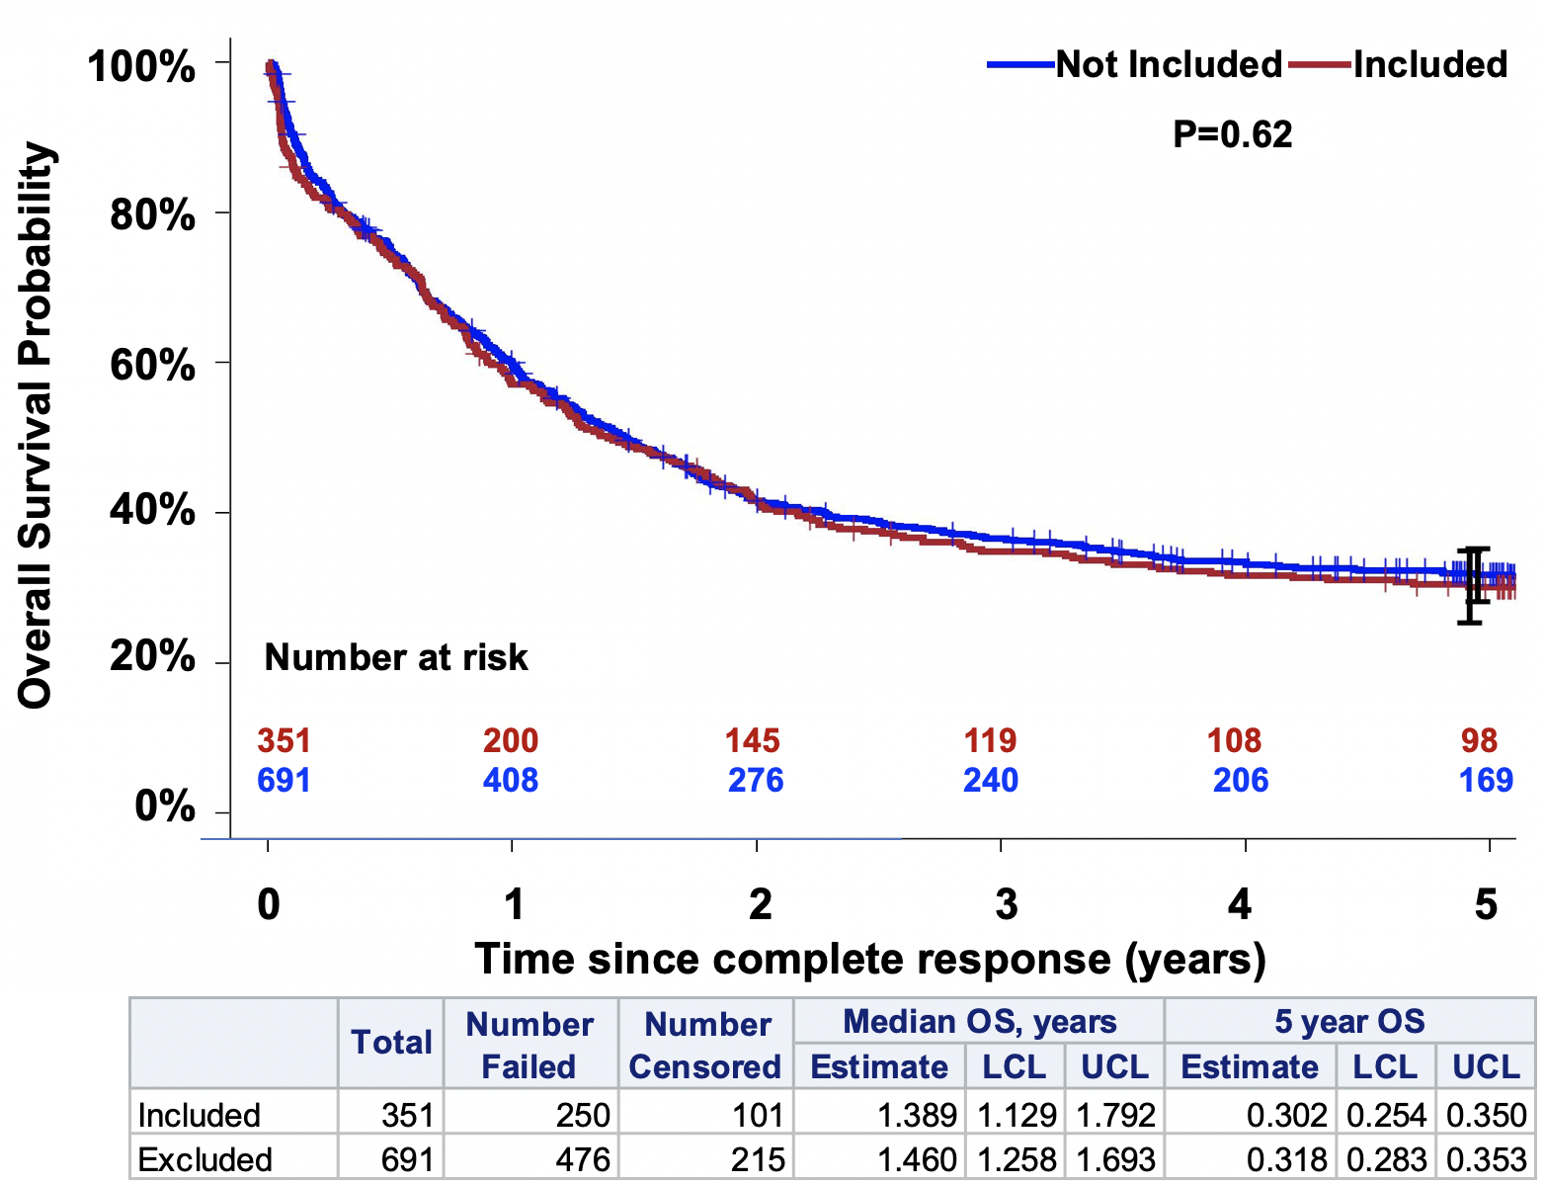
A. Relapse Free Survival
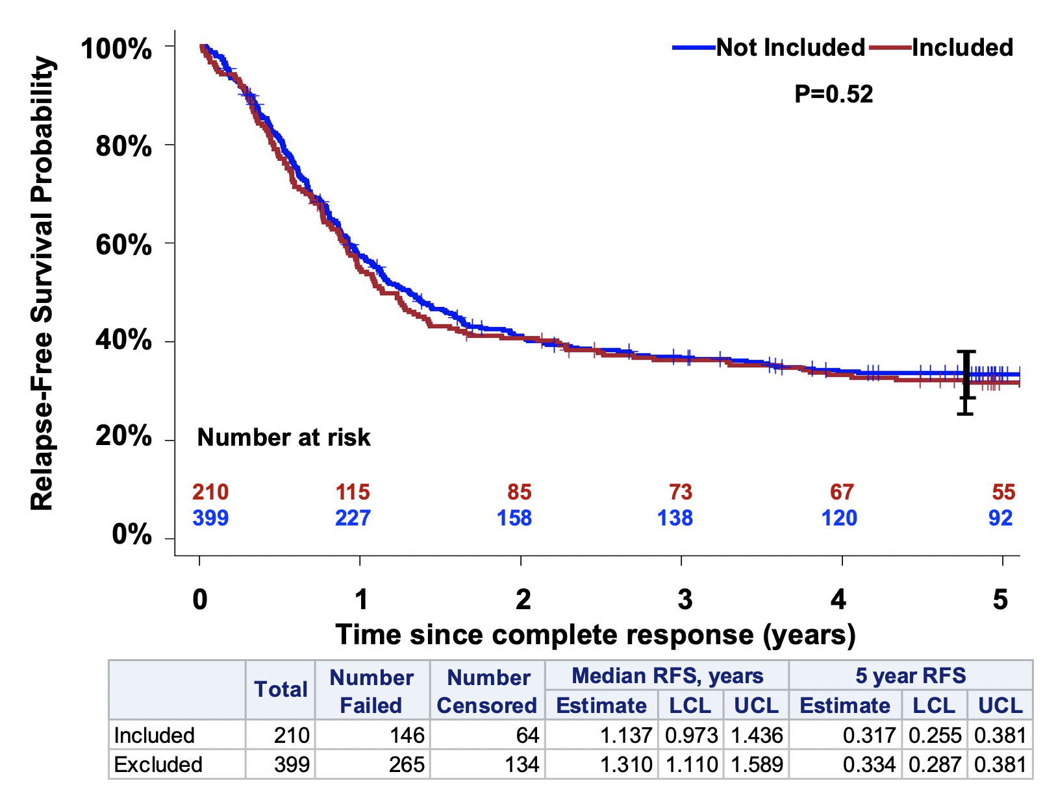

Fig. S1: Figure shows the probability (y-axis) for Relapse Free Survival (A) and Overall Survival (B) over the 5-year follow up period (x-axis) for SWOG patients that were included in this study (red line) and not included (blue line).

Table S4: Characteristics of SWOG patients in the discovery and validation cohorts
Characteristic |  | Total (N=351) |  | Discovery (N=185) |  | Validation (N=166)
 |  | No. |  | No. |  | No. |  | P*
Age (yrs) | median | 56.3 |  | 57.3 |  | 54.4 |  | 0.0865
Age (yrs) | Range | 18.5 -88.8 |  | 18.7 -84.2 |  | 18.5 -88.8 |  | 0.0865
Age (yrs) | N Missing | 0 |  | 0 |  | 0 |  | 0.0865
Marrow blasts (%) | median | 71 |  | 70.5 |  | 71 |  | 0.9802
Marrow blasts (%) | Range | 7 -100 |  | 17 -100 |  | 7 -100 |  | 0.9802
Marrow blasts (%) | N Missing | 11 |  | 5 |  | 6 |  | 0.9802
WBC (10^9/L) | median | 36.5 |  | 31.1 |  | 41.2 |  | 0.0188
WBC (10^9/L) | Range | 0.7 -369.7 |  | 0.9 -307.6 |  | 0.7 -369.7 |  | 0.0188
WBC (10^9/L) | N Missing | 0 |  | 0 |  | 0 |  | 0.0188
PB Blasts (%) | median | 41 |  | 43 |  | 39 |  | 0.7742
PB Blasts (%) | Range | 0 -99 |  | 0 -99 |  | 0 -99 |  | 0.7742
PB Blasts (%) | N Missing | 10 |  | 6 |  | 4 |  | 0.7742
PB Blasts (10^9/L) | median | 10.1 |  | 9.5 |  | 11 |  | 0.3117
PB Blasts (10^9/L) | Range | 0 -347.5 |  | 0 -261.5 |  | 0 -347.5 |  | 0.3117
PB Blasts (10^9/L) | N Missing | 10 |  | 6 |  | 4 |  | 0.3117
Neutrophils (%) | median | 8 |  | 8 |  | 8 |  | 0.8844
Neutrophils (%) | Range | 0 -96 |  | 0 -62 |  | 0 -96 |  | 0.8844
Neutrophils (%) | N Missing | 4 |  | 2 |  | 2 |  | 0.8844
ANC (10^9/L) | median | 2.1 |  | 1.8 |  | 2.2 |  | 0.1672
ANC (10^9/L) | Range | 0 -106.9 |  | 0 -34.4 |  | 0 -106.9 |  | 0.1672
ANC (10^9/L) | N Missing | 4 |  | 2 |  | 2 |  | 0.1672
Hg (g/dL) | median | 9.1 |  | 9.2 |  | 9 |  | 0.3255
Hg (g/dL) | Range | 4.4 -29.1 |  | 4.4 -29.1 |  | 4.9 -14.4 |  | 0.3255
Hg (g/dL) | N Missing | 8 |  | 4 |  | 4 |  | 0.3255
PLT (10^9/L) | median | 52.5 |  | 54 |  | 52 |  | 0.7656
PLT (10^9/L) | Range | 6 -449 |  | 9 -412 |  | 6 -449 |  | 0.7656
PLT (10^9/L) | N Missing | 1 |  | 1 |  | 0 |  | 0.7656
Viability by DAPI | median | 74.1 |  | 67.1 |  | 76.5 |  | 0.0010
Viability by DAPI | Range | 5.2 -97.2 |  | 5.2 -95.6 |  | 6.6 -97.2 |  | 0.0010
Viability by DAPI | N Missing | 2 |  | 2 |  | 0 |  | 0.0010
Lymphocytes (%) | median | 7.3 |  | 7.1 |  | 7.5 |  | 0.1543
Lymphocytes (%) | Range | 0.1 -72.9 |  | 0.4 -70.1 |  | 0.1 -72.9 |  | 0.1543
Lymphocytes (%) | N Missing | 5 |  | 5 |  | 0 |  | 0.1543
Registration year | median | 2005 |  | 2005 |  | 2005 |  | 0.9949
Registration year | Range | 1992 -2009 |  | 1992 -2009 |  | 1992 -2009 |  | 0.9949
Registration year | N Missing | 0 |  | 0 |  | 0 |  | 0.9949
Characteristic |  | No. | % | No. | % | No. | % | P*
Sex | Female | 169 | 48% | 81 | 44% | 88 | 53% | 0.0841
Sex | Male | 182 | 52% | 104 | 56% | 78 | 47% | 0.0841
Race | White | 291 | 83% | 158 | 85% | 133 | 80% | 0.4724
Race | Black | 37 | 11% | 17 | 9% | 20 | 12% | 0.4724
Race | Asian | 11 | 3% | 6 | 3% | 5 | 3% | 0.4724
Race | Am. Indian or Alaska Native | 2 | 1% | 0 | 0% | 2 | 1% | 0.4724
Race | Unknown | 10 | 3% | 4 | 2% | 6 | 4% | 0.4724
Hispanic ethnicity | Yes | 14 | 4% | 6 | 3% | 8 | 5% | 0.6185
Hispanic ethnicity | No | 288 | 82% | 155 | 84% | 133 | 80% | 0.6185
Hispanic ethnicity | Unknown | 49 | 14% | 24 | 13% | 25 | 15% | 0.6185
Secondary AML | No | 322 | 92% | 166 | 90% | 156 | 94% | 0.1491
Secondary AML | Yes | 29 | 8% | 19 | 10% | 10 | 6% | 0.1491
Cytogenetics | -5/5q-,-7/7q- | 22 | 6% | 14 | 8% | 8 | 5% | 0.0296
Cytogenetics | CBF | 40 | 11% | 17 | 9% | 23 | 14% | 0.0296
Cytogenetics | Normal | 127 | 36% | 57 | 31% | 70 | 42% | 0.0296
Cytogenetics | Normal+Nonclonal | 7 | 2% | 7 | 4% | 0 | 0% | 0.0296
Cytogenetics | Other | 76 | 22% | 38 | 21% | 38 | 23% | 0.0296
Cytogenetics | Missing | 79 | 23% | 52 | 28% | 27 | 16% | 0.0296
FAB class | M0 | 22 | 6% | 11 | 6% | 11 | 7% | 0.4569
FAB class | M1 | 75 | 21% | 41 | 22% | 34 | 20% | 0.4569
FAB class | M2 | 83 | 24% | 51 | 28% | 32 | 19% | 0.4569
FAB class | M3 | 1 | 0% | 1 | 1% | 0 | 0% | 0.4569
FAB class | M4/M4eos | 111 | 32% | 54 | 29% | 57 | 34% | 0.4569
FAB class | M5 | 47 | 13% | 21 | 11% | 26 | 16% | 0.4569
FAB class | M6 | 1 | 0% | 0 | 0% | 1 | 1% | 0.4569
FAB class | M7 | 1 | 0% | 1 | 1% | 0 | 0% | 0.4569
FAB class | Other | 4 | 1% | 2 | 1% | 2 | 1% | 0.4569
FAB class | Missing | 6 | 2% | 3 | 2% | 3 | 2% | 0.4569
Performance status | 0 | 108 | 31% | 63 | 34% | 45 | 27% | 0.0662
Performance status | 1 | 166 | 47% | 89 | 48% | 77 | 46% | 0.0662
Performance status | 2 | 48 | 14% | 17 | 9% | 31 | 19% | 0.0662
Performance status | 3 | 28 | 8% | 15 | 8% | 13 | 8% | 0.0662
Performance status | Missing | 1 | 0% | 1 | 1% | 0 | 0% | 0.0662
Clinical trial | S0106 | 206 | 59% | 99 | 54% | 107 | 64% | 0.0209
Clinical trial | S0112 | 23 | 7% | 15 | 8% | 8 | 5% | 0.0209
Clinical trial | S9031 | 57 | 16% | 27 | 15% | 30 | 18% | 0.0209
Clinical trial | S9333 | 65 | 19% | 44 | 24% | 21 | 13% | 0.0209
Immunophenotype | CD117 | 88 | 25% | 35 | 19% | 53 | 32% | 0.0006
Immunophenotype | CD34 | 188 | 54% | 99 | 54% | 89 | 54% | 0.0006
Immunophenotype | Double Negative | 72 | 21% | 50 | 27% | 22 | 13% | 0.0006
Immunophenotype | Not Done | 1 | 0% | 1 | 1% | 0 | 0% | 0.0006
Immunophenotype | Inconclusive | 2 | 1% | 0 | 0% | 2 | 1% | 0.0006
Cytogenetic risk | Favorable | 42 | 12% | 19 | 10% | 23 | 14% | 0.0280
Cytogenetic risk | Intermediate | 182 | 52% | 86 | 46% | 96 | 58% | 0.0280
Cytogenetic risk | Unfavorable | 51 | 15% | 30 | 16% | 21 | 13% | 0.0280
Cytogenetic risk | Unknown | 76 | 22% | 50 | 27% | 26 | 16% | 0.0280
Complete response | No | 141 | 40% | 79 | 43% | 62 | 37% | 0.3071
Complete response | Yes | 210 | 60% | 106 | 57% | 104 | 63% | 0.3071

Abbreviations: WBC, white blood cell count; PB, peripheral blood; ANC, absolute neutrophil count; Hg, hemoglobin; PLT, platelet count; AML, acute myeloid leukaemia; FAB, French American British classification.
*P-value from Wilcoxon rank-sum tests for continuous variables and chi-squared or Fisher’s exact tests for categorical variables, depending on the frequency distribution. Missing values were excluded from testing.

Fig. S2: Comparison of Survival Outcomes of SWOG patients in the discovery and validation cohorts.
B. Overall Survival
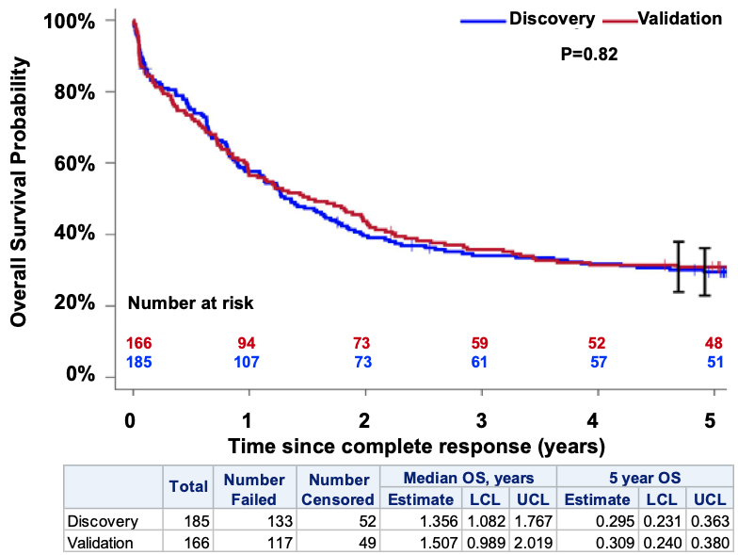
A. Relapse Free Survival
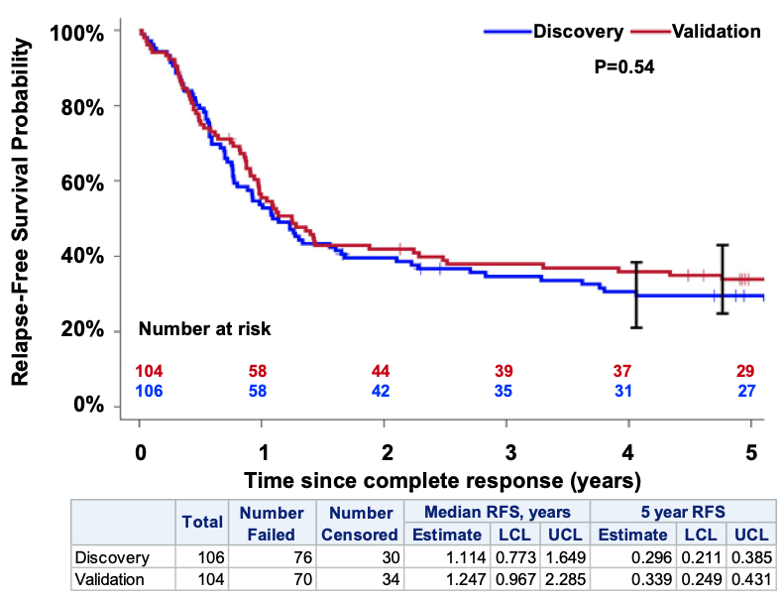

Fig. S2: Figure shows the probability (y-axis) for Relapse Free Survival (A) and Overall Survival (B) over the 5-year follow up period (x-axis) for SWOG patients in the discovery (blue line) and validation (red line) cohorts.

Table S5: Mutation distribution in discovery and validation cohorts
Characteristic |  | Total  (N=351) |  | Discovery (N=185) |  | Validation (N=166) |  | P*
 |  | No. |  | No. |  | No. |  | P*
FLT3-ITD AR (MNCs) | Median | 0.6 |  | 0.6 |  | 0.7 |  | 0.0935
FLT3-ITD AR (MNCs) | Range | 0 -13.2 |  | 0 -5.4 |  | 0 -13.2 |  | 0.0935
FLT3-ITD AR (MNCs) | Negative | 240 |  | 130 |  | 110 |  | 0.0935
FLT3-ITD AR (MNCs) | Missing | 0 |  | 0 |  | 0 |  | 0.0935
FLT3-ITD AR (VLBs) | Median | 0.8 |  | 0.7 |  | 0.8 |  | 0.0646
FLT3-ITD AR (VLBs) | Range | 0 -20 |  | 0 -20 |  | 0.2 -20 |  | 0.0646
FLT3-ITD AR (VLBs) | Negative | 234 |  | 123 |  | 111 |  | 0.0646
FLT3-ITD AR (VLBs) | Missing | 6 |  | 0 |  | 6 |  | 0.0646
Characteristic |  | No. | % | No. | % | No. | % | P*
ASXL1  (all that agree) | Wild type | 314 | 89% | 159 | 86% | 155 | 93% | 0.0439
ASXL1  (all that agree) | Mutant | 35 | 10% | 24 | 13% | 11 | 7% | 0.0439
ASXL1  (all that agree) | Missing | 2 | 1% | 2 | 1% | 0 | 0% | 0.0439
FLT3-ITD  (all that agree) | Wild type | 240 | 68% | 130 | 70% | 110 | 66% | 0.4225
FLT3-ITD  (all that agree) | ITD | 109 | 31% | 54 | 29% | 55 | 33% | 0.4225
FLT3-ITD  (all that agree) | Missing | 2 | 1% | 1 | 1% | 1 | 1% | 0.4225
NPM1 | Wild type | 225 | 64% | 123 | 66% | 102 | 61% | 0.2923
NPM1 | Mutant | 125 | 36% | 61 | 33% | 64 | 39% | 0.2923
NPM1 | Missing | 1 | 0% | 1 | 1% | 0 | 0% | 0.2923
RUNX1 | Wild type | 311 | 89% | 160 | 86% | 151 | 91% | 0.1875
RUNX1 | Mutant | 40 | 11% | 25 | 14% | 15 | 9% | 0.1875
TP53 | Wild type | 325 | 93% | 167 | 90% | 158 | 95% | 0.0795
TP53 | Mutant | 26 | 7% | 18 | 10% | 8 | 5% | 0.0795
CEBPA | Wild type | 330 | 94% | 176 | 95% | 154 | 93% | 0.2462
CEBPA | Mutant | 20 | 6% | 8 | 4% | 12 | 7% | 0.2462
CEBPA | Missing | 1 | 0% | 1 | 1% | 0 | 0% | 0.2462
* P-value from Wilcoxon rank-sum tests for continuous variables and chi-squared tests for categorical variables. Missing values were excluded from testing.

Fig. S3: Oncoprint, Mutation frequency
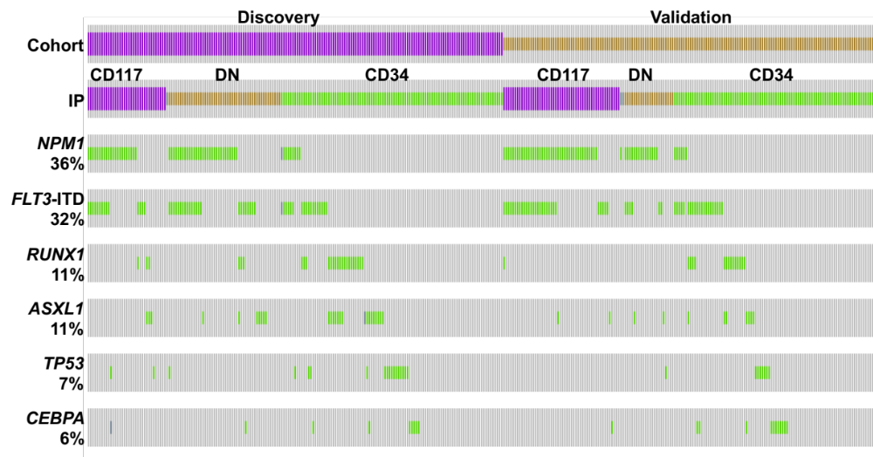

Fig. S3: Mutation OncoPrint. Figure shows the mutation distribution for NPM1, FLT3-ITD, RUNX1, ASXL1, TP53 and CEBPA (rows 3-8, green) in individual patients within the discovery (purple) and validation (orange) cohorts (top bar) stratified by the immunophenotype (IP: CD34, green; CD117, purple; or double negative, DN, orange, second bar). Missing data is identified by dark gray bars.

Table S6: Expression fold change differences between MNCs and VLBs in discovery cohort

Biomarker | MNCs |  | VLBs |  | P-value*
Biomarker | Mean | Range | Mean | Range
BAALC | 18.252 | (0.003 - 260.816) | 29.237 | (0.0001 - 369.468) | <0.0001
CCNA1 | 57.403 | (0.001 - 1802.729) | 71.034 | (0.001 - 2153.210) | 0.0059
CEBPA | 3.309 | (0.008 - 46.232) | 3.158 | (0.004 - 43.903) | 0.3553
ERG1 | 5.028 | (0 - 27.368) | 6.524 | (0 - 33.532) | <0.0001
EVI1 | 6.281 | (0.0003 - 333.139) | 7.022 | (0.0003 - 370.968) | 0.0007
FLT3 | 9.477 | (0.332 - 116.304) | 9.990 | (0.266 - 108.116) | 0.0243
GATA2 | 6.409 | (0.004 - 90.883) | 6.334 | (0.004 - 75.729) | 0.3544
IL3RA | 3.927 | (0.029 - 49.363) | 4.220 | (0.0003 - 39.001) | 0.0693
JAG1 | 7.453 | (0.0004 - 64.092) | 7.348 | (0.0001 - 154.053) | 0.0739
KIT | 4.565 | (0.0001 - 46.525) | 4.732 | (0.007 - 33.324) | 0.4152
MN1 | 21.133 | (0.0001 - 210.250) | 25.441 | (0.0002 - 296.055) | <0.0001
RUNX1 | 2.900 | (0.117 - 18.596) | 3.458 | (0.003 - 23.120) | 0.0012
WT1 | 0.118 | (0 - 1.077) | 0.144 | (0 - 1.027) | <0.0001
FLT3 (AR) | 0.729 | (0.04 - 5.36) | 1.420 | (0.03 - 20) | 0.0012
*P-value from Wilcoxon signed rank test for paired data. Mean and range are shown for paired samples only (patients with only MNCs or only VLBs not included).

Table S7: Univariate Analyses Results, non-significant findings
Variable |  | Cell Population
Biomarker | Value | MNCs |  |  | Blasts
Complete Response, CR |  | N | OR (95% CI) | P | N | OR (95% CI) | P
FLT3-ITD AR, NPM1+ | Continuous | 63 | 0.86 (0.66 - 1.13) | 0.28 | 60 | 0.93 (0.84 - 1.04) | 0.22
FLT3-ITD AR, NPM1+ | IQR | 63 | 0.93 (0.82 - 1.06) | 0.28 | 60 | 0.96 (0.90 - 1.03) | 0.22
BAALC | Continuous | 178 | 0.99 (0.98 - 1.00) | 0.079 | 162 | 1.00 (0.99 - 1.00) | 0.12
BAALC | IQR | 178 | 0.86 (0.72 - 1.02) | 0.079 | 162 | 0.87 (0.73 - 1.04) | 0.12
CCNA1 | Continuous | 178 | 1.00 (1.00 - 1.00) | 0.47 | 162 | 1.00 (1.00 - 1.00) | 0.7
CCNA1 | IQR | 178 | 0.97 (0.89 - 1.06) | 0.47 | 162 | 0.98 (0.90 - 1.07) | 0.7
CEBPA | Continuous | 178 | 0.98 (0.93 - 1.04) | 0.54 | 162 | 0.96 (0.89 - 1.03) | 0.25
CEBPA | IQR | 178 | 0.95 (0.82 - 1.11) | 0.54 | 162 | 0.89 (0.72 - 1.09) | 0.25
FLT3 | Continuous | 178 | 0.99 (0.97 - 1.02) | 0.58 | 162 | 0.99 (0.97 - 1.02) | 0.56
FLT3 | IQR | 178 | 0.95 (0.78 - 1.15) | 0.58 | 162 | 0.95 (0.78 - 1.14) | 0.56
GATA2 | Continuous | 178 | 0.97 (0.93 - 1.00) | 0.066 | 162 | 0.96 (0.92 - 1.00) | 0.052
GATA2 | IQR | 178 | 0.80 (0.63 - 1.02) | 0.066 | 162 | 0.69 (0.47 - 1.00) | 0.052
IL3RA | Continuous | 178 | 1.01 (0.95 - 1.07) | 0.82 | 162 | 0.99 (0.94 - 1.06) | 0.87
IL3RA | IQR | 178 | 1.03 (0.82 - 1.29) | 0.82 | 162 | 0.98 (0.79 - 1.22) | 0.87
JAG1 | Continuous | 178 | 0.99 (0.96 - 1.01) | 0.3 | 162 | 1.00 (0.98 - 1.02) | 0.89
JAG1 | IQR | 178 | 0.90 (0.74 - 1.10) | 0.3 | 162 | 0.99 (0.85 - 1.15) | 0.89
RUNX1 | Continuous | 178 | 0.93 (0.84 - 1.05) | 0.23 | 162 | 0.92 (0.83 - 1.01) | 0.074
RUNX1 | IQR | 178 | 0.84 (0.64 - 1.12) | 0.23 | 162 | 0.71 (0.49 - 1.03) | 0.074
WT1 | Continuous | 178 | 0.61 (0.13 - 2.90) | 0.53 | 162 | 0.51 (0.09 - 2.81) | 0.44
WT1 | IQR | 178 | 0.93 (0.73 - 1.17) | 0.53 | 162 | 0.88 (0.63 - 1.22) | 0.44
Overall Survival, OS |  | N | HR (95% CI) | P | N | HR (95% CI) | P
FLT3-ITD AR, NPM1+ | Continuous | 63 | 1.13 (1.00 - 1.26) | 0.043 | 60 | 1.04 (0.98 - 1.11) | 0.16
FLT3-ITD AR, NPM1+ | IQR | 63 | 1.06 (1.00 - 1.12) | 0.043 | 60 | 1.03 (0.99 - 1.06) | 0.16
BAALC | Continuous | 178 | 1.00 (1.00 - 1.01) | 0.15 | 162 | 1.00 (1.00 - 1.01) | 0.12
BAALC | IQR | 178 | 1.06 (0.98 - 1.14) | 0.15 | 162 | 1.07 (0.98 - 1.16) | 0.12
CEBPA | Continuous | 178 | 1.02 (0.99 - 1.05) | 0.24 | 162 | 1.03 (0.99 - 1.07) | 0.12
CEBPA | IQR | 178 | 1.05 (0.97 - 1.14) | 0.24 | 162 | 1.09 (0.98 - 1.21) | 0.12
GATA2 | Continuous | 178 | 1.00 (0.98 - 1.02) | 0.99 | 162 | 1.01 (1.00 - 1.03) | 0.16
GATA2 | IQR | 178 | 1.00 (0.89 - 1.12) | 0.99 | 162 | 1.10 (0.96 - 1.27) | 0.16
JAG1 | Continuous | 178 | 1.01 (0.99 - 1.02) | 0.22 | 162 | 1.00 (0.99 - 1.01) | 0.68
JAG1 | IQR | 178 | 1.07 (0.96 - 1.20) | 0.22 | 162 | 1.02 (0.94 - 1.09) | 0.68
KIT | Continuous | 178 | 1.01 (0.99 - 1.04) | 0.42 | 162 | 1.00 (0.97 - 1.03) | 0.82
KIT | IQR | 178 | 1.04 (0.94 - 1.16) | 0.42 | 162 | 1.02 (0.88 - 1.17) | 0.82
MN1 | Continuous | 178 | 1.00 (1.00 - 1.01) | 0.72 | 162 | 1.00 (1.00 - 1.00) | 0.78
MN1 | IQR | 178 | 1.02 (0.93 - 1.12) | 0.72 | 162 | 1.01 (0.92 - 1.12) | 0.78
RUNX1 | Continuous | 178 | 1.04 (0.98 - 1.10) | 0.2 | 162 | 1.04 (1.00 - 1.09) | 0.067
RUNX1 | IQR | 178 | 1.10 (0.95 - 1.28) | 0.2 | 162 | 1.18 (0.99 - 1.41) | 0.067
WT1 | Continuous | 178 | 0.75 (0.27 - 2.08) | 0.58 | 162 | 0.78 (0.28 - 2.14) | 0.62
WT1 | IQR | 178 | 0.96 (0.82 - 1.12) | 0.58 | 162 | 0.95 (0.78 - 1.16) | 0.62
Relapse-Free Survival, RFS |  | N | HR (95% CI) | P | N | HR (95% CI) | P
FLT3-ITD AR, NPM1+ | Continuous | 39 | 1.05 (0.87 - 1.28) | 0.59 | 36 | 1.04 (0.96 - 1.14) | 0.34
FLT3-ITD AR, NPM1+ | IQR | 39 | 1.03 (0.94 - 1.12) | 0.59 | 36 | 1.03 (0.97 - 1.08) | 0.34
BAALC | Continuous | 101 | 1.00 (0.99 - 1.01) | 0.9 | 91 | 1.00 (1.00 - 1.01) | 0.4
BAALC | IQR | 101 | 0.99 (0.81 - 1.20) | 0.9 | 91 | 1.07 (0.92 - 1.25) | 0.4
CEBPA | Continuous | 101 | 1.03 (0.98 - 1.08) | 0.29 | 91 | 1.01 (0.94 - 1.09) | 0.7
CEBPA | IQR | 101 | 1.08 (0.94 - 1.24) | 0.29 | 91 | 1.04 (0.84 - 1.29) | 0.7
ERG1 | Continuous | 101 | 1.01 (0.97 - 1.06) | 0.56 | 91 | 1.03 (1.00 - 1.07) | 0.081
ERG1 | IQR | 101 | 1.07 (0.86 - 1.33) | 0.56 | 91 | 1.29 (0.97 - 1.72) | 0.081
FLT3 | Continuous | 101 | 1.01 (0.99 - 1.03) | 0.28 | 91 | 1.01 (0.99 - 1.03) | 0.29
FLT3 | IQR | 101 | 1.08 (0.94 - 1.25) |  | 91 | 1.08 (0.94 - 1.24) | 0.29
GATA2 | Continuous | 101 | 0.98 (0.95 - 1.02) | 0.37 | 91 | 1.01 (0.97 - 1.05) | 0.63
GATA2 | IQR | 101 | 0.89 (0.70 - 1.14) |  | 91 | 1.09 (0.78 - 1.51) | 0.63
JAG1 | Continuous | 101 | 1.01 (0.99 - 1.03) | 0.48 | 91 | 1.00 (0.99 - 1.01) | 0.6
JAG1 | IQR | 101 | 1.06 (0.90 - 1.24) |  | 91 | 1.02 (0.94 - 1.11) | 0.6
KIT | Continuous | 101 | 1.01 (0.97 - 1.04) | 0.71 | 91 | 1.01 (0.96 - 1.06) | 0.7
KIT | IQR | 101 | 1.03 (0.88 - 1.20) | 0.71 | 91 | 1.05 (0.83 - 1.31) | 0.7
MN1 | Continuous | 101 | 1.00 (0.99 - 1.01) | 0.89 | 91 | 1.00 (0.99 - 1.01) | 0.7
MN1 | IQR | 101 | 1.01 (0.87 - 1.17) | 0.89 | 91 | 1.04 (0.86 - 1.26) | 0.7
RUNX1 | Continuous | 101 | 1.02 (0.94 - 1.10) | 0.66 | 91 | 1.04 (0.97 - 1.12) | 0.29
RUNX1 | IQR | 101 | 1.05 (0.86 - 1.28) | 0.66 | 91 | 1.16 (0.88 - 1.54) | 0.29
WT1 | Continuous | 101 | 0.74 (0.18 - 3.12) | 0.68 | 91 | 1.24 (0.31 - 5.03) | 0.76
WT1 | IQR | 101 | 0.96 (0.77 - 1.19) | 0.68 | 91 | 1.04 (0.80 - 1.37) | 0.76
Transcript expression fold changes were analyzed both as unadjusted variables (Cont.) and adjusted (divided) by the interquartile range (IQR) of the corresponding expression variable in the discovery data.

Models Details

These details contain R code and output for the final models produced by the algorithm described in the main paper. Models were built separately for each outcome (OS, RFS, CR) and for each type of cells (MNCs and blasts). Examples are given to illustrate how different values of each covariate impact a hypothetical patient’s probability of achieving CR or risk of relapse or death.
Overall Survival
MNCs:
> coxph(Surv(SURTIM, SURIND) ~ AGE + ELN + ERG1 + EVI1 + JAG1 + ELN:JAG1, data=datat0)

Call:
coxph(formula = Surv(SURTIM, SURIND) ~ AGE + ELN + ERG1 +
EVI1 + JAG1 + ELN:JAG1, data = datat0)

coef exp(coef) se(coef) z p
AGE 0.057655 1.059349 0.007834 7.360 1.84e-13
ELNAdverse 0.450146 1.568541 0.376064 1.197 0.2313
ELNFavorable 0.118981 1.126349 0.405543 0.293 0.7692
ELNUnknown 0.750523 2.118108 0.400016 1.876 0.0606
ERG1 0.029921 1.030373 0.018084 1.655 0.0980
EVI1 0.005175 1.005188 0.002342 2.210 0.0271
JAG1 0.089656 1.093798 0.041792 2.145 0.0319
ELNAdverse:JAG1 -0.055747 0.945778 0.043982 -1.268 0.2050
ELNFavorable:JAG1-0.095132 0.909253 0.045045 -2.112 0.0347
ELNUnknown:JAG1 -0.093796 0.910468 0.043593 -2.152 0.0314

Likelihood ratio test=92.16 on 10 df, p=1.993e-15
n= 178, number of events= 128

The four “risk groups” defined by the model in the discovery cohort are as follows:
1st quartile (lowest risk): ≤ 3.00
2nd quartile: (3.00, 4.06]
3rd quartile: (4.06, 4.65]
4th quartile (highest risk): > 4.65

For example, a patient aged 60 years with Adverse ELN risk, ERG1 = 15.8, EVI1 = 0.18, JAG1 = 0:
0.0577*(60) + 0.4501*(1) + 0.1190*(0) + 0.7505*(0)+ 0.0299*(15.8)+ 0.0052*(0.18) + 0.0897*(0) - 0.0557*(1*0) -0.0951*(0*0) -0.0938* (0*0) = 4.39
This patient would fall into the 3rd risk group.

Another patient, aged 40 years with Intermediate ELN risk, ERG1 = 0.13, EVI1 = 0, JAG1 = 0.07:
0.0577*(40) + 0.4501*(0) + 0.1190*(0) + 0.7505*(0)+ 0.0299*(0.13)+ 0.0052*(0) + 0.0897*(0.07) - 0.0557*(0*0.07) -0.0951*(0*0.07) -0.0938* (1*0.07) = 2.31
This patient would fall into the 1st risk group.

Blasts:
> coxph(Surv(SURTIM, SURIND) ~ AGE + ELN_B1 + EVI1_B1 + ERG1_B1 + CCNA1_B1, data=datab1)

Call:
coxph(formula = Surv(SURTIM, SURIND) ~ AGE + ELN_B1 + EVI1_B1 +
ERG1_B1 + CCNA1_B1, data = datab1)

coef exp(coef) se(coef) z p
AGE 0.0510072 1.0523304 0.0079516 6.415 1.41e-10
ELN_B1Adverse 0.0451177 1.0461510 0.2876724 0.157 0.8754
ELN_B1Favorable -0.5550882 0.5740216 0.3233422 -1.717 0.0860
ELN_B1Unknown 0.2448697 1.2774548 0.2957343 0.828 0.4077
EVI1_B1 0.0052446 1.0052584 0.0024434 2.146 0.0318
ERG1_B1 0.0292303 1.0296617 0.0143178 2.042 0.0412
CCNA1_B1 0.0008558 1.0008561 0.0004952 1.728 0.0840

Likelihood ratio test=78.05 on 7 df, p=3.44e-14
n= 162, number of events= 120

The four “risk groups” defined by the model in the discovery cohort are as follows:
1st quartile (lowest risk): ≤ 2.27
2nd quartile: (2.27, 3.22]
3rd quartile: (3.22, 3.85]
4th quartile (highest risk): > 3.85

For example, a patient aged 44 years with Adverse ELN risk, EVI1 = 0, ERG1 = 7.2, CCNA1 = 7.6:
0.0510*(44) + 0.0451*(1) - 0.5551*(0) + 0.2449*(0) + 0.0052*(0) + 0.0292*(7.2) + 0.0009*(7.6) = 2.51
This patient would fall into the 2nd risk group.

Another patient, aged 58 years with Favorable ELN risk, , EVI1 = 0.062, ERG1 = 5.10, CCNA1 = 50.91:
0.0510*(58) + 0.0451*(0) - 0.5551*(1) + 0.2449*(0) + 0.0052*(0.062) + 0.0292*(5.10) + 0.0009*(50.91) = 2.60
This patient would also fall into the 2nd risk group.
Relapse-Free Survival
MNCs:
> coxph(Surv(RFSTIM, RFSIND) ~ AGE + ELN_T0 + EVI1_T0 + CCNA1_T0, data=datat0)

Call:
coxph(formula = Surv(RFSTIM, RFSIND) ~ AGE + ELN_T0 + EVI1_T0 +
CCNA1_T0, data = datat0)

Coef exp(coef) se(coef) z p
AGE 0.022790 1.023052 0.008999 2.533 0.011323
ELN_T0Adverse 1.018995 2.770410 0.272969 3.733 0.000189
EVI1_T0 0.015929 1.016056 0.005336 2.985 0.002836
CCNA1_T0 0.003510 1.003516 0.001525 2.301 0.021383

Likelihood ratio test=35.75 on 4 df, p=3.251e-07
n= 101, number of events= 73

The four “risk groups” defined by the model in the discovery cohort are as follows:
1st quartile (lowest risk): ≤ 1.01
2nd quartile: (1.01, 1.43]
3rd quartile: (1.43, 2.18]
4th quartile (highest risk): > 2.18
For example, a patient aged 72 years with Adverse ELN risk, EVI1 = 87.14, CCNA1 = 10.01:
0.0228*(72) + 1.0190*(1) + 0.0159*(87.14) + 0.0035*(10.01) = 4.08
This patient would fall into the 4th risk group.

Another patient, aged 36 years with Unknown ELN risk, EVI1 = 0, CCNA1 = 11.19:
0.0228*(36) + 1.0190*(0) + 0.0159*(0) + 0.0035*(11.19) = 0.86
This patient would fall into the 1st risk group.

Blasts:
> coxph(Surv(RFSTIM, RFSIND) ~ AGE + ELN_B1 + EVI1_B1 + CCNA1_B1, data=datab1)

Call:
coxph(formula = Surv(RFSTIM, RFSIND) ~ AGE + ELN_B1 + EVI1_B1 +
CCNA1_B1, data = datab1)

coef exp(coef) se(coef) z p
AGE 0.0188577 1.0190366 0.0097114 1.942 0.052159
ELN_B1Adverse 1.0260804 2.7901082 0.2841832 3.611 0.000305
EVI1_B1 0.0162788 1.0164121 0.0062708 2.596 0.009432
CCNA1_B1 0.0017304 1.0017319 0.0009977 1.734 0.082855

Likelihood ratio test=29.59 on 4 df, p=5.934e-06
n= 91, number of events= 68

The four “risk groups” defined by the model in the discovery cohort are as follows:
1st quartile (lowest risk): ≤ 0.84
2nd quartile: (0.84, 1.19]
3rd quartile: (1.19, 2.04]
4th quartile (highest risk): > 2.04

For example, a patient aged 54 years with Intermediate ELN risk, EVI1 = 0, CCNA1 = 5.83:
0.0189*(54) + 1.0260*(0) + 0.0163*(0) + 0.0017*(5.83) = 1.03
This patient would fall into the 2nd risk group.

Another patient, aged 56 years with Adverse ELN risk, EVI1 = 0.04, CCNA1 = 1.14:
0.0189*(56) + 1.0260*(1) + 0.0163*(0.04) + 0.0017*(1.14) = 2.09
This patient would fall into the 4th risk group.

Complete Response
MNCs:
> summary(glm(CR ~ AGE + PS + GATA2_T0 + BAALC_T0, data=datat0, family=binomial(link="logit")))

Call:
glm(formula = CR ~ AGE + PS + GATA2_T0 + BAALC_T0, family = binomial(link = "logit"), data = datat0)

Deviance Residuals:
Min 1Q Median 3Q Max
-1.8710 -1.1107 0.6543 0.9587 1.7013

Coefficients:
Estimate Std. Error z value Pr(>|z|)
(Intercept) 3.038788 0.699580 4.344 1.4e-05 ***
AGE -0.038915 0.011289 -3.447 0.000566 ***
PS2 - 3 -0.909079 0.431626 -2.106 0.035189 *
GATA2_T0 -0.038585 0.020813 -1.854 0.063759 .
BAALC_T0 -0.010302 0.005538 -1.860 0.062862 .
---
Signif. codes: 0 ‘***’ 0.001 ‘**’ 0.01 ‘*’ 0.05 ‘.’ 0.1 ‘ ’ 1

(Dispersion parameter for binomial family taken to be 1)

Null deviance: 241.83 on 176 degrees of freedom
Residual deviance: 215.36 on 172 degrees of freedom
AIC: 225.36

Number of Fisher Scoring iterations: 4

The four “risk groups” defined by the model in the discovery cohort are as follows:
1st quartile (lowest probability of CR): ≤ -0.20
2nd quartile: (-0.20, 0.35]
3rd quartile: (0.35, 0.99]
4th quartile (highest probability of CR): > 0.99

For example, a patient aged 61 years with PS = 2, GATA2 = 0.664, BAALC = 94.46:
3.0388 – 0.0389*(61) – 0.9091*(1) – 0.0386*(0.664) – 0.0103*(94.46) = -1.24
This patient would fall into the 1st risk group, with a low probability of achieving a CR.

Another patient, aged 48 years with PS = 1, GATA2 = 2.05, BAALC = 2.22:
3.0388 – 0.0389*(48) – 0.9091*(0) – 0.0386*(2.05) – 0.0103*(2.22) = 1.07
This patient would fall into the 4th risk group, with a high probability of achieving a CR.

Blasts:
> summary(glm(CR ~ AGE + PS + MN1_B1 + GATA2_B1, data=datab1, family=binomial(link="logit")))

Call:
glm(formula = CR ~ AGE + PS + MN1_B1 + GATA2_B1, family = binomial(link = "logit"), data = datab1)

Deviance Residuals:
Min 1Q Median 3Q Max
-1.9122 -1.0803 0.6128 0.9041 1.9013

Coefficients:
Estimate Std. Error z value Pr(>|z|)
(Intercept) 3.119632 0.754104 4.137 3.52e-05 ***
AGE -0.037653 0.012024 -3.131 0.00174 **
PS2 - 3 -1.050215 0.466547 -2.251 0.02438 *
MN1_B1 -0.011590 0.004687 -2.473 0.01340 *
GATA2_B1 -0.042702 0.023449 -1.821 0.06860 .
---
Signif. codes: 0 ‘***’ 0.001 ‘**’ 0.01 ‘*’ 0.05 ‘.’ 0.1 ‘ ’ 1

(Dispersion parameter for binomial family taken to be 1)

Null deviance: 220.45 on 160 degrees of freedom
Residual deviance: 191.35 on 156 degrees of freedom
AIC: 201.35

Number of Fisher Scoring iterations: 4

The four “risk groups” defined by the model in the discovery cohort are as follows:
1st quartile (lowest risk): ≤ -0.29
2nd quartile: (-0.29, 0.40]
3rd quartile: (0.40, 0.98]
4th quartile (highest risk): > 0.98

For example, a patient aged 69 years with PS = 0, MN1 = 3.28, GATA2 = 4.62:
3.1196 – 0.0377*(69) – 1.0502*(0) – 0.0116*(3.28) – 0.0427*(4.62) = 0.028
This patient would fall into the 2nd risk group.

Another patient, aged 43 years with PS = 1, MN1 = 0, GATA2 = 1.21:
3.1196 – 0.0377*(43) – 1.0502*(0) – 0.0116*(0) – 0.0427*(1.21) = 1.45
This patient would fall into the 4th risk group.

AGE, PS and multivariable models for CR, OS and RFS (for comparison)
Model |  |  | MNCs |  | VLBs
Complete Response (CR, AUC) |  |  | Discovery | Validation | Discovery |  | Validation
ELN₂₀₁₇ |  |  | 0.66 | 0.73 | 0.66 |  | 0.67
AGE |  |  | 0.66 | 0.60 | 0.65 |  | 0.62
PS |  |  | 0.57 | 0.58 | 0.58 |  | 0.59
AGE+ELN₂₀₁₇ |  |  | 0.71 | 0.72 | 0.71 |  | 0.72
ELN+PS |  |  | 0.70 | 0.73 | 0.70 |  | 0.73
AGE+PS |  |  | 0.68 | 0.64 | 0.69 |  | 0.65
AGE+ELN₂₀₁₇+PS |  |  | 0.72 | 0.73 | 0.73 |  | 0.73
Overall Survival (OS, C Statistic) |  |  | Discovery | Validation | Discovery |  | Validation
ELN₂₀₁₇ |  |  | 0.60 | 0.68 | 0.59 |  | 0.68
AGE |  |  | 0.71 | 0.65 | 0.69 |  | 0.65
PS |  |  | 0.54 | 0.57 | 0.54 |  | 0.57
AGE+ELN₂₀₁₇ |  |  | 0.72 | 0.70 | 0.71 |  | 0.71
ELN+PS |  |  | 0.62 | 0.71 | 0.63 |  | 0.71
AGE+PS |  |  | 0.71 | 0.66 | 0.69 |  | 0.66
AGE+ELN₂₀₁₇+PS |  |  | 0.72 | 0.70 | 0.71 |  | 0.71
Relapse-Free Survival (RFS, C Statistic) |  |  | Discovery | Validation | Discovery |  | Validation
ELN₂₀₁₇⍒ |  |  | 0.6 | 0.54 | 0.61 |  | 0.54
AGE |  |  | 0.64 | 0.62 | 0.63 |  | 0.61
PS |  |  | 0.5 | 0.57 | 0.50 |  | 0.57
AGE + ELN₂₀₁₇⍒ |  |  | 0.67 | 0.63 | 0.66 |  | 0.62
ELN₂₀₁₇⍒+PS |  |  | 0.61 | 0.57 | 0.61 |  | 0.57
AGE+PS |  |  | 0.64 | 0.63 | 0.64 |  | 0.63
AGE+ELN₂₀₁₇⍒+PS |  |  | 0.67 | 0.68 | 0.67 |  | 0.67
⍒Due to small sample size, ELN₂₀₁₇ in the RFS models was categorized into adverse vs. not adverse (including intermediate, favorable, and unknown).

Table S8: ELN₂₀₁₇ and ELN_{2017 MOD} risk assignments in MNCs and VLBs

MNCs | ELN₂₀₁₇
ELN_{2017 MOD} | Adverse | Intermediate | Favorable | Unknown | Total
Adverse | 66 | 0 | 2 | 0 | 68
Intermediate | 29 | 64 | 15 | 0 | 108
Favorable | 0 | 0 | 99 | 0 | 99
Unknown | 0 | 0 | 0 | 76 | 76
Total | 95 | 64 | 116 | 76 | 351

VLBs | ELN₂₀₁₇
ELN_{2017 MOD} | Adverse | Intermediate | Favorable | Unknown | Total
Adverse | 68 | 0 | 2 | 0 | 70
Intermediate | 26 | 60 | 15 | 0 | 101
Favorable | 0 | 0 | 94 | 0 | 94
Unknown | 1 | 0 | 0 | 85 | 86
Total | 95 | 60 | 111 | 85 | 351

