Table.S1. The information of mir-767-105 cluster from miRBase
Office Symbol | miRBase | Chromosome Location
hsa-mir-105-1 | MI0000111 | chrX: 152392219-152392299
hsa-mir-767 | MI0003763 | chrX: 152393421-152393529
hsa-mir-105-2 | MI0000112 | chrX: 152394412-152394492

Fig.S1
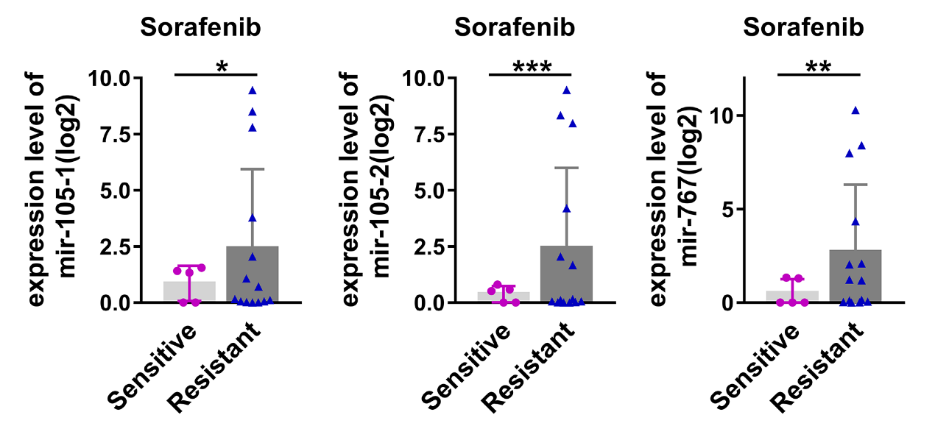
comparison of the mir-105-1 (left), mir-105-2 (middle), mir-767 (right) expression levels between the sorafinib sensitive group and sorafinib resistant group. Error bars represented the mean ± standard error of the mean. “*”, “**”, “***”represent a P -value < 0.05, 0.01, 0.001, respectively.

Table.S2 The correlation between the three mirnas and the clinicopathological characteristics.
Charactristics | has-mir-767(n) |  |  |  | Has-mir-105-1(n) |  |  |  | Has-mir-105-2(n)
Charactristics | Low | High | p |  | low | High | p |  | low | High | p
Age(y)
<65 | 191 | 41 | <0.001 |  | 130 | 102 | 0.004 |  | 129 | 103 | 0.008
≥65 | 89 | 49 |  |  | 56 | 82 |  |  | 57 | 81
Gender
Female | 69 | 50 | 0.048 |  | 62 | 57 | 0.63 |  | 66 | 53 | 0.158
Male | 117 | 135 |  |  | 124 | 128 |  |  | 120 | 132
BMI(kg/m² )
≥25 | 137 | 43 | 0.387 |  | 141 | 39 | 0.491 |  | 146 | 34 | 0.362
<25 | 113 | 44 |  |  | 118 | 39 |  |  | 121 | 36
Vascular_tumor
None | 156 | 50 | 0.448 |  | 107 | 99 | 0.983 |  | 163 | 43 | 0.994
Invasion | 79 | 31 |  |  | 57 | 53 |  |  | 87 | 23
Surgery extension
Segmentectomy | 136 | 39 | 0.171 |  | 138 | 37 | 0.258 |  | 142 | 33 | 0.374
Lobectomy | 119 | 48 |  |  | 123 | 44 |  |  | 129 | 38
Residual tumor
RO | 243 | 81 | 0.791 |  | 250 | 74 | 0.628 |  | 258 | 66 | 0.850
R1+R2 | 13 | 5 |  |  | 13 | 5 |  |  | 14 | 4
Viral hepatitis
Only HBV positive | 46 | 11 | 0.880 |  | 46 | 11 | 0.951 |  | 46 | 11 | 0.772
Only HCV positive | 14 | 4 |  |  | 17 | 4 |  |  | 18 | 3
HBV+HCV positive | 62 | 18 |  |  | 63 | 17 |  |  | 63 | 17
Fibrosis(ishak score)
0 | 56 | 19 | 0.863 |  | 58 | 17 | 0.788 |  | 58 | 17 | 0.622
1-4 | 44 | 16 |  |  | 46 | 14 |  |  | 48 | 12
5-6 | 61 | 18 |  |  | 64 | 15 |  |  | 66 | 13
Tumor burden
Low | 202 | 73 | 0.641 |  | 208 | 67 | 0.780 |  | 218 | 57 | 0.307
High | 66 | 27 |  |  | 69 | 24 |  |  | 69 | 24
Tumor Stage
Low | 191 | 66 | 0.697 |  | 196 | 61 | 0.892 |  | 205 | 52 | 0.401
High | 65 | 25 |  |  | 68 | 22 |  |  | 68 | 22
Tumor grade
Low | 173 | 58 | 0.294 |  | 179 | 52 | 0.243 |  | 187 | 44 | 0.096
High | 95 | 41 |  |  | 98 | 38 |  |  | 100 | 36
Event
Alive | 190 | 53 | 0.002 |  | 194 | 49 | 0.007 |  | 201 | 42 | 0.003
Death | 81 | 47 |  |  | 86 | 42 |  |  | 89 | 39

Fig.S2
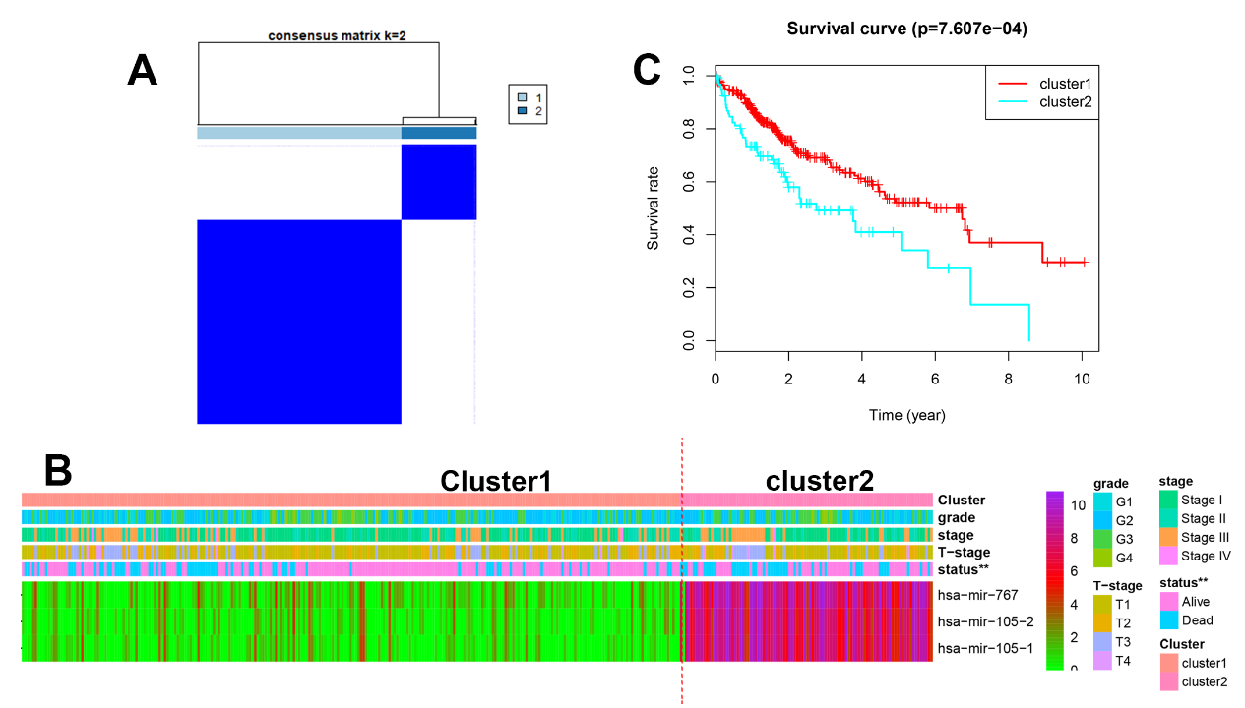
S1 A) According to the 3-mirna differentiated expression levels, the HCC samples were divided into two clusters, by “ConsensusClusterPlus” package.
S1 B) Characteristics of the two cluster were presented with heatmap. The cluster 2 integrated HCC samples with relatively higher mir-767-105 cluster expression.
S1 C) Kaplan-Meier survival analysis showed that the cluster 2 with relatively higher mir-767-105 cluster expression achieved poorer outcome.

Fig.S3
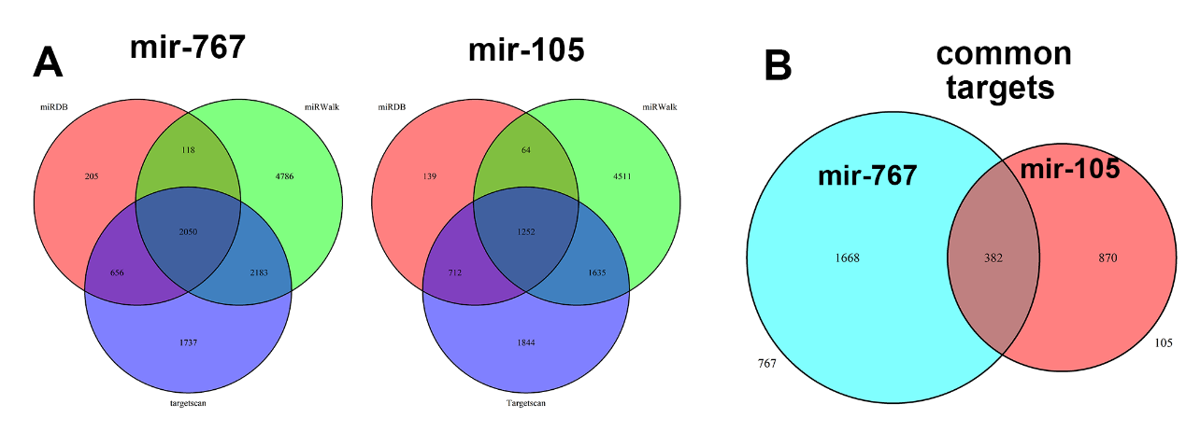
S A) The predicted target genes of mir-767 and mir-105 from the miRDB(red colour), miRWalk(green colour), TargetScan (blue colour) databases were overlapped.
S B) The mir-767 (green colour) and mir-105 (red colour) target genes were further overlapped. A total of 378 genes may be co-targeted by the cluster.

Fig.S4
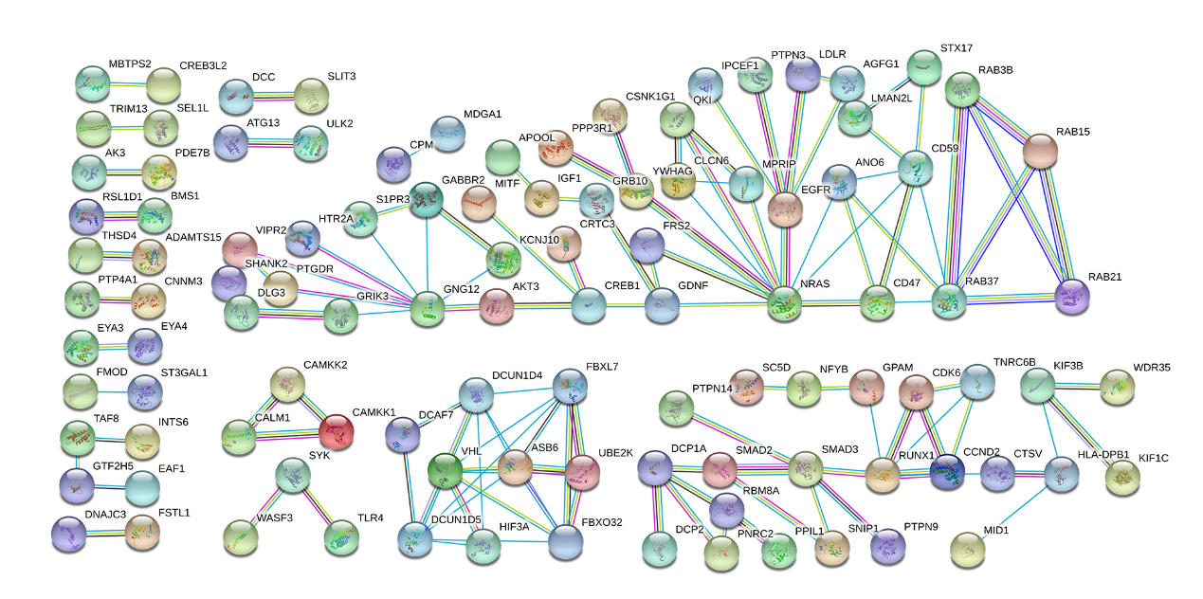
S3) Protein-protein interaction analysis showed the target nodes with the highest confidence.

