Additional file 4: Figure S4
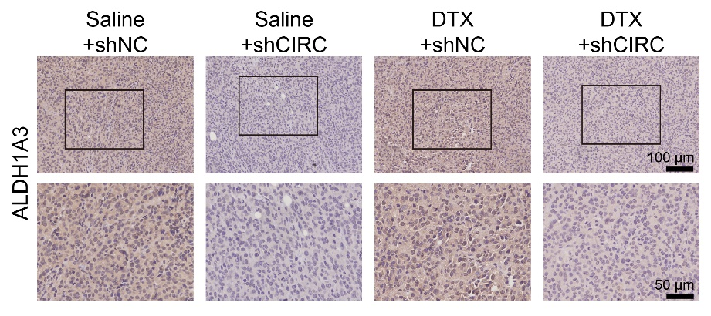
Figure S4. Representative images of IHC (ALDH1A3) staining of the xenograft tumors.

