Supplementary Figures
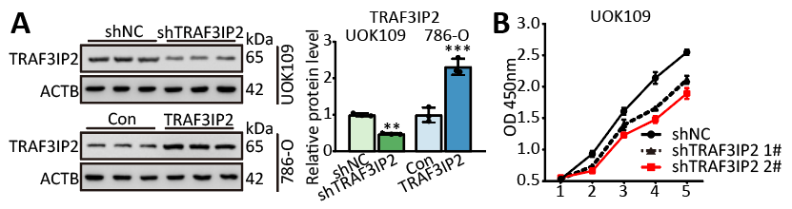
Figure S1 (A) The protein level of TRAF3IP2 after up-/down-regulated TRAF3IP2. (B) The effects of TRAF3IP2 knockdown on the proliferation of UOK109 and 786-O cells respectively were examined by CCK-8 assay.The data are presented as the mean ± SD, **P< 0.01, ***P< 0.001

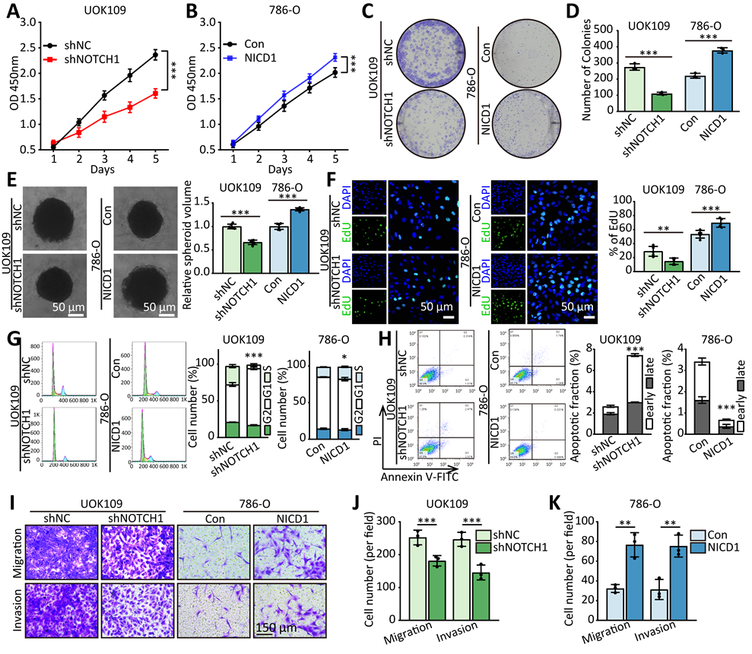
Figure S2 NOTCH1 pathway induces development of NONO-TFE3 tRCC. (A-E) The effects of NICD1 overexpression or NOTCH1 knockdown on the proliferation of UOK109 and 786-O cells respectively were examined by CCK-8 assay (A-B), colony formation assays (C-D) and tumor sphere formation (E). (F) EdU assays were used to detect the proliferation rate of UOK109 and 786-O cells after transfection for 48h. (G) Cell cycle was analyzed using flow cytometry after transfection for 48h. H Cell apoptosis was analyzed via flow cytometry using an Annexin V/PI kit after transfection for 48h. (I-K) Migration and invasion assays were performed with transfected cells using Transwell inserts. The data are presented as the mean ± SD, *P< 0.05, **P< 0.01, ***P< 0.001

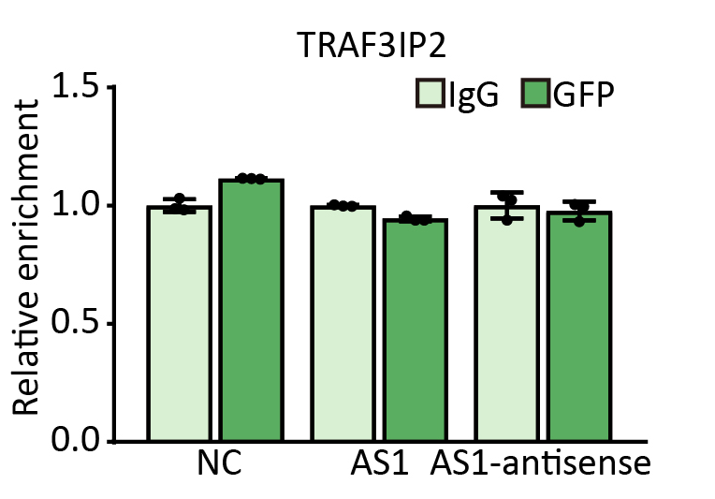
Figure S3 Level of TRAF3IP2 mRNA detected by qRT-PCR after MS2-RIP for GFP in UOK109 cells. AS1, NC and AS1-antisense correspond to TRAF3IP2-AS1, empty vector and TRAF3IP2-AS1-antisense. The data are presented as the mean ± SD.

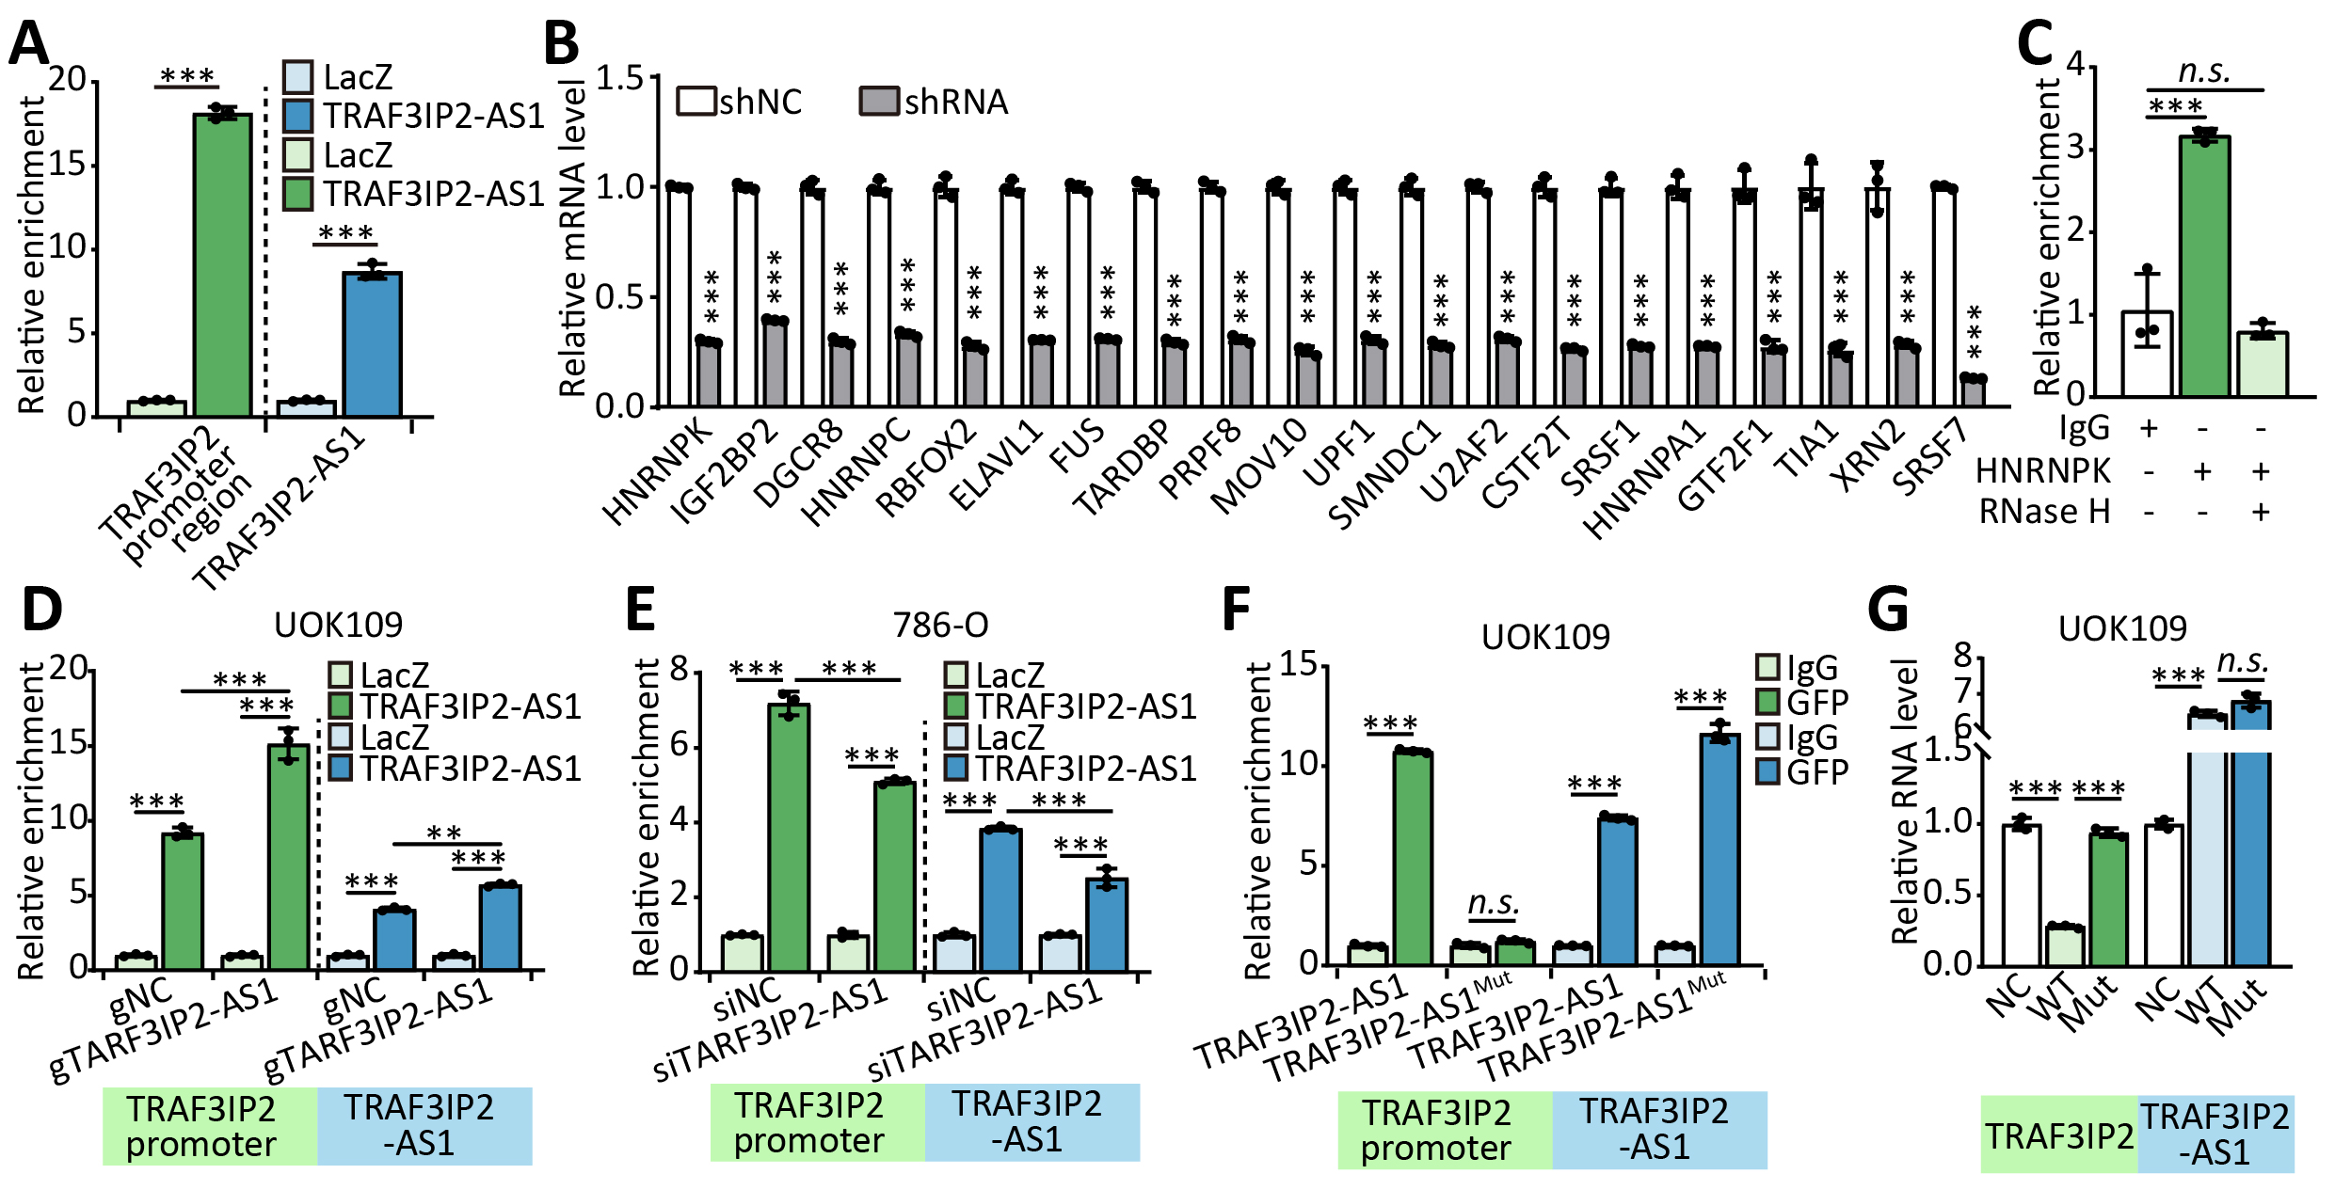
Figure S4 TRAF3IP2-AS1 down-regulates TRAF3IP2 by recruiting HNRNPK to TRAF3IP2 promoter. (A) UOK109 cells were lysed, then CHIRP were performed with TRAF3IP2-AS1 probe or LacZ probe. (B) The mRNA levels were detected by qRT-PCR after transfected with shRNA targeted the potential TRAF3IP2-AS1 binding proteins. (C) UOK109 cells were lysed, then ChIP were performed with anti-HNRNPK antibody. (D-E) UOK109 cells were transfected with indicated lentivirus and siRNAs, then the promoter region of TRAF3IP2 and TRAF3IP2-AS1 were enriched by TRAF3IP2-AS1 probe. (F) UOK109 cells were co-transfected with TRAF3IP2-AS1/ TRAF3IP2-AS1^{Mut} and MS2-GFP, then MS2-RIP assay was performed. (G) The mRNA level of TRAF3IP2 were detected in UOK109 cells transfected TRAF3IP2-AS1/TRAF3IP2-AS1^{Mut}. The data are presented as the mean ± SD, **P< 0.01, ***P< 0.001
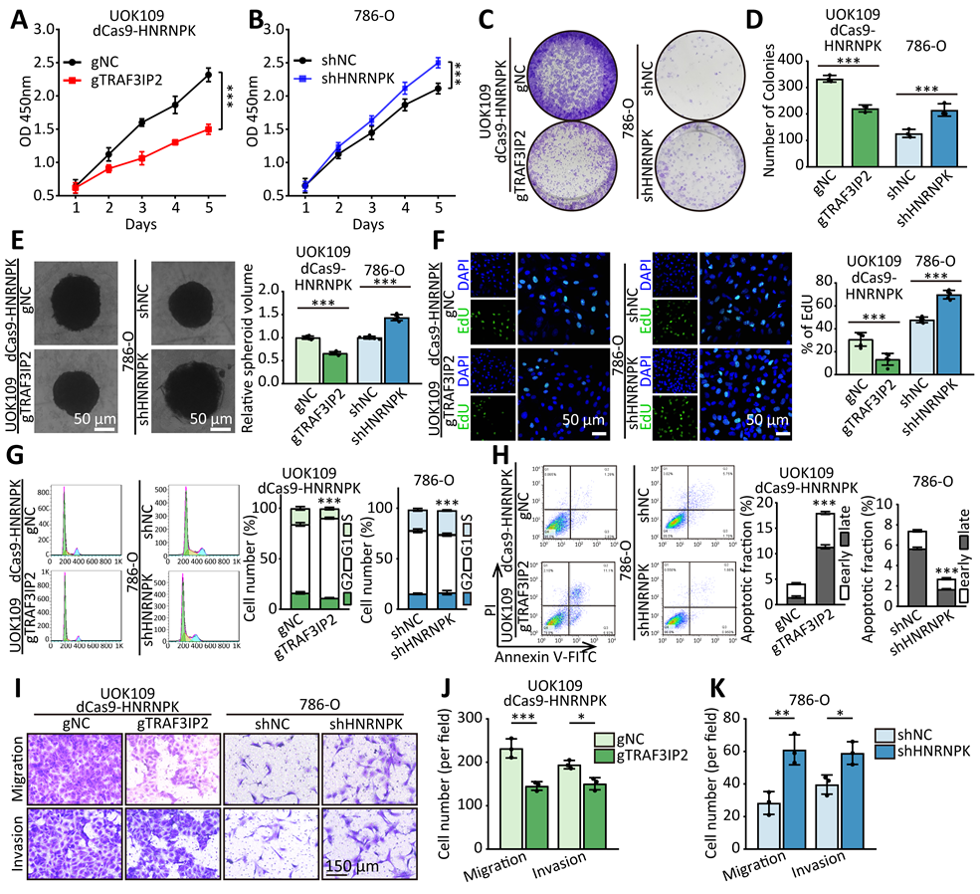
Figure S5 HNRNPK inhibits development of NONO-TFE3 tRCC by down-regulating the expression of TRAF3IP2. (A-E) The effects of HNRNPK on the proliferation of UOK109 and 786-O cells respectively were examined by CCK-8 assay (A-B), colony formation assays (C-D) and tumor sphere formation (E). (F) EdU assays were used to detect the proliferation rate of UOK109 and 786-O cells after transfection for 48h. (G) Cell cycle was analyzed using flow cytometry after transfection for 48h. (H) Cell apoptosis was analyzed via flow cytometry using an Annexin V/PI kit after transfection for 48h. (I-K) Migration and invasion assays were performed with transfected cells using Transwell inserts. The data are presented as the mean ± SD, **P< 0.01, ***P< 0.001

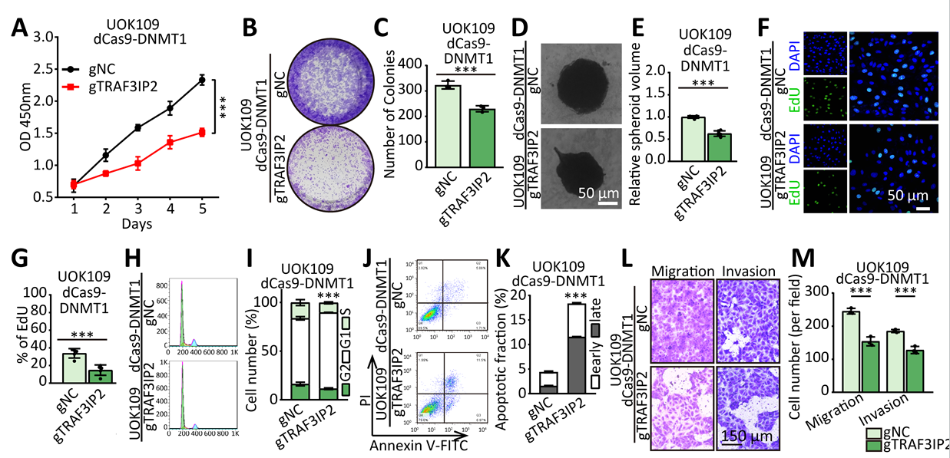
Figure S6 DNMT1 inhibits development of NONO-TFE3 tRCC by down-regulating the expression of TRAF3IP2. (A-E) The effects of DNMT1 on the proliferation of UOK109 cells respectively were examined by CCK-8 assay (A), colony formation assays (B-C) and tumor sphere formation (D-E). (F-G) EdU assays were used to detect the proliferation rate of UOK109 cells after transfection for 48h. (H-I) Cell cycle was analyzed using flow cytometry after transfection for 48h. (J-K) Cell apoptosis was analyzed via flow cytometry using an Annexin V/PI kit after transfection for 48h. (L-M) Migration and invasion assays were performed with transfected cells using Transwell inserts. The data are presented as the mean ± SD, *P< 0.05, **P< 0.01, ***P< 0.001

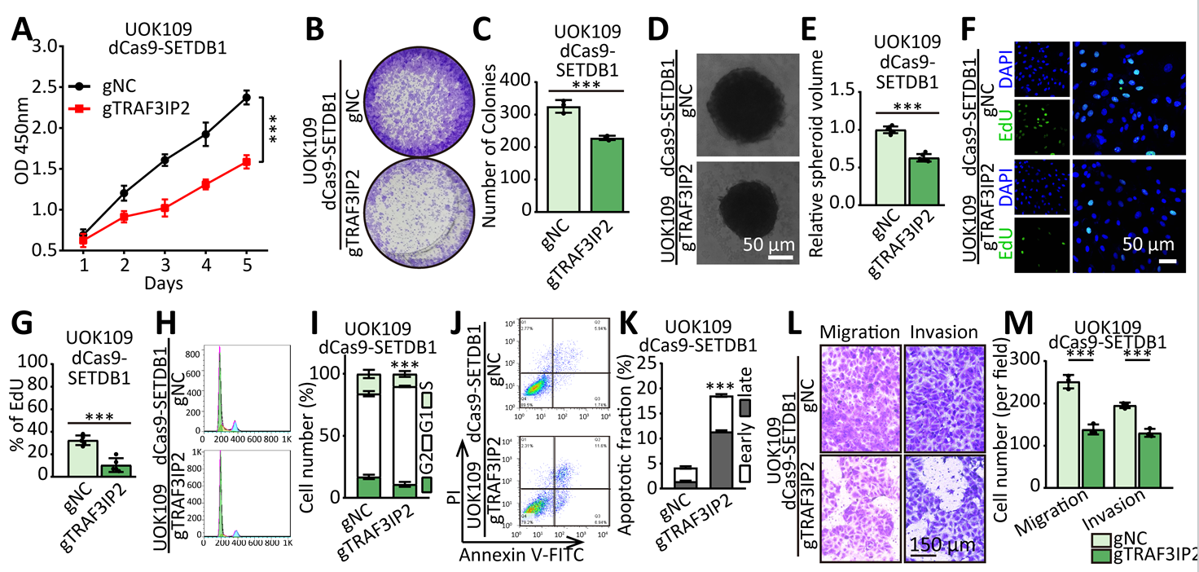
Figure S7 SETDB1 inhibits development of NONO-TFE3 tRCC by down-regulating the expression of TRAF3IP2. (A-E) The effects of SETDB1 on the proliferation of UOK109 cells respectively were examined by CCK-8 assay (A), colony formation assays (B-C) and tumor sphere formation (D-E). (F-G) EdU assays were used to detect the proliferation rate of UOK109 cells after transfection for 48h. (H-I) Cell cycle was analyzed using flow cytometry after transfection for 48h. (J-K) Cell apoptosis was analyzed via flow cytometry using an Annexin V/PI kit after transfection for 48h. (L-M) Migration and invasion assays were performed with transfected cells using Transwell inserts. The data are presented as the mean ± SD, *P< 0.05, **P< 0.01, ***P< 0.001

Supplementary Tables
Table S1. Primers used for real-time PCR.
Target  gene | Primer sequence (5’-3’) |  | Size  (bp)
Target  gene | Forward | Reverse | Size  (bp)
TRAF3IP2-AS1 | TTTGGCGGCTATGCAGGATT | TGTCCATGTGGTATTGGGCA | 189
TRAF3IP2 | TGGCACCCAACAGCTTGTC | GATACAGGCCGCTGGTGATTT | 106
PSENEN | CTGGAGCGAGTGTCCAATGAG | GCGCCAGACATAGCCTTTGAT | 171
VASN | TCTCACCTATCGCAACCTATCG | CAGACGGAGTAAGTGGCGTT | 117
18s rRNA | CAGCCACCCGAGATTGAGCA | TAGTAGCGACGGGCGGTGTG | 252
HNRNPK | CAATGGTGAATTTGGTAAACGCC | GTAGTCTGTACGGAGAGCCTTA | 172
DNMT1 | CCTAGCCCCAGGATTACAAGG | ACTCATCCGATTTGGCTCTTTC | 118
SETDB1 | TAAGACTTGGCACAAAGGCAC | TCCCCGACAGTAGACTCTTTC | 104
TFE3 | TGCCTGTGTCAGGGAATCTG | CGACGCTCAATTAGGTTGTGAT | 184
IGF2BP2 | AGTGGAATTGCATGGGAAAATCA | CAACGGCGGTTTCTGTGTC | 185
DGCR8 | AGCGTGAGCTTTACCGAGAG | CTACCCCGTCACCAACACTC | 157
HNRNPC | CCCTTCTCCGTCCCCTCTAC | CCCGAGCAATAGGAGGAGGA | 122
RBFOX2 | TTTAATGAACGTGGCTCTAAGGG | CGGACCATATACAGCTCCAAC | 216
ELAVL1 | AACTACGTGACCGCGAAGG | CGCCCAAACCGAGAGAACA | 194
FUS | ATGGCCTCAAACGATTATACCCA | GTAACTCTGCTGTCCGTAGGG | 114
TARDBP | GGGAAATCTGGTGTATGTTGTCA | TTTTCTGGACTGCTCTTTTCACT | 104
PRPF8 | TGACAAAAGGGTTTACTTGGGTG | CTCATTGACGAAGGAAATGGCT | 145
MOV10 | GGGCCAGTGTTTCGAGAGTTT | TCTTGGTGACGTAGGCCAGA | 176
UPF1 | ACCGACTTTACTCTTCCTAGCC | AGGTCCTTCGTGTAATAGGTGTC | 248
SMNDC1 | AGCGGAGATTGAGGAGATAGATG | GGTTCAACAGTGGAGTCACTTC | 92
U2AF2 | CGGCAGCTCAACGAGAATAAA | GGGAACGAATCAGTCCACCG | 214
CSTF2T | TCACTGCGTTCCGTGTTCG | CCCTTGGGTTTTCCCGTCTC | 134
SRSF1 | GGAAGACGCGGTGTATGGTC | CACCTGCTTCACGCATGTG | 236
HNRNPA1 | TCAGAGTCTCCTAAAGAGCCC | ACCTTGTGTGGCCTTGCAT | 227
GTF2F1 | CAACTTTGCTACGTGGAATCAGG | GAGGACGATGCCGTACTTCTT | 154
TIA1 | CGAGATGCCCAAGACTCTATACG | CCTTACCCATTATCTTCCGTCCA | 215
XRN2 | CCTTCGGCTTAATGTTCTTCGT | TGAAAACCCAGTCATCAATGCT | 104
SRSF7 | CGGTACGGAGGAGAAACCAAG | AGCCACAAATCACCTTTCCATC | 208

Table S2. Primers used for ChIP/CHIRP/MS2-RIP assay.
Target  promoter | Primer sequence (5’-3’) |  | Size  (bp)
Target  promoter | Forward | Reverse | Size  (bp)
PSENEN site1 | GCACCTTGACATAGACGTTGC | GATTCCACCCTGCCCGC | 250
PSENEN site2 | GGTACAGGTTGAGCAGCACT | TCTTAGGGGCAAAGGATCGC | 167
PSENEN site3 | AGAAGGGGAAGGGCCAGG | AAGGACAAGTGAGAACGGGC | 286
VASN site1 | AGGCTGCACAGCACTGATTG | TGAAGGCACTGCTAACATTGAA | 242
VASN site2 | TTATACTTAGGAGGCTCTTGAAAGG | GAATCCTAAGCGTCACAGCC | 296
VASN site3 | GAAACCTGCCCAGTGTCATC | AGGCAGGTCGCGCCTTA | 216
TRAF3IP2 primer1 | CAACGGCTGAGGAGTCACTT | CTTCTTAGCTGGGTGGCGAA | 110
TRAF3IP2 primer2 | TCTACGGAGCCTAGGAAGCC | CACTGCGACTACACTGAGGT | 200
HES1 | AAACCAAAGCCCAGAGGGAG | ATATCTGGGACTGCACGCGA | 240
HEY1 | GCCTCGGTCCCAGAAATCAA | CCTAGCGCCACCGTAAATCT | 246
MYC | ATAGCGATTGGTTGCTCCCC | CCCTCCACCACCTCCAAAAG | 230
BCL2 | GGCGTCCCTAGACATTGCTT | CTGGACCCTTTCTAGCCGTG | 194
CCND1 | ACTTACTGTTGGTGGGACGC | ATGAACAGGGGAGGGATGGA | 236

Table S3. Primary antibodies used in this study.
Source | Primary antibodies | Catalog no. | Working dilution
Sigma-Aldrich | Anti-TFE3 antibody produced in rabbit | HPA023881 | WB: 1:2000 ChIP: 5μg
ABclonal | Anti-TRAF3IP2 antibody produced in rabbit | A6776 | WB: 1:1000 IHC: 1:200
Santa Cruz Biotechnology | Anti-TRAF3IP2 antibody produced in mouse | sc-100647 | CoIP/ChIP: 5μg
ProteinTech | Anti-NOTCH1 antibody produced in rabbit | 10062-2-AP | WB: 1:1500 CoIP: 5μg
ProteinTech | Anti-Histone H3 antibody produced in rabbit | 17168-1-AP | WB: 1:1000
Abcam | Anti-Histone H3 antibody produced in rabbit | ab1791 | ChIP: 5μg
Abcam | Anti-H3K9me3 antibody produced in rabbit | ab8898 | ChIP: 5μg
Abcam | Anti-5mC antibody produced in rabbit | ab214727 | MeDIP: 5μg
ProteinTech | Anti-HA antibody produced in rabbit | 51064-2-AP | WB: 1:2500
ProteinTech | Anti-V5 antibody produced in rabbit | 14440-1-AP | WB: 1:2500
ProteinTech | Anti-Flag antibody produced in rabbit | 80010-1-RR | WB: 1:2500 ChIP: 5μg
ProteinTech | Anti-GFP antibody produced in rabbit | 50430-2-AP | WB: 1:2500 RIP: 5μg
ProteinTech | Anti-KAT2B antibody produced in rabbit | 13983-1-AP | WB: 1:1000
ProteinTech | Anti-MAML1 antibody produced in rabbit | 55493-1-AP | WB: 1:1000
ABclonal | Anti-EP300 antibody produced in rabbit | A13016 | WB: 1:1000
ProteinTech | Anti-RBPJ antibody produced in rabbit | 14613-1-AP | WB: 1:1000 CoIP: 5μg
Cell Signaling Technology | Anti-RBPJ antibody produced in rabbit | 5313 | ChIP: 5μg
ProteinTech | Anti-HEY1 antibody produced in rabbit | 19929-1-AP | WB: 1:1000
ABclonal | Anti-HES1 antibody produced in rabbit | A11718 | WB: 1:1000
ProteinTech | Anti-MYC antibody produced in rabbit | 10828-1-AP | WB: 1:1000
ABclonal | Anti-PSENEN antibody produced in rabbit | A15172 | WB: 1:1000
ABclonal | Anti-VASN antibody produced in rabbit | A16215 | WB: 1:1000
ABclonal | Anti-NUMB antibody produced in rabbit | A9352 | WB: 1:1000
ProteinTech | Anti-HNRNPK antibody produced in rabbit | 11426-1-AP | WB: 1:1000 RIP/CoIP/ChIP: 5μg
ProteinTech | Anti-DNMT1 antibody produced in rabbit | 24206-1-AP | WB: 1:1000 CoIP: 5μg
ProteinTech | Anti-SETDB1 antibody produced in rabbit | 11231-1-AP | WB: 1:1000 CoIP: 5μg
ABclonal | Anti-ACTB antibody produced in rabbit | AC026 | WB: 1:10000

Table S4. Primers used for MSP analysis.
Target  transcript | Primer sequence (5’-3’) |  | Size  (bp)
Target  transcript | Forward | Reverse | Size  (bp)
TRAF3IP2 M 1 | TTTTGGTTAATAAGGTGAAATTTCG | GCCCAATCTAAAATACAATAACGAT | 173
TRAF3IP2 U 1 | TTTGGTTAATAAGGTGAAATTTTGT | ACCCAATCTAAAATACAATAACAAT | 172
TRAF3IP2 M 2 | TTTTGGTTAATAAGGTGAAATTTCG | GCCCAATCTAAAATACAATAACGAT | 173
TRAF3IP2 U 2 | TTGGTTAATAAGGTGAAATTTTGT | ACCCAATCTAAAATACAATAACAAT | 171

Table S5. Small-molecule inhibitors used in this study.
Source | Small-molecule inhibitors | Catalog no. | Working dilution
MedChemExpress | DAPT | HY-13027 | 20 µM
Selleck | 5-Azacytidine (5-Aza) | S1782 | 10 µM
Selleck | Bobcat339 | S6682 | 10 μM
Selleck | BRD4770 | S7591 | 2.5 μM
MedChemExpress | Toxoflavin | HY-100760 | 1 μM

Table S6. SiRNA, shRNA and ASOs used for silencing target genes.
Target  transcript |  | Sequence (5’-3’)
 |  | sense | antisense
TRAF3IP2-AS1 siRNA seq1 |  | CAUUAGAAGUUAUAAUAAACA | UUUAUUAUAACUUCUAAUGUG
TRAF3IP2-AS1 siRNA seq2 |  | GGAGUAUGUGCUUAAGGAAAU | UUCCUUAAGCACAUACUCCAA
TRAF3IP2-AS1 siRNA seq3 |  | GAGCUGUGAUUCAAAUAUAAG | UAUAUUUGAAUCACAGCUCUG
TFE3 shRNA | CAGCTCCGAATTCAGGAACTA
TRAF3IP2 shRNA | CCGTGATGATAATCGTAGCAA
HNRNPK shRNA | TGATGTTTGATGACCGTCGCG
DNMT1 shRNA | GCCCAATGAGACTGACATCAA
SETDB1 shRNA | GCTCAGATGATAACTTCTGTA
IGF2BP2 shRNA | AGTGAAGCTGGAAGCGCATAT
DGCR8 shRNA | GCTCGATGAGTTAGAAGATTT
HNRNPC shRNA | GCCTTCGTTCAGTATGTTAAT
RBFOX2 shRNA | GTATATGGTCCGGAGTTATAT
ELAVL1 shRNA | GCAGCATTGGTGAAGTTGAAT
FUS shRNA | ATGAATGCAACCAGTGTAAGG
TARDBP shRNA | GCTCTAATTCTGGTGCAGCAA
PRPF8 shRNA | GCCCTGTATGTGTTACGTGAA
MOV10 shRNA | GCTGACCTTCAAGGTGAACTT
UPF1 shRNA | GCATCTTATTCTGGGTAATAA
SMNDC1 shRNA | CTGGTAAAGTTGGAGTAGGAA
U2AF2 shRNA | CGACGAGGAGTATGAGGAGAT
CSTF2T shRNA | GCGTCTGTTCACTTTAAGTTA
SRSF1 shRNA | GAAGCAGGTGATGTATGTTAT
HNRNPA1 shRNA | GACCAGGTGCCTACTTAACAG
GTF2F1 shRNA | GCTGTGACTTATCCACCACAT
TIA1 shRNA | GCCGTTGTTTACTTAAAGATT
XRN2 shRNA | CGTGAGTATTTGGAAAGAGAA
SRSF7 shRNA | GATCAAGATCCAGGTCTATTT
TRAF3IP2-AS1 ASO | G^{M}G^{M}A^{M}G^{M}T^{D}A^{D}T^{D}G^{D}T^{D}G^{D}C^{D}T^{D}T^{D}A^{D}A^{D}G^{D}G^{M}A^{M}A^{M}A^{M}

Table S7. Guide RNA used for CRISPR/dCas9 system.
Target promoter | gRNA sequence (5’-3’)
TRAF3IP2-AS1 gRNA1 | AGGGGGAGAAAGCCCCTTCT
TRAF3IP2-AS1 gRNA2 | GGGATCGATGACTCGGCTGG
TRAF3IP2-AS1 gRNA3 | GGGGTGTGTGTGGCGAAGGG
TRAF3IP2 gRNA1 | CCGTTGATTCACTGCCCACA
TRAF3IP2 gRNA2 | TGGCCCTTTCTCATGAATGA
TRAF3IP2 gRNA3 | TCTGCTCAAAATCTCCCTGT

Table S8. Primers used for MSP analysis.
Target promoter | gRNA sequence (5’-3’)
SETDB1 Full-length F | gggagacccaagctggctagcGCCACCATGTCTTCCCTTCCTGGGTGC
SETDB1 Full-length R | tccttgtagtcacttaagctAAGAAGACGTCCTCTGCATTCAA
SETDB1 Δ1 F | gggagacccaagctggctagcGCCACCATGTCTTCCCTTCCTGGGTGC
SETDB1 Δ1 R | tccttgtagtcacttaagctACTGAGTGCAGGAGATGTAGGGG
SETDB1 Δ2 F | gggagacccaagctggctagcGCCACCATGTCTTCCCTTCCTGGGTGC
SETDB1 Δ2 R | tccttgtagtcacttaagctCTCATTGACACAGGATAGGGGAA
SETDB1 Δ3 F | gggagacccaagctggctagcGCCACCATGTCTTCCCTTCCTGGGTGC
SETDB1 Δ3 R | tccttgtagtcacttaagctTCCATGTTGCACCAACCGG
SETDB1 Δ4 F1 | gggagacccaagctggctagcATGTCTTCCCTTCCTGGGTGC
SETDB1 Δ4 R1 | agagtagctcTCCATGTTGCACCAACCGG
SETDB1 Δ4 F2 | gcaacatggaGAGCTACTCTGTTGCTGTGGGG
SETDB1 Δ4 R2 | ccggttggtgcaacatggaAAGAAGACGTCCTCTGCATTCA
HNRNPK Full-length F | gggagacccaagctggctagcGCCACCATGGAAACTGAACAGCCAGAAGA
HNRNPK Full-length R | tccttgtagtcacttaagctGAAAAACTTTCCAGAATACTGCTTCA
HNRNPK Δ1 F | gggagacccaagctggctagcGCCACCATGGAAACTGAACAGCCAGAAGA
HNRNPK Δ1 R | tccttgtagtcacttaagctAACCATGCCGTCGTAACGG
HNRNPK Δ2 F | gggagacccaagctggctagcGCCACCATGGAAACTGAACAGCCAGAAGA
HNRNPK Δ2 R | tccttgtagtcacttaagctGATGATCTTTATGCACTCTACAACCC
HNRNPK Δ3 F | gggagacccaagctggctagcGCCACCATGGAAACTGAACAGCCAGAAGA
HNRNPK Δ3 R | tccttgtagtcacttaagctGATTTTCTTCAGAATTTCTCCAATTG
HNRNPK Δ4 F | gggagacccaagctggctagcGCCACCATGATGTTTGATGACCGTCGC
HNRNPK Δ4 R | tccttgtagtcacttaagctAACCATGCCGTCGTAACGG
DNMT1 Full-length F | gggagacccaagctggctagcGCCACCATGCCGGCGCGTACCGCC
DNMT1 Full-length R | tccttgtagtcacttaagctGTCCTTAGCAGCTTCCTCCTCC
DNMT1 Δ1 F | gggagacccaagctggctagcGCCACCATGCCGGCGCGTACCGCC
DNMT1 Δ1 R | tccttgtagtcacttaagctATTTACTTTTTCAGGTTCTTTTTCTTCG
DNMT1 Δ2 F | gggagacccaagctggctagcGCCACCATGCCACAGATTTCTGATGAAAAAGACG
DNMT1 Δ2 R | tccttgtagtcacttaagctGAAGATCTGGTAGACCAGCTTGGT
DNMT1 Δ3 F | gggagacccaagctggctagcGCCACCATGGATACTTTCTTCGCAGAGCAAATTG
DNMT1 Δ3 R | tccttgtagtcacttaagctCCCTTTGTTTCCAGGGCTACG
DNMT1 Δ4 F | gggagacccaagctggctagcGCCACCATGCAAGCCTGTGAGCCGAGCG
DNMT1 Δ4 R | tccttgtagtcacttaagctGTCCTTAGCAGCTTCCTCCTCC
DNMT1 Δ5 F | gggagacccaagctggctagcGCCACCATGCCGGCGCGTACCGCC
DNMT1 Δ5 R | tccttgtagtcacttaagctCCCTTTGTTTCCAGGGCTACG
TRAF3IP2-AS1 NheI | tttaaatttgcgcatgctagcCGGAAGGGGCGGCGGAGC
TRAF3IP2-AS1 HindIII | acgacggccagtgccaagcttTTTGAGGTTGTTCTCTAAATGTTTATTATAA
TRAF3IP2-AS1 HindIII 500 | acgacggccagtgccaagcttAAATATGGAGAAAGCCGACAGAA
TRAF3IP2-AS1 HindIII 1000 | acgacggccagtgccaagcttTATCTCTGCAGGGGAAATTCTTAGA
TRAF3IP2-AS1 HindIII 1500 | acgacggccagtgccaagcttGCGGTGTCATGAGTTCCTCATT
TRAF3IP2-AS1 HindIII 2000 | acgacggccagtgccaagcttGAGGAGGCAAAAAGGAAGACAA
TRAF3IP2-AS1 HindIII 2500 | acgacggccagtgccaagcttGCCACTGTTCACTGTGGATGTG
TRAF3IP2-AS1 NheI 2500 | tttaaatttgcgcatgctagcTTCTGCCTTCCAGATGGGC
TRAF3IP2-AS1 NheI 3000 | tttaaatttgcgcatgctagcATCTCGTTTGGTCCTTAAAACAAGC
TRAF3IP2-AS1 NheI 3500 | tttaaatttgcgcatgctagcATGGTGACTACGTGGGAAATGC
TRAF3IP2-AS1 NheI 4000 | tttaaatttgcgcatgctagcTAAATTTTAATCATTAACTGAATTCAAAATAA
TRAF3IP2-AS1 NheI 4500 | tttaaatttgcgcatgctagcGGATTTAAAAAAAAATCTTTAAACTCATTAA
AS1 AS NheI | acgacggccagtgccaagcttCGGAAGGGGCGGCGGAGC
AS1 AS HindIII | tttaaatttgcgcatgctagcTTTGAGGTTGTTCTCTAAATGTTTATTATAA

