Supplementary Information
Table S1 The information of ELISA Kits used in this study
Testing Target | Catalog numbers | Manufacturer
sLRP1 | SEB010Hu | Cloud-Clone Corp.Wuhan
KLK4 | CSB-EL012455HU | CUSABIO
Gelsolin(GSN) | SEA372Hu | Cloud-Clone Corp. Wuhan
Caspase 3 | ZN2053 | Beijing Biolaibo Technology Co., LTD

Figure Legends
Fig. S1. The distribution of four plasma proteins between APOE ε4 carriers and non-carriers. A-D shows plasma levels of sLRP1, KLK4, GSN, and Caspase 3. Red denotes APOE ε4 carriers. Blue denotes APOE ε4 non-carriers. *P < 0.05, **P < 0.01, ***P < 0.001
Fig. S2. The distribution of four plasma proteins between females and males. A-D shows plasma levels of sLRP1, KLK4, GSN, and Caspase 3. Red denotes female. Blue denotes male. *P < 0.05, **P < 0.01, ***P < 0.001
Fig. S3 Four blood-based biomarkers and their composite for AD and MCI classification. A, Receiver operating characteristic (ROC) curves showing the performance of four blood-based biomarkers and their composite for AD classification in combined cohorts. B, ROC analyses for MCI classification in combined cohorts

Fig. S1
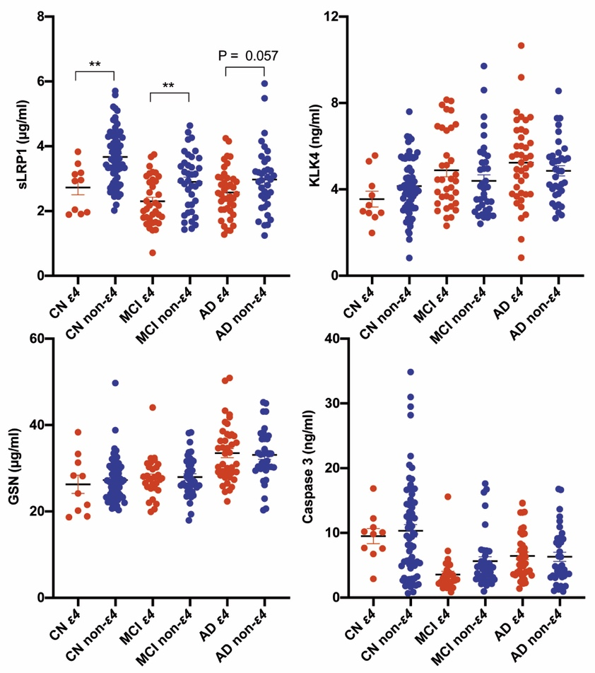
Fig. S2
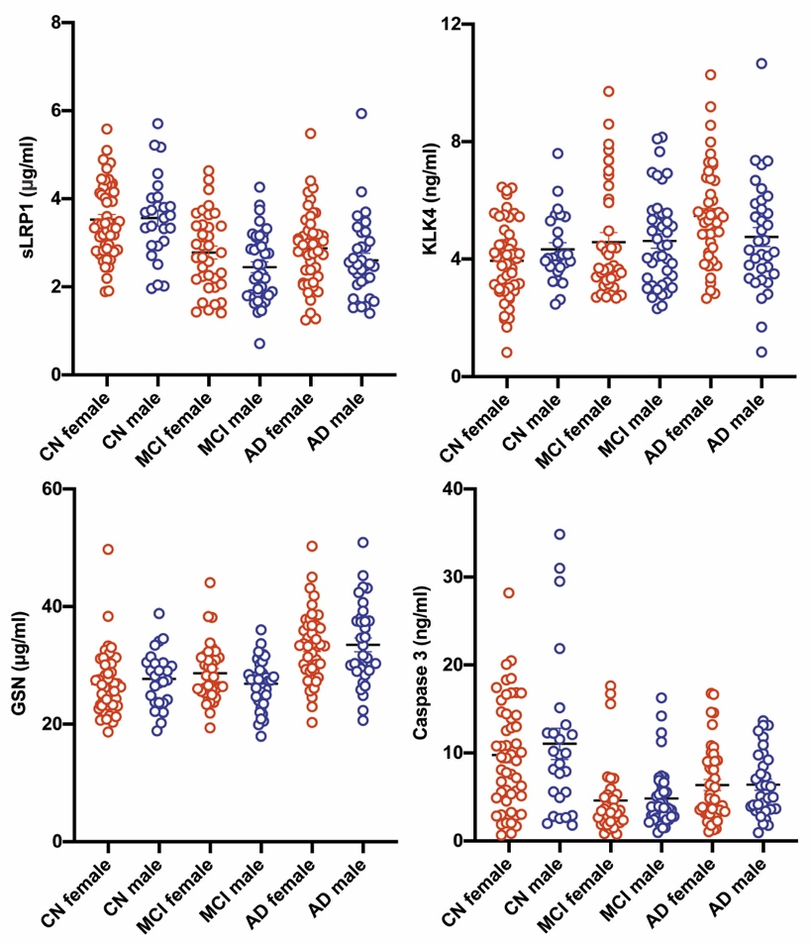
Fig. S3
