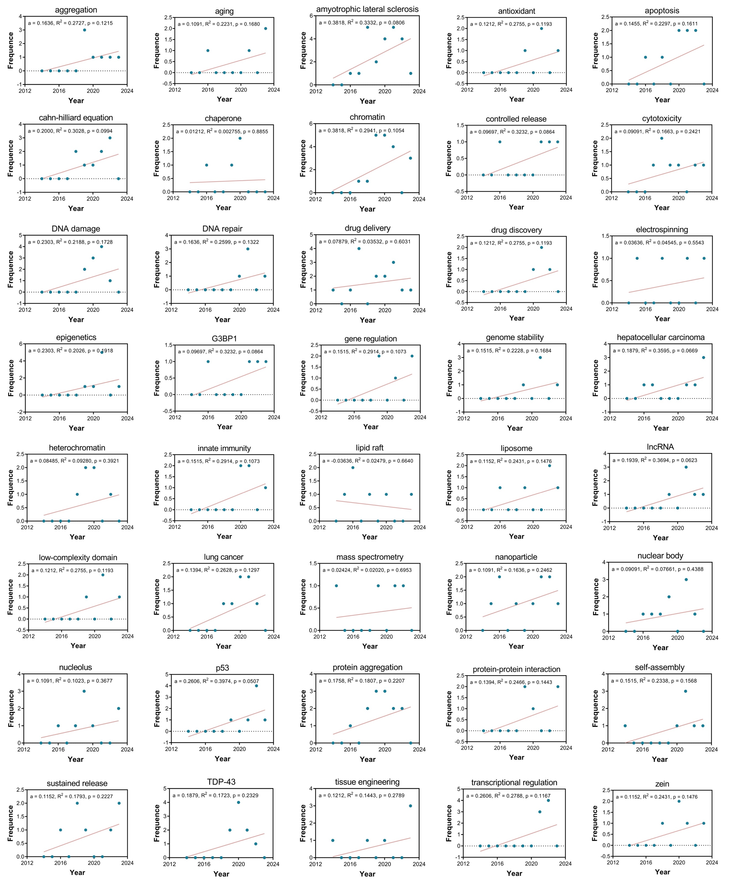
Additional file 6
Additional file 6. The population of regression-fitted curves without statistical significance based on the frequency of annual occurrence for the themes regarding phase separation in oncology. "a" indicates the slope of the fitted curve. "R²" indicates the degree of correlation between the two variables.

