Table of Supporting Information Contents:
1. Supplementary Experimental Procedures
1.1 Detailed experimental parameters of UPLC-MS analysis
1.2 Cell lines and culture
1.3 Tissue collection and preparation
1.4 Machine learning
1.5 Detailed procedure of transcriptome analysis
2. Supplementary Figures
Figure S1 Distribution of propensity scores in the disease and control groups.
Figure S2 Reproducibility of urine detection within the same batch or between different batches.
Figure S3 The OPLS-DA scores plot for QC sample and clinical samples involved in this project.
Figure S4 MS spectra and MS/MS fragment profiles of urinary metabolites and commercial standard reagents.
Figure S5 Intersection analysis of enriched pathways disturbed in the three groups.
Figure S6 Common disturbed metabolic pathways in different phenotypes.
Figure S7 Volcano plot showing the differential expressed genes between PCa tumors and non-tumor adjacent normal tissues.
Figure S8 KEGG pathway enrichment analysis of differential genes and dysregulated metabolites.
Figure S9 Compound-reaction-enzyme-gene network built by MetScape on the basis of PCa-related metabolites.
Figure S10 The expression of candidate genes in prostate cancer from open-source TCGA database.
Figure S11 Survival analysis of candidate genes expressions in PCa patients.
Figure S12 Correlation between the levels of candidate gene expression and nodal metastasis status in PCa patients.
Figure S13 Correlation between the levels of candidate gene expression and patient’s Gleason score.
Figure S14 The expression of candidate genes in prostate cancer from open-source Asian datasets.
Figure S15 Perturbations of metabolite-related genes in PCa compared to BPH.
Figure S16 Predicted score distribution of PCa patients in different groups sorted by PSA level, Gleason score, ISUP stage, and tumor metastasis.
Figure S17 Discrimination results for discovery and external test sets with the built model.
Figure S18 Discrimination results for significant PCa patients.
3. Supplementary Tables
Table S1. Clinical characteristics of the subjects in the discovery cohort.
Table S2. Clinical characteristics of the subjects in the internal validation cohort.
Table S3. Clinical characteristics of the subjects in the independent validation cohort.
Table S4. Clinical characteristics of the subjects for RT-PCR and Western Blot analysis.
Table S5. Summary of feature peaks that could be used to distinguish PCa patients from healthy controls.
Table S6. Summary of feature peaks that could be used to distinguish BPH patients from healthy controls.
Table S7. Summary of feature peaks that could be used to distinguish PCa patients from BPH subjects.
Table S8. LC-MS/MS identification of potential feature peaks for discrimination of patients with prostate disease.
Table S9. MALDI-TOF/TOF tandem mass spectrometry identification of urine metabolites.
1. Supplementary Experimental Procedures
1.1 Detailed experimental parameters of UPLC-MS analysis
Here, the detailed experimental parameters of UPLC-MS analysis of urine samples were summarized. Frozen urine was thawed on ice before the UPLC-MS analysis. Subsequently, the urine sample (200 μL) was mixed with acetonitrile (200 μL) to precipitate proteins. After vortexing for 60 s, incubating for 10 min and storing at -20°C overnight, the mixtures were centrifuged at 4000 g for 20 min at 4℃. The supernatant was filtered through syringe filters (0.22 μm) before UPLC-MS analysis. RPLC separation was performed on an ACQUITY UPLC T3 column (2.1×100 mm, 1.8 μm, Waters, UK). The column was maintained at 35℃. In RPLC mode, gradient elution was performed with the following solvent system: (A) 0.1% formic acid-water, (B) ACN with 0.1% formic acid. The gradient elution conditions were as follows with a flow rate of 0.4 mL/min: 5% solvent B for 0-0.5 min; 5-100% solvent B for 0.5-7 min; 100% solvent B for 7-8 min; 100-5% solvent B for 8-8.1min; and 5% solvent B for 8.1-10min. Mass spectrometry experiments were performed on a Triple TOF 5600 Plus high-resolution tandem mass spectrometer (SCIEX, Warrington, UK) with both positive and negative ion modes. The ion spray floating voltage was set at 5kV for the positive-ion mode and ‐4.5kV for the negative-ion mode. The MS data were acquired in the IDA mode and the m/z range was set at 60-1200 Da.
1.2 Cell lines and culture
RWPE-1 cells were cultured in McCoy's 5A medium (Servicebio), PC3, C4-2 and C4-2B cells were cultured in RPMI-1640 medium (Thermo Fisher Scientific), and DU145 cells were cultured in MEM (Pricella). The cells mentioned above were supplemented with 10% FBS (Gibico), 1% penicillin (Biosharp) and 1% streptomycin (Biosharp) (penicillin-streptomycin) at 37°C under 5% CO₂. WPMY-1 were cultured in DMEM (Thermo Fisher Scientific) supplemented with 5% FBS (Gibico), 1% penicillin (Biosharp) and 1% streptomycin (Biosharp) (penicillin-streptomycin) at 37°C under 5% CO₂. All cells are negative for mycoplasma infection.
1.3 Tissue collection and preparation
Prostate cancer and paired adjacent tissues were collected from patients undergoing radical prostatectomy at Sir Run Run Shaw Hospital, Zhejiang University School of Medicine. The clinical characteristics of all participants in tissue collection project are shown in Table S4.
1.4 Machine learning
The retrospective cohort collected from June 1st, 2021 to December 31st, 2022 was employed for model establishment and parameter optimization, and the retrospective cohort was divided into training set and internal validation set at a ratio of 2:1. The independent cohort collected from January 1st, 2023 to April 30th, 2023 was employed for model external validation. Discriminant models were constructed by the in-built “Regression learner” and “Classification learner” modules in MATLAB software via cross-validation (10-folds). Seven machine learning algorithms were investigated in this work, including decision trees (DT), nearest neighbor classifier (KNN), naïve Bayesian classifier (NB), LASSO regression, linear discriminant analysis (LDA), logistic regression (Logi), and support vector machine (SVM). Kappa statistic, accuracy, F-measure, precision, recall and the area under the curve (AUC) were utilized to evaluate the classification performance of different machine learning models. Sensitivity, specificity and AUC were selected as diagnostic indicators to evaluate the classification results of the prediction model in the training, internal validation and external validation set.
1.5 Detailed procedure of transcriptome analysis
The transcriptomics profiles of PCa tumor and adjacent normal tissues were downloaded from open-source TCGA dataset. Statistical analysis was performed using R 3.5.2 software and the differentially expressed genes were screened out by the R edgeR package. Statistical significance was defined as FDR < 0.05 and |log₂FC| > 1. Gene ontology and KEGG pathway enrichment analysis were performed by online KOBAS database (http://kobas.cbi.pku.edu.cn/kobas3). Kaplan–Meier survival analysis was completed with GEPIA (http://gepia.cancer-pku.cn). Furthermore, correlation analysis of clinical parameters with the mRNA expression of enzyme genes was investigated by UALCAN website (http://ualcan.path.uab.edu).

2. Supplementary Figures
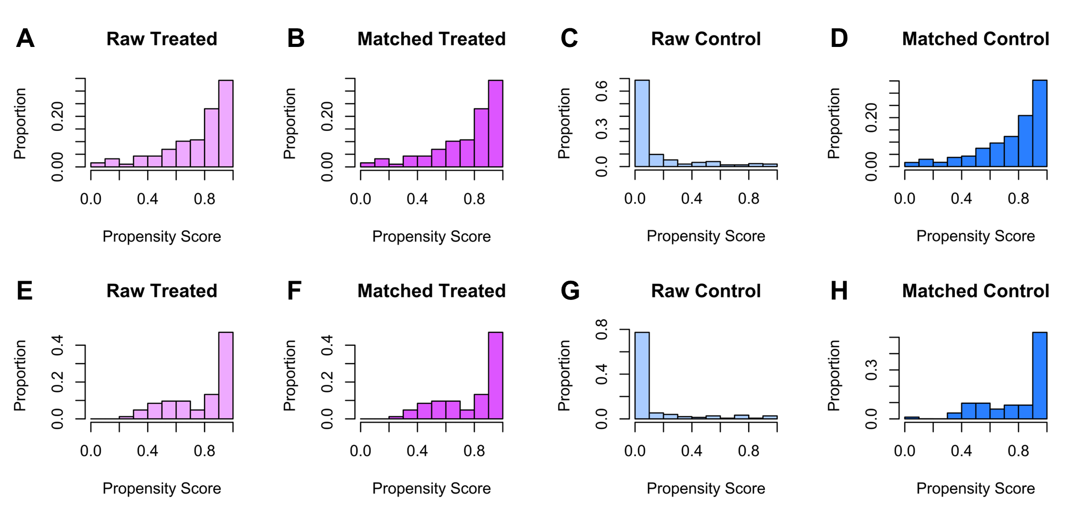
Figure S1 Distribution of propensity scores in the disease and control groups. (A)(B) Disease group in the retrospective cohort. (C)(D) Healthy control group in the retrospective cohort. (E)(F) Disease group in the external validation cohort. (G)(H) Healthy control group in the external validation cohort.
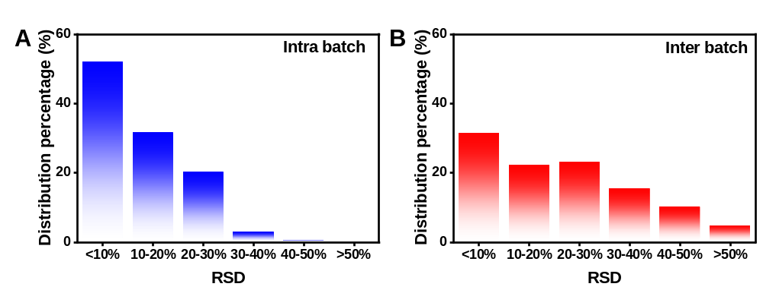
Figure S2 Reproducibility of urine detection within the same batch or between different batches. (A) Intra-batch and (B) inter-batch stability for metabolite profiles in QC sample, respectively.
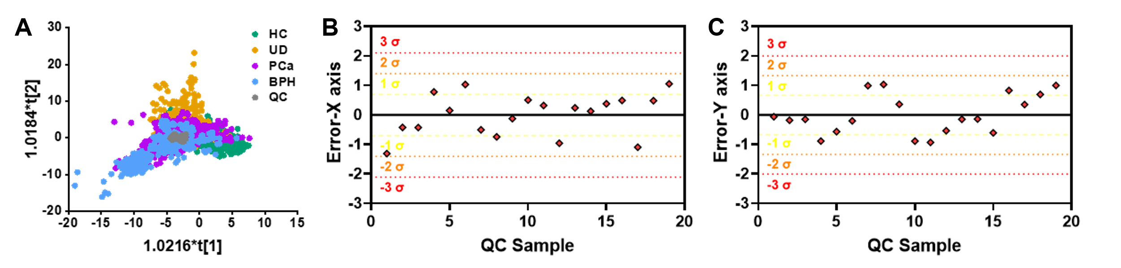
Figure S3 The OPLS-DA scores plot for QC sample and clinical samples involved in this project. (A) OPLS-DA scores plot. (B)(C) Line plots of QC samples for LDI‐MS analysis generated by OPLS-DA. (B) Distribution of the X-axis error. (C) Distribution of the X-axis error.

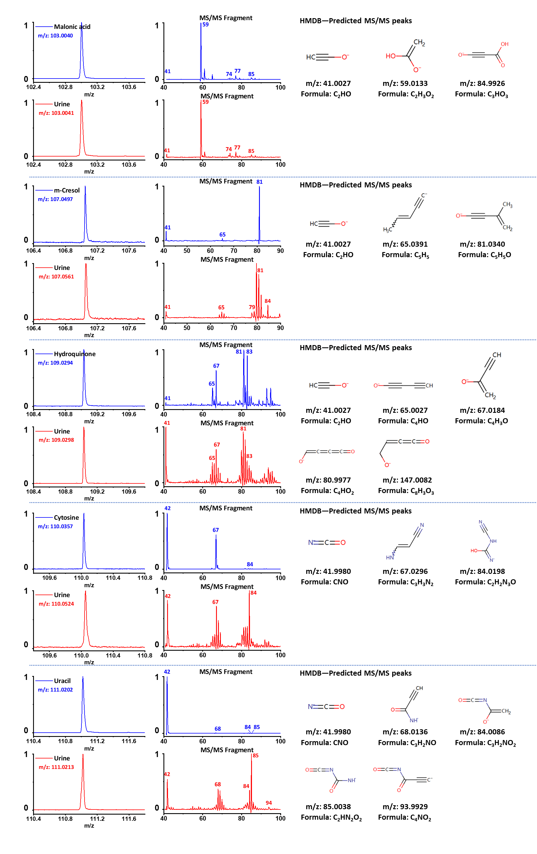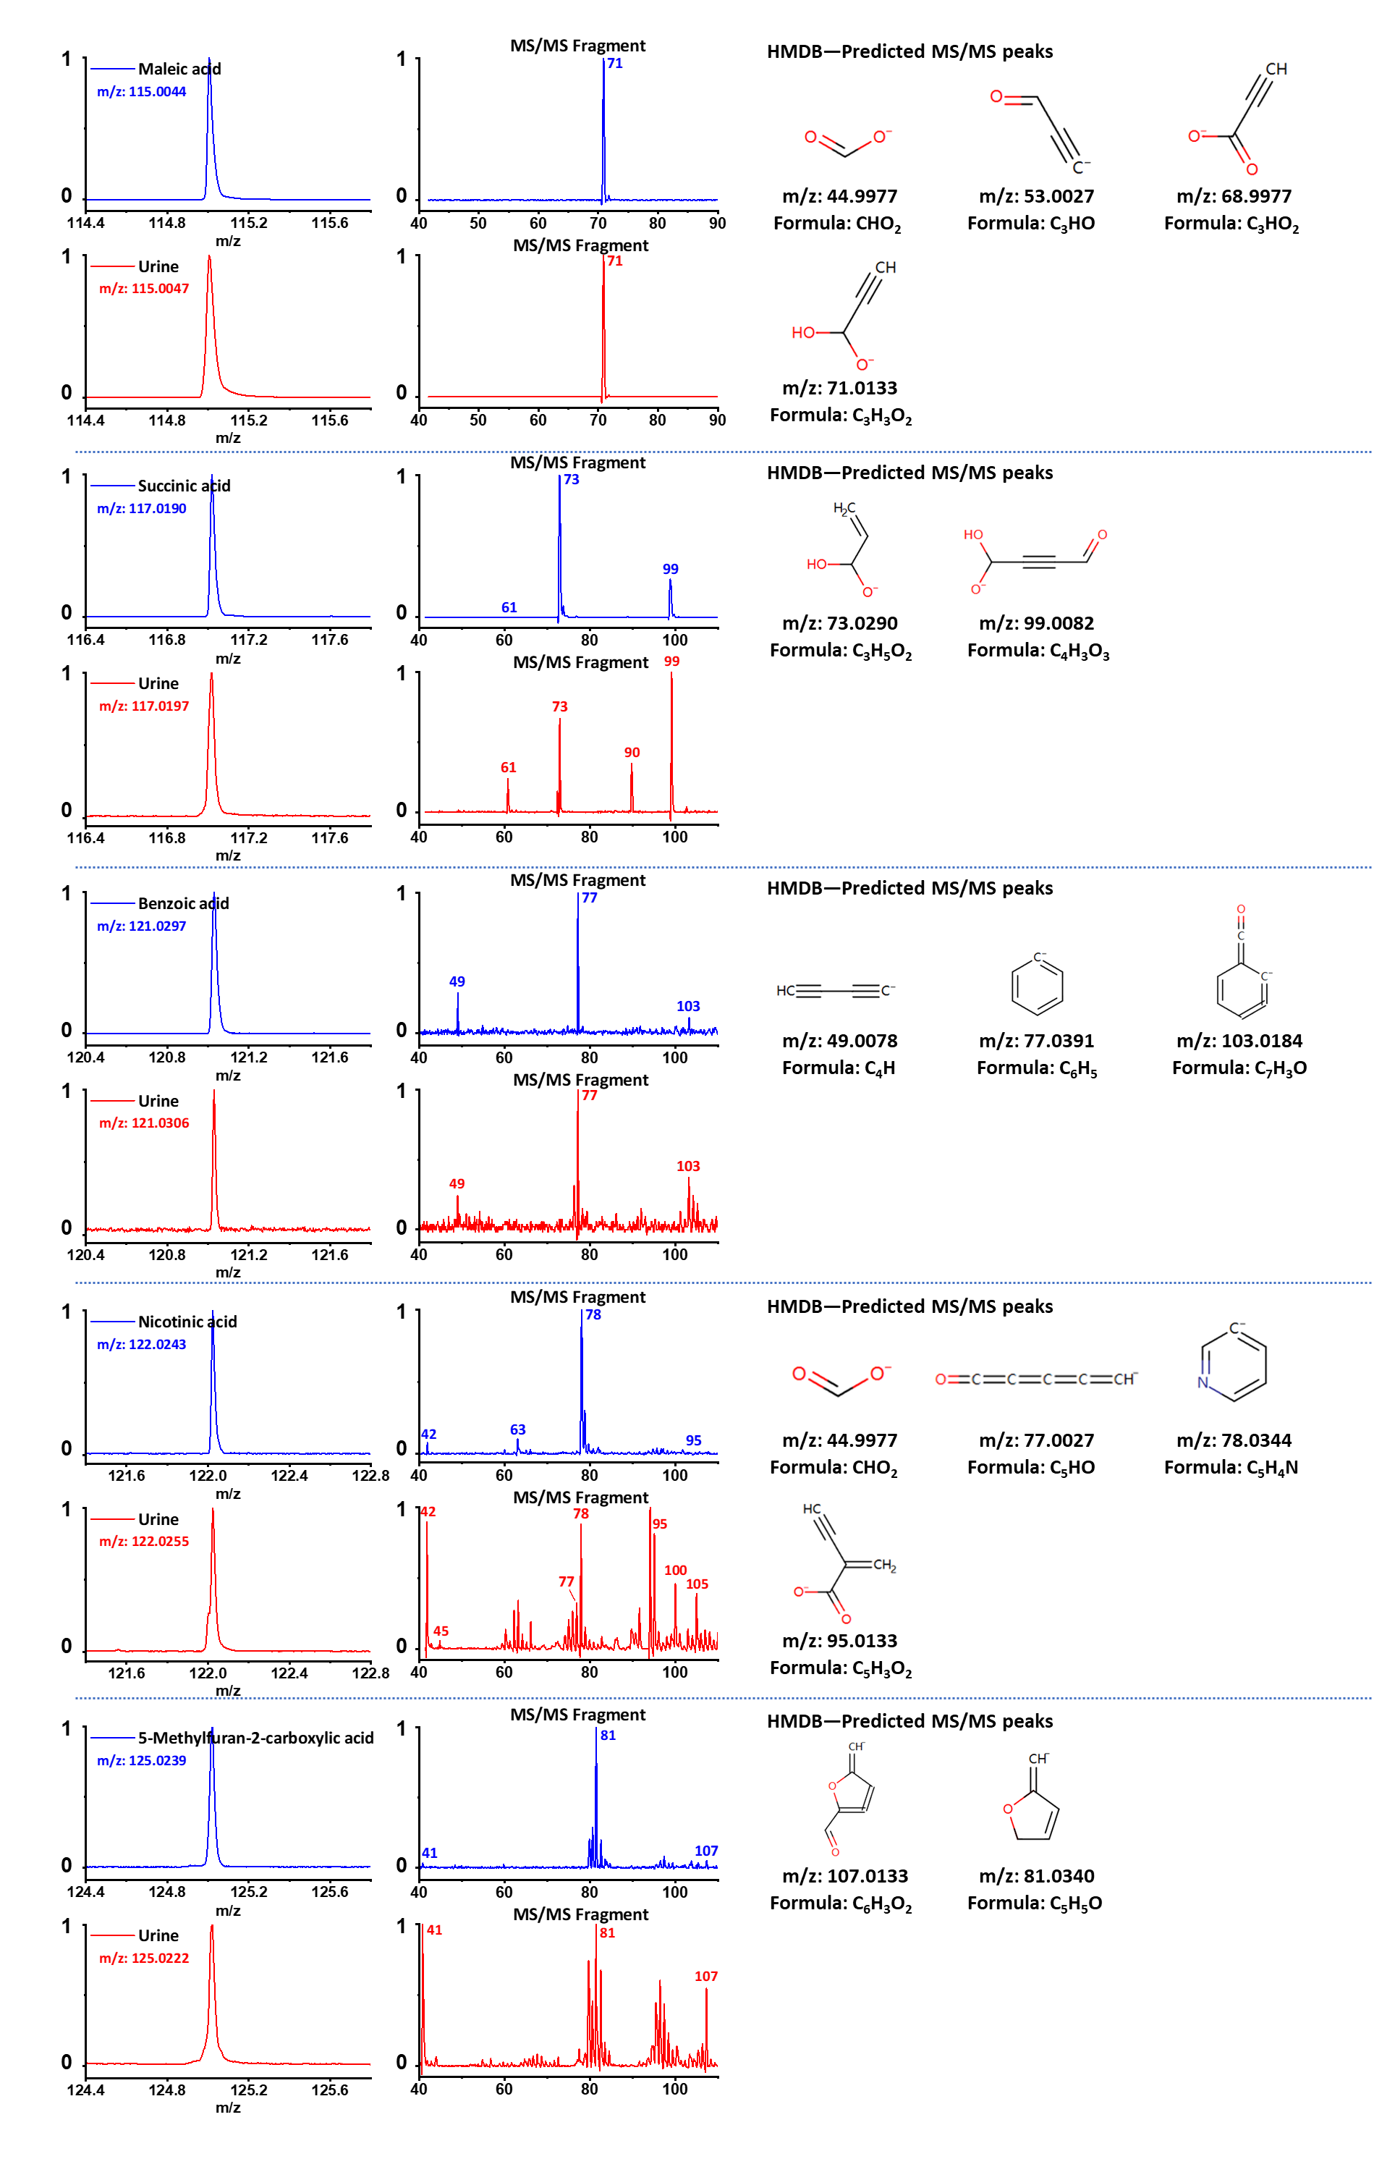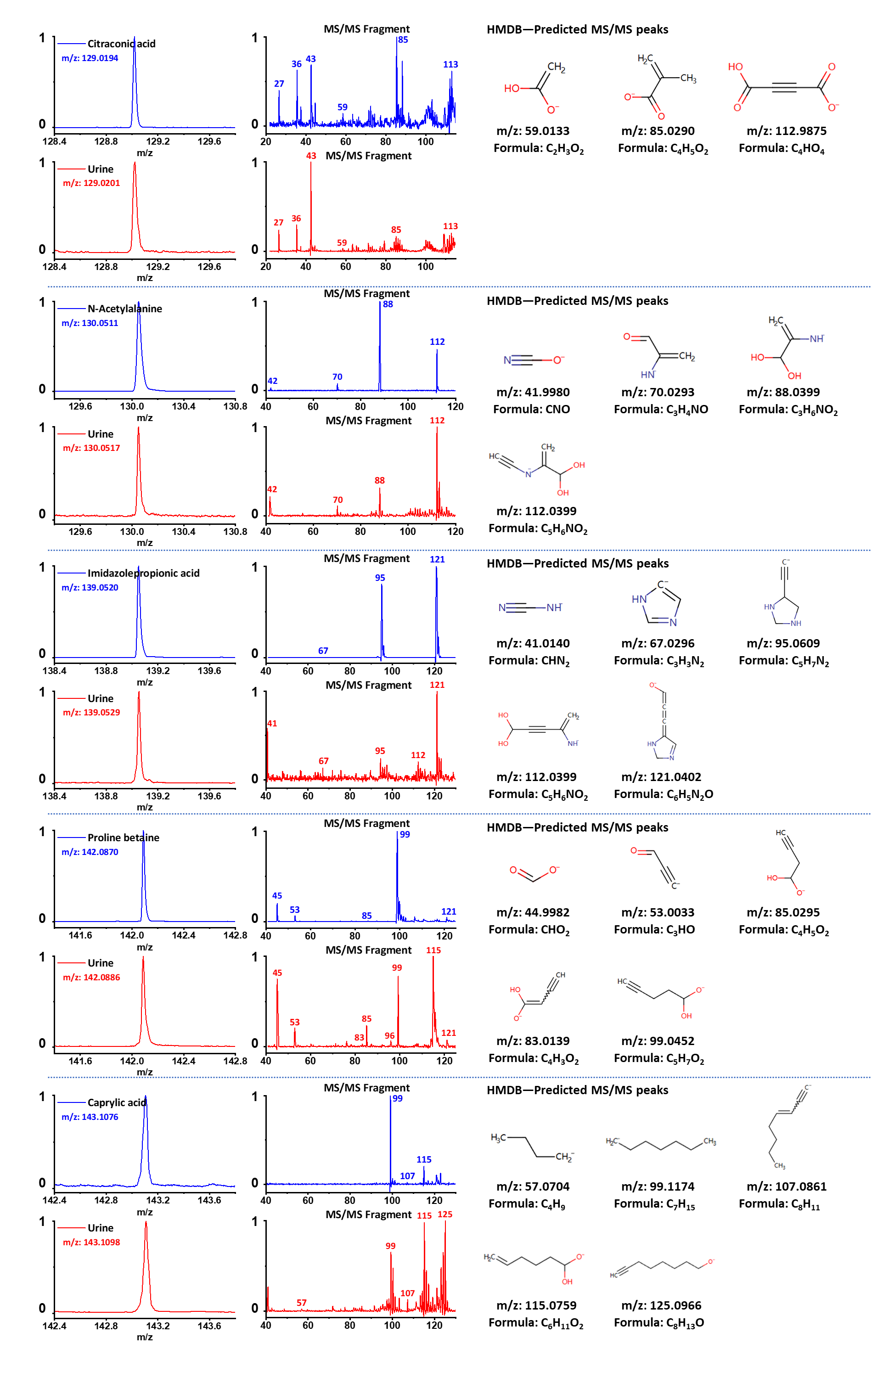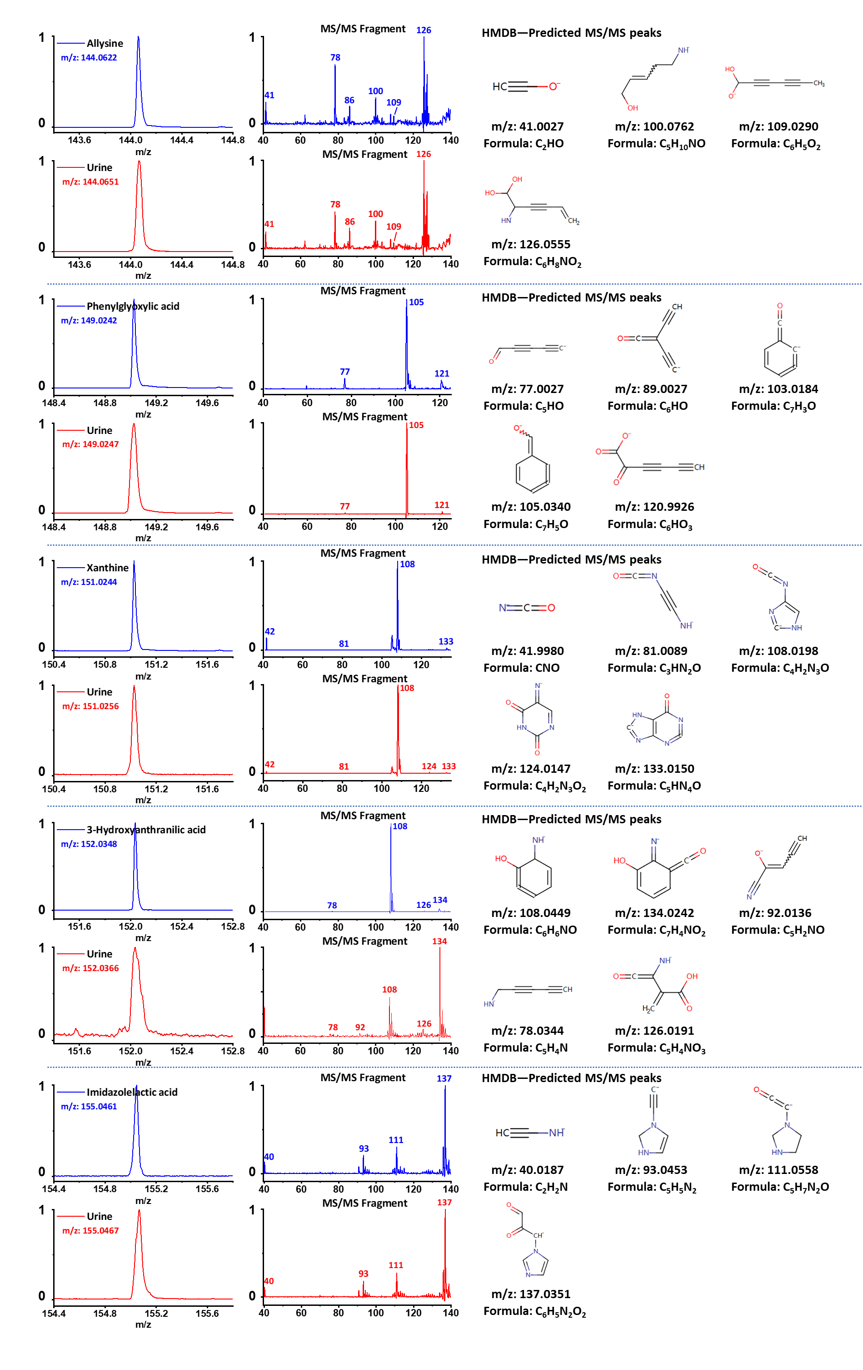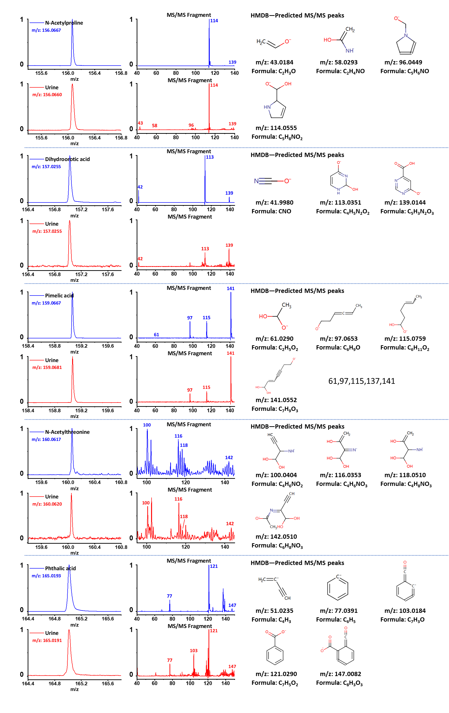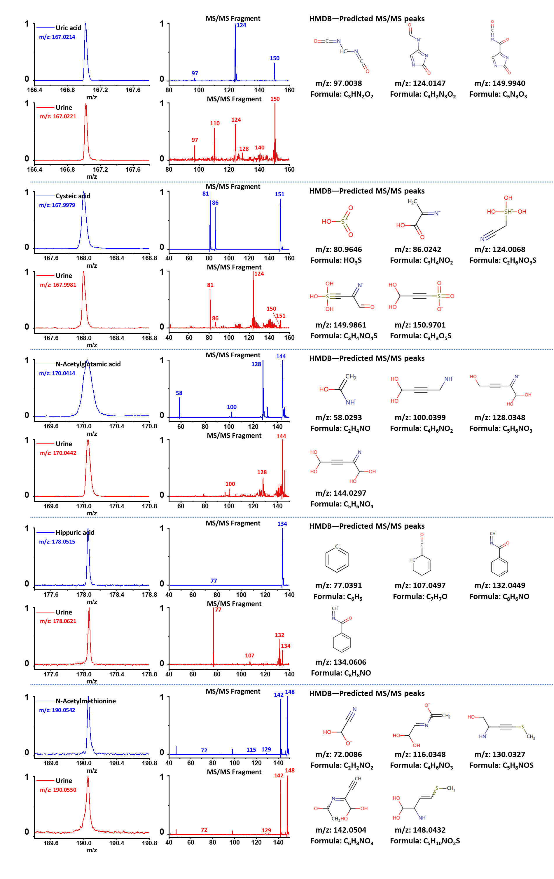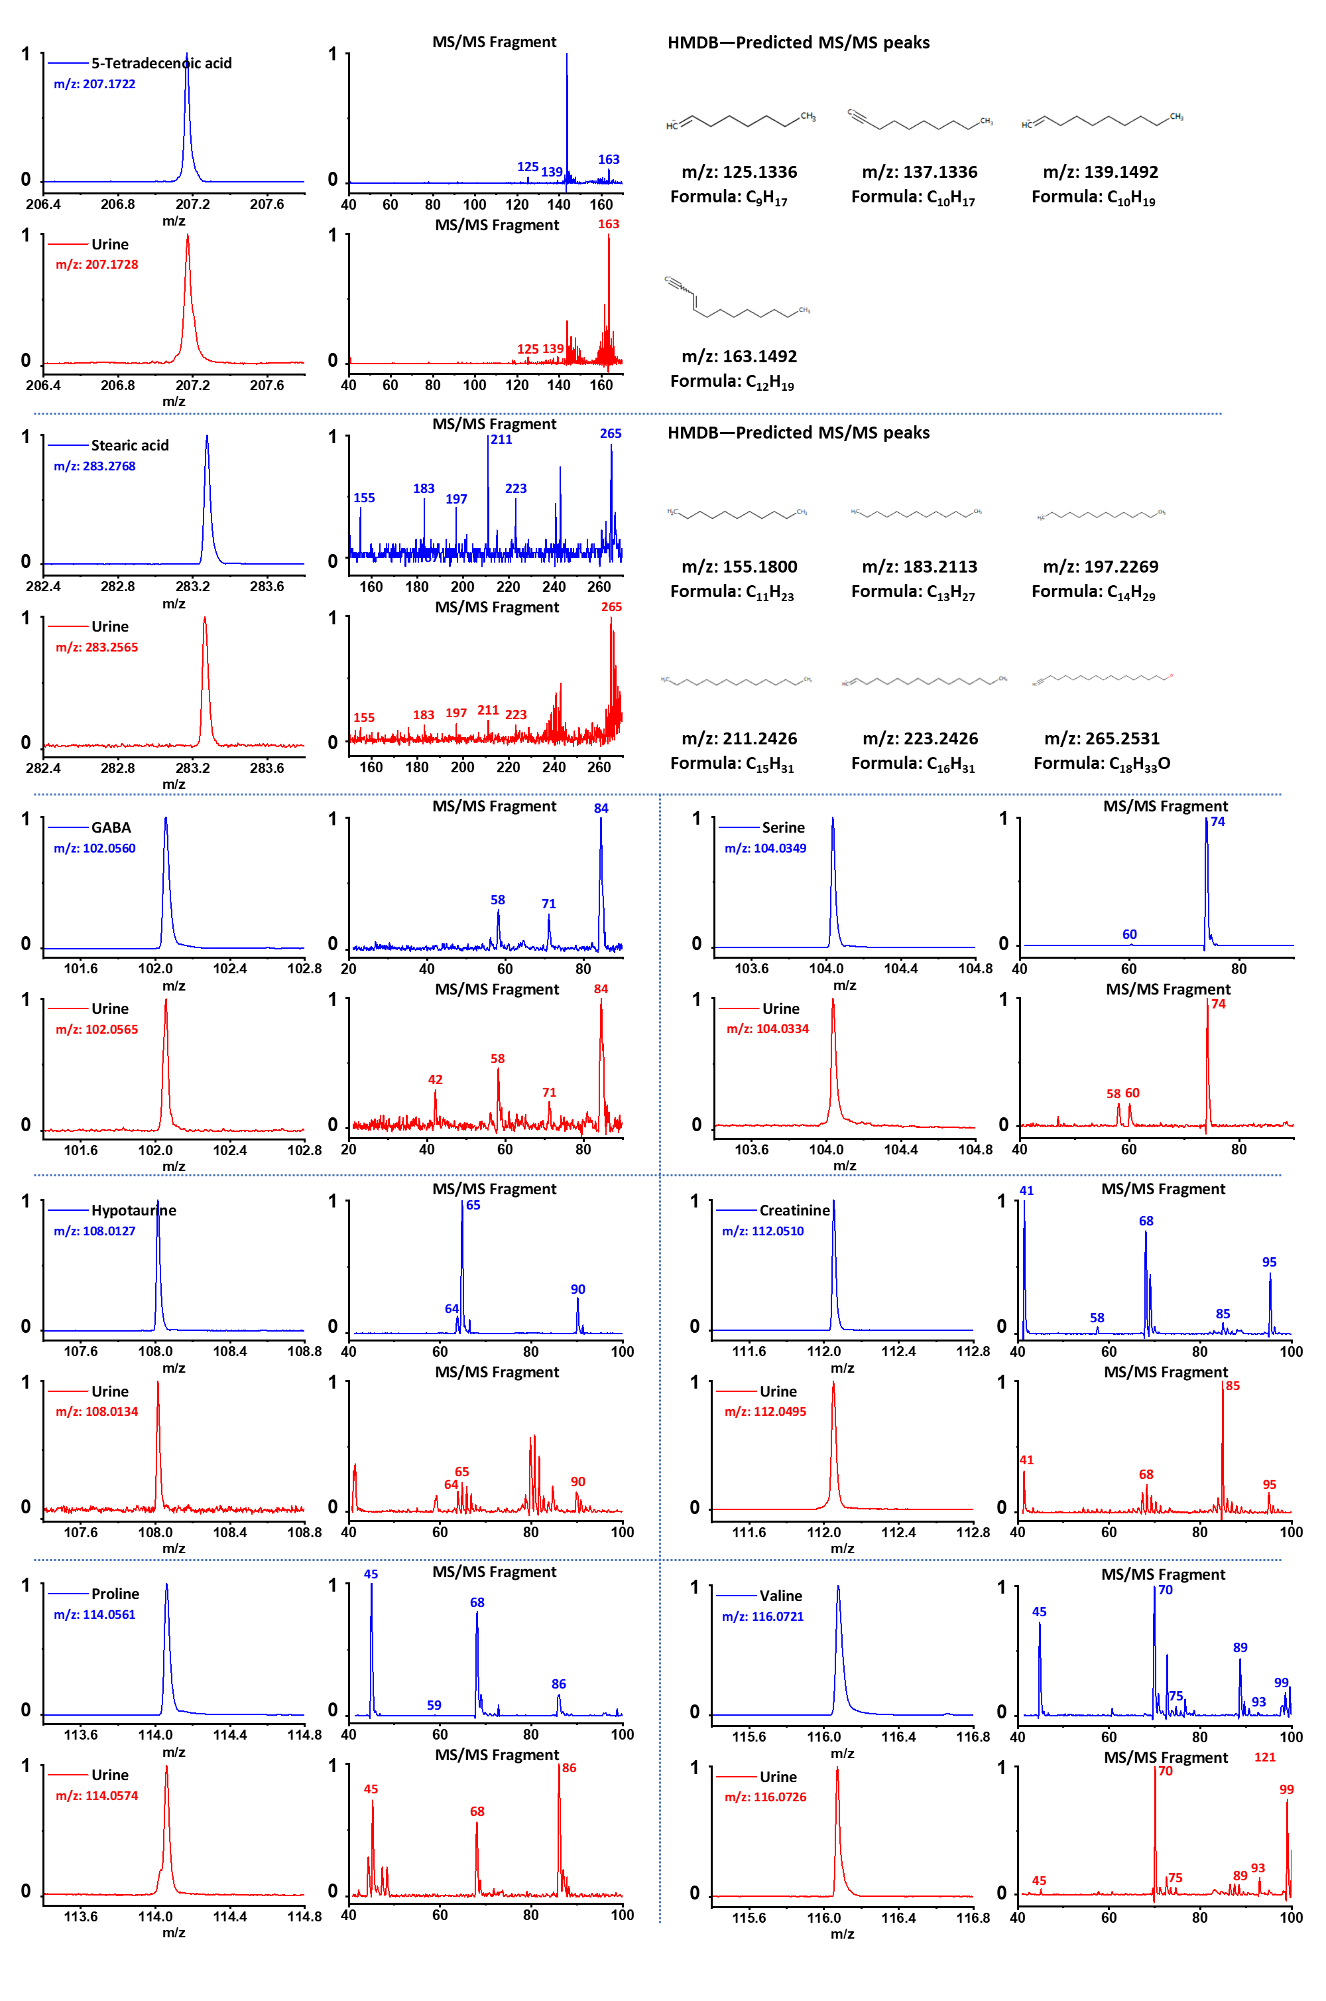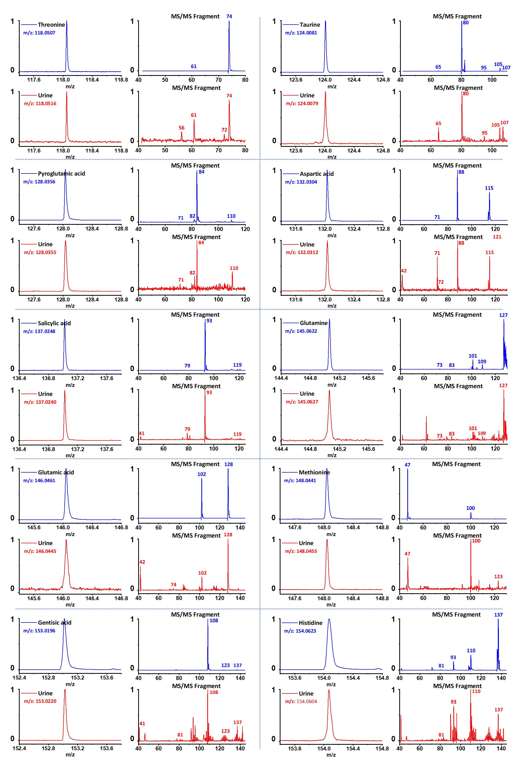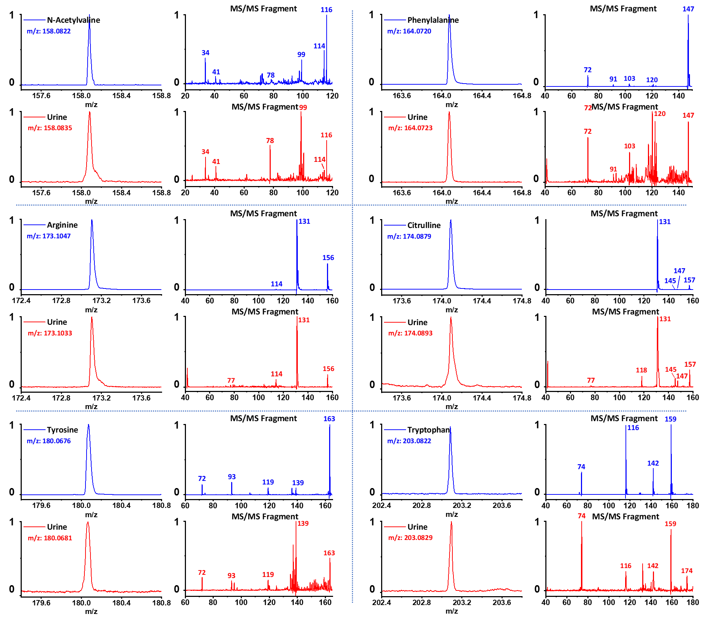
Figure S4 MS spectra and MS/MS fragment profiles of urinary metabolites and commercial standard reagents. Note: Predicted fragment peaks for several metabolites are not available in the HMDB database.
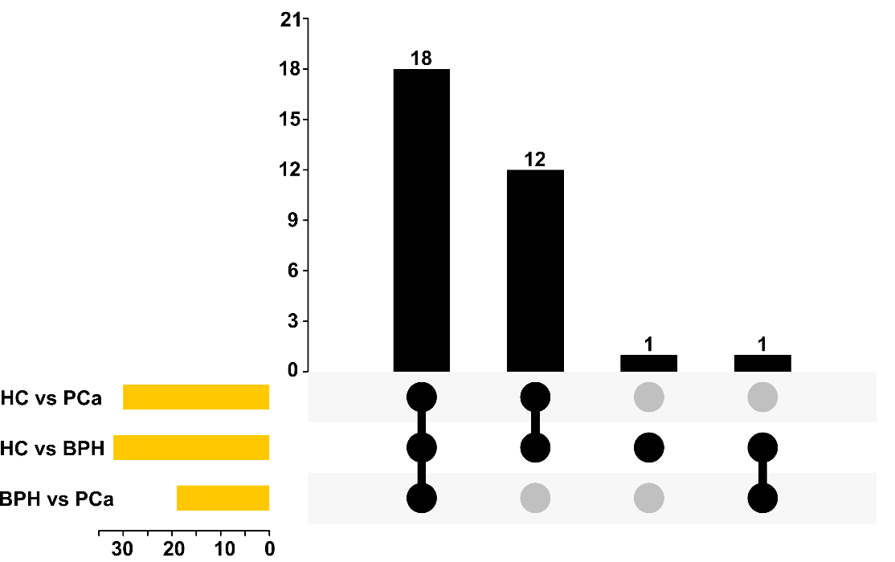
Figure S5 Intersection analysis of enriched pathways disturbed in the three groups. The bar chart at the bottom left represents the number of processes included in each group. The black bar chart above represents the number of common processes in each intersection.
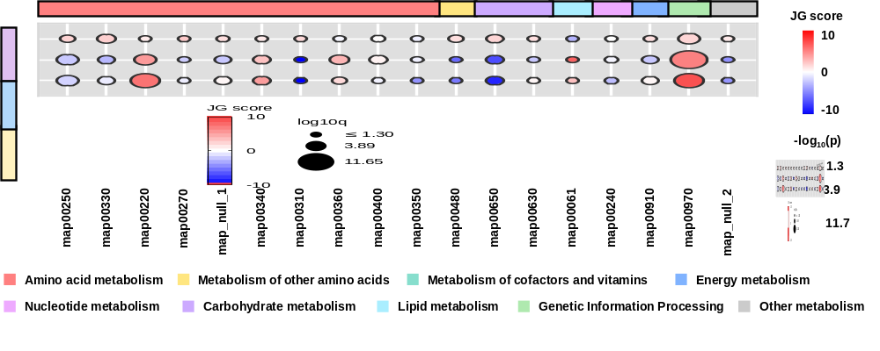
Figure S6 Common disturbed metabolic pathways in different phenotypes. The circle colors represent JG scores of certain disturbed pathways between two groups. The circle size is proportional to the log10(p) value. In the left ribbon, purple, blue and yellow represent pairwise analysis between BPH and PCa, HC and BPH, HC and PCa, respectively. Map_null_1 refers to D-Glutamine and D-glutamate metabolism and map_null_2 refers to porphyrin and chlorophyll metabolism, which do not match the corresponding numbers in the KEGG database.
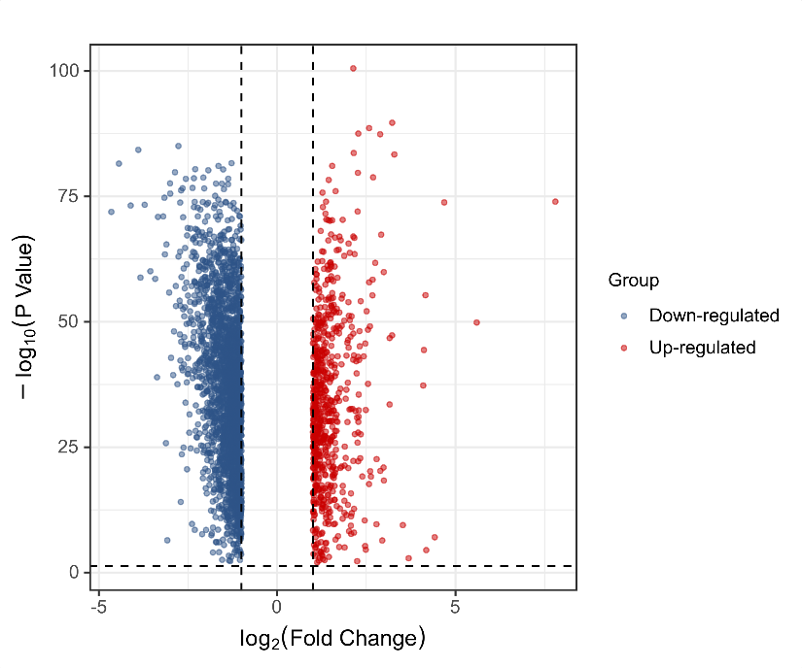
Figure S7 Volcano plot showing the differential expressed genes between PCa tumors and non-tumor adjacent normal tissues. Notably, p value was adjusted by Benjamini-Hochberg method.
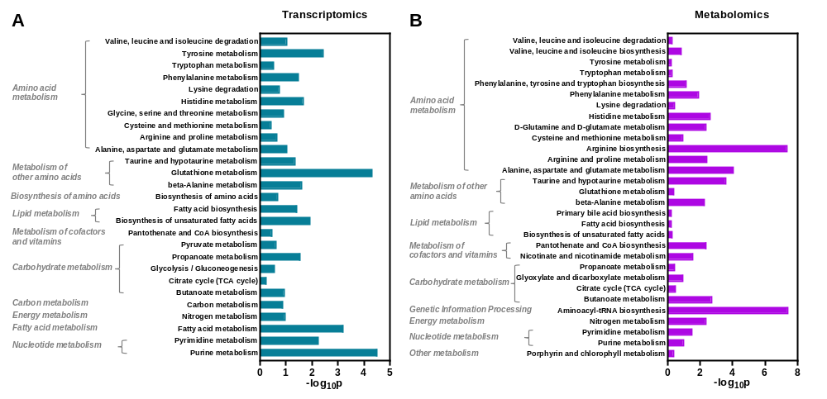
Figure S8 KEGG pathway enrichment analysis of differential genes and dysregulated metabolites.
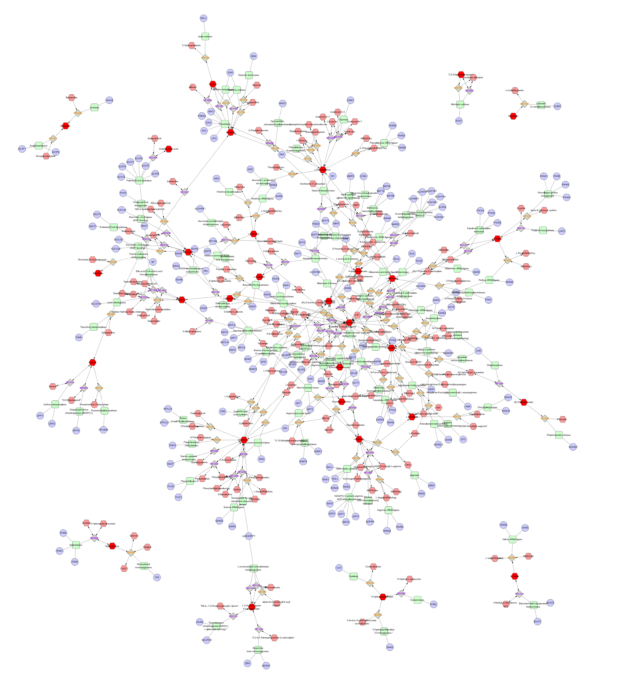
Figure S9 Compound-reaction-enzyme-gene network built by MetScape on the basis of PCa-related metabolites.
Figure S10 The expression of candidate genes in prostate cancer from open-source TCGA database. (A) AASS, (B) AGA, (C) ALDH1A3, (D) AOX1, (E) ASPA, (F) BHMT2, (G) CBS, (H) CSAD, (I) DDAH1, (J) FTCD, (K) GATM, (L) GFPT1, (M) GFPT2, (N) GGT1, (O) GPT, (P) HAAO, (Q) HDC, (R) NADSYN1, (S) P4HB, (T) PON3, (U) PYCR1, (V) SLC27A2, and (W) UPP1.
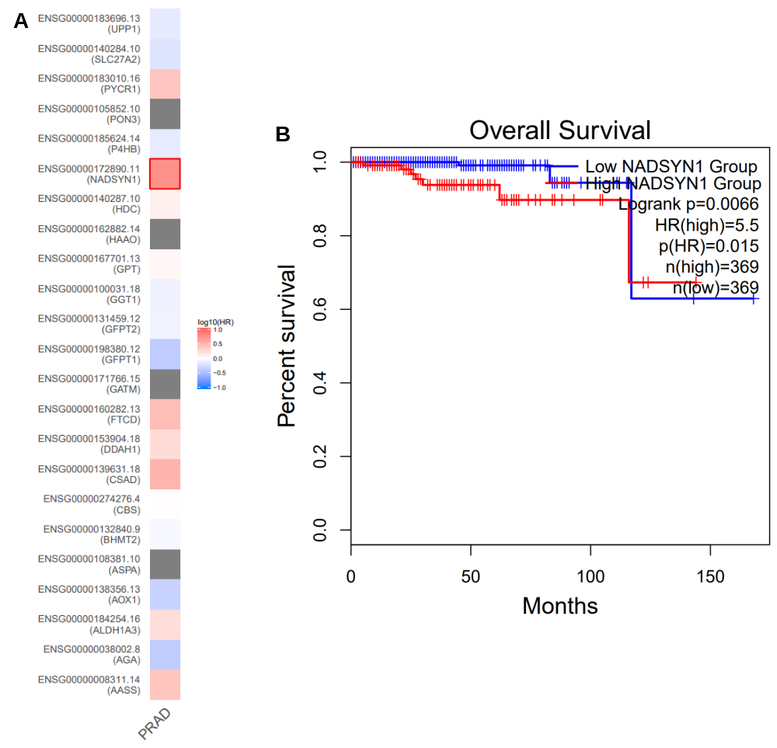
Figure S11 Survival analysis of candidate genes expressions in PCa patients. (A) Survival map of all differential metabolite-related genes. (B) Kaplan-Meier curve of NADSYN1.
Figure S12 Correlation between the levels of candidate gene expression and nodal metastasis status in PCa patients.
Figure S13 Correlation between the levels of candidate gene expression and patient’s Gleason score.
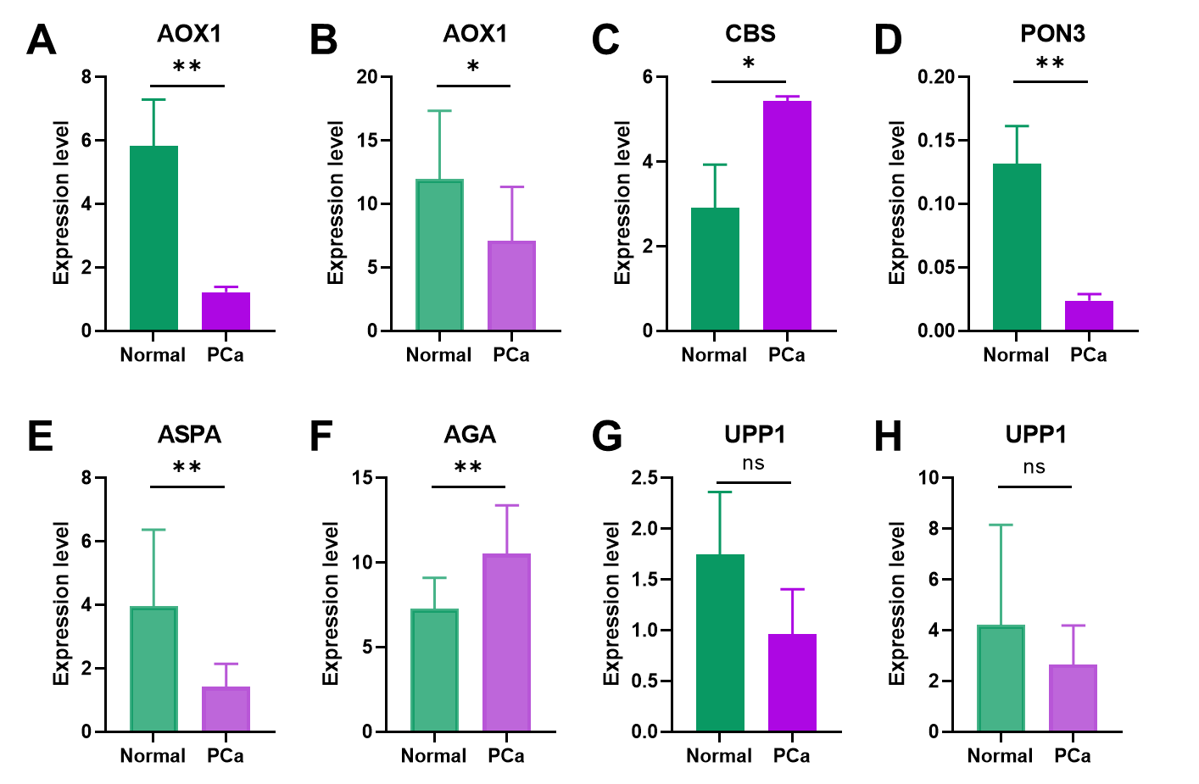
Figure S14 The expression of candidate genes in prostate cancer from open-source Asian datasets. (A)(B) The mRNA level of AOX1 in the (A) GSE179321 and (B) GSE114740 datasets. (C) CBS and (D) PON3 in the GSE179321 dataset. (E) ASPA and (F) AGA in the GSE114740 dataset. (G)(H) UPP1 in the GSE179321 and GSE114740 datasets.
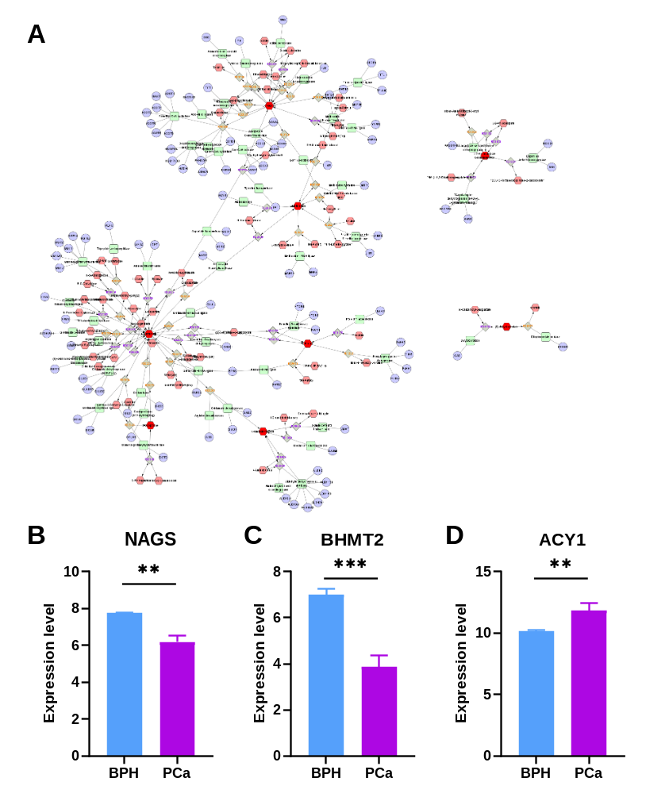
Figure S15 Perturbations of metabolite-related genes in PCa compared to BPH. (A) Metabolite-reaction-enzyme-gene network based on the differentially expressed metabolites between PCa and BPH groups. (B-D) The expression of differential genes from GSE30994 dataset.
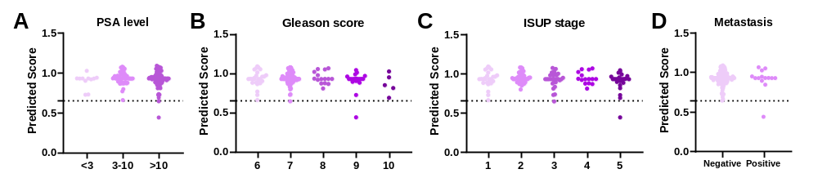
Figure S16 Predicted score distribution of PCa patients in different groups sorted by (A) PSA level, (B) Gleason score, (C) ISUP stage, and (D) tumor metastasis.
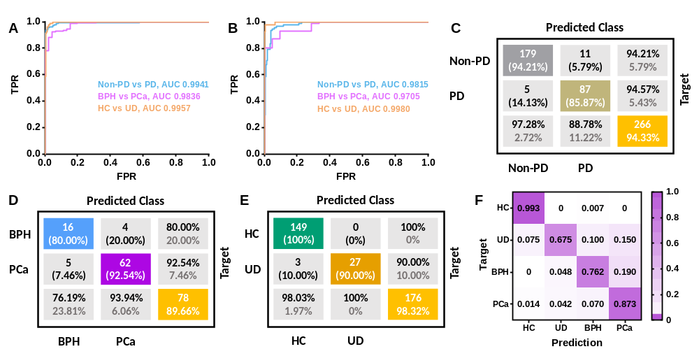
Figure S17 Discrimination results for discovery and external test sets with the built model. (A)(B) Receiver operating curves for the stepwise prediction in the discovery (A) and external validation (B) cohorts, respectively. (C-E) Confusion matrix for the first (C), second (D and third (E) step predictions in the external test sets. (F) Heatmap displays the ratios of predicted cases to true cases in the external test sets.
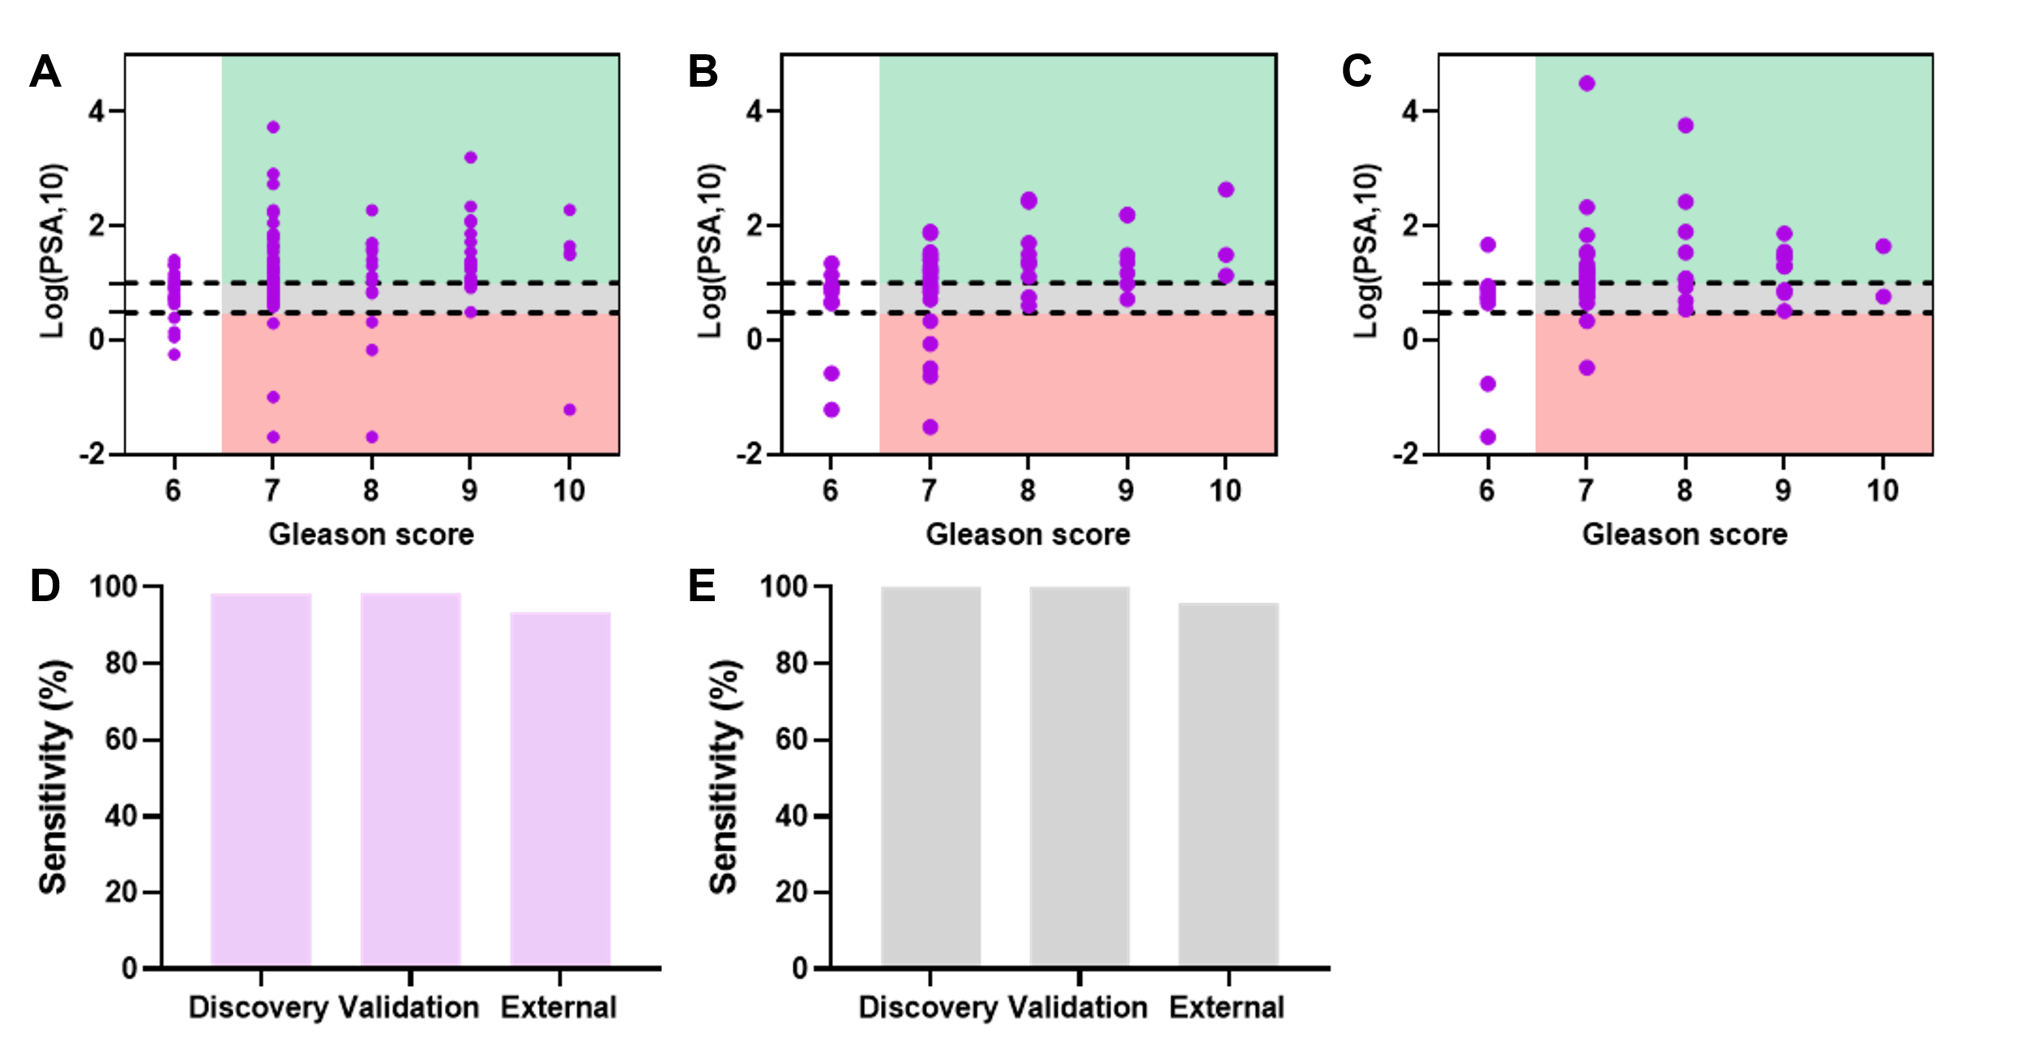
Figure S18 Discrimination results for significant PCa patients. (A-C) Gleason score and PSA level (ng/mL) of PCa patients in the discovery, internal validation, and external validation sets, respectively. (D) Diagnostic sensitivity of the constructed model for significant PCa patients (GS ≥ 7). (E) Diagnostic sensitivity of significant PCa patients in the gray area (3 < tPSA < 10 ng/mL).
3. Supplementary Tables
Table S1. Clinical characteristics of the subjects in the discovery cohort.
Characteristics | Discovery set |  |  |  | p value
Characteristics | HC | UD | BPH | PCa | p value
Cases | 300 | 80 | 45 | 142 | -
Age (average/range) | 62.38 (42-83) | 63.56 (41-94) | 64.32 (44-85) | 68.44 (43-91) | 0.0997
PSA (ng/mL) | - | - | <3 (n=8);  3-10 (n=20);  >10 (n=17) | <3 (n=11);  3-10 (n=50);  >10 (n=81) | 0.2936
fPSA/tPSA (median/range) | - | - | 0.15 (0.06-0.39) | 0.12 (0.005-0.91) | 0.0946
BMI (kg/m²) | 24.77 (2.63) | 24.69 (3.00) | 24.86 (3.45) | 23.90 (2.94) | 0.1537
HDL (mmol/L) | 1.35 (0.29) | 1.03 (0.18) | 1.33 (0.63) | 1.21 (0.51) | 0.0801
LDL (mmol/L) | 3.31 (0.80) | 3.01 (0.79) | 2.99 (0.74) | 2.95 (0.93) | 0.0625
TG (mmol/L) | 1.49 (0.94) | 1.62 (0.92) | 1.49 (0.91) | 1.58 (0.96) | 0.627
TC (mmol/L) | 5.30 (1.07) | 4.64 (0.92) | 4.84 (1.18) | 4.66 (1.03) | 0.082
Smoking status | Yes (n=28)  No (n=272) | Yes (n=8)  No (n=72) | Yes (n=4)  No (n=41) | Yes (n=14)  No (n=128) | 0.9949
Alcohol consumption | Yes (n=28)  No (n=272) | Yes (n=10)  No (n=70) | Yes (n=2)  No (n=43) | Yes (n=21)  No (n=121) | 0.1611
Cardiovascular disease | Yes (n=24)  No (n=276) | Yes (n=11)  No (n=69) | Yes (n=6)  No (n=39) | Yes (n=18)  No (n=124) | 0.2604
Hypertension | Yes (n=44)  No (n=256) | Yes (n=16)  No (n=64) | Yes (n=8)  No (n=37) | Yes (n=29)  No (n=113) | 0.4175
Diabetes | Yes (n=22)  No (n=278) | Yes (n=12)  No (n=68) | Yes (n=6)  No (n=39) | Yes (n=20)  No (n=122) | 0.0658
Primary/Secondary | - | - | - | Primary | -
Tumor metastasis | - | - | - | Positive (n=14);  Negative (n=128) | -
TNM stage |  |  |  | I (n=46);  II (n=62);  III (n=33);  IV (n=1) | -
Gleason score | - | - | - | 6 (n=26);  7 (n=75);  8 (n=15);  9 (n=21);  10 (n=5) | -
Note: p value was calculated by one-way ANOVA (analysis of variance) method.

Table S2. Clinical characteristics of the subjects in the internal validation cohort.
Characteristics | Validation set |  |  |  | p value
Characteristics | HC | UD | BPH | PCa | p value
Cases | 150 | 40 | 23 | 71 | -
Age (average/range) | 65.93 (41-87) | 67.39 (44-93) | 69.70 (49-92) | 69.61 (46-89) | 0.0926
PSA (ng/mL) | - | - | <3 (n=1);  3-10 (n=15);  >10 (n=7) | <3 (n=7);  3-10 (n=23);  >10 (n=41) | 0.0976
fPSA/tPSA (median/range) | - | - | 0.18 (0.03-0.36) | 0.12 (0.008-0.79) | 0.3706
BMI (kg/m²) | 24.22 (2.97) | 23.68 (3.29) | 23.97 (3.19) | 24.17 (3.11) | 0.8295
HDL (mmol/L) | 1.34 (0.30) | 1.10 (0.32) | 1.11 (0.21) | 1.24 (0.55) | 0.0788
LDL (mmol/L) | 3.22 (0.74) | 2.92 (0.60) | 2.84 (0.84) | 2.86 (0.81) | 0.1012
TG (mmol/L) | 1.47 (0.87) | 1.49 (0.89) | 1.53 (0.58) | 1.52 (0.83) | 0.8843
TC (mmol/L) | 5.18 (1.04) | 4.58 (0.89) | 4.48 (1.09) | 4.58 (1.13) | 0.0810
Smoking status | Yes (n=12)  No (n=138) | Yes (n=4)  No (n=36) | Yes (n=2)  No (n=21) | Yes (n=11)  No (n=60) | 0.3919
Alcohol consumption | Yes (n=14)  No (n=136) | Yes (n=5)  No (n=35) | Yes (n=2)  No (n=21) | Yes (n=10)  No (n=61) | 0.7230
Cardiovascular disease | Yes (n=18)  No (n=132) | Yes (n=4)  No (n=36) | Yes (n=3)  No (n=20) | Yes (n=8)  No (n=63) | 0.9815
Hypertension | Yes (n=19)  No (n=131) | Yes (n=5)  No (n=35) | Yes (n=3)  No (n=20) | Yes (n=9)  No (n=62) | 0.9981
Diabetes | Yes (n=16)  No (n=134) | Yes (n=4)  No (n=36) | Yes (n=3)  No (n=20) | Yes (n=7)  No (n=64) | 0.9776
Primary/Secondary | - | - | - | Primary | -
Tumor metastasis | - | - | - | Positive (n=3);  Negative (n=68) | -
TNM stage |  |  |  | I (n=23);  II (n=35);  III (n=13);  IV (n=0) | -
Gleason score | - | - | - | 6 (n=10);  7 (n=39);  8 (n=9);  9 (n=8);  10 (n=5) | -
Note: p value was calculated by one-way ANOVA (analysis of variance) method.

Table S3. Clinical characteristics of the subjects in the independent validation cohort.
Characteristics | External validation set |  |  |  | p value
Characteristics | HC | UD | BPH | PCa | p value
Cases | 150 | 40 | 21 | 71 | -
Age (average/range) | 62.55 (47-85) | 60.15 (42-91) | 65.67 (51-83) | 69.49 (55-89) | 0.0754
PSA (ng/mL) | - | - | <3 (n=5);  3-10 (n=9);  >10 (n=7) | <3 (n=4);  3-10 (n=31);  >10 (n=36) | 0.5172
fPSA/tPSA (median/range) | - | - | 0.16 (0.05-0.33) | 0.12 (0.006-0.50) | 0.141
BMI (kg/m²) | 24.13 (2.69) | 24.14 (2.93) | 25.32 (2.68) | 23.82 (2.69) | 0.0944
HDL (mmol/L) | 1.34 (0.29) | 1.17 (0.24) | 1.19 (0.17) | 1.15 (0.27) | 0.0636
LDL (mmol/L) | 3.15 (0.67) | 2.63 (0.70) | 2.89 (0.85) | 2.75 (0.73) | 0.0712
TG (mmol/L) | 1.54 (0.91) | 1.63 (1.03) | 1.62 (0.89) | 1.51 (0.72) | 0.9198
TC (mmol/L) | 5.06 (0.87) | 4.64 (0.92) | 4.61 (1.15) | 4.55 (1.14) | 0.0846
Smoking status | Yes (n=14)  No (n=136) | Yes (n=3)  No (n=37) | Yes (n=3)  No (n=18) | Yes (n=5)  No (n=66) | 0.8214
Alcohol consumption | Yes (n=18)  No (n=132) | Yes (n=5)  No (n=35) | Yes (n=2)  No (n=19) | Yes (n=9)  No (n=62) | 0.9646
Cardiovascular disease | Yes (n=18)  No (n=132) | Yes (n=5)  No (n=35) | Yes (n=1)  No (n=20) | Yes (n=7)  No (n=64) | 0.7119
Hypertension | Yes (n=18)  No (n=132) | Yes (n=6)  No (n=34) | Yes (n=3)  No (n=18) | Yes (n=9)  No (n=62) | 0.9679
Diabetes | Yes (n=14)  No (n=136) | Yes (n=4)  No (n=36) | Yes (n=2)  No (n=19) | Yes (n=8)  No (n=63) | 0.9712
Primary/Secondary | - | - | - | Primary | -
Tumor metastasis | - | - | - | Positive (n=8);  Negative (n=63) | -
TNM stage | - | - | - | I (n=25);  II (n=33);  III (n=13);  IV (n=0) | -
Gleason score | - | - | - | 6 (n=11);  7 (n=40);  8 (n=9);  9 (n=9);  10 (n=2) | -
Note: p value was calculated by one-way ANOVA (analysis of variance) method.

Table S4. Clinical characteristics of the subjects for RT-PCR and Western Blot analysis.
Number | Age | Gender | Gleason score | Pathological classification
#1 | 74 | Male | 4+3 | Prostate Adenocarcinoma
#2 | 62 | Male | 4+4 | Prostate Adenocarcinoma
#3 | 59 | Male | 3+4 | Prostate Adenocarcinoma
#4 | 72 | Male | 4+5 | Prostate Adenocarcinoma
#5 | 81 | Male | 4+4 | Prostate Adenocarcinoma
#6 | 77 | Male | 3+4 | Prostate Adenocarcinoma
#7 | 57 | Male | 3+4 | Prostate Adenocarcinoma
#8 | 73 | Male | 4+3 | Prostate Adenocarcinoma
#9 | 80 | Male | 4+3 | Prostate Adenocarcinoma
#10 | 56 | Male | 4+3 | Prostate Adenocarcinoma
#11 | 65 | Male | 4+3 | Prostate Adenocarcinoma
#12 | 82 | Male | 4+5 | Prostate Adenocarcinoma
#13 | 72 | Male | 4+5 | Prostate Adenocarcinoma
#14 | 64 | Male | 3+4 | Prostate Adenocarcinoma
#15 | 70 | Male | 3+4 | Prostate Adenocarcinoma
#16 | 68 | Male | 3+4 | Prostate Adenocarcinoma
#17 | 68 | Male | 4+3 | Prostate Adenocarcinoma
#18 | 76 | Male | 4+3 | Prostate Adenocarcinoma
#19 | 58 | Male | 3+4 | Prostate Adenocarcinoma
#20 | 72 | Male | 4+3 | Prostate Adenocarcinoma

Table S5. Summary of feature peaks that could be used to distinguish PCa patients from healthy controls.
No. | Detected m/z | Identification | Discovery  p value | Validation  p value | Trend
1 | 102.0565 | GABA | 1.15×10⁻³² | 6.75×10⁻¹⁷ | ↓
2 | 103.0041 | Malonic acid | 5.46×10⁻²⁷ | 8.67×10⁻¹³ | ↓
3 | 104.0334 | Serine | 1.07×10⁻⁴ | 1.01×10⁻³ | ↓
4 | 107.0561 | m-Cresol | 2.37×10⁻¹⁰ | 1.09×10⁻⁴ | ↓
5 | 108.0134 | Hypotaurine | 1.52×10⁻³ | 3.84×10⁻² | ↑
6 | 109.0298 | Hydroquinone | 3.37×10⁻³⁸ | 1.91×10⁻²² | ↓
7 | 110.0524 | Cytosine | 1.04×10⁻² | 1.73×10⁻² | ↑
8 | 111.0213 | Uracil | 1.57×10⁻²⁷ | 6.87×10⁻¹² | ↓
9 | 112.0495 | Creatinine | 3.66×10⁻² | 1.62×10⁻⁴ | ↑
10 | 114.0574 | L-Proline | 2.06×10⁻²³ | 3.78×10⁻¹⁰ | ↑
11 | 115.0047 | Maleic acid | 9.09×10⁻⁵ | 6.37×10⁻³ | ↑
12 | 116.0726 | L-Valine | 4.06×10⁻⁷ | 1.64×10⁻³ | ↑
13 | 117.0197 | Succinic acid | 4.07×10⁻² | 3.04×10⁻² | ↑
14 | 121.0306 | Benzoic acid | 3.24×10⁻⁷⁶ | 5.80×10⁻⁴¹ | ↓
15 | 122.0255 | Nicotinic acid | 3.77×10⁻⁸ | 1.17×10⁻⁸ | ↓
16 | 124.0079 | Taurine | 9.23×10⁻⁸ | 5.45×10⁻⁹ | ↑
17 | 125.0222 | 5-Methylfuran-2-carboxylic acid | 1.08×10⁻¹⁷ | 2.84×10⁻¹⁵ | ↑
18 | 129.0201 | Citraconic acid | 2.35×10⁻² | 9.57×10⁻⁵ | ↑
19 | 130.0517 | N-Acetylalanine | 5.57×10⁻⁵ | 4.15×10⁻⁴ | ↑
20 | 132.0312 | L-Aspartic acid | 6.70×10⁻¹⁰ | 3.49×10⁻⁵ | ↑
21 | 137.0240 | Salicylic acid | 1.38×10⁻⁵⁶ | 1.55×10⁻³² | ↓
22 | 139.0529 | Imidazolepropionic acid | 2.03×10⁻⁴ | 3.75×10⁻³ | ↑
23 | 142.0886 | Proline betaine | 1.11×10⁻³ | 2.85×10⁻² | ↓
24 | 143.1098 | Caprylic acid | 1.96×10⁻³ | 2.32×10⁻² | ↑
25 | 144.0651 | Allysine | 8.58×10⁻⁵⁸ | 2.22×10⁻³⁴ | ↓
26 | 145.0627 | Glutamine | 2.18×10⁻⁶ | 7.65×10⁻⁷ | ↑
27 | 146.0445 | Glutamic acid | 2.84×10⁻⁵ | 2.46×10⁻³ | ↓
28 | 148.0455 | L-Methionine | 1.87×10⁻¹⁰ | 4.46×10⁻⁵ | ↓
29 | 149.0247 | Phenylglyoxylic acid | 1.72×10⁻¹⁵ | 2.26×10⁻⁷ | ↓
30 | 151.0256 | Xanthine | 6.85×10⁻¹¹ | 8.06×10⁻¹⁰ | ↓
31 | 152.0366 | 3-Hydroxyanthranilic acid | 8.05×10⁻⁹ | 7.10×10⁻⁶ | ↑
32 | 153.0220 | Gentisic acid | 2.19×10⁻¹⁷ | 1.07×10⁻⁹ | ↓
33 | 154.0604 | L-Histidine | 5.33×10⁻¹¹ | 4.45×10⁻⁷ | ↑
34 | 155.0467 | Imidazolelactic acid | 1.62×10⁻⁵ | 6.44×10⁻³ | ↑
35 | 156.0660 | N-Acetylproline | 3.94×10⁻³⁴ | 8.85×10⁻¹³ | ↑
36 | 157.0255 | L-Dihydroorotic acid | 1.20×10⁻² | 3.46×10⁻² | ↑
37 | 158.0835 | N-Acetylvaline | 2.61×10⁻²³ | 8.67×10⁻¹⁴ | ↓
38 | 164.0723 | Phenylalanine | 2.38×10⁻⁴ | 8.79×10⁻³ | ↓
39 | 165.0191 | Phthalic acid | 7.31×10⁻¹⁵ | 3.68×10⁻⁷ | ↓
40 | 167.0221 | Uric acid | 5.03×10⁻¹⁴ | 2.75×10⁻⁷ | ↑
41 | 167.9981 | Cysteic acid | 1.03×10⁻⁷ | 1.28×10⁻⁴ | ↑
42 | 170.0442 | N-Acetylglutamic acid | 3.85×10⁻² | 1.96×10⁻² | ↑
43 | 173.1033 | L-Arginine | 1.41×10⁻⁶ | 1.33×10⁻⁴ | ↑
44 | 174.0893 | Citrulline | 5.86×10⁻⁶ | 5.59×10⁻⁵ | ↑
45 | 178.0621 | Hippuric acid | 4.67×10⁻⁵ | 2.76×10⁻³ | ↑
46 | 190.0550 | N-Acetylmethionine | 4.05×10⁻⁹ | 1.26×10⁻⁵ | ↑
47 | 207.1728 | 5-Tetradecenoic acid | 6.35×10⁻¹¹ | 2.36×10⁻⁴ | ↑
48 | 283.2565 | Stearic acid | 8.87×10⁻²⁰ | 4.30×10⁻¹² | ↑
Note: p value was calculated by student’s t test and corrected by Benjamini-Hochberg method.

Table S6. Summary of feature peaks that could be used to distinguish BPH patients from healthy controls.
No. | Detected m/z | Identification | Discovery  p value | Validation  p value | Trend
1 | 102.0565 | GABA | 7.20×10⁻²⁶ | 8.96×10⁻¹⁴ | ↓
2 | 103.0041 | Malonic acid | 8.10×10⁻²⁶ | 3.13×10⁻²⁶ | ↓
3 | 104.0334 | Serine | 1.35×10⁻⁴ | 1.26×10⁻³ | ↓
4 | 107.0561 | m-Cresol | 5.51×10⁻⁶ | 3.15×10⁻⁶ | ↓
5 | 109.0298 | Hydroquinone | 1.95×10⁻¹⁶ | 7.59×10⁻¹⁰ | ↓
6 | 111.0213 | Uracil | 3.00×10⁻¹² | 3.31×10⁻⁸ | ↓
7 | 114.0574 | L-Proline | 8.13×10⁻¹⁰ | 2.30×10⁻² | ↑
8 | 116.0726 | L-Valine | 1.75×10⁻¹⁰ | 5.48×10⁻⁶ | ↑
9 | 117.0197 | Succinic acid | 2.80×10⁻⁴ | 8.08×10⁻⁵ | ↑
10 | 118.0516 | L-Threonine | 2.24×10⁻⁴ | 1.08×10⁻³ | ↑
11 | 121.0306 | Benzoic acid | 2.31×10⁻⁵² | 6.18×10⁻²⁵ | ↓
12 | 122.0255 | Nicotinic acid | 1.07×10⁻¹³ | 1.58×10⁻³ | ↓
13 | 124.0079 | Taurine | 3.45×10⁻⁴ | 6.72×10⁻⁶ | ↑
14 | 125.0222 | 5-Methylfuran-2-carboxylic acid | 1.66×10⁻⁶ | 6.52×10⁻⁷ | ↑
15 | 128.0355 | L-Pyroglutamic acid | 7.52×10⁻⁵ | 1.10×10⁻³ | ↓
16 | 132.0312 | L-Aspartic acid | 2.76×10⁻⁹ | 1.62×10⁻⁸ | ↑
17 | 137.0240 | Salicylic acid | 1.46×10⁻³³ | 3.41×10⁻¹⁹ | ↓
18 | 139.0529 | Imidazolepropionic acid | 5.64×10⁻¹⁸ | 9.54×10⁻¹⁰ | ↑
19 | 142.0886 | Proline betaine | 9.94×10⁻³ | 2.73×10⁻³ | ↓
20 | 143.1098 | Caprylic acid | 5.39×10⁻¹⁵ | 3.24×10⁻⁷ | ↑
21 | 144.0651 | Allysine | 3.02×10⁻³² | 4.89×10⁻²¹ | ↓
22 | 145.0627 | Glutamine | 3.21×10⁻² | 1.11×10⁻⁴ | ↑
23 | 146.0445 | Glutamic acid | 1.92×10⁻⁵ | 2.01×10⁻³ | ↓
24 | 148.0455 | L-Methionine | 2.38×10⁻¹⁴ | 7.25×10⁻⁴ | ↓
25 | 149.0247 | Phenylglyoxylic acid | 3.87×10⁻⁸ | 2.20×10⁻⁴ | ↓
26 | 151.0256 | Xanthine | 1.01×10⁻⁸ | 2.56×10⁻⁵ | ↓
27 | 153.0220 | Gentisic acid | 6.58×10⁻¹¹ | 1.66×10⁻⁵ | ↓
28 | 154.0604 | L-Histidine | 2.03×10⁻⁴ | 7.76×10⁻⁵ | ↑
29 | 155.0467 | Imidazolelactic acid | 1.00×10⁻¹⁹ | 1.29×10⁻¹⁰ | ↑
30 | 156.0660 | N-Acetylproline | 2.33×10⁻³⁴ | 1.28×10⁻¹⁴ | ↑
31 | 157.0255 | L-Dihydroorotic acid | 2.17×10⁻⁷ | 6.19×10⁻⁷ | ↑
32 | 158.0835 | N-Acetylvaline | 1.94×10⁻¹³ | 4.06×10⁻⁸ | ↓
33 | 160.0620 | N-Acetylthreonine | 5.41×10⁻⁵ | 1.39×10⁻⁴ | ↑
34 | 164.0723 | Phenylalanine | 9.52×10⁻⁷ | 6.37×10⁻³ | ↓
35 | 165.0191 | Phthalic acid | 4.55×10⁻⁸ | 2.79×10⁻⁴ | ↓
36 | 167.0221 | Uric acid | 1.15×10⁻¹² | 4.43×10⁻⁹ | ↑
37 | 167.9981 | Cysteic acid | 4.07×10⁻⁷ | 7.41×10⁻⁵ | ↑
38 | 173.1033 | L-Arginine | 1.47×10⁻⁴ | 9.89×10⁻⁴ | ↑
39 | 178.0621 | Hippuric acid | 2.11×10⁻⁸ | 2.70×10⁻¹¹ | ↑
40 | 180.0681 | L-Tyrosine | 8.39×10⁻⁹ | 3.10×10⁻⁶ | ↑
41 | 190.0550 | N-Acetylmethionine | 1.24×10⁻⁴ | 3.92×10⁻⁴ | ↑
42 | 203.0829 | L-Tryptophan | 1.15×10⁻² | 1.27×10⁻³ | ↑
43 | 207.1728 | 5-Tetradecenoic acid | 2.95×10⁻¹⁵ | 1.56×10⁻⁸ | ↑
44 | 283.2565 | Stearic acid | 5.33×10⁻³⁴ | 2.81×10⁻¹³ | ↑
Note: p value was calculated by one-way ANOVA (analysis of variance) method.

Table S7. Summary of feature peaks that could be used to distinguish PCa patients from BPH subjects.
No. | Detected m/z | Identification | Discovery  p value | Validation  p value | Trend
1 | 102.0565 | GABA | 5.71×10⁻³ | 9.22×10⁻³ | ↑
2 | 103.0041 | Malonic acid | 3.82×10⁻² | 7.54×10⁻³ | ↑
3 | 110.0524 | Cytosine | 4.20×10⁻² | 6.48×10⁻³ | ↑
4 | 112.0495 | Creatinine | 3.60×10⁻² | 7.09×10⁻³ | ↑
5 | 114.0574 | L-Proline | 4.31×10⁻² | 4.50×10⁻⁴ | ↑
6 | 128.0355 | L-Pyroglutamic acid | 4.17×10⁻² | 2.18×10⁻³ | ↑
7 | 139.0529 | Imidazolepropionic acid | 2.78×10⁻³ | 4.12×10⁻⁵ | ↓
8 | 143.1098 | Caprylic acid | 3.22×10⁻³ | 6.02×10⁻³ | ↓
9 | 144.0651 | Allysine | 3.93×10⁻² | 1.46×10⁻³ | ↑
10 | 146.0445 | Glutamic acid | 3.06×10⁻² | 3.22×10⁻² | ↑
11 | 148.0455 | L-Methionine | 1.84×10⁻⁴ | 3.07×10⁻² | ↑
12 | 155.0467 | Imidazolelactic acid | 1.86×10⁻³ | 2.22×10⁻⁴ | ↓
13 | 156.0660 | N-Acetylproline | 4.15×10⁻² | 1.78×10⁻² | ↓
14 | 157.0255 | L-Dihydroorotic acid | 4.73×10⁻² | 9.58×10⁻³ | ↓
15 | 158.0835 | N-Acetylvaline | 3.71×10⁻² | 2.93×10⁻² | ↑
16 | 159.0681 | Pimelic acid | 3.78×10⁻² | 1.59×10⁻² | ↓
17 | 160.0620 | N-Acetylthreonine | 4.63×10⁻² | 8.98×10⁻³ | ↓
18 | 165.0191 | Phthalic acid | 1.82×10⁻² | 1.34×10⁻² | ↑
19 | 180.0681 | L-Tyrosine | 3.95×10⁻² | 1.98×10⁻³ | ↓
20 | 190.0550 | N-Acetylmethionine | 3.26×10⁻² | 1.20×10⁻² | ↑

Table S8. LC-MS/MS identification of potential feature peaks for discrimination of patients with prostate disease.
No. | Measured m/z | Theoretical m/z | Adductive ions | Identification | Delta (ppm) | Main fragments | Database
1 | 102.0581 | 102.0561 | M-H | GABA | 20 | 58,84 | HMDB
2 | 103.0042 | 103.0037 | M-H | Malonic acid | 5 | 41,59,85 | HMDB
3 | 104.0368 | 104.0353 | M-H | Serine | 14 | 43,56,74 | HMDB
4 | 107.0524 | 107.0502 | M-H | m-Cresol | 20 | 65,79,91 | HMDB
5 | 110.0260 | 110.0270 | M+H | Hypotaurine | 9 | 69,81,92 | HMDB
6 | 109.0308 | 109.0295 | M-H | Hydroquinone | 12 | 41,53,55,65,81 | HMDB
7 | 112.0519 | 112.0505 | M+H | Cytosine | 12 | 52,67,68,69,95 | HMDB
8 | 111.0217 | 111.0200 | M-H | Uracil | 15 | 42,50,68,94 | HMDB
9 | 114.0668 | 114.0662 | M+H | Creatinine | 5 | 44,55,72,86 | HMDB
10 | 116.0715 | 116.0706 | M+H | L-Proline | 8 | 54,55,56,70,71,98 | HMDB
11 | 115.0043 | 115.0037 | M-H | Maleic acid | 5 | 45,53,69,71,97 | HMDB
12 | 118.0866 | 118.0863 | M+H | L-Valine | 3 | 56,57,60,72,74 | HMDB
13 | 117.0204 | 117.0193 | M-H | Succinic acid | 9 | 45,55,71,73,81,99 | HMDB
14 | 120.0661 | 120.0655 | M+H | L-Threonine | 5 | 56,58,74,102 | HMDB
15 | 121.0299 | 121.0295 | M-H | Benzoic acid | 3 | 49,51,77,103 | HMDB
16 | 122.0255 | 122.0248 | M-H | Nicotinic acid | 6 | 78,95,96 | HMDB
17 | 126.0224 | 126.0219 | M+H | Taurine | 4 | 84,98,109,115 | HMDB
18 | 125.0259 | 125.0244 | M-H | 5-Methylfuran-2-carboxylic acid | 12 | 63,65,81,89,107 | HMDB
19 | 128.0365 | 128.0353 | M-H | L-Pyroglutamic acid | 9 | 52,59,72,82 | HMDB
20 | 129.0218 | 129.0193 | M-H | Citraconic acid | 19 | 65,85,111 | HMDB
21 | 130.0527 | 130.0510 | M-H | N-Acetylalanine | 13 | 58,70,82,86,88,114 | HMDB
22 | 134.0458 | 134.0448 | M+H | L-Aspartic acid | 8 | 77,79,89,90,116 | HMDB
23 | 137.0240 | 137.0244 | M-H | Salicylic acid | 3 | 65,67,75,93 | HMDB
24 | 139.0523 | 139.0513 | M-H | Imidazolepropionic acid | 7 | 41,67,95,112,121 | HMDB
25 | 142.0897 | 142.0874 | M-H | Proline betaine | 17 | 45,53,59,69,83 | HMDB
26 | 143.1088 | 143.1078 | M-H | Caprylic acid | 7 | 45,53,57,67,81,95,107,125 | HMDB
27 | 144.0677 | 144.0666 | M-H | Allysine | 8 | 45,53,74,82,100,102,126 | HMDB
28 | 145.0631 | 145.0619 | M-H | Glutamine | 9 | 42,58,74,82,109,127 | HMDB
29 | 148.0617 | 148.0604 | M+H | Glutamic acid | 9 | 59,75,102,115 | HMDB
30 | 148.0436 | 148.0438 | M-H | L-Methionine | 1 | 47,73,86,100,115 | HMDB
31 | 149.0290 | 149.0244 | M-H | Phenylglyoxylic acid | 31 | 65,77,89,103,105 | HMDB
32 | 151.0278 | 151.0261 | M-H | Xanthine | 11 | 42,53,81,108,124,133 | HMDB
33 | 154.0510 | 154.0499 | M+H | 3-Hydroxyanthranilic acid | 7 | 53,54,80,92,108,136 | HMDB
34 | 153.0206 | 153.0193 | M-H | Gentisic acid | 8 | 53,69,81,108 | HMDB
35 | 154.0627 | 154.0622 | M-H | L-Histidine | 3 | 67,80,81,93,110,137 | HMDB
36 | 155.0470 | 155.0462 | M-H | Imidazolelactic acid | 5 | 40,67,81,111 | HMDB
37 | 156.0663 | 156.0666 | M-H | N-Acetylproline | 2 | 45,83,96,114 | HMDB
38 | 157.0263 | 157.0255 | M-H | L-Dihydroorotic acid | 5 | 42,72,113,129,139 | HMDB
39 | 158.0821 | 158.0823 | M-H | N-Acetylvaline | 1 | 41,58,98,116 | HMDB
40 | 159.0666 | 159.0663 | M-H | Pimelic acid | 2 | 59,69,97,115,141 | HMDB
41 | 160.0621 | 160.0615 | M-H | N-Acetylthreonine | 4 | 58,74,98,116,118,142 | HMDB
42 | 164.0729 | 164.0717 | M-H | Phenylalanine | 7 | 72,77,92,103,120,147 | HMDB
43 | 165.0215 | 165.0193 | M-H | Phthalic acid | 13 | 51,77,93,95,103,121,147 | HMDB
44 | 167.0223 | 167.0211 | M-H | Uric acid | 7 | 42,69,81,96,124,149 | HMDB
45 | 167.9990 | 167.9972 | M-H | Cysteic acid | 11 | 72,81,88,95,107,124,150 | HMDB
46 | 170.0461 | 170.0453 | M-H₂O-H | N-Acetylglutamic acid | 5 | 58,72,85,100,128,144,146 | HMDB
47 | 173.1060 | 173.1044 | M-H | L-Arginine | 9 | 41,69,72,81,112,131,155 | HMDB
48 | 174.0882 | 174.0884 | M-H | Citrulline | 1 | 42,59,66,83,85,114,131 | HMDB
49 | 178.0512 | 178.0510 | M-H | Hippuric acid | 1 | 77,100,105,107,132,134 | HMDB
50 | 180.0674 | 180.0666 | M-H | L-Tyrosine | 4 | 72,93,119 | HMDB
51 | 190.0562 | 190.0543 | M-H | N-Acetylmethionine | 10 | 58,116,128,130,148,172 | HMDB
52 | 203.0837 | 203.0826 | M-H | L-Tryptophan | 5 | 72,74,116,130,142 | HMDB
53 | 207.1761 | 207.1749 | M-H₂O-H | 5-Tetradecenoic acid | 6 | 45,59,71,97,109,125,135,139,149,163 | HMDB
54 | 283.2661 | 283.2643 | M-H | Stearic acid | 7 | 99,125,139,155,183,197,211,239,265 | HMDB

Table S9. MALDI-TOF/TOF tandem mass spectrometry identification of urine metabolites.
No. | Identification | Detected m/z in urine | MS/MS fragments of urine metabolites in MALDI | Detected m/z of standard | MS/MS fragments of standard in MALDI | Possible metabolites | Molecular formula | Theoretical m/z
1 | standard* | 102.0565 | 42,58,71,84 | 102.0560 | 58,71,84 | GABA | C₄H₉NO₂ | 102.0561
2 | standard* | 103.0041 | 41,44,59,72,75,85 | 103.0040 | 41,44,59,72,75,85 | Malonic acid | C₃H₄O₄ | 103.0037
3 | standard* | 104.0334 | 58,60,74 | 104.0349 | 58,60,74 | Serine | C₃H₇NO₃ | 104.0353
4 | standard | 107.0561 | 41,65,79,81,84 | 107.0497 | 41,65,79,81,84 | m-Cresol | C₇H₈O | 107.0502
5 | standard* | 108.0134 | 64,65,90 | 108.0127 | 64,65,90 | Hypotaurine | C₂H₇NO₂S | 108.0125
6 | standard* | 109.0298 | 41, 65,81,83 | 109.0294 | 41,65,81,83 | Hydroquinone | C₆H₆O₂ | 109.0295
7 | standard* | 110.0524 | 42,67,84 | 110.0357 | 42,67,84 | Cytosine | C₄H₅N₃O | 110.0360
8 | standard* | 111.0213 | 42,68,84,85 | 111.0202 | 42,68,84,85,94 | Uracil | C₄H₄N₂O₂ | 111.0200
9 | standard* | 112.0495 | 41,68,85,95 | 112.0510 | 41,68,85,95 | Creatinine | C4H7N3O | 112.0516
10 | standard* | 114.0574 | 45,59,68,86 | 114.0561 | 45,59,68,86 | L-Proline | C₅H₉NO₂ | 114.0561
11 | Standard* | 115.0047 | 45,53,69 | 115.0044 | 45,53,69,71 | Maleic acid | C₄H₄O₄ | 115.0037
12 | standard* | 116.0726 | 45,70,75,89,93,99 | 116.0721 | 45,70,75,89,93 | L-Valine | C₅H₁₁NO₂ | 116.0717
13 | standard* | 117.0197 | 73,90,99 | 117.0190 | 61,73,90,99 | Succinic acid | C₄H₆O₄ | 117.0193
14 | standard* | 118.0516 | 56,72,74 | 118.0507 | 56,72,74 | L-Threonine | C₄H₉NO₃ | 118.0510
15 | standard* | 121.0306 | 49,77,103 | 121.0297 | 49,77,103 | Benzoic acid | C₇H₆O₂ | 121.0295
16 | standard | 122.0255 | 45,77,78,95,100,105 | 122.0243 | 77,78,95,100,105 | Nicotinic acid | C₆H₅NO₂ | 122.0248
17 | standard* | 124.0079 | 60,65,79,80,95,105,107 | 124.0081 | 60,65,79,80,95,105 | Taurine | C₂H₇NO₃S | 124.0074
18 | standard* | 125.0222 | 41,81,107 | 125.0239 | 41,81,107 | 5-Methylfuran-2-carboxylic acid | C₆H₆O₃ | 125.0244
19 | standard* | 128.0355 | 82,84,102,103,110 | 128.0356 | 71,82,84,102,103,110 | L-Pyroglutamic acid | C₅H₇NO₃ | 128.0353
20 | standard* | 129.0201 | 27,36,43,59,88,113 | 129.0194 | 27,36,43,59,88,113 | Citraconic acid | C₅H₆O₄ | 129.0193
21 | standard* | 130.0517 | 42,70,88,112 | 130.0511 | 42,70,88,112 | N-Acetylalanine | C₅H₉NO₃ | 130.0510
22 | standard* | 132.0312 | 42,71,72,88,115 | 132.0304 | 42,71,72,88 | L-Aspartic acid | C₄H₇NO₄ | 132.0302
23 | standard* | 137.0240 | 79,93,119 | 137.0248 | 41,79,93,119 | Salicylic acid | C₇H₆O₃ | 137.0244
24 | standard* | 139.0529 | 67,95,121 | 139.0520 | 41,67,95,112,121 | Imidazolepropionic acid | C₆H₈N₂O₂ | 139.0513
25 | standard* | 142.0886 | 45,53,96,99,115,121 | 142.0870 | 45,53,83,85,96,99,115,121 | Proline betaine | C₇H₁₃NO₂ | 142.0874
26 | standard* | 143.1098 | 57,99,107,115,125 | 143.1076 | 57,99,107,115,125 | Caprylic acid | C₈H₁₆O₂ | 143.1078
27 | standard* | 144.0651 | 41,100,116,126 | 144.0622 | 41,100,108,116,126 | Allysine | C₆H₁₁NO₃ | 144.0666
28 | standard* | 145.0627 | 73,101,109,127 | 145.0622 | 73,83,101,109,127 | Glutamine | C₅H₁₀N₂O₃ | 145.0619
29 | standard* | 146.0445 | 42,74,102,128 | 146.0461 | 74,102,128 | Glutamic acid | C₅H₉NO₄ | 146.0459
30 | standard* | 148.0455 | 47,100,123 | 148.0441 | 47,100,123 | Methionine | C₅H₁₁NO₂S | 148.0438
31 | standard* | 149.0247 | 77,89,103,105 | 149.0242 | 77,89,105,121 | Phenylglyoxylic acid | C₈H₆O₃ | 149.0244
32 | standard* | 151.0256 | 42,81,108,133 | 151.0244 | 108,124,133 | Xanthine | C₅H₄N₄O₂ | 151.0261
33 | standard* | 152.0366 | 78,92,108,126,134 | 152.0348 | 78,108,126,134 | 3-Hydroxyanthranilic acid | C₇H₇NO₃ | 152.0353
34 | standard* | 153.0220 | 41,81,108,123,137 | 153.0196 | 41,108,123,137 | Gentisic acid | C₇H₆O₄ | 153.0193
35 | standard* | 154.0604 | 81,93,110,137 | 154.0623 | 81,93,110,137 | L-Histidine | C₆H₉N₃O₂ | 154.0622
36 | standard* | 155.0467 | 40,67,81 | 155.0461 | 40,67,81 | Imidazolelactic acid | C₆H₈N₂O₃ | 155.0462
37 | standard* | 156.0660 | 43,58,96,114,139 | 156.0667 | 43,96,114,139 | N-Acetylproline | C₇H₁₁NO₃ | 156.0666
38 | standard* | 157.0255 | 42,113,129,130,139 | 157.0255 | 42,113,129,139 | L-Dihydroorotic acid | C₅H₆N₂O₄ | 157.0255
39 | standard* | 158.0835 | 34,41,78,99,114,116 | 158.0822 | 34,41,78,99,114,116 | N-Acetylvaline | C₇H₁₃NO₃ | 158.0823
40 | standard* | 159.0681 | 97,115,137,141 | 159.0667 | 61,97,115,137,141 | Pimelic acid | C₇H₁₂O₄ | 159.0663
41 | standard* | 160.0620 | 100,116,118,142 | 160.0617 | 100,116,118,142 | N-Acetylthreonine | C₆H₁₁NO₄ | 160.0615
42 | standard* | 164.0723 | 91,103,120,147 | 164.0720 | 72,91,103,120,147 | Phenylalanine | C₉H₁₁NO₂ | 164.0717
43 | standard* | 165.0191 | 51,77,121,147 | 165.0193 | 77,103,121,147 | Phthalic acid | C₈H₆O₄ | 165.0193
44 | standard* | 167.0221 | 97,110,124,128,140,151 | 167.0214 | 69,97,124,128,140 | Uric acid | C₅H₄N₄O₃ | 167.0211
45 | standard* | 167.9981 | 81,86,124,150,151 | 167.9979 | 86,124,150,151 | Cysteic acid | C₃H₇NO₅S | 167.9972
46 | standard* | 170.0442 | 100,128,144 | 170.0414 | 58,100,128,144 | N-Acetylglutamic acid | C₇H₁₁NO₅ | 170.0453
47 | standard | 173.1033 | 77,114,131,156 | 173.1047 | 77,114,131,156 | L-Arginine | C₆H₁₄N₄O₂ | 173.1044
48 | standard | 174.0893 | 118,131,145,147 | 174.0879 | 118,131,145,147,157 | Citrulline | C₆H₁₃N₃O₃ | 174.0884
49 | standard* | 178.0621 | 77,107,132,134 | 178.0515 | 77,107,132,134 | Hippuric acid | C₉H₉NO₃ | 178.0510
50 | standard* | 180.0681 | 72,93,119,139,163 | 180.0676 | 72,93,119,139 | L-Tyrosine | C₉H₁₁NO₃ | 180.0666
51 | standard | 190.0550 | 72,129,142,148 | 190.0542 | 72,115,129,142,148 | N-Acetylmethionine | C₇H₁₃NO₃S | 190.0543
52 | standard* | 203.0829 | 74,116,142,159,174 | 203.0822 | 74,142,159,174 | L-Tryptophan | C₁₁H₁₂N₂O₂ | 203.0826
53 | standard* | 207.1728 | 111,125,135,139,149,163 | 207.1722 | 111,125,135,149,163 | 5-Tetradecenoic acid | C₁₄H₂₆O₂ | 207.1749
54 | standard* | 283.2565 | 155,183,197,211,223,239,265 | 283.2768 | 155,183,197,211,223,239,265 | Stearic acid | C₁₈H₃₆O₂ | 283.2643
Note: Because the ion source of two MS technologies (UPLC-MS and MALDI-TOF MS) are different, so the tandem MS results are not comparable, * represents the MALDI -TOF/TOF tandem mass spectrometry results of some metabolites are consistent with the UPLC-MS/MS data.

