Fig. S1 | Extended multi-omics characterization of thymoma subtypes. A, Volcano plots showing 723 downregulated (blue) and 326 upregulated (red) proteins in MGTH vs TH (|log2FC|>1, p < 0.05). B, Functional enrichment network of GO and KEGG pathways. C, AChR antibodies detection via cell-based array. D, Unsupervised PCA of TCGA thymoma RNA-seq data (n = 107) showing group and subtype stratification. E, Volcano plot of 1019 upregulated (red) and 675 downregulated (blue) genes in MGTH vs TH (|log2FC|>1, padj < 0.05). F, Heatmap of synapse-related genes across MGTH/TH cohorts. G, Expression trends of AChR subunit genes (CHRNB1, CHRND, CHRNE) in transcriptomic data. MGTH, MG-associated thymomas.
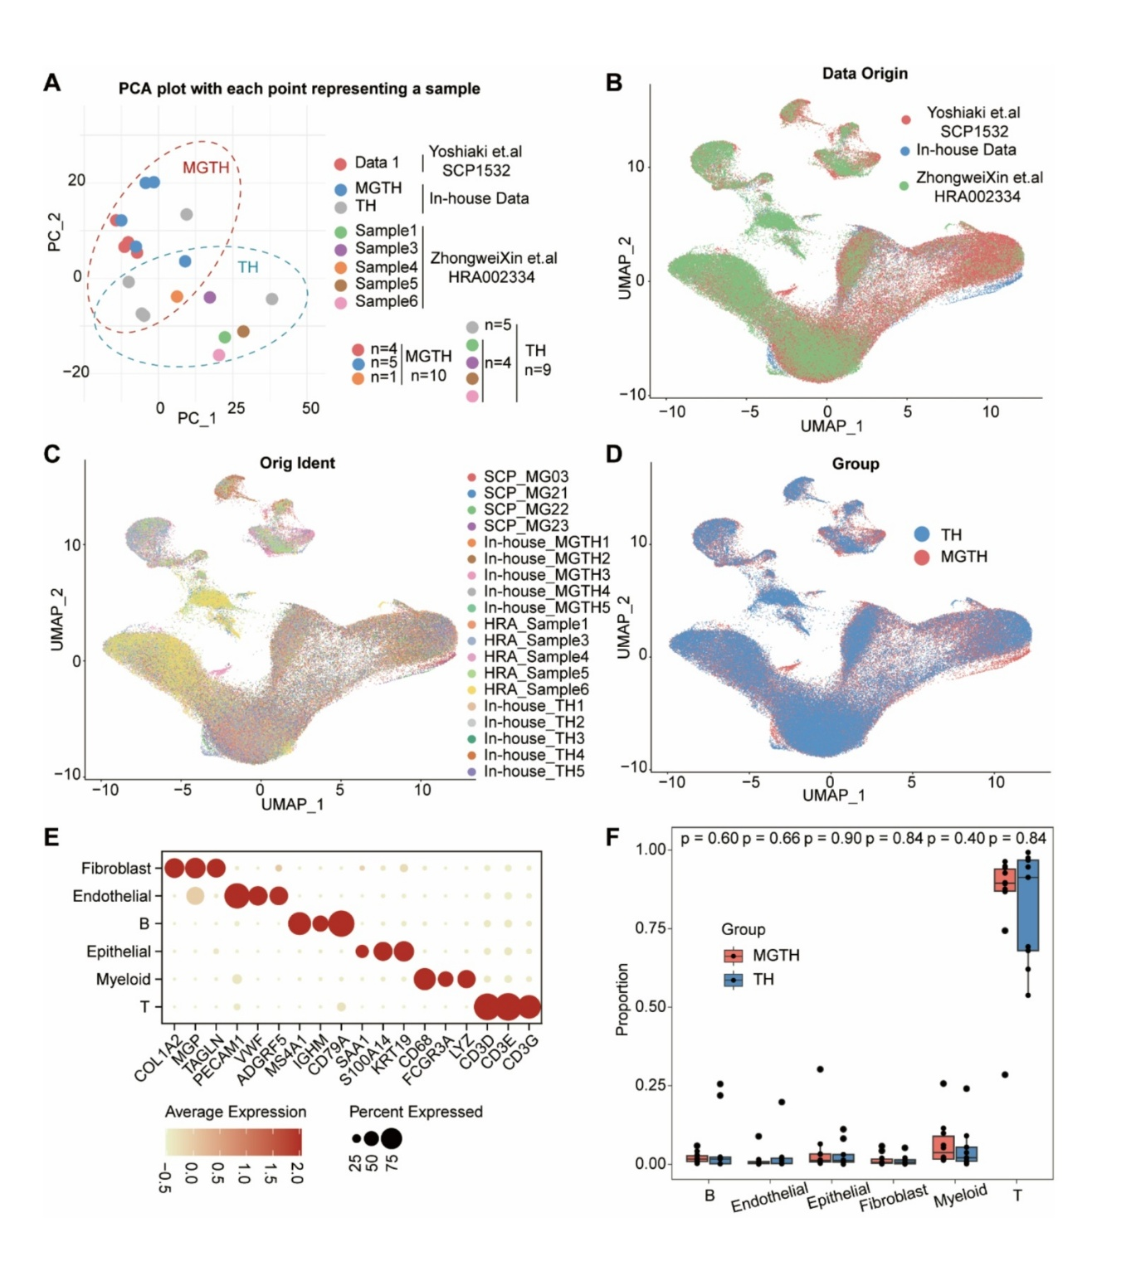
Fig. S2 | Quality control and extended analysis of thymoma single-cell data. A, Principal Component Analysis (PCA) group separation. B-D, Batch effect evaluation: integration by data source (B), sample type (C), and disease group (D). E, Subcluster annotation of major cell types. F, Cell type proportion comparison between MGTH and TH groups (two-sided χ² test, P > 0.05). Data generated using Seurat v4.0 integration pipeline with 3,000 variable features. MGTH, MG-associated thymomas.
Fig. S3 | Extended T cell characterization and validation. A, Transcription factor activity dynamics during T cell maturation. B, T cell subset proportion comparison (Wilcox t test, P > 0.05). C, GO enrichment of cell subset-specific genes. D, Number of differentially expressed genes of different T subsets. E, InferCNV analysis excluding malignant clones. F-H, Group-specific JUND/SOCS3 expression patterns at mRNA and protein levels. I, Single-cell profiling of PBMCs from MGTH patients and healthy controls. J, JUND and SOCS3 expression in normal thymus. K, TCGA-THYM expression trends of JUND and SOCS3. Data generated using Monocle3 (pseudotime) and Cell Ranger v6.0 pipelines. MGTH, MG-associated thymomas.
Fig. S4 | Analysis of functional and transcriptional regulation. A, Hallmark pathway enrichment across T cell maturation phases. B, SOCS3 expression in PBMCs from patients with autoimmune diseases (RA: rheumatoid arthritis, T1D: type 1 diabetes, SS: Sjögren’s syndrome, SLE: systemic lupus erythematosus). C, Transcription factor (TF) activity analysis identifying JUND as a top upregulated TF in MGTH Tregs. D, Feature plot of Foxp3 expression between groups.
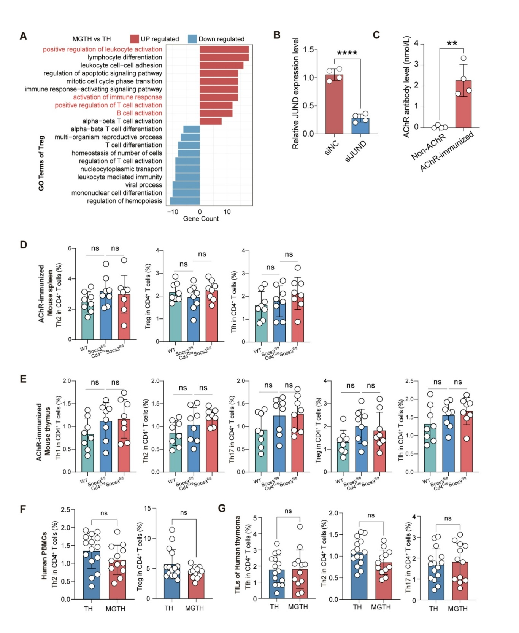
Fig. S5 | Extended validation of SOCS3 suppression in T helper cell dysregulation. A, GO enrichment of differentially expressed genes in Treg between MGTH and TH (|Log2FC|>1, padj < 0.05). B, Validation of JUND knockdown in Jurkat T cells through qPCR. C, Measurement of anti-AChR antibodies by radioimmunoassay. D-E, Analysis of Th subset frequencies in spleen and thymus of AChR-immunized Cd4^{Cre}Socs3^{fl/fl} versus Socs3^{fl/fl} mice. F-G, Comparable proportions of human Th cell in PBMCs and thymoma tissues between MGTH and TH cohorts. PBMCs, Peripheral blood mononuclear cells; MGTH, MG-associated thymomas.
Fig. S6 | Extended profiling of nsTEC molecular signatures. A, TCGA-based neurosynaptic gene expression across TEC subsets. B, Dot plots of marker genes across TEC subsets between MGTH and TH. C, GO enrichment of TEC subset-specific genes. D, GO enrichment of MGTH nsTEC upregulated genes. E, Postsynaptic gene expression in nsTECs between groups. F, Feature plot of represented gene expression. G, nsTEC marker genes absence in normal thymus. H, InferCNV analysis of different TECs using Naïve B cells as reference. I, HLA family gene expression across independent datasets. J, GSVA pathway enrichment analysis of different TECs. K, CellChat analysis of nsTEC-T cell interactions. L, Co-expression of nsTEC markers SYNE1 and KCNMA1 in TECs. nsTEC, neuro-synaptic thymic epithelial cell; MGTH, MG-associated thymomas.
Fig. S7 | Functional analysis of nsTECs and flow cytometry gating strategy. A, GSVA pathway enrichment analysis across TEC subsets between groups. B, Feature plot showing the expression of surface marker LGR5 in nsTEC. C, Gating strategy of flow cytometry analysis for TECs and nsTECs.
Fig. S8 | Extended B cell characterization. A, Pseudotime branch-specific gene expression patterns. B, TTN expression in memory_B cells between groups. C-D, TTN expression in B cells from PBMCs of MGTH patients and healthy controls. E-F, Absence of TTN expression in healthy thymic B cells. MGTH, MG-associated thymomas.
Fig. S9 | Extended cell-cell communication analysis. A, Heatmap quantifying interaction strengths between cell types with intergroup comparative analysis. B, Ligand-receptor pair analysis confirmed absence of HLA-I/II-mediated nsTEC-T cell interactions and enhanced HLA-I/CD8⁺ T cell signaling of CCR7_T in MGTH. MGTH, MG-associated thymomas.
Fig. S10 | Extended TCR/BCR repertoire characterization. A, Developmental stage-specific clonotype size mapping. B, Clonal expansion metrics: large clonotype frequency and top-ranked clonotype abundance. C-D, Unique TCR clonotype counts and distribution. E, TRBV/TRBJ gene usage heatmap. F-G, BCR clonotype analysis: hyperexpansion in GC_B/plasma cells (F) and clonotype distribution (G).
Fig. S11 | Gating strategy for flow cytometry. A-B, Gating strategy of Th cells in PBMCs (A) or TILs (B) of thymoma patients with or without myasthenia gravis (MG). C-D, Gating strategy of Th cells in spleen (C) and thymus (D) of AChR-immunized Cd4^{Cre}Socs3^{fl/fl}/Socs3^{fl/fl} mice. PBMCs, Peripheral blood mononuclear cells; TILs, Tumor infiltrating lymphocytes.

Supplementary Tables
Table S1. Characteristics of 136 thymoma patients with or without MG in our center.
Characteristics | MGTH (n = 66) | TH (n = 70) | p value
Characteristics | Number of patients (Percentage)
Age (y)
Mean ± SD | 49.7 ± 13.3 | 50.3 ± 13.8
≤ 50 | 30 (45.5%) | 32 (45.7%) | 0.9758
> 50 | 36 (54.5%) | 38 (54.3%) | 0.9758
Gender
Female | 31 (47.0%) | 23 (32.9%) | 0.0927
Male | 35 (53.0%) | 47 (67.1%) | 0.0927
Pathology
A | 1 (1.5%) | 0 (0.0%) | 0.0013
AB | 14 (20.6%) | 33 (47.1%) | 0.0013
B1 | 5 (7.6%) | 10 (14.3%) | 0.0013
B2 | 33 (50.0%) | 24 (34.3%) | 0.0013
B3 | 13 (19.7%) | 3 (4.3%) | 0.0013
Tumor size (cm)
Mean ± SD | 4.72 ± 1.99 | 5.21 ± 3.21
≤3 | 16 (24.2%) | 22 (31.4%) | 0.3506
> 3 | 50 (75.8%) | 48 (68.6%) | 0.3506
Masaoka stage
I | 18 (27.3%) | 25 (35.7%) | 0.4164
II | 37 (56.1%) | 34 (48.6%) | 0.4164
III | 8 (12.1%) | 5 (7.1%) | 0.4164
IV | 3 (4.5%) | 6 (8.6%) | 0.4164
MGFA subtype |  | NA
1 | 9 (13.6%) | NA
2 | 22 (33.3%) | NA
3 | 31 (47.0%) | NA
4 | 4 (6.1%) | NA
Preoperative duration of MG |  | NA
≤ 6 months | 45 (68.2%) | NA
＞ 6 months | 21 (31.8%) | NA
Titin antibody |  | NA
Positive | 31 (47.0%) | NA
Negative | 35 (53.0%) | NA
Postoperative MG occurrence
Yes | NA | 5 (7.1%)
No | NA | 65 (92.9%)
Surgical Strategy
Bilateral thoracoscopic surgery plus cervical resection | 5 (7.6%) | 0 (0.0%) | 0.0228
Lateral thoracoscopic surgery | 4 (6.1%) | 9 (12.9%) | 0.0228
Modified subxiphoid thoracoscopic surgery | 42 (63.6%) | 40 (57.1%) | 0.0228
Transsternal thymectomy | 13 (19.7%) | 12 (17.1%) | 0.0228
Robot-assisted thoracoscopic surgery | 2 (3.0%) | 9 (12.9%) | 0.0228
Status of resection
R0 | 64 (97.0%) | 65 (92.9%) | 0.2780
R1 | 2 (3.0%) | 5 (7.1%) | 0.2780
MG, Myasthenia Gravis; MGFA, Myasthenia Gravis Foundation of America.

Table S2. Antibodies for immunohistochemistry, IF, western blotting and ChIP analysis.
Antibody | Company | Reactivity | Application | Cat No.
CHRNA1 | Proteintech | human, mouse, rat | WB, IHC, IF/ICC, ELISA | 10613-1-AP
SOCS3 | Abcam | Mouse, Rat, Human | IHC-P, IP, WB | ab280884
JUND | Abcam | Mouse, Rat, Human | ICC/IF, IHC-P, WB | ab181615
JUND | Active Motif | Human | ChIP-Seq, IP, WB | 61403
SYNE1 | Abmart | Human, Mouse, Rat | WB, IHC, ICC/IF, FCM | T58207S
KCNMA1 | Abmart | Human | WB, IHC | PS11039S
TTN | Abcam | Mouse, Rat, Human | mIHC, IHC-P, IHC-Fr, ICC/IF | ab307446
CD19 | Abcam | Human | Flow Cyt (Intra), WB, IHC-P, ICC/IF, IHC-Fr | ab134114
BCL6 | Abcam | human | WB, IHC-P, IP | ab317337

Table S3. The qRT-PCR primers used in this study.
Gene | Forward primer | Reverse primer
CHRNA1 | ATGACCCCAGGGGCTCTG | TCAAGGAAAGGGGTCTGGAGG
CHRNB1 | CTACCTCATCATCCGCCGCAAG | AGCAGCAGCAGGAACACAGTAAG
CHRND | ATGGAGGGGCCAGTGCTGA | CTAGATGAAGCGCTTGTCCTG
CHRNE | ATGGCAAGGGCTCCGCTTG | CTAAGGCTGGATACACGGCG
JUND | TGCCGAACCTGTGCCCTTC | CCGTCTGTGGCTCGTCCTTG
SOCS3 | GACTGCGTGCTCAAGCTGGTG | CTCGGAGGAGGGTTCAGTAGGTG
GAPDH | CAGGAGGCATTGCTGATGAT | GAAGGCTGGGGCTCATTT
JUN (Promoter) | TGCCGAACCTGTGCCCTTC | CCGTCTGTGGCTCGTCCTTG
SOCS3 (Promoter) | CCACAAGGCAGGCATTCTCATCC | GCACCAGAAGTGACCAGTCCAAG
GAPDH (Exome) | ATGCTGCGCCTGCGGTAG | CCTCGCTCCACCTGACTTCC

Table S4. Antibodies for flow cytometry analysis.
Antibody | Company | Reactivity | Channel | Cat No.
CD3 | BioLegend | Human | Alexa Fluor® 700 | 300323
CD8 | BioLegend | Human | PerCP/Cyanine5.5 | 344710
IFNγ | BioLegend | Human | PE/Cyanine7 | 502527
IL4 | BioLegend | Human | Brilliant Violet 605™ | 500827
IL17 | BioLegend | Human | Brilliant Violet 711™ | 512328
CXCR5 | BioLegend | Human | APC | 356907
CD19 | BioLegend | Human | KIRAVA Blue 520™ | 302283
CD11c | BioLegend | Human | APC/Fire™ 750 | 371510
FOXP3 | BioLegend | Human&Mouse&RAT | PE | 320007
CD4 | BioLegend | Mouse | FITC | 100510
CD8 | BioLegend | Mouse | APC/Cyanine7 | 100714
CD19 | BioLegend | Mouse | PerCP/Cyanine5.5 | 115533
CD11c | BioLegend | Mouse | Brilliant Violet 605™ | 117333
IFNγ | BioLegend | Mouse | PE/Cyanine7 | 505825
IL4 | BioLegend | Mouse | Brilliant Violet 421™ | 504119
IL17 | BioLegend | Mouse | Brilliant Violet 711™ | 506941
CXCR5 | BioLegend | Mouse | APC | 145505
EpCAM | BioLegend | Human | FITC | 324204
LGR5 | BioLegend | Human | PE | 373803
HLA-A, B, C | BioLegend | Human | BV510 | 311436
HLA-DR | BioLegend | Human | APC | 307610
L&D | BioLegend | NA | Zombie Aqua Fixable Viability Kit BV510 | 423101
True-Stain Monocyte Blocker | BioLegend | NA | NA | 426101
FcBlocker | BD Pharmingen | Human | NA | 564220
FcBlocker | BD Pharmingen | Mouse | NA | 553141

Table S5. The siJUND sequences and plasmid information.
Plasmid Information
Plasmid Name |  | Description |  | Key Features | Verification
pGL3-SOCS3-WT | SOCS3 promoter (chr17:78,354,778 − 78,356,777) in pGL3-Basic |  |  | Contains wild-type AP-1 site: 5'-CTGACTCAA-3' | Restriction digest & Sanger sequencing (primer: GL Primer 2)
pGL3-SOCS3-Mut | Mutant SOCS3 promoter in pGL3-Basic |  |  | AP-1 site mutated to: 5'-CGATAGCAA-3' | Sanger sequencing to confirm mutation
pcDNA3.1-JUND | Human JUND CDS (NM_005354.4) in pcDNA3.1(+) |  |  | - | Restriction digest & Sanger sequencing (primer: BGH Reverse)
siJUND sequence |  |  | ACUGAAAACAGAAAACCGGGC

Table S6. The magnetic sorting beads and OVA peptide information.
Magnetic Sorting Beads |  |  | Company |  | Cat No.
Anti-CD326 (EpCAM) MicroBeads |  | MiltenyiBiotec |  |  | 130-061-101
Anti-LGR5 MicroBeads |  | MiltenyiBiotec |  |  | 130-104-072
OVA type | Description |  |  | Company |  | Cat No.
OVA₂₅₇‑₂₆₄ peptide | The OVA MHC class I -restricted peptide epitope for OT-I cells |  |  | MedChemExpress |  | HY-P1489
OVA₃₂₃‑₃₃₉ peptide | The OVA MHC class I I-restricted peptide epitope for OT-I cells |  |  | MedChemExpress |  | HY-P0286

