Supplementary Materials

Page 2. Study eligibility criteria
Page 3-4. Search strategy
Page 5-6. Selection process and data extraction
Page 7. Risk of Bias assessment
Page 8. Data synthesis and statistical analysis
Page 9. Supplementary Table 1
Page 10. Supplementary Table 2
Page 11. Supplementary Table 3
Page 12. Supplementary Figures 1-2
Page 13. Supplementary Figure 3
Page 14. Supplementary Figure 4
Page 15. Supplementary Figure 5
Study eligibility criteria
To be eligible for inclusion in the present metanalysis, studies had to analyze time-to-event outcomes in term of time to first treatment (TTFT) of CLL patients with BL-IGHV mutational status compared with CLL patients with M-IGHV status (<97.00% identity) and U-IGHV status (>98% identity). To define patients with BL-IGHV mutational status, cutoffs in the IGHV gene identity to the germline sequence of either 97.00% - 98.99% or 97.00% - 97.99% were considered, as these were the ones utilized in the original studies analyzing clinical outcomes of patients BL-IGHV mutational status. Abstracts, case reports, case series and duplicates were not considered, as well as those not reporting analysis of original data such as reviews, and publications not in English. Articles not reporting sufficient information to conduct the analysis (i.e. absence of hazard ratios or Kaplan-Meier curves) were also excluded.
Search strategy
Literature search was performed in three databases (PubMed, Scopus, and Web of Science) with the following keywords in titles and abstracts: chronic lymphocytic leukemia, CLL, small lymphocytic lymphoma, SLL, borderline, mutational status, IGHV, somatic hypermutation. The keywords were selected after consultation between the investigators. Data cutoff for articles inclusion in the screening phase was November 1st, 2025.

PubMed: ((Chronic lymphocytic leukemia[Title/Abstract]) OR (CLL[Title/Abstract]) OR (Small lymphocytic lymphoma[Title/Abstract]) OR (SLL[Title/Abstract])) AND ((Borderline[Title/Abstract]) OR (mutational status[Title/Abstract]) OR (IGHV gene identity[Title/Abstract]) OR (somatic hypermutation [Title/Abstract]))

Scopus: TITLE-ABS (cll OR "Chronic lymphocytic leukemia" OR sll OR "Small lymphocytic lymphoma" ) AND TITLE-ABS ( borderline OR "mutational status" OR "IGHV gene identity" OR “somatic hypermutation”)

Web Of Science: (TI=(cll or "chronic lymphocytic leukemia" OR sll OR “small lymphocytic lymphoma) OR AB=( cll or "chronic lymphocytic leukemia" OR sll OR “small lymphocytic lymphoma))
AND
(TI=(borderline OR "mutational status" OR "IGHV gene identity" OR "somatic hypermutation") OR AB=(borderline OR "mutational status" OR "IGHV gene identity" OR "somatic hypermutation"))
DATABASE | RESULTS | DUPLICATES | REMAINING
PubMed | 724 | 0 | 724
Scopus | 743 | 632 | 111
Web Of Science | 663 | 533 | 130
TOTAL | 2130 | 1165 | 965

Selection process and data extraction
A total of 1020 studies were identified after removal of duplicates, which were then screened in their titles and abstracts to determine eligibility. Abstracts and full-text screening were performed by two investigators independently (F.A. and A.B.) with disagreements resolved by a third investigator (A.V.). After titles and abstract screening, 842 articles were deemed irrelevant while 123 were assessed for eligibility criteria by full-text review. A total of 3 studies were judged eligible according to the prespecified criteria, all consisting of retrospective cohort studies (2 multicentric and 1 monocentric).
Data extraction was performed by two investigators independently (F.A. and A.S.), any discrepancy was resolved by a third investigator (A.V.). Data extraction and synthesis followed PRISMA guidelines. From each eligible study, the following information was extracted: total number of enrolled patients and for each group by mutational status (BL-IGHV, M-IGHV and U-IGHV); the cutoff in identity of the IGHV gene to its germline sequence used to define BL-IGHV status; the comparisons between groups performed (e.g., BL-IGHV vs. M-IGHV and/or U-IGHV); hazard ratios (HRs) for TTFT for the comparison of BL-IGHV with M-IGHV patients and U-IGHV ones; number of patients belonging to BCR subset #2 for each group.
The first study, by Davis et. al, provided HRs and Kaplan-Meier curves for TTFT in a combined cohort of patients with Binet stage A disease excluding subset #2 patients, and this population was used in the meta-analysis for the primary endpoint, while for the secondary endpoint the frequency of subset #2 patients was calculated over the whole stage A cohort. For the second study, by Raponi et. al, the Kaplan-Meier curves for TTFT in the combined cohort of newly diagnosed patients, including those with subset #2, was used in the meta-analysis for the primary endpoint to extract HRs. The third work, by Angotzi et al., provided both HRs and TTFT Kaplan-Meier curves for the whole population included in the study and these were used directly. Two other studies were included in a sensitivity analysis, as they only provided TTFT HRs for the comparison between patients with an IGHV gene identity 97.00% - 97.99% (BL-IGHV) and those with an IGHV gene identity <91.00% in the study by Morabito et al. (multicentric retrospective, 2 cohorts), and with an identity <94.99% in the study by Shi et al (monocentric retrospective). Both of these studies did not report the frequency of subset #2 patients so a sensitivity analysis for the secondary outcome was not performed.
Two more sensitivity analyses were also conducted. In the first, in order to obtain a BL-IGHV group defined by a common threshold of 97-97.99% across all 3 studies, we performed a TTFT meta-analysis for BL-IGHV vs. M-IGHV but utilizing the TTFT HR provided by the Davis al. study for patients with 97-97.99% vs. ≤94.99% IGHV gene identity. In the second one, we analyzed the TTFT for BL-IGHV vs. M-IGHV patients but with the exclusion of subset #2 patients. This second sensitivity analysis was possible since: 1) The work by Davis et al. already reported Kaplan-Meier curves without subset#2; 2) Raponi et al. also provided Kaplan-Meier curves excluding subset #2 in the supplementary material; 3) Angotzi et al. directly reported the HR for BL-IGHV vs. M-IGHV excluding subset #2 patients. However, we could not perform the same sensitivity analyses for BL-IGHV vs. U-IGHV patients as there was not enough information reported in all 3 studies.

Risk of bias assessment
Risk of bias evaluation was conducted for all included studies through the Cochrane Risk of Bias in Non-Randomized Studies – of Interventions (ROBINS-I) version 2 (November 22, 2024), and was performed separately by two investigators (F.A. and A.S.) with discrepancies resolved by a third one (A.V.).

Data synthesis and statistical analysis
The primary endpoint was TTFT, using hazard ratios (HRs) with corresponding 95% confidence intervals (95% CI) extracted from each study as the measure of effect. The secondary endpoint was the frequency of patients belonging to BCR stereotype subset #2 across different IGHV mutational groups, expressed as odds ratios (ORs). Two separate meta-analyses were performed for each endpoint: the first comparing patients with BL-IGHV to those with M-IGHV, and the second comparing BL-IGHV to U-IGHV cases. All meta-analyses were conducted using a random-effects model based on the restricted maximum likelihood (REML) estimator for HRs, and the Mantel–Haenszel method for ORs, implemented in the R package meta. Study heterogeneity was assessed using the Cochran Q statistic and the I² statistic. For each effect measure, cumulative HRs and ORs were reported with their respective 95% CIs. Cumulative survival estimates and pooled Kaplan–Meier survival curves were generated using the DerSimonian–Laird method implemented in the R package RISCA.
Two approaches were used to obtain hazard ratios (HRs) from each study. When HRs and corresponding 95% confidence intervals (95% CI) were explicitly reported, these values were extracted directly. In studies where only Kaplan–Meier survival curves were provided without HR estimates, individual patient data (IPD) were reconstructed according to the modified iKM method implemented in the R package IPDfromKM after importing the survival curves into R Studio software. For odds ratios (ORs) evaluating the frequency of patients belonging to BCR subset #2 across different IGHV mutational groups, values were calculated directly from the data reported in each study.

Table S1: Individual characteristics of included studies
*Analysis only reported excluding subset #2 patients; NR: Not reported
Author | Type | Patients number | BL-IGHV cutoffs | Subset #2 patients  (%) | Groups comparisons | Evaluated outcomes | Median follow-up | Other characteristics analyzed
Davis et. a | Retrospective, multicentric | 49 (BL-IGHV)  252 (M-IGHV)  127 (U-IGHV) | 97-98.99% | 4 (8.2% of BL-IGHV)  4 (1.6% of M-IGHV)  1 (0.8% of U-IGHV) | BL-IGHV vs. M-IGHV*  BL-IGHV vs. U-IGHV* | TTFT*  OS | 87.7 months  (range: 0 – 420) | Subset #2
Raponi et. al | Retrospective, multicentric | 47 (BL-IGHV)  676 (M-IGHV)  363 (U-IGHV) | 97-97.99% | 5 (10.6% of BL-IGHV)  4 (0.6% of M-IGHV)  6 (1.7% of U-IGHV) | BL-IGHV vs. M-IGHV  BL-IGHV vs. U-IGHV | TTFT | 90.5 months  (range: 0 – 120) | Subset #2  del(11q)  TP53  NOTCH1
Angotzi et. al | Retrospective, monocentric | 30 (BL-IGHV)  350 (M-IGHV)  273 (U-IGHV) | 97-97.99% | 4 (13.3% of BL-IGHV)  9 (2.6% of M-IGHV)  2 (0.7% of U-IGHV) | BL-IGHV vs. M-IGHV  BL-IGHV vs. U-IGHV | TTFT  OS | NR | Subset #2  FISH  TP53  NOTCH1

Table S2: Baseline and disease characteristics of M-IGHV, BL-IGHV and U-IGHV patients by study.
 |  | Study
Characteristic | IGHV status | Davis et al. | Raponi et al. | Angotzi et al.
 | M-IGHV | NR | 61 | 62.9
Age, median | BL-IGHV | NR | 61 | 66.4
 | U-IGHV | NR | 61.5 | 65.2
 | M-IGHV | NR | 49.4% | 39.7%
Sex (female) | BL-IGHV | NR | 32% | 50%
 | U-IGHV | NR | 45.5% | 36.6%
 | M-IGHV | NR | 7% | NR
CD38+ | BL-IGHV | NR | 17% | NR
 | U-IGHV | NR | 44% | NR
 | M-IGHV | NR | 21% | NR
ZAP70 | BL-IGHV | NR | 39% | NR
 | U-IGHV | NR | 71% | NR
 | M-IGHV | NR | NR* | 2.4%
del(11q) | BL-IGHV | NR | NR* | 10.7%
 | U-IGHV | NR | NR* | 21.7%
 | M-IGHV | NR | NR | 12.1%
+12 | BL-IGHV | NR | NR | 3.6%
 | U-IGHV | NR | NR | 16.1%
 | M-IGHV | NR | NR* | 4.1%
del(17p) | BL-IGHV | NR | NR* | 0.0%
 | U-IGHV | NR | NR* | 14.3%
 | M-IGHV | NR | NR | 62.8%
del(13q) | BL-IGHV | NR | NR | 57.1%
 | U-IGHV | NR | NR | 42.2%
 | M-IGHV | NR | 4% | 8.43%
TP53 | BL-IGHV | NR | 8% | 6.7%
 | U-IGHV | NR | 7% | 22.9%
 | M-IGHV | NR | 3% | 8%
NOTCH1 | BL-IGHV | NR | 4% | 6.7%
 | U-IGHV | NR | 27% | 22.1%
 | M-IGHV | 1.6% | 0.6% | 2.6%
Subset #2 | BL-IGHV | 8.2% | 11% | 13.3%
 | U-IGHV | 2.1% | 2% | 0.7%

Table S3: Risk of bias evaluation conducted with the ROBINS-I tool.
 | Risk of bias domains
 | D1 | D2 | D3 | D4 | D5 | D6 | D7 | Overall
Davis et. al |  | 
Raponi et. al
Angotzi et. al
Domains:  D1: Bias due to confounding  D2: Bias due to selection of participants  D3: Bias in classification of interventions  D4: Bias due to deviations from intended interventions  D5: Bias due to missing data  D6: Bias in measurement of outcomes  D7: Bias in selection of the reported results |  |  |  |  |  |  |  | Judgment:  Low  Moderate

Figure S1: Forest plot of TTFT for BL-IGHV vs. M-IGHV for the sensitivity analysis including only patients with 97-97.99% in the study by Davis et al.
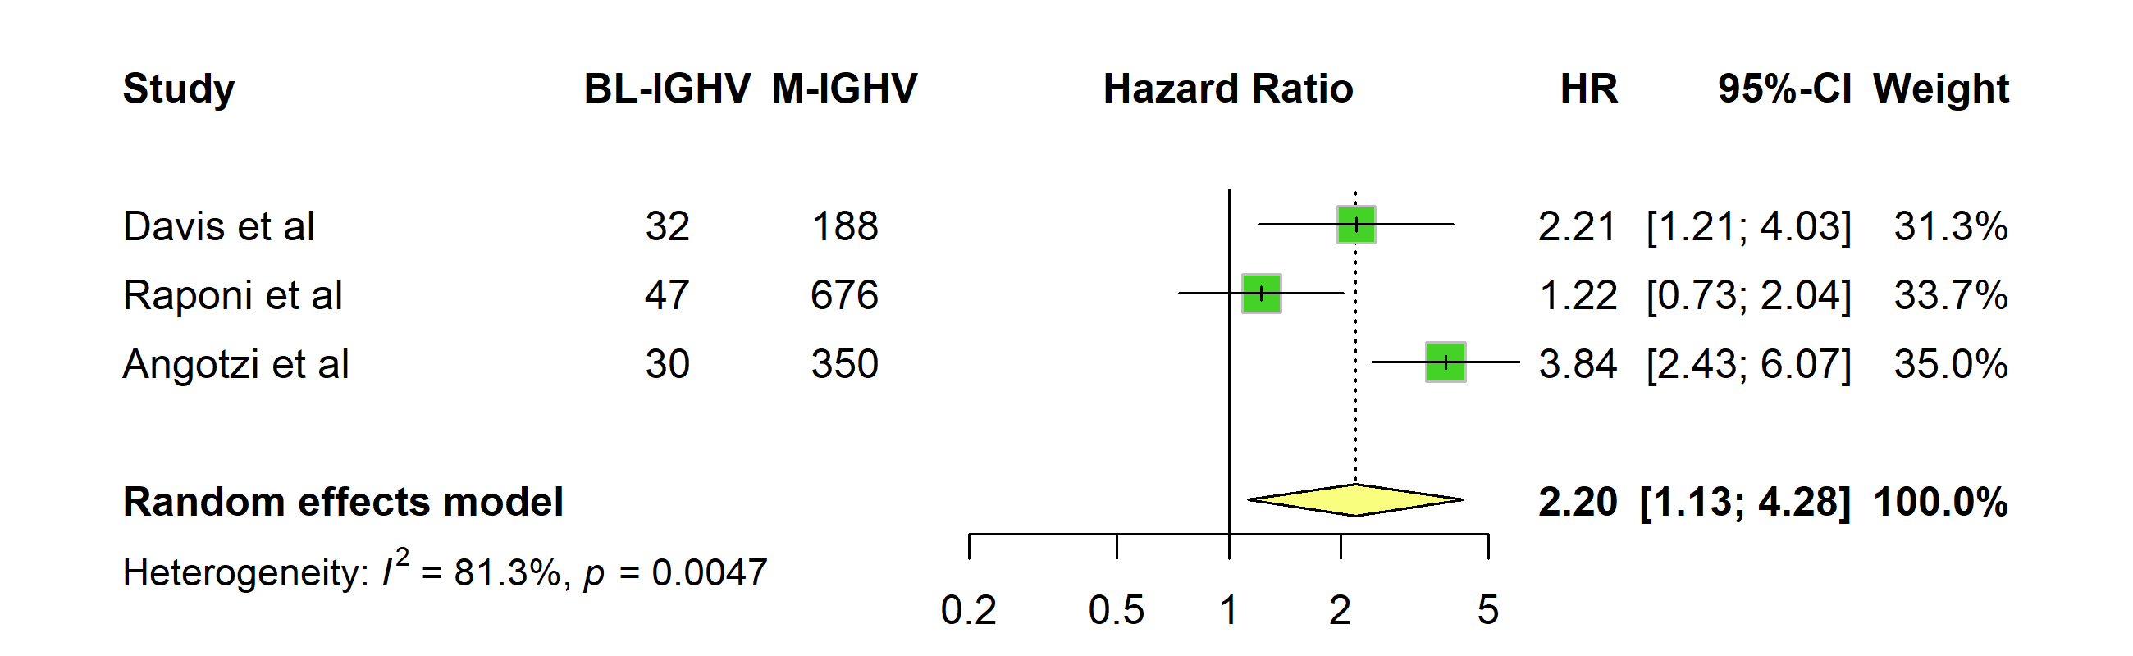

Figure S2: Forest plot of TTFT for BL-IGHV vs. M-IGHV for the sensitivity analysis including the two additional studies by Shi et. al and Morabito et al. (2 cohorts).
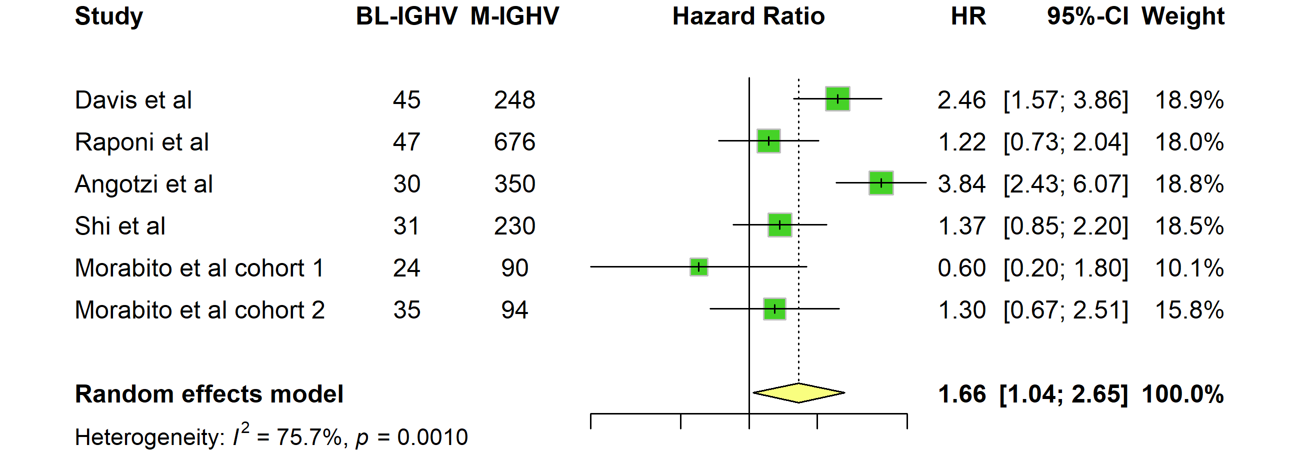

Figure S3: Cumulative Kaplan-Meier curve including patients from the 3 studies included in the primary analysis. Estimated numbers at risk at each timepoint for each group are shown in the bottom table.
Figure S4: Forest plots for subset #2 prevalence among BL-IGHV patients vs. M-IGHV (A) and U-IGHV (B).
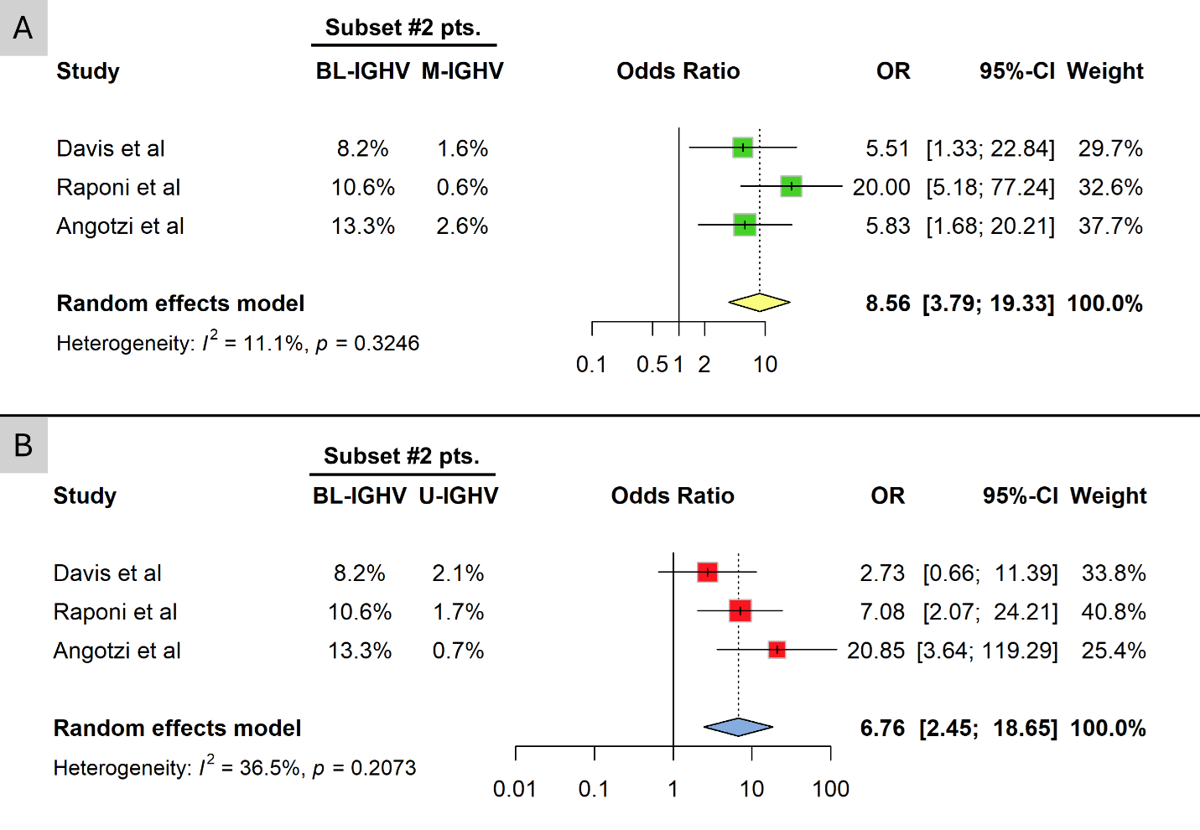

Figure S5: Forest plots for TTFT in BL-IGHV vs. M-IGHV patients with the exclusion of subset #2 patients from all studies.
