Supplementary materials and methods
Isolation of BM CD45⁺ immune cells from healthy control and AIHA patients. BM mononuclear cells (BMMCs) were collected from healthy donors and AIHA patients. Cells were resuspended in 50 µL of phosphate-buffered saline (PBS) containing 2% fetal bovine serum (FBS) and 2 mM EDTA, then incubated with human CD45 microbeads (Miltenyi Biotec, Cat#:130-045-801) on ice in the dark for 30 min. After washing, CD45⁺ immune cells were positively selected using LS columns following the manufacturer’s instructions.
Preparation of single-cell suspension from human,mouse and rat. For the isolation of BM, cells were flushed from the tibia and femur of mice using PBS supplemented with 2% FBS and 2 mM EDTA and subsequently passed through a 70 µm cell strainer into a 50 mL centrifuge tube containing cold PBS with 2% FBS and 2 mM EDTA. For spleen isolation, the freshly dissected organ was placed on a 70 µm cell strainer and gently crushed through the strainer into a 50 mL centrifuge tube containing the same cold buffer. The cell suspensions were then centrifuged at 300 × g for 5 minutes at 4°C. Following centrifugation, the cell pellet was resuspended in PBS with 2% FBS and 2 mM EDTA buffer for further processing.
Flow cytometry assay. The flow cytometry strategy was assessed as we previously described.^{[1,2]} Briefly, for mouse BFU-E and CFU-E staining, Cells were blocked with anti‑mouse CD16/CD32 (1:100) in PBS/0.5% BSA for 15 min. Surface staining was performed on ice in the dark for 30 min with the following antibodies (per 10⁶ cells): BV421‑Lineage (1 µL), BV421‑CD41 (1 µL), PE‑Cy7‑CD34 (1 µL), PE‑Cy7‑CD16/32 (1 µL), APC‑Cy7‑Scal‑1 (1 µL), APC‑c‑Kit (CD117, 1 µL), and PerCP‑Cy5.5‑CD71 (1 µL). For mouse erythroblast staining, Cells (per 10⁶ cells) were blocked with anti‑mouse CD16/CD32 (1:100) in PBS/0.5% BSA at 4 °C for 15 min, then stained on ice for 30 min with APC-Cy7 CD11b (0.5µL), APC-Cy7 Gr1 (0.5µL), APC-Cy7 CD45 (0.5µL), PE Ter119 (0.05µL), and APC CD44 (2µL) on ice for 30 minutes. For mouse macrophage staining, BM cells (5×10⁶ cells) were blocked with anti‑mouse CD16/CD32 (1:100) in PBS/0.5% BSA/2 mM EDTA, then stained on ice in the dark for 30 min with BV421 Ly6G (0.4µL), AF647 F4/80 (0.8µL cells), Percp-Cy5.5 Ly6C (1µL), and APC-Cy7 CD11b (1µL) on ice in the dark for 30 minutes. Cells were washed once with PBS/0.5% BSA/2 mM EDTA and resuspended in 500 µL of the same buffer for analysis. Additional antibodies included PE‑Cy7‑Vcam1, BV605‑CD169, PE‑Cy7‑CD163, PE‑Cy7‑Mertk, PE‑Cy7‑Axl, and BV605‑Timd4 (all 1 µL/5×10⁶ cells). 7‑AAD or DAPI was used for viability discrimination. For Hmox1 staining, cells were fixed with 4% PFA for 15 min at RT, permeabilized with 0.2% Tween 20 for 10 min, and incubated with anti‑HMOX1 antibody (1 µL/5×10⁶ cells) followed by anti‑rabbit IgG Alexa Fluor 488 for 20 min.
Rat flowcytometry: were harvested from the hind legs of SD rats. Single-cell suspensions were prepared by pipetting and passing through a 70 µm cell strainer (Fisher Scientific, 352340, NH, USA). The following antibodies were used for cell surface and intracellular staining, as previously described.^{[3]} Briefly, for SD rat erythroblast staining, APC-CyTM7 mouse anti-Rat CD45, APC-conjugated anti-CD71, PE-conjugated anti-CD44H, and FITC-conjugated anti-HIS49 were used. Thereafter, Epor-eGFP-cre rat was used for SD rat macrophage staining, with the antibodies including RB705 mouse anti-rat CD163, BV421 mouse anti-rat CD11b/c , PE mouse anti-rat CD106 and AF647-conjugated anti-CD169. Cells were stained at room temperature in the dark for 20 minutes. Samples were run on a BD FACS Aria™ III, and Flow Jo was used to analyze the data.
Human flowcytometry: Human BM single cells were suspended in cold PBS/2% FBS/2mM EDTA at a concentration of 5×10⁶ cells per 100 μL and incubated with anti-human PE Cy7 CD45, anti-human Percp-Cy5.5 CD3, anti-human APC Cy7 CD4, anti-human PE CD19, anti-human PE CD56, anti-human FITC CD14, and anti-human APC CD163 antibodies on ice in the dark for 30 minutes. Samples were run on a BD FACS Aria™ III, and Flow Jo was used to analyze the data.
FACS Sorting of BM CD163⁺ and CD163⁻ macrophages. To isolate mouse BM CD163⁺ and CD163⁻ macrophages, BM single cells were suspended in cold PBS/2% FBS/2mM EDTA at a concentration of 5×10^{^6} cells per 100 μL and incubated with CD16/CD32, Ly6G, F4/80, and CD163 antibodies on ice in the dark for 30 minutes. CD163⁺ cells were labeled Ly6G⁻F4/80⁺CD163⁺, while CD163⁻ cells were labeled Ly6G⁻F4/80⁺CD163⁻.
Human BM single cells were suspended in cold PBS/2% FBS/2mM EDTA at a concentration of 5×10⁶ cells per 100 μL and incubated with CD45, CD3, CD4, CD19, CD56, CD14, and CD163 antibodies on ice in the dark for 30 minutes. CD163⁺ cells were labeled CD45⁺CD3⁻CD4⁻CD19⁻CD56⁻CD14⁺CD163⁺, and CD163⁻ cells were labeled CD45⁺CD3⁻CD4⁻CD19⁻CD56⁻CD14⁺CD163⁻.
Epor-eGFP-Cre rat BM single cells were suspended in cold PBS/2% FBS/2mM EDTA at a concentration of 5×10⁶ cells per 100 μL and incubated with CD45, CD163, and CD11b/c antibodies on ice in the dark for 30 minutes. CD163⁺ cells were labeled CD45⁺CD11b/c⁺Epor⁺CD163⁺, and CD163⁻ cells were labeled CD45⁺CD11b/c⁺Epor⁺CD163⁻. After staining and washing, the cells were suspended in PBS/2% FBS/2mM EDTA containing 7-AAD (1 µL/ml) on ice in the dark for 10 minutes. Finally, the cells were sorted with the use of a BD FACS Aria™ III cell sorter.
Elisa assay. Peripheral blood serum was collected via orbital puncture, allowed to clot at 4 °C for 30 min, and centrifuged at 1,000 × g for 15 min to obtain serum. Serum levels of erythropoietin (EPO), hepcidin, transferrin, and ferritin were quantified using species‑specific ELISA kits (mouse or rat) according to the manufacturer’s instructions. Briefly, 25 μL of standard or sample was added to 100 μL assay buffer per well, and plates were incubated at 37 °C for 60 min. Following three washes, 100 μL HRP‑conjugated detection antibody was added, and plates were incubated at 37 °C for 60 min. After subsequent washes, 90 μL substrate was added and incubated at 37 °C in the dark for 15 min. The reaction was terminated with 50 μL stop solution, and absorbance was measured using a Thermo Scientific Varioskan ALF microplate reader.
In vitro human EBI formation through co-culture late stages of erythroblasts with CB-CD34⁺HSC derived macrophages. Erythroblasts were derived from cord blood CD34⁺ HSCs, as previously described. ^{[4,5]} Macrophages were also derived from cord blood CD34⁺ cells, as outlined in our earlier research.^{[6]} In brief, CD34+ hematopoietic stem cells were cultured from day 0 to day 7 in IMDM supplemented with 2% human peripheral blood plasma, 3% human AB serum, 3 IU/mL heparin, 10 µg/mL insulin, 10 ng/mL SCF, 1 ng/mL IL‑3, 100 ng/mL M‑CSF, 50 ng/mL FLT3, and 1× penicillin‑streptomycin. The medium was refreshed every four days, and cell density was maintained at 1×10⁵ cells/mL. On day 7, non‑adherent cells were removed, and adherent macrophages were retained. Macrophages were pretreated with 1µM dexamethasone for 24h. Dexamethasone‑pretreated or untreated macrophages were then co‑cultured with day 11 erythroblasts at a 1:20 ratio for 12 h in IMDM containing 2% human peripheral blood plasma, 3% human AB serum, 1 IU/mL EPO, 3 IU/mL heparin, 10 µg/mL insulin, 200 µg/mL holo‑human transferrin, 5 mM Mg²⁺, and 5 mM Ca²⁺.
Culture of Bone marrow-derived macrophages (BMDMs). The BM single-cell suspension was centrifuged at 300 g for 5 minutes. Cell pellets were subjected to RBC lysis at room temperature in the dark for 15 minutes. After centrifuging, the cells were resuspended with DMEM/10% FBS/M-CSF (1 μL/mL) to achieve a cell density of 1×10⁶ cells/ml. After 5 days, the cells were centrifuged at 300 g for 5 minutes. Half of the cells were resuspended in DMEM/10% FBS for the control group, while the remaining cells were resuspended in DMEM/10% FBS/DEX for the DEX group.
Serum iron. Serum iron levels were determined using a 96‑well plate assay. Each well was prepared as follows: 100 µL of iron buffer was added, followed by 20 µL of deionized water (blank), standard solution (standard), or sample. The initial absorbance (A₁) at 560 nm was recorded with the blank set to zero. After adding 2 µL of iron color reagent, the plate was incubated at 37 °C for 10 min, and the absorbance (A₂) was measured. Serum iron concentration (µg/dL) was calculated as: (A₂sample – A₁sample)/(A₂standard – A₁standard) × standard concentration.
Unsaturated iron-binding capacity (UIBC) and total iron binding capacity (TIBC) detection. For unsaturated iron‑binding capacity (UIBC) measurement, 80 µL of UIBC buffer was added to each well. The blank well received 40 µL of deionized water; the standard well received 20 µL of deionized water and 20 µL of standard; the sample well received 20 µL of standard and 20 µL of sample. Absorbance readings (A₁ and A₂) were taken as described above. UIBC (µg/dL) was calculated as: UIBC = C_std –[(A₂sample–A₁sample)/(A₂standard – A₁standard) × C_std]. Total iron‑binding capacity (TIBC) was obtained by adding the serum iron value to the UIBC value.
BM tissues iron quantification. BM and spleen tissues were digested in 1 mL of tissue digestion solution at 65 °C for 50 h to ensure complete dispersion. Digested samples (10 µL) were mixed with 200 µL of iron staining working solution in a 96‑well plate. Each plate included blanks (10 µL ddH₂O), tissue digestion solution blanks (10 µL), iron standards (10 µL of 500 µg/dL solution), and sample digests (10 µL, n = 3 replicates). After thorough mixing and incubation at room temperature for 10 min, absorbance was measured at 535 nm using a microplate reader. Tissue iron content (µg/g wet weight) was calculated as follows: (sample OD – blank OD) / (standard OD – blank OD) × 7.5 / tissue weight.

EBI enrichment and cytospins,Giemsa staining and quantification. EBIs in mouse BM were enriched and quantified, as per our previous study.^{[2,6]} Briefly, a three‑layer density gradient was prepared by sequentially layering 5 mL of 3%, 5 mL of 1.5%, and 5 mL of 0% density gradient solution in a 50 mL centrifuge tube. BM cells flushed from two femurs and two tibias were resuspended in 5 mL of 0% solution, gently overlaid onto the gradient, and kept at room temperature for 30 min. The interface containing the 0% and 1.5% layers was collected, EBIs were collected by centrifuged 3% layer at 300g, at 4℃ for 10 minutes. Cytospins were performed using 3% of mouse BM layers on slides, which were placed in a low-speed centrifugal cytospin (Baioukeji, TDL-40B); Giemsa staining and Prussian blue staining were then performed.
EBI macrophage Giemsa staining and quantification. The slides were stained with 500 µL of Wright–Giemsa solution A (Baso Diagnostics Inc., Zhuhai) for 1 minute. Thereafter, 1 mL of Wright–Giemsa solution B was added to solution A two to three times, and the mixture was thoroughly mixed with a rubber pipette. The staining process lasted for 5–10 minutes. Afterwards, the slides were gently rinsed with water, dried, and the results were observed under a microscope (Olympus BX53). The number of EBIs in each group was quantified at least 300 cells.
BM tissues and EBI macrophage Prussian blue staining. Tissue sections were deparaffinized and rehydrated by sequential immersion in: dewaxing solution I (5 min), dewaxing solution II (5 min), absolute ethanol I (2 min), absolute ethanol II (2 min), 95% ethanol I (2 min), 95% ethanol II (2 min), and 75% ethanol (2 min), followed by a distilled water rinse. Sections were then incubated in a 1:1 mixture of potassium ferricyanide and hydrochloric acid solutions at room temperature for 20–30 min. After washing, nuclei were counterstained with nuclear fast red for 2 min. Finally, slides were dehydrated, cleared, mounted, and imaged under an Olympus BX53 microscope.
EBI macrophage iron quantification. After the EBIs were iron stained, 300 were randomly selected under the microscope and divided into intracellular iron containing EBIs and membrane iron EBIs for absolute quantification according to the manifestation of iron on EBI macrophages. Ultimately, the respective percentages of intracellular iron EBIs and membrane iron EBIs in the 300 EBIs were calculated according to the results of the absolute quantification and analyzed statistically.
Immunofluorescence staining of paraffin embedded bone marrow cells. Formalin-fixed, paraffin-embedded (FFPE) bone marrow tissues from patients were sectioned at 4–5 µm. Sections were floated on a 40 °C water bath, mounted on slides, and dried for 12h. The sections were dehydrated through a graded series of ethanol (70%, 90%, 100%) and finally cleared in xylene. Antigen retrieval was carried out in 10 mM citrate buffer (pH 6.0) at 95–100 °C for 10 min, and slides were blocked with 3% BSA in PBS (25 °C, 30 min). Primary antibody incubation was performed at 4 °C overnight, followed by secondary antibody incubation at 25 °C for 30 min. Nuclei were stained with Hoechst 33342. Primary antibodies used are listed below:CD68 Monoclonal Antibody(FA-11), CD163 Polyclonal antibody. Secondary antibodies were Donkey anti-Rabbit or Donkey anti-Rat labeled with Alexa Fluor™ 647 or Plus 555. Pannoramic MIDI (3DHISTECH) slice scanner was used to acquire images.
RNA seq. The RNA-seq were prepared by Huada Gene Technology Service Co., Ltd. Briefly, RNA was extracted from DEX-treated human CB-derived “EBI-like” macrophages and control human CB-derived macrophages and BMDM from DEX-treated and control. Libraries were prepared using Illumina TruSeq kit and sequenced on an Illumina HiSeq 4000, with ~160 million 150bp pair-end reads produced for each sample. Raw data were filtered by Trim Galore for quality control and mapped to human (UCSC GRCh38 h) genome by subread. Gene expression and differentially expressed genes were estimated by Deseq2 package. Data representation and statistics were conducted by R, and principal component analysis was performed on expressed genes in DEX-treated macrophages and control macrophages. Gene set enrichment analysis (GSEA) was performed using the Molecular Signatures Database (MSigDB) version 6.0.
scRNA-seq：scRNA-seq data of HCs were downloaded from the GEO database GSE120221. ScRNA-seq data (mouse, rat, AIHA patients) have been deposited in the NODE database (https://www.biosino.org/node/index).
Library preparation and sequencing of scRNA-seq. Mouse F4/80⁺ macrophages, as well as rat and human CD45⁺ single‑cell suspensions, were sorted for sequencing. Cells were washed twice in PBS containing 0.1% BSA, counted (Halo Counter HD‑4FL), and approximately 10,000 cells per lane were loaded onto a Chromium™ Single Cell A Chip using the Chromium™ Single Cell 3′ Library & Gel Bead Kit v2 (10X Genomics). Gel bead‑emulsion generation, cell lysis, barcoded reverse transcription, cDNA amplification, fragmentation, and adapter ligation were performed on the Chromium™ instrument according to the manufacturer’s instructions. Libraries were sequenced on an Illumina platform (PE150) by Annoroad Gene Technology (Beijing, China).
Data processing. Raw sequencing data were processed with Cell Ranger (v8.0.1) using default parameters. Reads were aligned to reference genomes GRCm39 (mouse), mRatBN7.2 (rat), or GRCh38 (human). A gene‑expression matrix was generated from confidently mapped reads containing valid barcodes and UMIs.
Quality Control and Normalization
Gene‑count matrices were imported into R (v4.4.3) and analyzed with Seurat (v5.1.3). Genes detected in fewer than three cells and cells expressing fewer than 500 genes were excluded. Cells with >10% mitochondrial gene content were also removed. Expression values were normalized using the NormalizeDatafunction and scaled with ScaleData. The top 2,000 highly variable genes were identified (FindVariableFeatures, selection.method = “vst”). Principal component analysis (PCA) was performed using RunPCA.
Batch correction. The PCA embedding were adjusted for batch effects by applying alternative algorithms to the same Seurat object through Harmony(v 1.2.3 ) with the first 20 PCA dimensions and the default theta parameter.
EBI Macrophage Signature Score Analysis
The EBI macrophage signature score was calculated based on the expression levels of 13 genes that are established markers of erythroblastic island macrophages and are critically involved in their core functions, including adhesion, iron recycling, phagocytosis. The gene set includes:SPIC, MARCO, CD163, HMOX1, TRF, SLC40A1, FTH1, MERTK, TIMD4, NR1H3, NCOA4, LRP1, and SLC48A1.
Assay for Transposase-Accessible Chromatin with high throughput sequencing analysis. Publicly available ATAC-seq data (GSE248042) were obtained from the Gene Expression Omnibus (GEO). Peaks were called using MACS2 (v2.1.1) with a q-value cutoff of <0.05. Peak annotation was performed with ChIPseeker (v1.20.0). For promoter-associated accessibility, regions within 3 kb of transcription start sites (TSS) were considered promoter peaks. Differential accessibility analysis was performed with DiffBind (v3.8.4) using DESeq2. BigWig-format signal tracks were generated with deepTools (v2.5.7) and normalized to 1 million reads for visualization. Read coverage and sequencing depth were quantified using SAMtools (v1.6)^{[7-10]}.
CUT&Tag. The CUT&Tag data (GSE250376) were downloaded from the GEO database. MACS2 version 2.1.1 (https://pypi.org/project/MACS2/) was used to identify peaks q value of <0.05.^{[9]} The annotation of peaks was performed using ChIPseeker (v1.20.0) ^{[10]}.
ChIP-seq. Publicly available ChIP-seq data (GSE247447) were downloaded from the GEO database. Reads were aligned to the reference genome using Bowtie2 (v2.3.5.1). Uniquely mapped, non-duplicate reads were retained for downstream analysis. Peaks were called using MACS2 (v2.1.1) in broad-peak mode with a q-value cutoff <0.01. Peak annotation was performed with ChIPseeker (v1.20.0).

Graph-based clustering and differential gene expression analyses. Cell clusters were identified with the Louvain algorithm using the FindClustersfunction. Two‑dimensional embeddings were generated by t‑SNE and UMAP. Cluster‑specific genes were detected via FindAllMarkers(only.pos=FALSE, min.pct=0.1), and differentially expressed genes (DEGs) were identified with FindMarkers(only.pos= FALSE, min.pct=0.1, logfc.threshold>0.1). For erythroblastic island (EBI) signature scoring, the AddModuleScore_UCellfunction from the UCell package was applied. Iron‑metabolism and phagocytosis‑related pathways were obtained from the Gene Ontology and KEGG databases.

Reference:
[1] ZHANG H, WANG S, LIU D, et al. EpoR-tdTomato-Cre mice enable identification of EpoR expression in subsets of tissue macrophages and hematopoietic cells[J]. Blood, 2021, 138(20): 1986-1997.
[2] CAO W, FAN W, WANG F, et al. GM-CSF impairs erythropoiesis by disrupting erythroblastic island formation via macrophages[J]. Journal of Translational Medicine, 2022, 20(1): 11.
[3] ZHANG J, LIU Y, HAN X, et al. Rats provide a superior model of human stress erythropoiesis[J]. Experimental Hematology, 2019, 78: 21-34.e3.
[4] LI M, LIU D, XUE F, et al. Stage-specific dual function: EZH2 regulates human erythropoiesis by eliciting histone and non-histone methylation[J]. Haematologica, 2023, 108(9): 2487-2502.
[5] WANG Y, LI W, SCHULZ V P, et al. Impairment of human terminal erythroid differentiation by histone deacetylase 5 deficiency[J/OL]. Blood, 2021, 138(17): 1615-1627.
[6] LI W, WANG Y, ZHAO H, et al. Identification and transcriptome analysis of erythroblastic island macrophages[J]. Blood, 2019, 134(5): 480-491.
[7] ROSS-INNES C S, STARK R, TESCHENDORFF A E, et al. Differential oestrogen receptor binding is associated with clinical outcome in breast cancer[J]. Nature, 2012, 481(7381): 389-393.
[8] RAMÍREZ F, DÜNDAR F, DIEHL S, et al. deepTools: a flexible platform for exploring deep-sequencing data[J]. Nucleic Acids Research, 2014, 42(Web Server issue): W187-191.
[9] ZHANG Y, LIU T, MEYER C A, et al. Model-based analysis of ChIP-Seq (MACS)[J]. Genome Biology, 2008, 9(9): R137.
[10] YU G, WANG L G, HE Q Y. ChIPseeker: an R/Bioconductor package for ChIP peak annotation, comparison and visualization[J]. Bioinformatics (Oxford, England), 2015, 31(14): 2382-2383.

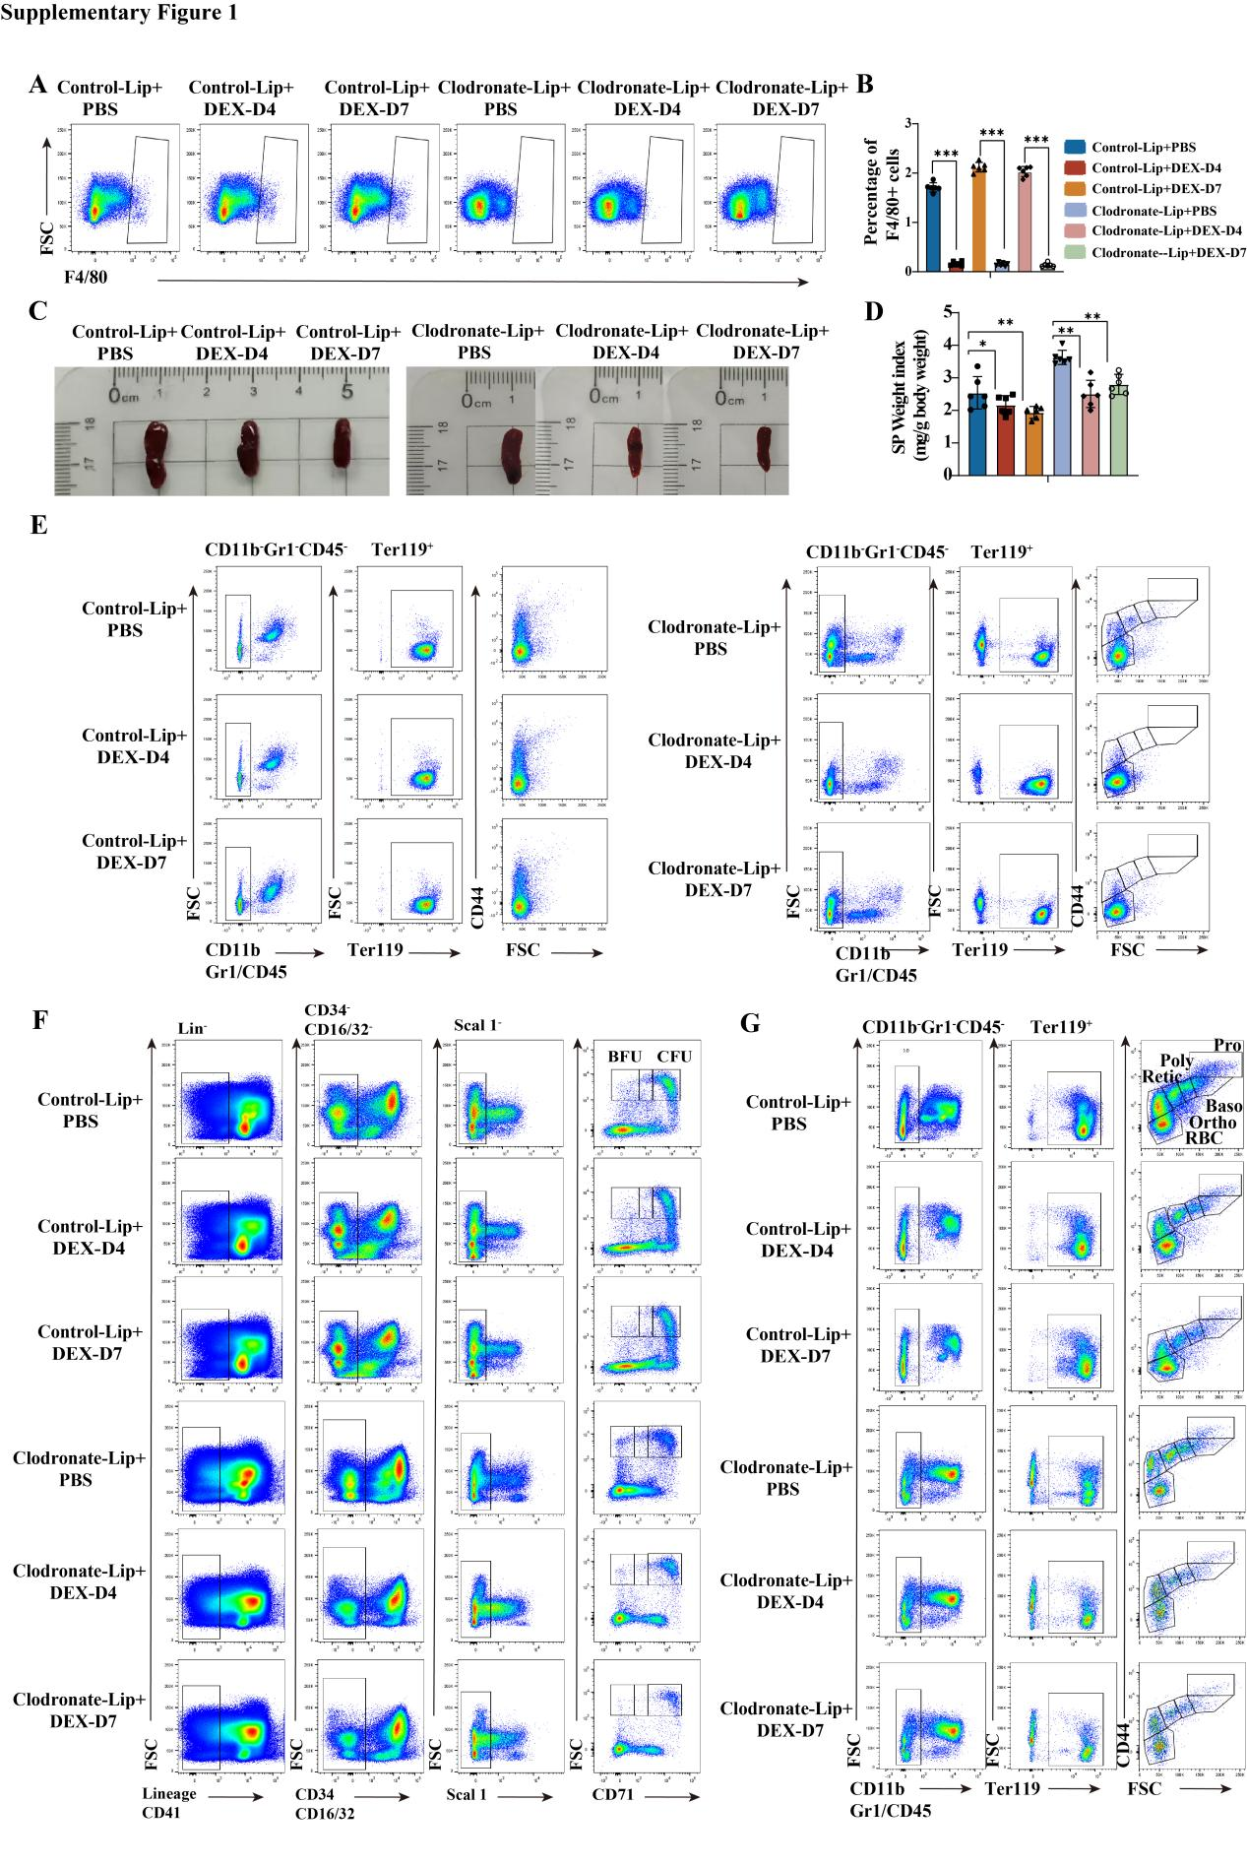

Supplementary Figure 1 Flow cytometry gating strategies for F4/80⁺ macrophages, erythroid progenitors, and erythroblasts.
- Flow cytometry analysis of F4/80⁺macrophages in PBS or DEX treated control-Lip and clodronate-Lip pretreated mice on days 4 and 7. (B) Percentage of F4/80⁺ macrophages in PBS or DEX treated control-Lip and clodronate-Lip pretreated mice on days 4 and 7. (C) Representative images of the spleen in control-Lip and clodronate-Lip pretreated mice treated with PBS and DEX on days 4 and 7. (D) Statistical analysis of SP-to-body weight ratio of control-Lip and clodronate-Lip pretreated mice treated with PBS and DEX on days 4 and 7. (E) Representative gating for SP erythroid stage enrichment for Pro-E, Baso-E, Poly-E, Ortho-E, Retic, and RBC, the plot of CD44 versus FSC from Ter119⁺ cells, showing different erythroid stages in PBS or DEX treated control-Lip and clodronate-Lip pretreated mice on days 4 and 7. (F) Representative gating strategy for BM BFU‑E/CFU‑E isolation cells: CD71 vs. c‑Kit plot derived from 7‑AAD⁻ Lineage⁻ CD16/32⁻ CD41⁻ CD34⁻ Sca‑1⁻ cells, showing three distinct populations in PBS or DEX treated control-Lip and clodronate-Lip pretreated mice on days 4 and 7. (G) Representative gating for BM erythroid stage enrichment for Pro-E, Baso-E, Poly-E, Ortho-E, Retic, and RBC, the plot of CD44 versus FSC from Ter119⁺ cells, showing different erythroid stages in PBS or DEX treated control-Lip and clodronate-Lip pretreated mice on days 4 and 7.* p < 0.05, ** p < 0.01, *** p < 0.001. NS, not significant.

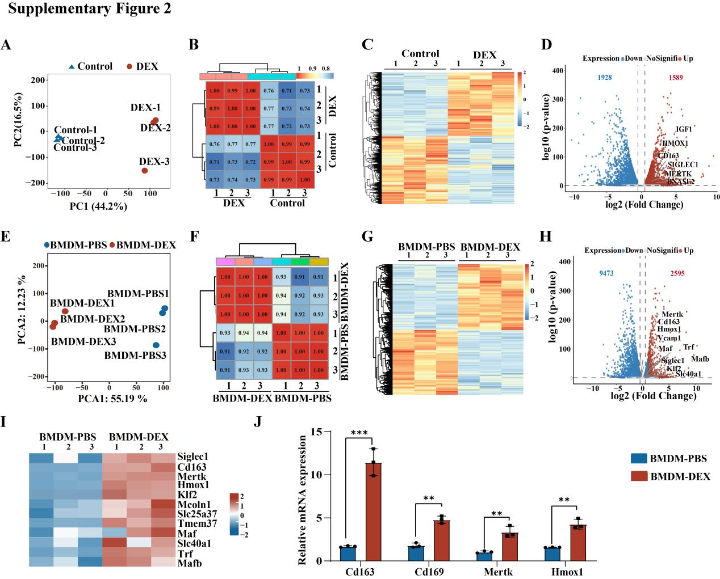
Supplementary Figure 2. RNA-seq analysis.
- Principal component analysis (PCA) of samples from three biological replicates of control and DEX-treated human CD34⁺ HSCs-derived macrophages. (B) Pearson correlation analysis of samples from three biological replicates of control or DEX-treated human CD34⁺ HSCs-derived macrophages. (C) Heatmaps illustrating the expression levels of DEGs between control or DEX-treated human CD34⁺ HSCs-derived macrophages. (D) Volcano plot displaying up-regulated and down-regulated genes between control and DEX-treated human CD34⁺ HSCs-derived macrophages. (E) Principal component analysis (PCA) of samples representing three biologic replicates from DEX or PBS pre-treated mouse BMDMs, cocultured with sorted BM erythroblasts. (F) Pearson correlation analysis of DEX or PBS pre-treated mouse BMDMs. (G) Heatmap illustrating the expression levels of DEGs in the DEX or PBS pre-treated mouse BMDMs. (H) Volcano plot displaying the upregulated and downregulated genes in DEX or PBS pre-treated mouse BMDMs. (I) Heatmap showing the expression of phagocytosis and iron metabolism-related genes. (J) Quantitative analysis of the mRNA expression level of CD163, CD169, Hmox1 and Mertk in DEX and PBS pre-treated mouse BMDM groups from 3 independent experiments. * p < 0.05, ** p < 0.01, *** p < 0.001. NS, not significant.

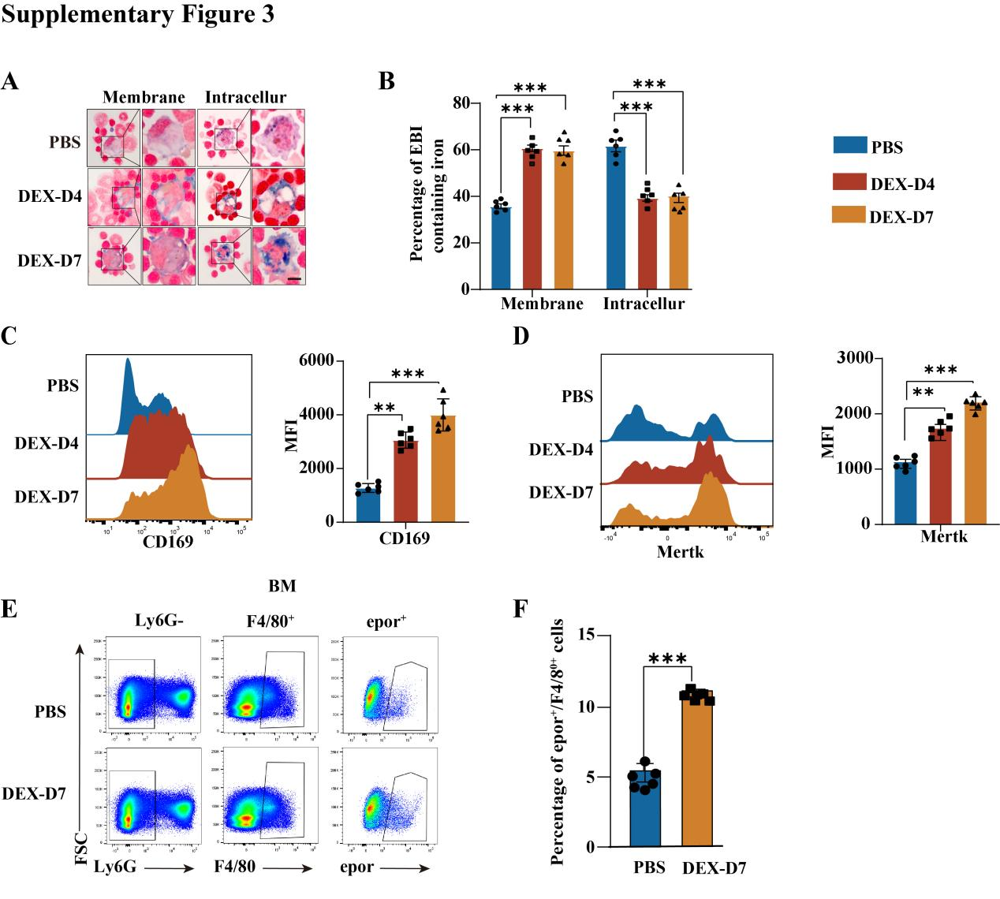
Supplementary Figure 3 Detection of EBI iron and key gene expression levels on BM F480⁺ macrophage of DEX and PBS pre-treated mice.
- Representative Perls’Prussian blue staining of iron in EBIs from DEX or PBS pretreated mice on days 4 and 7. Scale bar, 10 µm. (B) Quantification of EBI macrophages containing membrane‑associated iron and intracellular iron in DEX or PBS pre-treated mice on days 4 and 7 (n = 6). (C) Flow cytometry analysis (left) and MFI (right) of CD169 expression in DEX and PBS pre-treated mice on days 4 and 7 (n=6). (D) Flow cytometry analysis (left) and MFI (right) of Mertk expression in DEX and PBS pre-treated mice on days 4 and 7 (n=6). (E) Flow cytometric analysis showing the gating strategy for BM EBI macrophages, the plot of epor versus FSC from Ly6g⁻F4/80⁺ cells, in DEX- or PBS-pretreated mice on day 7 (n=6). (F) Quantification of BM EBI macrophage numbers in DEX- and PBS-pretreated mice on day 7 (n = 6).*p < 0.05, **p < 0.01, ***p < 0.001. NS, not significant.

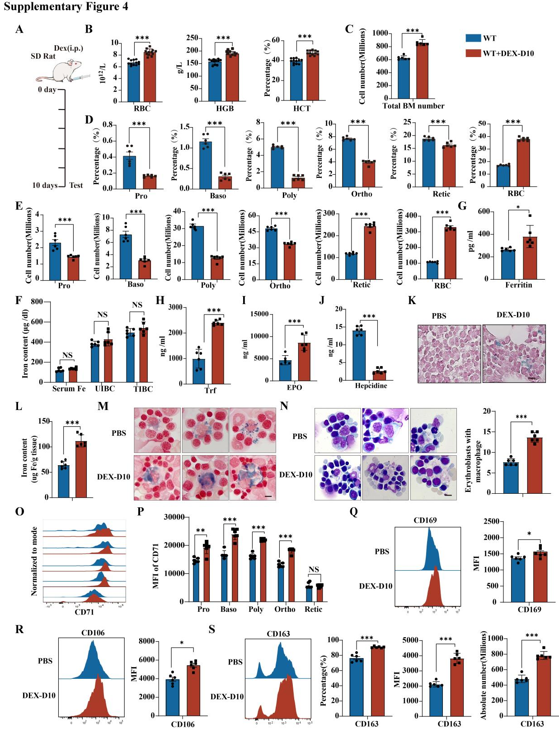
Supplementary Figure 4 Glucocorticoids promoted RBCs production via enhancing EBI formation and iron metabolism in rat BM
- Diagram of SD rat treated with PBS or DEX for 10 days. (B) RBC numbers, HGB and HCT levels in SD rats on 10 day after PBS or DEX treatment. (C) Quantitative analysis total BM cell number of SD rat on 10 day after treatment with DEX or PBS (n=12). (D) Percentages of Pro-E, Baso-E, Poly-E, Ortho-E, Reti and RBC in SD rat treated with PBS and DEX on day 10 (n=6). (E) Quantitative analysis of cell number of Pro-E, Baso-E, Poly-E, Ortho-E, Reti and RBC in SD rat treated with PBS and DEX on day 10 (n=6). (F) Quantitative analysis of serum Fe, UIBC, and TIBC levels between DEX and PBS pre-treated SD rat on day 10 (n=6). (G-J) Quantitative analysis of serum ferritin (G), serum TF (H), serum EPO (I) and serum hepcidine (J) levels between DEX and PBS pre-treated SD rat on day 10 (n=6). (K) Representative Perls’ Prussian blue staining images for iron staining of BM tissue between DEX and PBS pre-treated SD rat on day 10, scale bar,50µm. (L) Quantitative analysis iron staining of BM tissue between DEX and PBS pre-treated SD rat on day 10 (n=6). (M) Representative Perls’ Prussian blue staining images for iron in EBI formed DEX and PBS pre-treated SD rat on day 10, scale bar, 10µm. (N) Representative cytospin images of EBIs formed by DEX and PBS pre-treated SD rat on day 10, scale bar, 10µm (left). Quantitative analysis of erythroblasts with macrophages between DEX and PBS pre-treated SD rat on days 4 and 7 (right) (n=6). (O-P) Representative flow cytometry plots (O) and CD71 expression (P) in BM erythroid cells enriched for ProE, BasoE, PolyE, OrthoE and Retic of DEX and PBS pre-treated SD rat on day 10 (n=6). (Q) Flow cytometry analysis showing the protein expression level of CD169 (left) and quantitative analysis MFI (right) of CD169 between DEX and PBS pre-treated SD rat on day 10 (n=6). (R) Flow cytometry analysis showing the protein expression level of CD106 (left) and quantitative analysis MFI (right) of CD106 between DEX and PBS pre-treated SD rat on day 10 (n=6). (S) Flow cytometry analysis showing the protein expression level of CD163 of DEX and PBS pre-treated SD rat on day 10 (n=6). Statistical the percentage, MFI and absolute number of CD163 from DEX and PBS pre-treated SD rat on day 10 (n=6) . * p < 0.05, ** p < 0.01, *** p < 0.001.NS, not significant.

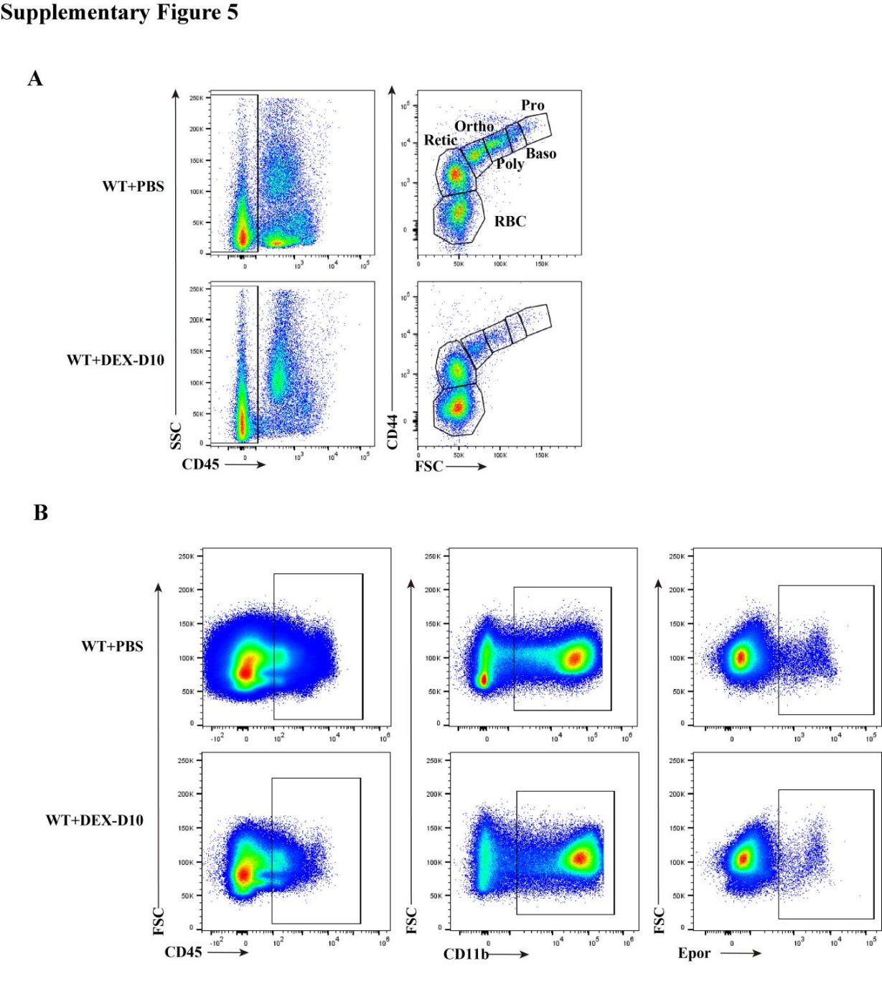
Supplementary Figure 5 Gating strategy for rat erythroid progenitors and macrophage cells.
- The representative gating strategy is shown for the isolation of BM erythroid cells enriched for Pro-E, Baso-E, Poly-E, Ortho-E, Retic, and RBC, the plot of CD44 versus FSC from CD45⁺ cells, showing different erythroid stages in WT and clodronate-pretreated mice treated with PBS and DEX on days 10. (B) The representative gating strategy is shown for the isolation of BM macrophage cells enriched for Epor⁺ cells, the plot of Epor versus FSC from CD45⁺CD11b⁺ cells, showing Epor⁺ cells in WT and clodronate-pretreated mice treated with PBS and DEX on days 10.

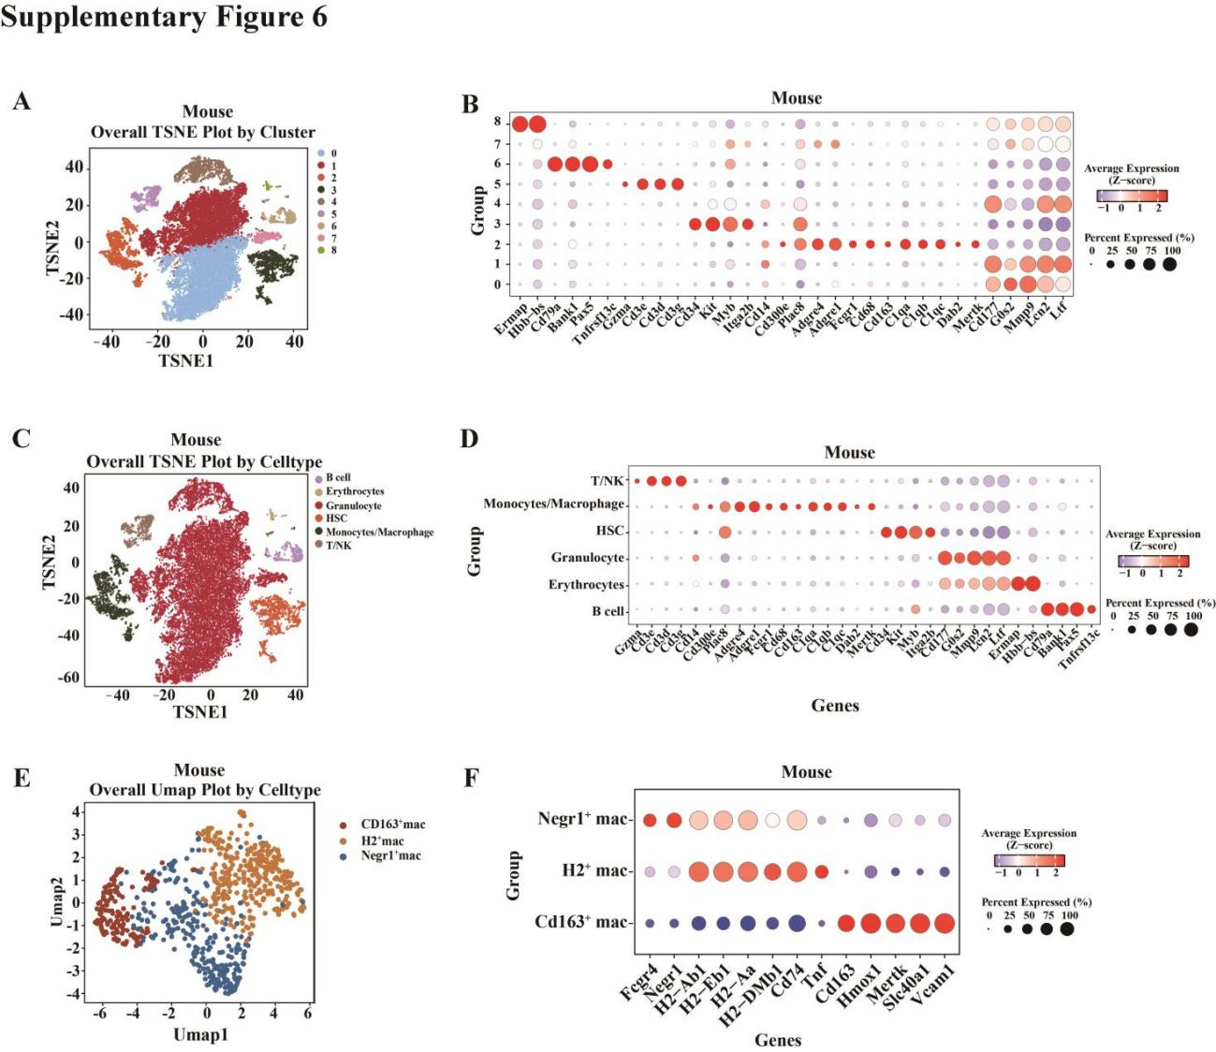
Supplementary Figure 6 scRNA-seq analysis of mouse BM CD45⁺ cells.
- TSNE visualization showing the cluster for CD45⁺ cells from mice BM. (B) Dot plot showing the expression of marker genes of each cluster. (C) TSNE visualization showing the cell types for CD45⁺ cells from mice BM. (D) Dot plot showing the expression of marker genes of each cell types. (E) TSNE visualization showing the macrophages subsets. Colors indicate different cell types. (F) Dot plot showing the expression of marker genes of each macrophage cell types.
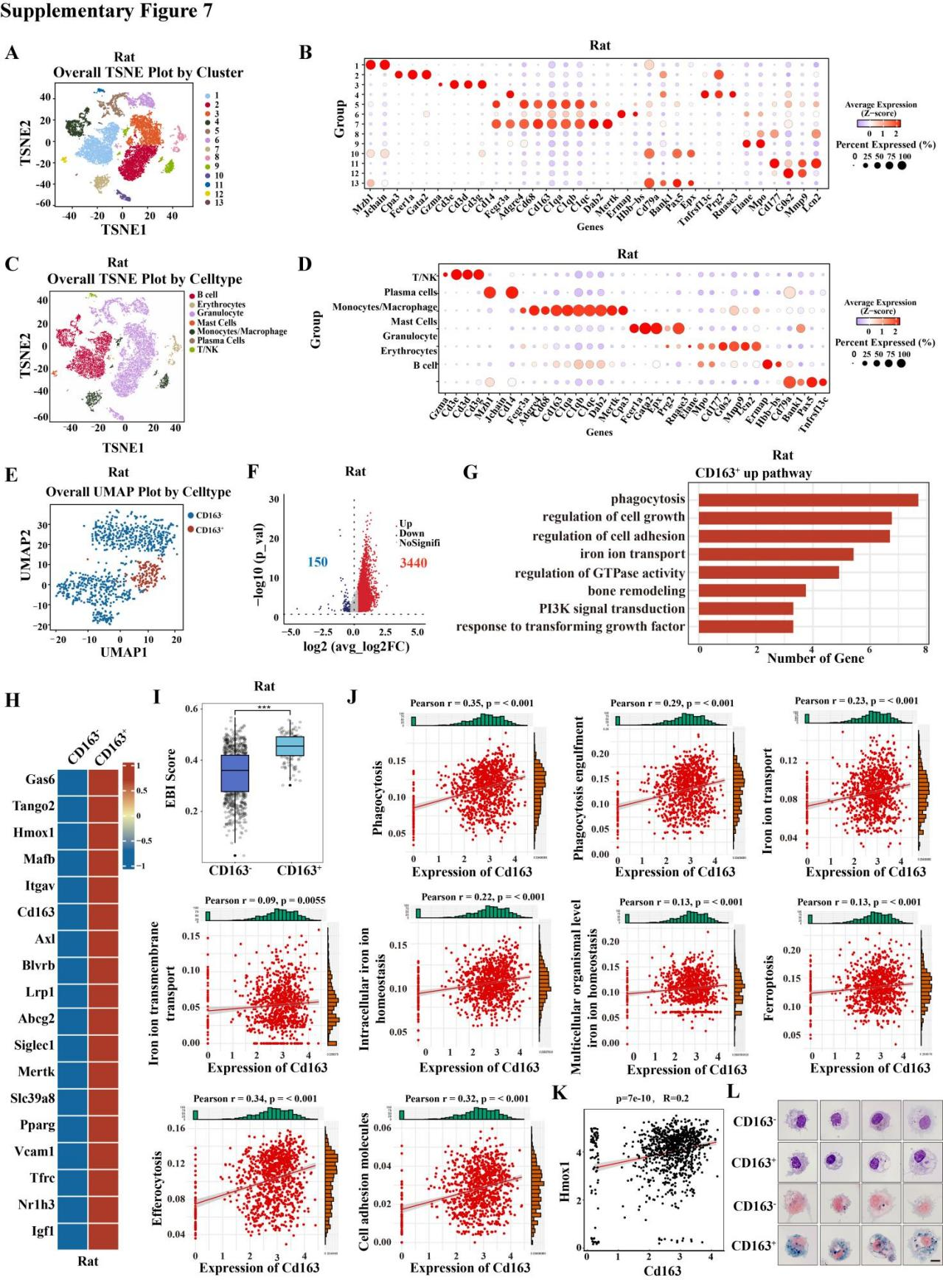
Supplementary Figure 7 CD163 expression on rat BM EBI macrophages were positively correlated with iron metabolism under homeostasis.
(A) TSNE visualization showing the cluster for BM CD45⁺ cells from the SD rat. Colors indicate different clusters. (B) Dotplot showing the expression of marker genes of each cluster. (C) TSNE visualization showing the cell types for BM CD45⁺ cells from the SD rat. Colors indicate different clusters. (D) Dotplot showing the expression of marker genes of each cell types. (E) UMAP visualization showing the macrophages subsets. Colors indicate different cell types. (F) Volcano plot displaying the DEGs between CD163⁺ and CD163⁻ macrophages. (G) Enrichment of biological process from upregulated genes in CD163⁺ macrophages. (H) Heatmaps exhibiting values of phagocytosis and iron metabolism-related genes expression between CD163⁺ and CD163⁻ macrophages. (I) Box plot showing the score of EBI genes for each macrophage subset. (J) Scatter plot showing the correlation between the expression of CD163 and the score of iron metabolism-related pathways score respectively. (K) Scatter plot showing the correlation between the expression of CD163 and Hmox1. (L) Cytospin images showing Giemsa staining and Prussian blue staining of CD163⁻ and CD163⁺ macrophages. * p < 0.05, ** p < 0.01, *** p < 0.001. NS, not significant.

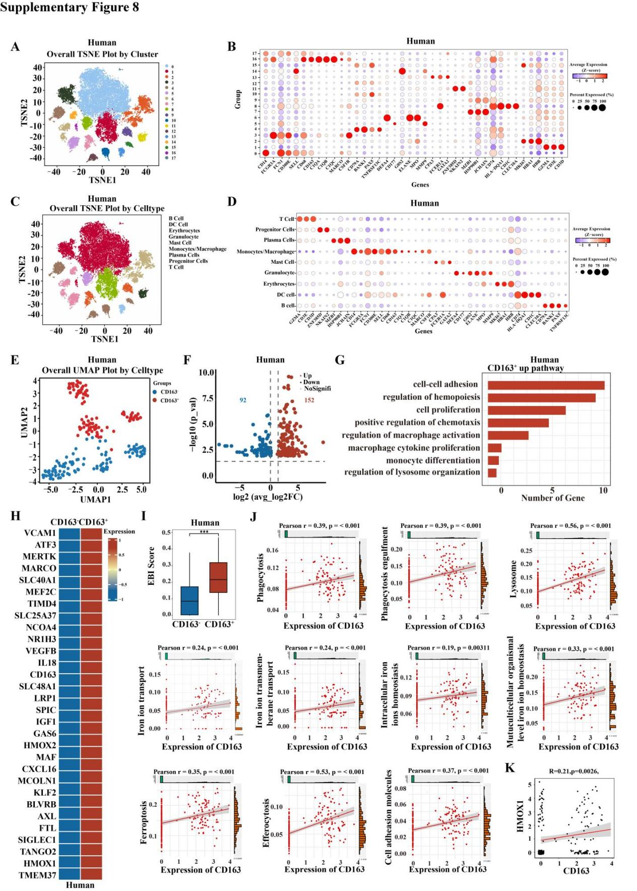
Supplementary Figure 8 CD163 expression on human BM EBI macrophages were positively correlated with iron metabolism under homeostasis
- TSNE visualization showing the cluster for BM CD45⁺ cells from the human. Colors indicate different clusters. (B) Dotplot showing the expression of marker genes of each cluster. (C) TSNE visualization showing the cell types for BM CD45⁺ cells from the human. Colors indicate different clusters. (D) Dotplot showing the expression of marker genes of each cell types. (E) UMAP visualization showing the macrophages subsets, including CD163⁺ and CD163⁻ macrophages. Colors indicate different cell types. (F) Volcano plot displaying the DEGs between CD163⁺ and CD163⁻ macrophages. (G) Enrichment of biological process between CD163⁺ and CD163⁻ macrophages based on the DEGs. (H) Heatmaps exhibiting values of phagocytosis and iron metabolism-related genes expression between CD163⁺ and CD163⁻ macrophages. (I) Box plot showing the score of EBI genes for each macrophage subset. (J) Scatter plot showing the correlation between the expression of CD163 and the score of iron metabolism-related pathways score respectively. (K) Scatter plot showing the correlation between the expression of CD163 and HMOX1. * p < 0.05, ** p < 0.01, *** p < 0.001. NS, not significant.

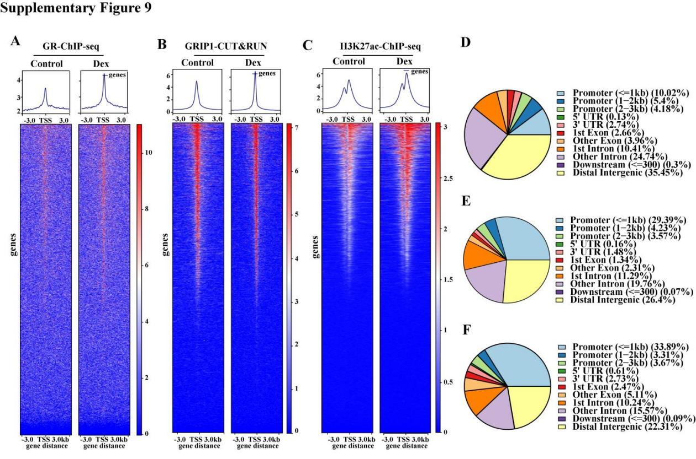
Supplementary Figure 9 Multomics analysis of control and DEX-treated macrophages.
- C) Heatmaps and peak chart images displayed normalized ATAC-seq GR-ChIP-seq (A), GRIP1-CUT&RUN (B), and H3K27ac-ChIP-seq (C) signals of DEX and PBS pre-treated BMDM groups at gene body regions. The window represents ±3 kb regions around the gene body. (D-F) Bar plot illustrating the distribution of ChIPseeker-derived annotations of the genomic loci covered by peaks of GR-ChIP-seq (D), GRIP1-CUT&RUN (E) and H3K27ac-ChIP-seq (F). TES, transcriptional end site; TSS, transcriptional start site.

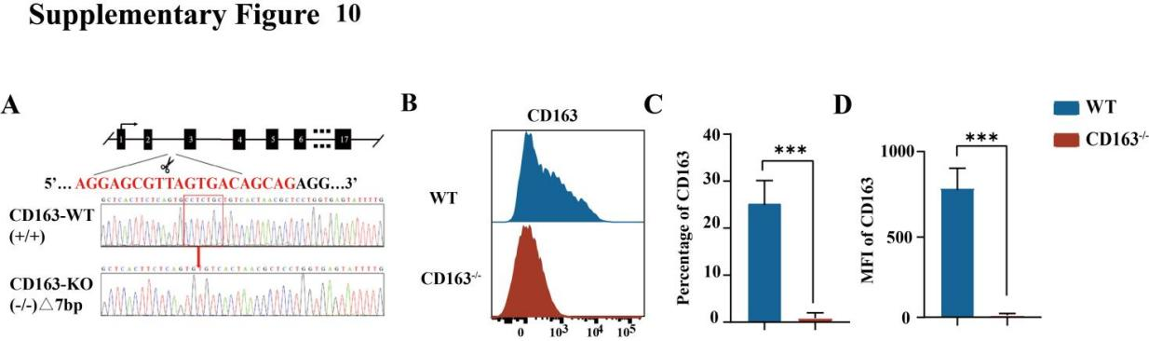
Supplementary Figure 10 Generation of CD163^{-/-} mice.
- Schematic representation of the mouse CD163 gene locus, highlighting the exons and gene targeting site. The sgRNA (single-guide ribonucleic acid) target sequence is shown in green and the protospacer adjacent motif (PAM) is in red. Sanger sequencing analysis for CRISPR-induced mutations in the CD163-targeted region reveals a 7-base pair deletion (highlighted in the red box) compared to the wild type (WT). (B) Flow cytometry analysis of CD163 expression on BM CD11b⁻F4/80⁺ macrophages in WT and CD163^{-/-} mice. (C) Statistical analysis of the percentage of BM CD163⁺CD11b⁻F4/80⁺ macrophages in WT and CD163^{-/-} mice (n=6). (D) Quantitative analysis of the mean fluorescence intensity (MFI) of CD163 on F4/80⁺ macrophages in WT and CD163^{-/-} mice (n=6). * p < 0.05, ** p < 0.01, *** p < 0.001. NS, not significant.

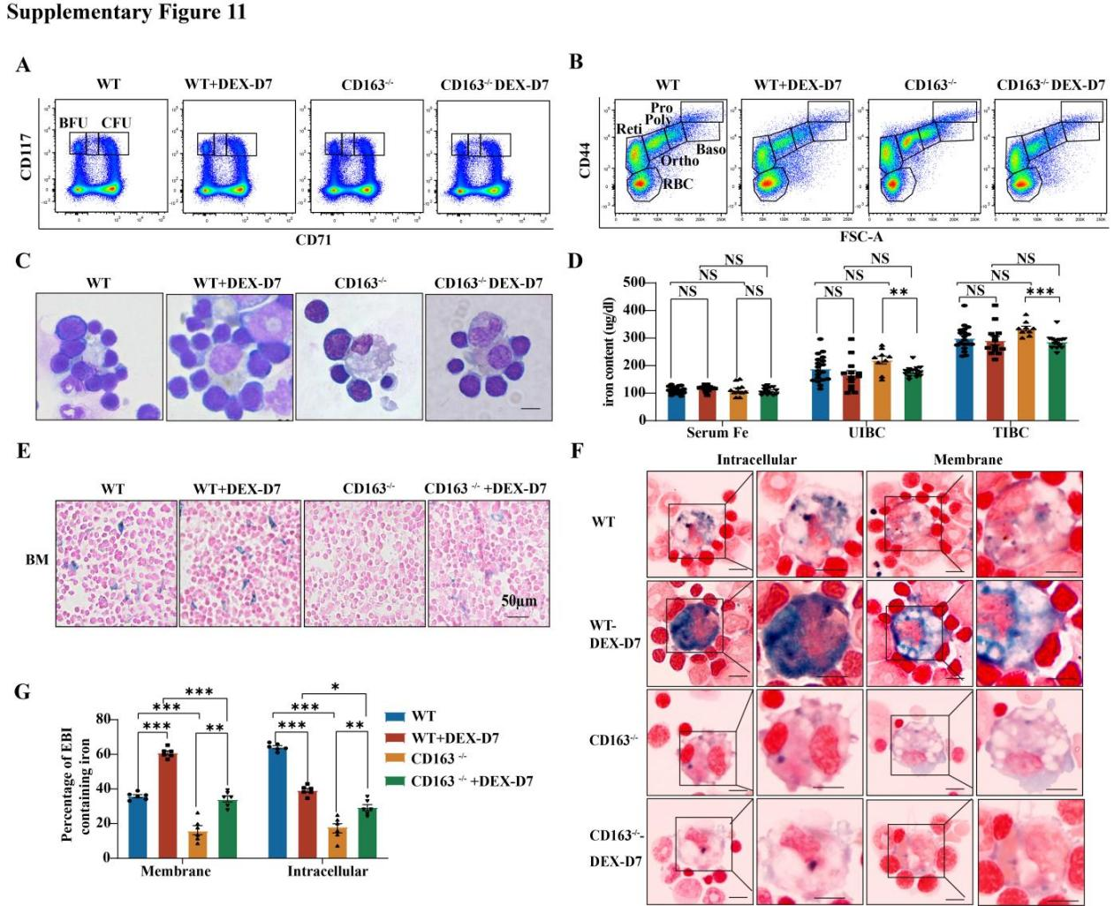
Supplementary Figure 11 Deletion of CD163 on macrophages decreased the effects of glucocorticoids in promoting the production of erythroid cells.
- Plot of CD71 versus c-Kit of 7AAD⁻Lin⁻CD16⁻CD32⁻CD41⁻CD34⁻Sca1⁻cells revealing three populations in BM of WT and CD163^{-/-} mice on day 7 after treatment with DEX or PBS. (B) Representative plot of CD44 versus FSC of Ter119⁺cells revealing different staged erythroid cells in BM of WT and CD163^{-/-} mice on day 7 after treatment with DEX or PBS. (C) Representative cytospin images of EBIs formed by WT and CD163^{-/-} mice on day 7 after treatment with DEX or PBS, scale bar, 10µm. (D) Quantitative analysis of serum Fe, UIBC and TIBC between WT and CD163^{-/-} mice on day 7 after treatment with DEX or PBS (n=12). (E) Representative Perl's Prussian blue staining images for iron in EBI in WT and CD163^{-/-} mice treated with PBS or DEX on day 7, scale bar, 50µm. (F) Representative Perls’ Prussian blue staining images for iron in EBI formed by WT and CD163^{-/-} mice on day 7 after treatment with DEX or PBS, scale bar, 10µm. (G) Statistical analysis of EBI macrophages with membrane iron and EBI macrophages with intracellular iron between WT and CD163^{-/-} mice on day 7 after treatment with DEX or PBS (n=6). * p < 0.05, ** p < 0.01, *** p < 0.001. NS, not significant.

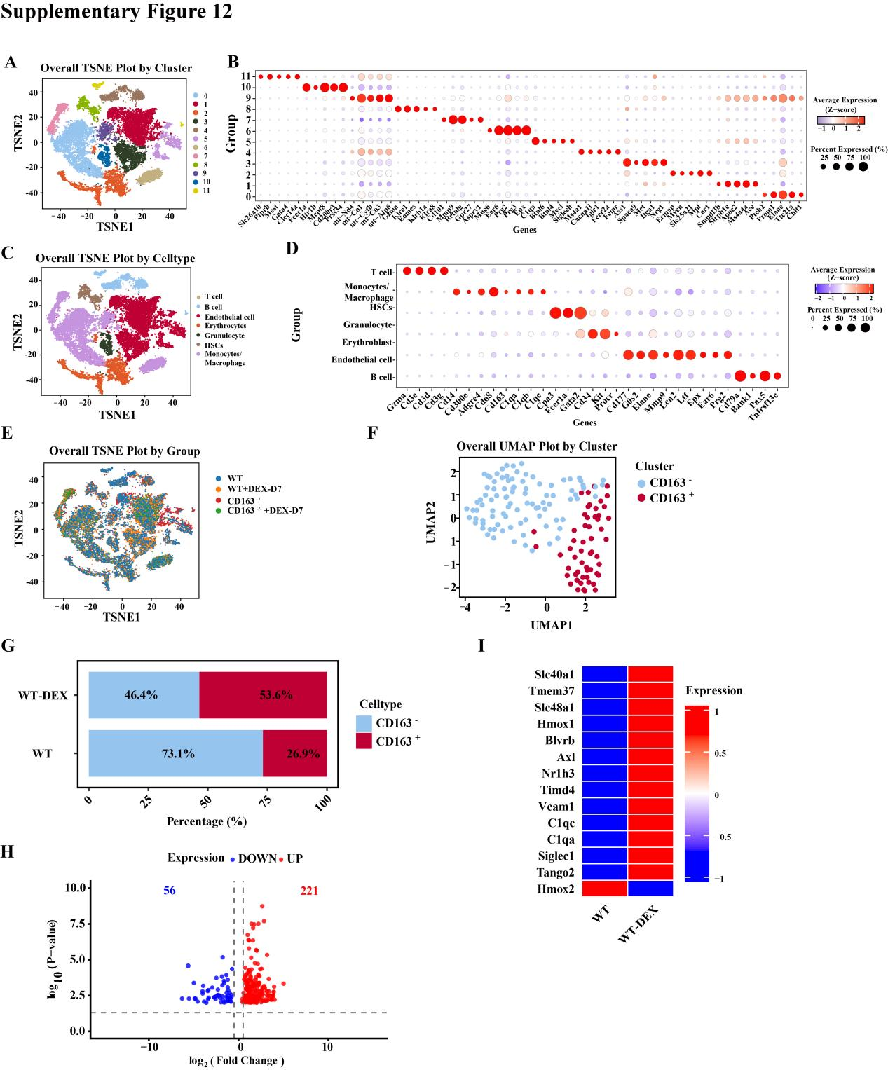
Supplementary Figure 12 scRNA-seq analysis for CD45⁺ cells from the BM of WT and CD163^{-/-} mice treated with PBS or DEX.
- TSNE visualization showing the clusters for CD45⁺ cells from the BM of WT and CD163^{-/-} mice treated with PBS or DEX. Colors indicate different clusters. (B) Dotplot showing the expression of marker genes of each cluster. Color represents normalized expression levels and dot size indicates the fraction of expressing cells. (C) TSNE visualization showing the cell types from the BM of WT and CD163^{-/-} mice treated with PBS or DEX. Colors indicate different cell types. (D) Dot plot showing the expression of marker genes of cell types. Color represents normalized expression levels and dot size indicates the fraction of expressing cells. (E) TSNE visualization showing the groups for macrophage subsets from the BM of WT and CD163^{-/-} mice treated with PBS or DEX. Colors indicate different groups. (F) UMAP visualization showing the CD163⁺ and CD163⁻macrophages subsets of WT mice treated with PBS or DEX. Colors indicate different cell types. (G)The bar graph depicts the proportions of CD163⁺ and CD163⁻ cells of WT mice treated with PBS or DEX. (H) The volcano plot visualizes differentially expressed genes of WT mice treated with PBS or DEX. Genes with significantly increased expression (upregulated) are highlighted in red, while those with decreased expression (downregulated) are shown in blue. (I) The heatmap displays expression differences of hallmark functional genes in CD163⁺ macrophages in WT mice treated with PBS or DEX groups.

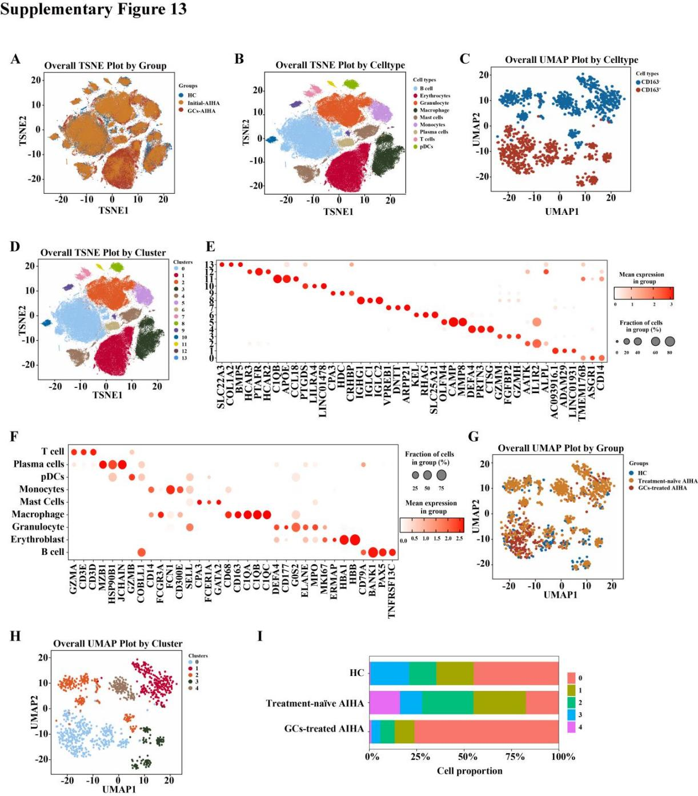
Supplementary Figure 13 scRNA-seq analysis for CD45⁺ cells from the BM of HC, treatment-naïve AIHA patients and GCs-treated AIHA patients.
- TSNE visualization showing groups of BM CD45⁺ cells from HC, treatment-naïve AIHA and GCs-treated AIHA patients. Colors indicate different groups. (B) TSNE visualization showing the cell types for CD45⁺ cells from the BM of HC, treatment-naïve AIHA patients and GCs-treated AIHA patients. Colors indicate different cell types. (C) UMAP visualization showing the cell types for macrophage subsets from the BM of HC, treatment-naïve AIHA patients and GCs-treated AIHA patients. Colors indicate different cell types. (D)TSNE visualization showing the clusters for CD45⁺ cells from the BM of HC, treatment-naïve AIHA patients and GCs-treated AIHA patients. Colors indicate different clusters. (E) Dotplot showing the expression of marker genes of each cluster. Color represents normalized expression levels and dot size indicates the fraction of expressing cells. (F) Dot plot showing the expression of marker genes of cell types. Color represents normalized expression levels and dot size indicates the fraction of expressing cells. (G) UMAP visualization showing the groups for macrophage subsets from the BM of HC, treatment-naïve AIHA patients and GCs-treated AIHA patients. Colors indicate different groups. (H) UMAP visualization showing the cluster for macrophage subsets from the BM of HC, treatment-naïve AIHA patients and GCs-treated AIHA patients. Colors indicate different clusters. (I) Bar plot showing the percentages for macrophage subsets from the BM of HC, treatment-naïve AIHA patients and GCs-treated AIHA patients.

