Supplementary Information for
Malignant Epithelial States Drive Immune Dysfunction in Ampulla of Vater Carcinoma

Hyoung-oh Jeong, Young Hoon Choi, Hyemin Kim, Aryoung Kim, Kyoung Jun Lee, Jaewoong Lee, Hyeong Seok Kim, Hochang Chae, Hongbeom Kim, Sang Hyun Shin, In Woong Han, Jin Seok Heo, Se-Hoon Lee, Kwang Hyuck Lee, Kyu Taek Lee, Jong Kyun Lee, Kee-Taek Jang,§ Semin Lee,§ Joo Kyung Park§

§Corresponding authors.
Email: mdsophie@gmail.com, ktjang12@gmail.com, seminlee@unist.ac.kr

Supplement methods
MACSima imaging cyclic staining (MICS)
FFPE sections (3 μm) were deparaffinized, hydrated and, washed three times with MACSima™ Running Buffer (130-121-565, Miltenyi Biotec), and immediately mounted onto an appropriate MACSwell™ Imaging Frame (Four: 130-124-676, Miltenyi Biotec). Sections were covered with MACSima™ Running Buffer until initial 4′,6-diamidino-2-phenylindole (DAPI) staining. Primary DAPI staining was performed right before the experiment by removing the MACSima™ Running Buffer and adding a 1:10 DAPI (130-111-570, Miltenyi Biotec) dilution in Running Buffer. After 10 mins incubation at room temperature, the samples were washed three times with Running Buffer and covered with the final sample volume (250µl). MACSwell™ Imaging Frames were sealed with MACSwell™ Sealing Foil (130-126-866, Miltenyi Biotec) to prevent evaporation and protect the samples from contaminants. Primary fluorochrome-labeled antibodies conjugated to fluorescein isothiocyanate (FITC) or phycoerythrin (PE) were used for MICS. Antibodies were prepared in a MACSwell™ Deepwell Plate (130-126-865, Miltenyi Biotec) in the appropriate dilution with MACSima™ Running Buffer for the respective MACSwell™ imaging frame working volumes. DAPI was added to the antibody-containing Deepwell Plate in a 1:50 dilution in every eighth antibody cycle.
The MACSima™ Imaging System provides a fully automated workflow for iterative cycles of immunofluorescence sample staining, multi-field imaging, and fluorochrome removal (photobleaching or enzymatic digest). The sample slides mounted with a MACSwell ™ Imaging Frame as well as the antibody-containing MACSwell™ Deepwell Plate were placed on the xy-stage which moves reagents and samples to the correct needle and microscope positions. Antibody incubation was performed for 10 mins (standard setting), followed by excitation of the fluorochromes by specific laser/filter combinations and detection with a monochromatic scientific CMOS camera. Before the iterative cycles were initiated, ROIs were defined and the focus was adjusted. ROIs were defined based on the DAPI signal shown in the overview scan and are based on customized numbers of overlapping fields of view (FoV). The MACSima™ captures various raw images of each FoV and each cycle. Individual raw FoV images were processed with the automated pipeline on the MACS iQ View software (Version 1.3.2).

Table S1. Baseline characteristics of study patients.
Characteristics | n=70
Age (year), median (range) | 61.5 (36-83)
Gender, n (%)
Male | 33 (47.1%)
Female | 37 (52.9%)
Pathologic differentiation, n (%)
Well differentiated | 16 (22.9%)
Moderately differentiated | 41 (58.6%)
Poorly differentiated | 12 (17.1%)
NA | 1 (1.4%)
AJCC staging, n (%)
0 | 1 (1.4%)
I | 30 (42.9%)
II | 15 (21.4%)
III | 22 (31.4%)
IV | 2 (2.9%)
T stage, n (%)
Tis | 1 (1.4%)
1 | 27 (38.6%)
2 | 15 (21.4%)
3 | 27 (38.6%)
4 | 0
N stage, n (%)
0 | 48 (68.6%)
1 | 21 (30%)
2 | 1 (1.4%)
M stage, n (%)
0 | 68 (97.1%)
1 | 2 (2.9%)
Adjuvant chemotherapy, n (%)
Yes | 14 (20%)
No | 53 (75.7%)
NA | 3 (4.3%)
Recurrence, n (%)
Yes | 23 (32.9%)
No | 44 (62.9%)
NA | 3 (4.3%)
Death, n (%)
Yes | 27 (38.6%)
No | 43 (61.4%)
Histologic subtype, n (%)
Intestinal type | 21 (30%)
Pancreatobiliary type | 33 (47.1%)
Mixed type | 16 (22.9%)
Table S2. Signature genes of the four NMF subtypes.
Int-Wnt | PB-KRAS | Int-Hypoxia | Cycling
CHRM3 | MUC5B | MUC17 | S100A6
CADPS | CRISP3 | EMP1 | S100A11
GPHN | CLDN10 | CES2 | KRT19
KCNH8 | NRG3 | ALDOB | PFN1
APBB2 | FXYD2 | NEDD4L | TSPAN8
TOX | QKI | ANPEP | B2M
KCNQ1OT1 | LINC02532 | SI | AGR2
LRMDA | RALYL | SDCBP2 | LYZ
SLC38A11 | SCGB3A1 | HSPA1A | RAN
DPEP1 | SERPING1 | BTNL8 | ATP5MC3
NEBL | FCGBP | HSD17B2 | CSTB
CEMIP | WDR72 | MACC1 | GPX2
ITPR2 | GC | SELENOP | SLC25A5
PRUNE2 | PDGFC | GDA | TAGLN2
LRRC23 | TCN1 | NR5A2 | PPIB
GDF15 | MEIS1 | HSPA1B | SH3BGRL3
PDZRN3 | GABRP | CLTB | C1QBP
SNTB1 | ONECUT1 | EPB41L3 | LDHA
SLC16A10 | LINC02381 | IQGAP2 | ENO1
RAP1B | CFH | SLC26A3 | TXNDC17
NKD1 | PDGFD | FABP1 | S100A16
ZNF804A | OSMR | RBP2 | H2AFZ
TBC1D4 | PTPRM | LIPH | HMGA1
KIAA1324 | MUC1 | CLDN3 | PLP2
MARCH3 | UTRN | ADIRF | CRIP1
KIF26B | CASR | WWC1 | ATP5MC1
LINC01811 | TFF2 | ARHGAP42 | TOMM5
PROX1 | TFF1 | HPGD | SNRPF
CELF2 | PRKAA2 | HHLA2 | NME1
CACHD1 | DOK5 | FAM3C | RANBP1
DENND5A | COL4A4 | LINC01133 | TUBB
MAN1A1 | LYPD6B | THRB | IFITM3
FRMD5 | PLAT | SGMS2 | REG4
HIST1H4C | CHST9 | FABP2 | PRDX4
RBFOX1 | CES1 | MUC3A | PHLDA2
LGR5 | UGT2B15 | MYRFL | FXYD3
KLF12 | AQP5 | XIST | TUBA1B
PHACTR1 | NBEA | RESF1 | PRELID1
PAM | POU6F2 | DUSP1 | S100A14
SORBS1 | PTPRS | AGMO | LSM5
REG1A | CPNE8 | LTBP1 | RPL22L1
TMEM178B | ETV1 | TM4SF4 | ATP6V0B
ABTB2 | AC019117.1 | TMPRSS15 | TIMP1
DNAH14 | AGBL4 | THSD4 | MYDGF
APOLD1 | CTNND2 | NCKAP5 | SRI
HOMER1 | HLA-DPB1 | MAF | LSM3
LINC02315 | BICC1 | LAMA3 | CCT2
VCL | EPB41L4A | MEIS2 | SSR3
CCND2 | MAP9 | PTGR1 | GGCT
MAPRE2 | ASRGL1 | FOXP2 | IGFBP2
STARD13 | SLPI | LMO4 | TM4SF1
LINC02432 | TUSC3 | DHRS11 | ATP5PB
LIMCH1 | MITF | MB21D2 | OSTC
TAF4B | ALDH1A2 | MGAM2 | HMGN2
SEMA4A | ZG16B | CYP2C18 | SPINK1
WWOX | ARHGAP6 | APOB | OLFM4
DLL4 | TTLL7 | AREG | IL32
GRIP1 | RHEX | TM4SF20 | CCND1
MAN1A2 | VNN2 | AKR7A3 | TFF3
NFATC1 | HLA-DPA1 | MALL | LCN2
ASCL2 | MUC5AC | CTSD | AC020656.1
PTPRN2 | RORA | SLC6A8 | PDZK1IP1
RASEF | NR2F2 | SLC15A1 | SFN
DLGAP1 | LINC00342 | AKR1B10 | MRPL17
ERO1B | EYA2 | TRIM31 | CENPX
REG3A | ALCAM | SLC30A10 | SDF2L1
NRCAM | BMPR1B | EPHA2 | FDPS
MTSS1 | C6 | CNKSR3 | C12orf75
LINC01619 | MYOM1 | FA2H | S100P
LEF1 | CEACAM7 | FOLH1 | DUT
HIVEP3 | ANKRD36C | AC005062.1 | ANXA5
SERPINB9 | DPYD | SEMA6A | EID1
TUBA1A | MUC6 | MTUS1 | MANF
CNOT2 | CXCL17 | GULP1 | TMBIM4
RAB3IP | LDHB | MME | CD59
AC138305.1 | SERPINA6 | MT1E | RPA3
TRAF5 | SSBP2 | XKR9 | DTYMK
DOCK4 | NR2F2-AS1 | DLEU1 | CEACAM6
AC007368.1 | KCNJ15 | TMCC3 | LY6E
POLG2 | FOLR1 | TIMP2 | EIF4EBP1
SMOC2 | RASSF8 | RHOF | S100A13
UTY | GLIS3 | CYP2C19 | TPM1
LAMC1 | CLU | PRAG1 | NAP1L1
ITPKC | SORBS2 | C3orf85 | ANXA4
SLC35F1 | TRPS1 | BNIP5 | CKLF
FYN | AC087477.2 | MEP1A | SEC11C
SLIT2 | GP2 | BTNL3 | ANXA3
ROR1 | TGM2 | CYBRD1 | AC008397.1
AL078604.4 | HDGFL3 | CREB3L3 | FABP5
BAMBI | PTPN13 | ISG15 | PLAAT3
RAI2 | GALNT18 | GPRC5D-AS1 | GCSH
TTTY14 | PRKG1 | EDN1 | HIGD1A
TSHZ2 | IL1RAPL2 | PLAC8 | LMAN1
DAPK1 | ATP13A4 | PCK1 | SRPRB
TNFRSF10D | NRP1 | HLA-DRB1 | AK1
TSPAN5 | FAM107B | PLD1 | IFITM2
WNT5B | KYNU | TXNIP | CA9
AZIN1-AS1 | WWC2 | MT1G | RNASE1
LINC01913 | LINC00472 | GATA4 | MRPL37
CTNNA2 | RARB | GSTA1 | CD47
Table S3. Histologic types and transcriptional subtype composition of the scRNA-seq cohort.
Patients | Histologic type | Relative proportions of transcriptional subtypes
Patients | Histologic type | NMF-1  (Int-Wnt) | NMF-2  (PB-KRAS) | NMF-3  (Int-Hypoxia) | NMF-4  (Cycling)
AoV-S1 | Pancreatobiliary type | 0.00 | 0.00 | 0.00 | 1.00
AoV-S2 | Intestinal type | 0.01 | 0.05 | 0.72 | 0.21
AoV-S3 | Intestinal type | 0.04 | 0.44 | 0.39 | 0.13
AoV-S4 | Intestinal type | 0.48 | 0.00 | 0.07 | 0.45
AoV-S5 | Intestinal type | 0.09 | 0.00 | 0.70 | 0.20
AoV-S6 | Intestinal type | 0.06 | 0.34 | 0.41 | 0.19
AoV-S7 | Pancreatobiliary type | 0.02 | 0.34 | 0.29 | 0.36
AoV-S8 | Intestinal type | 0.66 | 0.00 | 0.05 | 0.29

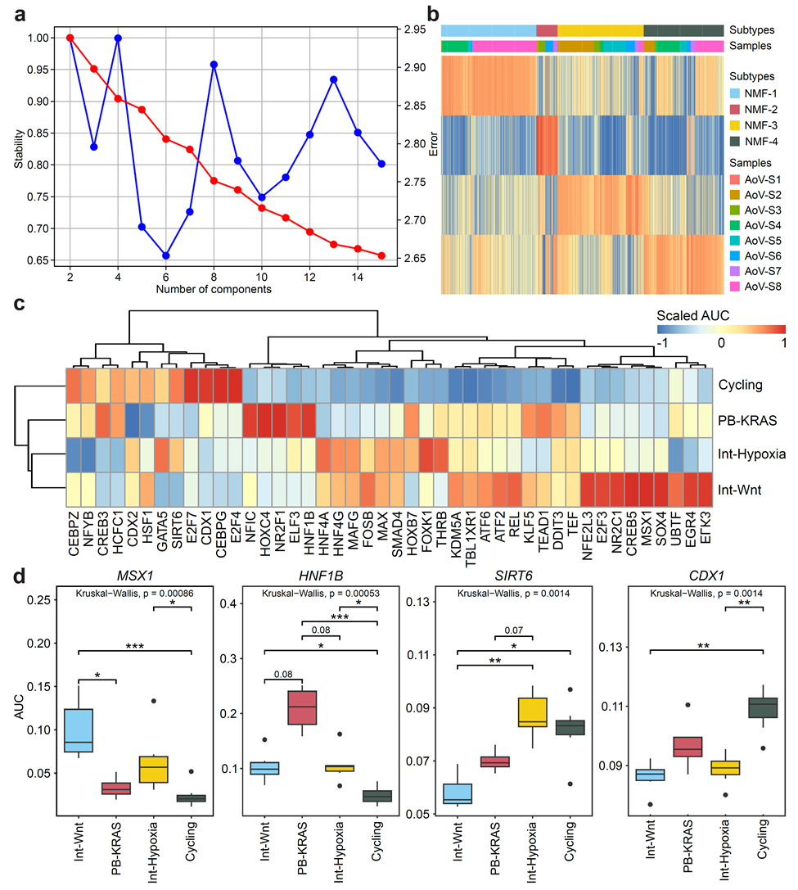

Fig. S1 Transcription factor activity analysis reveals subtype-specific regulatory programs in ampulla of Vater (AoV) carcinoma epithelial cells. (a) Optimization of consensus non-negative matrix factorization (cNMF) for subtype identification. The stability (blue) and error (red) are plotted against the number of components (k), with optimal performance observed at k = 4. (b) Heatmap and annotation bar plots showing cNMF clustering results for epithelial cells from AoV carcinoma patients. Four transcriptional subtypes (NMF-1 to NMF-4) were identified, which correspond to the biologically defined subtypes: Int-Wnt, PB-KRAS, Int-Hypoxia, and Cycling. Patient origin is annotated by color bars. (c) Scaled activity scores (AUC) of differentially active transcription factors (TFs) across the four subtypes. Hierarchical clustering based on TF activity reveals distinct subtype-specific regulatory modules. (d) Box plots showing AUC for representative TFs highly enriched in each subtype: MSX1 (Int-Wnt), HNF1B (PB-KRAS), SIRT6 (Int-Hypoxia), and CDX1 (Cycling). Statistical significance for global comparisons among groups was determined using the Kruskal-Wallis test. For pairwise post-hoc comparisons, Dunn’s test was used to adjust for multiple comparisons. *Padj < 0.05, **Padj < 0.01, *** Padj < 0.001; n.s., not significant.
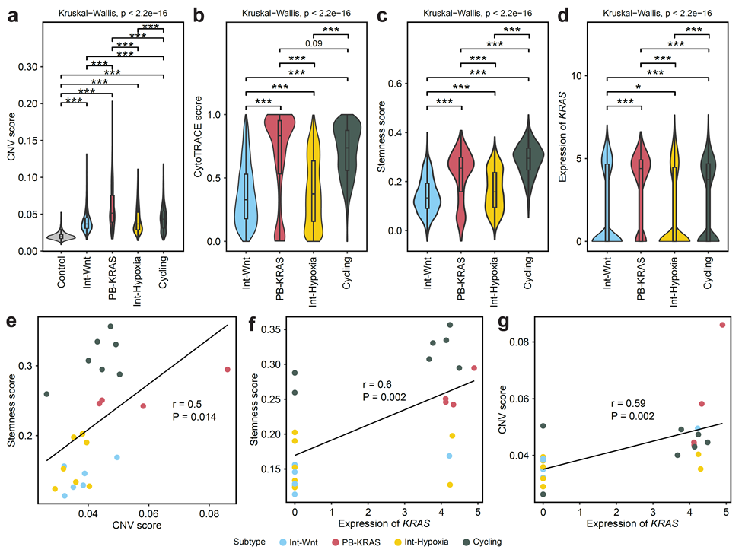
Fig. S2 Molecular subtypes of AoV carcinoma exhibit distinct stemness features, differentiation states, and genomic instability. (a-d) Violin plots compare cell-level CNV scores (a), CytoTRACE scores (b), stemness scores (c), and expression of KRAS (d) across the four subtypes (Int-Wnt, PB-KRAS, Int-Hypoxia, Cycling). Statistical significance for global comparisons among groups was determined using the Kruskal-Wallis test. For pairwise post-hoc comparisons, Dunn’s test was used to adjust for multiple comparisons. *Padj < 0.05, **Padj < 0.01, ***Padj < 0.001; n.s., not significant. (e-g) Scatter plots show the correlations between sample-level CNV score, stemness score, and expression of KRAS. Specifically, plot (e) shows the correlation between CNV score and stemness score; plot (f) shows the correlation between expression of KRAS and stemness score; and plot (g) shows the correlation between expression of KRAS and CNV score.
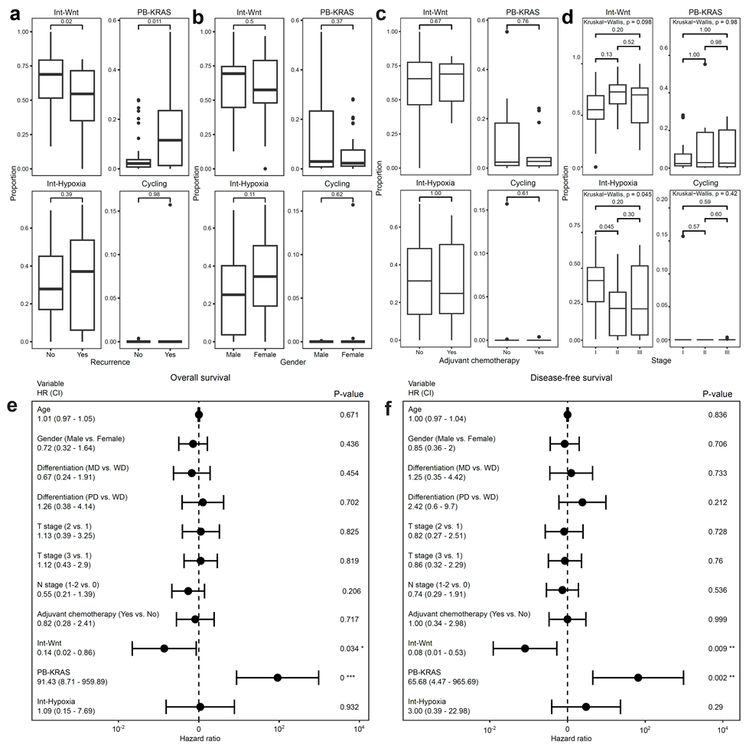

Fig. S3 Association between molecular subtypes of AoV carcinoma and clinicopathologic features. (a-d) Box plots showing the proportion of each molecular subtype (Int-Wnt, PB-KRAS, Int-Hypoxia, and Cycling) stratified by clinical variables: recurrence status (a), gender (b), adjuvant chemotherapy (c) and tumor stage (d). Statistical significance was assessed using the Wilcoxon rank-sum test (a-c). Statistical significance for global comparisons among groups was determined using the Kruskal-Wallis test. For pairwise post-hoc comparisons, Dunn’s test was used to adjust for multiple comparisons (d). (e-f) Forest plots of Univariate Cox proportional hazards models displaying hazard ratios with 95% confidence intervals for overall survival (OS; e) and disease-free survival (DFS; f), incorporating both clinical and molecular variables.

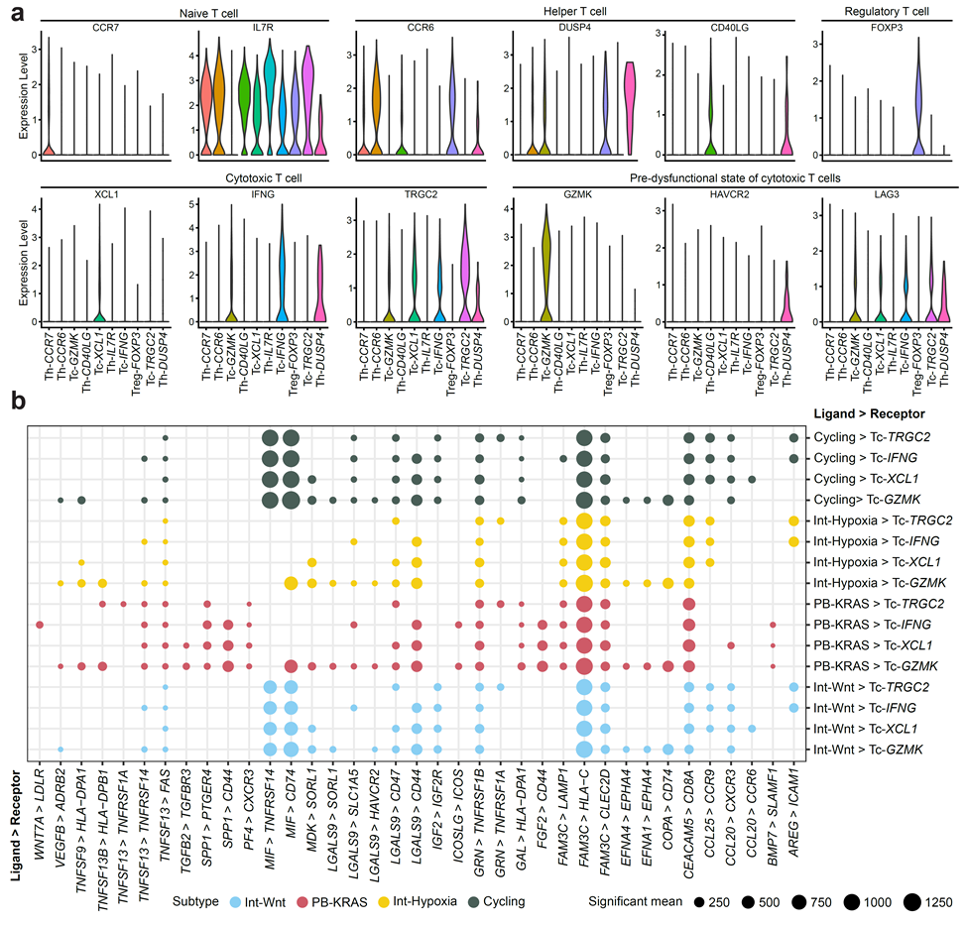
Fig. S4 Subtype-specific epithelial-T cell interactions in AoV carcinoma. (a) Violin plots illustrating the expression levels of canonical marker genes across T cell subsets. (b) Dot plot showing significant ligand-receptor interactions from malignant epithelial cells to Tc cell subsets, stratified by molecular subtype (Int-Wnt, PB-KRAS, Int-Hypoxia, and Cycling). Dot size represents the mean expression of significant interactions, and color indicates the subtype.

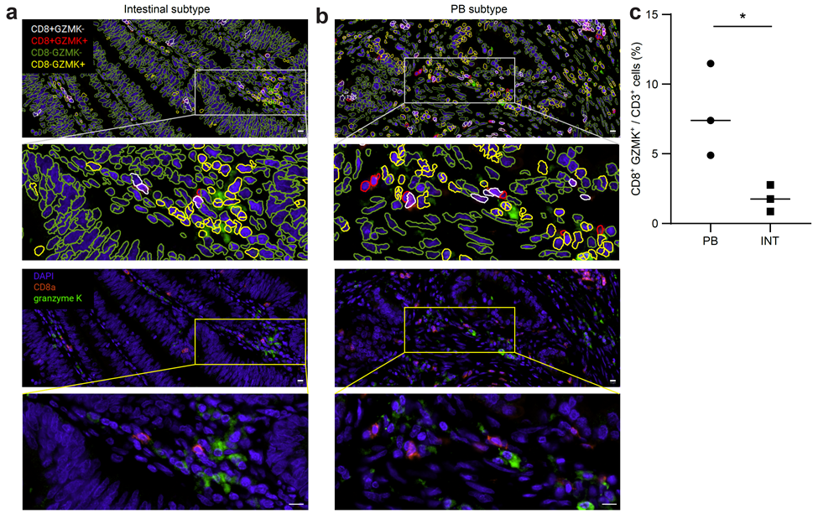
Fig. S5 Spatial distribution and quantification of CD8⁺ GZMK⁺ T cells in AoV carcinoma. (a-b) Representative multiplex immunofluorescence images showing CD8⁺ GZMK⁺ T cells in intestinal (a) and PB subtype (b). (Upper panels) Phenotypic segmentation maps showing single-cell boundaries color-coded by cell phenotype: CD8⁺ GZMK⁻ (white), CD8⁺ GZMK⁺ (red), CD8⁻ GZMK⁻ (green), and CD8⁻ GZMK⁺ (yellow). High-magnification insets (second row) from the indicated regions (white boxes). (Lower panels) Raw immunofluorescence images displaying DAPI (blue), CD8a (red), and granzyme K (GZMK, green). High-magnification insets (fourth row) from the selected regions (yellow boxes). (c) Quantification of CD8⁺ GZMK⁺ T cells as a proportion of total CD3⁺ cells.

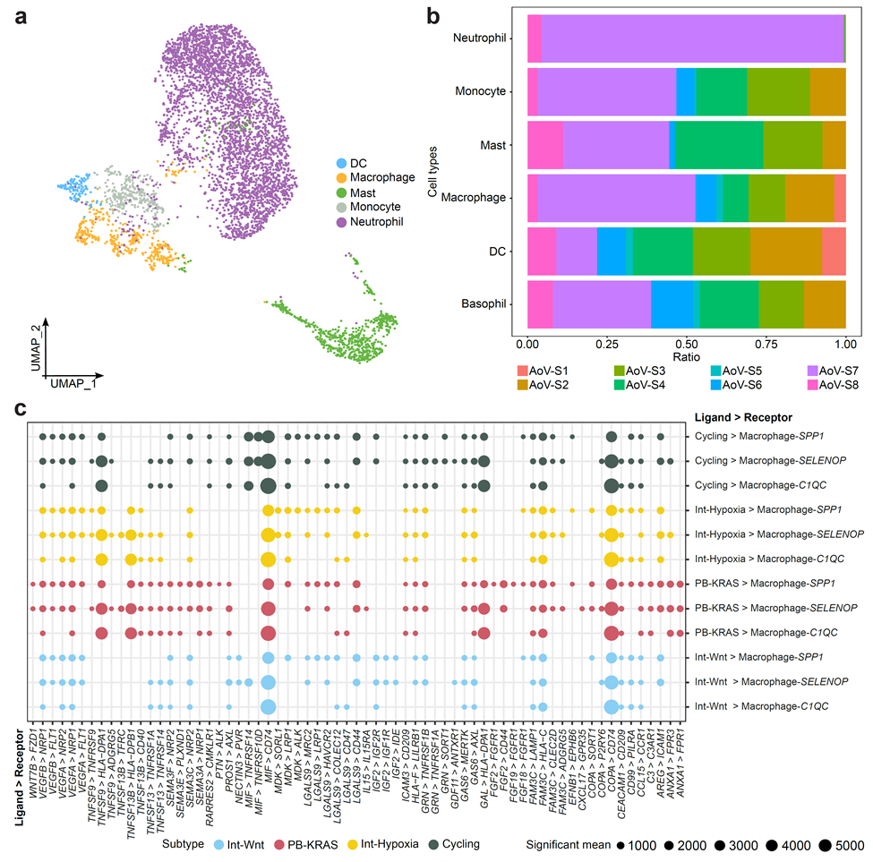
Fig. S6 Clustering of myeloid cells and sample proportions of each cell type. (a) UMAP plot depicting the clustering of myeloid cells. Each point corresponds to a single cell, color-coded according to its annotated cell type: dendritic cells (DC, blue), macrophage (orange), mast cells (green), monocytes (grey), and neutrophil (purple). (b) Stacked bar plot showing the proportions of each patient contributing to the defined myeloid cell types. (c) Dot plot showing significant ligand-receptor interactions from malignant epithelial cells to macrophage subsets, stratified by molecular subtype (Int-Wnt, PB-KRAS, Int-Hypoxia, and Cycling). Dot size represents the mean expression of significant interactions, and color indicates the subtype.

