Supplementary results
Genomic distribution of 5hmC in cfDNA
The distribution of 5hmC signals across the genome was not random. After quality control and read alignment, normalized 5hmC signals were compared across genomic functional regions. Overall, 5hmC signals were mainly enriched in gene bodies, including UTRs, exons, and introns, with particularly high signal levels in the 5′UTR, 3′UTR, and exon regions. In contrast, CpG islands and introns showed lower enrichment, while intergenic regions exhibited the weakest signal. Among regulatory regions, enhancers showed higher 5hmC levels than promoters (Fig. A). Metagene profiling further revealed marked depletion of 5hmC around both the transcription start site (TSS) and transcription end site (TES), with relatively elevated signals in gene-flanking and gene-body regions (Fig. B). Enhancer-centered profiling showed dynamic variation of 5hmC signal across enhancer regions (Fig. C). Together, these results indicate that cfDNA 5hmC is distributed in a structured, region-dependent manner, with preferential enrichment in gene-associated and regulatory regions rather than a random genome-wide pattern.

Supplementary methods
5hmC normalized count across genomic region
Genomic annotations were downloaded from UCSC Table Browser, including 3′ UTR, 5′ UTR, CpG island, intron, exon, promoter, enhancer, and intergenic regions. They were sorted and merged to remove overlapping intervals within each category. Paired-end reads from each sample’s BAM file were assigned to the merged regions using featureCounts, and counts from all intervals within the same category were summed. The 5hmC signal for each genomic region was normalized by the total merged region length and sample library size as follows:
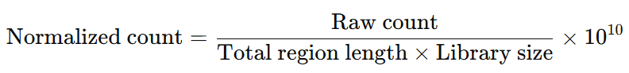
The normalized counts were used to compare genome-wide 5hmC distribution across functional genomic regions.

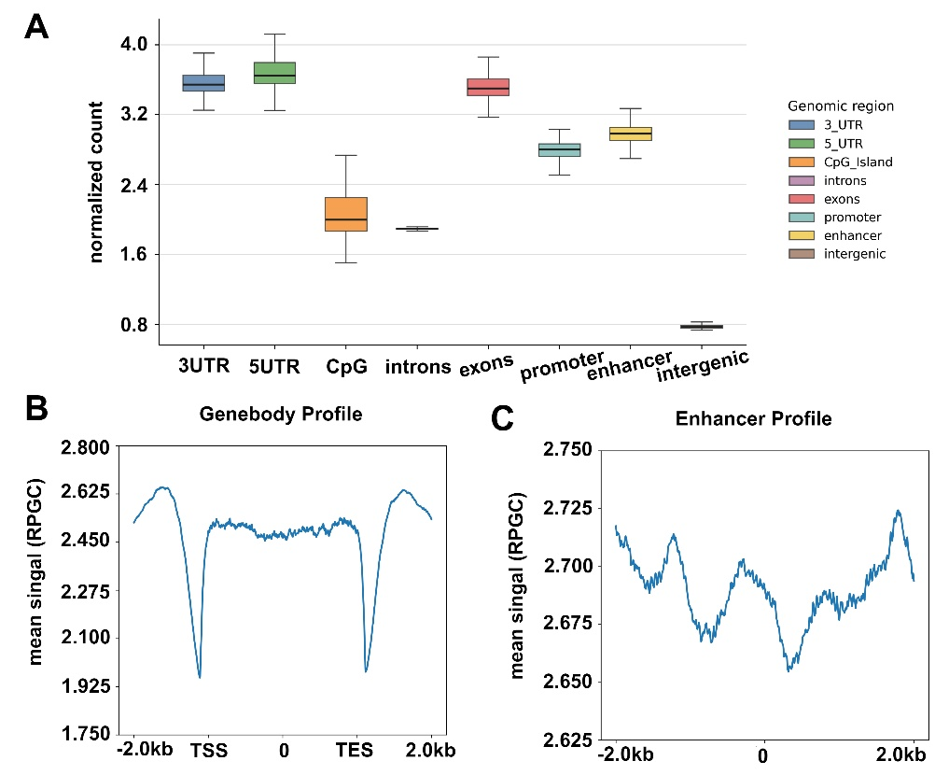

Figure. Genomic distribution of cfDNA 5hmC signals.
- 5hmC normalized counts across genomic annotations, including gene-associated regions (intron, exon, 3′UTR, 5′UTR), promoter, enhancer, CpG island and intergenic regions.
- Metagene profile of normalized 5hmC signal across gene-flanking regions, TSS, gene body, and TES (±2 kb). The y-axis represents mean RPGC (reads per gene count).
- Metaprofile of normalized 5hmC signal around enhancer regions (±2 kb from enhancer centers).

