Supplemental Materials
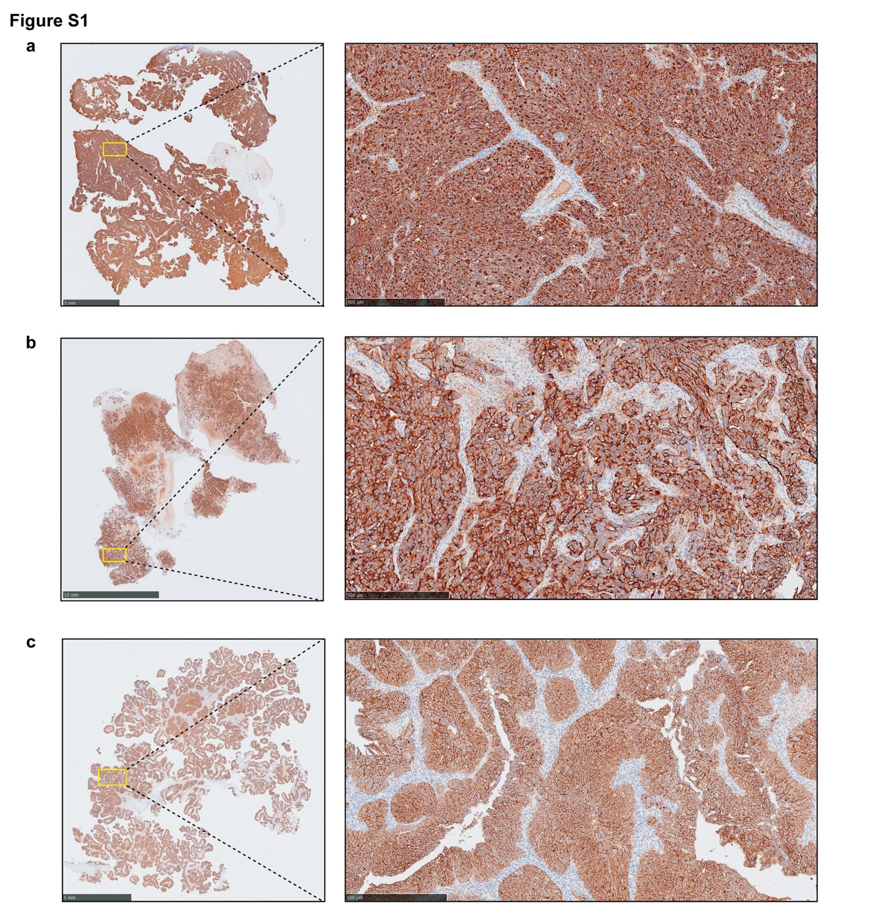
Fig S1. Immunohistochemical staining for MSLN in three additional ovarian cancer tumor specimens from the same independent institutional tissue-validation set. All samples (a–c) demonstrated strong and diffuse membranous positivity, consistent with MSLN overexpression.
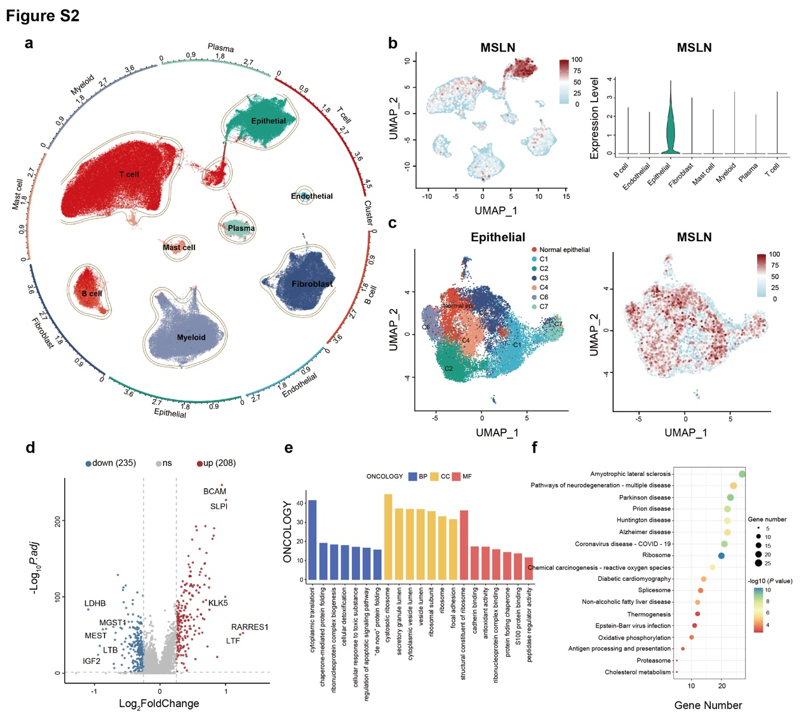
Fig S2. Single-cell and pathway-enrichment analyses related to MSLN expression in ovarian cancer. (a) Uniform Manifold Approximation and Projection (UMAP) plot showing clustering of ovarian cancer samples using transcriptome data from The Cancer Genome Atlas (TCGA) and Gene Expression Omnibus (GEO). (b) UMAP overlaid with MSLN expression, indicating enrichment in epithelial cell clusters. (c) UMAP plot focusing on epithelial cells, showing no significant difference in MSLN distribution. (d) Volcano plot displaying 443 differentially expressed genes between high and low MSLN expression groups. (e) Gene Ontology enrichment analysis. (f) Kyoto Encyclopedia of Genes and Genomes pathway analysis.

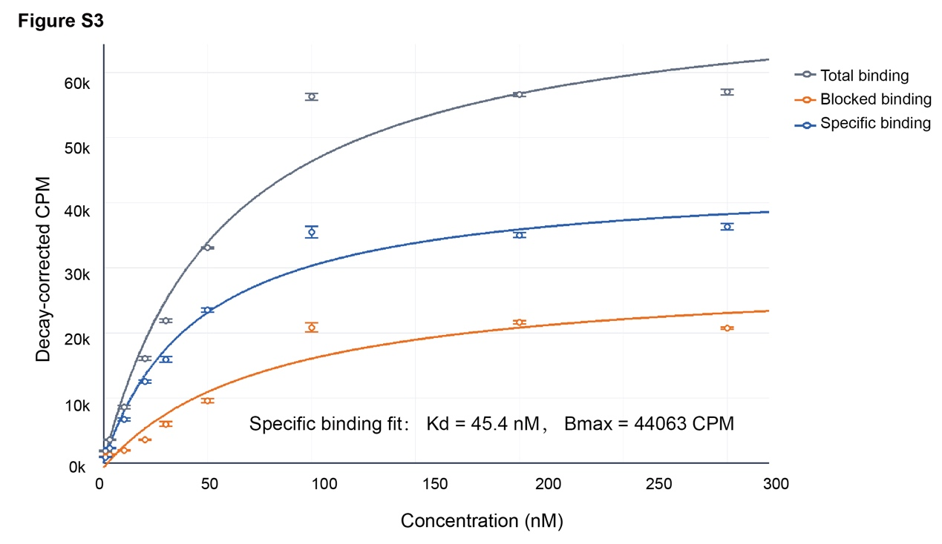
Fig S3. Saturation binding assay of ⁶⁸Ga-XH04 in OVCAR-3 cells. Total binding, blocked binding, and calculated specific binding are shown across increasing tracer concentrations. Blocking was performed using excess unlabeled XH04 at a final concentration of 2 µM. Data are shown as mean ± SEM from three technical replicates. One-site fitting of the specific-binding curve yielded an apparent KD of 45.4 nM and Bmax of 44,063 decay-corrected counts per minute (CPM).

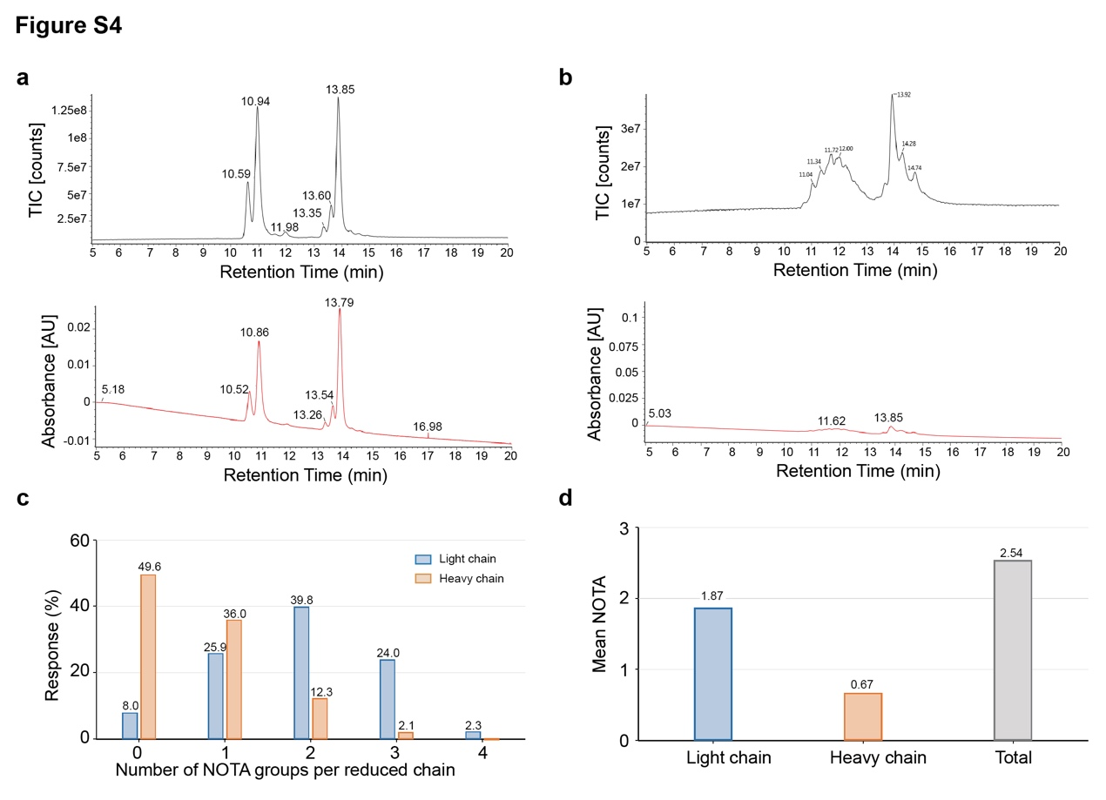
Fig S4. Reduced-chain reversed-phase chromatography-mass spectrometry (RPC-MS) analysis of NOTA-XH04. (a) Total ion chromatogram (TIC) and ultraviolet (UV) chromatograms of reduced unconjugated XH04 Fab. (b) TIC and UV chromatograms of reduced NOTA-XH04 Fab, showing heterogeneous NOTA substitution species. (c) Response-weighted distribution of NOTA substitution numbers on the light and heavy chains. (d) The average substitution numbers were 1.87 on the light chain and 0.67 on the heavy chain, corresponding to an average NOTA-to-XH04 substitution number of 2.54 per Fab molecule.
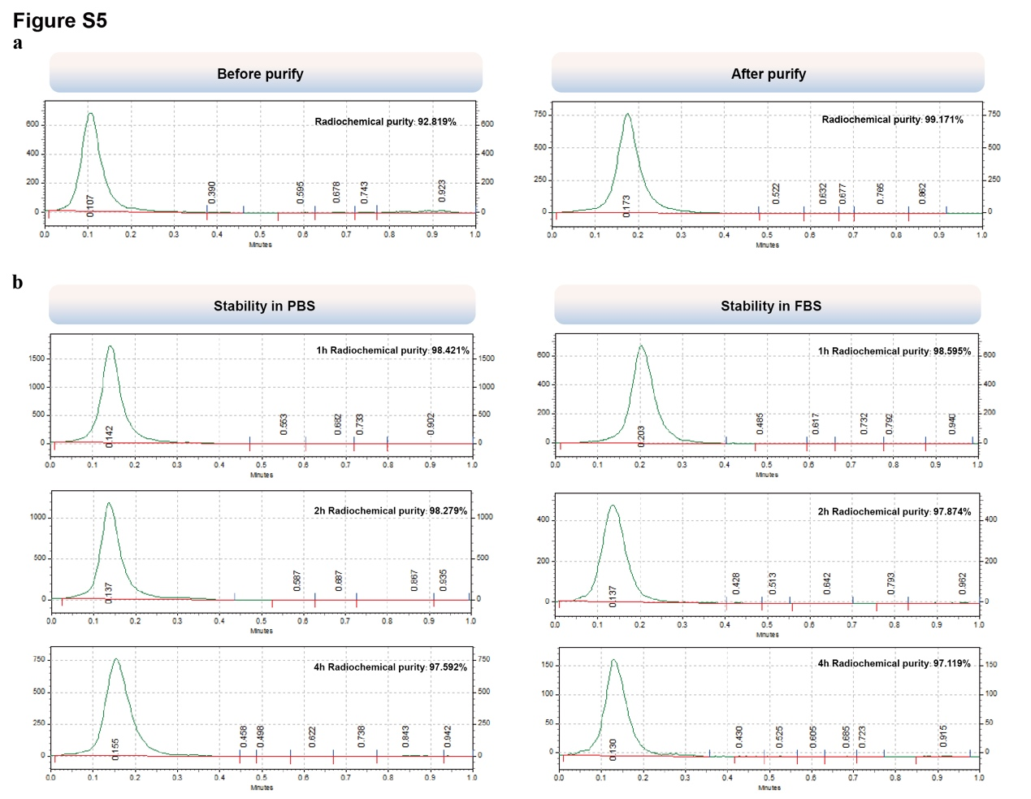
Fig S5. Radiochemical purity and stability of ⁶⁸Ga-XH04. (a) Instant thin-layer chromatography (ITLC) profiles of ⁶⁸Ga-XH04 before and after purification showing high radiochemical purity. (b) In vitro stability of ⁶⁸Ga-XH04 in phosphate-buffered saline (PBS) and fetal bovine serum (FBS) over 1 to 4 hours, demonstrating excellent radiochemical stability under physiological conditions.

Table S1. Exploratory pairwise statistical comparisons for preclinical quantitative uptake analyses. Values shown in the matrices are Tukey-adjusted P values from pairwise comparisons after one-way ANOVA. Since the preclinical analyses included limited animal-group sizes (n = 3) or technical replicates in the in vitro uptake assay, these comparisons were considered exploratory.
A. Comparison of cellular uptake of ⁶⁸Ga-XH04 in AsPC-1, BxPC-3, and AsPC-1 blocking groups.
Time point | Comparison matrix | AsPC-1 | BxPC-3 | AsPC-1 blocking
0.5 h | AsPC-1 | / | 0.0033 | 0.0008
 | BxPC-3 | / | / | 0.2460
 | AsPC-1 blocking | / | / | /
1 h | AsPC-1 | / | 0.0262 | 0.0003
 | BxPC-3 | / | / | 0.0044
 | AsPC-1 blocking | / | / | /
2 h | AsPC-1 | / | 0.0150 | 0.0002
 | BxPC-3 | / | / | 0.0030
 | AsPC-1 blocking | / | / | /
B. Comparison of PET-derived tumor uptake of ⁶⁸Ga-XH04 among OVCAR-3, AsPC-1, SKOV-3, and BxPC-3 xenograft models at 4 h post-injection.
Comparison matrix | OVCAR-3 | AsPC-1 | SKOV-3 | BxPC-3
OVCAR-3 | / | 0.9941 | 0.0028 | 0.0006
AsPC-1 | / | / | 0.0037 | 0.0007
SKOV-3 | / | / | / | 0.5059
BxPC-3 | / | / | / | /
C. Comparison of ex vivo tumor biodistribution of ⁶⁸Ga-XH04 among OVCAR-3, AsPC-1, SKOV-3, and BxPC-3 xenograft models at 4 h post-injection.
Comparison matrix | OVCAR-3 | AsPC-1 | SKOV-3 | BxPC-3
OVCAR-3 | / | 0.9920 | 0.0002 | 0.0001
AsPC-1 | / | / | 0.0002 | 0.0001
SKOV-3 | / | / | / | 0.7086
BxPC-3 | / | / | / | /

Table S2. Administered activity and exploratory OLINDA-derived effective dose estimates for ⁶⁸Ga-XH04 PET imaging
Case | Participant type | Injected activity  (MBq) | ED coefficient  (mSv/MBq) | Estimated ED  (mSv)
Participant 01 | Healthy volunteer | 247.9 | 0.0192 | 4.76
Participant 02 | Ovarian cancer patient | 240.5 | 0.0164 | 3.94
Participant 03 | Ovarian cancer patient | 177.6 | 0.0233 | 4.14
Participant 04 | Ovarian cancer patient | 159.1 | 0.0205 | 3.26
Mean ± SD |  |  | 0.0198 ± 0.0029 | 4.03 ± 0.62
Note. Estimated effective doses were calculated by multiplying the Organ Level Internal Dose Assessment Modeling (OLINDA)-derived effective dose coefficient by the injected activity. These values are retrospective exploratory estimates and should not be interpreted as definitive prospective dosimetry results. PET, positron emission tomography. ED, effective dose.

Table S3. Exploratory OLINDA-derived organ-absorbed dose coefficients and effective dose estimates from four-case 2-time-point PET imaging
Target organ | Participant 01 | Participant 02 | Participant 03 | Participant 04 | Mean | SD
Adrenals | 9.64E-02 | 5.70E-02 | 7.49E-02 | 7.41E-02 | 7.56E-02 | 1.61E-02
Brain | 2.09E-03 | 4.42E-03 | 4.07E-03 | 3.91E-03 | 3.62E-03 | 1.04E-03
Esophagus | 2.06E-02 | 2.41E-02 | 2.72E-02 | 2.88E-02 | 2.52E-02 | 3.62E-03
Eyes | 4.16E-03 | 3.59E-03 | 1.76E-02 | 4.57E-03 | 7.48E-03 | 6.76E-03
Gallbladder Wall | 2.39E-02 | 2.24E-02 | 2.11E-02 | 2.95E-02 | 2.42E-02 | 3.70E-03
Left colon | 7.38E-03 | 7.28E-03 | 1.09E-02 | 1.05E-02 | 9.02E-03 | 1.95E-03
Small Intestine | 7.64E-03 | 6.86E-03 | 1.11E-02 | 1.08E-02 | 9.10E-03 | 2.16E-03
Stomach Contents | 9.14E-03 | 8.13E-03 | 1.31E-02 | 8.07E-03 | 9.61E-03 | 2.38E-03
Right colon | 9.08E-03 | 6.68E-03 | 1.21E-02 | 9.38E-03 | 9.31E-03 | 2.22E-03
Rectum | 5.10E-03 | 4.28E-03 | 6.18E-03 | 8.99E-03 | 6.14E-03 | 2.05E-03
Heart Wall | 5.68E-02 | 1.21E-01 | 1.50E-01 | 9.44E-02 | 1.06E-01 | 3.96E-02
Kidneys | 5.58E-01 | 8.80E-02 | 2.14E-01 | 2.71E-01 | 2.83E-01 | 1.99E-01
Liver | 5.68E-02 | 9.57E-02 | 9.32E-02 | 8.88E-02 | 8.36E-02 | 1.81E-02
Lungs | 1.66E-02 | 2.39E-02 | 3.55E-02 | 2.31E-02 | 2.48E-02 | 7.86E-03
Pancreas | 4.20E-02 | 3.11E-02 | 4.66E-02 | 3.08E-02 | 3.76E-02 | 7.93E-03
Salivary Glands | 1.03E-02 | 5.47E-03 | 8.41E-03 | 6.46E-03 | 7.66E-03 | 2.14E-03
Red Marrow | 1.31E-02 | 1.07E-02 | 1.76E-02 | 2.55E-02 | 1.67E-02 | 6.51E-03
Spleen | 8.61E-02 | 7.02E-02 | 1.03E-01 | 8.41E-02 | 8.58E-02 | 1.34E-02
Thyroid | 1.94E-02 | 1.45E-02 | 3.88E-02 | 1.41E-02 | 2.17E-02 | 1.17E-02
Urinary Bladder Contents | 2.66E-02 | 1.84E-02 | 2.56E-02 | 2.66E-02 | 2.43E-02 | 3.96E-03
Total Body | 7.98E-03 | 7.03E-03 | 9.03E-03 | 8.71E-03 | 8.19E-03 | 8.88E-04
Effective dose (mSv/MBq) | 1.92E-02 | 1.64E-02 | 2.33E-02 | 2.05E-02 | 1.98E-02 | 2.87E-03
Note. Organ-absorbed dose coefficients are reported in mGy/MBq, and effective dose coefficients are reported in mSv/MBq. Values are exploratory Organ Level Internal Dose Assessment (OLINDA)-derived estimates based on the available 1 h and 3 h PET-derived organ time-activity data from all four participants, using the adult female reference phantom with International Commission on Radiological Protection (ICRP) Publication 89-based organ masses.
Table S4. Exploratory OLINDA-derived organ dose coefficients incorporating the 3.5 h delayed abdominopelvic regional acquisition for participant 03 and participant 04
Target organ | Participant 03 | Participant 04 | Mean | SD
Gallbladder Wall | 2.09E-02 | 2.94E-02 | 2.51E-02 | 6.01E-03
Left colon | 1.13E-02 | 1.05E-02 | 1.09E-02 | 5.66E-04
Small Intestine | 1.16E-02 | 1.08E-02 | 1.12E-02 | 5.66E-04
Stomach Contents | 1.36E-02 | 8.08E-03 | 1.08E-02 | 3.90E-03
Right colon | 1.12E-02 | 9.23E-03 | 1.02E-02 | 1.39E-03
Rectum | 6.41E-03 | 9.03E-03 | 7.72E-03 | 1.85E-03
Heart Wall | 1.47E-01 | 9.48E-02 | 1.21E-01 | 3.69E-02
Kidneys | 2.53E-01 | 2.84E-01 | 2.68E-01 | 2.19E-02
Liver | 9.24E-02 | 8.92E-02 | 9.08E-02 | 2.26E-03
Lungs | 3.54E-02 | 2.33E-02 | 2.94E-02 | 8.56E-03
Pancreas | 4.44E-02 | 3.07E-02 | 3.76E-02 | 9.69E-03
Red Marrow | 1.76E-02 | 2.53E-02 | 2.15E-02 | 5.44E-03
Spleen | 1.04E-01 | 8.45E-02 | 9.43E-02 | 1.38E-02
Urinary Bladder Contents | 2.39E-02 | 2.66E-02 | 2.53E-02 | 1.91E-03
Total Body | 9.04E-03 | 8.70E-03 | 8.87E-03 | 2.40E-04
Effective dose (mSv/MBq) | 2.12E-02 | 1.93E-02 | 2.03E-02 | 1.34E-03
Note. Participant 03 and participant 04 had an additional delayed abdominopelvic regional PET acquisition at 3.5 h. Therefore, these estimates, incorporating the available third delayed regional time point, are provided separately as a supplementary exploratory dosimetry analysis. Organ dose coefficients are reported in mGy/MBq, and effective dose coefficients are reported in mSv/MBq.

Radiolabeling of XH04 with ⁶⁸Ga
⁶⁸Ga (t_{1/2} = 68 min) was used for radiolabeling, with p-SCN-Bn-NOTA serving as the chelating agent. XH04 was initially purified using PD-10 desalting columns, and its purity was confirmed via size-exclusion high-performance liquid chromatography (SEC-HPLC). The purified antibody solution was adjusted to pH 9.0 using a 0.1 M Na₂CO₃/NaHCO₃ buffer (pH 9.2), followed by the addition of p-SCN-Bn-NOTA at a 20-fold molar excess (dissolved in a minimal amount of DMSO). The conjugation reaction was performed in the dark at 28°C for 3 hours to synthesize NOTA-XH04.

The conjugated product was further purified using a PD-10 desalting column to remove unbound NOTA. Protein concentration was measured using a microplate reader. If the concentration was low, ultrafiltration was performed using Millipore centrifugal filter units (0.5 mL/10 kDa) to concentrate the product. SEC-HPLC was used for quality control.

⁶⁸GaCl₃ was eluted from a ⁶⁸Ge/⁶⁸Ga radionuclide generator (ITM Medical Isotope GmbH, Germany) using 5 mL of 0.1 M HCl. The pH of the eluate was adjusted to 4.0-4.5 using 0.5 M sodium acetate buffer. The purified NOTA-XH04 was then mixed thoroughly with ⁶⁸GaCl₃ and incubated at 37°C for 20 minutes in a metal bath with shaking at 400 rpm. The radiolabeled product was purified using a PD-10 desalting column. Radiochemical purity was assessed using an ITLC scanner with 0.1 M citric acid–sodium citrate buffer (pH 5.0) as the mobile phase.

Radioactivity was measured at multiple production steps, including before radiolabeling, after radiolabeling, after purification, after sterile filtration, and after withdrawal into the injection syringe. Based on the starting radioactivity, radioactivity after purification, and elapsed time between the two measurements, the decay-corrected radiochemical yield was recalculated as 64.2 ± 12.0% across 10 representative batches, with a range of 46.4–79.3%. The molar activity of ⁶⁸Ga-XH04 at the end of purification was 28.6 ± 4.4 MBq/nmol, with a range of 23.1–35.9 MBq/nmol.

For NOTA conjugation, p-SCN-Bn-NOTA was added at a 20-fold molar excess relative to XH04. The average NOTA-to-XH04 substitution number was further assessed by reduced-chain reversed-phase chromatography-mass spectrometry (RPC-MS). Briefly, unconjugated XH04 and NOTA-XH04 were reduced with dithiothreitol, followed by RPC-MS analysis of the light- and heavy-chain species. Response-weighted calculation estimated an average NOTA substitution number of 1.87 on the light chain and 0.67 on the heavy chain, corresponding to an average NOTA-to-XH04 substitution number of approximately 2.54 per Fab molecule.

For preclinical administration, the purified ⁶⁸Ga-XH04 product was diluted in sterile phosphate-buffered saline (PBS) before injection. For clinical administration, the final product was formulated in sterile normal saline and passed through a sterile filter before administration. Sterility testing was performed for three clinical batches, and aerobic bacteria, anaerobic bacteria, and fungi were negative. Bacterial endotoxin testing met the release criterion of <20 EU/mL.

Cell Culture
Human ovarian cancer cell lines OVCAR-3 and SKOV-3, as well as human pancreatic cancer cell lines AsPC-1 and BxPC-3, which were included as complementary models representing different levels of mesothelin expression, were used in this study. OVCAR-3 cells were cultured in RPMI-1640 medium (ATCC 30-2001) supplemented with 1.6 mL of Gibco human recombinant insulin and 20% FBS (ATCC 30-2020). SKOV-3 cells were maintained in McCoy's 5a Modified Medium (ATCC 30-2007) with 10% FBS. Both AsPC-1 and BxPC-3 cells were cultured in RPMI-1640 medium supplemented with 10% FBS. All cell lines were maintained in a humidified incubator at 37°C with 5% CO₂ and 95% air.

The expression level of MSLN in the four cell lines was quantitatively assessed by western blot (WB) analysis using a recombinant monoclonal mesothelin antibody (Abcam, ab196235) and a recombinant monoclonal GAPDH antibody (Abway, #AB0037) as the internal control. Band intensities were analyzed by grayscale densitometry using ImageJ software. Qualitative and semi-quantitative evaluations of MSLN expression were further conducted using immunocytochemistry and immunofluorescence staining techniques.

Saturation Binding Assay
Saturation binding assays were performed using OVCAR-3 cells seeded in 24-well plates. On the day of the experiment, cells were gently washed once and incubated with serial concentrations of ⁶⁸Ga-XH04. The final tracer concentrations were 1, 3, 10, 20, 30, 50, 100, 200, and 300 nM, with three technical replicates for each concentration. For the blocking condition, cells were preincubated with excess unlabeled XH04 at a final concentration of 2 µM, followed by incubation with the same serial concentrations of ⁶⁸Ga-XH04. Total binding was measured in parallel wells without unlabeled XH04. After incubation, cells were washed to remove unbound tracer and lysed, and cell-associated radioactivity was measured using a gamma counter. ⁶⁸Ga counts were decay-corrected to a common reference time. Specific binding was calculated by subtracting blocked binding from total binding at each tracer concentration, and the specific-binding data were fitted using a one-site binding model to estimate the apparent KD and Bmax.

Animals and Tumor Models
All animal experiments were conducted in accordance with the guidelines approved by the Institutional Animal Care and Use Committee of Huazhong University of Science and Technology (IACUC No. [2024]4667; approval validity: March 1, 2024 to June 1, 2025). Female Balb/c nude mice aged 6-8 weeks were used in this study. OVCAR-3, AsPC-1, SKOV-3, and BxPC-3 cells in the logarithmic growth phase were harvested and digested with trypsin. After centrifugation, the cell pellets were collected, washed twice with pre-cooled PBS, and recentrifuged. The cells were then resuspended in a 1:1 mixture of PBS and Matrigel. The suspension was mixed thoroughly to ensure uniform distribution of cells.

Each mouse was subcutaneously inoculated with 1 × 10⁷ cells in a total volume of 100 μL, injected into the right axillary region. Tumor-bearing mice were used for imaging when the maximum tumor diameter reached 8–10 mm, as measured using calipers.

MicroPET/CT Imaging and Biodistribution Studies
Tumor-bearing nude mice implanted with OVCAR-3, AsPC-1, SKOV-3, or BxPC-3 cells were intravenously injected with ⁶⁸Ga-XH04 (5.0 ± 1.2 MBq) via the tail vein. PET/CT scans were performed at 1, 2, and 4 hours post-injection under isoflurane anesthesia using the microPET/CT (Chengdu Novel Medical Equipment Ltd., China, Inliview-3000B). Each scan lasted approximately 15 minutes. Following acquisition, PET and CT images were reconstructed with attenuation correction. For animal PET/CT analysis, VOIs were manually delineated over tumors and major organs on reconstructed PET/CT images using NMSoft-AIWS software, with reference to the corresponding CT images. Tracer uptake was expressed as the percentage of injected dose per gram of tissue (%ID/g).

At 4 hours post-injection, mice were euthanized by cervical dislocation under anesthesia. Tissues and organs of interest—including blood, brain, heart, lungs, liver, spleen, kidneys, stomach, small intestine, large intestine, muscle, bone, entire tail, tumor tissue, and pancreas—were collected, rinsed with PBS, and weighed. Radioactivity (counts per minute, CPM) was measured using an automated gamma counter. Ex vivo tissue uptake was expressed as the percentage of injected dose per gram of tissue (%ID/g) and calculated as follows:
%ID/g = [CPM_{tissue} / (CPM_{injected dose} - CPM_{tail})] x [100 / tissue weight (g)]
where CPM_{tissue} represents the gamma-counter-measured radioactivity of each collected tissue, CPM_{injected dose} represents the net injected activity converted to CPM after correction for syringe residual activity, CPM_{tail} represents the measured activity retained in the collected tail, and tissue weight is the measured tissue mass in grams.

This formula was applied to ex vivo gamma-counter biodistribution measurements. PET/CT VOI-derived uptake was obtained from reconstructed PET images using NMSoft-AIWS software and was analyzed separately from the ex vivo gamma-counter measurements.

First-in-human Study
This study was approved by the Medical Ethics Committee of Union Hospital, Tongji Medical College, Huazhong University of Science and Technology ([2024]0723) and registered at ClinicalTrials.gov (NCT06843629). Eligible participants included adults with either clinically suspected or histologically confirmed ovarian cancer, as well as healthy volunteers, all of whom provided written informed consent and were capable of complying with the study protocol. Key exclusion criteria included pregnancy, lactation, or any condition that precluded the completion of PET/MR or PET/CT imaging (e.g., inability to lie supine, severe claustrophobia).
All enrolled participants underwent sequential ⁶⁸Ga-XH04 PET/MR and ¹⁸F-FDG PET/CT imaging. For ⁶⁸Ga-XH04 PET/MR, patients received an intravenous injection of ⁶⁸Ga-XH04 at a dose of 1.85-3.70 MBq/kg, followed by PET/MR acquisition at 1 hour and 3 hours post-injection using a SIGNATM integrated PET/MR scanner (GE Healthcare). During PET scanning (3 minutes per bed position), simultaneous whole-body MR imaging was performed from the brain to the upper thighs, including the following sequences: high-resolution axial T1-weighted liver imaging using a volume-accelerated FLEX sequence; axial T2-weighted fast recovery fast spin-echo (FRFSE); dedicated multi-sequence abdominal and pelvic imaging, including T1-weighted, T2-weighted, and diffusion-weighted imaging (DWI). PET images were reconstructed using a 3D ordered-subset expectation maximization (OSEM) algorithm with time-of-flight (TOF) information.

For ¹⁸F-FDG PET/CT, ¹⁸F-FDG was administered at a dose of 3.70-5.55 MBq/kg following at least 6 hours of fasting, with blood glucose levels confirmed to be within the normal range prior to injection. Imaging was performed 60 minutes post-injection using a PET/CT system (Biography Vision 600®; Siemens), covering the vertex to the upper thighs. CT acquisition parameters were as follows: 120 kV, 110 mA, and 3.75 mm slice thickness. PET acquisition was performed at 40 seconds per bed position.

Safety assessments were conducted throughout the study period. Immediately after tracer administration, patients were observed for any acute adverse reactions. Vital signs, including respiratory rate, heart rate, and blood pressure, were monitored for 4-6 hours post-injection. Additionally, routine clinical parameters—such as complete blood count, serum biochemistry, liver and renal function tests, and electrocardiography—were evaluated within two weeks after tracer administration.
All image data were processed using an Advantage Workstation (version 4.6, GE Healthcare). Lesion VOIs were generated using a 40% SUVmax threshold-based semi-automatic approach when applicable, followed by manual review and adjustment on fused PET/MR or PET/CT images when necessary. Normal-organ VOIs were manually placed in representative regions of each organ. Image quantification procedures were performed and reviewed by experienced nuclear medicine physicians.

Exploratory OLINDA-derived Radiation Dosimetry
For exploratory radiation dosimetry, normal-organ VOIs were placed in representative parenchymal regions of each organ while avoiding obvious vessels, organ boundaries, and spill-in from adjacent physiologic uptake where feasible. Positron emission tomography (PET)-derived organ activity data at 1 h and 3 h from all four participants were used to estimate time-integrated activity coefficients for a four-case Organ Level INternal Dose Assessment (OLINDA) analysis using the adult female reference phantom with International Commission on Radiological Protection (ICRP) Publication 89-based organ masses. Additional delayed regional PET data from the abdominopelvic acquisition at 3.5 h, available for participant 03 and participant 04, were incorporated in a supplementary exploratory dosimetry analysis to assess the impact of adding a third time point. Because the clinical acquisition protocol was not prospectively optimized for complete radiation dosimetry, the number of time points was limited, and urinary excretion data were incomplete, the resulting OLINDA-derived organ-absorbed dose coefficients and effective dose estimates are presented as exploratory estimates.

Histological Identification
Tumor tissues were fixed in 4% paraformaldehyde, dehydrated through a graded ethanol series, cleared with xylene, and embedded in paraffin to prepare tissue blocks. The paraffin-embedded tissues were sectioned using a microtome. Hematoxylin and eosin (HE) staining, and MSLN immunohistochemical (IHC) staining were performed on separate sections. A recombinant monoclonal mesothelin antibody (Abcam, ab196235) was used for IHC detection.

