Additional file 5
Detection of CT antigen T cell responses in the healthy T cell repertoire. (A) Following enrichment and expansion of CT antigen-specific T cells from healthy PBMCs, CT antigen CD8⁺ T cell responses were detected using PE and APC conjugated HLA-A*02:01 multimers. T cells were stained with a pool of 11 CT antigen multimers, as well as individual CT antigen multimers. Flow cytometry plots are gated on live CD8⁺ cells. n=1. (B) Following the detection of a LAGE-1 multimer⁺ T cell population, a LAGE-1 multimer⁺ T cell clone was successfully isolated.
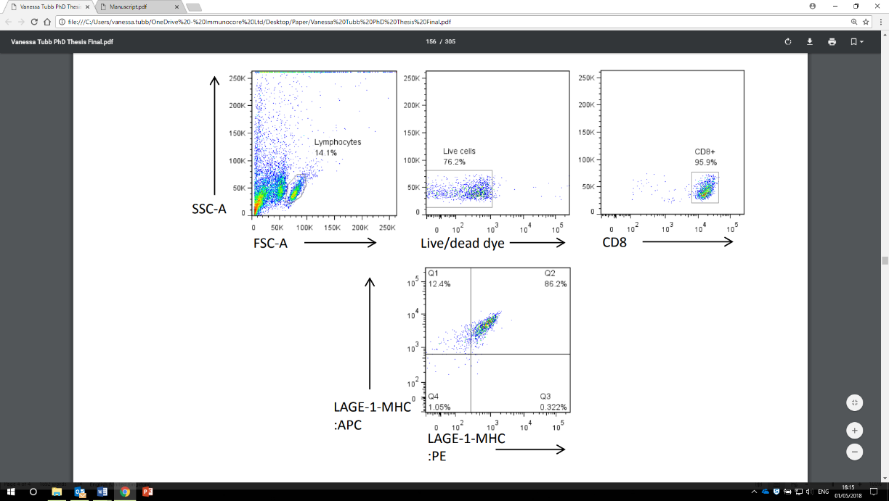
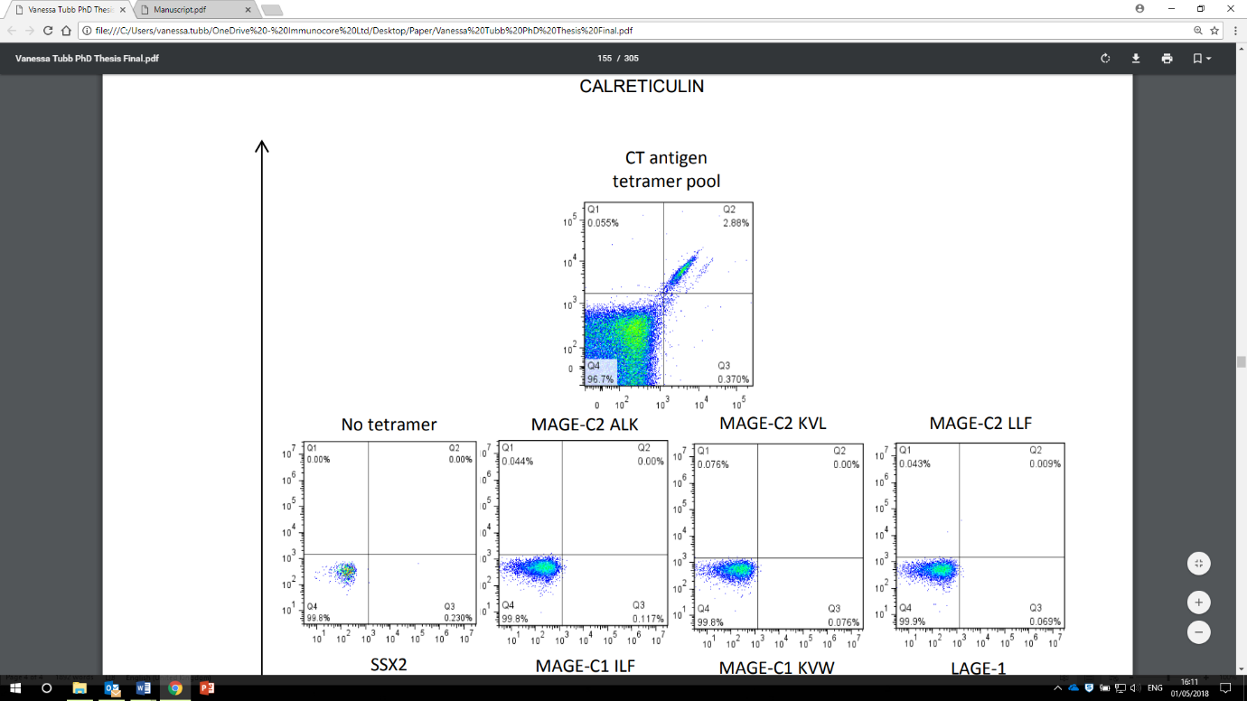
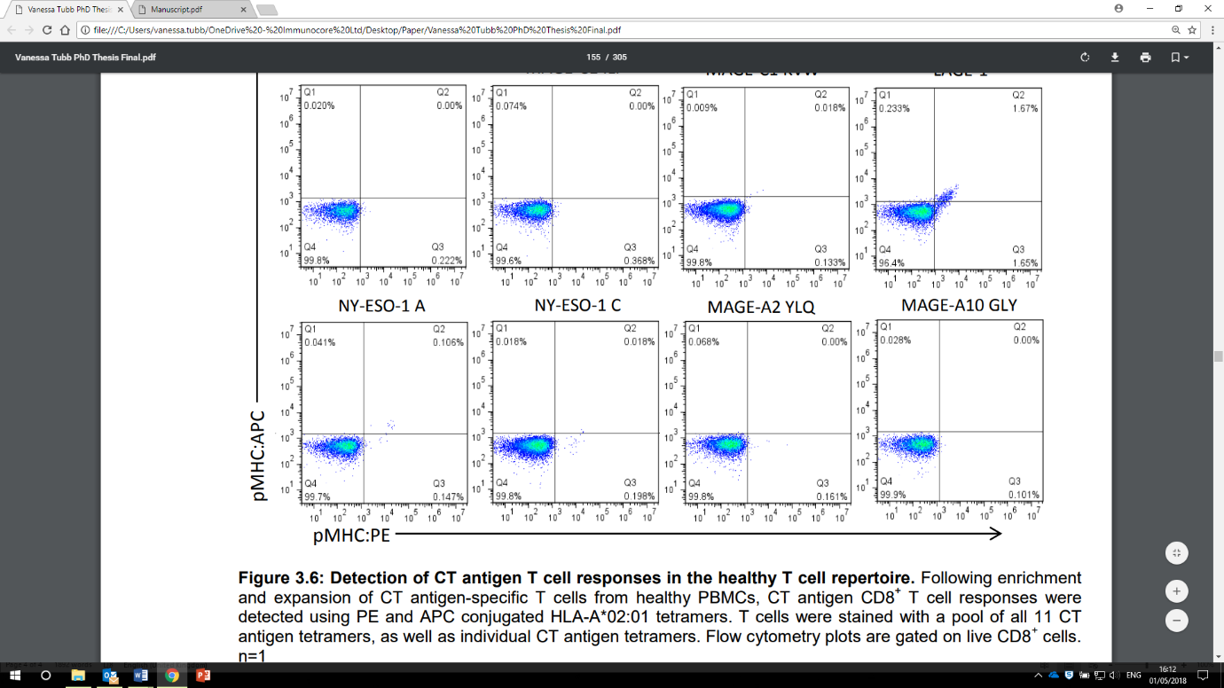
B
A

