Additional file 7
Engineering of mCALR-expressing target cells: (A) HLA-A*03:01⁺ HLA-B*07:02⁺ LCLs were retrovirally transduced with a mCALR-GFP mini gene. (B) To confirm mCALR gene expression RNA was isolated from mCALR-GFP⁺ LCLs, DNase treated, and converted to cDNA. mCALR expression was determined by mCALR PCR. No reverse trancriptase (RT) controls were included to exclude any mCALR amplification from contaminating DNA. The pmx-mCALR-IRES-GFP DNA vector was used as a positive control. mCALR product = 113bps. (n=1) (C) MARIMO cells naturally expressing a frameshift mutation in CALR exon 9 were retrovirally transduced with HLA-A*03:01-GFP and HLA-B*07:02-GFP.
A
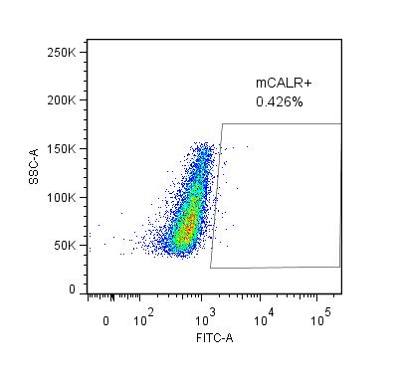
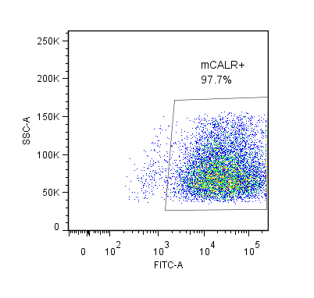
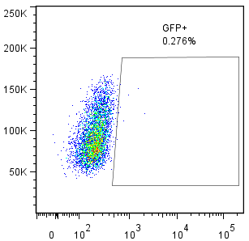
mCALR-GFP-transduced
HLA-A*03:01⁺
HLA-B*07:02⁺
LCL
Mock-transduced

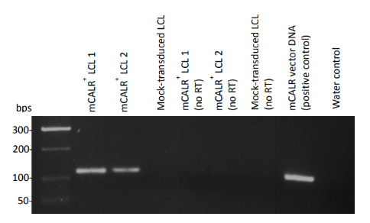
B

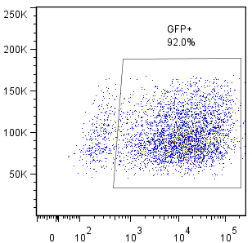
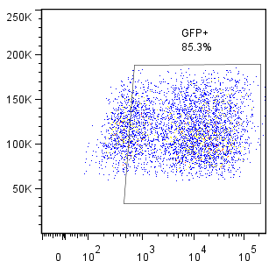
HLA-B7-GFP-transduced
HLA-A3-GFP-transduced
Mock-transduced
MARIMO
C

