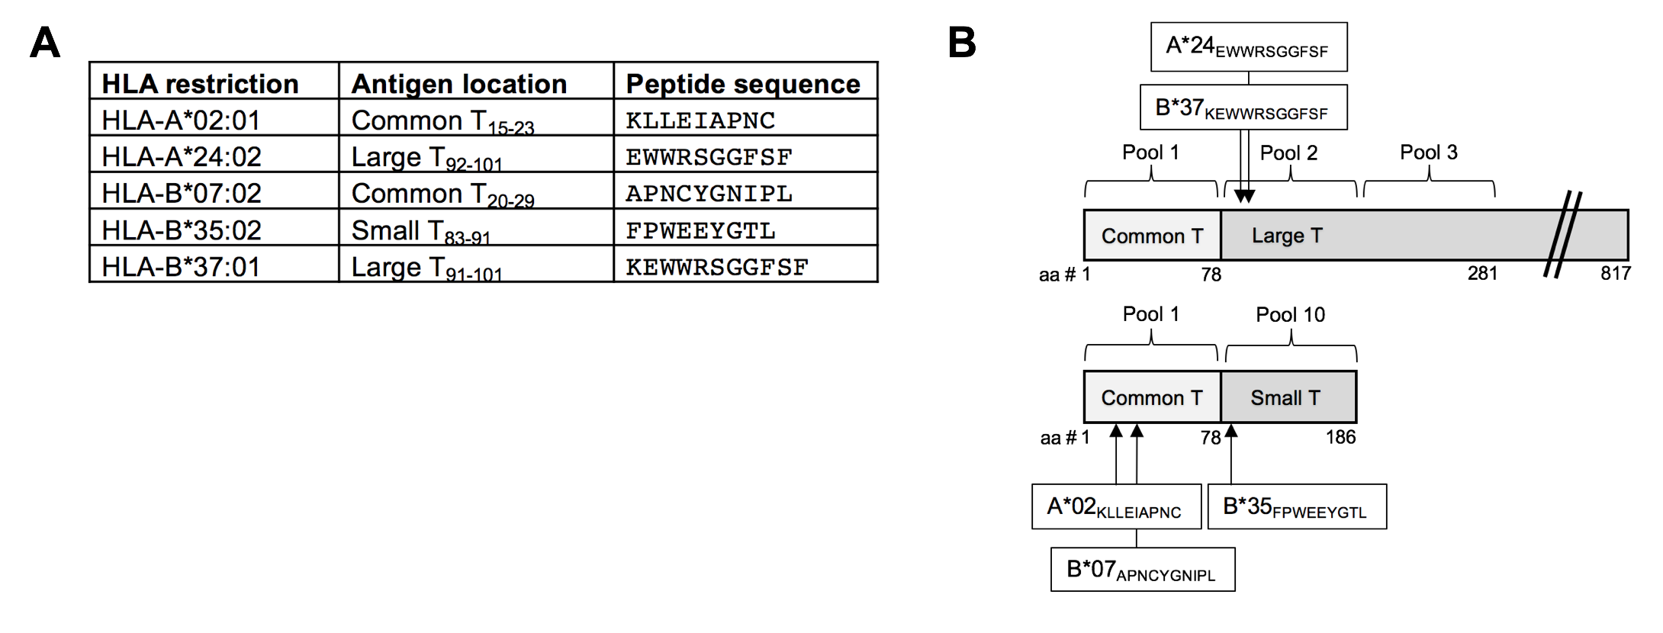

Additional file 2: Class I HLA Tetramers and MCPyV peptide pools.
A) Summary of HLA and peptide combinations used for CD8 class I tetramers including which position of the MCPyV oncoprotein (small, common, or large T antigen) the peptide corresponds to. B) Schematic of MCPyV peptide pools and locations of tetramer epitopes. Details of peptide pools are available in Iyer et al., 2011.

References:

- Iyer JG, Afanasiev OK, McClurkan C, Paulson K, Nagase K, Jing L, et al. Merkel cell polyomavirus-specific CD8(+) and CD4(+) T-cell responses identified in Merkel cell carcinomas and blood. Clinical Cancer Research. 2011;17(21):6671-6680.

